Open Source Development Lab

Content Management System

# Algorithms By Jobanputra

A website to learn about Data Structures and Algorithms

**Screenshots:**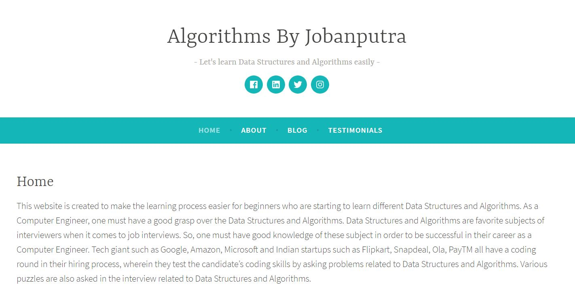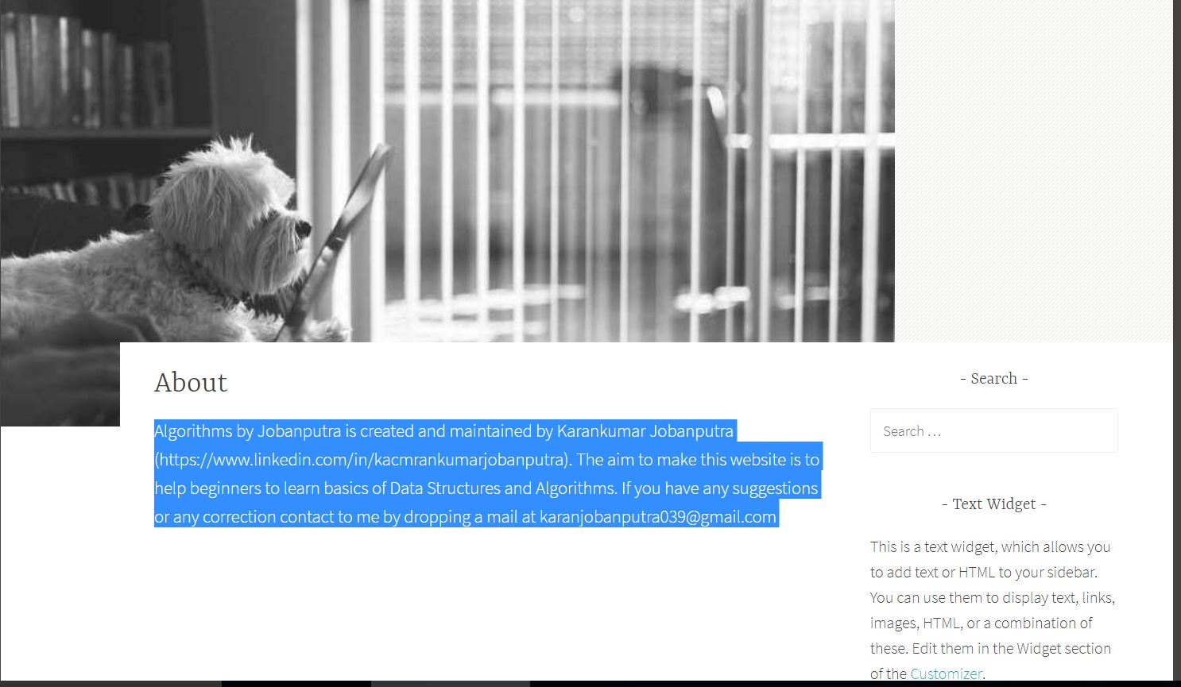

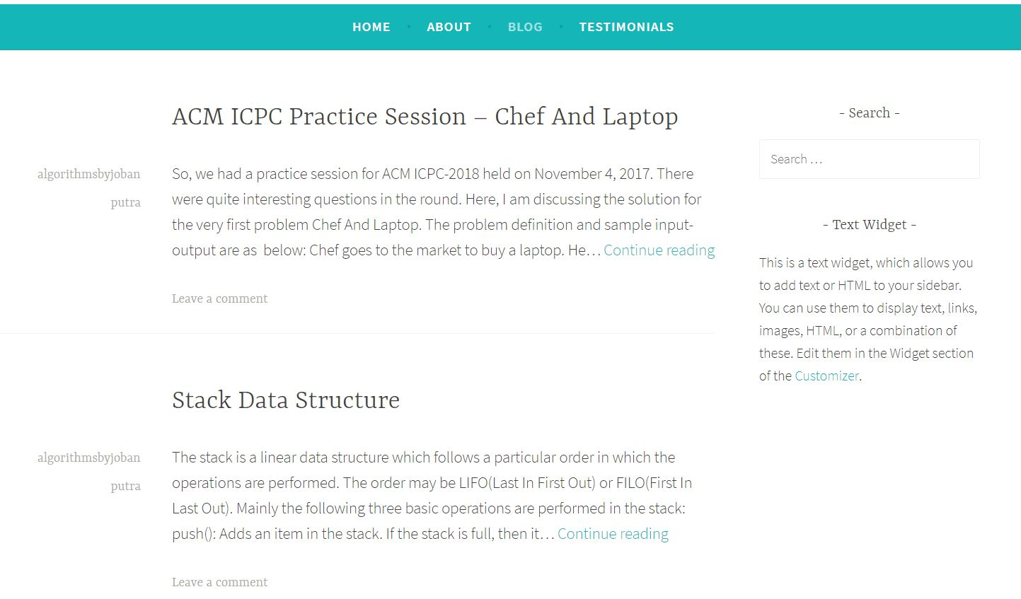

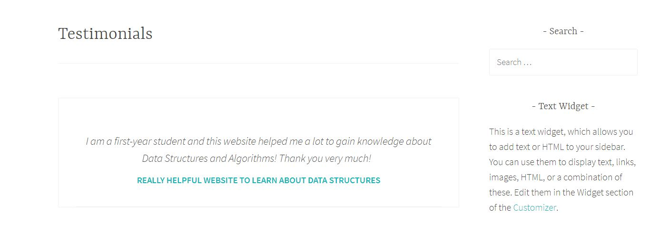

**Completed By:**

Jobanputra Karankumar ( 14BCE039 )