1

Merge Sort, Quick Sort and the Insertion Sort Analysis for the Random, Decreasing and the Increasing order Input Integers.

Index

- Plot1, plot2 and Plot3………………………………………………………………………………………………………………2-4

- Reasons to chose the platform and difficulties faced………………………………………………………………5-6

- Conclusion…………………………………………………………………………………………………………….6-9
2

Random Input for the Quick, Merge and Insertion Sort Graph

X-Axis : No of Input Integers

Y-Axis: Running time of Algorithm in Milliseconds.
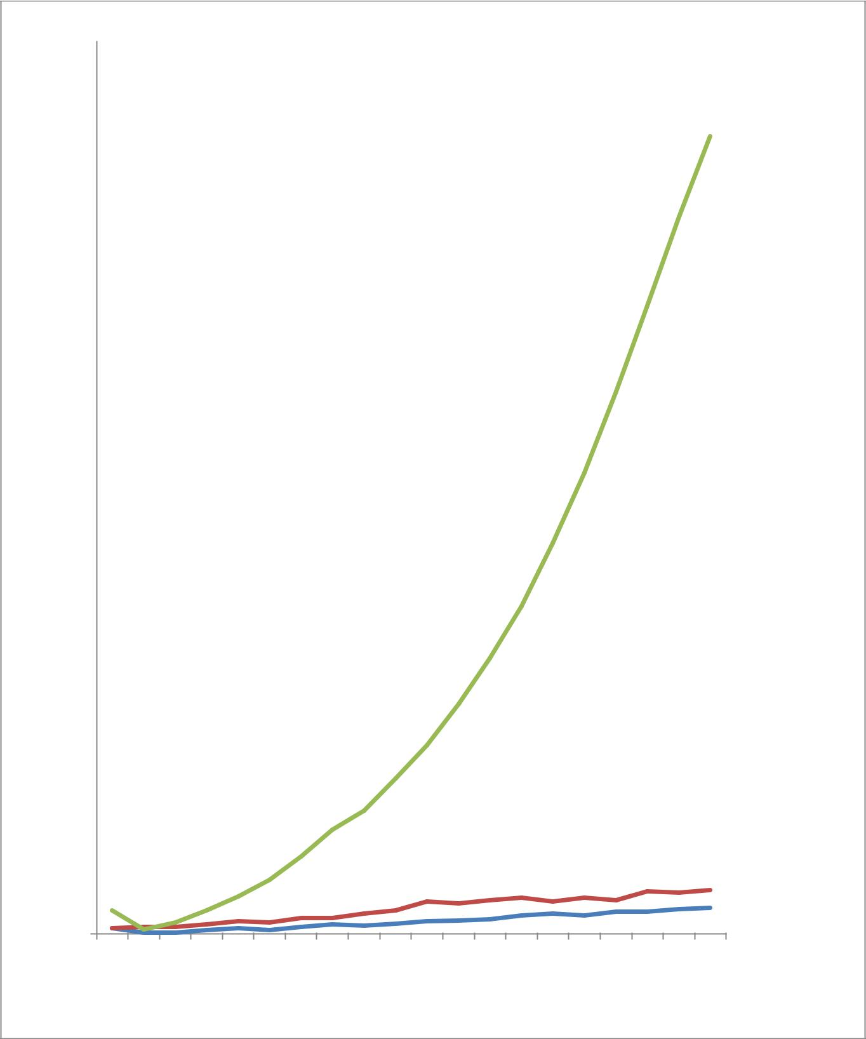

80
70
60
50 |  |  |  | Quick Sort
40 |  |  |  | Quick Sort
 |  |  |  | Merge
 |  |  |  | Sort
30 |  |  |  | Insertion
 |  |  |  | Sort
20
10

0

500 | 1000 | 1500 | 2000 | 2500 | 3000 | 3500 | 4000 | 4500 | 5000 | 5500 | 6000 | 6500 | 7000 | 7500 | 8000 | 8500 | 9000 | 9500 | 10000

Figure 1 Plot 1 for the Random Input

3

Non-Decreasing Order Input for the Quick, Merge and the Insertion Sort.

X-Axis : No of Input Integers

Y-Axis: Running time of Algorithm in Milliseconds.
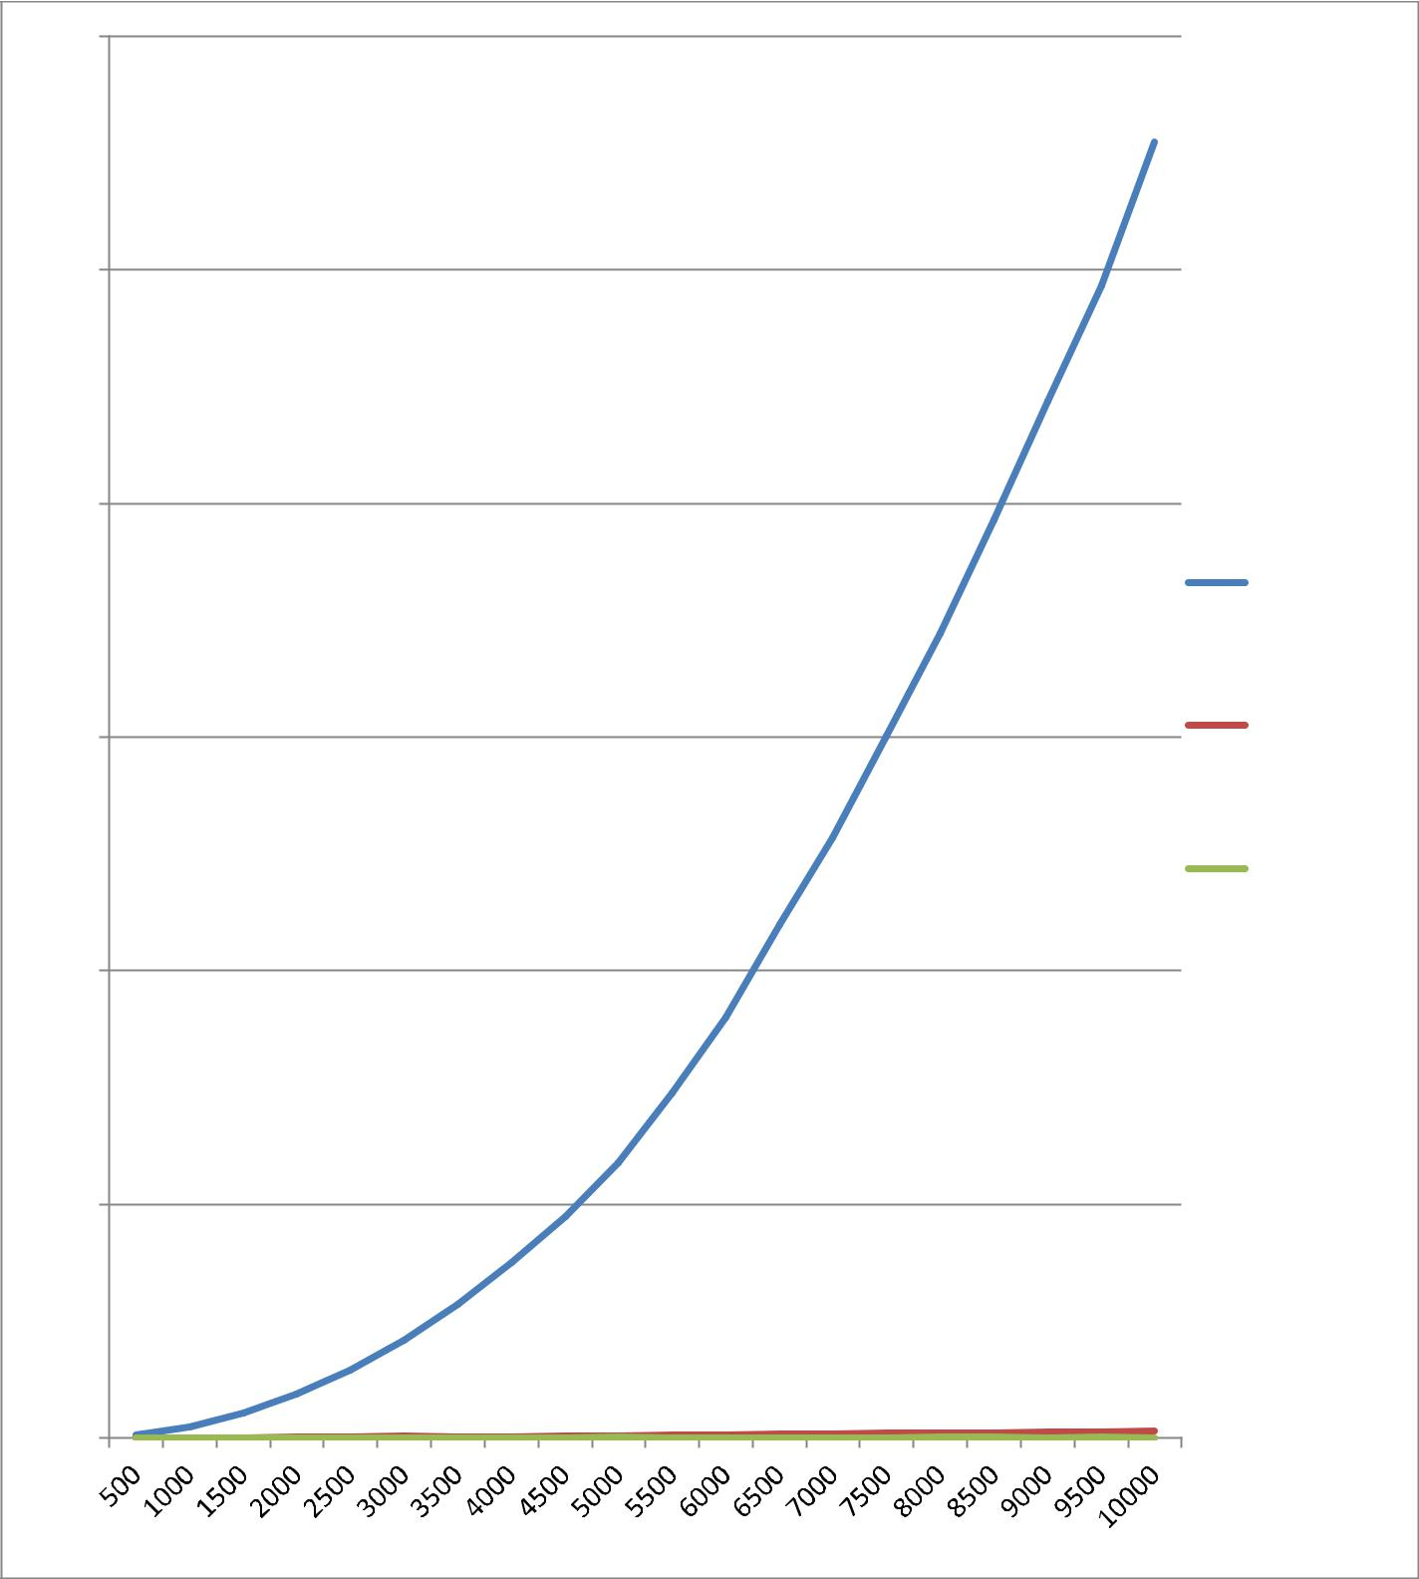

600

500

400

300

200

Quick
Sort_Non_
Decreasing

Merge_Sort
_Non_Decr
easing

Insertion_S
ort_Non_D
ecreasing

100

0

Figure 2 Plot 2 for the Non Decreasing Order Inputs

4

Decreasing Order Input for the Quick, Merge and the Insertion Sort.

X-Axis : No of Input Integers

Y-Axis: Running time of Algorithm in Milliseconds.
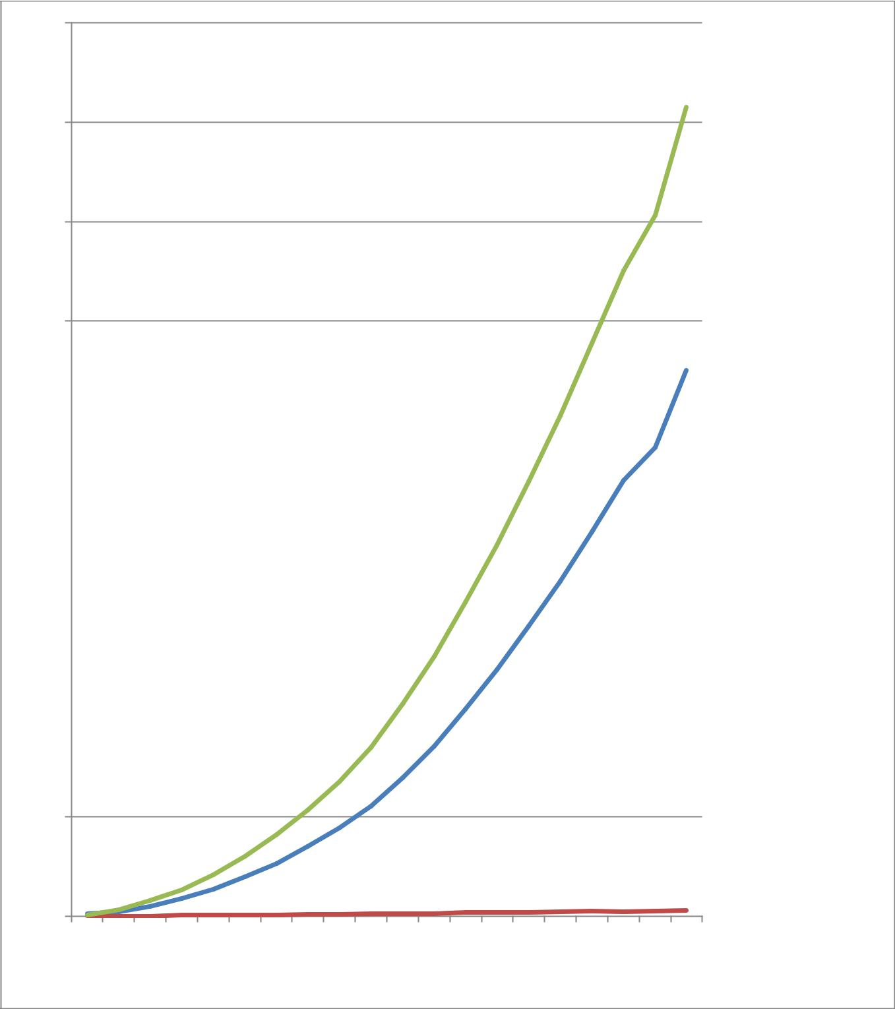

450

400

350

300

250 |  |  |  | Quick_Sor
 |  |  |  | t_Decreas
200 |  |  |  | ing_
 |  |  |  | Merge
 |  |  |  | Sort_Decr
150 |  |  |  | easing_
150 |  |  |  | Insertion_
 |  |  |  | Quick_De
 |  |  |  | creasing_
100

50

0

500 | 1000 | 1500 | 2000 | 2500 | 3000 | 3500 | 4000 | 4500 | 5000 | 5500 | 6000 | 6500 | 7000 | 7500 | 8000 | 8500 | 9000 | 9500 | 10000

Figure 3 Plot 3 for the Decreasing order

5

Reason’s to choose Java as the platform to perform this assignment:

The platform that I chose was Java, the first main reason why I wrote the code in Java because I believe that Java can have less implementation dependencies and in future if I have to demonstrate my code on the other machines then the output will not differ much, and I have more experience in programming with Java.

Also as compared to the other platforms Java running time is more faster, although we will know this fact after we run the program this is one of the secondary reason to choose Java.

The object manipulation can be done easily using Java and we tend to get most of the run time error free outputs.

Debugging is easier in Java than compared to the other languages.

I have stored the output in the csv file and generated the graph using the MS Excel through the CSV file itself, the three files will be generated plot1.csv, plot2.csv and plot3.csv which will contain the output of the program average running times for the respective inputs.

Steps and Difficulties that I came across while building the code:

- While implementing this code the first major task was to write the code for the deterministic quick sort, merge sort and the insertion sort, in which writing the code using the recursion and tracing the errors where challenging.

- After implementing these algorithms in code, we need to generate the file and store the inputs of the various size, and then we need to input them to the quick sort merge sort and insertion sort algorithms. I decided to use only one file to generate three files, write and read all the input sizes from three files. I created an object to the file to write the generated numbers using the random function and store them in the files. The files that will be generated as insert.txt, insert1.txt and insert2.txt which holds the integers and these will be read into an array list and the array list will be given as the input to the sorting algorithms.

- The next difficulty was when I need to store the random generated numbers then the numbers will need to be wrote in a cycled way like 500, 1000………10,000. The way I did it was by running the file through the 20 loops and every time inside the loop I ran the random function for 500, 1000, 1500 and so on times.

- After generation of the file and numbers these numbers needed to be input to the bubble sort and insertion sort. The best way I thought was to store them in the array list and pass the array list to be sorted, as the array list will give more accurate results than the array.

- After I had written the code I had faced the problem of the stack overflow, I ran the same program using the –Xms1024m argument, it was successfully run.

- The average times and the inputs are written in the csv file using the string builder function, and the graph is generated in the excel as it provides much better functionality to produce the graph.
6

- When we open the file and read a certain set of the inputs we need to again flush the file before reading the file for the next time and this was got missed by eye, and I had to take some time to figure it out.

Report and the conclusion:

The first two algorithms are supposed to have n polylog running time. Does the first plot reflect this?

An algorithm is said to have the polylogarithmic time if running time T(n) = O(logn)^k, and for both these algorithms we have the k = 1, so they have the n polylog running time, except for the quicksort when it is input the sorted array (it is going to be worst case of O(n^2) we observe the same in the plot 2).

Yes, the first plot reflects this, as we are comparing the inputs and the outputs of the first plot as recorded below, we see that the running time of the quick sort and the Merge Sort is O(nlogn), when the random integers are given as the input.

How do the three algorithms compare in terms of running time?

For Random Input

The three algorithms Quick, Merge and the insertion sort as observed with the output we can comment that when we input the random integers to these three algorithms we see that the quick sort takes the least time to sort the integers although with the other inputs it has almost the same time as the Merge sort (as both the algorithms have the running time of the O(nlogn)), merge sort takes little more time than compared to the quick sort, and the insertion sort is going to take the maximum time as compared to the merge and quick. We also observe that this proves that the insertion sort is going to have the quadratic running time of O(n^2). (Since both of the loops will be executed to shift the elements).

For the Non-Decreasing Order

Here we see that the running time is the highest for the Quicksort, since the quicksort is going to have the O(n^2) while the increasing order inputs are given to sort, because every time the swap takes place in the partition while the pivot element is compared.

For the merge sort the running time is O(nlogn) and we can see the same as well from the results captured.

With respect to the insertion sort, the insertion sort performs pretty well as this is going to be best case for the insertion sort and the insertion sort is going to have the least running time of O(n).(as the second loop never gets executed)

For the Decreasing Order Inputs

We can see that the Insertion sort and the Quick sort have taken the more time for sorting the integers in the decreasing order , and also we can observe that the running time for the insertion and the quick
7

sort is O(n^2) since the no of swaps are more, and for the merge sort the running time is O(nlogn) and it takes the least time in comparison with the other two algorithms for the decreasing order inputs.

How about the second plot? Which algorithm do you think this one is the best here?

The second plot depicts the increasing order inputs and the insertion sort performs better in this case, with the running time of the O(n). The quick sort will have the running time as the worst case for the sorted array input of O(n^2), where as the merge sort will have the O(nlogn).

The insertion sort is best here and hence can be used when the list is large and the time is premium.

Why do you think it looks the way it does? As we can see that the quick, merge and the insertion sort graphs.

Plot 1 with the random input.

Merge sort divides the array into two halves every time recursively, and later combines them. Everytime when the array is divided and new arrays are formed, so the space utilized is more and this is not in place algorithm. The divide and conquer strategy makes this algorithm have the running time of O(nlogn), so the graph is almost near to the x-axis.

Quick sort also have the running time of O (nlogn), so the graph is almost low and near to the x-axis, this algorithms also uses the divide and conquer methodology.

Insertion sort has the running time of O(n^2). So the graph is quadratic for insertion sort, since there are two for loop which need to be executed with the random input the two of the loops get executed and will have the running time of O(n^2).

Plot 2 with non-decreasing order input.

Quick sort kicks to be quadratic because maximum no of the swaps takes place while portioning. As the last element is pivot, in ascending order the pivot is the greatest so all the elements will be moved to the left of it and hence it becomes quadratic.

Merge sort takes less time to sort, and the insertion sort has the best case and it takes the least time.

Plot 3 with the decreasing order input.

Here more no of the swaps take place for the quick and the insertion sort, so the graph kicks high for these two to be quadratic.

The graph has the merge sort to be performing in the optimal condition as before.
8

How does the third compare to the first and the second?

In the third plot both the algorithms insertion and the quick sort have the quadratic running time of the O(n^2) since the swaps are more the running time is quadratic for every input of x increases the y increase twice and the no of inputs is directly proportional to the running time.

Merge sort has the same sort of the running time in third as well.

What kind of functions do you think you‘re observing in the three plots (linear, logarithmic, quadratic, exponential, etc )?

In the plot 1 we are observing the logarithmic functions i.e.. of the type n polylog, for the merge and the quick sort.

In plot 2 we are observing the quadratic function for the quick sort since it has the highest no of swaps for the sorted array and the worst case, and the n polylog for the merge sort, and linear function for the insertion sort.

In plot 3 we are observing the quadratic function for the insertion and the quick sort as the more no of the swaps take place for these two algorithms, and the merge has the function of the n polylog.

Real Life usage

Merge Sort

The merge sort is the best algorithm to use when we cannot predict the order of the input numbers because it always performs in the constant way as we shouldn’t be getting unpredictable results when we don’t know the order.

Insertion Sort.

The algorithm can be used when the list is large and we need to sort or study the sorted algorithm, and when the time is premium.

Practically speaking this only performs well when the array is sorted so even this has the best case for the sorted array, the circumstances are less where one wants to sort the already sorted array.

Quick Sort

The quick sort can be used when we need to sort the list of random integers, and seeing the plot results we need to avoid it during the sorted and the decreasing order inputs.

