**EVENT MANAGEMENT SYSTEM**

**AIM**

To create a system to perform the Event Management system.

**PROBLEM STAEMENT**

In any event many service providers work simultaneously and it is very hard to manage these providers. It is also important for event organizer that he has all the contact details of these service providers so that he can contact them any time to plan a event at given time. In present system Event Company has to do all management work manually.

They keep all payment information on papers. There is no system to check the past expenses on any event. To do this, they have to check payment register and this task is very time consuming and tiresome.

**DESCRIPTION OVERVIEW**

Event management is the application of project management to the creation and development of large scale events such as festivals etc. To get success in event management, event organizer should have strong network contacts of service provider. To make an event successful event manager needs different service provider.Popular digital assistants, include:

**TECHNOLOGY USE**

Html , css, javascript

Visual Studio

**SOFTWARE INSTALLATIONS:**

**1. Installation of Visual Studio Code On Windows**

**Step 01:** Visit the official website of the Visual Studio Code and it starts downloading <https://code.visualstudio.com/docs/?dv=win>

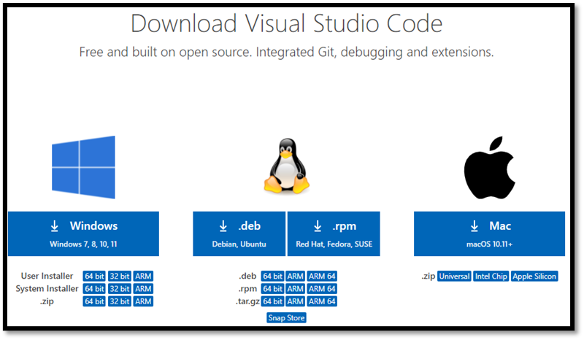

**Fig 1.1**

**Step 02:** Press the “Download for Windows” button on the website to start the download of the Visual Studio Code Application.

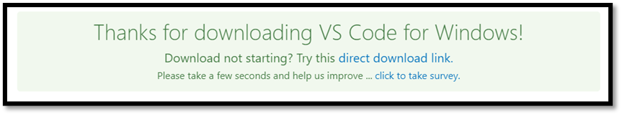

**Fig 1.2**

**Step 03:** When the download finishes, then the Visual Studio Code icon appears in

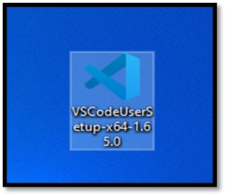 the downloads folder

**Step 04:** Click on the installer icon to start the installation process of the Visual Studio Code.

**Step 05:** After the Installer opens, it will ask you for accepting the terms and conditions of the Visual Studio Code. Click on I accept the agreement and then click the Next button.

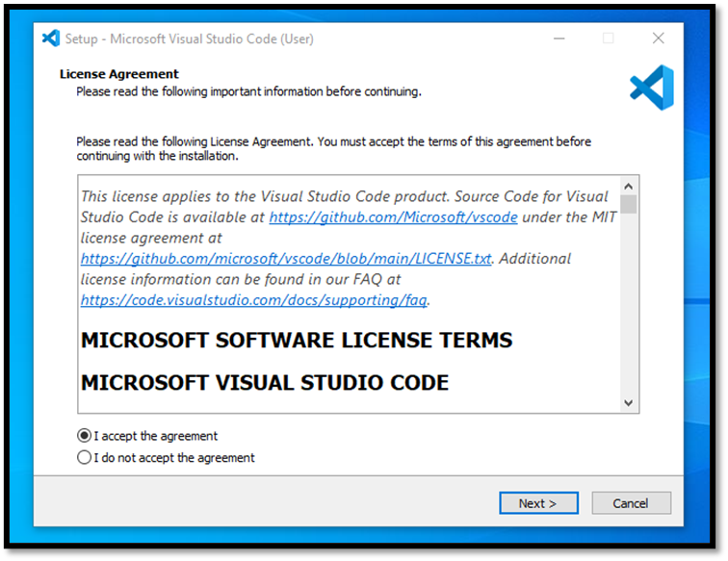

**Fig 1.4**

**Step 06:** Choose the location data for running the Visual Studio Code. It will then ask you for browsing the location. Then click on Next button.

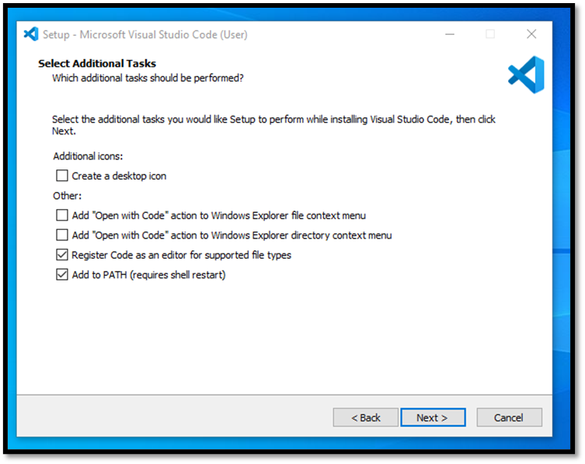

**Fig 1.5**

**Step 07:** Then it will ask for beginning the installing setup. Click on the Install button.

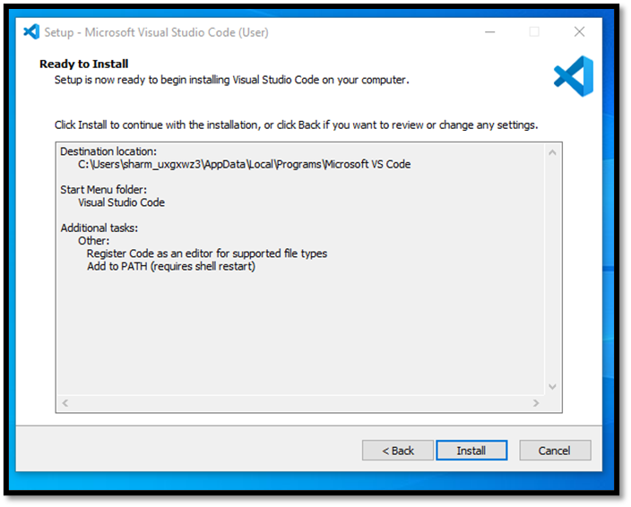

**Fig 1.6**

**Step 08:** After clicking on Install, it will take about 1 minute to install the Visual Studio Code on your device.

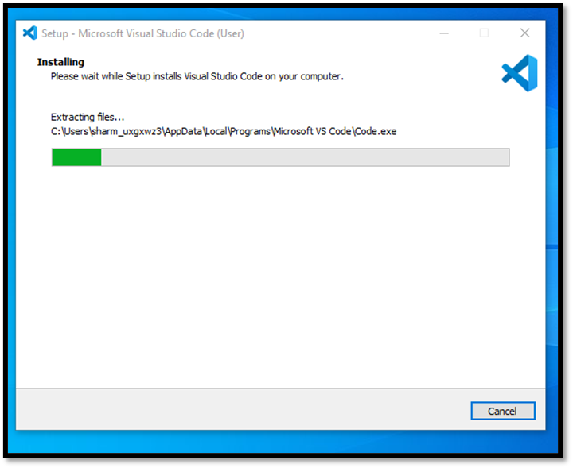

**Fig 1.7**

**Step 09:** After the Installation setup for Visual Studio Code is finished, it will show a window like this below. Tick the **“Launch Visual Studio Code”** checkbox and then click Next.

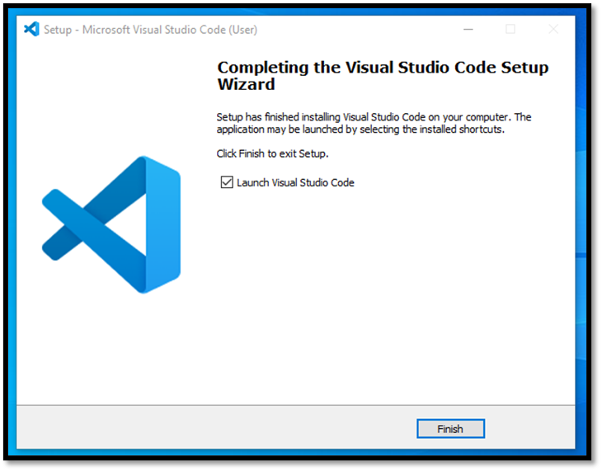

**Fig 1.8**

**Step 10:** After the previous step, the Visual Studio Code window opens successfully. Now you can create a new file in the Visual Studio Code window and choose a language of yours to begin your programming journey!

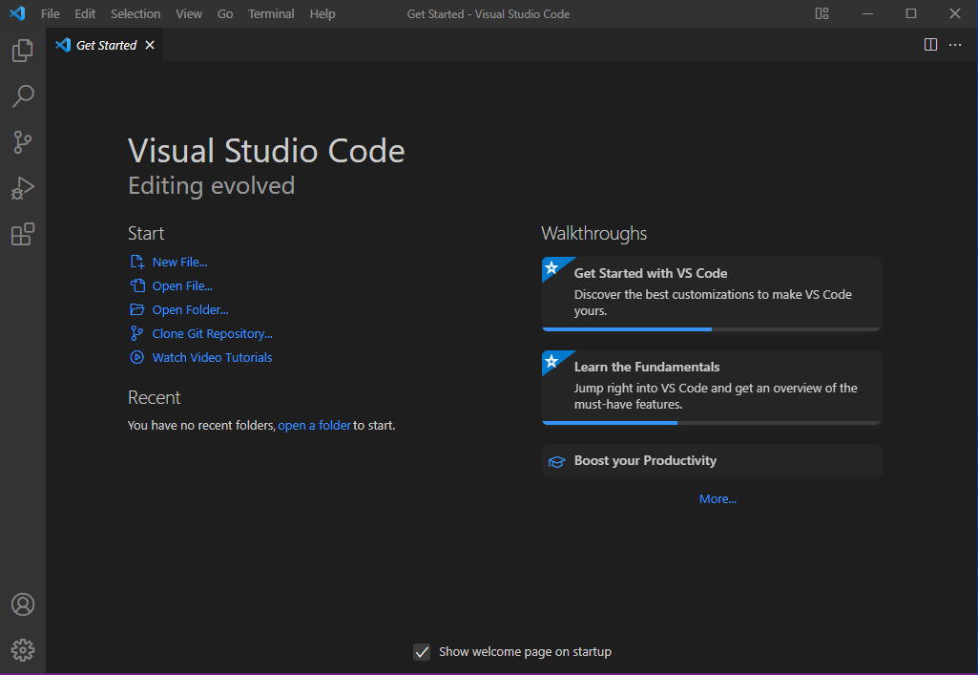

**FLOW CHART DIAGRAM**

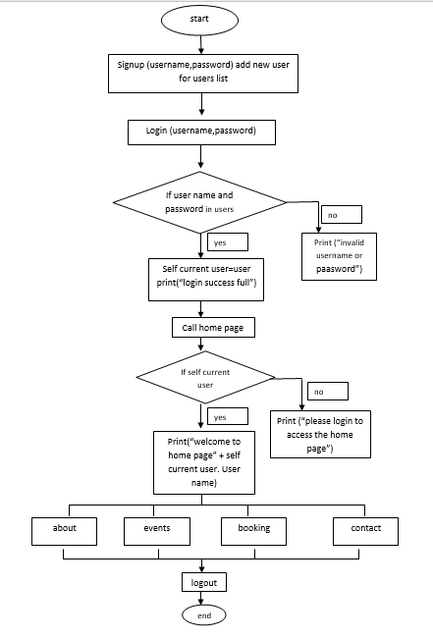

**IMPLEMENTATION OF PROJECT:**

**Output Code :**

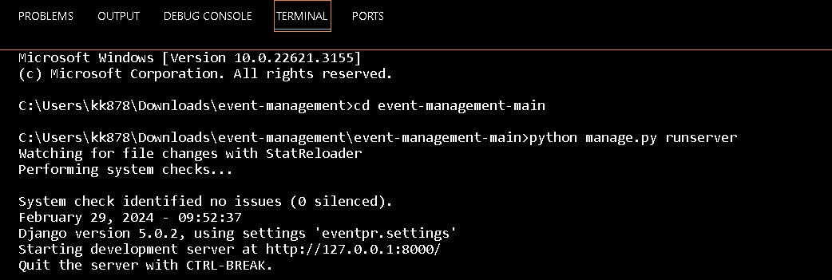

**CUSTOMER WEBSITE:**

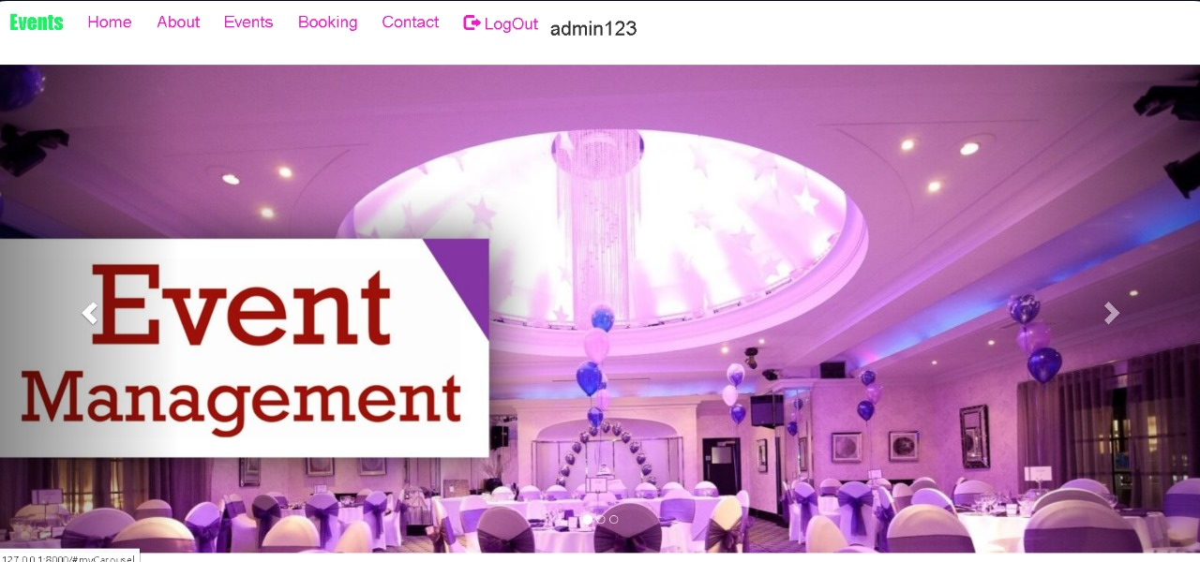

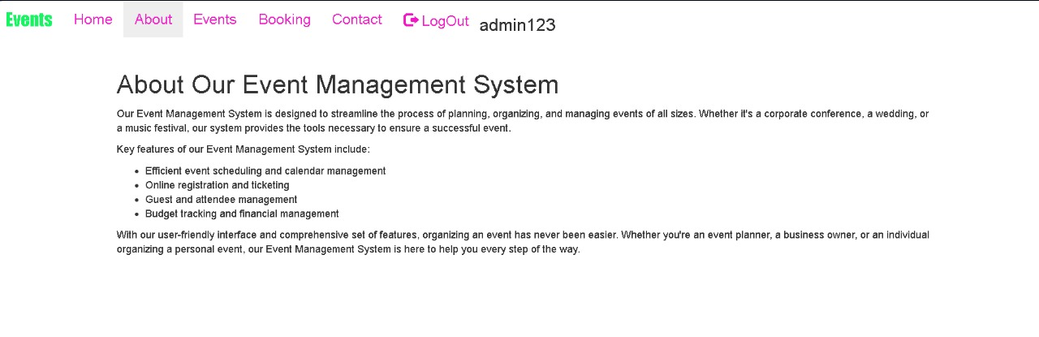**# ABOUT**

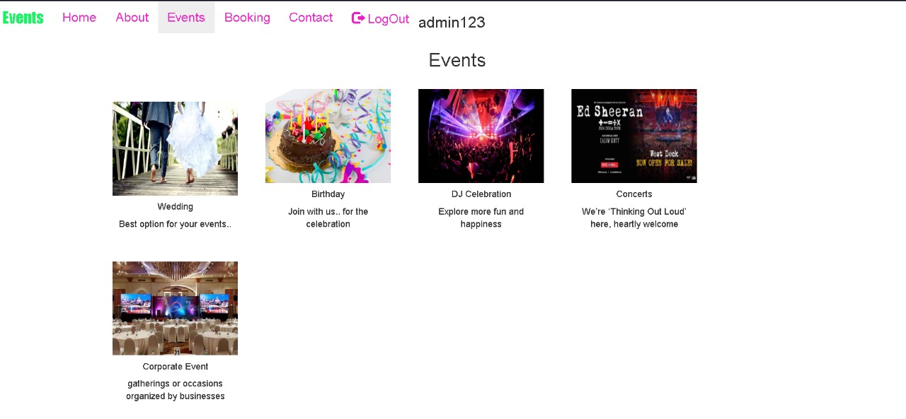**# Events**

**# ADMIN PAGE**

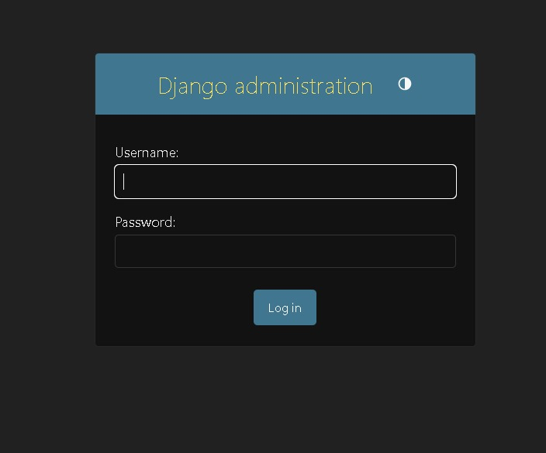

**# CONCLUSION**

an effective event management system is crucial for seamless planning, execution, and post-event analysis. It streamlines processes, enhances communication, and ensures a memorable experience for both organizers and attendees. Embracing technology and robust planning methodologies can significantly contribute to the success of any event.