**Heuristic Analysis for an Adversarial Game Playing agent**

**Karan Pinto**

The results obtained from tournament.py are as follows:

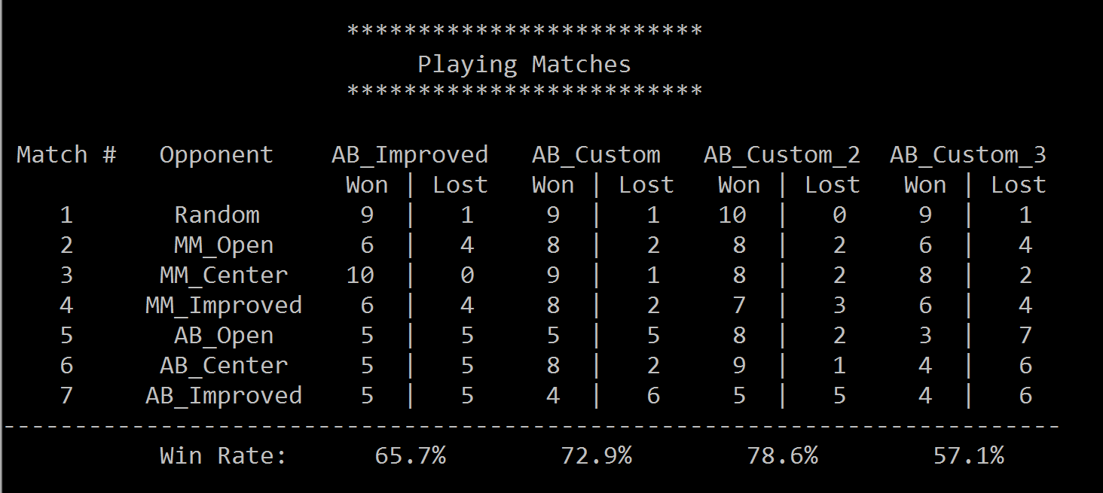

The heuristic functions evaluate the game result when the maximum depth is reached by the searching tree.

**Heuristic 1**

With this heuristic, the **more available moves player has available from the evaluated position, the better**. Here, the function simply returns the difference in number of legal moves left between the players.

* If the player and its opponent have the same number of moves, then the returned value is zero.
* If the returned value is positive/negative, then the player is doing better/worse than its opponent.
* If the returned value is "inf"/"-inf", then the player has won/lost the game.

**Analysis**

* A decent win rate!
* It is **easily interpretable and fast** to compute.
* But on the downside, it is not really "game aware". It is oblivious to the notion of positional advantage and isn't influenced at all by the specific mechanics of the game that only knight moves are allowed.

**Heuristic 2**

(own_moves/(1+opp_moves**2))

This Heuristic attempted at providing a more wholesome evaluation by amplifying the effect of increasing opponent moves and increasing the sensitivity for our player!

**Analysis**

* This proves to be the best heuristic out of the three with the highest win percentage!!
* It only experiences its worst win percentage in AB_Improved

**Heuristic 3**

(moves - opp_moves + centrality(game, game.get_player_location(player)))

Attempted to try a different approach including centrality to reflect potential of available moves, total moves and opponents moves. I would characterize this as a defensive approach, which attempts to make moves as close to the centre of the board as possible.

**Analysis**

* Not great at offensive but reasonable defence attributes!
* The worst out of the three in terms of win percentage -- Only wins in Random and MM_Open!