Smart Career Recommendation System
Group Members: Karan (023-23-0208)
Muneer (023-23-0238)

Supervisor: Dr Ismail Mangrio

Class: BSCS-V Sec ‘E’

Abstract
Finding suitable job opportunities has become increasingly challenging due to the vast number of job postings available across multiple online platforms. Job seekers often struggle to identify positions that align with their skills, education, and experience. This project presents a Smart Career Recommendation System designed to assist users in discovering relevant job opportunities efficiently.
The system utilizes Natural Language Processing (NLP) techniques, specifically Term Frequency–Inverse Document Frequency (TF-IDF) vectorization and cosine similarity, to measure the relevance between a user’s profile and job descriptions. Job postings from multiple portals are processed and ranked based on textual similarity and experience compatibility. Additionally, the system identifies missing skills for each recommended job and provides direct application links.
The proposed system does not involve machine learning model training; instead, it relies on similarity-based text analysis and rule-based heuristics. Experimental results demonstrate that the system effectively ranks job opportunities and provides meaningful recommendations, making it suitable for practical deployment in career guidance application. The system also supports resume upload in PDF and DOCX formats, enabling automatic skill extraction from resumes. In addition to job recommendations, the system suggests relevant online courses to help users bridge identified skill gaps

1. Introduction
The rapid expansion of online job portals has made job searching both accessible and overwhelming. While numerous platforms provide thousands of job listings, job seekers often face difficulty in identifying roles that truly match their qualifications and career interests. Manual searching is time-consuming and prone to mismatches between job requirements and user skills.
Problem Statement:
Despite the availability of multiple job portals, there is a lack of intelligent systems that can effectively filter job opportunities based on a comprehensive analysis of user skills, experience, and interests. As a result, job seekers often apply to unsuitable positions or overlook relevant opportunities.
To address this issue, intelligent career recommendation systems have gained importance. Such systems aim to filter and rank job opportunities based on user profiles, thereby improving efficiency and decision-making. This project focuses on developing a smart career recommendation system that leverages Natural Language Processing (NLP) techniques to analyze job descriptions and user-provided information.
In addition to basic job matching, the proposed system incorporates multiple filtering mechanisms, including semantic relevance filtering, skill-based filtering, and experience-based filtering. The system supports resume-based input, allowing users to upload their resumes so that skills and experience can be automatically extracted and utilized for job matching.
Furthermore, the system distinguishes between perfect matches and partial matches by analyzing skill overlap between the user profile and job requirements. For partial matches, the system identifies missing skills and recommends relevant learning resources or courses to help users bridge their skill gaps, thereby supporting continuous professional development.

2. Literature Review
Several studies have been conducted on job recommendation systems to assist job seekers in identifying suitable career opportunities. Early job recommendation systems primarily relied on keyword matching and manual filtering, which often resulted in irrelevant recommendations and limited personalization.
Content-based recommendation systems have gained popularity due to their ability to match user profiles with job descriptions based on textual similarity. These systems analyze user skills, interests, and job requirements to generate recommendations without relying on historical user interaction data. TF-IDF has been widely used in such systems to assign weights to important terms while reducing the impact of commonly occurring words.
Cosine similarity is frequently employed alongside TF-IDF to measure the similarity between user profiles and job descriptions. Several researchers have demonstrated that this combination is effective for document matching and information retrieval tasks due to its simplicity and interpretability.
Recent studies have explored deep learning-based approaches, such as Word2Vec and BERT, to capture semantic relationships between skills and job descriptions. Although these approaches improve contextual understanding, they require large datasets and high computational resources. Furthermore, many existing systems do not incorporate experience-based filtering or provide skill gap analysis. This project addresses these limitations by integrating rule-based experience matching and missing skill identification into a content-based job recommendation framework

3. Proposed Methodology
The proposed system follows a content-based recommendation approach using NLP techniques. The overall workflow of the system is illustrated below:
Workflow:
- User inputs education, skills, interests, and experience.
- Job data is loaded from multiple job portals.
- Text preprocessing is applied to both user input and job descriptions.
- TF-IDF vectorization converts text into numerical vectors.
- Cosine similarity is computed between the user profile and each job description.
- A rule-based experience matching score is calculated.
- Final job ranking is produced using a weighted scoring mechanism.
- Missing skills are identified and displayed with each recommendation.
Data Loading:
Job data is loaded from a structured dataset and preprocessed to extract relevant textual and skill-based information prior to similarity computation.
User Interface:
The validated recommendation logic was integrated into a web-based graphical user interface to enable real-time user interaction. The GUI serves as an interface layer and does not alter the underlying recommendation methodology.
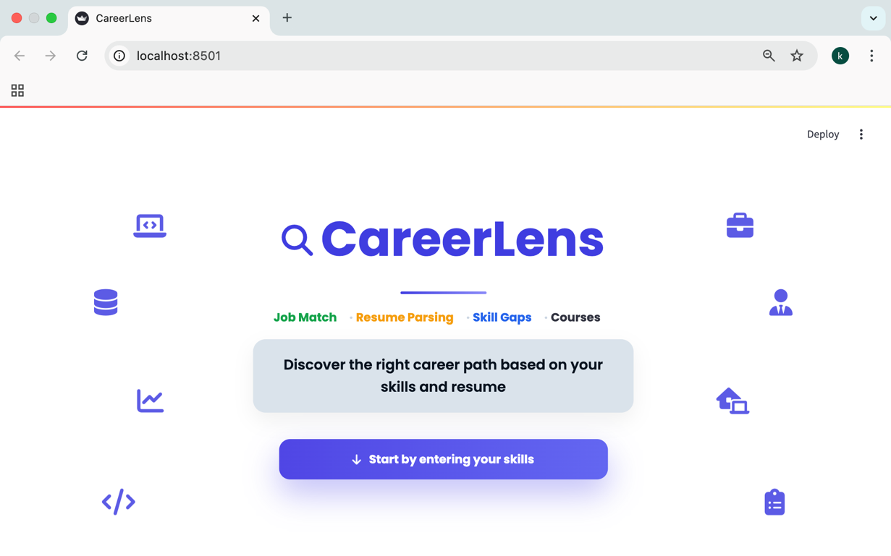
User Input Form
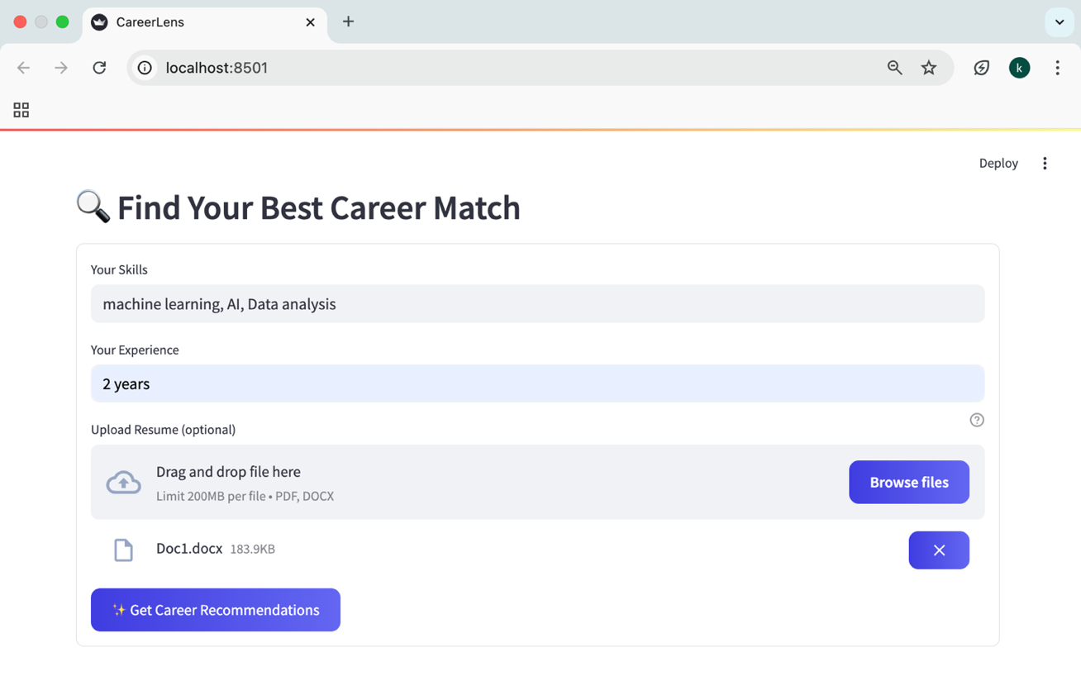
Resume Parsing and Skill Extraction:
The proposed system includes a resume upload feature that allows users to upload resumes in PDF or DOCX format. The uploaded resume is processed using text extraction techniques, where PDF files are handled using pdfplumber and DOCX files using python-docx. The extracted text is cleaned and analyzed to automatically identify user skills. These extracted skills are merged with manually entered user inputs to form a comprehensive user profile for job recommendation.
TF-IDF Vectorization:
TF-IDF assigns importance to words based on their frequency in a document and rarity across documents, ensuring that meaningful skills receive higher weight.
Cosine Similarity:
Cosine similarity measures the angular similarity between vectors, allowing the system to identify how closely a job description matches the user profile.
Experience Matching:
A rule-based function evaluates whether the user’s experience satisfies the job’s required experience and adjusts the final score accordingly.

Match Classification Logic (Perfect vs Partial):
The system employs a hybrid match classification strategy that dynamically adapts based on the availability of skill information in job postings. This approach ensures accurate and fair classification while handling real-world inconsistencies in job data.

When a job posting explicitly specifies required skills or when skills can be reliably inferred from the job title and description, match classification is performed using skill coverage. A job is classified as a Perfect Match if all specified or inferred skills are satisfied by the user profile. If some of the required skills are missing, the job is classified as a Partial Match.
In cases where a job posting does not specify skills explicitly and no reliable skill inference is possible, the system relies on semantic similarity scores computed using TF-IDF vectorization and cosine similarity. Jobs with high semantic similarity scores are classified as Perfect Matches, jobs with moderate similarity scores are classified as Partial Matches, and jobs with low similarity scores are filtered out entirely. This three-level decision mechanism ensures that incomplete or unstructured job postings are evaluated intelligently while weak or uncertain recommendations are excluded.

Result Filtering: After computing the final relevance score for each job posting, filtering rules are applied based on the presence or absence of skill information. For jobs with explicitly specified or inferred skills, recommendations are retained and classified based on skill coverage to ensure eligibility-based fairness.

For job postings without explicit or inferable skills, a strict semantic filtering mechanism is applied. Only jobs with sufficiently high semantic similarity scores are retained as perfect matches, moderately relevant jobs are retained as partial matches, and weakly relevant jobs are removed from the final recommendation list. This filtering strategy significantly reduces noise and ensures that only meaningful and high-confidence recommendations are presented to users.

Jobs recommended
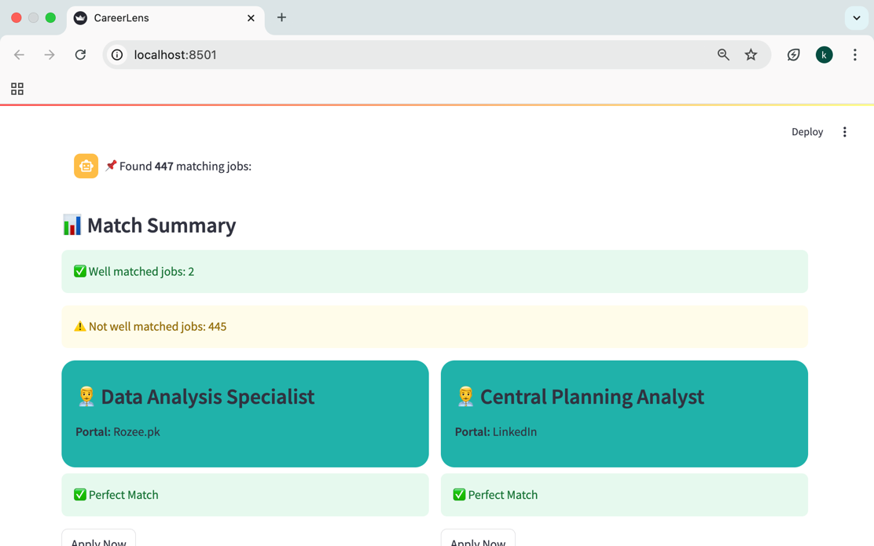

Job Recommendations Showing Missing Skills and Suggested Courses
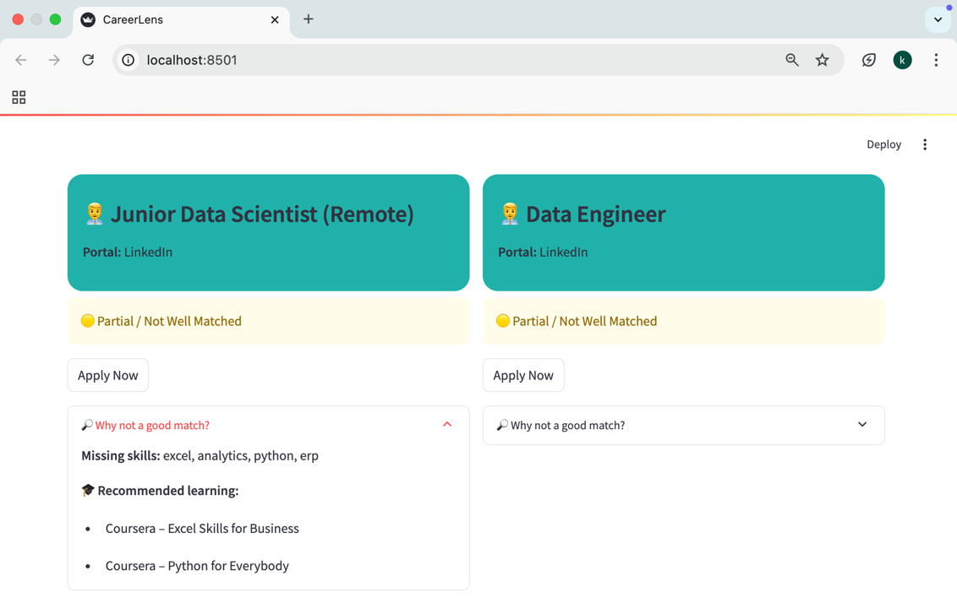

Scoring and Ranking:
For each job posting, a final relevance score is computed using a weighted combination of three components: semantic similarity, skill matching, and experience compatibility. Semantic similarity is calculated using TF-IDF vectorization and cosine similarity between the user profile and job description. Skill matching is computed based on the overlap between user skills and job-required or inferred skills, while experience compatibility is evaluated using a rule-based comparison between user experience and job requirements.
The final relevance score is primarily used to rank job recommendations. Additionally, this score plays a decisive role in match classification when job skill information is unavailable. In such cases, predefined semantic similarity thresholds are used to distinguish between perfect, partial, and weak matches, ensuring relevance-based and intelligent decision-making.

Course Recommendation Module:
The system also incorporates a course recommendation module that suggests relevant learning resources based on identified skill gaps. After comparing user skills with job requirements, missing skills are determined. For each missing skill, the system recommends suitable online courses sourced from platforms such as Coursera, Udemy, and free learning repositories. This feature enables users to upskill and improve their employability.

4. Experimental Setup
The system was implemented using the following tools and technologies:
- Programming Language: Python
- Framework: Streamlit (for web-based user interface + CSS for further styling)
- Dataset: Job postings collected from Kaggle(CSV format)
- Libraries Used:
  - Pandas (data handling)
  - Scikit-learn (TF-IDF and cosine similarity)
  - NumPy (numerical operations)
  - Regular Expressions (skill extraction)
The experimental analysis of the proposed system was conducted using a Jupyter Notebook environment. The notebook contains the complete implementation for data loading, preprocessing, TF-IDF vectorization, cosine similarity computation, and evaluation of recommendation results. This notebook was used for testing different experimental settings prior to GUI deployment.
- Data cleaning techniques were applied to find null values and fill them properly.
- I also found variables names different in 3 different datasets, thus renamed them carefully in order to avoid name error.
- Then, started recommendation engine logic by implementing TF-IDF algorithm and cosine similarity.
- I got correct output with sample datasets created manually then started building real project with GUI and accurate recommendation engine logic

Data Loading and preprocessing:
Job posting data was loaded using a dedicated data loading module that reads structured files obtained from a Kaggle dataset. The module handles file parsing, column selection, and data normalization. Relevant fields such as job title, description, required skills, experience, and portal information were extracted and combined into a unified textual representation for further processing. The processed data was stored in a tabular format using Pandas and served as input for the recommendation pipeline.
User Interface:
A web-based graphical user interface was developed using the Streamlit framework. The GUI allows users to input their education, skills, interests, and experience and receive real-time job recommendations. The recommendation logic implemented and validated in the Jupyter Notebook was modularized and integrated into the GUI without modification.
Supporting Modules:
A utility module was developed to handle common preprocessing tasks such as text normalization, skill extraction, and input cleaning. These helper functions were reused across different components of the system to ensure modularity and code maintainability.
Resume parsing:
Resume parsing was implemented using the pdfplumber and python-docx libraries to support automatic extraction of skills from uploaded resumes.
Course Recommendation:
Course recommendations were implemented using a predefined mapping between skills and learning resources.

5. Findings
The proposed system successfully generates ranked job recommendations tailored to individual user profiles. Jobs with higher semantic similarity and compatible experience requirements consistently achieved higher relevance scores. The system also effectively identifies missing skills by comparing job-required or inferred skills with user-provided skills.
Experimental evaluation revealed the following key findings:
• Data cleaning and normalization significantly improved recommendation accuracy and consistency across multiple datasets.
• Resolving inconsistent variable naming across different datasets was essential to avoid data conflicts and ensure correct processing.
• Job postings with explicitly defined or inferred skills were accurately classified using skill coverage, resulting in transparent and rule-consistent recommendations.
• Job postings without specified skills were intelligently evaluated using semantic similarity scores, allowing the system to identify relevant opportunities that would otherwise be misclassified by rigid rule-based approaches.
• Weakly relevant job postings lacking skill information were successfully filtered out, improving overall recommendation quality and reducing noise.
• The hybrid classification strategy enhanced the system’s robustness in handling real-world, inconsistent, and unstructured job data.
• TF-IDF and cosine similarity proved effective for relevance-based ranking, while rule-based skill matching ensured eligibility accuracy.
• Experience-based scoring further improved recommendation precision.
• The course recommendation module successfully suggested relevant learning resources corresponding to identified skill gaps, providing users with clear pathways for professional development.
These findings confirm that the system effectively assists users in identifying relevant and meaningful job opportunities.

6. Discussion
The use of TF-IDF vectorization combined with cosine similarity proved effective for relevance-based job matching. This approach is computationally efficient, interpretable, and does not require labeled training data, making it suitable for academic as well as practical applications. By converting user profiles and job descriptions into numerical vectors, the system was able to identify and rank relevant job opportunities based on textual similarity.
One limitation of the approach is its reliance on keyword-based representations, which may not fully capture deeper semantic relationships between related terms (for example, “ML” and “Machine Learning”). However, this limitation is mitigated through the integration of explicit and inferred skill extraction, experience-based scoring, and adaptive match classification.
Rather than relying solely on rigid rules, the system adopts a hybrid strategy that combines rule-based skill matching with semantic similarity analysis. When skill information is available, transparent rule-based decisions ensure fairness and eligibility accuracy. When skill information is missing or incomplete, semantic similarity scores enable intelligent decision-making. This hybrid design allows the system to handle real-world job postings, which are often inconsistent and unstructured, while maintaining transparency and explainability.
The modular architecture of the system further supports extensibility. Individual components such as skill extraction, scoring, filtering, and course recommendation can be independently enhanced or replaced, enabling future upgrades without redesigning the entire system.

7. Conclusion
This project successfully developed a Smart Career Recommendation System using Natural Language Processing techniques to assist users in identifying relevant job opportunities. By leveraging TF-IDF vectorization and cosine similarity, the system effectively measures the relevance between user profiles and job descriptions without relying on machine learning model training.
The integration of experience-based scoring, skill gap analysis, and adaptive match classification significantly enhanced recommendation quality. Jobs with explicitly defined or inferred skills were classified using skill coverage, while jobs lacking skill information were intelligently evaluated using semantic similarity thresholds. This adaptive hybrid classification strategy enables the system to balance explicit skill matching with semantic relevance, making it robust against incomplete and unstructured real-world job postings.
In addition to job recommendations, the system provides actionable insights by identifying missing skills and suggesting relevant learning resources, supporting continuous professional development. Overall, the system demonstrates that meaningful, intelligent, and practical job recommendations can be achieved using lightweight NLP techniques.
Future enhancements may include the use of semantic embeddings, incorporation of user feedback for personalization, and real-time job data scraping to further improve recommendation accuracy and system scalability.

