**Program Title :** Smart Irrigation

**Aim :** Design a smart irrigation system ( using a Potentiometer , Servo motor shaft).

**Hardware Required:**

* Arduino Board
* Bread board
* Wires
* Potentiometer
* Micro servo

**Circuit Diagram :**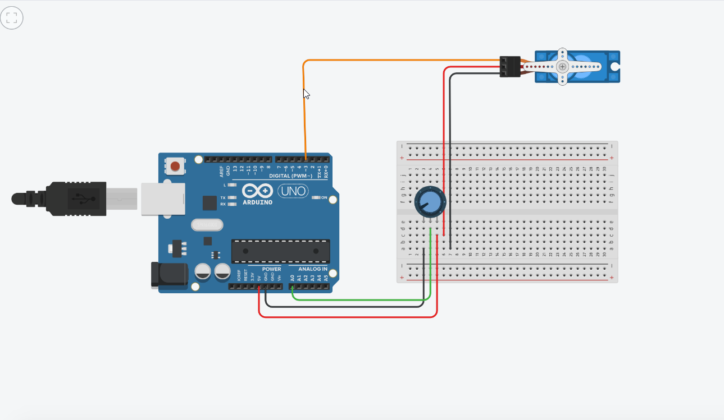

**Code:**

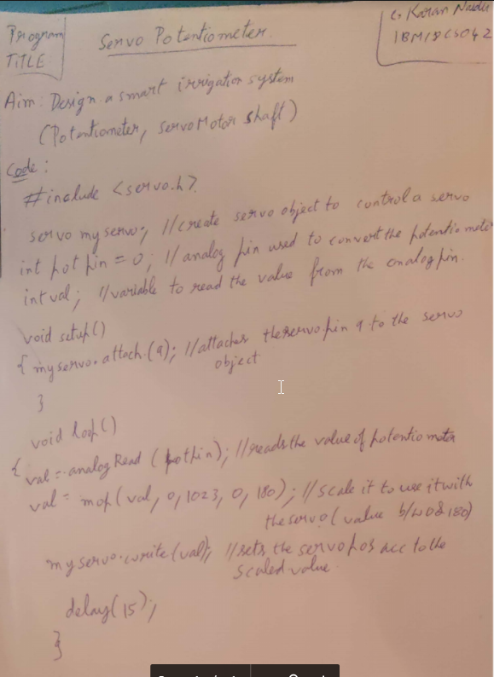

**Observation :**

The shaft rotates in the clockwise as well as anticlockwise as the potentiometer is rotated.