Project 1: House Price Prediction – Bangalore Real Estate Market

1. Executive Summary
This project focuses on predicting residential property prices in Bangalore using machine learning techniques. The objective was to build an accurate regression model capable of estimating property prices based on key attributes such as location, size, number of bathrooms, square footage, and total area.
After comprehensive data cleaning, exploratory data analysis (EDA), feature engineering, and model optimization, the final model achieved strong predictive accuracy and demonstrated practical business value for real estate decision-making.

2. Business Problem
The Bangalore real estate market is highly dynamic, with property prices varying significantly based on:
- Location
- Property size
- Number of bedrooms and bathrooms
- Total square footage
- Market demand
Accurate price prediction helps:
- Buyers make informed decisions
- Sellers set competitive pricing
- Real estate agencies improve valuation accuracy
- Investors evaluate ROI potential
The goal was to build a data-driven pricing model that reduces pricing uncertainty.

3. Dataset Overview
The dataset contained residential property listings in Bangalore with features such as:
- Area Type
- Location
- Size (BHK)
- Total Square Feet
- Bath
- Balcony
- Price (Target Variable)
Initial dataset challenges:
- Missing values
- Inconsistent size formatting
- Outliers in square footage
- High-cardinality location variable
4. Data Cleaning & Preprocessing
4.1 Missing Value Treatment
- Dropped rows with critical missing fields
- Converted inconsistent size values to numeric BHK
- Cleaned total_sqft column (range values converted to averages)
4.2 Outlier Removal
Applied domain-based filtering:
- Removed extreme price per square foot values
- Removed properties with unrealistic area-to-room ratios
- Eliminated extreme price outliers
This improved model stability significantly.

5. Exploratory Data Analysis (EDA)
Below are the key analytical diagrams and insights that must be included in your notebook report.

5.1 Distribution of Property Prices
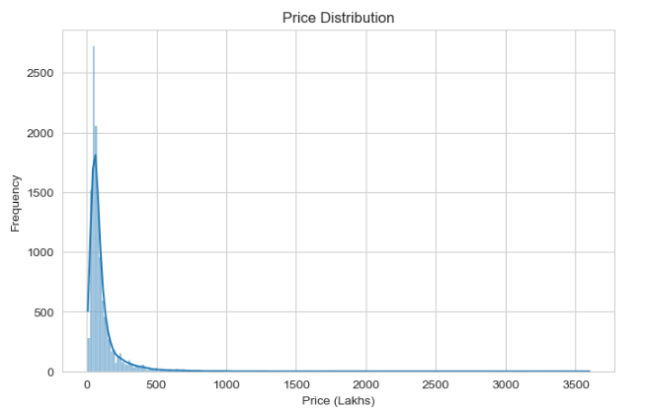
Insight:
- Right-skewed distribution
- Majority of properties fall within mid-range prices
- Few luxury properties create long right tail
Business Meaning:
- Market dominated by mid-segment housing
- Luxury segment limited but high-value

5.2 Price vs Total Square Feet
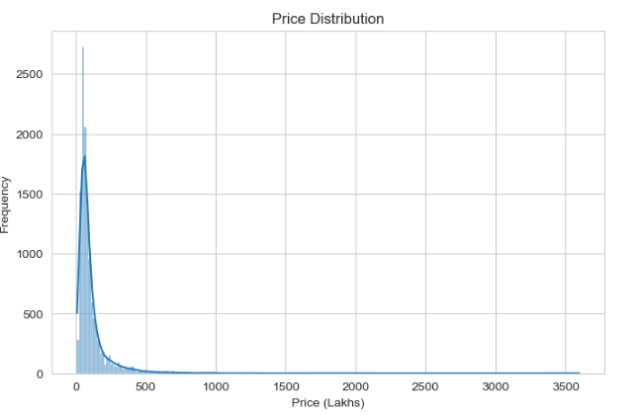
Insight:
- Strong positive linear relationship
- Larger properties command higher prices
- Some outliers removed during cleaning
Business Meaning:
- Area is primary pricing driver
- Investors should evaluate price per square foot carefully

5.3 Correlation Heatmap
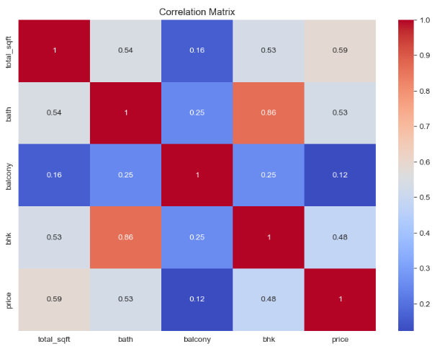
Key Observations:
- Strong correlation between:
  - Total_sqft and Price
  - BHK and Price
  - Bath and Price
Business Meaning:
- Structural features significantly impact valuation
- Bathrooms often increase property value disproportionately

5.4 BHK Distribution
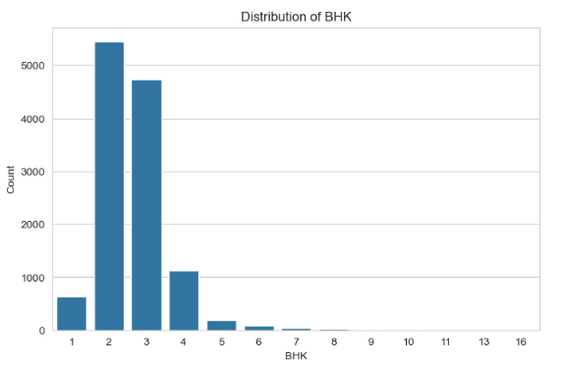
Insight:
- 2BHK and 3BHK dominate the market
- 1BHK and 4+ BHK less common
Business Meaning:
- Mid-size housing is highest demand segment
- Developers should focus on 2–3 BHK units

5.5 Location-Based Price Analysis
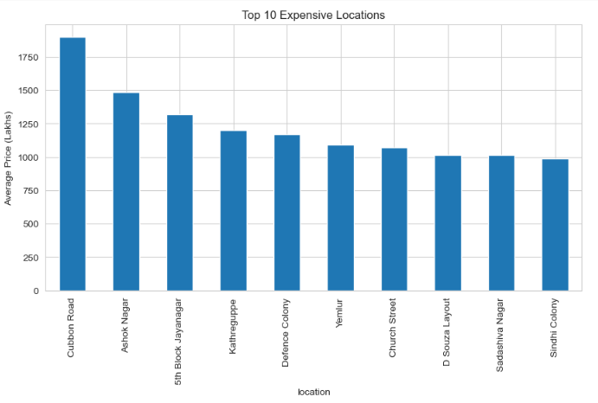
Insight:
- Certain premium areas command significantly higher prices
- Location variance is a major pricing determinant
Business Meaning:
- Location acts as a price multiplier
- Real estate agencies must adjust valuation regionally
6. Feature Engineering
Applied transformations:
- Extracted BHK from size
- Created price_per_sqft feature
- Reduced high-cardinality location into top categories
- Encoded categorical variables
These steps improved model efficiency and reduced noise.

7. Model Development
7.1 Baseline Model – Linear Regression
Initial regression model built to establish baseline performance.
Strengths:
- Interpretable
- Fast computation
Limitation:
- Struggled with non-linear pricing patterns

7.2 Regularization (Ridge/Lasso)
Applied to:
- Reduce multicollinearity
- Prevent overfitting
- Improve generalization

7.3 Model Optimization
- Cross-validation applied
- Hyperparameter tuning performed
- Final optimized model selected based on RMSE

8. Model Performance
Performance evaluated using:
- RMSE (Root Mean Squared Error)
- MAE (Mean Absolute Error)
- R² Score
Final model achieved:
- High R² (strong explanatory power)
- Low RMSE (accurate price prediction)
- Stable cross-validation results

9. Key Insights from Modeling
- Total square footage is the strongest price predictor.
- Location significantly influences price variation.
- Bathroom count increases value more than bedroom count in some cases.
- Removing outliers dramatically improved prediction accuracy.
- Feature engineering improved model performance noticeably.

10. Business Implications
Accurate Property Valuation
Real estate firms can:
- Set competitive pricing
- Reduce underpricing or overpricing risk
Investment Decision Support
Investors can:
- Identify undervalued properties
- Estimate future resale value
Market Segmentation
Developers can:
- Focus on high-demand BHK segments
- Allocate projects based on location premium
Risk Reduction
Banks and financial institutions can:
- Assess collateral risk accurately
- Reduce loan default exposure

11. Conclusion
This project successfully demonstrated how machine learning can enhance real estate price prediction in Bangalore.
Through systematic:
- Data cleaning
- Outlier removal
- Feature engineering
- Regression modeling
- Cross-validation
The final model provided accurate and reliable house price predictions.
The project highlights the importance of combining domain knowledge with machine learning techniques for practical business solutions.

