Karan Patel
SEIS 763 Machine Learning 1
Software Engineering and Data Science
SEIS 763: Machine Learning
Assignment #4 (100 points)
Due Date: March 3rd

Write a program with excellent comments using a programming language of your choice to perform AND provide answers to the following tasks:

- Load the patient data from “ML_HW_Data_Patients.csv” file (same data file in the last assignment). 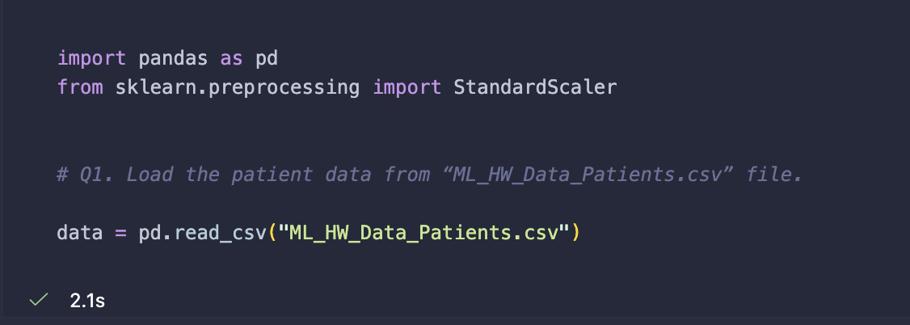
- Use the following 7 variables Age, Gender, Height, Weight, Smoker, Location, SelfAssessedHealthStatus to build a linear regression model to predict the systolic blood pressure.
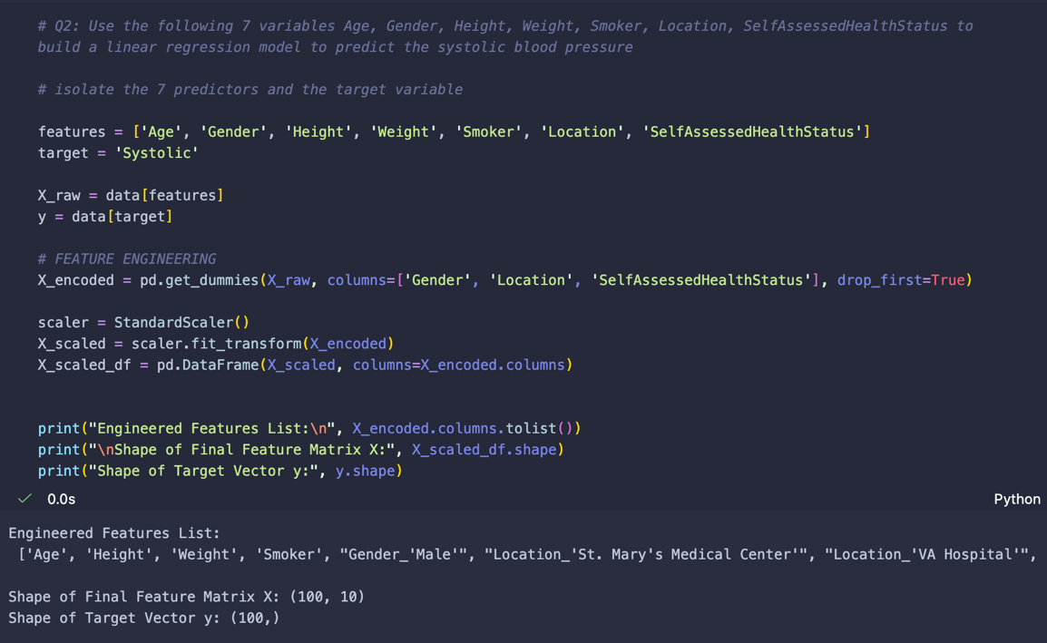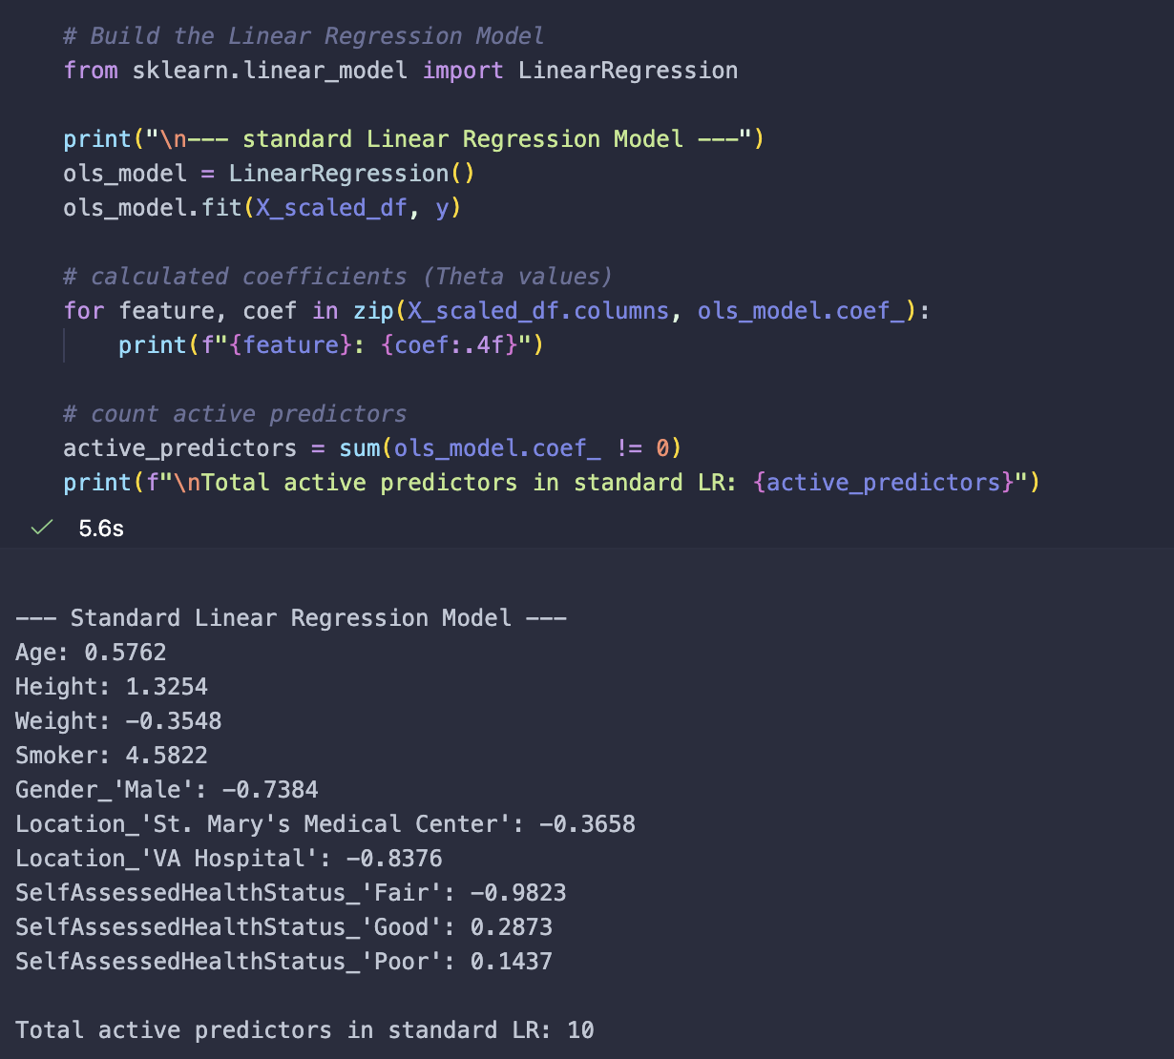

- Use **lasso regression** with **10-fold cross-validation** to identify useful predictors. 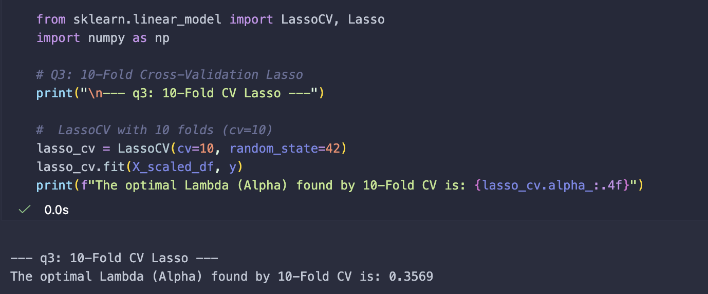
- Which top **TWO** remaining predictors (with non-zero theta values) are you going to select after the lasso analysis?
The top two remaining predictors are Smoker and SelfAssessedHealthStatus_'Fair'.
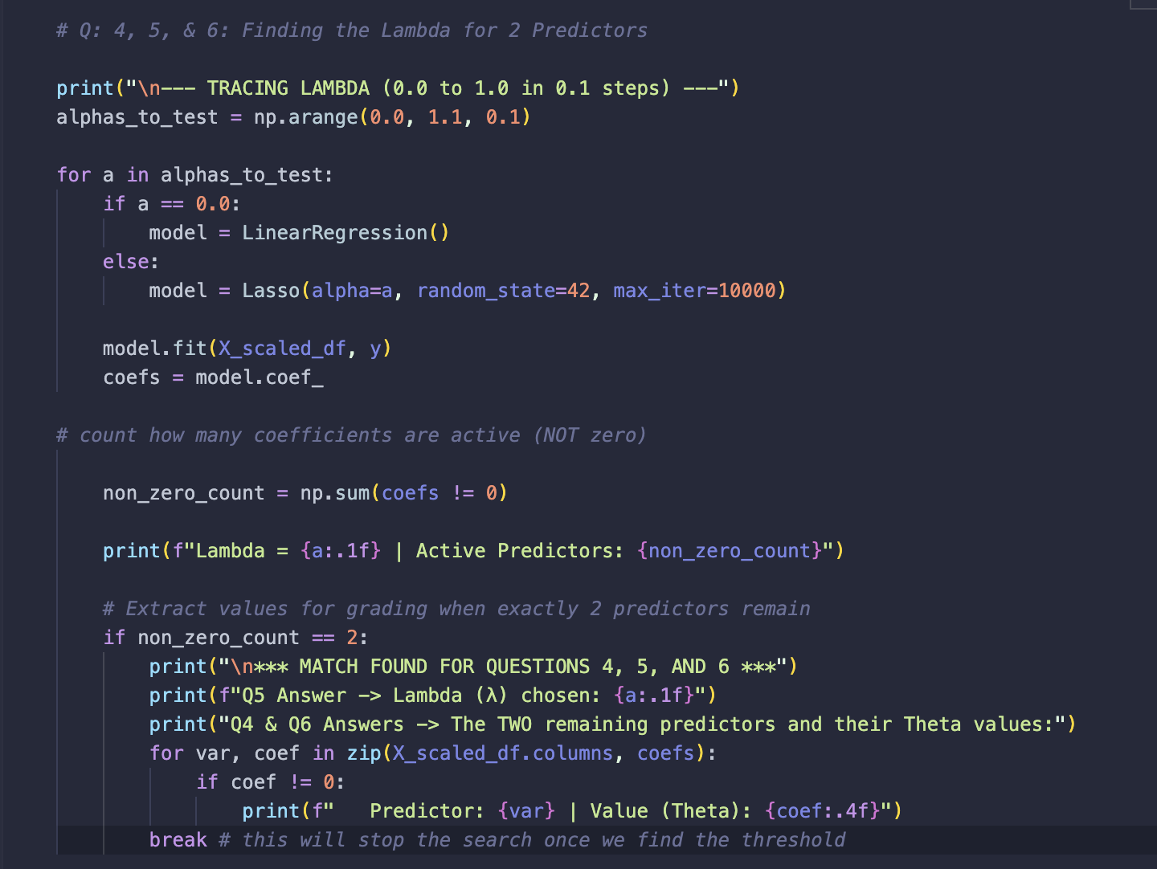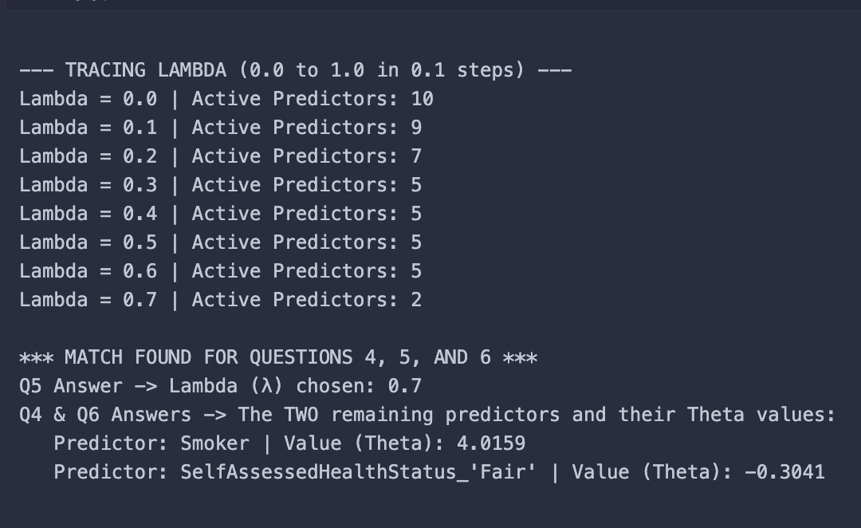
- What is the lambda (l) value you choose in order to select the top two predictors you identified in the last question?
Chosen lambda is 0.7
- What are the q values for the two selected predictors at the lambda (l) value you identified in the last question?
At ambda = 0.7, the coefficient (theta) for Smoker is 4.0159 and the coefficient for SelfAssessedHealthStatus_'Fair' is -0.3041.
- This question can be more difficult in Python; hence optional if you use Python. Plot a lasso plot with OR without cross-validation. Please have readable tick labels on the X and Y axes in your plot for easy visualization and verification.
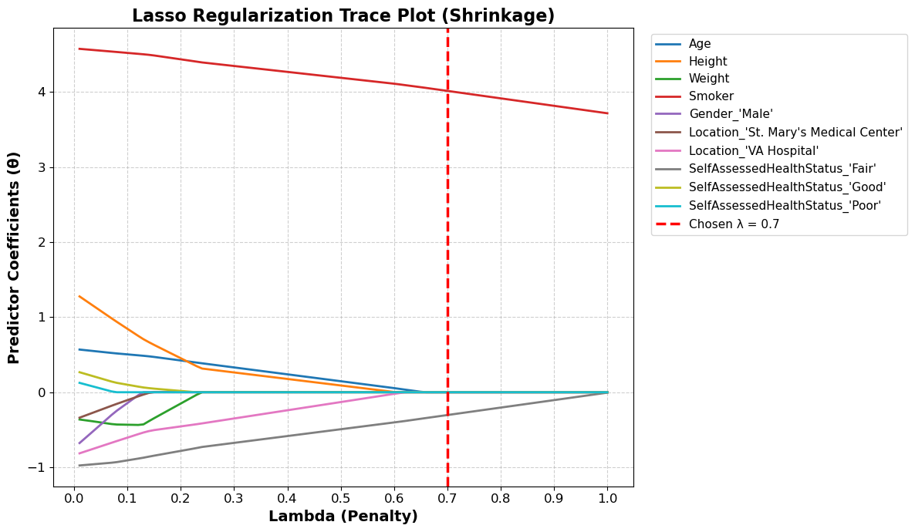

Submission Guideline:
- Please include the WORD document to include your answers (and clearly readable figures/screenshots) to the above questions. Please include your name on the top of your WORD document.
- Please print your program (matlab or python) as PDF / html and include the PDF / html in your submission. Please name your program as “a4.m/.mlx/.py/.inpyb”, depending on the programming language / environment you used.
- Please also include your program in the formats like .m/.mlx/.py/.inpyb in your submission.
- Prepare EVERYTHING mentioned in the guideline and submit them on Canvas no later than the due date. Please do NOT zip your files.
- Please carefully follow the submission guideline. Otherwise, the instructor may not be able to grade your assignment.
© Dr. Chih Lai University of St. Thomas

