KARAN PATEL S
SEIS 763-02
Software Engineering and Data Science
SEIS 763: Machine Learning
Assignment #1 (100 points)
Due Date: February 10th

Write a MatLab or Python program to answer the following questions in sequence:

- Read in the CSV file “ML_HW_Data_FisherIris.csv” into a matrix named as “Iris”. Please do NOT output the whole matrix in our answer. 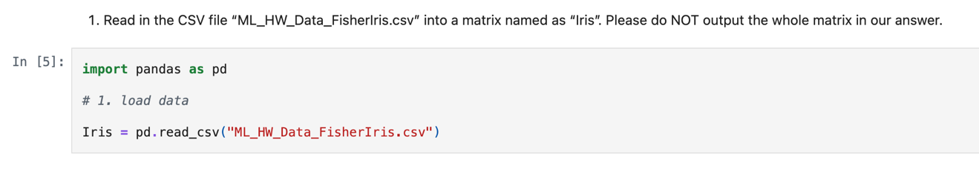
- Display total number of rows and total number of columns of the matrix “Iris”. 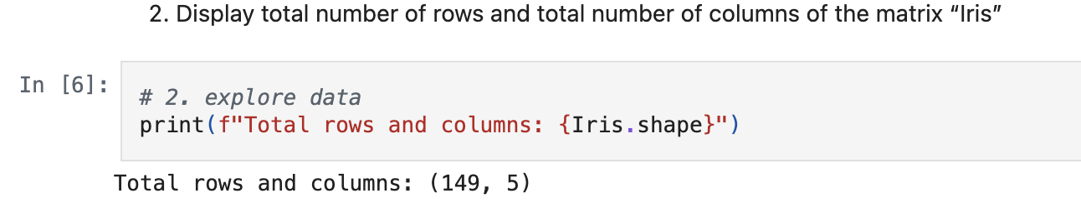
- Display all the row numbers (i.e. record numbers) that have the 5th column less than 0. 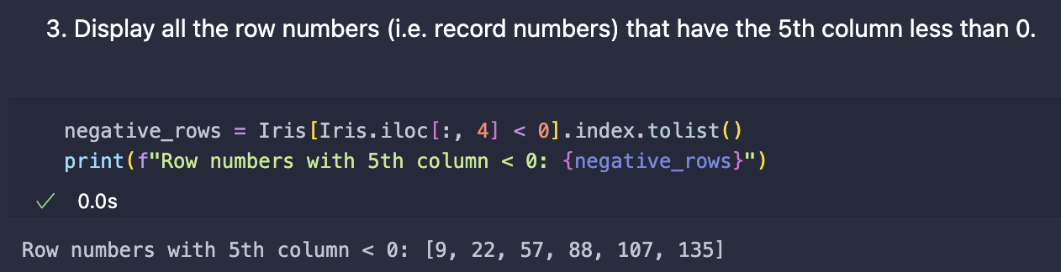
- Remove the rows with the 5th column less than 0 from the “Iris” matrix. Please do **NOT** output or include the whole resulting matrix in our answer.
- Display total number of rows and total number of columns of the “Iris” matrix again. 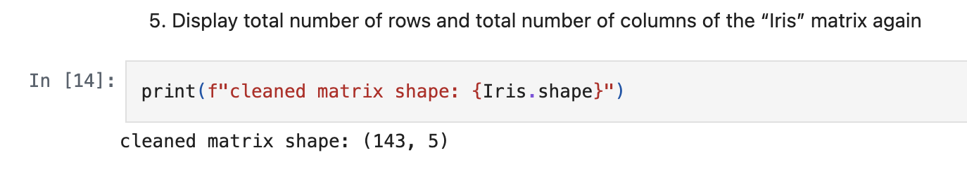
- Copy the first 4 columns in the new “Iris” matrix into a new matrix “X”. Please do **NOT** output or include the whole resulting matrix in our answer.
- Copy the 5th columns in the new “Iris” matrix into a new variable (or matrix) “Y”. Please do **NOT** output or include the whole resulting matrix in our answer.
- Display the maximum value and the minimum value of EACH column in “X”. 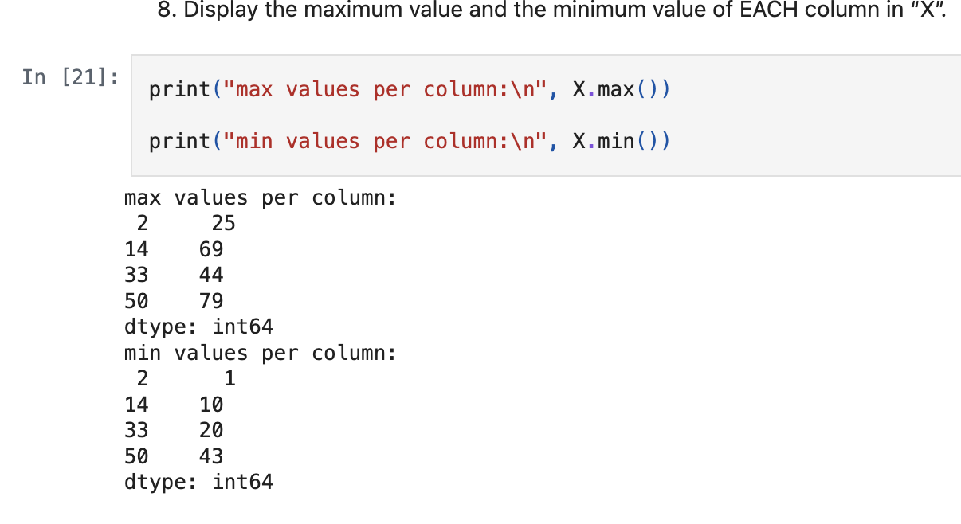
- Display total number of elements (i.e. items) in the third column of the matrix “X” that are greater than 36. 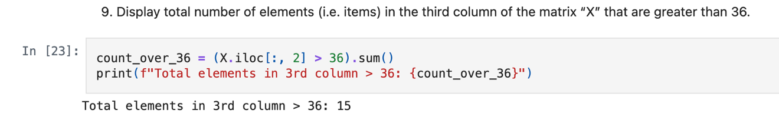

Submission Guideline:
- Please include the answers to the above questions that required your program to “display” in a WORD document. Please also put your name on the top of your WORD document.
- Please print your program (matlab or python) as PDF / html and include the PDF / html in your submission.
https://github.com/karanpalts/SEIS763_MACHINE_LEARNING/blob/main/HOMEWORK/WEEK_1/Assignment1.ipynb
- Please also include your program in the formats like .m/.mlx/.py/.inpyb in your submission.
- Prepare EVERYTHING mentioned in the guideline and submit them on Canvas no later than the due date. Please do NOT zip your files.
- Please carefully follow the submission guideline. Otherwise, the instructor may not be able to grade your assignment.
© Dr. Chih Lai University of St. Thomas

