KARAN PATEL
SEIS 763 Machine Learning 1
Software Engineering and Data Science
SEIS 763-02: Machine Learning
Assignment #2 (100 points)
Due Date: February 17th

Write a program (Python or Matlab) to find results / answers to the following tasks:

- Load the patient data from “ML_HW_Data_Patients.csv” file. 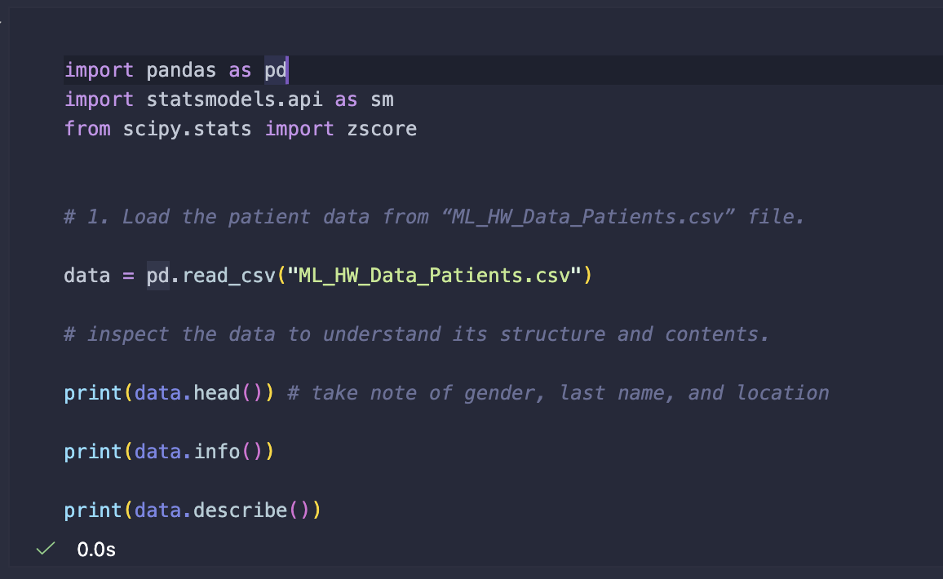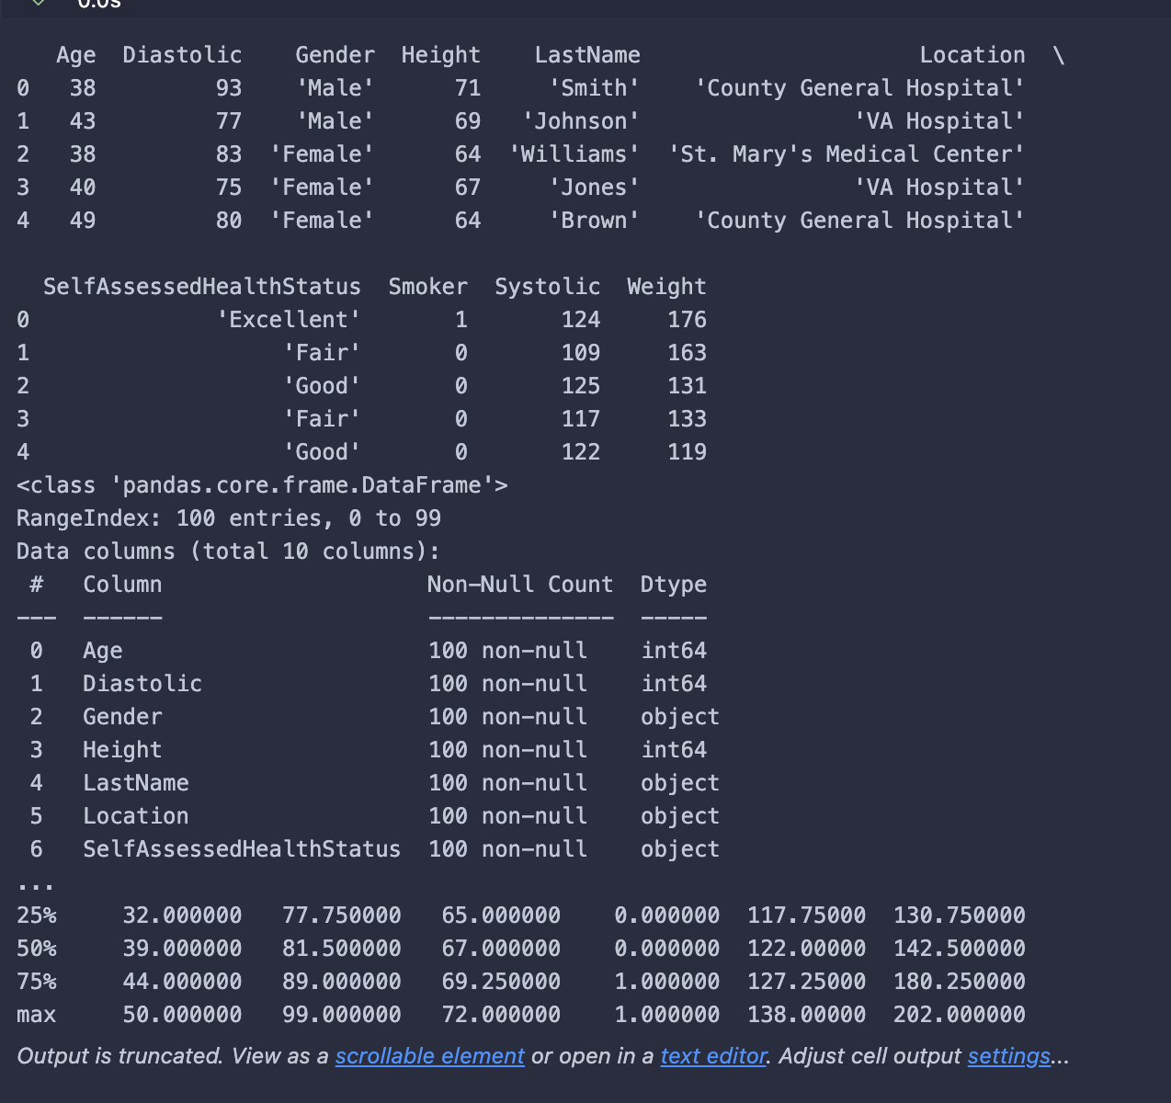
- Use variables Age, Gender, Height, Weight, Smoker, Location, SelfAssessedHealthStatus to build a linear regression model to predict the systolic blood pressure. You do NOT need to split data into training and testing sets. 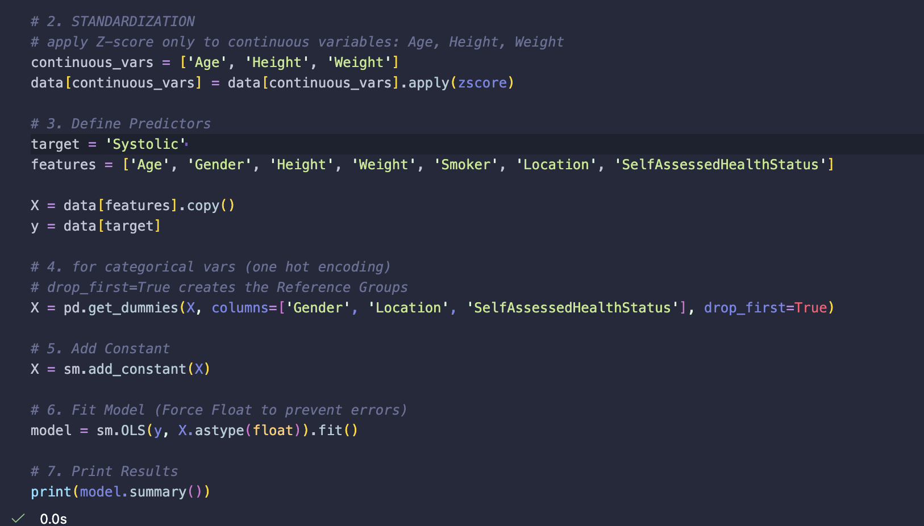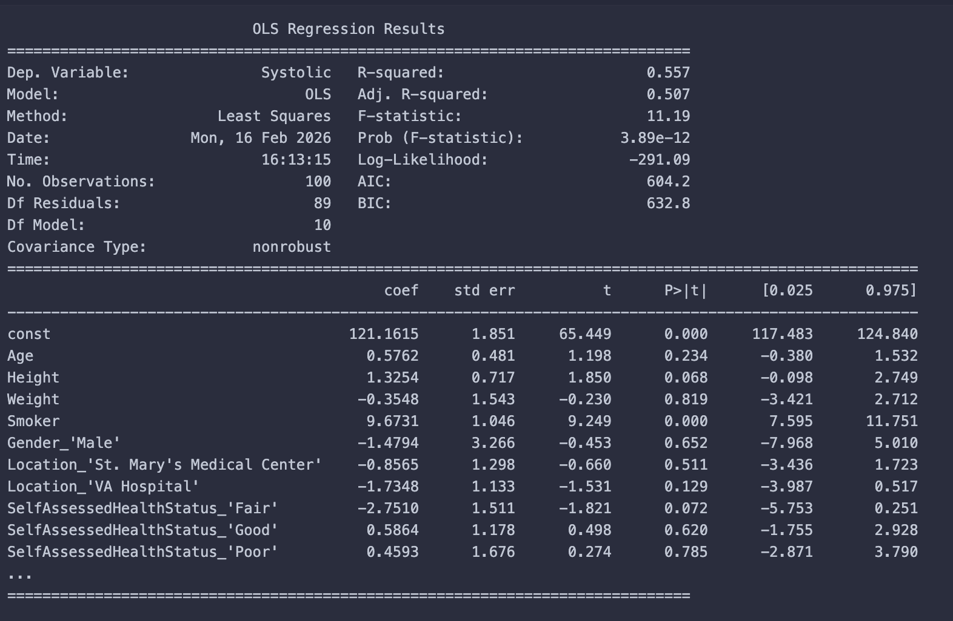

- What are the regression coefficients (thetas)? 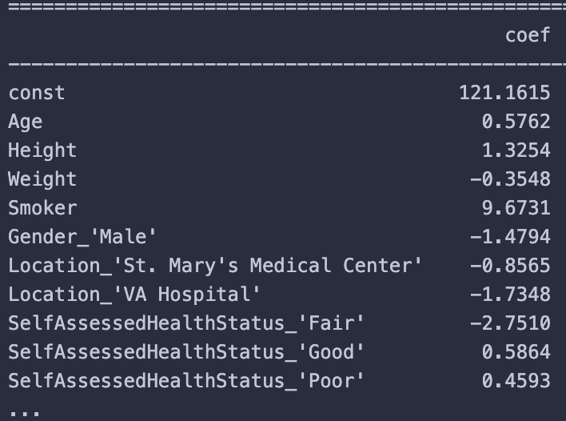

Above image shows the thetas along with the 121.1615 intercept
- How do you interpret those numbers in thetas?
Intercept (121.16): This represents the expected Systolic Blood Pressure for a patient in the Reference Group (Female, Non-Smoker, County General, Excellent Health) who has Average Age, Average Height, and Average Weight (since a Z-score of 0 equals the mean).

Height (1.33): Holding all other variables constant, an increase of one Standard Deviation in Height is associated with an increase of 1.33 mmHg in Systolic Blood Pressure.

Age (0.58): Holding all other variables constant, an increase of one Standard Deviation in Age is associated with an increase of 0.58 mmHg in Systolic Blood Pressure.

Weight (-0.35): Holding all other variables constant, an increase of one Standard Deviation in Weight is associated with a decrease of 0.35 mmHg in Systolic Blood Pressure.

Smoker (9.67): (Since this is categorical, we do not use Standard Deviation). Compared to a Non-Smoker, being a Smoker is associated with an increase of 9.67 mmHg in BP, holding all else constant.

- If you need to identify one or few useless features (independent variables or predictors), which one(s) will you choose? Why do you reach this conclusion?
I would identify Weight (P=0.819), Gender (P=0.652), and Location (P>0.12) as useless features. The reason being standardization did not change the P-values. These features still have P-values far above the 0.05 threshold, meaning their relationship with Blood Pressure is statistically indistinguishable from random noise.

Submission Guideline:
- Please include the WORD document to include your answers to the above questions. Please include your name on the top of your WORD document.
- Please print your program (matlab or python) as PDF / html and include the PDF / html in your submission. Please name your program as “a2.m/.mlx/.py/.inpyb”, depending on the programming language / environment you used.
- Please also include your program in the formats like .m/.mlx/.py/.inpyb in your submission.
- Prepare EVERYTHING mentioned in the guideline and submit them on Canvas no later than the due date. Please do NOT zip your files.
- Please carefully follow the submission guideline. Otherwise, the instructor may not be able to grade your assignment.

© Dr. Chih Lai University of St. Thomas

