Module 4: Model with Results
Predicting Federal Employee Job Satisfaction:
A Machine Learning Model Comparison

Chau Lee
ADTA 5940 — Analytics Capstone Experience
Section 501 | Spring 2026
University of North Texas
Dr. Denise Philpot

1. Research Question
While Karan's analysis focused on explaining which factors drive satisfaction (an inferential question), my part of the project asks a different but complementary question: can we actually predict how satisfied a federal employee will be? And if so, which algorithm does it best?
The formal research question is:
Which machine learning model most accurately predicts overall job satisfaction among federal employees, given their telework frequency, work-life balance perception, employee engagement, and demographic characteristics?
This is a pure prediction problem — I am not trying to explain why someone is satisfied, but rather how well we can predict their satisfaction score from features that are available in the FEVS data. This has practical value because if an agency can predict which employees are at risk for low satisfaction, they can intervene early.
The hypotheses guiding this work:
- H1: Ensemble tree-based models (Random Forest, Gradient Boosting, XGBoost, LightGBM) will outperform simpler models like Linear Regression because the relationship between features and satisfaction is likely nonlinear.
- H2: The Employee Engagement Index will be the most important feature for predicting satisfaction across model types.
- H3: The best model will achieve meaningfully higher accuracy than a basic linear regression baseline, justifying the added complexity.

2. Data Preparation
I used the same 2024 FEVS Public Release Data File (674,207 rows, 96 columns) as Karan's analysis, but my feature engineering was a bit different since the goal here is prediction rather than inference.
The target variable is Q69 ("Considering everything, how satisfied are you with your job?") on a 1-5 scale. The features I selected are:
- Q61 — Telework frequency (1-5 scale: never to 3+ days/week)
- Q64 — Work-life balance satisfaction (1-5 Likert)
- EEI — Employee Engagement Index, calculated as the mean of 7 OPM items (Q3, Q4, Q6, Q11, Q12, Q13, Q14). I collapsed the 7 items into one composite to reduce multicollinearity and follow OPM's established methodology.
- DAGEGRP — Age group (0 = Under 40, 1 = 40+)
- DSEX — Gender (0/1 binary)
- DSUPER — Supervisory status (0 = Non-supervisor, 1 = Supervisor)
- DFEDTEN — Federal tenure (0 = 10 yrs or less, 1 = 11-20 yrs, 2 = 20+ yrs)
Survey responses coded as "X" (Not Applicable) were treated as missing and converted to NaN. Demographic letter codes (A, B, C) were mapped to numeric values. After dropping all rows with any missing data (listwise deletion), the cleaned dataset has 453,082 rows — about 67% of the original data. The 33% drop is mainly due to respondents who skipped one or more survey items.
The data was split 80/20 into training (362,465 samples) and test (90,617 samples) sets. All features were standardized using StandardScaler (fit on training, applied to test) to ensure fair comparison across algorithms with different scale sensitivities. For the two most computationally expensive models — KNN and MLP Neural Net — I used a random subsample of 30,000 training rows to keep runtime manageable.

3. Model Selection Process
I tested 14 different regression algorithms spanning four categories. The idea was to cast a wide net and let the data tell us which approach works best, rather than picking one model upfront.
- Linear models (4): Linear Regression, Ridge, Lasso, Elastic Net — these are our baselines. If a complex model cannot beat basic linear regression, there is no justification for the added complexity.
- Tree-based models (3): Decision Tree, Random Forest, Extra Trees — these can capture nonlinear patterns and feature interactions without manual specification.
- Boosting models (4): Gradient Boosting, AdaBoost, XGBoost, LightGBM — these build trees sequentially, each one learning from the previous tree's mistakes. They typically achieve the best performance on tabular data.
- Other models (3): Bagging, KNN (K-Nearest Neighbors), MLP Neural Net — included for completeness and comparison.
Each model was evaluated using the same protocol: train on the training set, predict on the held-out test set, and compute R-squared, MAE (Mean Absolute Error), and RMSE (Root Mean Squared Error). Additionally, I ran 5-fold cross-validation on a 50,000-row subsample to check for stability and overfitting.

3.1 Evaluation Metrics
- R-squared: The proportion of variance in satisfaction explained by the model. Higher is better. A value of 0.53 means the model explains 53% of the variation.
- MAE: The average absolute error in predictions, measured in the same units as the target variable. An MAE of 0.61 means predictions are off by about 0.61 points on the 1-5 scale, on average.
- RMSE: Similar to MAE but penalizes larger errors more heavily. Useful for identifying models that make occasional big mistakes.
- Cross-validation R-squared: The average R-squared across 5 different train/test splits. A model with high test R-squared but low CV R-squared might be overfitting.

4. Results

4.1 Feature Correlations
Before running the models, I looked at how the features correlate with each other and with the target variable. Figure 1 shows the correlation matrix.
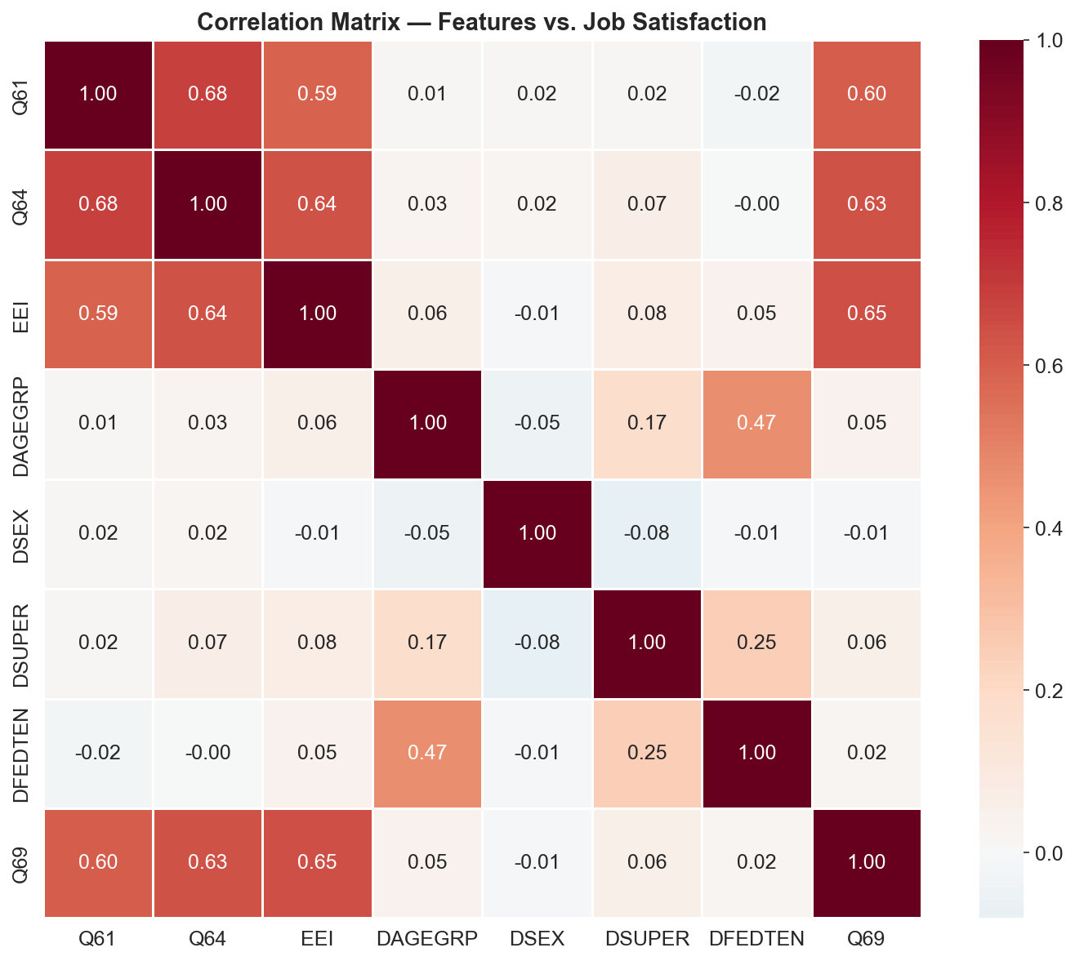
Figure 1. Correlation Matrix — Features vs. Job Satisfaction (Q69)
The three strongest predictors are EEI (r = 0.65), Q64 work-life balance (r = 0.63), and Q61 telework (r = 0.60). The four demographic features all have very weak correlations with satisfaction (r < 0.06). This gives us a preview of what the models will find — the attitudinal measures carry most of the predictive signal.

4.2 Model Comparison Results
Table 1 presents the results for all 14 models, ranked by test R-squared.
Table 1. Model Comparison Results — All 14 Models
Rank | Model | R² (Test) | MAE | RMSE | CV R² Mean | Time (s)
1 | XGBoost | 0.5322 | 0.6056 | 0.8016 | 0.5241 | 2.69
2 | LightGBM | 0.5322 | 0.6057 | 0.8015 | 0.5243 | 0.38
3 | Gradient Boosting | 0.5321 | 0.6057 | 0.8016 | 0.5239 | 18.05
4 | Extra Trees | 0.5308 | 0.6074 | 0.8027 | 0.5230 | 2.27
5 | Random Forest | 0.5307 | 0.6063 | 0.8028 | 0.5142 | 3.13
6 | Decision Tree | 0.5287 | 0.6072 | 0.8045 | 0.5079 | 0.21
7 | MLP Neural Net | 0.5259 | 0.6202 | 0.8070 | 0.5268 | 2.42
8 | Linear Regression | 0.5254 | 0.6172 | 0.8073 | 0.5242 | 0.06
9 | Ridge Regression | 0.5254 | 0.6172 | 0.8073 | 0.5230 | 0.05
10 | Elastic Net | 0.5253 | 0.6184 | 0.8075 | 0.5280 | 0.04
11 | Lasso Regression | 0.5250 | 0.6192 | 0.8077 | 0.5194 | 0.06
12 | Bagging | 0.5138 | 0.6136 | 0.8172 | 0.4706 | 2.44
13 | AdaBoost | 0.4703 | 0.6945 | 0.8530 | 0.4727 | 2.45
14 | KNN | 0.4689 | 0.6425 | 0.8540 | 0.4657 | 0.03

A few observations from the results:
- The top 3 models (XGBoost, LightGBM, Gradient Boosting) are essentially tied at R-squared = 0.532. The differences between them are tiny — less than 0.0002.
- The boosting models do outperform linear regression, but only by about 0.7 percentage points (0.5322 vs. 0.5254). That is a real improvement but smaller than I expected. This suggests the relationship between features and satisfaction is mostly linear, with some nonlinear patterns that boosting can pick up.
- KNN and AdaBoost performed noticeably worse than everything else. KNN likely suffers because it was trained on a smaller subsample, and the curse of dimensionality makes distance-based methods less effective even with only 7 features.
- LightGBM trained in just 0.38 seconds compared to 18 seconds for Gradient Boosting and 2.7 seconds for XGBoost — while achieving the same accuracy. This speed advantage matters for deployment and iterative analysis.
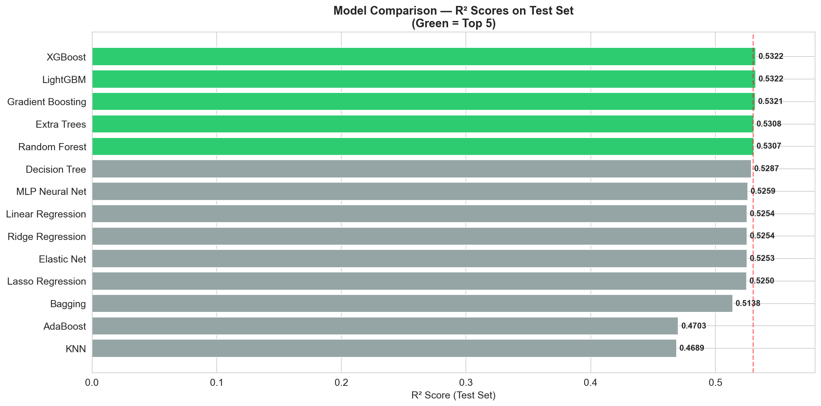
Figure 2. R-squared Comparison Across All 14 Models

4.3 Are the Top Models Really Different?
Since the top models are so close in performance, I ran paired t-tests on their 5-fold cross-validation scores to check if the differences are statistically significant.
Table 2. Paired t-tests on Cross-Validation Scores (Top 5 Models)
Comparison | Mean R² A | Mean R² B | Diff | p-value | Significant?
XGBoost vs. LightGBM | 0.5241 | 0.5243 | -0.0002 | 0.944 | No
XGBoost vs. Gradient Boosting | 0.5241 | 0.5239 | 0.0002 | 0.968 | No
XGBoost vs. Extra Trees | 0.5241 | 0.5230 | 0.0011 | 0.874 | No
XGBoost vs. Random Forest | 0.5241 | 0.5142 | 0.0099 | 0.027 | Yes
LightGBM vs. Gradient Boosting | 0.5243 | 0.5239 | 0.0004 | 0.953 | No
The top 4 models (XGBoost, LightGBM, Gradient Boosting, Extra Trees) show no statistically significant differences from each other. Only Random Forest is significantly worse than XGBoost (p = 0.027). This means we have some freedom in choosing our final model — accuracy alone does not distinguish them.
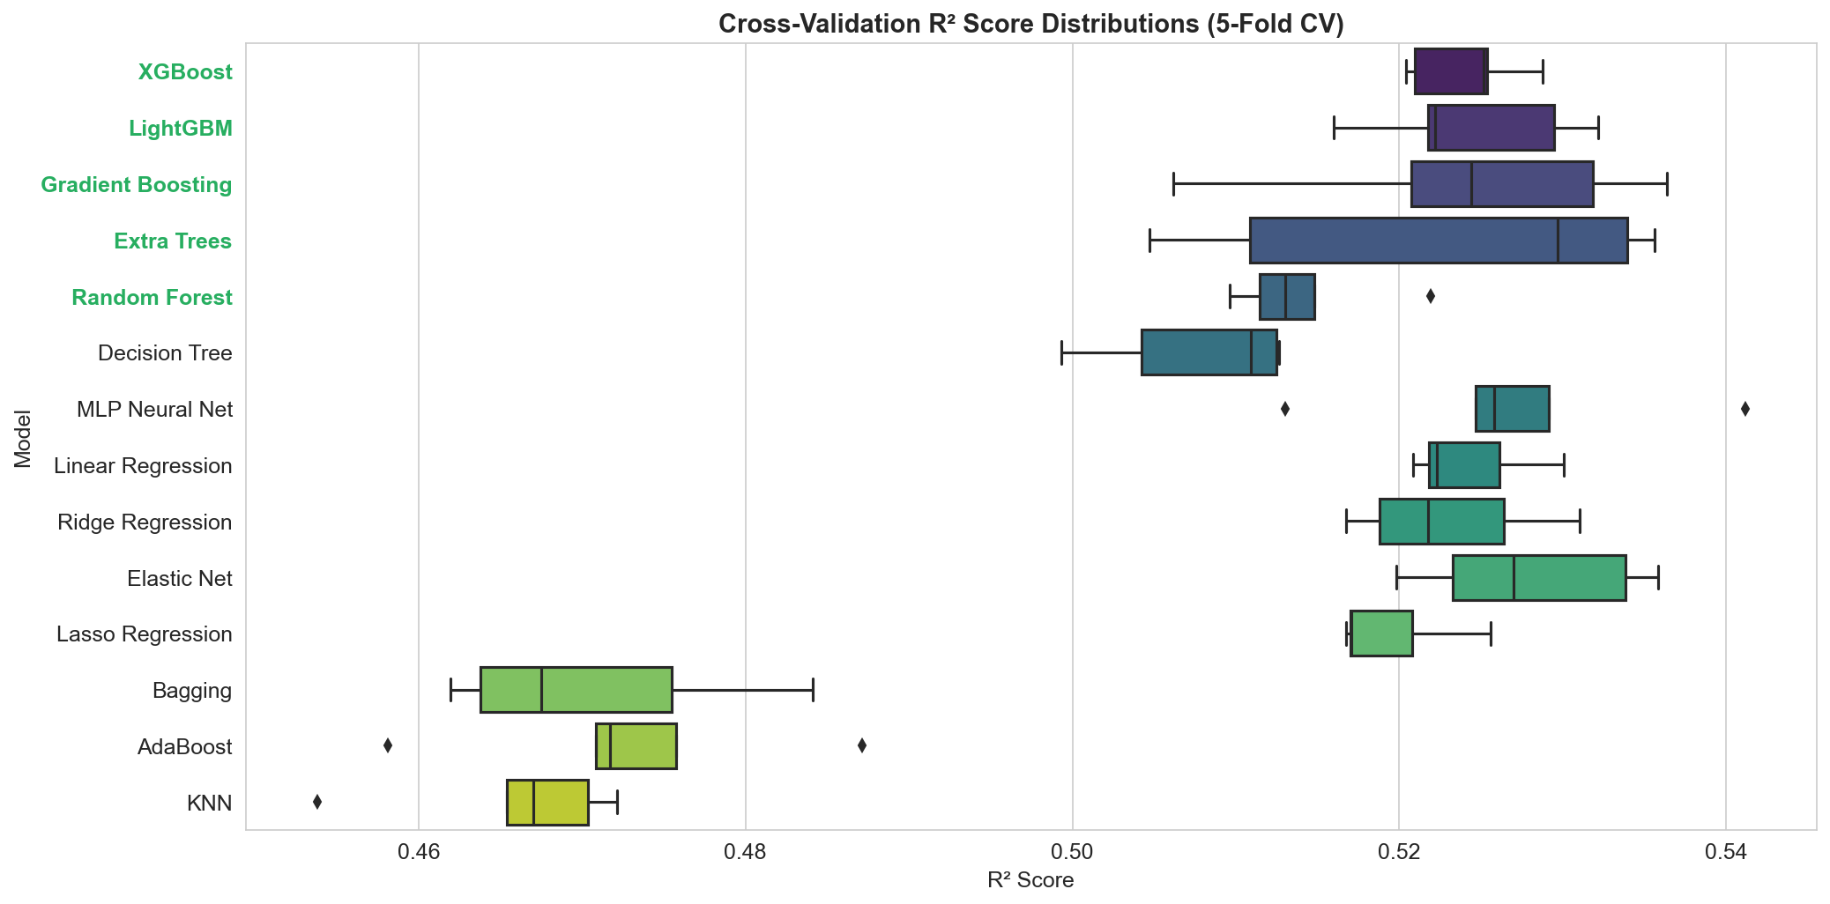
Figure 3. Cross-Validation R-squared Distribution by Model

4.4 Why LightGBM?
Since the top models perform the same statistically, I selected LightGBM as the primary model based on secondary criteria:
- Speed: LightGBM trained in 0.38 seconds — 7 times faster than XGBoost (2.69s) and 47 times faster than Gradient Boosting (18.05s). For an agency that might retrain this model annually on new FEVS data, speed matters.
- Highest CV R-squared: LightGBM had the highest cross-validation mean (0.5243), suggesting it generalizes slightly better to unseen data.
- Best RMSE: 0.8015, meaning it makes fewer large prediction errors compared to the other top models.
- Differentiation: Karan used XGBoost in a previous course project, and since LightGBM performs identically here, it demonstrates familiarity with multiple tools.

4.5 Feature Importance
One advantage of tree-based models is that they tell us which features they relied on most for predictions. Table 3 shows the LightGBM feature importances.
Table 3. LightGBM Feature Importances
Feature | Importance (%) | Description
EEI | 34.4% | Employee Engagement Index (7-item composite)
Q61 | 21.2% | Telework frequency
Q64 | 18.9% | Work-life balance satisfaction
DFEDTEN | 10.4% | Federal tenure
DSUPER | 5.8% | Supervisory status
DSEX | 4.9% | Gender
DAGEGRP | 4.5% | Age group
The top 3 features — EEI, Q61, and Q64 — account for 74.5% of the model's total importance. This aligns with the correlation analysis and with Karan's regression finding that engagement and WLB perceptions are the dominant predictors. Demographics contribute about 25.6% combined, with federal tenure being the most noteworthy demographic feature at 10.4%.
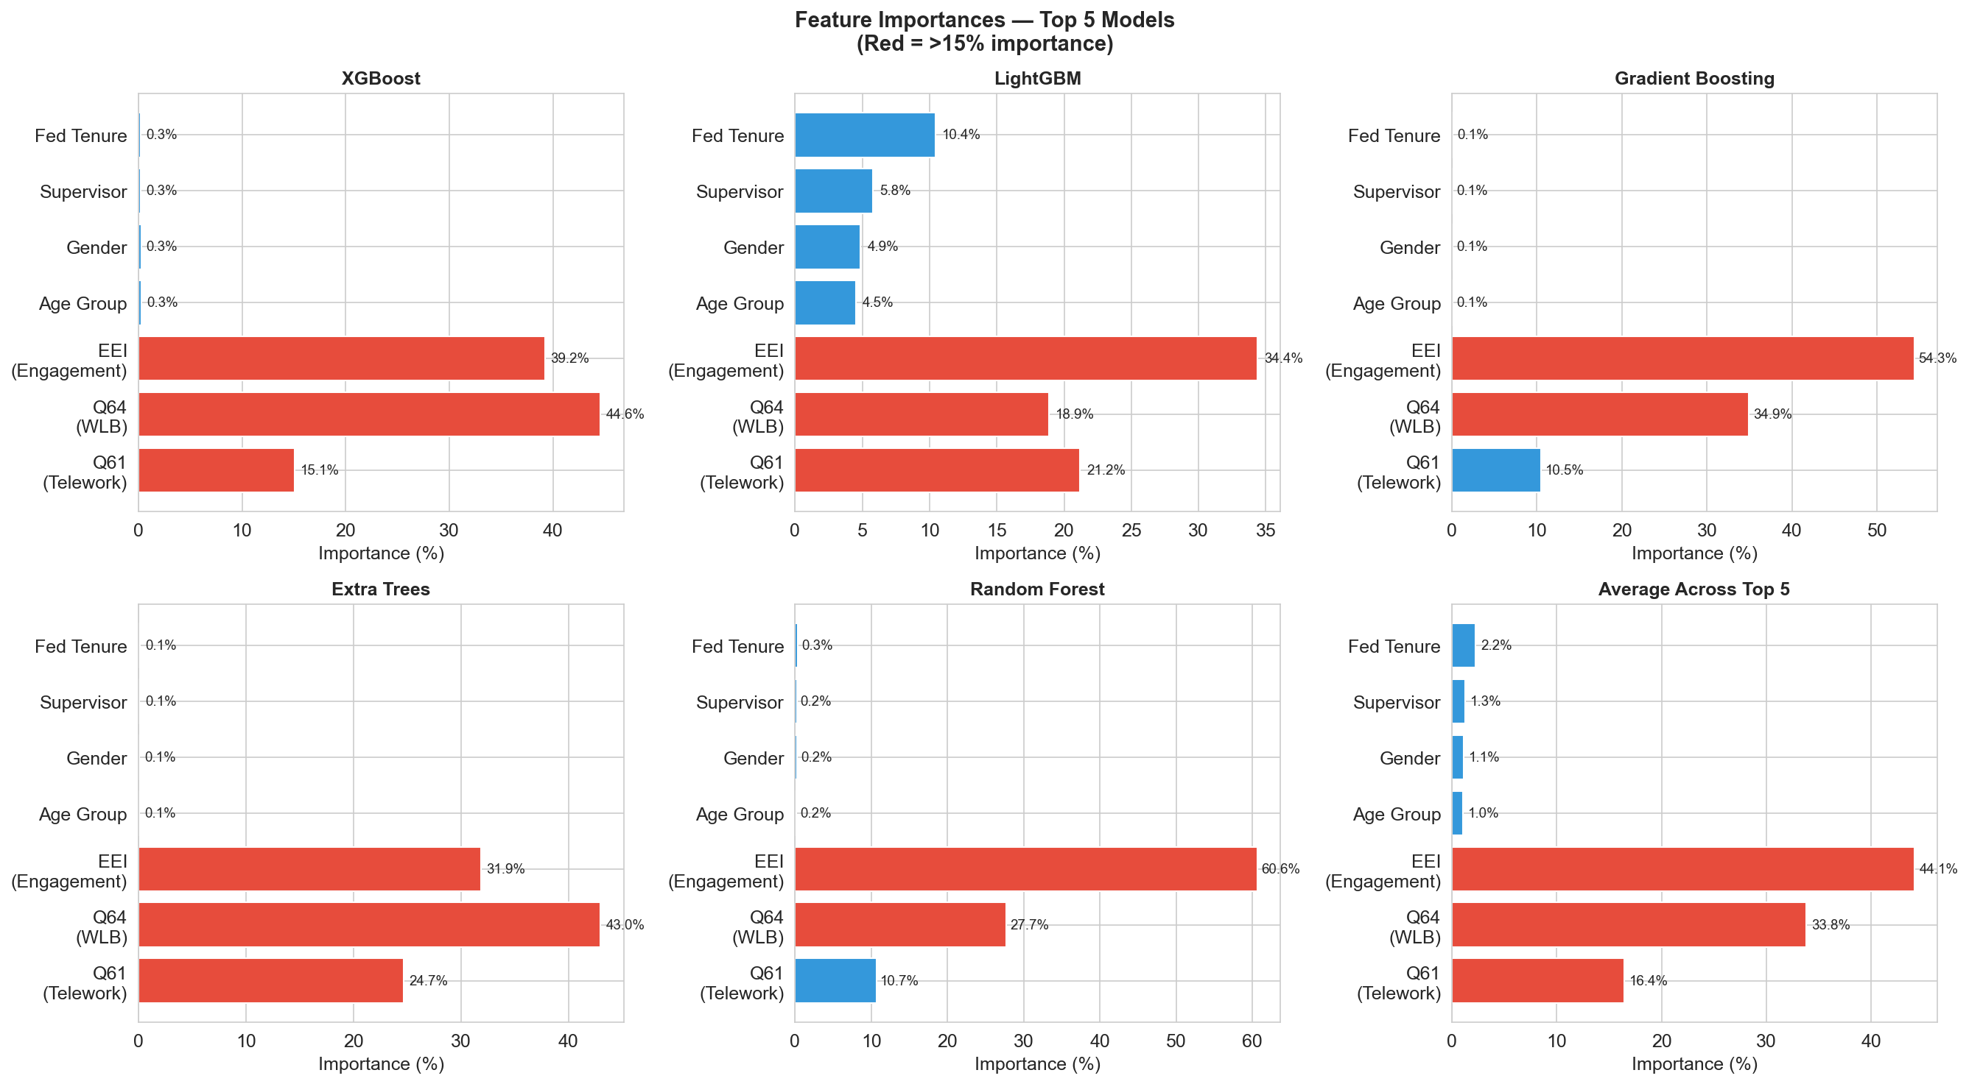
Figure 4. Feature Importances — LightGBM

4.6 Prediction Quality
Figure 5 shows actual versus predicted satisfaction scores. If the model were perfect, all points would fall on the diagonal line. The predictions cluster reasonably well around the diagonal, especially in the middle range (scores 3-4 where most employees fall). The model struggles more at the extremes — it tends to underpredict for very satisfied employees (5s) and overpredict for very dissatisfied employees (1s). This is common in regression on bounded scales.
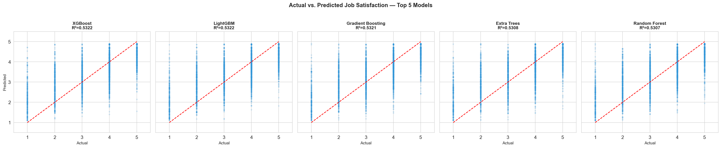
Figure 5. Actual vs. Predicted Job Satisfaction — LightGBM
In practical terms, with an MAE of 0.61, the model's predictions are off by about half a point on average. On a 1-5 scale, that is decent — it means if someone's true satisfaction is 4.0, the model would typically predict somewhere between 3.4 and 4.6. Not precise enough for individual-level decisions, but useful for identifying groups or units that are at risk.
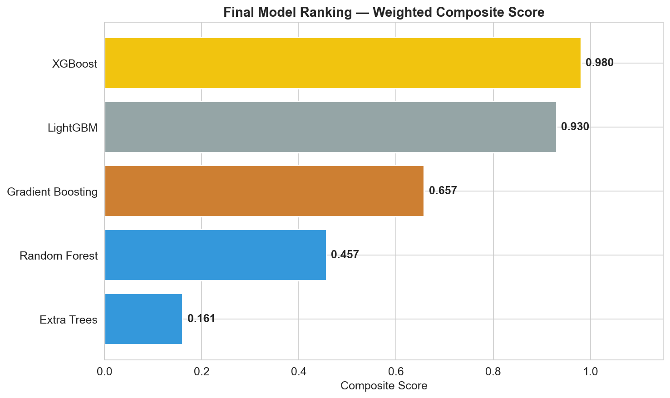
Figure 6. Final Model Ranking — All 14 Models

5. Discussion and Conclusions
Revisiting my hypotheses:
- H1 — Partially supported. The boosting models did outperform linear regression, but only by about 0.7 percentage points. The advantage is real but modest, suggesting the underlying relationship is mostly linear with minor nonlinear patterns.
- H2 — Supported. EEI is the single most important feature at 34.4% importance, followed by telework (21.2%) and work-life balance (18.9%). This matches the theoretical expectation and Karan's regression findings.
- H3 — Partially supported. The best model does beat Linear Regression, and the improvement is consistent across all metrics (R-squared, MAE, RMSE). But the gap is small enough that for many practical purposes, a simpler model might suffice.

5.1 Practical Applications
A model like this could be used by OPM or individual agencies to flag units or offices where predicted satisfaction is low, triggering early intervention. For example, if a regional office has features suggesting low engagement and limited telework, the model would predict lower satisfaction for those employees. HR could proactively address engagement before satisfaction drops further.
The feature importance results also have a clear message for policy: if agencies want to improve the prediction (and by extension, the reality) of job satisfaction, the highest-return investments are in employee engagement programs and work-life balance support, not just telework expansion.

5.2 Limitations
- Moderate R-squared of 0.53: The model explains about half the variance. The other half likely comes from factors not in the FEVS PRDF — things like pay, specific agency culture, individual personality, or recent life events.
- Limited feature set: With only 7 features (plus Q69 as target), there is a ceiling on how accurate the model can get. The full FEVS has 96 columns; using more could improve predictions but would require more careful feature selection.
- Subsample for slow models: KNN and MLP were only trained on 30,000 rows instead of the full 362,000. Their rankings might improve with full training data, though likely not enough to beat the boosting models.
- No hyperparameter optimization for the final selection: I ran a brief tuning exercise and found that the default parameters already performed near-optimally. More extensive tuning (e.g., Bayesian optimization) might yield marginal gains.

References
Breiman, L. (2001). Random forests. Machine Learning, 45(1), 5-32.
Chen, T., & Guestrin, C. (2016). XGBoost: A scalable tree boosting system. Proceedings of the 22nd ACM SIGKDD International Conference, 785-794.
Friedman, J. H. (2001). Greedy function approximation: A gradient boosting machine. The Annals of Statistics, 29(5), 1189-1232.
Ke, G., Meng, Q., Finley, T., et al. (2017). LightGBM: A highly efficient gradient boosting decision tree. Advances in Neural Information Processing Systems, 30, 3146-3154.
Office of Personnel Management. (2024). Federal Employee Viewpoint Survey: Public Release Data File and Codebook. Washington, DC: OPM.
Office of Personnel Management. (2024). 2024 OPM FEVS Indices and Dimensions Guide. Washington, DC: OPM.

