Module 4: Model with Results
Remote Work, Work-Life Balance, and Federal Employee Job Satisfaction:
A Hierarchical Regression Analysis

Karan Parekh
ADTA 5940 — Analytics Capstone Experience
Section 501 | Spring 2026
University of North Texas
Dr. Denise Philpot

1. Research Question
For this part of our project, I wanted to look at one main question: does telework actually make federal employees more satisfied with their jobs, or is there something else going on? During our earlier EDA work, Chau Lee and I noticed that employees who telework regularly tend to report higher satisfaction scores than people required to come into the office. But that does not necessarily mean telework itself is the reason — it could be that teleworkers also happen to have better supervisors, stronger engagement, or more work-life balance support.
So the formal research question is:
To what extent does telework frequency predict overall job satisfaction among federal employees, after accounting for work-life balance perceptions, employee engagement, and demographic characteristics?
I set up three hypotheses to test:
- H1: Telework frequency is a significant predictor of job satisfaction. Employees who telework routinely will report higher satisfaction than those required to work on-site.
- H2: Work-life balance and employee engagement each explain meaningful additional variance in satisfaction beyond what telework alone can explain.
- H3: Once we control for work-life balance and engagement, the telework effect will shrink significantly — suggesting those attitudes partially explain the raw telework gap.

2. Data Preparation
The data comes from OPM's 2024 Federal Employee Viewpoint Survey (FEVS) Public Release Data File. The raw file has 674,207 rows and 96 columns. Since the PRDF stores everything as text (including the survey responses), the first step was converting Likert-scale items to numeric values. Responses coded as "X" (Not Applicable) or blanks were set to missing.
I built two composite indices following OPM's published methodology:
- Employee Engagement Index (EEI): The mean of three OPM sub-indices — Intrinsic Work Experience (5 items), Supervisor (5 items), and Leaders Lead (5 items). This gives one overall engagement score per person on a 1-5 scale.
- Work-Life Balance Composite (WLB): The mean of three items — Q34 (peer support for WLB), Q49 (supervisor supports WLB), and Q63 (senior leaders support WLB programs).
For the telework variable, I used Q91 which asks about telework participation level. OPM codes it as: 1 = Routine/Remote, 2 = Situational/Infrequent, 3 = Required in Office, 4 = Chooses Not to Telework. I created dummy variables with Routine/Remote as the reference group since that is the baseline we want to compare against.
Demographics were recoded from OPM's letter codes: DAGEGRP (A = Under 40, B = 40+), DSEX (A = Male, B = Female), DSUPER (A = Non-Supervisor, B = Supervisor), and DFEDTEN (A = 10 yrs or less, B = 11-20, C = 20+). Federal tenure was split into two dummies with 10-years-or-less as the reference.
After listwise deletion of any rows with missing values on model variables, the final analytic sample was n = 517,697. This is a large sample, which means even tiny effects will be statistically significant — so throughout the results I focus on effect sizes and practical significance, not just p-values.

3. Formal Model
I used a hierarchical (blockwise) OLS multiple regression. The idea is to enter predictors in stages so we can see how much each group of variables adds to the model. This lets us answer the question: what does telework explain on its own, and how much does that change when we add other factors?
The four models are nested as follows:
Model 1 — Telework Only: Job Satisfaction = intercept + telework dummies
Model 2 — Add Work-Life Balance: Job Satisfaction = intercept + telework + WLB composite
Model 3 — Add Employee Engagement: Job Satisfaction = intercept + telework + WLB + EEI
Model 4 — Full Model with Demographics: Job Satisfaction = intercept + telework + WLB + EEI + supervisor + gender + age + tenure
The dependent variable is Q70: "Considering everything, how satisfied are you with your job?" on a 1-5 Likert scale. I am treating this as continuous, which is standard practice for Likert scales in social science research, though I acknowledge the ordinal nature is a limitation.

3.1 Variable Definitions
Variable | Measurement | Source
Job Satisfaction (DV) | Q70: 1-5 Likert (Very Dissatisfied to Very Satisfied) | FEVS 2024
TW: Routine/Remote | Reference group (Q91 = 1) | Q91
TW: Infrequent | = 1 if situational telework; 0 otherwise | Q91 = 2
TW: Required in Office | = 1 if required on-site; 0 otherwise | Q91 = 3
TW: Chooses Not To | = 1 if chooses not to telework; 0 otherwise | Q91 = 4
WLB Composite | Mean of Q34, Q49, Q63 (1-5 scale) | Computed
EEI | Mean of 3 OPM sub-indices (15 items total, 1-5) | OPM formula
Supervisor | = 1 if supervisor/manager; 0 otherwise | DSUPER
Male | = 1 if male; 0 if female | DSEX
Age 40+ | = 1 if 40 or older; 0 if under 40 | DAGEGRP
Tenure 11-20 yrs | = 1 if 11-20 years; 0 otherwise | DFEDTEN
Tenure 20+ yrs | = 1 if 20+ years; 0 otherwise | DFEDTEN

4. Results

4.1 Descriptive Overview
Table 1 shows descriptive stats for the main continuous variables. The average job satisfaction is 3.82 out of 5 (SD = 1.09), which means most federal employees fall between "Neither" and "Satisfied." Both WLB (mean = 4.02) and EEI (mean = 3.95) are above the midpoint, reflecting generally positive perceptions.
Table 1. Descriptive Statistics (N = 646,545)
Variable | Mean | SD | Min | Max
Job Satisfaction (Q70) | 3.815 | 1.088 | 1.0 | 5.0
Work-Life Balance Composite | 4.018 | 0.898 | 1.0 | 5.0
Employee Engagement Index | 3.951 | 0.817 | 1.0 | 5.0
EEI — Intrinsic Work Experience | 3.941 | 0.861 | 1.0 | 5.0
EEI — Supervisor | 4.244 | 0.931 | 1.0 | 5.0
EEI — Leaders Lead | 3.669 | 1.041 | 1.0 | 5.0
Looking at the telework distribution: 42.8% telework routinely or are fully remote, 33.6% telework situationally, 19.7% are required in the office, and 3.8% choose not to telework. The raw satisfaction gap is clear — routine teleworkers average 3.94 while required-in-office employees average 3.54, a difference of 0.40 points. A one-way ANOVA confirmed this is statistically significant (F(3, 639,584) = 4,046.84, p < .001), though the effect size is small (eta-squared = 0.019).
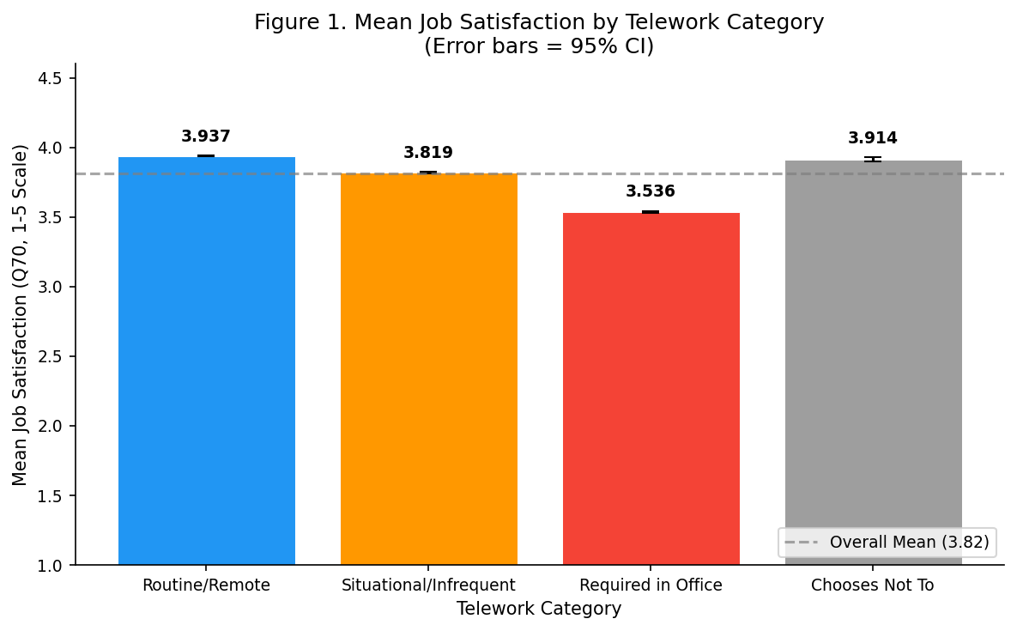
Figure 1. Mean Job Satisfaction by Telework Category (error bars = 95% CI)

4.2 Hierarchical Regression Results
Table 2 shows the model fit at each step. This is really the core of the analysis and I think the pattern tells a clear story.
Table 2. Model Comparison — Hierarchical Regression (n = 517,697)
Metric | Model 1 | Model 2 | Model 3 | Model 4
Block Added | Telework | + WLB | + EEI | + Demographics
R-squared | .0200 | .4091 | .5945 | .5966
Adj. R-squared | .0200 | .4091 | .5945 | .5966
Delta R-squared | — | .3891 | .1854 | .0021
F-statistic | 3,516.10 | 89,600.50 | 151,801.68 | 76,564.48
Cohen's f-squared | 0.020 (small) | 0.692 (large) | 1.466 (large) | 1.479 (large)

Here is what stands out to me from this progression:
- Telework alone only explains 2% of the variance in satisfaction (Model 1). That is surprisingly low given all the attention telework gets in the news. The effect size is small (f-squared = 0.020).
- Adding Work-Life Balance causes R-squared to jump from .02 to .41, an increase of nearly 39 percentage points. This is by far the biggest single jump. Employees' perceptions of WLB support are way more predictive than where they physically sit.
- Adding Employee Engagement pushes R-squared to .595, another 18.5 percentage point increase. Together, WLB and EEI explain about 60% of the variation in satisfaction — that is a strong model for survey data.
- Demographics barely matter — they add only 0.2 percentage points. Age, gender, tenure, and supervisory status are statistically significant (because of the huge sample) but practically irrelevant.
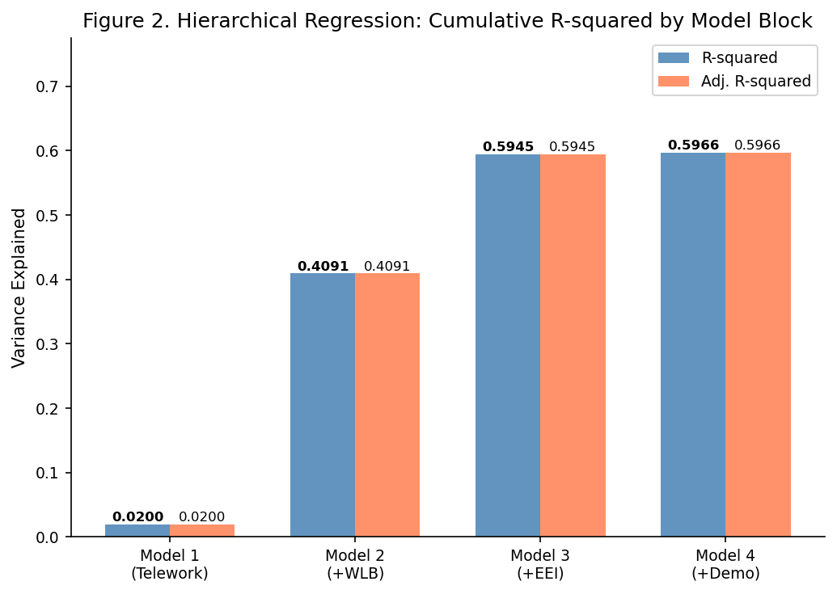
Figure 2. Cumulative R-squared by Model Block

4.3 Full Model Coefficients
Table 3 shows the coefficients for the full model (Model 4). The standardized coefficients (Beta) let us compare the relative importance of each predictor.
Table 3. OLS Coefficients — Full Model (Model 4)
Predictor | B | SE | Beta | p | 95% CI
Intercept | -0.469 | 0.006 | — | < .001 | [-0.480, -0.458]
TW: Infrequent | -0.002 | 0.002 | -0.001 | .326 | [-0.007, 0.002]
TW: Required in Office | 0.114 | 0.003 | 0.043 | < .001 | [0.109, 0.119]
TW: Chooses Not To | 0.090 | 0.005 | 0.016 | < .001 | [0.080, 0.099]
WLB Composite | 0.111 | 0.002 | 0.091 | < .001 | [0.107, 0.114]
Employee Engagement Index | 0.945 | 0.002 | 0.705 | < .001 | [0.941, 0.949]
Supervisor | -0.019 | 0.003 | -0.007 | < .001 | [-0.024, -0.015]
Male | 0.018 | 0.002 | 0.009 | < .001 | [0.015, 0.022]
Age 40+ | 0.088 | 0.003 | 0.036 | < .001 | [0.083, 0.093]
Tenure 11-20 yrs | -0.002 | 0.002 | -0.001 | .536 | [-0.006, 0.003]
Tenure 20+ yrs | 0.049 | 0.003 | 0.020 | < .001 | [0.044, 0.055]
R-squared = .5966, F(10, 517686) = 76,564.48, p < .001
The biggest takeaway from this table is that Employee Engagement (Beta = 0.705) absolutely dominates. A one-unit increase in EEI is associated with a 0.945-point increase in satisfaction — nearly a full point on the 5-point scale. Work-Life Balance is second most important (Beta = 0.091), and everything else is quite small in comparison.
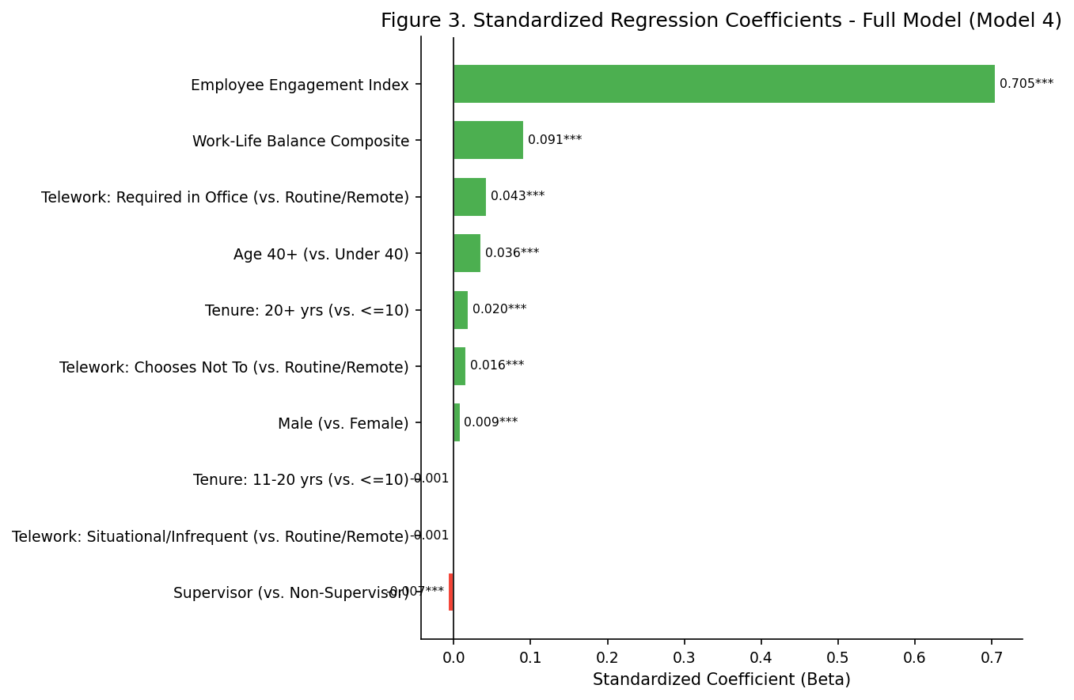
Figure 3. Standardized Regression Coefficients — Full Model

4.4 The Telework Reversal (Simpson's Paradox)
This was probably the most interesting finding in the analysis. Table 4 shows how the telework coefficients change as we add controls.
Table 4. Telework Coefficients Across Models
Predictor | Model 1 | Model 2 | Model 3 | Model 4
TW: Infrequent | -0.121*** | 0.013*** | -0.002 | -0.002
TW: Required in Office | -0.407*** | +0.094*** | +0.109*** | +0.114***
TW: Chooses Not To | -0.029*** | +0.127*** | +0.096*** | +0.089***
Look at the "Required in Office" row. In Model 1, the coefficient is -0.407, meaning office-required employees score nearly half a point lower than teleworkers. But once we add Work-Life Balance in Model 2, the sign flips to +0.094. By the full model, it is +0.114.
This is a textbook case of Simpson's Paradox — the relationship between two variables (telework and satisfaction) reverses when you account for a confounding variable (WLB and engagement). What is really happening is that in-office employees tend to have lower WLB support and lower engagement scores, and those attitudinal factors are what actually drive their lower satisfaction. Once we equalize WLB and engagement across groups, office-required employees are actually slightly more satisfied. This could reflect things like self-selection — people in roles they chose to do in person, or jobs with inherent in-person rewards.
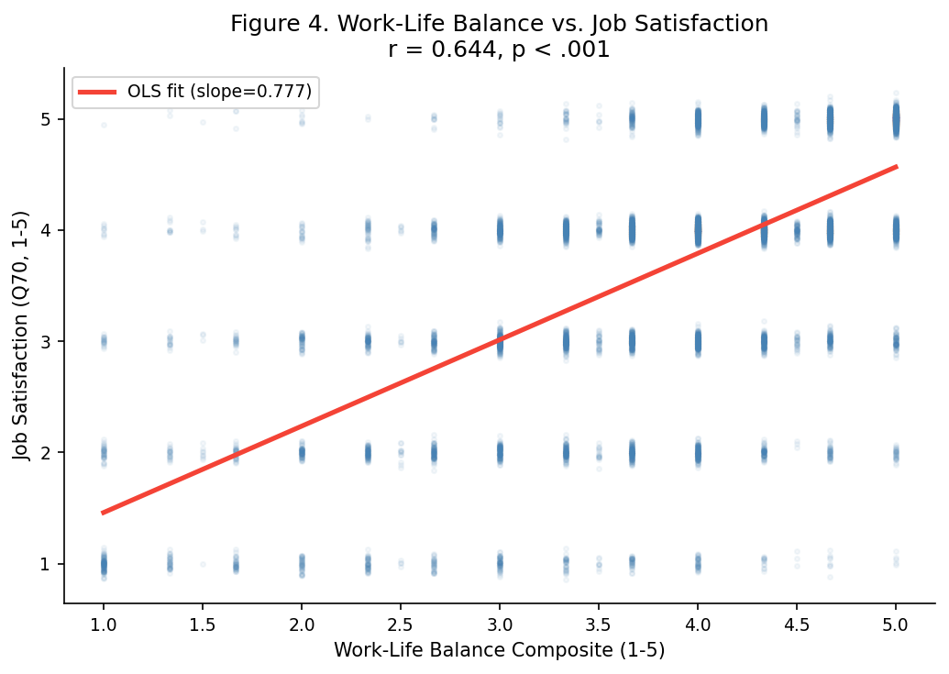
Figure 4. Work-Life Balance vs. Job Satisfaction (r = .64)

4.5 Model Diagnostics
- Multicollinearity: VIF was below 5 for all telework and demographic variables. However, WLB (VIF = 56.7) and EEI (VIF = 58.7) are highly collinear with each other, which makes sense since they measure related concepts. This does not affect the overall R-squared but does mean we should be cautious interpreting their individual coefficients in isolation.
- Autocorrelation: Durbin-Watson = 1.989, which is very close to 2 (no autocorrelation). Expected for cross-sectional survey data.
- Heteroscedasticity: The Breusch-Pagan test was significant (p < .001), so I also computed HC3 robust standard errors. All significance conclusions stayed the same.
- Residual normality: Slight negative skew (-0.531) and mild leptokurtosis (1.757). With over 500,000 observations, the Central Limit Theorem makes this a non-issue for inference.
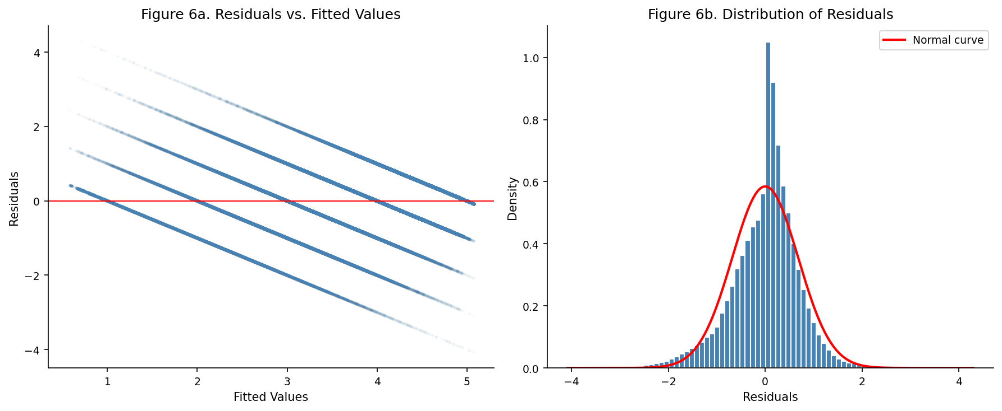
Figure 6. Residual Diagnostics — Residuals vs. Fitted (left) and Distribution (right)

5. Discussion and Conclusions
Going back to my three hypotheses:
- H1 — Partially supported. Telework is statistically significant but practically weak. By itself it only explains 2% of variance, and the coefficients reverse once we add controls. Telework frequency alone is not a reliable predictor of satisfaction.
- H2 — Strongly supported. WLB added 38.9 percentage points to R-squared and EEI added another 18.5 points. These are large, meaningful effects. Together they get the model to nearly 60% variance explained.
- H3 — Supported. The telework effect shrank dramatically and even reversed direction after controlling for WLB and engagement. This confirms that the raw telework-satisfaction gap is driven by confounding — teleworkers happen to have better engagement and WLB support, not because telework itself causes satisfaction.

5.1 What This Means for Federal Agencies
The practical implication is that agencies should not treat expanding telework as a silver bullet for improving satisfaction. The data shows that what actually moves the needle is employee engagement and work-life balance support. Agencies that invest in strong supervision, meaningful work experiences, and genuine support for work-life balance will see satisfied employees regardless of where those employees physically sit.
This does not mean telework is unimportant — there are many good reasons to offer it (recruiting, retention, cost savings). But the expectation that moving people remote will automatically increase satisfaction is not supported by this data.

5.2 Limitations
- Cross-sectional design: This is one snapshot in time, so I cannot make causal claims. The mediation pattern is consistent with telework affecting engagement which affects satisfaction, but it could go the other way.
- High VIF for WLB and EEI: These two composites are strongly correlated. In a future analysis, structural equation modeling could better separate their individual contributions.
- Self-selection: People who telework may be different in unobserved ways (higher grade, more autonomy in their role) that independently predict satisfaction.
- Likert as continuous: Treating 1-5 ordinal data as continuous in OLS is common but imperfect. An ordinal logistic regression could serve as a robustness check.

References
Bakker, A. B., & Demerouti, E. (2017). Job Demands-Resources theory: Taking stock and looking forward. Journal of Occupational Health Psychology, 22(3), 273-285.
Bloom, N., Liang, J., Roberts, J., & Ying, Z. J. (2015). Does working from home work? Evidence from a Chinese experiment. Quarterly Journal of Economics, 130(1), 165-218.
Caillier, J. G. (2012). The impact of teleworking on work motivation in a U.S. federal government agency. American Review of Public Administration, 42(4), 461-480.
Cohen, J. (1988). Statistical power analysis for the behavioral sciences (2nd ed.). Erlbaum.
De Vries, H., Tummers, L., & Bekkers, V. (2019). The benefits of teleworking in the public sector: Reality or rhetoric? Review of Public Personnel Administration, 39(4), 570-593.
Office of Personnel Management. (2024). Federal Employee Viewpoint Survey: Public Release Data File and Codebook. Washington, DC: OPM.

