Module 4: Model with Results
Remote Work, Work-Life Balance, and
Federal Employee Job Satisfaction

Karan Parekh
ADTA 5940 — Analytics Capstone Experience
Section 501 | Spring 2026
University of North Texas
Dr. Denise Philpot

1. Research Question
During our EDA, we noticed a pattern: federal employees who telework regularly tend to rate their job satisfaction higher than those required to come in. But is telework itself the driver, or are other factors — like engagement and work-life balance support — doing the heavy lifting? That is what this analysis sets out to answer.
To what extent does telework frequency predict overall job satisfaction among federal employees, after accounting for work-life balance perceptions, employee engagement, and demographic characteristics?
Three hypotheses guide the analysis:
- H1: Telework frequency significantly predicts job satisfaction.
- H2: Work-life balance and employee engagement each add meaningful explanatory power beyond telework alone.
- H3: After controlling for WLB and engagement, the telework effect will shrink substantially, indicating partial mediation.

2. Data Preparation
The dataset is OPM's 2024 Federal Employee Viewpoint Survey (FEVS) Public Release Data File — 674,207 rows and 96 columns. Likert-scale survey items were converted from text to numeric (1–5), with non-applicable responses ("X") treated as missing. Two composite indices were created following OPM's published methodology: the Employee Engagement Index (EEI), which averages three sub-indices covering intrinsic work experience, supervisor effectiveness, and leadership; and a Work-Life Balance (WLB) composite averaging three items on peer, supervisor, and senior leader support for work-life programs.
The telework variable (Q91) has four categories: Routine/Remote, Situational, Required in Office, and Chooses Not To. Dummy variables were created with Routine/Remote as the reference group. Demographic controls include age (under/over 40), gender, supervisory status, and federal tenure (three levels). After listwise deletion, the analytic sample is n = 517,697.

3. Formal Model
I used a hierarchical OLS regression, entering predictors in four blocks. This approach lets us see how much each group of variables adds — and specifically, what happens to the telework effect as we layer in stronger predictors.
- Model 1 (Telework only): Satisfaction = telework dummies
- Model 2 (+ Work-Life Balance): adds WLB composite
- Model 3 (+ Employee Engagement): adds EEI
- Model 4 (Full): adds supervisor status, gender, age, and tenure
The dependent variable is Q70 ("Considering everything, how satisfied are you with your job?") on a 1–5 Likert scale.

4. Results

4.1 Descriptive Overview
Average job satisfaction is 3.82 out of 5 (SD = 1.09). The WLB composite averages 4.02 and EEI averages 3.95, both above the scale midpoint. About 42.8% of respondents telework routinely, 33.6% situationally, 19.7% are required on-site, and 3.8% choose not to telework.
Figure 1 shows a clear raw gap: routine teleworkers average 3.94 on satisfaction while required-in-office employees average 3.54 — a 0.40-point difference. A one-way ANOVA confirms this is statistically significant (F(3, 639,584) = 4,047, p < .001), though the effect size is small (η² = 0.019).
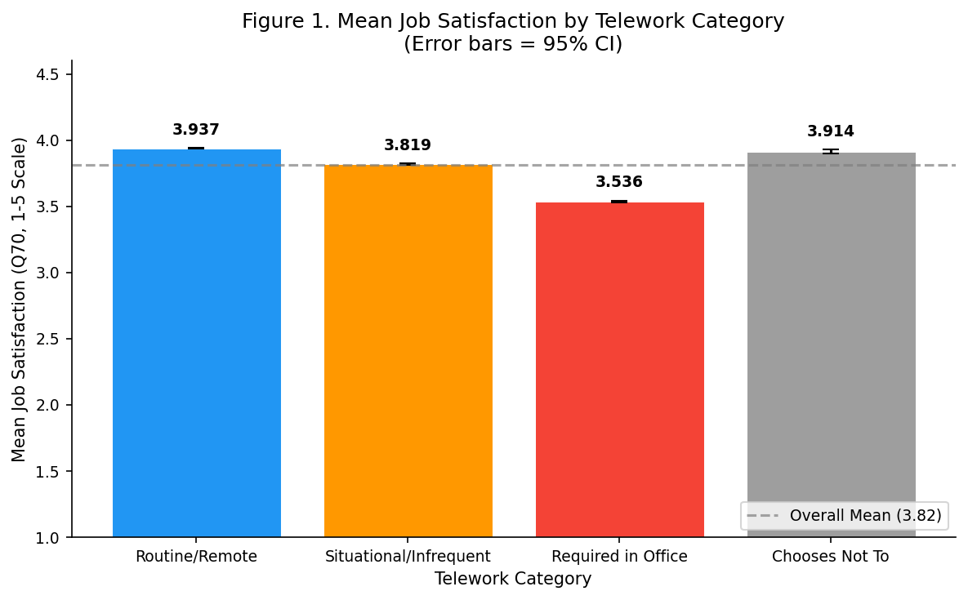
Figure 1. Mean Job Satisfaction by Telework Category (95% CI)

4.2 Hierarchical Regression
Table 1 shows how the model improves at each step. This is the core finding.
Table 1. Hierarchical Regression Summary (n = 517,697)
Metric | Model 1 | Model 2 | Model 3 | Model 4
Block added | Telework | + WLB | + EEI | + Demographics
R² | .020 | .409 | .595 | .597
ΔR² | — | .389 | .185 | .002
Cohen's f² | 0.020 (small) | 0.692 (large) | 1.466 (large) | 1.479 (large)

Telework alone explains just 2% of variance (Model 1). Adding WLB jumps R² to .41 — by far the biggest single gain. EEI pushes it to .60. Demographics add only 0.2 percentage points. In short, engagement and work-life balance perceptions do almost all the explanatory work.
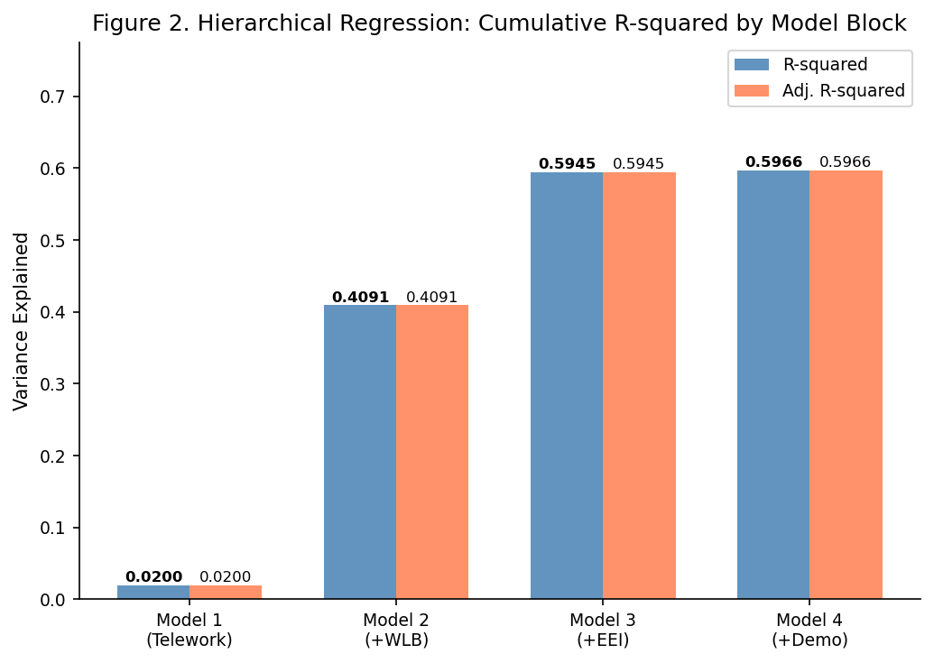
Figure 2. R² Progression Across Model Blocks

4.3 Key Coefficients
Table 2 shows the full model coefficients. The standardized Beta values show relative importance.
Table 2. Full Model Coefficients (Model 4)
Predictor | B | Beta | p
Employee Engagement Index | 0.945 | 0.705 | < .001
Work-Life Balance Composite | 0.111 | 0.091 | < .001
TW: Required in Office | 0.114 | 0.043 | < .001
TW: Chooses Not To | 0.090 | 0.016 | < .001
TW: Infrequent | −0.002 | −0.001 | .326
Age 40+ | 0.088 | 0.036 | < .001
Tenure 20+ yrs | 0.049 | 0.020 | < .001
Male | 0.018 | 0.009 | < .001
Supervisor | −0.019 | −0.007 | < .001
R² = .597, F(10, 517,686) = 76,564, p < .001
EEI dominates with Beta = 0.705 — a one-unit increase in engagement corresponds to nearly a full point increase in satisfaction. WLB is a distant second (Beta = 0.091). Every other predictor has a Beta below 0.05.
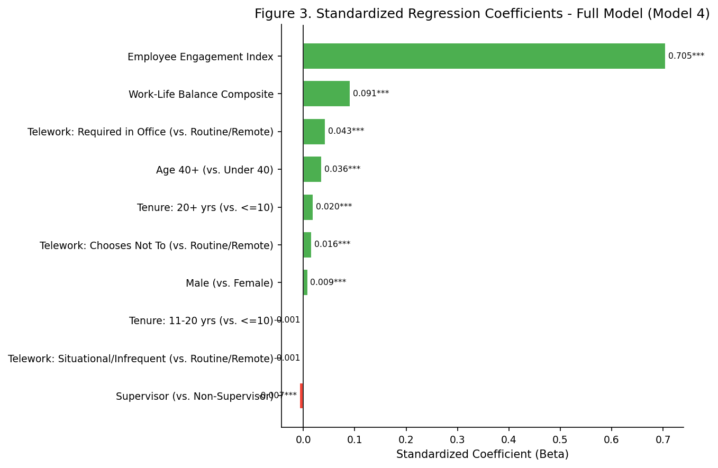
Figure 3. Standardized Coefficients — Full Model

4.4 The Telework Reversal
The most striking finding is what happens to the telework coefficients across models (Table 3).
Table 3. Telework Coefficients Across Models
Predictor | Model 1 | Model 2 | Model 3 | Model 4
TW: Infrequent | −0.121*** | 0.013*** | −0.002 | −0.002
TW: Required in Office | −0.407*** | +0.094*** | +0.109*** | +0.114***
TW: Chooses Not To | −0.029*** | +0.127*** | +0.096*** | +0.089***
In Model 1, required-in-office employees score 0.41 points lower than teleworkers. But in Model 2, after adding WLB, the sign flips to +0.09. By the full model it is +0.11. This is Simpson's Paradox: the raw telework gap is not caused by the work arrangement itself. In-office employees tend to report lower WLB support and engagement — and those are what actually drive their lower satisfaction. Once we hold those factors constant, office workers are actually slightly more satisfied.

5. Discussion
Returning to the hypotheses:
- H1 — Partially supported. Telework is statistically significant but explains only 2% of variance alone, and the effect reverses with controls.
- H2 — Strongly supported. WLB added 39 percentage points to R² and EEI added another 19. Together they get the model to 60% explained variance.
- H3 — Supported. The telework coefficient reversed direction once WLB and engagement were held constant.

5.1 Implications for Agencies
The practical takeaway is that expanding telework alone will not reliably increase satisfaction. What moves the needle is employee engagement — effective supervision, meaningful work, and visible leadership commitment. Agencies that invest in those areas will see satisfied employees regardless of where they physically work. This does not make telework unimportant (it supports recruitment and retention), but the data does not support treating it as a satisfaction silver bullet.

5.2 Limitations
- This is cross-sectional data (one point in time), so causal claims are not possible. The mediation pattern is suggestive but not confirmed.
- WLB and EEI are highly correlated (VIF > 50), which inflates their individual standard errors. Their combined effect is stable, but separating their unique impacts would require structural equation modeling.

References
Bakker, A. B., & Demerouti, E. (2017). Job Demands-Resources theory: Taking stock and looking forward. Journal of Occupational Health Psychology, 22(3), 273–285.
Caillier, J. G. (2012). The impact of teleworking on work motivation in a U.S. federal government agency. American Review of Public Administration, 42(4), 461–480.
Cohen, J. (1988). Statistical power analysis for the behavioral sciences (2nd ed.). Erlbaum.
Office of Personnel Management. (2024). Federal Employee Viewpoint Survey: Public Release Data File and Codebook. Washington, DC: OPM.

AI Usage Disclosure
In accordance with course AI policy, I used GitHub Copilot (an AI coding assistant) during this project. Specifically, AI was used to assist with writing and debugging the Python code that runs the regression models and generates figures. The research question, hypotheses, model design, interpretation of results, and all written analysis reflect my own understanding of the data and methods. All statistical outputs were verified independently. The final document was reviewed and edited by me to ensure accuracy and original expression.

