1. Product Contribution Of Sales

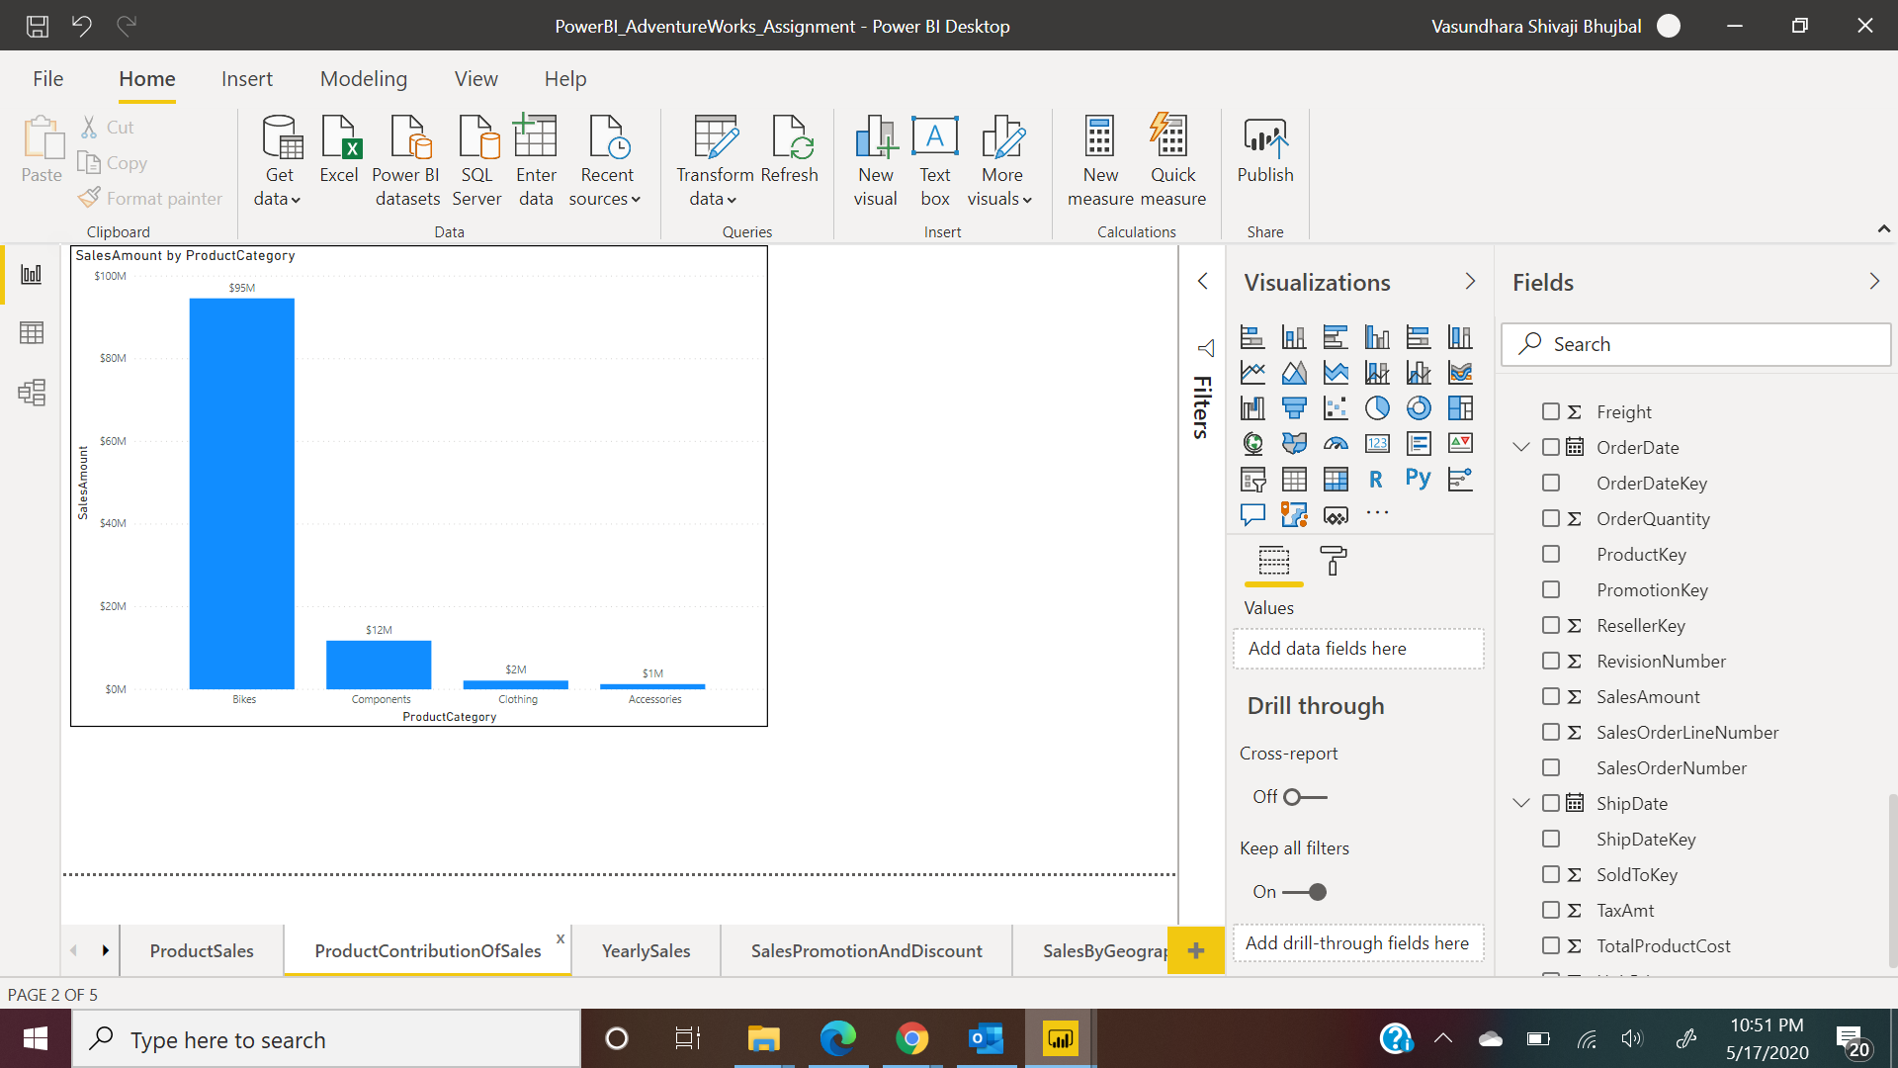

1. Comparison Of Yearly Sales

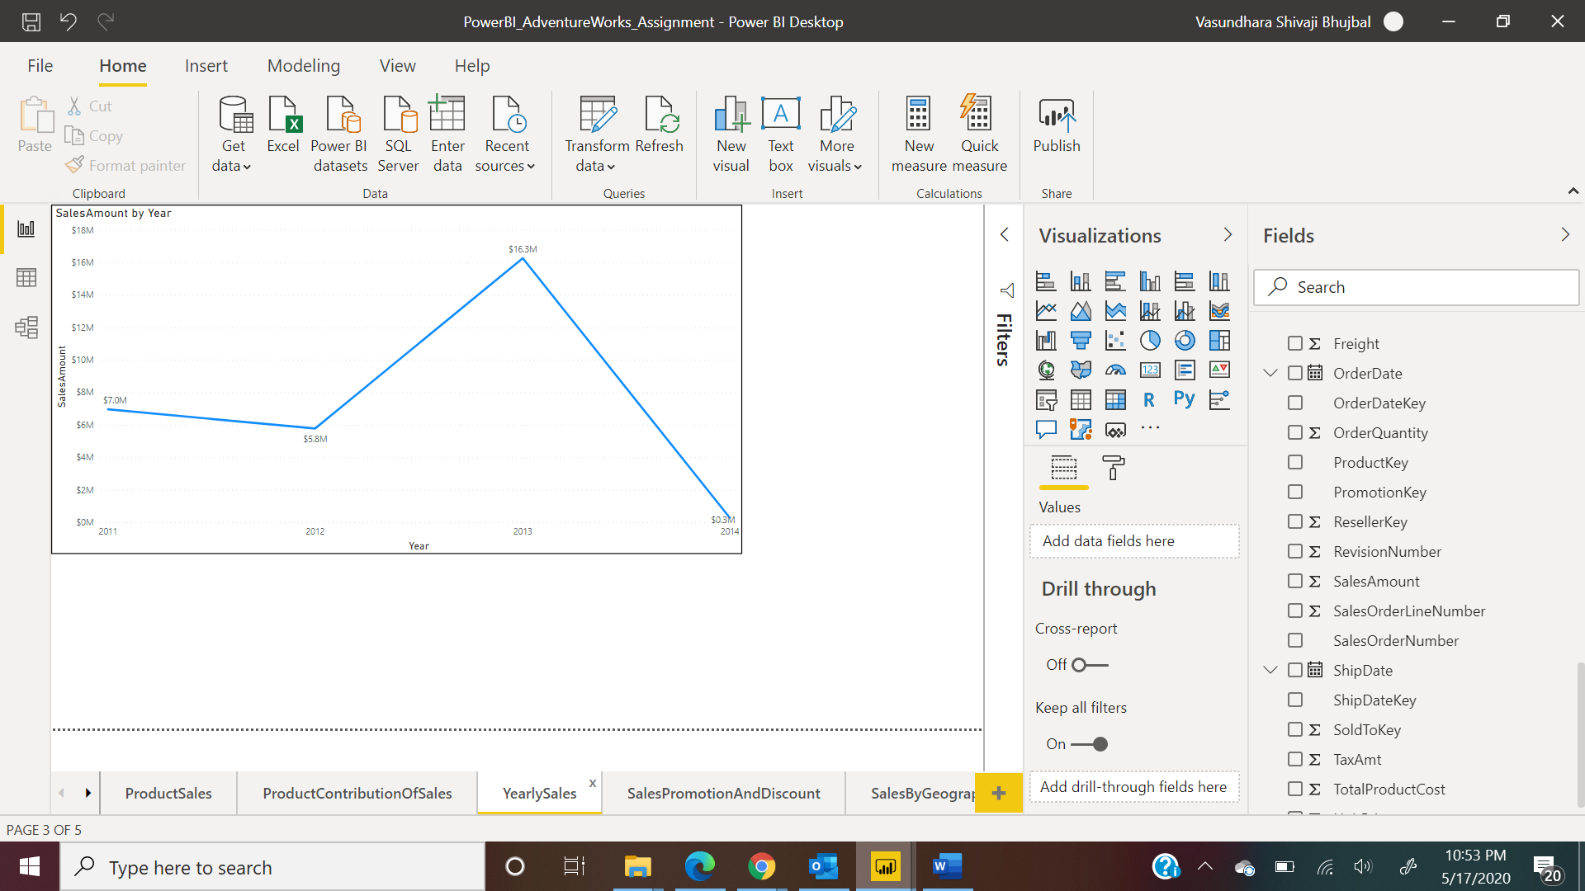

1. Sales Promotions and discounts

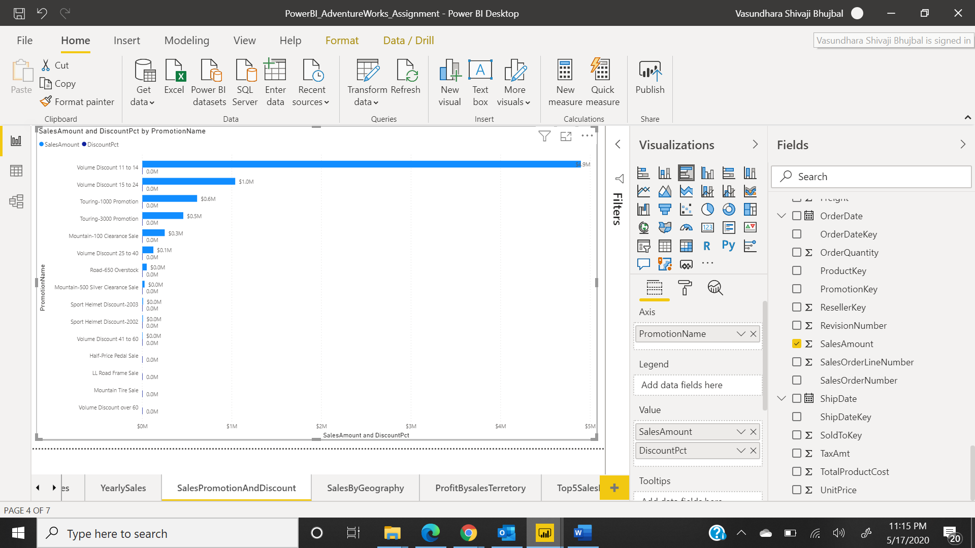

1. Product Sales by geography

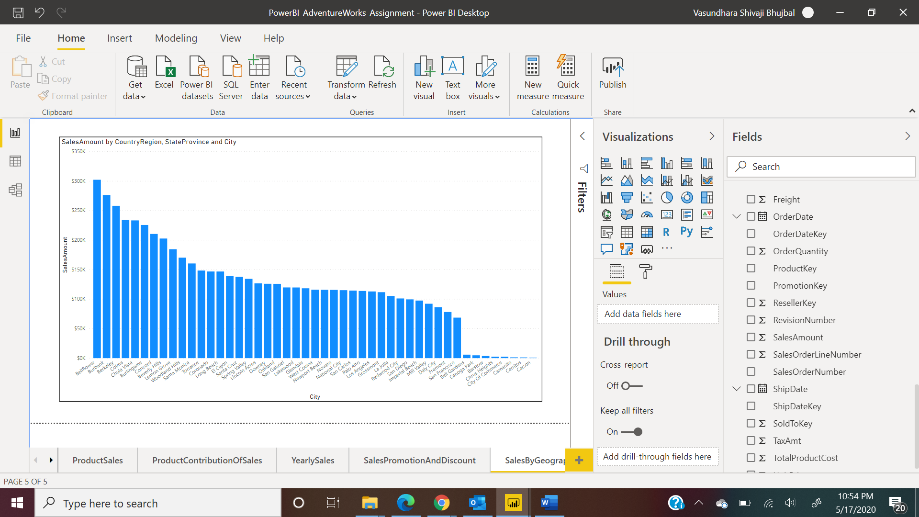

1. Product profit by sales territory

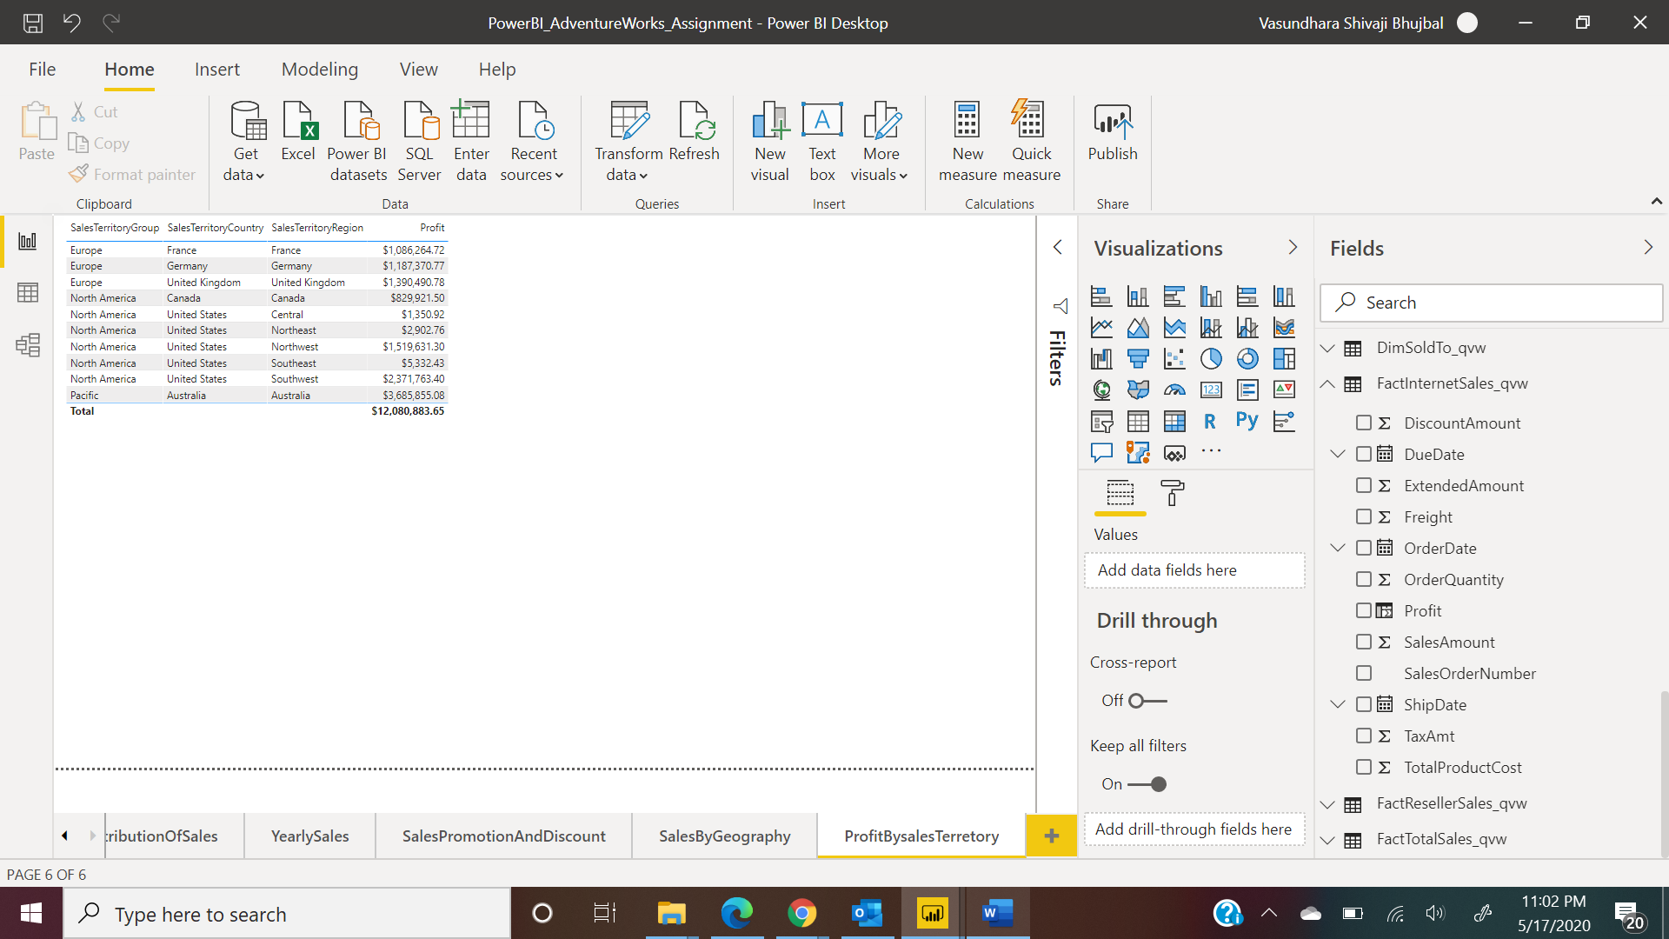

1. Top 5 Sales People Ranked

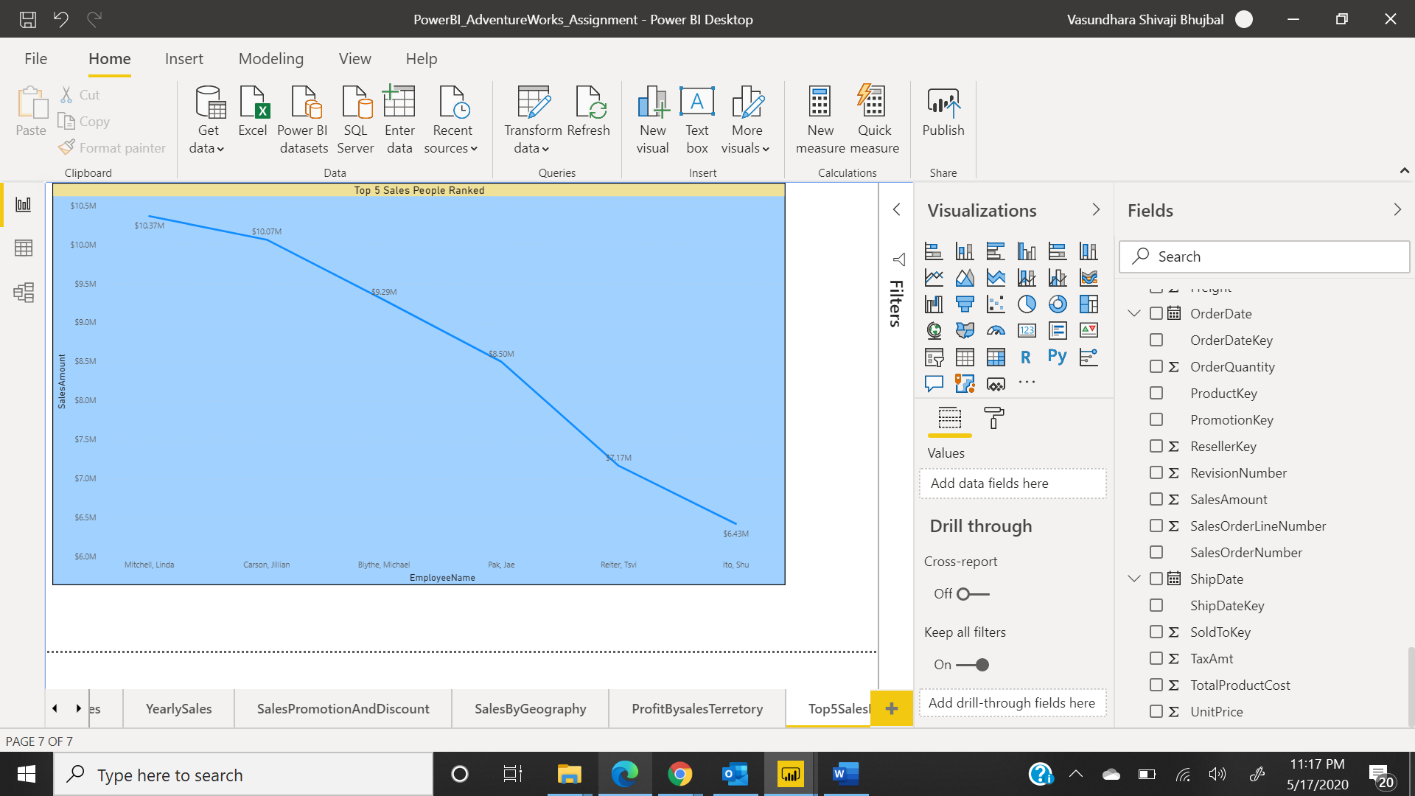

1. Top 10 Resellers (Stores) Ranked

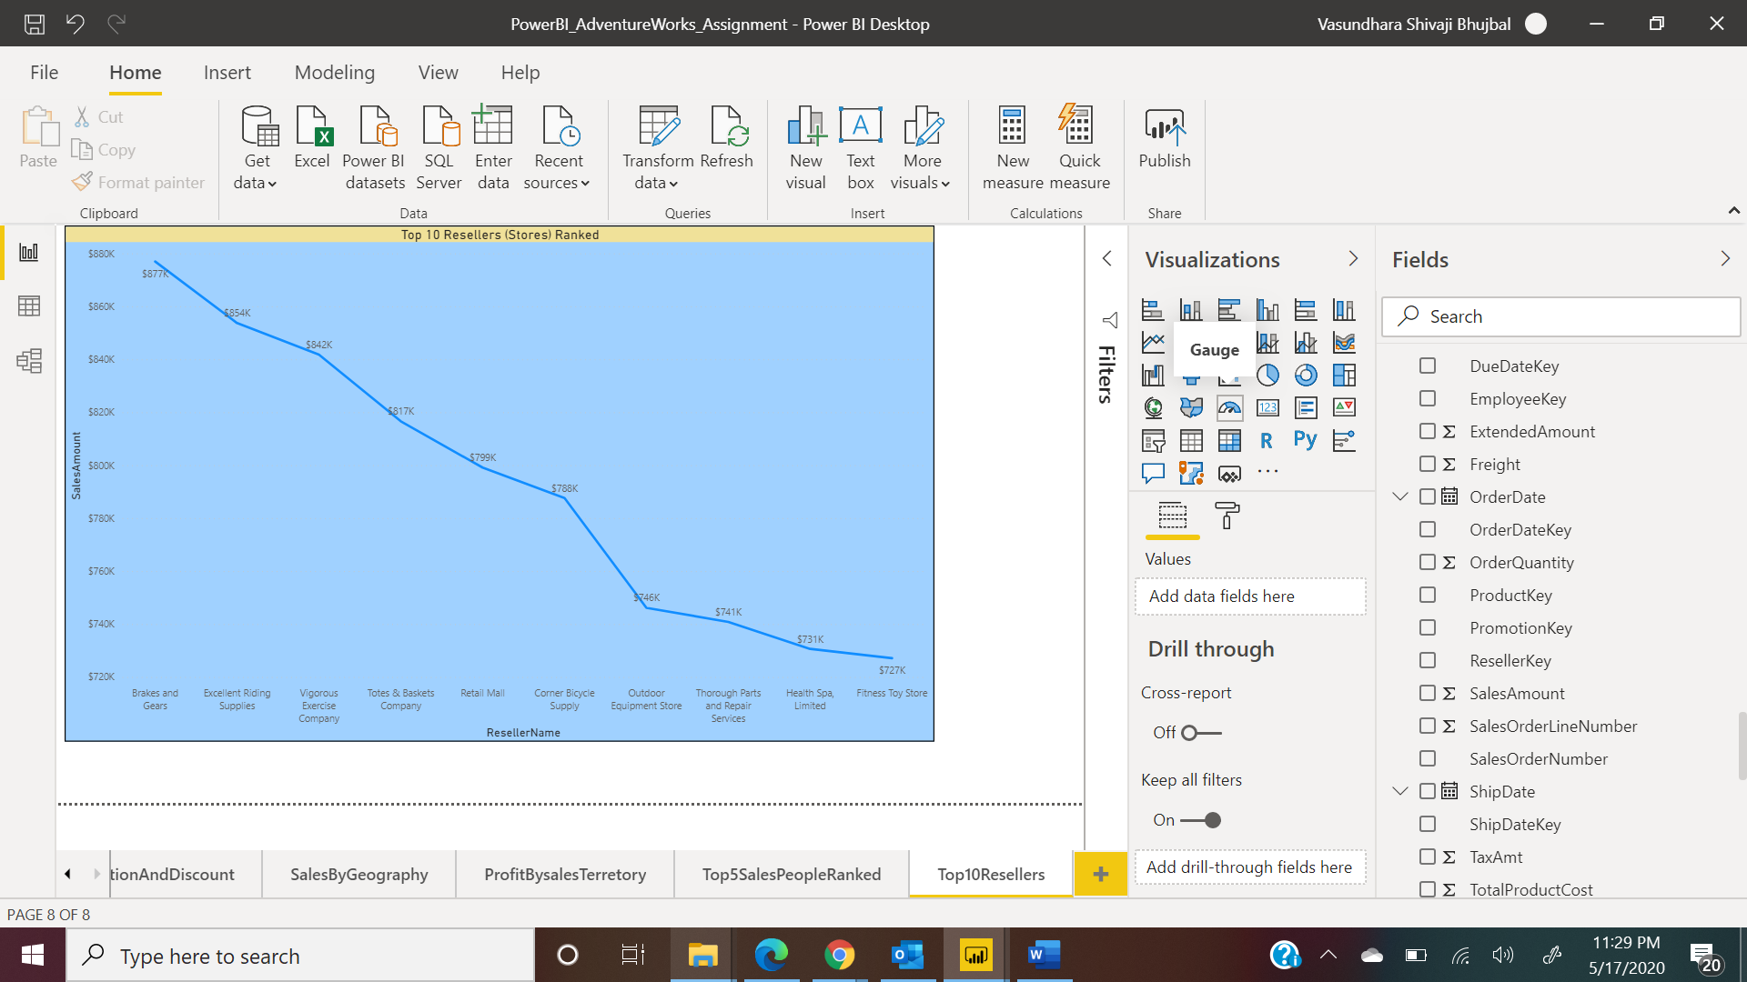

1. Geography based contribution to Sales

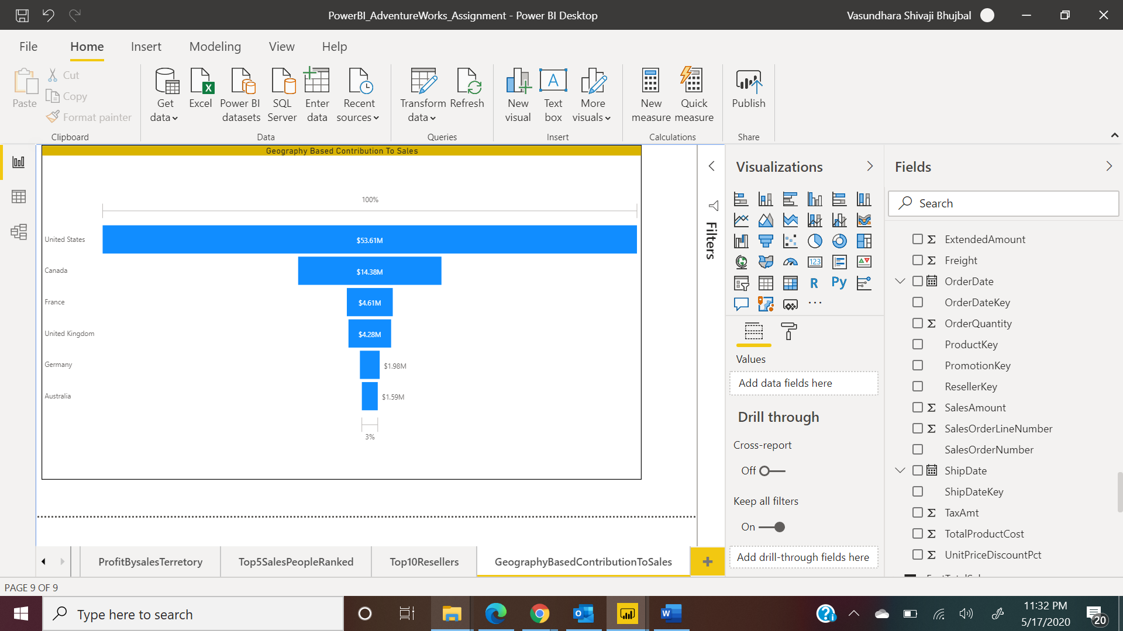

1. Two people related attributes correlated to their Sales

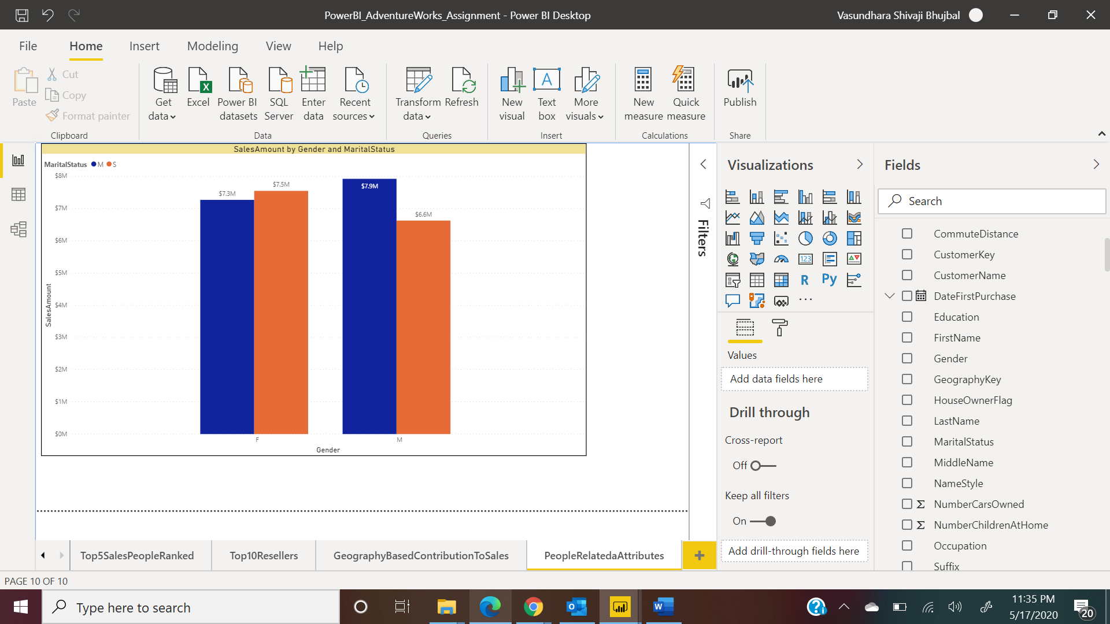

1. Any Reseller attribute(at least one) correlated to their sales

