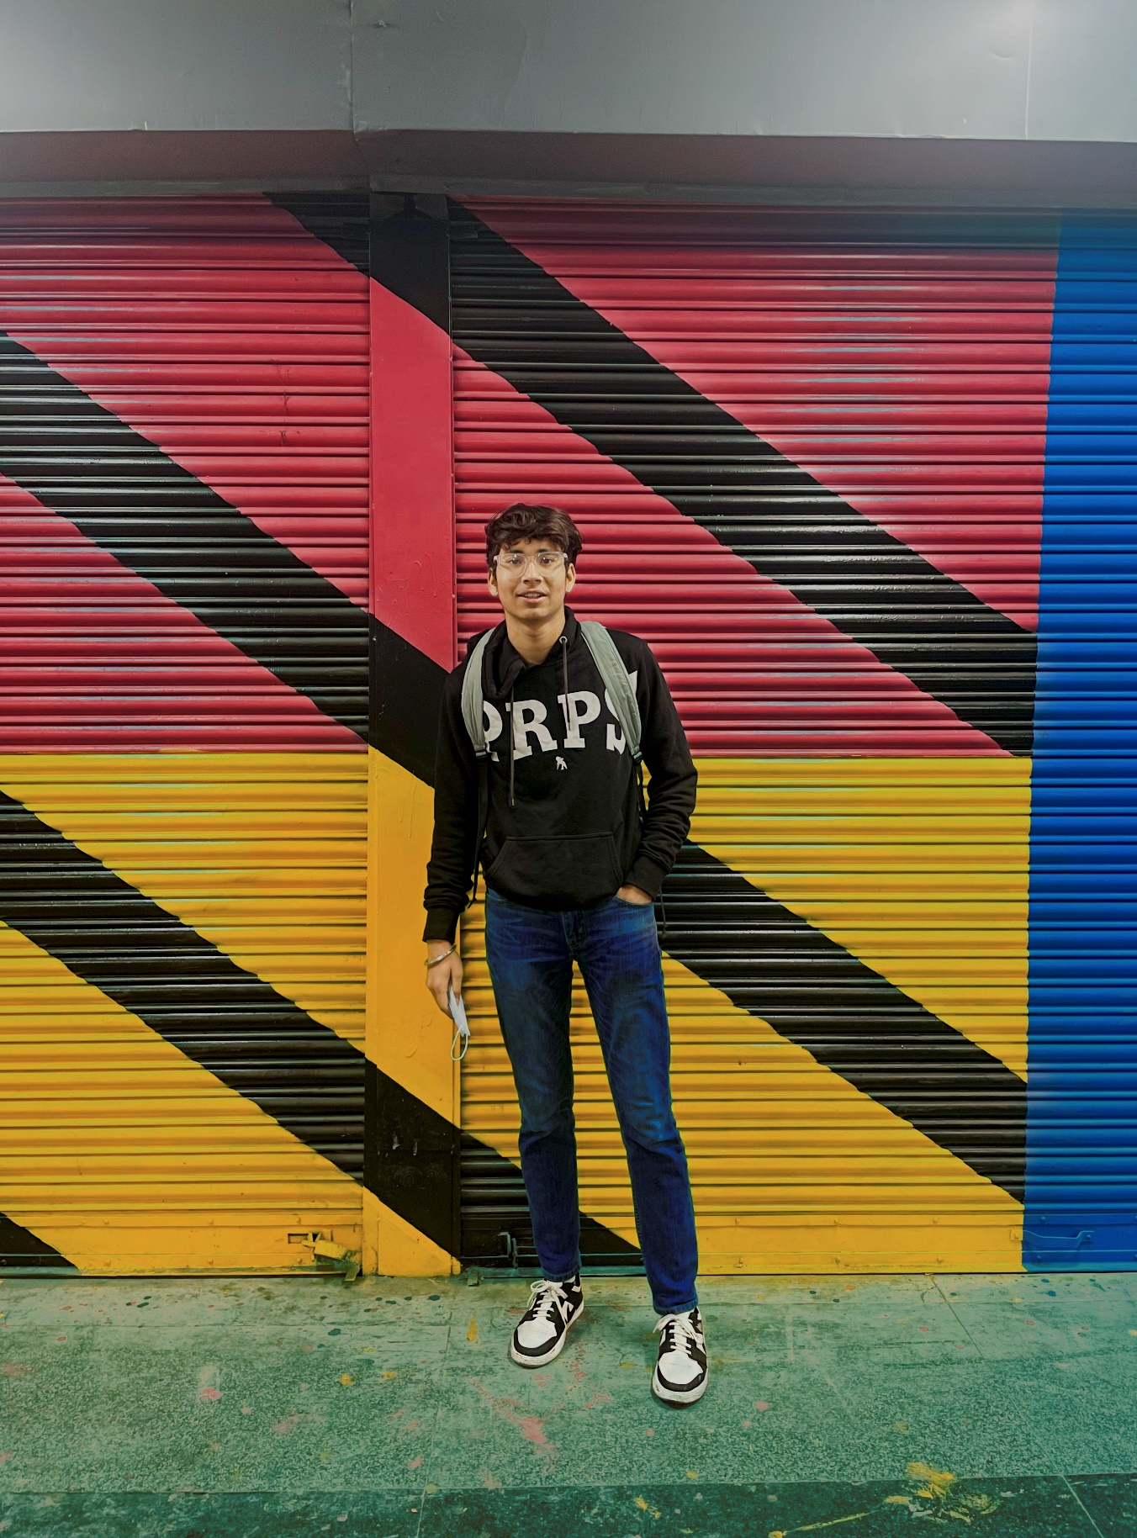

As a web designer, my objective is to make a positive impact on clients, co-workers, and the Internet using my skills and experience to design compelling and attractive websites and web graphics. Editing & Design with designing team in the company to build perfect web designs and other graphics.

**PROFILE**

**KARAN SINGH**

**PATWAL**



**WORK**

**ADDRESS**

**LANGUAGES**

* HINDI
* ENGLISH

**( WEB DESIGNER** **)**

* Website Design

https://karanpatwal99.github.io/cnc-website/

https://www.behance.net/karanpatwal

https://karanpatwal99.github.io/health-care-website/

kspatwal03@gmail.com

+91-7428451101

**CONTACT**

**E-MAIL**

kspatwal03@gmail.com

**PHONE**

BADARPUR BORDER, MOLARBAND EXTN.

NEW DELHI-110044

* Photoshop
* Illustrator
* Canva
* Html5 & CSS
* Wordpress
* Bootstrap
* Web Graphics

**SKILLS**

**OCT 2022 -**

**JUNE 2023**

**GRAPHIC DESIGNER**

SOCIAL GHOST AGENCY

* Create web graphics
* Create static AD post for social media
* Create motion videos

**WORK HISTORY**

I solemnly declare that all the information furnished in this document is free of errors to the best of my knowledge.

**Arena Animation South Extn.**

*Graphic Web Designing and Development*

**Secondary School**

*Stanford Convent School - Badarpur*

**Higher Secondary School**

*Govt Boys Senior Secondary School No.4 Sarojini Nagar*

**2020 -**

**2021**

**2018 -**

**2019**

**EDUCATION**

**2022 –**

**2023**

**2021 -**

**Present**

**Bachelor of Commerce**

*SOL Delhi University*

**DECLARATION**