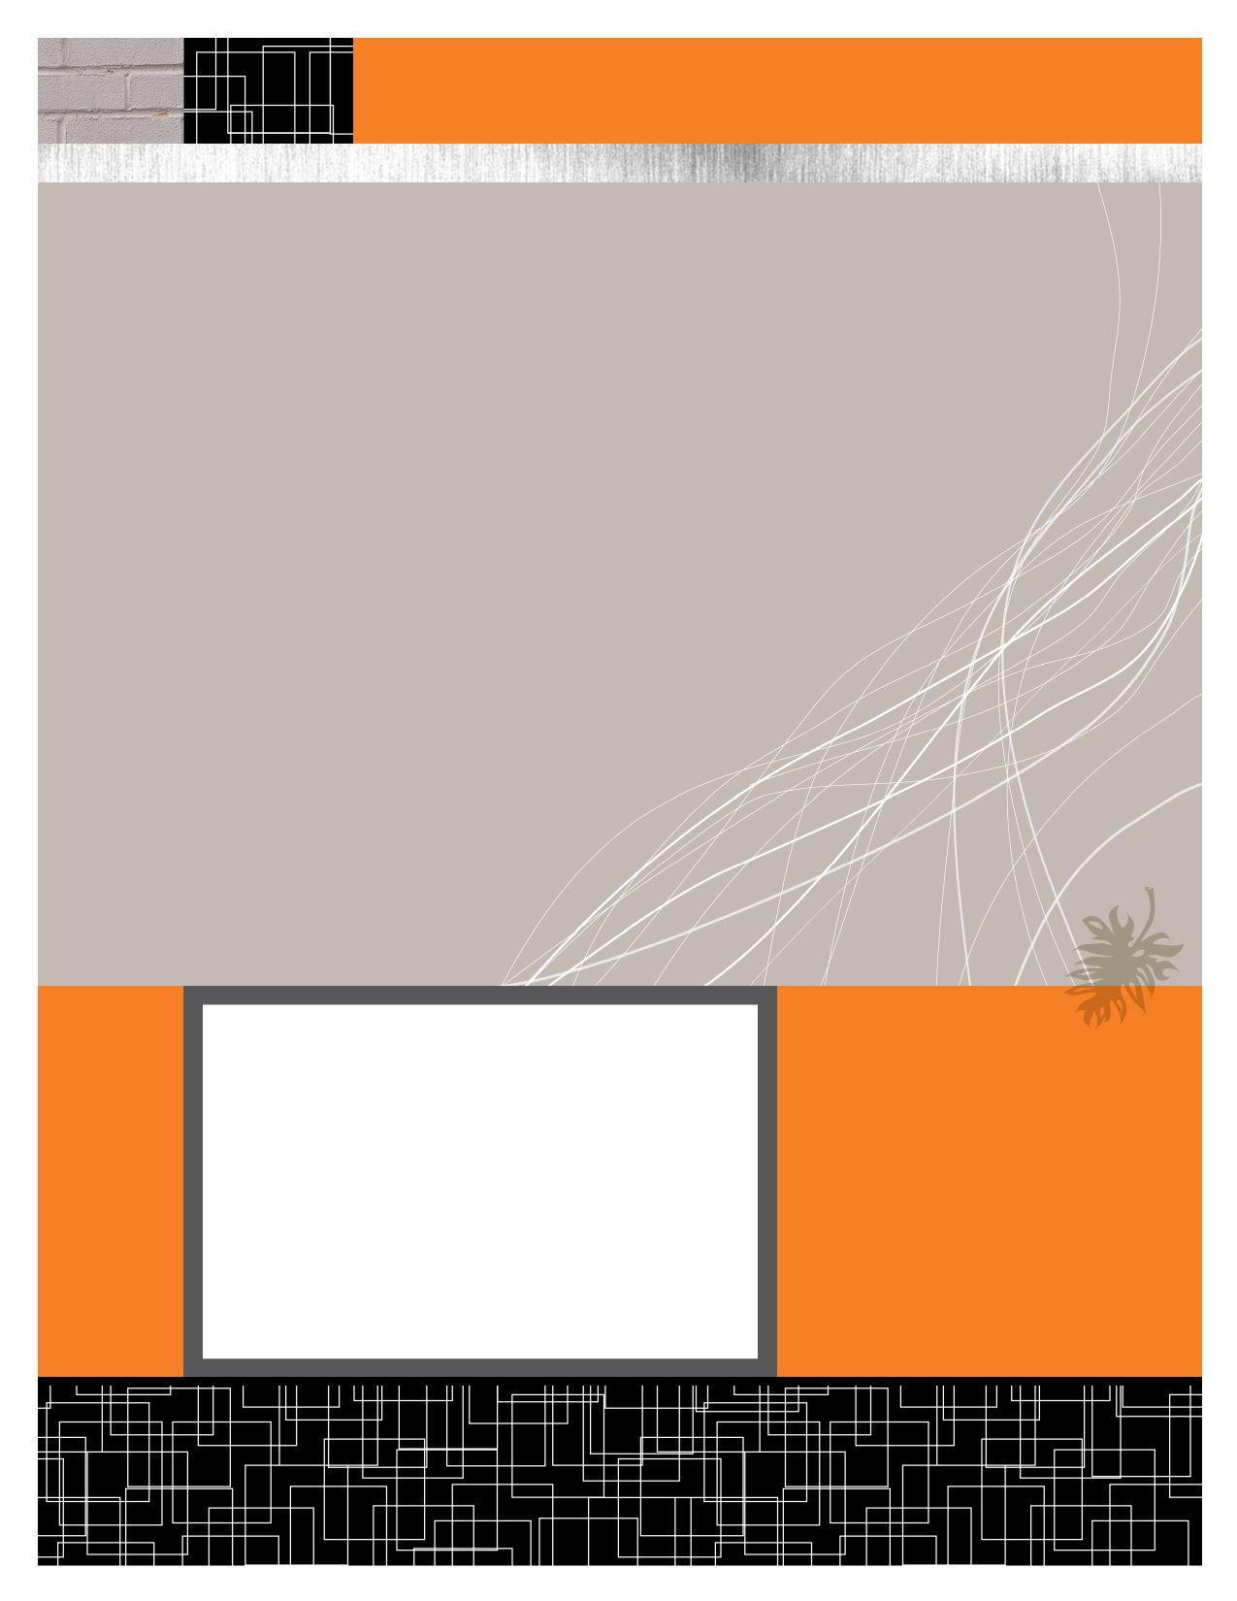

Anshul Jain (Y09UC027)

Mumal Seth (Y09UC086)

Shreya Mundra (Y09UC150)

Karan Poddar (Y09UC301)

Course Registration Portal

Data Flow Description

February 22, 2012

|  |  |  |
| --- | --- | --- |
| Data Flow Description | DATA ITEM | REMARKS |
| DF3a(i): Payment Details | 1. Physical Registration Status | Fee Payment Received or Not |
| DF4a(i): ACK-DF3a(i) | 1. List of Students who have physically registered OR  2. Error Message |  |
| DF9a(i) & b(i): Registration Status | 1. Physical Registration Status |  |
| DF9a(ii) & b(ii): Login Details | 1. Username  2. Password  3. Physical Registration Status |  |
| DF1a(i): Username, Password | 1. Username 2. Password |  |
| DF2a(i): ACK-DF1a(i) | 1) Confirmation and will show the home page of DEAN if details given in DF1a(i) are correct in accordance to DS1.  2) Will show an error if details are wrong. |  |
| DF7a(i): Username, Password | 1. Username 2. Password |  |
| DF8a(i): ACK-DF7a(i) | 1) Confirmation and will show the home page of PROFESSOR if details given in DF7a(i) are correct in accordance to DS1.  2) Will show an error if details are wrong. |  |
| DF5a(i): Username, Password | 1. Username 2. Password |  |
| DF6a(i): ACK-DF5a(i) | 1) Confirmation and will show the home page of STUDENT if details given in DF5a(i) are correct in accordance to DS1.  2) Will show an error if details are wrong.  3) Physical Registration Status |  |
| DF1b(i): Available Courses, Adding new Courses | 1. Course Code  2. Name(Course Name)  3. Professor ID  4. Credits  6. Elective/Compulsory |  |
| DF2b(i): ACK-DF2b(i) | 1. Error Message OR  2. Confirmation Message |  |
| DF7b(i): Pre-requisites, Course structure | 1. No. of seats  2. Pre-requisites  3. Description |  |
| DF8b(i): ACK-DF7b(i) | 1. Error Message OR  2. Confirmation Message |  |
| DF5b(i): Preferences, Registration Type | 1. Students ID  2. Course ID  3. Type(Special/Overload/Normal)  4. Preference |  |
| DF6b(i): ACK-5b(i) | 1. Error Message OR  2. Confirmation Message for registration complete |  |
| DF5b(ii): Swapping Details | 1. Student ID_1  2. Student ID_2  3. Course ID_1  4. Course ID_2 |  |
| DF6b(ii): Whether swap successful or not. | 1. Error Message OR  2. Confirmation Message for request send |  |
| DF15a&b: Swapping Details | 1. Student ID_1  2. Student ID_2  3. Course ID_1  4. Course ID_2 |  |
| DF13a(i) & 13b(i): Registration Type, Courses Chosen | 1. Students ID  2. Course ID  3. Type(Special/Overload/Normal)  4. Preference |  |
| DF10a(i) & b(i): Course Details | 1. Course Code  2.Name(Course Name)  3. Professor ID  4.No. of students allowed  5.Credits  6. Pre-requisites  7. Elective/Compulsory  8. Description |  |
| DF17a: Student Registration Details (Normal Registration) | 1. Students ID  2. Course ID  3. Type(Special/Overload/Normal)  4. Preference |  |
| DF17b: ACK-DF17a | 1. Error Message OR  2. Completion Message |  |
| DF16a: Updated Student Details | 1. Students ID  2. Course ID  3. Type(Special/Overload/Normal)  4. Preference |  |
| DF16b: Currently Registered Students Details | 1. Students ID  2. Course ID |  |
| DF13a(ii) & b(ii): Registration Type, Courses Chosen | 1.Student ID  2.Application Content  3.Status  4.Type |  |
| DF11a(i): Student Details | 1.Student ID  2.Course ID  3.Semester |  |
| DF11b(i): ACK-11a(i) | 1. Error Message OR  2. Completion Message |  |
| DF5b(ii): Preferences, Registration type | 1. Students ID  2. Course ID  3. Type(Special/Overload/Normal)  4. Preference |  |
| DF6b(ii): ACK-5b(i) | 1. Error Message OR  2. Confirmation Message for add/drop complete |  |
| DF1b(ii): Application Status Details | 1.Student ID  2.Application Content  3.Status  4.Type |  |
| DF2b(ii): ACK-DF1b(ii) | 1. Error Message OR  2. Confirmation Message |  |
| DF12a(i) & b(i): Application Details | 1.Student ID  2.Application Content  3.Status  4.Type |  |

