

LPG Controller/ Monitoring System

3CP08 (Design Engineering)

ID: 20CP306 (Karan Raj)

20CP315 (Dhaval Rana)



[Birla Vishvakarma Mahavidhyalaya](https://www.google.com/search?q=Birla+Vishvakarma+Mahavidyalaya+(BVM)&ludocid=771070764652987212&lsig=AB86z5VLZs-5lPsrDpro0V7Ep5ln&sa=X&ved=2ahUKEwiwl87K8onwAhUXxzgGHSkMBFgQ8G0oADAaegQIIxAB)

Engineering College

[An Autonomous Institution]

A

Project Report

On

**LPG CONTROLLER/ MONITORING SYSTEM**

Under the course of

**DESIGN ENGINEERING -3CP08**

B. E. Semester – IV

**(Computer Engineering)**

**Submitted by:**

|  |  |  |
| --- | --- | --- |
| **Sr.** | **Name of student** | **Enrolment No.** |
| 1 | Raj Karansinh | 20CP306 |
| 2 | Dhaval Rana | 20CP315 |

Guided by

**Kirtikumar Sharma**

Academic year

**(2021-2022)**

**CERTIFICATE**

This is to certify that the students namely, **Mr. Raj Karansinh (20CP306), Mr. Dhaval Rana (20CP315)** of ***B. E. (Computer Engineering) Semester VI*** have successfully completed the course work and related tasks for the course of **Design Engineering 3CP08** during the academic term ending in the month of May 2022.

**Date:** __________

**Place:** ____VVN______

**(Faculty Guide) Head of the Department**

[Birla Vishvakarma Mahavidhyalaya](https://www.google.com/search?q=Birla+Vishvakarma+Mahavidyalaya+(BVM)&ludocid=771070764652987212&lsig=AB86z5VLZs-5lPsrDpro0V7Ep5ln&sa=X&ved=2ahUKEwiwl87K8onwAhUXxzgGHSkMBFgQ8G0oADAaegQIIxAB)

[An Autonomous Institution]

Computer Engineering Department

**3CP08: Design Engineering**

(AY-2021-22)

|  |  |  |
| --- | --- | --- |
| **Sr. No.** |  | **Page No.** |
| **1.** | **Introduction**   * Finalized project definition * Problem Statement | **5** |
| **2.** | **Literature Survey**   * Case study of existence solution | **6-12** |
| **3.** | **Design Considerations for Detail Design**   * Entity Relation Diagram (ER Diagram) * Data Flow Diagram * Work Flow Diagram | **13-16** |
| **4.** | **Prototype**   * Hardware Prototype * Software Prototype | **17-18** |
| **5.** | **Implementation/ Simulation**   * Firebase Database * Hardware (IOT) Simulation * Android Application | **19-24** |
| **6.** | **Analysis and Result Discussion** | **25** |
| **7.** | **Conclusion and Future Scope** | **26** |
| **8.** | **References** | **27** |

**(1) Introduction**

* **Finalized project definition**

LPG Controller / Monitoring System

* **Problem Statement**
* Liquid Petroleum Gas (LPG) is a highly flammable chemical that consists of mixture of propane and butane. LPG is used for cooking at home, restaurant, and certain use for industry. They have certain weaknesses that make the gas leakage occur.
* The leakage of gases only can be detected by human nearby and if there are no human nearby, it cannot be detected. But sometimes it cannot be detected by human that has a low sense of smell. Thus, this system will help to detect the presence of gas leakage.
* Gas leakage can cause fire that will lead to serious injury or death and it also can destroy human properties. This system was developed by using IOT to give real-time response to the users.
* Gas weight data in percentage, kg
* Daily report of gas usage
* Email or SMS of reports
* Automatic booking of Gas with the help of Email/SMS

**(2) Literature Survey**

* + - A number of reviews on the subject of gas leakage detection techniques were done in the past either as part of research papers/technical reports on a certain leak detection method and other gas related subjects.
    - A.Mahalingam, r. T. Naayagi, n. E. Mastorakis; they introduce design and implementation of an economic gas leakage detector. They gave the formulation of many problems in previous gas leakage detectors.
    - Prof. M.Amsaveni, A.Anurupa, R.S.Anu Preetha, C.Malarvizhi, M.Gunasekaran; they told in their research paper on “GSM based LPG leakage detection and controlling system” the leakage of LPG gas is detected by the MQ-6 gas sensor.
    - Its analog output is given to the microcontroller. It consists of predefined instruction set. Based on this, the exhaust fan is switched on. So, the concentration of gas inside the room gets decreased. Then, the stepper motor is rotated thus closing the knob of the cylinder. Because of this process, the leakage of gas is stopped.
    - The buzzer produces an alarm to indicate the gas leakage. Then, the user is alerted by SMS through the GSM module.
    - B. B. Did paye, Prof. S. K. Nanda; in this paper they told about their research on leakage detection and review of “Automated unified system for LPG using microcontroller and GSM module”. Their

paper proposed an advance and innovative approach for LPG leakage detection, prevention and automatic booking for refill.

* + - In advance, the system provides the automatic controlling of LPG regulator also if leakage is detected the system will automatically turn off the main switch of power supply. Hence it helps to avoid the explosion and blast.
* Hina Ruqsar , Chandana R , Nandini R , Dr. T P Surekha, have proposed a system that along with monitoring and detection of gas leakage, real time data is made available through real time feed over internet They have used Xively IOT platform to provide real time sensor data over the internet.

**Case study of existence solution**

## **1) LPG Smart valve + IOT System for LPG**

**By:** Karan Raj (20CP306)

**Imp aspect:** Use of solenoid valve

**Algorithm:**

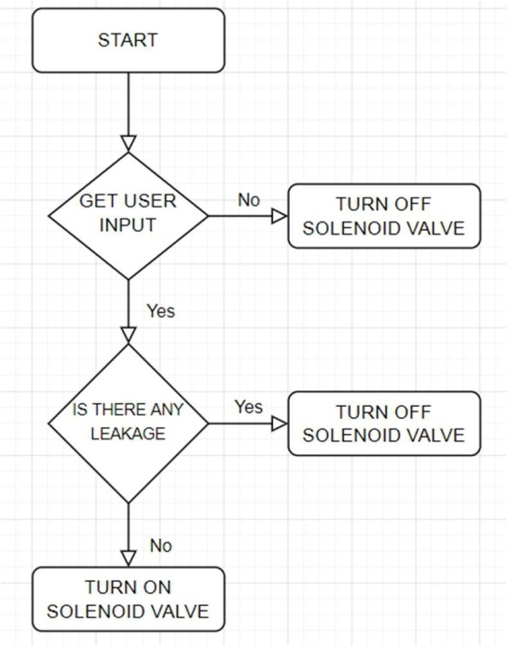

**Cost analysis:**

* We have to implement solenoid valve which require new regulator or in some cases new LPG cylinder which can fit solenoid valve technology.
* Existing LPG user can’t adapt this with low cost.
* Moderate to high cost.

**Hardware details:**

* Microcontroller
* Solenoid valve
* MQ-2 Sensor
* Buzzer
* LCD Display

**Software/ Tools details:**

* Tinkercad Design tool
* Arduino IDE
* Html/ css/ JavaScript/ PHP
* Android
* MySQL

**Features:**

* A solenoid valve is used to turn on/off gas valve remotely using app/ website. • MQ-2 sensor is a sensor which is specifically designed to detect LPG Leakage. A buzzer is placed inside the system which acts as alarm.
* Booking of Gas with app/website in few clicks.
* Track Gas delivery status with app.

**Advantages:**

* This system does not require any human interactions.
* To develop a reliable safety system for gas leakage.
* To avoid the unwanted accidents due to gas leakage.
* To remotely control LPG valve (on/off LPG with just few clicks).
* Booking of LPG from app.

**Disadvantages/ Limitations:**

* There is no way for a user to use system who can’t install solenoid valve based regulator.
* It’s costlier than current system.
* There is no way for a user to see current gas level.
* There is no way for a user to see past usages data, or reports.

**Future Work:**

* Improve Design of website and app
* Provide a way for a user to see current gas level, past activity, and generate reports
* Provide automatic booking of LPG when certain level reaches
* Provide alerts using email/SMS

## **2) AUTOMATED LPG LEAKAGE DETECTION AND CUT-OFF SYSTEM**

**By:** Karan Raj (20CP306)

**Imp aspect:** Use of DC Gear Motor to turn valve

**Algorithm:**

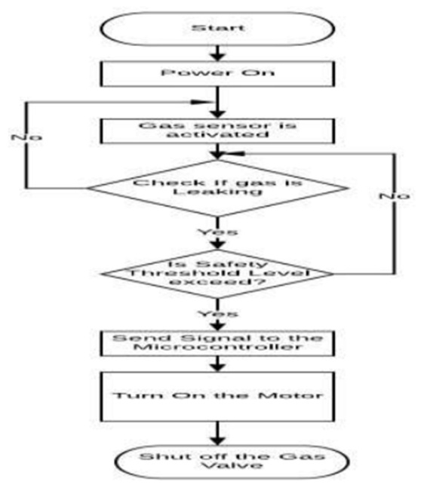

**Cost analysis:**

* We have to just implement DC Gear motor with the existing system regulator’s valve, which can be rotated to turn on/off valve.
* No special regulator or LPG cylinder is required.
* Existing LPG user can adapt this with low cost.
* Low to moderate cost.

**Hardware details:**

* Microcontroller
* Switch
* MQ-6 Sensor
* Geared DC Motor

**Software/ Tools details:**

* Protus Design tool
* Arduino IDE
* Html/ css/ JavaScript
* MySQL

**Features:**

* A geared Dc motor is used to turn off the main regulator of gas cylinder whenever LPG leaks and the rotation of geared DC motor is controlled through microcontroller. A knob attached to the tip of DC motor which provides interface between Dc motor and regulator. Knob rotates in certain angle to turn off the main valve and prevent further gas leakage
* MQ-6 sensor is a sensor which is specifically designed to detect LPG, iso-butane, propane. This sensor works under all kinds of environments and will be able to sense gas leakage of about 100500ppm
* A buzzer is placed inside the system which acts as alarm

**Advantages:**

* This system does not require any human interference in its working and will be able to completely operate remotely
* To develop a reliable safety system for gas leakage.
* To avoid the unwanted accidents due to gas leakage.
* To provide a low cost safety device for common people

**Disadvantages/ Limitations:**

* There is no way for a user to see current gas level
* There is no way for a user to see past usages data, or reports
* Android/IOS application is not available
* Not user friendly GUI

**Future Work:**

* Improve Design
* Provide a way for a user to see current gas level, past activity, and generate reports

## **3) GSM BASED LPG WEIGHT AND LPG LEAKAGE DETECTION SYSTEM**

**By:** Dhaval Rana (20CP315)

**Imp aspect:** Weight and Leakage Detection

**Algorithm:**

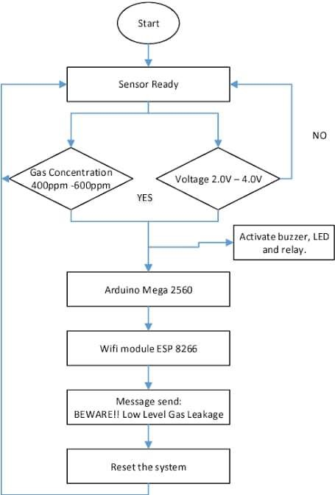

**Cost analysis:**

* No special regulator or LPG cylinder is required.
* Existing LPG user can adapt this with low cost.
* Load cell sensor is required.
* Low to moderate cost.

**Hardware details:**

* Microcontroller
* Switch
* MQ-6 Sensor
* Load cell sensor
* Wifi module

**Software/ Tools details:**

* Protus Design tool
* Arduino IDE
* Html/ css/ JavaScript
* MySQL

**Features:**

* MQ-6 sensor is a sensor which is specifically designed to detect LPG, iso-butane, propane. This sensor works under all kinds of environments and will be able to sense gas leakage of about 100500ppm
* A buzzer is placed inside the system which acts as alarm
* Load cell sensor is used to detect current weight of LPG
* Using Wi-Fi module weight data can be stored in database to do further processing.

**Advantages:**

* To develop a reliable safety system for gas leakage.
* To avoid the unwanted accidents due to gas leakage. • To provide a low cost safety device for common people • User don’t have to guess about LPG remain gas level.
* User can see his activity and past usages.

**Disadvantages/ Limitations:**

* There is no way for a user turn on/off gas using app.
* Not user friendly GUI

**Future Work:**

* Improve Design
* Provide a way for a user to generate reports, email notification.

## **4) LPG GAS MONITORING & AUTOMATIC CYLINDER BOOKING**

**By:** Dhaval Rana (20CP315)

**Imp aspect:** Gas monitoring and Auto Booking

**Algorithm:**

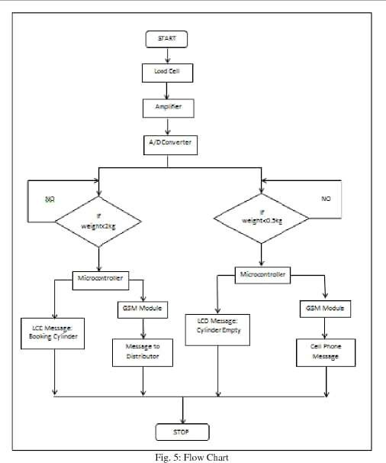

**Cost analysis:**

* No special regulator or LPG cylinder is required. • Existing LPG user can adapt this with low cost • Wifi Module and GSM Module is required.
* Low to moderate cost.

**Hardware details:**

* Microcontroller
* Load cell sensor
* Wifi module
* GSM module

**Software/ Tools details:**

* Protus Design tool
* Arduino IDE
* Android
* PHP
* SMS Services
* MySQL

**Features:**

* Load cell sensor is used to detect current weight of LPG.
* Using Wi-Fi module weight data can be stored in database to do further processing.
* When gas level reaches certain level automatic booking of new LPG. • SMS/Email services. • Monitoring of LPG

**Advantages:**

* User don’t have to guess about LPG remain gas level.
* User can see his activity and past usages.
* User don’t have to worry about booking of LPG

**Disadvantages/ Limitations:**

* There is no way for a user turn on/off gas using app.

**Future Work:**

* Improve design.

**(3) Design Considerations for Detail Design**

* **Entity Relation Diagram (ER Diagram)**

**Entity Sets & Attributes**

|  |  |  |
| --- | --- | --- |
|  | **Entity Set** | **Attributes** |
| **User** |  | ConsumerNumber, consumerName, consumerAddress, consumerPhone, consumerMail |
| **LPG** |  | lpgID, currentCapacity, initCapacity, joinDate, onoffState, leakageStatus, ConsumerNumber |
| **Usage** |  | Date, Time, Capacity, lpgID |

**Relationship Set**

|  |  |  |
| --- | --- | --- |
| **Entity sets** | **Relationship set** | **Mapping cardinality** |
| **User - LPG** | User_lpg | One To Many |
| **LPG - Usage** | Lpg_usage | One To Many |

**E-R Diagram**



USER



USAGE



LPG



USER

_LPG



LPG_US

AGE

* **Data Flow Diagram**

**Level 0 Diagram: Context Level Diagram**

0

LPG Controller /

Monitoring System



USER



Search keyword / New Data / Modified



Detailed data / ACK

**Level 1 Diagram: Manage LPG**



1

Manage LPG



USER



Search keyword / New Data / Modified



Detailed Data/



Data to be Stored / Modified

/ Deleted



Detailed



LPG

**Level 1 Diagram: Manage Users**



1

Manage User



USER



Search keyword / New Data /



Detailed Data/



Data to be Stored /

Modified / Deleted



Detailed



User

**Level 1 Diagram: Manage Usages**



1

Manage Usage



USER



Search keyword / New Data / Modified



Detailed Data/



Data to be Stored / Modified

/ Deleted



Detailed



Usage

**Level 1 Diagram: Generate Report**



LPG Data



Usage Data



1

Generate Report



USER



Search



Detailed Data / Report



LPG



User



Usage



User Data

**Level 1 Diagram: Turn On/Off Valve**



1

Turn on-off

Valve



USER



Data



Acknowledgement



Data to be updated



Detailed



LPG

**Level 1 Diagram: Leakage Detection**

1

Leakage

Detection

User



LPG

Leakage Alert

Leakage

* **Work Flow Diagram**

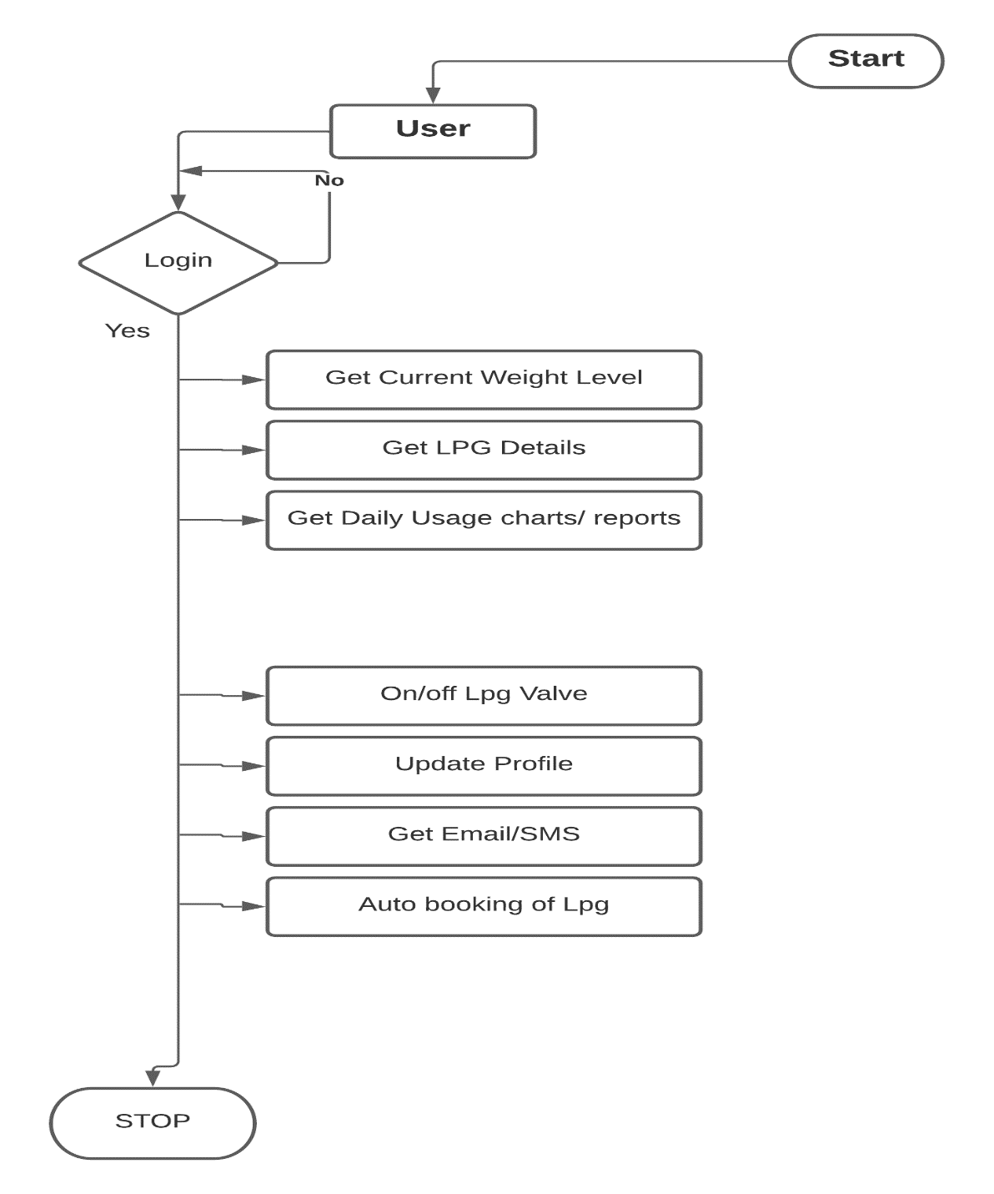

**(4) Prototype**

* **Hardware Prototype**

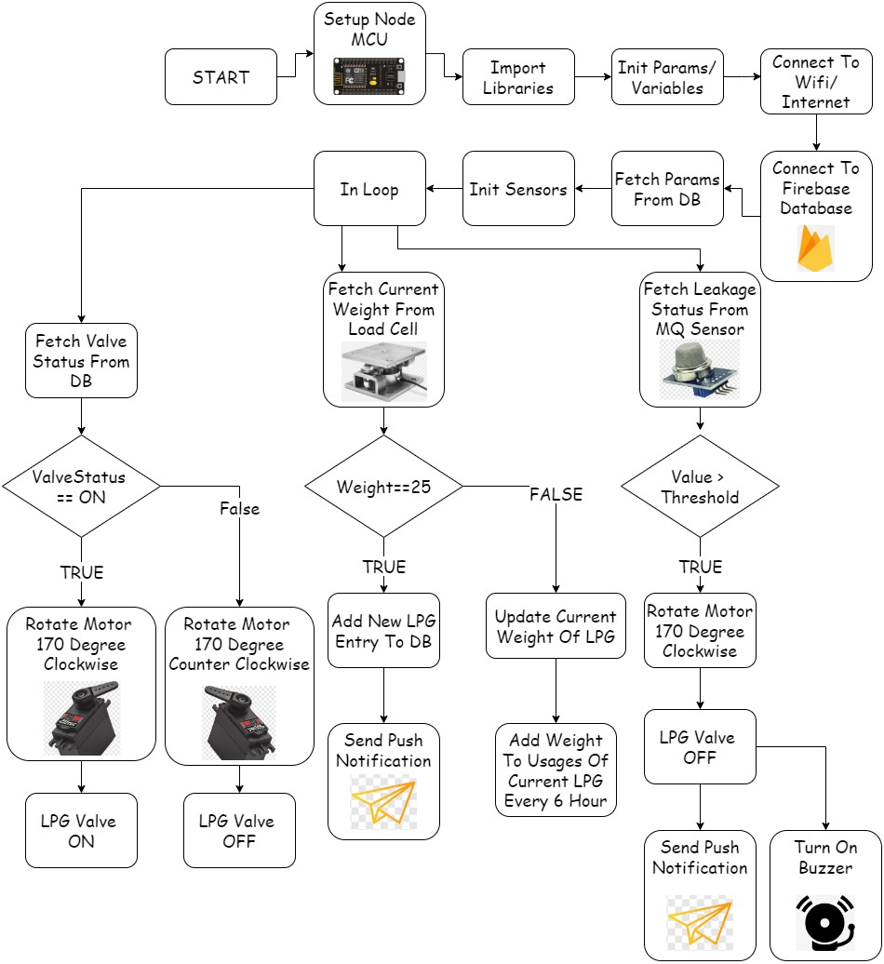

* **Software Prototype**

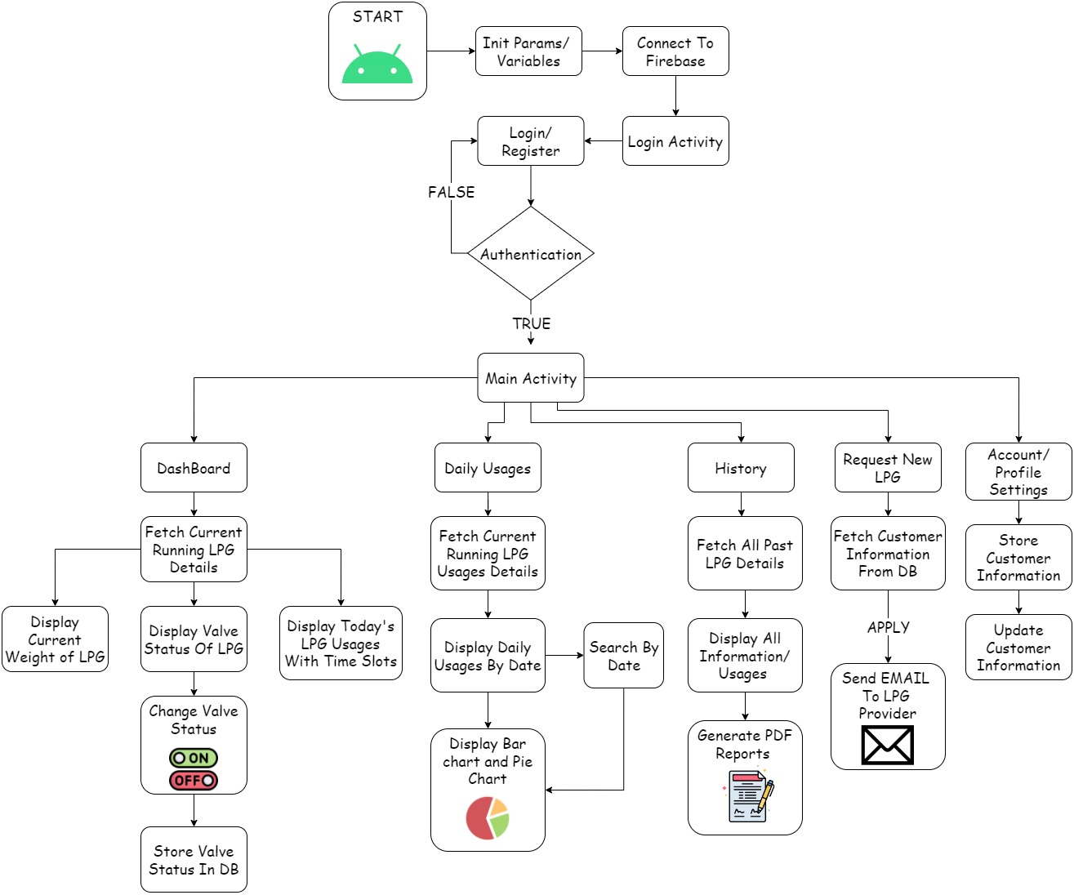

**(5) Implementation/ Simulation**

* **Firebase Database Snapshot**

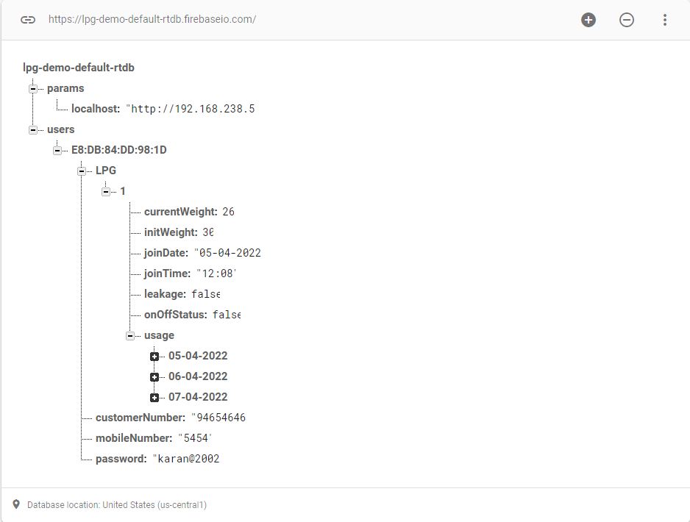

Structure of Firebase Database

* **Hardware Simulation Snapshot**

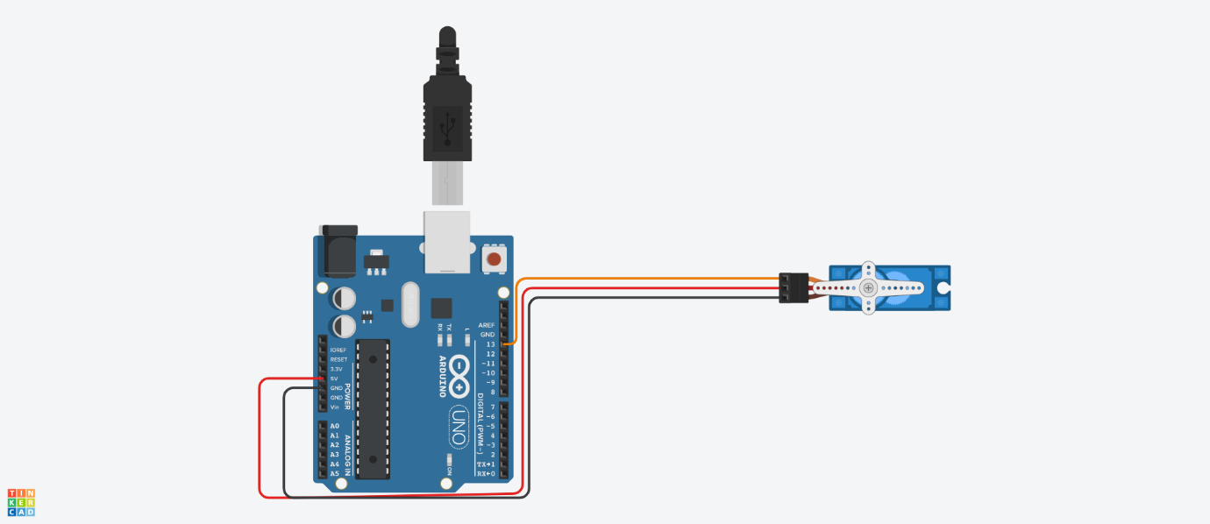

Simulation of **Servo Motor** in Tinkercad

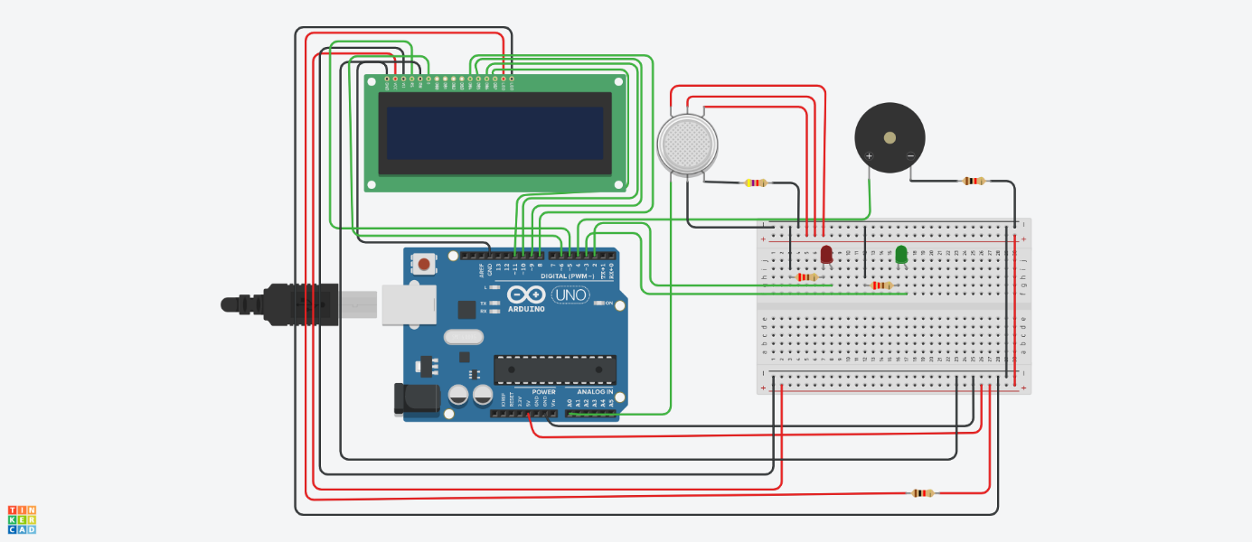

Simulation of **MQ Gas Sensor** and **Buzzer** in Tinkercad

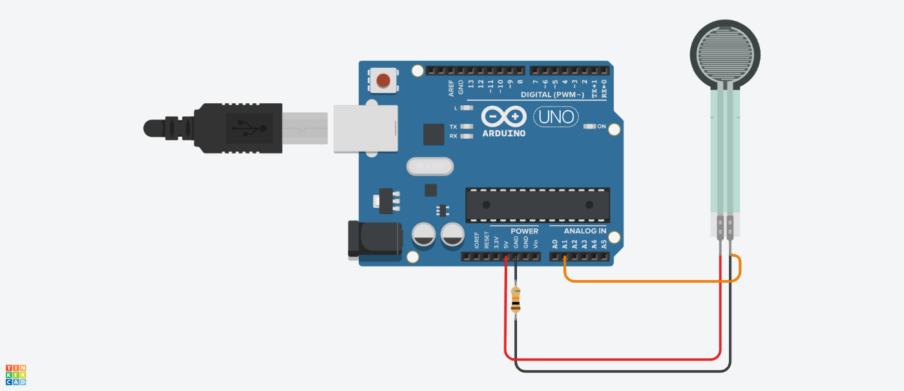

Simulation of **Load Cell Sensor** in Tinkercad

* **Software Simulation Snapshot (Android Application)**

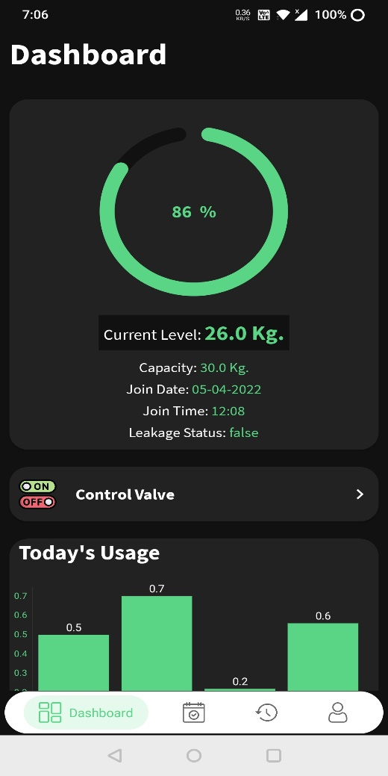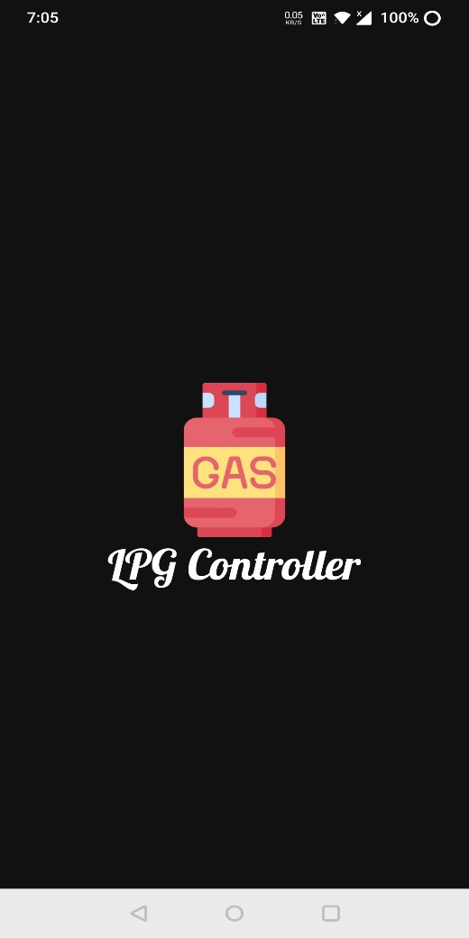

**Splash Screen** of application **Dashboard Screen** of application

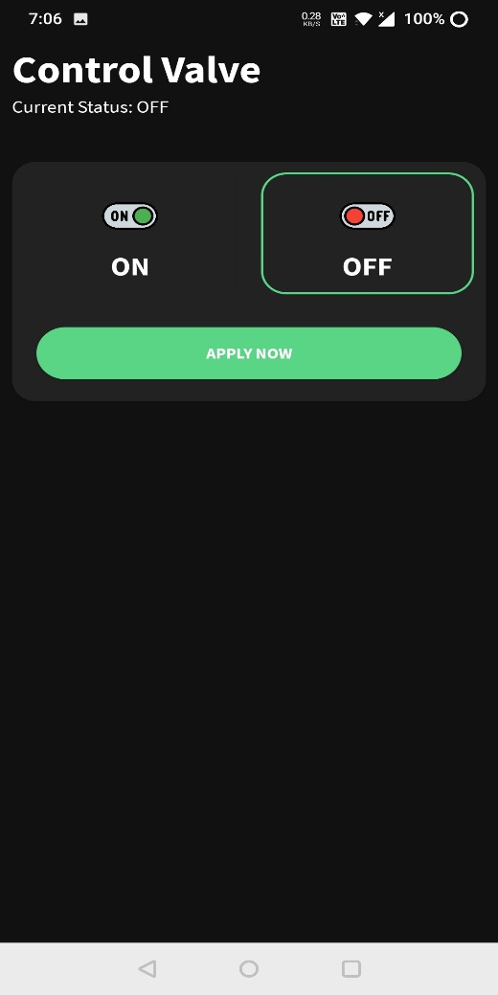

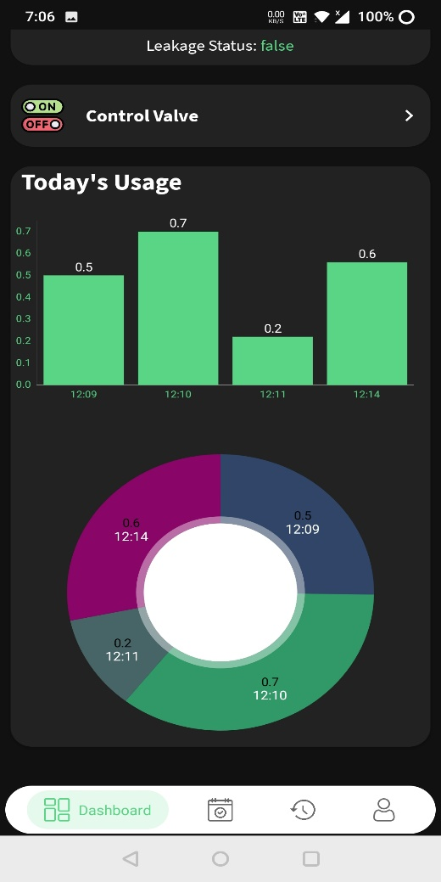

**Dashboard Screen** of application **Valve Control Screen** of application

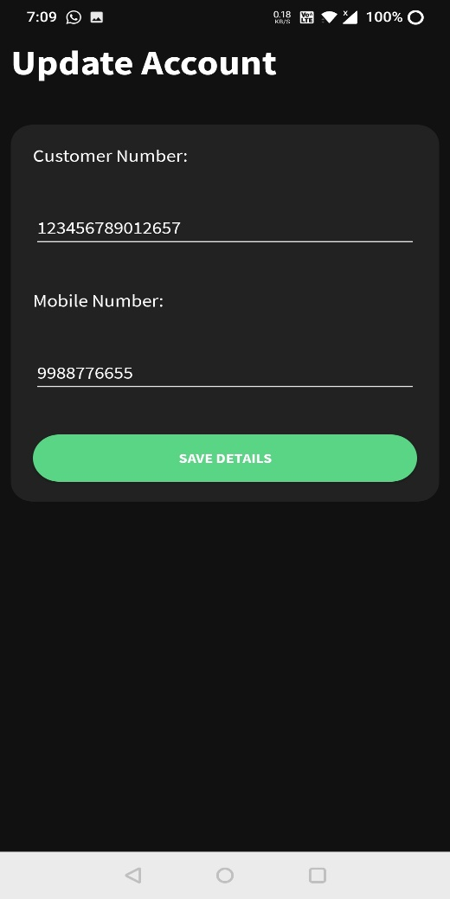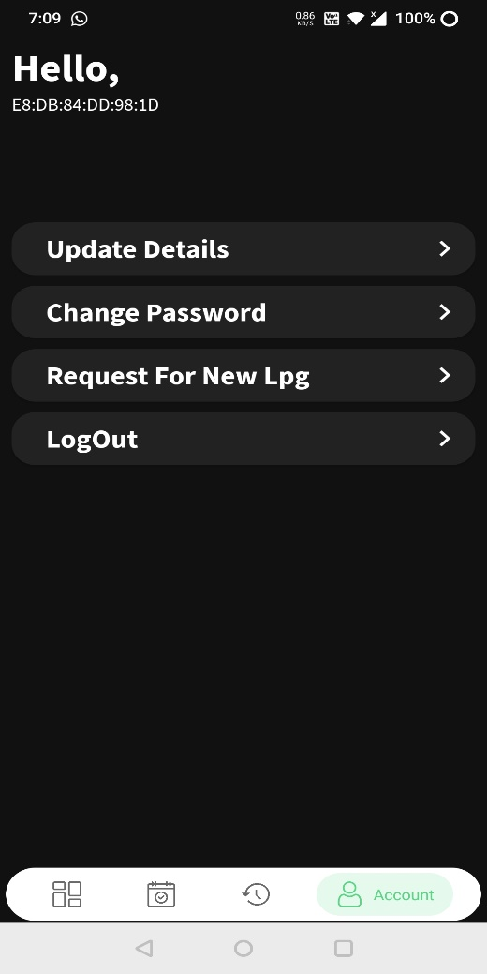 **Settings Screen** of application **Customer Info Update Screen** of application

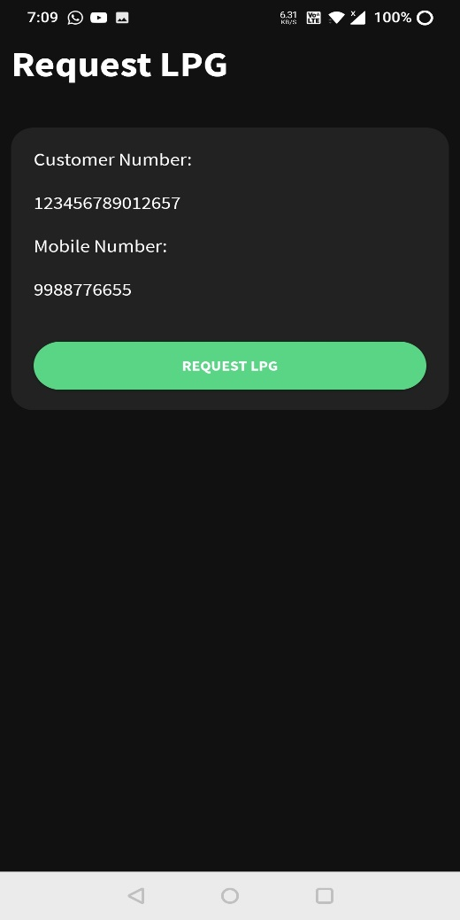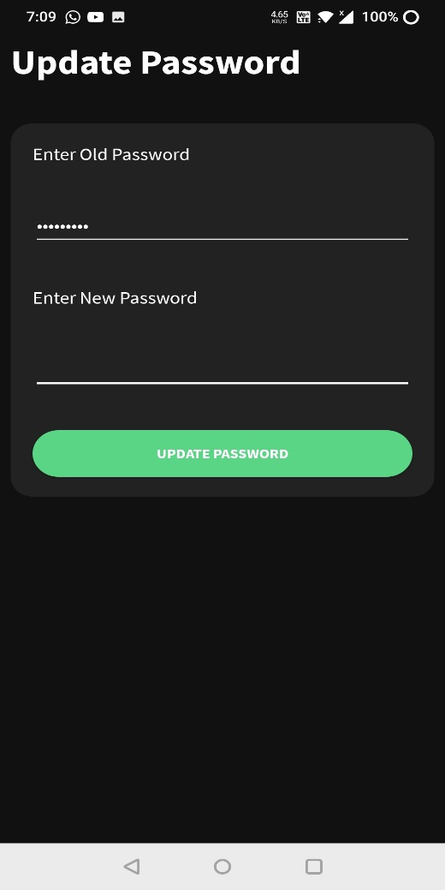

**Update Password Screen** of application **Request/Book New LPG Screen** of application

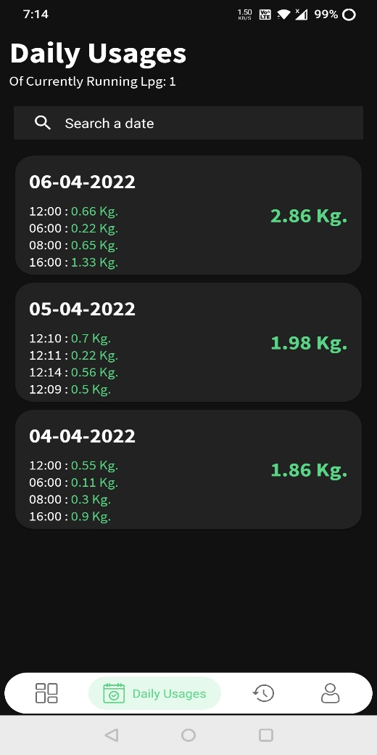

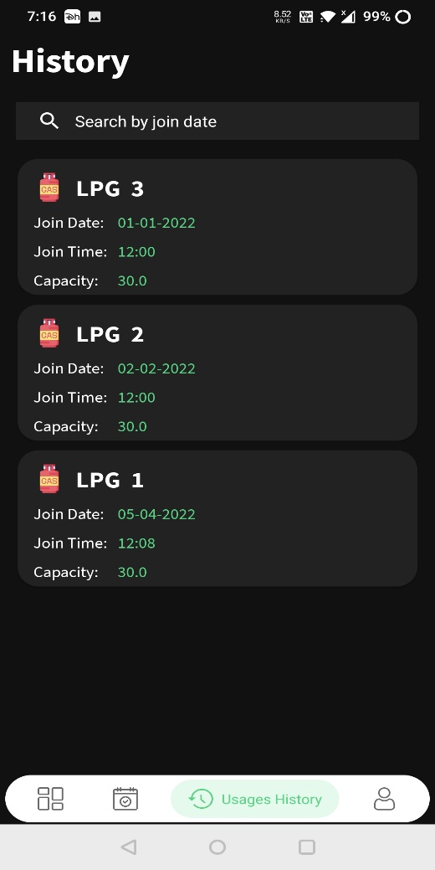

**Daily Usages Screen** of application **History (Past all LPGs) Screen** of application

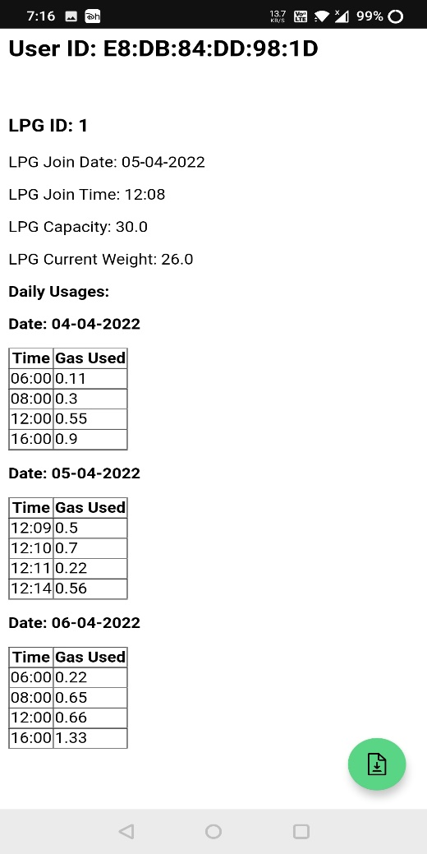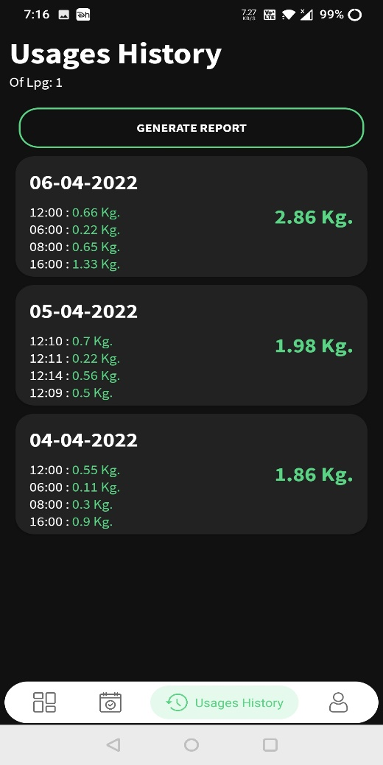

**Usages History of PLG Screen** of application **PDF Report of LPG Screen** of application

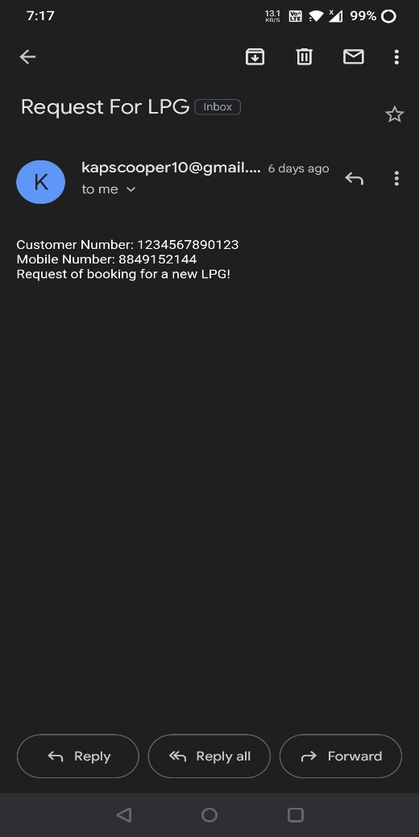

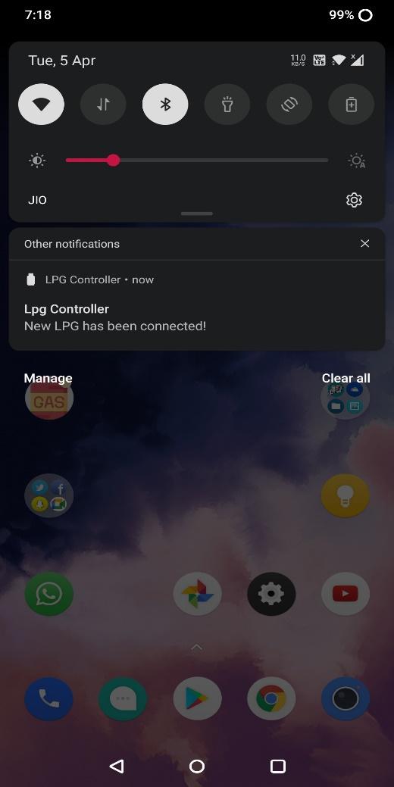

**Request Email** of application **Push Notification** of application

**(6) Analysis and Result Discussion**

* This system is based on Node MCU, MQ Gas Sensor, Load Cell Sensor, Servo Motor, Buzzer and Android application.
* When the gas sensor detects gas in atmosphere, it will give a digital output of 1 and if gas is not detected the sensor will give a digital output of 0.
  + - Node MCU will take the sensor output and if sensor output is high, then the buzzer will start and notification (Gas Leakage has been detected) will be send to Android application.
    - The load cell sensor detects LPG weight, it will give a analog output. Node MCU will take the sensor output and covert into required metric and store into database with date and time.
    - When Node MCU detects valve status on in database it will rotate servo motor 180 degree clockwise to turn on valve and if valve status is detected as off it will rotate servo motor 180 degree counter clockwise.
    - Android application allows user to login/ register themselves.
    - Allows users to get overview of current running LPG
    - Allows users to get Detailed Usages history of LPG as well as report generation.
    - Allows users to control valve with on/off button.
    - Allows users to send Email of new LPG booking

**(7) Conclusion and Future Scope**

* **Conclusion**

The project entitled “LPG Controller/ Monitoring System” was completed successfully. The system has been developed with much care and free of errors and at the same time it is efficient and less time consuming.

The purpose of this project was to develop an android application for monitoring LPG Usages, control LPG valve, Get Leakage notifications, New LPG booking through app, Display charts/ graphs and generate reports of usages.

This project helped us in gaining valuable information and practical knowledge on several topics like designing of responsive pages, designing of android applications, management of database using Firebase, Push notifications and emails, Integration of IOT, and Different kinds of sensors in IOT.

The entire system is secured. Also the project helped us understanding about the development phases of a project and software development life cycle.

We learned how to test different features of a project. This project has given us great satisfaction in having designed an application which can be implemented to any existing LPG systems with great flexibility.

* **Future Scope**
* Implementation of web application to enhance user base.
* Implementation of IOS application to enhance user base.
* Implementation of Machine Learning/ Deep Learning Models to predict future usages.
* Implementation of solution for Gas line users.
* Design Improvements like Dark Mode/ Light Mode.
* Enhancement in sensor integration.

**(8) Reference**

* **Tinkercad IDE**

<https://www.tinkercad.com/dashboard>

* **Arduino/Node MCU IDE**

<https://www.arduino.cc/en/software>

* **Firebase Database**

<https://console.firebase.google.com>

* **Android Studio**

https://developer.android.com/studio

* **XAMPP Server**

https://www.apachefriends.org/index.html

* **PHP**

<https://www.php.net/>

* **Adobe XD**

<https://www.adobe.com/in/products/xd.html>

* **Diagram Net**

<https://app.diagrams.net/>

* **Dribble**

<https://dribbble.com/>

* **Canvases**

https://de.gtu.ac.in/