1. *The project showing that you can view* ***YOUR*** *data tables in pycharm*

1. ***YOUR*** *project running correctly in the browser displaying your homepage with your data*

1. ***YOUR*** *project running correctly in the browser displaying your data record as a view of one record*

1. ***YOUR*** *project running correctly in the browser displaying a new record added to your home page*

(4.1 image)

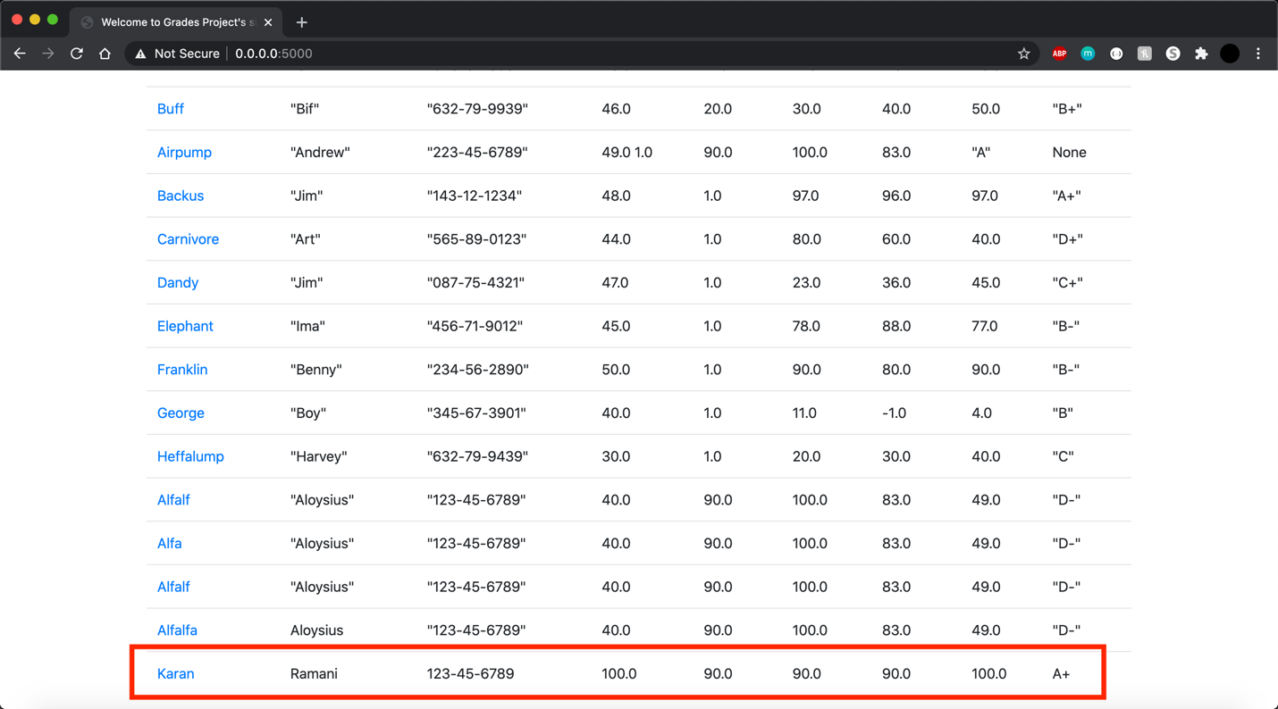

(4.2 image)

1. ***YOUR*** *project running correctly in the browser displaying an updated record added to your home page*

(5.1 image)

(5.2 image)

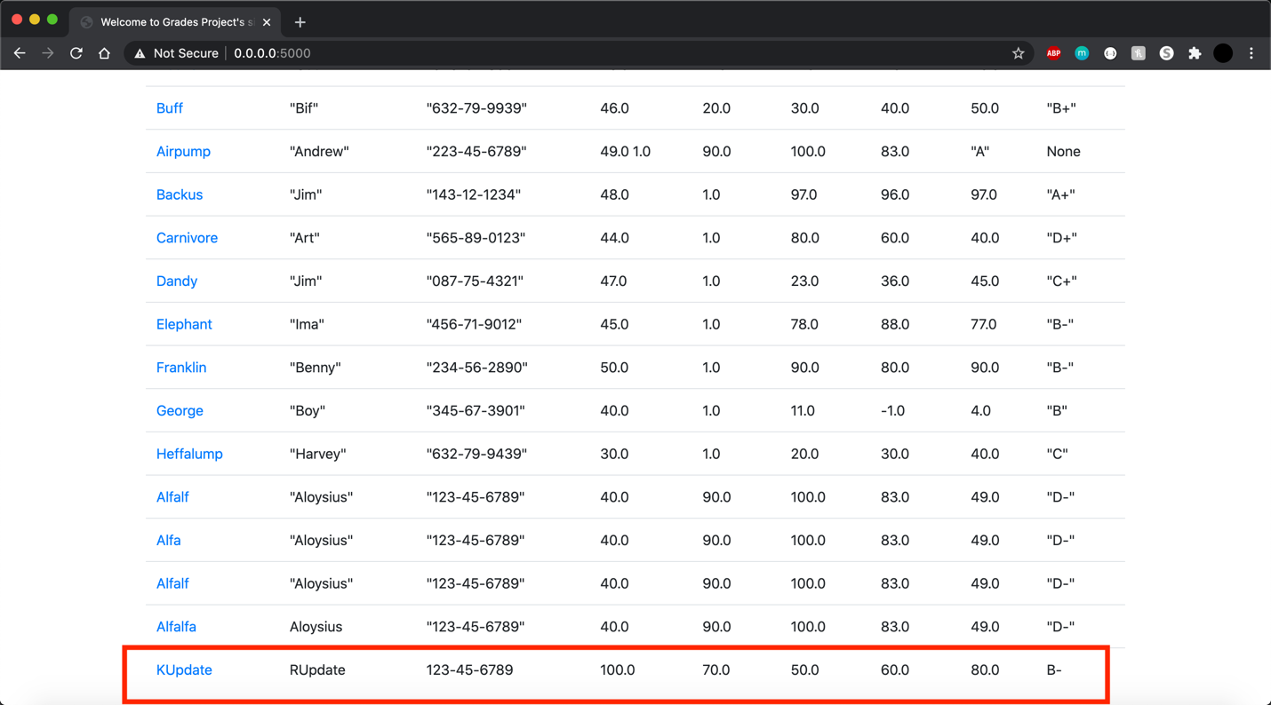

1. ***YOUR*** *project running correctly in the browser displaying a deleted record added to your home page*

