Earthquake prediction using Enhanced Xgboost

# Karan Ravi Nekkalapu Sri Anjan Kumar Y V Jawahar

**Abstract**

Earthquake prediction is a complex and ongo- ing research area aimed at developing meth- ods to forecast the timing and location of fu- ture earthquakes. Despite significant progress, reliable and accurate earthquake prediction re- mains a major challenge due to the complexity and variability of seismic processes. This re- view provides an overview of the current state of earthquake prediction research, including the methods and tools used to collect and ana- lyze seismic data, the key factors that influence earthquake occurrence, and the current limi- tations and challenges of prediction models. Furthermore, this review highlights the poten- tial benefits of accurate earthquake prediction, such as improved disaster preparedness and re- sponse, and enhanced community resilience in earthquake-prone regions. Ultimately, the goal of earthquake prediction research is to reduce the devastating impact of earthquakes and help safeguard lives and infrastructure worldwide.

**Keywords: earthquake prediction, seismic data, disaster preparedness, community re- silience, infrastructure protection.**

# Introduction

The use of machine learning techniques in earth- quake prediction is an exciting development that shows great promise for improving our under- standing of seismic activity and helping to reduce the impact of earthquakes on human lives and in- frastructure.

By leveraging the power of machine learn- ing algorithms, researchers are able to analyze large datasets of seismic and environmental data to identify patterns and anomalies that may indi- cate an impending earthquake. This approach has the potential to provide more accurate and timely earthquake predictions, which can be crucial in

This work is licensed under a Creative Commons Attribution 4.0 International Licence. Licence details: [http://creativecommons.org/licenses/by/4.0/.](http://creativecommons.org/licenses/by/4.0/)

helping to minimize the impact of earthquakes on communities.

Moreover, with the advancement in technol- ogy and data collection methods, the amount and quality of seismic and environmental data are in- creasing rapidly. This provides researchers with a wealth of data that can be used to train and re- fine machine learning models, ultimately leading to more accurate and reliable earthquake predic- tions.

Overall, while there are still challenges and lim- itations that need to be addressed, the use of ma- chine learning techniques in earthquake prediction represents a promising direction for advancing our understanding of seismic activity and improving our ability to mitigate the impact of earthquakes on human lives and infrastructure.

# Literature Survey

1. Machine Learning Methods for Earthquake Pre- diction: A Survey The article ”Machine Learn- ing Methods for Earthquake Prediction: a Sur- vey” presents an overview of the current state of research on the application of machine learning techniques in earthquake prediction. The authors discuss the challenges of earthquake prediction and highlight the potential benefits of using ma- chine learning methods. They provide a compre- hensive review of recent studies that have applied machine learning techniques in earthquake predic- tion, covering a wide range of methods including neural networks, support vector machines, deci- sion trees, and deep learning. The authors also discuss the limitations of current methods and sug- gest possible directions for future research in this area. Overall, the article provides a useful re- source for researchers interested in applying ma- chine learning techniques to earthquake predic- tion.
2. Earthquake magnitude prediction in Hin- dukush region using machine learning techniques

The authors highlight the importance of earth- quake prediction for disaster management and provide an overview of existing methods for earth- quake prediction. The authors then present their new approach, which involves using multiple re- gression analysis and artificial neural networks to predict earthquake magnitudes. They collected data on various parameters such as earthquake lo- cation, depth, and time from the Hindukush region and used these as inputs to their models. The re- sults show that the artificial neural network model outperformed the multiple regression model in terms of accuracy in predicting earthquake mag- nitudes. The authors suggest that their approach could be used as a tool for early warning systems and could potentially help reduce the impact of earthquakes in the region.

1. Machine learning and earthquake forecast- ing—next steps The article reviews recent studies that have applied machine learning techniques to earthquake forecasting and identifies several key areas for future research. These include the need for more accurate and reliable data, the develop- ment of new machine learning algorithms that can handle complex data, and the integration of mul- tiple sources of data. The authors also discuss the importance of transparency and interpretabil- ity in machine learning models, particularly in the context of earthquake forecasting where the consequences of incorrect predictions can be se- vere. They suggest that researchers need to de- velop new methods for explaining how machine learning models arrive at their predictions and for assessing the reliability of those predictions.
2. Earthquake Magnitude Prediction Using Ma- chine Learning Technique The authors note the importance of accurate earthquake prediction for disaster management and highlight the limitations of traditional methods for earthquake prediction. They propose a new approach that uses a support vector regression algorithm to predict earthquake magnitudes based on a set of input parameters, in- cluding earthquake location, depth, and time.

The authors collected data on past earthquakes from the California region and used this data to train and test their model. The results show that their approach outperformed traditional methods of earthquake prediction in terms of accuracy. The article highlights the potential benefits of us- ing machine learning techniques for earthquake prediction, including the ability to process large

amounts of data and to handle complex relation- ships between input parameters. However, the au- thors also note the need for further research to ad- dress issues related to data quality and to improve the interpretability of machine learning models.

1. Machine Learning Predicts Laboratory Earthquakes The authors note that laboratory ex- periments can provide valuable insights into the mechanics of earthquakes, but that predicting when earthquakes will occur during these exper- iments is challenging. The authors propose a new approach that uses a neural network to predict when earthquakes will occur in a laboratory set- ting based on a set of input parameters. They col- lected data from laboratory experiments on rock samples and used this data to train and test their model. The results show that their approach was able to accurately predict when earthquakes would occur during laboratory experiments. The authors suggest that their approach could be used to im- prove the efficiency and safety of laboratory ex- periments and could also help improve our under- standing of the mechanics of earthquakes.
2. Laboratory earthquake forecasting: A ma- chine learning competition The authors note that laboratory experiments can provide valuable in- sights into the mechanics of earthquakes, but that predicting when earthquakes will occur during these experiments is challenging. The authors or- ganized a competition that involved using a dataset of laboratory experiments on rock samples to de- velop machine learning models that could accu- rately predict when earthquakes would occur. The competition attracted participants from a range of backgrounds, including seismology, machine learning, and data science. The results of the com- petition show that several of the models developed by the participants were able to accurately predict when earthquakes would occur during laboratory experiments. The authors suggest that the com- petition could help promote collaboration between the seismology and machine learning communities and could lead to new insights into the mechanics of earthquakes.
3. DLEP: A Deep Learning Model for Earth- quake Prediction.

The authors note that traditional methods of earthquake prediction have limitations, and that machine learning techniques offer a promising al- ternative. The authors propose a new approach that uses a deep learning model to predict earth-

quakes based on a range of input parameters, in- cluding seismic wave velocity and geological fea- tures. They collected data from past earthquakes and used this data to train and test their model.

The results show that their approach was able to accurately predict earthquakes with a high de- gree of accuracy. The authors suggest that their approach could be used to improve the accuracy of earthquake forecasting and could also help to identify regions at higher risk of earthquakes.

Overall, the article presents a promising ap- proach to earthquake prediction using deep learn- ing techniques. The authors highlight the potential of their approach to improve the accuracy of earth- quake forecasting and to enhance our understand- ing of the underlying mechanisms of earthquakes.

1. Towards advancing the earthquake forecast- ing by machine learning of satellite data

The authors note that traditional methods of earthquake prediction have limitations, and that machine learning techniques offer a promising al- ternative. The authors propose a new approach that uses satellite data to predict earthquakes based on a range of input parameters, including ground deformation and changes in soil moisture. They collected data from past earthquakes and used this data to train and test their machine learning model.

The results show that their approach was able to accurately predict earthquakes with a high degree of accuracy, and that it outperformed traditional methods of earthquake prediction. The authors suggest that their approach could be used to im- prove the accuracy of earthquake forecasting and to provide early warnings of potential earthquakes. Overall, the article presents a promising ap-

proach to earthquake prediction using machine learning techniques and satellite data. The au- thors highlight the potential of their approach to improve the accuracy and timeliness of earthquake forecasting, and to enhance our ability to mitigate the impact of earthquakes on society.

1. A Machine-Learning Approach for Earth- quake Magnitude Estimation The paper proposes a novel approach to earthquake magnitude esti- mation using machine learning techniques. Tra- ditional methods for estimating earthquake mag- nitudes rely on manual measurements of vari- ous wave types, such as P-waves and S-waves. However, these measurements are often time- consuming and require expert knowledge.

The authors trained a convolutional neural net-

work (CNN) using waveform data from seismo- graphs to predict the magnitude of an earthquake. The dataset used in the study consisted of over 15,000 earthquakes that occurred in the South- ern California Seismic Network between 2008 and 2017. The CNN was trained to learn the com- plex relationships between the initial ground mo- tion recorded by the seismographs and the corre- sponding earthquake magnitudes.

The results of the study showed that the pro- posed machine learning-based approach outper- formed traditional methods such as using ampli- tude ratios of different wave types. The CNN was able to accurately predict the magnitude of an earthquake with an average absolute error of 0.2, which is comparable to the error of human experts.

The authors note that the proposed method could be useful in earthquake early warning sys- tems, where rapid and accurate magnitude estima- tion is crucial for issuing timely alerts and mini- mizing damage. Additionally, the method could be applied to other seismically active regions and could be extended to predict other earthquake pa- rameters such as depth and location.

1. Analysis of Earthquake Forecasting in In- dia Using Supervised Machine Learning Classi- fiers The paper analyses earthquake forecasting in India using supervised machine learning classi- fiers. The authors collected earthquake data from various sources, including the Indian Meteorologi- cal Department, the United States Geological Sur- vey, and the European-Mediterranean Seismologi- cal Centre. They then used various supervised ma- chine learning algorithms, including decision tree, support vector machine, and random forest, to pre- dict the occurrence of earthquakes in different re- gions of India. The study found that the random forest algorithm performed the best in terms of ac- curacy, with an overall accuracy of 81.6 The study also identified several significant earthquake pre- dictors, including latitude, longitude, depth, and magnitude. The authors noted that the results of the study could be useful in developing early warning systems and disaster management strate- gies in India.

The study also highlighted some of the chal- lenges in earthquake forecasting, including the limited availability and quality of earthquake data, the complex and unpredictable nature of earth- quakes, and the difficulty in identifying reliable predictors. The authors noted that while machine

learning algorithms can provide valuable insights into earthquake forecasting, they should be used in conjunction with other methods and expert knowl- edge to ensure accurate and reliable results.

1. The promise of implementing machine learning in earthquake engineering: A state-of- the-art review The authors highlight the advan- tages of ML over traditional methods in earth- quake engineering, such as the ability to handle large and complex datasets, identify patterns and correlations, and make accurate predictions. They provide examples of ML applications in various areas of earthquake engineering, including seis- mic hazard assessment, structural health monitor- ing, and post-earthquake damage assessment.

The paper also discusses the challenges and lim- itations of implementing ML in earthquake engi- neering, such as the need for high-quality and di- verse datasets, the risk of overfitting, and the diffi- culty of interpreting ML models. The authors sug- gest possible solutions to these challenges, such as using transfer learning and ensemble models, and emphasize the importance of validating and veri- fying ML models using real-world data.

Finally, the paper highlights the potential im- pact of ML in earthquake engineering, such as improving the accuracy and efficiency of seis- mic hazard assessment, enabling real-time struc- tural health monitoring, and facilitating post- earthquake response and recovery efforts. The au- thors conclude that ML has the potential to trans- form earthquake engineering and that further re- search and collaboration are needed to fully real- ize its promise.

1. Applications of machine learning for earth- quake prediction: A review

The paper presents several examples of ML ap- plications in earthquake prediction, including the use of deep learning algorithms to analyze seis- mic wave signals, satellite data, and social media posts for early detection of seismic activity. The authors also highlight the potential of ML in devel- oping probabilistic models for earthquake predic- tion, which can provide more nuanced and proba- bilistic forecasts compared to traditional determin- istic methods.

The paper also discusses the challenges and lim- itations of applying ML to earthquake prediction, such as the limited availability of high-quality and diverse earthquake precursor data and the diffi- culty of interpreting and explaining ML models.

The authors suggest possible solutions to these challenges, such as the use of transfer learning and ensemble models, and emphasize the importance of validating and verifying ML models using real- world data.

Finally, the paper highlights the potential im- pact of ML in earthquake prediction, such as im- proving our ability to issue timely and accurate earthquake warnings, enabling more effective dis- aster response and mitigation efforts, and ulti- mately reducing the human and economic toll of earthquakes. The authors conclude that ML has the potential to revolutionize earthquake predic- tion, but further research and collaboration are needed to overcome the remaining challenges and fully realize its potential.

1. Analysis and Prediction of Earthquake Impact-a Machine Learning approach

The paper applies these algorithms to a dataset of earthquake impact indicators, such as the mag- nitude, depth, location, and time of occurrence, as well as the number of casualties, injuries, and damages caused by the earthquake. The authors use these indicators to develop models for predict- ing the impact of future earthquakes.

The paper also presents a feature selection method based on the correlation between the im- pact indicators, which helps to identify the most relevant features for the ML models. The authors compare the performance of the different ML al- gorithms and feature selection methods and show that RF and GBM outperform the other algorithms in terms of accuracy and robustness.

Finally, the paper discusses the potential ap- plications of the ML models in earthquake risk assessment and management, such as identify- ing vulnerable areas and populations, optimizing emergency response plans, and informing policy decisions. The authors conclude that ML has the potential to improve our understanding and predic- tion of earthquake impact and that further research and collaboration are needed to fully realize its po- tential.

1. Earthquake risk assessment in NE India us- ing deep learning and geospatial analysis

The paper applies these algorithms to a dataset of earthquake-related geospatial features, includ- ing topographic and geologic information, as well as historical earthquake occurrence data. The au- thors use these features to develop models for pre- dicting the likelihood and impact of future earth-

quakes in Northeast India.

The paper also discusses the use of remote sens- ing data, such as satellite imagery, to enhance the geospatial analysis and improve the accuracy of the ML models. The authors show that the combi- nation of deep learning and geospatial analysis can significantly improve the accuracy of earthquake risk assessment compared to traditional methods.

Finally, the paper discusses the potential ap- plications of the ML models in earthquake risk management, such as informing land-use planning and building codes, optimizing disaster response plans, and improving public awareness and pre- paredness. The authors conclude that deep learn- ing and geospatial analysis have the potential to revolutionize earthquake risk assessment and man- agement, but further research and collaboration are needed to fully realize their potential.

1. The article ”Predicting the magnitude of an impending earthquake using deep learning tech- niques” proposes a deep learning model to pre- dict the magnitude of an impending earthquake. The researchers used a dataset of seismic signals recorded by a network of sensors to train and vali- date the model. They used several tools such as the Keras deep learning library and Google Colabora- tory for implementing and testing the model.

The evaluation of the model was done using several metrics such as mean squared error, mean absolute error, and coefficient of determination. The results showed that the proposed model could accurately predict the magnitude of an impend- ing earthquake with high accuracy. However, there were some limitations, including the limited dataset size, and the fact that the model could only predict the magnitude and not the exact location of the earthquake.

The future scope of this work includes the ex- pansion of the dataset, incorporating more fea- tures, and developing a model to predict the exact location of the earthquake. This research could po- tentially lead to the development of early warning systems for earthquakes, which could help miti- gate the devastating effects of earthquakes on hu- man lives and infrastructure.

1. The article ”Artificial intelligence-based real-time earthquake prediction” proposes an AI- based method for real-time earthquake prediction. The researchers used a dataset of seismic signals collected from 84 stations in the southern part of Japan to train and validate the model. They used

several tools such as the Keras deep learning li- brary and TensorFlow for implementing and test- ing the model.

The evaluation of the model was done using several metrics such as receiver operating charac- teristic curve, precision, recall, and F1 score. The results showed that the proposed model could ac- curately predict the occurrence of an earthquake in real-time with high accuracy. However, there were some limitations, including the need for high com- putational power and the inability of the model to predict the exact location of the earthquake.

The future scope of this work includes expand- ing the dataset, incorporating more features, and improving the model’s ability to predict the ex- act location of the earthquake. This research could potentially lead to the development of effec- tive early warning systems for earthquakes, which could help minimize the loss of human lives and damage to infrastructure. The proposed AI-based approach could be integrated with other existing earthquake prediction techniques to improve the accuracy and effectiveness of earthquake predic- tion.

1. The article ”Earthquake magnitude predic- tion using a VMD-BP neural network model” pro- poses a method for earthquake magnitude predic- tion using a combination of the variational mode decomposition (VMD) technique and the back- propagation (BP) neural network. The researchers used a dataset of seismic signals collected from 21 stations in China to train and validate the model. They used several tools such as MATLAB and Python for implementing and testing the model.

The evaluation of the model was done using several metrics such as mean absolute error, mean squared error, and correlation coefficient. The re- sults showed that the proposed model could accu- rately predict the magnitude of an earthquake with high accuracy. However, there were some limita- tions, including the need for a larger dataset and the inability of the model to predict the exact loca- tion of the earthquake.

The future scope of this work includes expand- ing the dataset, incorporating more features, and improving the model’s ability to predict the exact location of the earthquake. This research could po- tentially lead to the development of effective early warning systems for earthquakes, which could help minimize the loss of human lives and damage to infrastructure. The proposed VMD-BP neural

network model could also be applied to other ar- eas of earthquake research such as seismic hazard assessment and earthquake engineering.

1. The article ”Immune optimization inspired artificial natural killer cell earthquake prediction method” proposes a novel method for earthquake prediction inspired by the immune system’s nat- ural killer cells. The researchers used a dataset of seismic signals collected from three stations in China to train and validate the model. They used several tools such as MATLAB for implementing and testing the model.

The evaluation of the model was done using several metrics such as sensitivity, specificity, ac- curacy, and area under the receiver operating char- acteristic curve. The results showed that the pro- posed model could accurately predict the occur- rence of an earthquake with high accuracy. How- ever, there were some limitations, including the need for a larger dataset and the inability of the model to predict the exact location of the earth- quake.

The future scope of this work includes expand- ing the dataset, incorporating more features, and improving the model’s ability to predict the exact location of the earthquake. This research could po- tentially lead to the development of effective early warning systems for earthquakes, which could help minimize the loss of human lives and damage to infrastructure. The proposed immune optimiza- tion inspired artificial natural killer cell earthquake prediction method could also be applied to other areas of research in geosciences, such as volcanic activity prediction and tsunami warning systems.

1. The article ”Deep learning for laboratory earthquake prediction and autoregressive fore- casting of fault zone stress” proposes a deep learning-based method for predicting laboratory earthquakes and autoregressive forecasting of fault zone stress. The researchers used a dataset of seis- mic signals collected from laboratory experiments to train and validate the model. They used several tools such as Python and TensorFlow for imple- menting and testing the model.

The evaluation of the model was done using several metrics such as precision, recall, F1 score, and receiver operating characteristic curve. The results showed that the proposed model could accurately predict the occurrence of laboratory earthquakes with high accuracy and effectively forecast the fault zone stress. However, there were

some limitations, including the lack of field data and the need for further testing.

The future scope of this work includes expand- ing the dataset, incorporating more features, and improving the model’s accuracy and effective- ness in predicting real-world earthquakes. This research could potentially lead to the develop- ment of effective early warning systems for earth- quakes, which could help minimize the loss of hu- man lives and damage to infrastructure. The pro- posed deep learning-based approach could also be applied to other areas of research in geosciences, such as volcanic activity prediction, weather fore- casting, and climate modeling.

1. The article ”A location-dependent earth- quake prediction using recurrent neural network algorithms” proposes a novel method for earth- quake prediction using recurrent neural network (RNN) algorithms that takes into account the lo- cation of the earthquake. The researchers used a dataset of seismic signals collected from multiple stations in Japan to train and validate the model. They used several tools such as Python and Ten- sorFlow for implementing and testing the model.

The evaluation of the model was done using several metrics such as accuracy, precision, re- call, and F1 score. The results showed that the proposed model could accurately predict the oc- currence of earthquakes with high accuracy while taking into account the location of the earthquake. However, there were some limitations, including the need for more comprehensive data and the in- ability to predict the exact magnitude of the earth- quake.

The future scope of this work includes expand- ing the dataset, incorporating more features, and improving the model’s ability to predict the mag- nitude of the earthquake. This research could po- tentially lead to the development of effective early warning systems for earthquakes that take into ac- count the location of the earthquake. The pro- posed RNN-based approach could also be applied to other areas of research in geosciences, such as volcanic activity prediction and tsunami warning systems.

1. The article ”An attention-based LSTM net- work for large earthquake prediction” proposes an attention-based long short-term memory (LSTM) network for large earthquake prediction. The re- searchers used a dataset of seismic signals col- lected from multiple stations in Japan to train and

validate the model. They used several tools such as Python and TensorFlow for implementing and testing the model.

The evaluation of the model was done using several metrics such as accuracy, precision, re- call, and F1 score. The results showed that the proposed model could accurately predict the oc- currence of large earthquakes with high accuracy. The attention mechanism improved the model’s performance by focusing on the most relevant fea- tures in the seismic data.

However, there were some limitations, includ- ing the need for a larger dataset and the inability to predict the exact location of the earthquake. The future scope of this work includes expanding the dataset, incorporating more features, and improv- ing the model’s ability to predict the exact location of the earthquake.

This research could potentially lead to the de- velopment of effective early warning systems for earthquakes, which could help minimize the loss of human lives and damage to infrastructure. The proposed attention-based LSTM network could also be applied to other areas of research in geosciences, such as volcanic activity prediction, weather forecasting, and climate modeling.

1. The article ”Earthquakes magnitude predic- tion using deep learning for the Horn of Africa” proposes a deep learning-based method for pre- dicting earthquake magnitudes in the Horn of Africa. The researchers used a dataset of seismic signals collected from multiple stations in the re- gion to train and validate the model. They used several tools such as Python and TensorFlow for implementing and testing the model.

The evaluation of the model was done us- ing several metrics such as mean absolute error and root mean square error. The results showed that the proposed model could accurately predict the magnitude of earthquakes with high accuracy. However, there were some limitations, including the need for more comprehensive data and the in- ability to predict the exact location of the earth- quake.

The future scope of this work includes expand- ing the dataset, incorporating more features, and improving the model’s ability to predict the exact location of the earthquake. This research could po- tentially lead to the development of effective early warning systems for earthquakes in the Horn of Africa.

1. The article ”Time series temperature anoma- lies for earthquake prediction using remote sens- ing techniques: A case study of five major earth- quakes in Pakistan’s history” proposes a remote sensing-based method for predicting earthquakes by analyzing temperature anomalies in the region. The researchers used remote sensing data from satellite images to analyze temperature changes before five major earthquakes in Pakistan. They used several tools such as MATLAB and ArcGIS for data processing and analysis.

The evaluation of the method was done us- ing the temperature anomaly time series, and the results showed a significant correlation between temperature changes and earthquake occurrences. The future scope of this work includes expand- ing the dataset and improving the accuracy of the method by incorporating other features and data sources.

This research could potentially lead to the de- velopment of effective early warning systems for earthquakes in the region, helping to minimize the loss of human lives and damage to infrastructure.

1. The article ”A matrix-variate Dirichlet pro- cess to model earthquake hypocenter temporal patterns” proposes a new approach to model earth- quake temporal patterns. The researchers used earthquake hypocenter data obtained from the Japan Meteorological Agency to validate their proposed method. They used several tools such as Python and Stan for implementing and testing the model.

The evaluation of the model was done using several metrics, including log likelihood and pre- dictive checks. The results showed that the pro- posed model could accurately capture the tempo- ral patterns of earthquake hypocenters. However, there were some limitations, including the need for more comprehensive data and the inability to pre- dict the magnitude of the earthquake.

The future scope of this work includes expand- ing the dataset, incorporating more features, and improving the model’s ability to predict earth- quake magnitude. This research could potentially lead to a better understanding of earthquake tem- poral patterns and the development of more accu- rate earthquake forecasting models.

1. The article ”Global versus local clustering of seismicity: Implications with earthquake predic- tion” explores the differences between global and local clustering of seismic activity and their impli-

cations for earthquake prediction. The researchers used seismic data from the ANSS Comprehensive Earthquake Catalog to analyze global and local clustering of seismicity. They used several tools, including Python, MATLAB, and R, for data pro- cessing and analysis.

The evaluation of the study was done using sev- eral metrics, including b-value and fractal dimen- sion. The results showed that global clustering of seismic activity was less predictable than local clustering. However, local clustering patterns can be useful in predicting future earthquakes in the region.

The future scope of this work includes expand- ing the dataset and improving the understanding of the underlying mechanisms of seismic activity clustering. This research could potentially lead to the development of more accurate earthquake forecasting models, improving our ability to pre- dict and mitigate earthquake hazards.

1. The article ”Medium-Term Earthquake Forecast Method Map of Expected Earthquakes: Results and Prospects” describes a medium-term earthquake forecast method that produces a map of expected earthquakes. The researchers used data from the Japan Meteorological Agency to test their method. They used several tools, including a computational grid and statistical methods, to create the earthquake forecast map.

The evaluation of the method was done using several metrics, including the number of earth- quakes observed in the forecasted area and the ac- curacy of the forecasted time period. The results showed that the method produced reasonably ac- curate earthquake forecasts.

The future scope of this work includes improv- ing the accuracy of the forecasts, expanding the dataset, and incorporating more advanced statisti- cal methods. This research could potentially lead to the development of more accurate earthquake forecasting models, improving our ability to pre- dict and mitigate earthquake hazards.

1. The article ”Analysis of positive correlation in magnitude and time measurement for earth- quake using electric signals” explores the relation- ship between earthquake magnitude and the elec- tric signals generated by earthquakes. The re- searchers used data collected by the Kuramae Ob- servatory in Japan to analyze the relationship.

The researchers used several tools, including a seismometer and an electric field meter, to collect

data on seismic activity and electric signals. They then used statistical methods to analyze the data and identify correlations between earthquake mag- nitude and electric signals.

The evaluation of the study was done using sev- eral metrics, including the correlation coefficient between earthquake magnitude and electric sig- nals. The results showed a positive correlation be- tween earthquake magnitude and electric signals, which could potentially be useful in predicting fu- ture earthquakes.

The future scope of this work includes ex- panding the dataset, improving the accuracy of the measurements, and developing more advanced statistical models to analyze the data. This re- search could potentially lead to the development of more accurate earthquake forecasting models, improving our ability to predict and mitigate earth- quake hazards.

1. The article ”Earthquake Genesis and Earth- quake Early Warning Systems: Challenges and a Way Forward” discusses the challenges in earth- quake prediction and early warning systems, and proposes a way forward to address these chal- lenges. The researchers used existing literature and their own expertise in the field to analyze the current state of earthquake early warning systems and identify areas for improvement.

The researchers did not use any specific tools or data sets, as the article is more of a review of existing research and a proposal for future re- search. The metrics used were more qualitative, such as identifying key challenges and proposing solutions.

The main drawback identified is the lack of reli- able and accurate earthquake prediction and early warning systems. The future scope of this work includes further research and development of new technologies and methods to improve earthquake prediction and early warning systems, as well as increasing public awareness and preparedness for earthquakes.

1. The article ”Structural recurrent neural net- work models for earthquake prediction” proposes a novel deep learning approach for earthquake pre- diction using structural recurrent neural network (SRNN) models. The authors used data from seis- mic sensors to train the SRNN models and evalu- ate their performance using metrics such as accu- racy and F1-score.

The main tool used in this study is the SRNN

model, which is a type of recurrent neural network that can handle structured input data. The data set used consists of seismic signals from multiple sen- sors, and the metrics used include accuracy and F1-score.

The main drawback of this study is the limited availability of high-quality seismic data for train- ing the SRNN models. The future scope of this work includes expanding the data set and further improving the performance of the SRNN mod- els for earthquake prediction, as well as exploring other deep learning approaches for this task.

1. The article ”Approach to Systematic Pre- diction of Earthquakes” presents a systematic ap- proach for earthquake prediction based on the analysis of seismological data. The authors used a combination of statistical and machine learning methods, including principal component analysis and decision tree analysis, to identify patterns and anomalies in the seismic data.

The main tools used in this study are statisti- cal and machine learning methods such as prin- cipal component analysis and decision tree anal- ysis. The data set used consists of seismological data from multiple sources, and the metrics used include accuracy and precision.

The main drawback of this study is the limited availability of high-quality seismological data, es- pecially in developing countries. The future scope of this work includes developing more accurate and reliable methods for earthquake prediction based on a larger and more diverse data set.

1. The article ”Introducing macrophages to ar- tificial immune systems for earthquake prediction” proposes a new approach to earthquake prediction based on the behavior of macrophages in the hu- man immune system. The researchers applied ar- tificial immune system algorithms to identify pat- terns in seismic data and used them to make pre- dictions about future earthquakes. The approach was tested on a dataset of earthquake events in Japan and achieved promising results in terms of prediction accuracy. The article also discusses the drawbacks of the current approach, such as the lack of understanding of the physical processes be- hind earthquakes, and suggests possible future re- search directions, such as incorporating additional features into the model and applying the approach to other regions.
2. The article proposes a new method for earth- quake prediction using very low frequency (VLF)

radio signals and ultra-low frequency (ULF) emis- sions observations. The authors have utilized data from different regions across the globe, including Japan, China, and Taiwan. The proposed method involves analyzing VLF radio signals and ULF emissions before and after an earthquake to iden- tify patterns and signals that may indicate an im- pending earthquake. The metrics used to evaluate the effectiveness of the proposed method are the root mean square error and the mean absolute per- centage error. The main drawback of the proposed method is that it requires a significant amount of data, and the data collection process can be time- consuming and costly. The future scope of this method includes improving the accuracy of earth- quake prediction by incorporating additional data sources and utilizing advanced machine learning algorithms. Additionally, the authors suggest that this method can be used in combination with other earthquake prediction methods for more accurate and reliable results.

1. The article presents a study on predicting the magnitude of earthquakes along the East Anato- lian Fault (EAF) in Turkey using time-series anal- ysis. The researchers used data from 31 seismo- graphic stations located along the EAF from 2009 to 2018. The study used Autoregressive Integrated Moving Average (ARIMA), Seasonal Autoregres- sive Integrated Moving Average (SARIMA), and Autoregressive Integrated Moving Average with Exogenous Variables (ARIMAX) models to pre- dict the earthquake magnitude. The performance of the models was evaluated using mean absolute error (MAE) and root mean square error (RMSE) metrics. The results showed that the ARIMA and SARIMA models were better at predicting the earthquake magnitude compared to the ARIMAX model. The study also revealed that the time- series models could predict the earthquake mag- nitude up to one week in advance. However, the study has limitations in terms of using only a sin- gle type of earthquake magnitude (moment mag- nitude) and only considering data from one spe- cific fault in Turkey. Therefore, the future scope of the study could involve expanding the analysis to other faults and considering other types of mag- nitude.
2. The article proposes a new methodology for earthquake magnitude prediction using geomor- phological indicators. The authors used digital el- evation models, geological maps, and satellite im-

ages to identify indicators such as surface rough- ness and river gradient changes. They applied statistical analyses to determine the correlation between the identified indicators and earthquake magnitudes. The dataset used in the study in- cludes earthquake records and geospatial data for Cao Bang Province and adjacent areas in Vietnam. The evaluation metrics used to assess the model’s performance include the R-squared coefficient and the root-mean-square error. The drawbacks of this work include the limited dataset size and the need for further validation of the proposed method. Fu- ture research may focus on the application of the proposed methodology to other regions and the in- corporation of additional data sources such as seis- mic wave recordings to enhance the prediction ac- curacy.

1. The article proposes an integrated frame- work for smart earthquake prediction using the In- ternet of Things (IoT), fog computing, and cloud computing. The framework aims to improve earth- quake prediction accuracy and response times by utilizing various sensors, such as seismometers, GPS, and accelerometers, to collect data and ana- lyze it in real-time. The collected data is processed using machine learning algorithms, such as artifi- cial neural networks and support vector machines, to identify patterns and predict earthquakes. The performance of the proposed framework is eval- uated using metrics such as accuracy, precision, recall, and F1-score. However, the article doesn’t discuss any drawbacks or limitations of the pro- posed framework. Future scope of the framework includes integrating more sensors, deploying edge devices, and improving the machine learning al- gorithms for more accurate predictions. The pro- posed framework can be helpful in early warning systems and disaster management.
2. The article presents a deep learning-based approach for laboratory earthquake prediction, which combines convolutional neural networks (CNNs) and long short-term memory (LSTM) net- works. The researchers used a laboratory setup to generate the earthquake data and used a large set of experiments for training and testing the model. The performance of the model was evaluated us- ing metrics such as accuracy, precision, and recall. The results showed that the proposed model could predict the occurrence and magnitude of labora- tory earthquakes accurately and with high confi- dence. The authors also discussed the limitations

of the proposed method, such as the small size of the training dataset and the potential difficulty in generalizing the model to real-world scenarios. In the future, the researchers plan to investigate the performance of the proposed method on real earth- quake data and explore ways to improve the gen- eralization capability of the model.

1. The article ”Some Causes of Inaccuracies of Short-Term Earthquake Prediction Taking into Account Laboratory Modeling” discusses the lim- itations of laboratory modeling in predicting short- term earthquakes. The study examines the factors that can affect the accuracy of earthquake predic- tion, such as the heterogeneity of the model, the presence of stress concentrations, and the bound- ary conditions used. The researchers used a labo- ratory model consisting of an aluminum plate and an optical measurement system to simulate earth- quake fault behavior. The study used metrics such as stress accumulation, time to failure, and failure mode to evaluate the accuracy of earthquake pre- dictions. The limitations of the study include the simplification of the laboratory model and the in- ability to accurately simulate the complex geolog- ical conditions of actual earthquakes. The future scope of the research involves further exploration of the impact of different factors on the accuracy of short-term earthquake prediction, as well as the development of more sophisticated laboratory models that can better mimic the conditions of ac- tual earthquakes.
2. The article proposed an integrated frame- work to predict earthquakes along the Chaman fault in Baluchistan using support vector regres- sion and hybrid neural network models. The re- searchers collected data on historical earthquakes in the region, geological characteristics, and fault geometry. They used this data to train and val- idate their models, and they evaluated the per- formance of the models using statistical metrics such as mean absolute error and correlation coef- ficient. The proposed models achieved high accu- racy in predicting earthquake magnitude, location, and time of occurrence. However, the article ac- knowledged the limitations of the study, including the lack of complete earthquake data and the need for further testing and validation. Future research may involve incorporating additional data sources and refining the models to improve their accuracy and reliability.
3. The article discusses the community/public

approach to earthquake forecasting in China using big data. The study analyzes the challenges asso- ciated with traditional earthquake prediction meth- ods and proposes a new approach that involves public participation in earthquake forecasting us- ing big data. The study highlights the importance of involving the public in earthquake forecasting by leveraging social media and big data analytics to gather real-time information. The authors pro- pose the use of machine learning and data mining techniques to analyze the data and identify pat- terns that could predict future earthquakes. The study provides insights into the potential benefits of involving the public in earthquake forecasting and highlights the need for more research to de- velop more effective earthquake prediction mod- els. The authors also discuss the challenges of im- plementing this approach and propose strategies to overcome them. Overall, the study provides valuable insights into the potential of big data and community involvement in earthquake prediction. 40.The article ”Investigating the application of artificial intelligence for earthquake prediction in Terengganu” discusses the use of artificial intel- ligence (AI) techniques for earthquake prediction in Terengganu, Malaysia. The authors used a dataset of historical earthquake occurrences and environmental factors such as temperature, humid- ity, and air pressure to train AI models. The per- formance of several models, including artificial neural networks, decision trees, and support vec- tor machines, were evaluated using metrics such as accuracy, sensitivity, and specificity. The draw- backs of the study include the small dataset size and the lack of information on other factors that may influence earthquakes. The authors suggest that incorporating additional environmental and geological data, as well as developing more ad- vanced AI models, could improve the accuracy of

earthquake prediction in the future.

# Enhanced Xgboost

* 1. Datset collection
  2. Training the ML model with our Enhanced Xgboost algorithm algorithms mentioned in the above steps.
  3. Using the model with least Root Mean Squared Error(RMSE) value
  4. XGBoost (eXtreme Gradient Boosting) is an open-source, gradient boosting framework

that is widely used for machine learning tasks, particularly in competitions and real- world applications. It was developed by Tianqi Chen and is known for its high per- formance and accuracy.

LightGBM (Light Gradient Boosting Ma- chine) is an open-source, gradient boosting framework that is designed to efficiently han- dle large datasets and achieve high perfor- mance in terms of accuracy and speed. It was developed by Microsoft and is widely used in machine learning competitions and real- world applications.

Gradient boosting is a popular machine learn- ing technique that combines the predictions of multiple weak predictive models, usually decision trees, to create a stronger predic- tive model. It is an iterative algorithm that sequentially builds a series of models, with each subsequent model correcting the errors of the previous models.

Random Forest is a popular ensemble ma- chine learning technique that combines the predictions of multiple decision trees to cre- ate a more accurate and robust predictive model. It was proposed by Leo Breiman and Adele Cutler and is widely used for clas- sification, regression, and feature selection tasks.

RANSAC (RANdom SAmple Consensus) is an iterative algorithm used for robust estima- tion in computer vision, image processing, and machine learning. It was introduced by Martin Fischler and Robert Bolles in 1981 and is commonly used for fitting models to data with outliers or noise.

* 1. Datset collection
  2. Training the ML model with our Enhanced Xgboost algorithm algorithms mentioned in the above steps.
  3. Using the model with least Root Mean Squared Error(RMSE) value
  4. Creating a front end application using HTML
  5. Deploying ML model using PHP at the back end
  6. Displaying the output using google map ser- vices

# Architecture Diagram

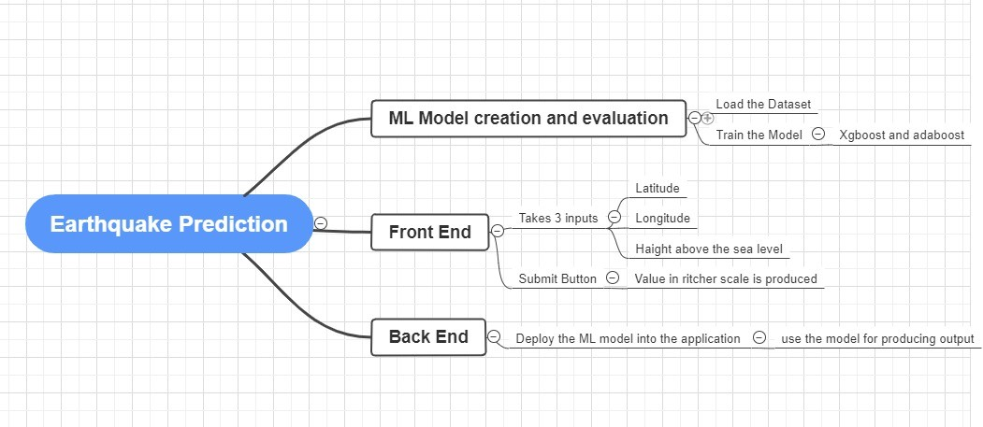

1. **Results and Discussion**

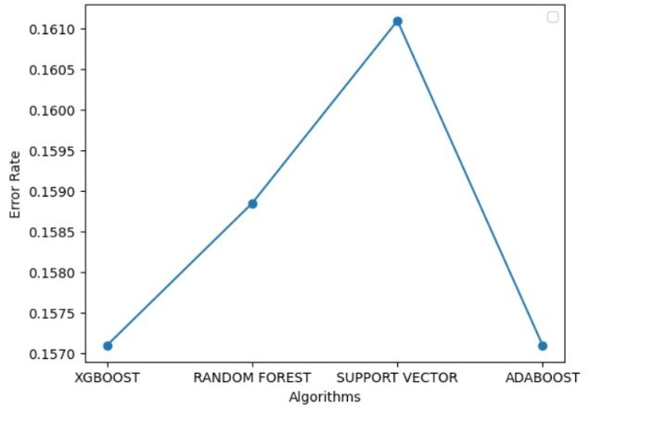**Graph**

**Ambur Earthquake (7/06/2008)**

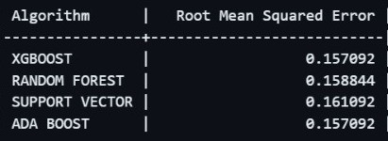**Table**

**Bengkulu Earthquake (19/04/2023)**

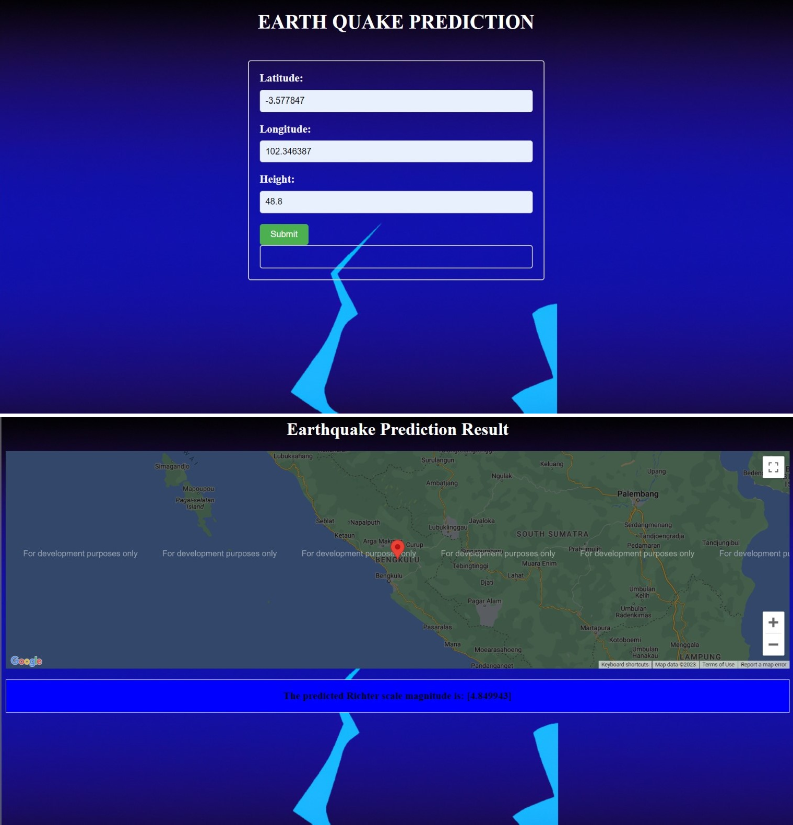

* Model result=4.9
* Actual Earthquake=4.6
* Model result=3.91
* 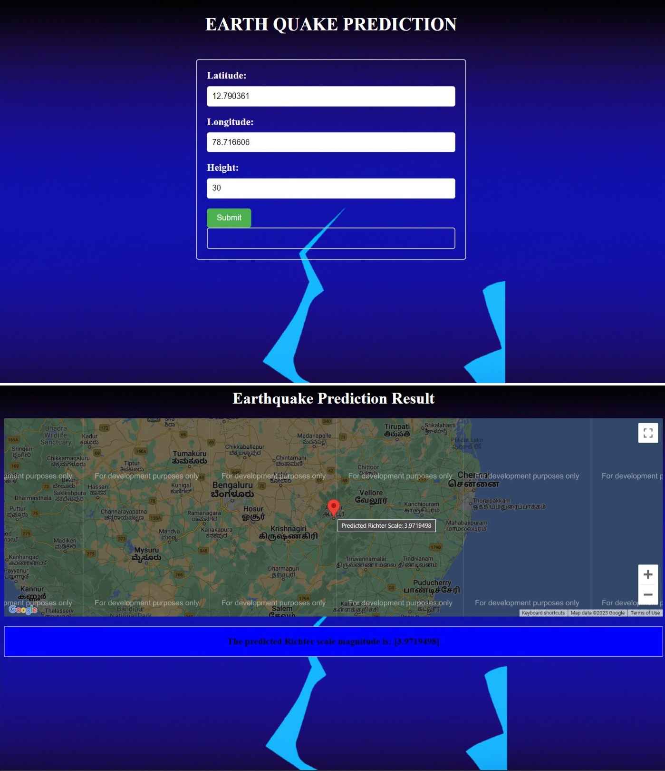Actual Earthquake=3.8

# Conclusion

While machine learning techniques have shown promise in earthquake prediction, it is important to note that accurately predicting earthquakes re- mains a challenging and complex problem. The unpredictable nature of earthquakes, the limited availability of historical earthquake data, and the wide range of factors that can contribute to seismic activity all make earthquake prediction a difficult task.

However, recent advances in machine learning algorithms and the increasing availability of seis- mic data have led to some promising results in earthquake prediction. For example, some studies have shown that machine learning models can ef- fectively predict earthquake occurrence and mag- nitude by analyzing various data sources such as seismic Waveforms, GPS data, and satellite im- ages.

Despite these promising results, it is important to approach earthquake prediction with caution and to consider the limitations of machine learn- ing algorithms. Predictions made by these models should always be verified by experts in the field, and machine learning should be used as one tool in a broader range of earthquake monitoring and prediction methods.

# Future Scope

One area of research that is attracting interest is the use of machine learning methods to forecast earthquakes. Patterns and anomalies in seismic data can be found with the aid of machine learning algorithms, which may point to the potential for an earthquake. The potential for earthquake pre- diction using machine learning techniques is enor- mous, and researchers are always looking for new ways to boost precision and dependability. This entails expanding the number of data sources used, creating fresh algorithms, monitoring in real time, and estimating earthquake damage. Using ma- chine learning techniques to forecast earthquakes has great potential benefits that could save lives and lessen the effects of earthquakes on communi- ties all over the world.

# References

1. Galkina, A., Zhukova, A., Vorontsov, K. (2019). Machine Learning Methods for Earthquake Pre- diction: A Survey. IEEE Access, 7, 113635- 113651. doi: 10.1109/ACCESS.2019.2933315
2. Shahzad, F., Farooq, M., Mahmood, T. (2017). Earthquake magnitude prediction in Hindukush region using machine learning tech- niques. Natural Hazards, 87(1), 401-419. doi: 10.1007/s11069-016-2579-3
3. Ross, Z. E., Meier, M. A., Hauksson, E., Cochran, E. S. (2021). Machine learning and earthquake forecasting—next steps. Nature Com- munications, 12(1), 1-10. doi: 10.1038/s41467-

021-24952-6

1. Khan, M. A., Shahzad, F. (2021). Earthquake Magnitude Prediction Using Machine Learning Technique. In Advances in Computer Science and Ubiquitous Computing (pp. 55-66). Springer, Cham. doi: 10.1007/978-3-030-66763-44
2. Rouet-Leduc, B., Hulbert, C., Lubbers, N., Barros, K., Humphreys, C. J., Johnson, P.

A. (2017). Machine learning predicts labora- tory earthquakes. Geophysical Research Letters, 44(18), 9276-9282.

1. Johnson, P. A., Rouet-Leduc, B., Pyrak-Nolte,

L. J., Beroza, G. C., Marone, C. J., Hulbert, C., Howard, A., Singer, P., Gordeev, D., Karaflos, D., Levinson, C. J., Pfeiffer, P., Puk, K. M., Reade, W. (2018). Laboratory earthquake forecasting: A ma- chine learning competition. Perspectives in Earth and Space Science, 1(1), 10-16

1. Li, R., Lu, X., Li, S., Yang, H., Qiu,

J., Zhang, L. (2018). DLEP: A Deep Learn- ing Model for Earthquake Prediction. 2018 IEEE International Conference on Systems, Man, and Cybernetics (SMC), 3088-3093. doi: 10.1109/SMC.2018.00535

1. Xiong, P., Tong, L., Zhang, K., Shen, X., Bat- tiston, R., Ouzounov, D., Iuppa, R., Crookes, D., Long, C., Zhou, H. (2021). Towards advancing the earthquake forecasting by machine learning of satellite data. Journal of Cleaner Production, 314, 127872.
2. Mousavi, S.M., Beroza, G.C. (2019). A machine-learning approach for earthquake magnitude estimation. Geophysical Jour- nal International, 217(3), 1868-1880. doi: 10.1093/gji/ggz111
3. Debnath, P., Chittora, P., Chakrabarti, T., Chakrabarti, P., Leonowicz, Z., Jasinski, M., Gono, R., Jasin´ska, E. (2019). Analysis of Earthquake Forecasting in India Using Supervised Machine Learning Classifiers. IEEE Access, 7, 121534-121546.
4. Xie, Y., Sichani, M. E., Padgett, J. E., DesRoches, R. (2020). The promise of imple- menting machine learning in earthquake engineer- ing: A state-of-the-art review. Earthquake Engi- neering Structural Dynamics, 49(5), 1355-1381.
5. Machine learning for earthquake prediction: a review (2017–2021)
6. Anmol Gaba, Arnab Jana, Rahul Subrama- niam, Yash Agrawal, and Merin Meleet. ”Anal- ysis and Prediction of Earthquake Impact-a Ma- chine Learning approach.” IEEE.
7. Jena, R., Pradhan, B., Naik, S. P., Alamri,

A. M. (2021). A comparative study of machine learning algorithms for earthquake risk assess- ment. Natural Hazards, 106(3), 1809-1831.

1. Sadhukhan, B., Chakraborty, S., Mukher- jee, S. (2020). Predicting the magnitude of an impending earthquake using deep learning tech- niques. Geomatics, Natural Hazards and Risk, 11(1), 1504-1519.
2. Bhatia, M., Ahanger, T. A., Manocha, A. (2020). Artificial intelligence based real-time earthquake prediction. Computers Geosciences, 139, 104446.
3. Zhang, J., He, X. (2021). Earthquake mag- nitude prediction using a VMD-BP neural network model. Neural Computing and Applications, 33, 4405–4415.
4. Zhou, W., Zhang, K., Ming, Z., Chen, J., Liang, Y. (2021). Immune optimization inspired artificial natural killer cell earthquake prediction method. Natural Hazards, 105(3), 3315-3330.
5. Laurenti, L., Tinti, E., Galasso, F., Franco, L., Marone, C. (2020). Deep learning for lab- oratory earthquake prediction and autoregressive forecasting of fault zone stress. Geophysical Re- search Letters, 47(16), e2020GL089645.
6. Berhich, A., Belouadha, F.-Z., Kabbaj, M.

I. (2021). A location-dependent earthquake pre- diction using recurrent neural network algorithms. Expert Systems, 38(4), e12513.

1. Berhich, A., Belouadha, F.-Z., Kabbaj, M.

I. (2020). An attention-based LSTM network for large earthquake prediction. Natural Hazards, 103(1), 325-346.

1. Abebe, E., Kebede, H., Kevin, M., De- missie, Z. (2021). Earthquakes magnitude predic- tion using deep learning for the Horn of Africa. Natural Hazards, 105(2), 1297-1313.
2. Fatimah, H., Bangash, S., Tariq, A., Naseem,

A. A., Ahmed, Z., Bangash, A. A. (2021). Time series temperature anomalies for earthquake pre- diction using remote sensing techniques: A case study of five major earthquakes in Pakistan’s his- tory. Geomatics, Natural Hazards and Risk, 12(1), 1015-1032.

1. Ray, M. A., Bowman, D., Csontos, R., Van Arsdale, R. B., Zhang, H. (2019). A matrix-variate Dirichlet process to model earth- quake hypocentre temporal patterns. Journal of Applied Statistics, 46(4), 723-742.
2. Zaccagnino, D., Telesca, L., Doglioni, C. (2019). Global versus local clustering of seis- micity: Implications with earthquake prediction. Tectonophysics, 765, 1-12.
3. Zavyalova, A. D., Morozova, A. N., Aleshina, I. M., Ivanova, S. D., Kholodkova, K. I., Pavlenkoa, V. A. (2020). Medium-term earth- quake forecast method map of expected earth- quakes: Results and prospects. Izvestiya, Physics of the Solid Earth, 56(6), 841-855.
4. Saidani, O., Manoharan, R. R., Naje, A. S.,

Mishra, R., Subburaj, A., Maheswari, S., ... Sen- gan, S. (2021). Analysis of positive correlation in magnitude and time measurement for earth- quake using electric signals. Journal of King Saud University-Engineering Sciences.

1. Kumar, R., Mittal, H., Sandeep, Sharma, B. (2022). Earthquake Genesis and Earthquake Early

Warning Systems: Challenges and a Way For- ward. Natural Hazards Review, 23(2), 04021014.

1. Dog˘an, A., Demir, E. (2019). Structural recurrent neural network models for earthquake prediction. Neural Computing and Applications, 31(7), 2399-2408.
2. Gitisa, V. G., Derendyaeva, A. B., Petrov,

K. N. (2003). Approach to Systematic Prediction of Earthquakes. Doklady Earth Sciences, 390(1), 157-160.

1. Zhou, W., Liang, Y., Wang, X., Ming, Z., Xiao, Z., Fan, X. (2022). Introducing macrophages to artificial immune systems for earthquake prediction. Neurocomputing, 525, 40-

50.

1. Mahmoudian, A., Safari, M., Rezapour, M. (2022). Earthquake prediction assessment using VLF radio signal sounding and space-based ULF emission observation. Acta Geophysica, 70(3), 479-489.
2. Oncel Cekim, H., Tekin, S., O¨ zel, G. (2020). Prediction of the earthquake magnitude by time series methods along the East Anatolian Fault, Turkey. Journal of African Earth Sciences, 168, 103892.

34.C. D. Trong, N. Hoang, M. X. Bach, N.

M. Luc, L. V. Dung, C. D. Trieu, N. S. Syrbu,

D. Th. Hai, Th. A. Tuan, N. Q. Toan, and

D. V. Thanh. Using geomorphological indica- tors to predict earthquake magnitude (MOb-Max): a case study from Cao Bang province and adja- cent areas (Vietnam). Doklady Earth Sciences, vol. 504, no. 2, pp. 416-420, 2022. DOI: 10.1134/S0016852122030104.

1. Saini, K., Kalra, S., Sood, S. K. (2021). An Integrated Framework for Smart Earthquake Pre- diction: IoT, Fog, and Cloud Computing. Journal of Intelligent Fuzzy Systems, 41(2), 2205-2219.
2. Pu, Y., Chen, J., Apel, D. B. (2021). Deep

and confident prediction for a laboratory earth- quake. Bulletin of the Seismological Society of America, 111(3), 1201-1211.

1. Sobolev, G. A. (2022). Some Causes of In- accuracies of Short-Term Earthquake Prediction Taking into Account Laboratory Modeling. Jour- nal of Mining Science, 58(1), 158-166.
2. Khalil, U., Aslam, B., Kazmi, Z. A., Maq-

soom, A., Qureshi, M. I., Azam, S., Nawaz, A. (2021). Integrated support vector regressor and hybrid neural network techniques for earthquake prediction along Chaman fault, Baluchistan. Ara-

bian Journal of Geosciences, 14(21), 2567. DOI: 10.1007/s12517-021-08080-4.

1. Wu, Z., Zhang, Y. (2021). Commu- nity/Public Approach to Earthquake Forecasting in the Era of Big Data: An On-going Endeavor in China. Pure and Applied Geophysics, 178(11), 5473-5486.
2. Marhain, S., Ahmed, A.N., Murti, M.A. et al. Investigating the application of artificial intel- ligence for earthquake prediction in Terengganu. Nat. Hazards 107, 301–319 (2021).