Does KGX1 Fit the Failure Pattern? A Counter-Case Test of the Google King’s Cross Headquarters (Platform 37) Against the Failure Signatures in Recognised Megaprojects

A retrospective project management analysis

Module: Project Management
Student name: [insert]
Student number: [insert]
Submission date: [insert]
Word count (main body): 3,360

Contents
Right-click and select Update Field to refresh the contents.

List of figures and tables
Figure 1: Failure signatures from the comparison projects and the KGX1 test
Figure 2: Life cycle stage at which each failure signature appears
Table 1: KGX1 scope statement
Figure 3: High-level KGX1 schedule with dependencies, float and critical path
Table 2: Documented KGX1 scope changes
Figure 4: What is publicly available to review, Crossrail and KGX1
Table 3: KGX1 resource categories and allocation
Figure 5: Evidence for each cost-escalation cause at KGX1
Figure 6: Estimated trade overlaps at KGX1
Table 4: KGX1 risk register
Figure 7: KGX1 risks on a response-mapped probability-impact matrix
Table 5: KPIs applied to documented KGX1 events
Figure 8: Retrospective change request for the 2020 hold
Table 6: Recovery options for the 2020 hold

Introduction
Platform 37 (KGX1), Google's King's Cross headquarters, was designed by BIG and Heatherwick Studio and delivered by Lendlease (Building, 2017a; Construction Enquirer, 2017). Megaprojects are prone to time, cost and benefit shortfalls (Flyvbjerg, Bruzelius and Rothengatter, 2003), and the assignment attaches five consequences of poor estimation to recognised projects: delays (Berlin Brandenburg Airport), budget overruns (the Big Dig), resource conflicts (Denver), reactive interventions (Sydney Opera House) and reputational damage (Crossrail). This report tests whether a privately funded building shows these signatures, and expects a mixed verdict. The comparison fails if public megaprojects are too unlike one private building for their signatures to transfer, since a case supports analytic, not statistical, generalisation (Flyvbjerg, 2006; Yin, 2018). Documented facts are cited; derived and assumed figures are labelled by tier, and three rival explanations are tested. Sections 1 to 5 follow the life cycle, business case, resources, risk and control.

Section 1: Project Life Cycle Analysis
The five signatures start at different stages, and KGX1's first visible signature starts early. KGX1 reads as a stage-gated hybrid: consent preceded construction, a sequential path, yet Lendlease was confirmed in February 2017, six months before reserved-matters approval in August 2017 (Construction Enquirer, 2017; Camden Council, 2017), so procurement overlapped planning. Waterfall (Initiate, Plan, Implement, Close) is commonly traced to Royce (1970), who did not use the word; agile (Concept, Plan, Build, Test, Review, Release) iterates instead (Cooper and Sommer, 2016).
Each stage should prevent a different failure. Business case preparation prevents solving the wrong problem and closes at funding approval. Planning prevents unconsented or unrealistic plans, closing at approval. Design prevents unbuildable solutions, closing at design freeze. Development prevents uncontrolled change, closing at completion. Deployment prevents unusable handover, closing at occupation. Evaluation prevents unlearned lessons, closing at benefits review (APM, 2019; PMI, 2021). Figures 1 and 2 locate the signatures.
Figure 1: Failure signatures from the comparison projects and the KGX1 test (KGX1 coded present, absent or not observable; best rival per row, completed after the tests)
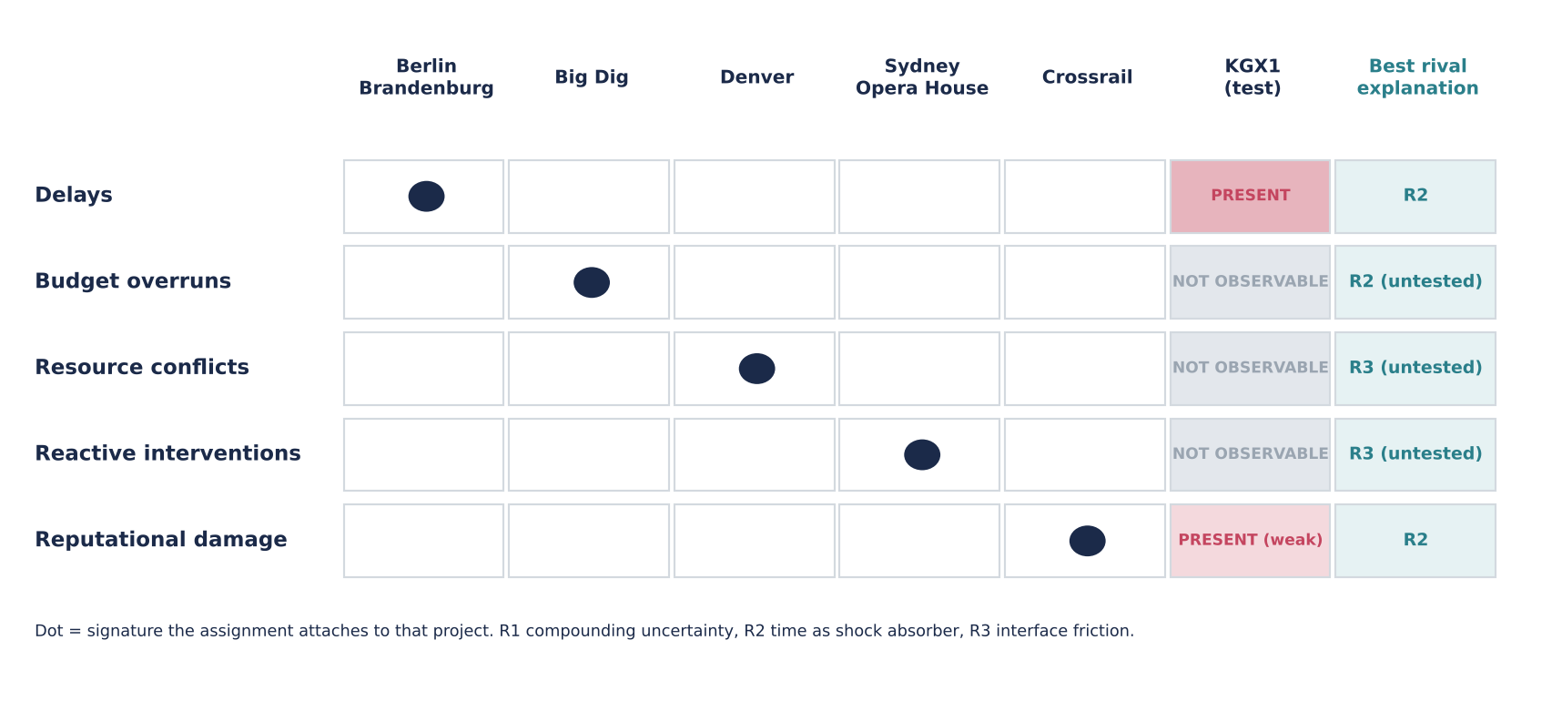
Sections 1 and 2 test delay, Sections 2 and 3 budget and resources, Section 4 reputational damage and Section 5 reactive intervention.
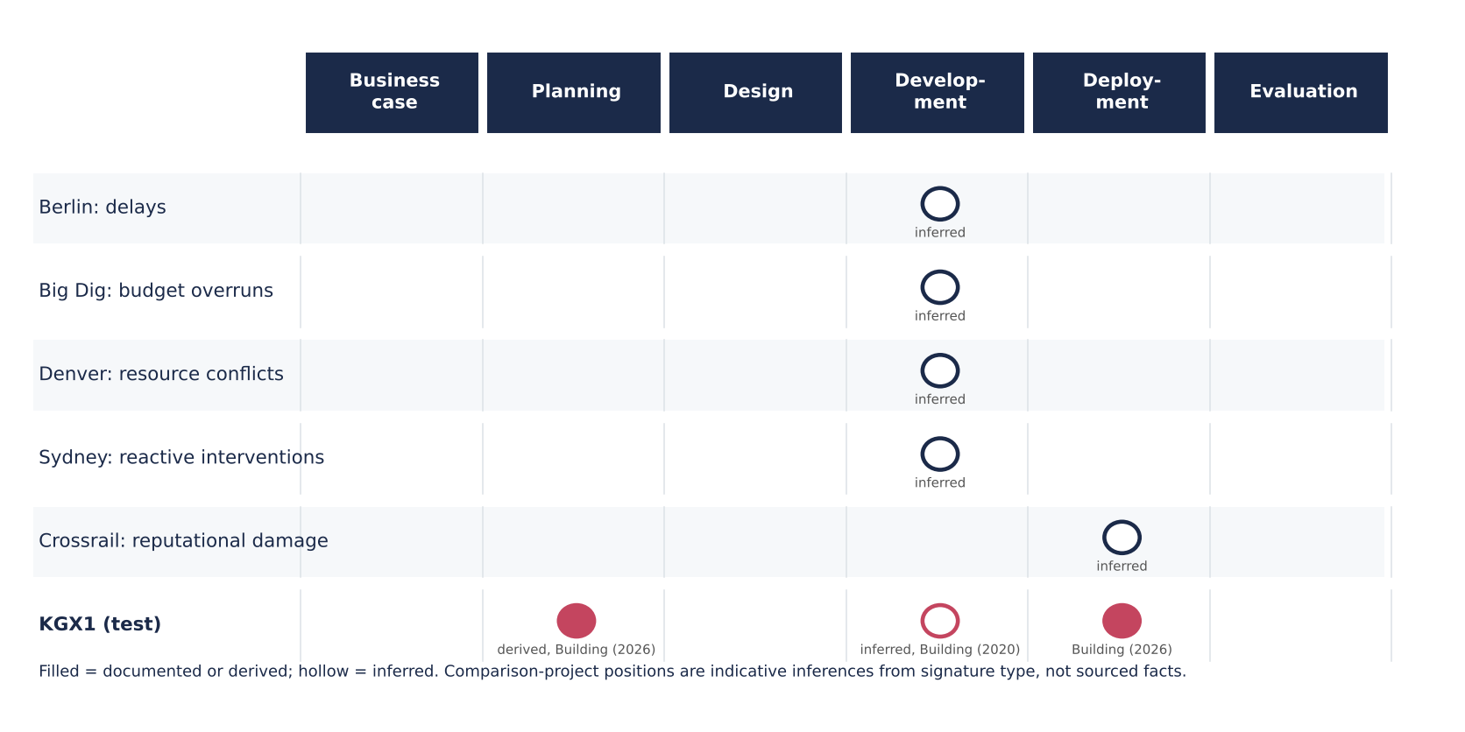
Figure 2: Life cycle stage at which each failure signature appears (filled dot documented or derived, hollow dot inferred)
The pattern suggests the front end matters most. KGX1's earliest documented signature, delay, appears before construction; comparison positions are indicative inferences from signature type, not sourced facts.
The documented sequence is as follows. Google's chief executive confirmed a King's Cross campus in November 2016 (Camden New Journal, 2016); Lendlease was confirmed in February 2017 for the shell and core; Camden approved reserved matters in August 2017; the structure was a hung frame of 17,000 t (New Steel Construction, n.d.); the site was shut in March 2020 and still on hold when other Lendlease sites reopened (Building, 2020); and the building opens about ten years after its first completion date (Building, 2026). That date, mid-2016 by derivation (T2), therefore passed before approval, so delay first appears at planning, although its cause is inferred. PMI lists change in organisational priorities among primary failure causes (PMI, 2018); a shift before approval is plausible but unsourced.
Which model would have caught each signature earlier? For cost control, waterfall's early baseline exposes drift only if estimates are mature. For stakeholder alignment, agile review would surface a client's rejection of a scheme sooner than a gate that merely records approval. For feasibility, stage-gate criteria concentrate checking where consent and structure are tested. For timeline, iteration inside gates shortens feedback but cannot prevent an external stoppage. Morris and Hough (1987) locate major-project failure in front-end definition and external pressure, so any model that strengthens early gates should catch more signatures than one that tests at handover. These frameworks share an assumption that uncertainty falls as stages close; they differ on whether iteration or fixity best achieves that, and agile evidence is largely software-based.
These perspectives rest on different assumptions. The sequential model assumes requirements can be fixed early; Morris and Hough's front-end view assumes definition quality determines outcomes; the hybrid assumes iteration can coexist with gates; Atkinson's critique assumes time, cost and quality omit other success criteria. They agree that early decisions dominate and disagree on whether flexibility or fixity serves them; all describe organisations that publish their processes, which KGX1 does not.
Earlier contractor involvement would improve buildability but binds the owner before consent. I recommend a formal design-freeze and approval gate, with a stated route for reopening it. Confidence is moderate: the front end is where most signatures start, but KGX1's pattern may be indistinguishable from a late, quiet success (Atkinson, 1999).

Section 2: Business Case, Scope & Schedule
The question is whether KGX1's front end showed the warning signs of the failed comparison projects. Strategically, Google committed publicly to a King's Cross campus (Camden New Journal, 2016); commercially, ownership gave control of a flagship asset; financially, private capital funded it, and no public cash flow exists to test the case. Competitiveness and technological positioning are visible in the first Google-owned and designed building outside the United States, as reported (New Steel Construction, n.d.); for low-carbon construction I found no objective on my sources, so that theme is untested. A disbenefit is capital concentrated in one asset. Measurable (SMART) benefits are not public, a recognised pitfall (Zwikael and Smyrk, 2011), so outputs (the building), outcomes (occupier use) and benefits (strategic value) cannot be reviewed. Where objectives are unpublished, the 'change in objectives' test can only be run on visible events.
Google held decisive influence, Camden consent power and Lendlease delivery control. The tension lies in the change of scheme between the 2013 outline approval and the 2017 approval (Building, 2017a), whose cause is inferred.
Table 1: KGX1 scope statement reconstructed from public sources (T1; inferred where marked)
Element | Content | Status
Deliverables | Hung-frame building; roof terraces and running track (New Steel Construction, n.d.) | Fixed
Deliverables | Steel package: 15,900 t at contract (Building, 2017b), 17,000 t later (New Steel Construction, n.d.) | Changed (T2)
Exclusions | Wider estate infrastructure; other Google buildings (inferred) | Fixed
Assumptions | Planning consent (Camden Council, 2017); site available on time | Fixed
Constraints | Dense urban site (inferred); technically demanding hung structure | Fixed

Because Google prioritised a single-owner flagship, scope fixed the structural concept, terraces and running track early and left detailed fit-out open (inferred). Two front-end failure causes can be tested: change in project objectives and inaccurate requirements gathering (PMI, 2018). The first is visible only as the change of scheme; the second is not observable. Public sources can neither confirm nor exclude either cause.
Three pressures shaped dates. Political expectations acted through planning consent, with approval in August 2017. Funding cycles were corporate capital, not public money, so dates could flex without external audit. Strategic priorities dominated: the first completion date was missed before approval, and the opening follows 107 months after approval (T2: August 2017 to July 2026). Optimism bias and strategic misrepresentation, which Flyvbjerg, Holm and Buhl (2002) treat as rival explanations of underestimation, both remain possible, and megaprojects habitually run late (Flyvbjerg, 2014); private funding reduces but does not remove these pressures.
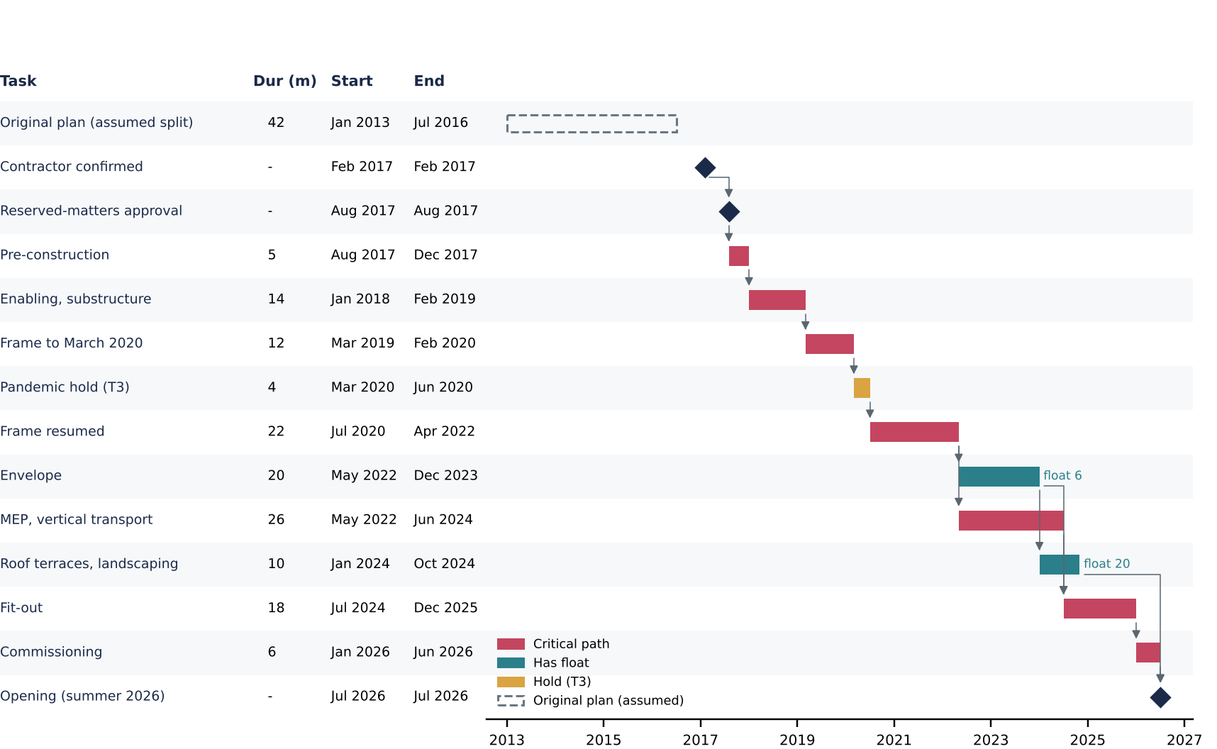
Figure 3: High-level KGX1 schedule with dependencies, float and critical path (milestones T1 where marked; durations T3; Appendix B)
The critical path runs from pre-construction through frame, hold, services, fit-out and commissioning (Gray and Larson, 2020); envelope carries six months of float. A Gantt chart shows no resource allocation.
Table 2: Documented KGX1 scope changes
Period | Change | Trigger | Approved by | Source | Evidence
2013 to 2017 | Earlier scheme replaced by BIG and Heatherwick scheme | Not public | Camden committee | Building (2017a) | Change T1; cause inferred
2017 to completion | Steel 15,900 t to 17,000 t, +6.9% | Not public | Not public | Building (2017b); New Steel Construction (n.d.) | T2

Only two changes are documentable; the shortness of the log reflects disclosure, not stability.
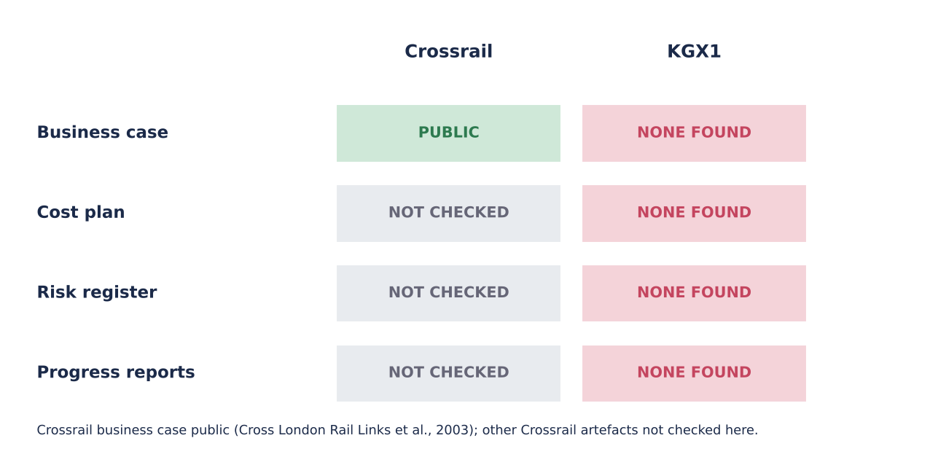
Figure 4: What is publicly available to review, Crossrail and KGX1 (T1; KGX1 cells mean none found)
Crossrail's business case is public (Cross London Rail Links, Strategic Rail Authority and Transport for London, 2003); KGX1's is not, so conclusions about KGX1 rest on absence of evidence, while Crossrail shows that disclosure does not prevent reputational damage. The comparison therefore supports only a limited inference: transparency enables review but does not predict success.
Recommendations: publish a scope-change log; set a dual baseline of strategic window and delivery plan; hold a scope-freeze gate before procurement; and record exclusions so that later cost comparisons are like for like.

Section 3: Resource Planning & Budget Analysis
Table 3: KGX1 resource categories and allocation (T1; inferred where marked)
Category | KGX1 examples | Quantity and duration | Constraint
Human | Architects, engineers, steel erectors | Not public | Availability
Materials | Structural steel | 17,000 t; frame about 34 months plus hold (T3) | Timing
Equipment | Cranes, access platforms (inferred) | Not public | Site space
Financial | Shell-and-core contract about £350m (Construction Enquirer, 2017) | February 2017 | Cost
Technical | Hung-structure design coordination (inferred) | Not public | Feasibility

Steel dominates the sequence: frame, then envelope and services, then fit-out. The quantity was 15,900 t at the 2017 contract (Building, 2017b) and 17,000 t later (New Steel Construction, n.d.), growth of (17,000 - 15,900) / 15,900 = 6.9% (T2), which I treat as a change indicator, not an overrun, since the basis of each figure is unknown. At an assumed 6 t per gang-day and 12-worker gangs over 34 months of 21 days, effort is 2,833 gang-days, about 48 erectors (T3); at 4 t the figure becomes about 71, and at 9 t about 32 (T3).
Estimating method should follow maturity (Gray and Larson, 2020). The shell-and-core contract of about £350m sits at contract stage and covers part of the scope; the £1bn headline appeared when the campus was announced (Camden New Journal, 2016), at concept stage, so the two cannot be compared directly. Their ratio, 2.9 (T2: 1,000 / 350), measures stage and scope, not overrun. Theories disagree on what such gaps mean: optimism bias and strategic misrepresentation predict systematic underestimation (Flyvbjerg, Holm and Buhl, 2002), whereas front-end definition predicts that mature definition narrows error (Merrow, 2011); public data cannot adjudicate. Contingency is judgement; I assume 10% (range 7% to 15%; T3). PERT for the frame, with optimistic 30, most likely 38 and pessimistic 54 months (T3), gives (30 + 152 + 54) / 6 = 39.3 months.
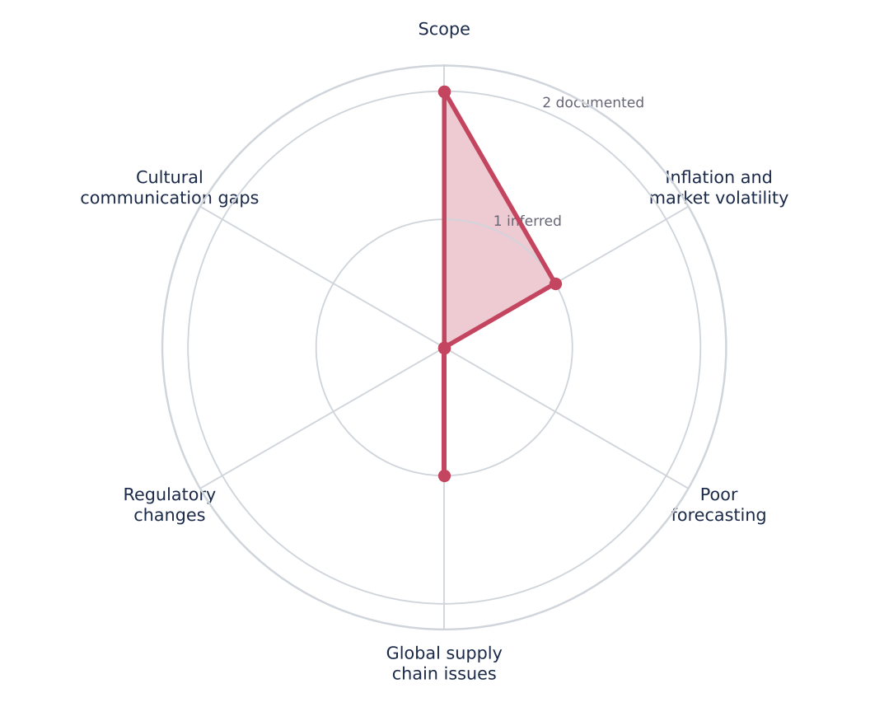
Figure 5: Evidence for each cost-escalation cause at KGX1 (0 none, 1 inferred, 2 documented; a qualitative evidence score, not a magnitude)
Only scope carries documented evidence, through the tonnage change; inflation and supply-chain pressure are plausible but inferred; forecasting, regulation and communication gaps are not observable.
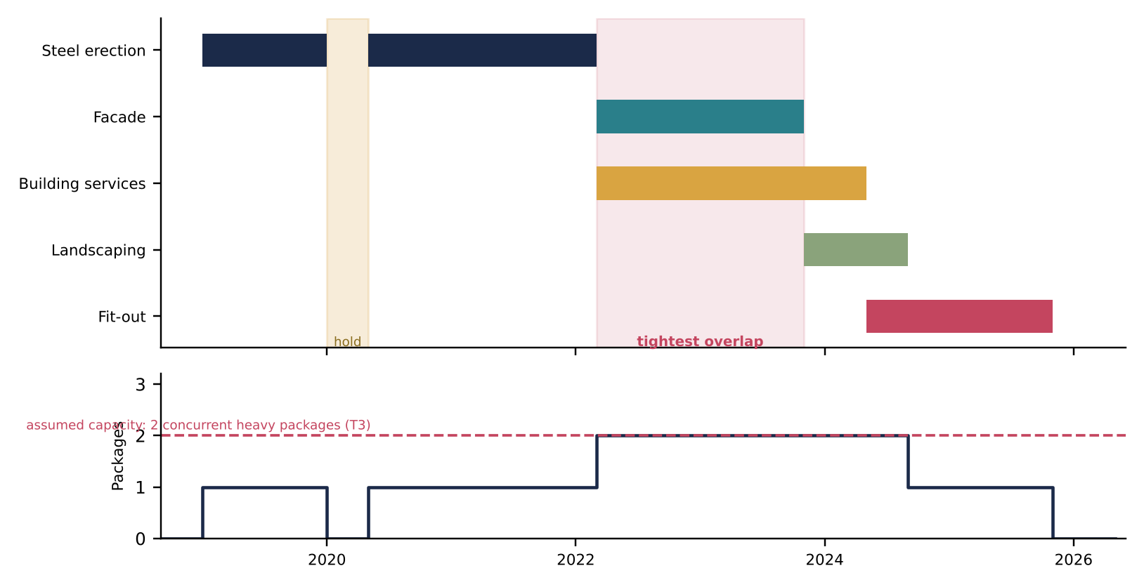
Figure 6: Estimated trade overlaps at KGX1 (assumed overlaps; T3; Appendix C)
Facade and services overlap tightest, at the assumed capacity of two concurrent heavy packages, so availability and timing, not cost, bind. Facade carries six months of float, so levelling it costs no programme time; levelling works only where float exists, and the critical packages have none.
Three theories explain estimate failure. Psychological optimism locates error in planners' cognition, strategic misrepresentation in incentives, and definitional theory in immature scope. They agree that early figures are unreliable but prescribe different remedies: reference-class checks, incentive reform or earlier definition. For a private owner-occupier, misrepresentation is weaker because the sponsor funds the outcome, which favours definitional explanations; that is an assumption, not evidence.
Constraints shaped four outcomes. Specialist availability affected scheduling because the frame gated every later trade. The hung structure affected risk exposure because one package's delay reaches every successor. Concurrent heavy packages affected feasibility because a dense site (inferred) limits crane and access space. Late scope change affected contractor performance because packages are repriced. Rival R3 adds a further constraint: a contractor-wide pause, not a site-level shortage, held the job (Building, 2020). The resource-conflict signature, illustrated by Denver's baggage system (Montealegre and Keil, 2000), is therefore not observable at KGX1, and R3 explains the observable hold better than R1 because the stoppage originated above the project.
Cost planning tested organisational skills and adaptability: a manager had to hold a baseline while reported totals differed. PMI lists inaccurate cost estimates and inadequate resource forecasting among failure causes (PMI, 2018); Section 4 turns these constraints into risks.

Section 4: Risk Assessment & Contingency Planning
Risk management follows four stages: identify, assess, respond, monitor (Chapman and Ward, 2003). I use four categories (operational, external, financial, technical), a 4x4 scale with score = probability x impact (Low 1-2, Medium 3-4, Serious 6-9, High 12-16), and a PMO that sets the framework and escalates; the process is never one and done (APM, 2019).
Table 4: KGX1 risk register (R4 and R6 inferred; others documented; Appendix E)
ID | Risk (category) | P | I | Score | Response used | Owner | Evidence
R1 | COVID-19 closure and hold (external) | 4 | 3 | 12 | Restart (reduce) | Lendlease | Building (2020)
R2 | Decision above project level keeping job on hold (external) | 3 | 3 | 9 | Escalate only | Contractor group | Building (2020)
R3 | Hung steel structure (technical) | 2 | 4 | 8 | Transfer | Steel supplier | New Steel Construction (n.d.)
R4 | Delivery and fit-out interface (operational) | 3 | 2 | 6 | Not evidenced | Google | Inferred
R5 | Cost-baseline uncertainty (financial) | 4 | 2 | 8 | Accept | Google | Reported totals differ
R6 | Dense site beside rail, canal (operational) | 2 | 2 | 4 | Not evidenced | Lendlease | Inferred
O1 | Specialist fabricate-and-erect delivery (opportunity) | 3 | 2 | 6 | Exploit | Steel supplier | New Steel Construction (n.d.)

Three scores carry the argument. R1 scores 12: the closure occurred, hence likelihood 4, and its impact was critical. R2 scores 9: a decision above project level kept the job on hold after other Lendlease sites reopened (Building, 2020). R3 scores 8: remote failure, catastrophic consequence on the critical frame. Figure 7 colours each cell by the response its position suggests. R3's transfer matches its cell; R1 and R2 do not, because avoidance and reduction were unavailable at project level; R5's acceptance does not match reduction. The matrix scores risks independently, yet R1 and R2 were one correlated event. These mismatches are findings, not failures: they show where project-level controls end.
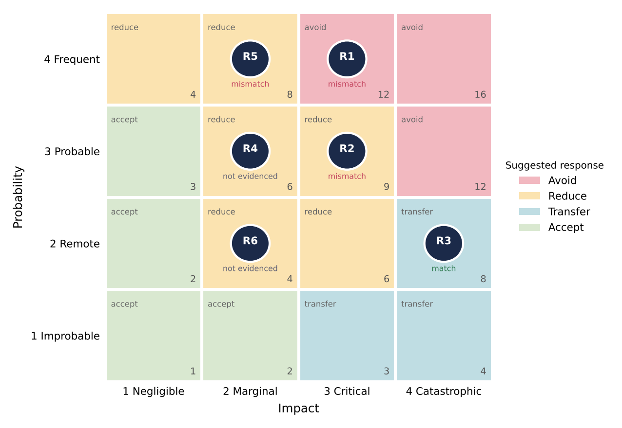
Figure 7: KGX1 risks plotted on a response-mapped probability-impact matrix (T3 scores)
A threat-only register assumes risks are separable and probabilistic; Chapman and Ward's uncertainty view and Hillson's opportunity view widen it, at the price of harder scoring.
For R1, restart after the hold was a reactive reduction, effective only after occurrence. For R2, no project-level response existed: the manager could only escalate, which fits R3 best. For R3, transfer to a specialist package suited a risk the supplier could price, yet delay still reaches the owner, because transfer moves risk without removing it. Other responses are inferred. For reputational damage, the trade press framed the opening as "ten years after it was first set to complete" (Building, 2026); that is one source, so the signature is present but weak. Brady and Davies (2010) show that a register stopping at construction can miss operational readiness, as at Terminal 5.
The assignment's HS2 case pairs delay and cost growth with public scrutiny, and its vaccine case pairs parallel research with contingency design. Neither fact base is on my source list, so I use them as prompts only: KGX1 shows the delay but no public scrutiny or parallel contingency design.
Plan B statements. R1: trigger, positive case or closure order; owner, contractor with client; action, phased restart plan; cost, upward. R2: trigger, group-wide stand-down notice; owner, client portfolio lead; action, pre-agreed standby terms; cost, neutral. R5: trigger, two published totals differing by more than 10%; owner, PMO; action, scope-defined baseline; cost, neutral. Contingency covers identified risks; management reserve covers unknowns.
Recommendations: hold an early risk workshop that includes operational readiness; keep one register across client and contractor; state an escalation route for decisions above project level; and treat opportunities such as O1 as part of the same process (Hillson, 2002). Poorly defined opportunities and risks are a listed failure cause (PMI, 2018), and stress management mattered because the manager carried accountability for risks owned elsewhere.

Section 5: Progress Review & Intervention Strategies
KGX1 spans 107 months from approval to opening (T2), with a hung 17,000 t structure and a dense site. Monitoring mattered most at approval, during frame erection, through the 2020 hold and at fit-out and commissioning.
Four KPI groups apply: schedule (milestones, SPI), cost (CPI, cost variance), quality (defects, rework) and stakeholder communication (Kerzner, 2022). Earned value shows that a project is off plan, not why (Fleming and Koppelman, 2010). Actual cost is not public, so a real CPI cannot be computed; the formulae are method only, and Table 5 applies them to documented events. Earned value also assumes a stable baseline: after a scope change, SPI and CPI measure against a plan that no longer holds, and success criteria beyond time, cost and quality go unmeasured (Atkinson, 1999).
Table 5: KPIs applied to documented KGX1 events (T1/T2; Appendix F)
KPI and formula | KGX1 evidence | What it shows | Missing
Schedule: SPI = EV / PV | Target mid-2016 (derived) against opening about ten years later (Building, 2026); approval August 2017 | Large slip; SPI not computable | Baselines, re-baseline dates
Cost: CPI = EV / AC | Shell and core about £350m; £1bn headline; steel +6.9% (T2) | Not a CPI; scope differences | Actual cost, change orders
Quality: defects, rework | No public data | Unknown | Defect and rework logs
Stakeholder communication | Press framing of delay (Building, 2026) | Public narrative only | Stakeholder register

Stakeholder communication is the only KPI group with a public trace, and it is narrative, not measured: a reviewer cannot tell whether communication was good or merely quiet.
Three deviations follow. The missed first completion date would have flagged at once against a baseline, and the 2020 hold within one reporting cycle. The cost-baseline uncertainty would have appeared at the first CPI, which cannot be computed until scope is fixed. Quality has no public data; I would track defects per package and rework hours.
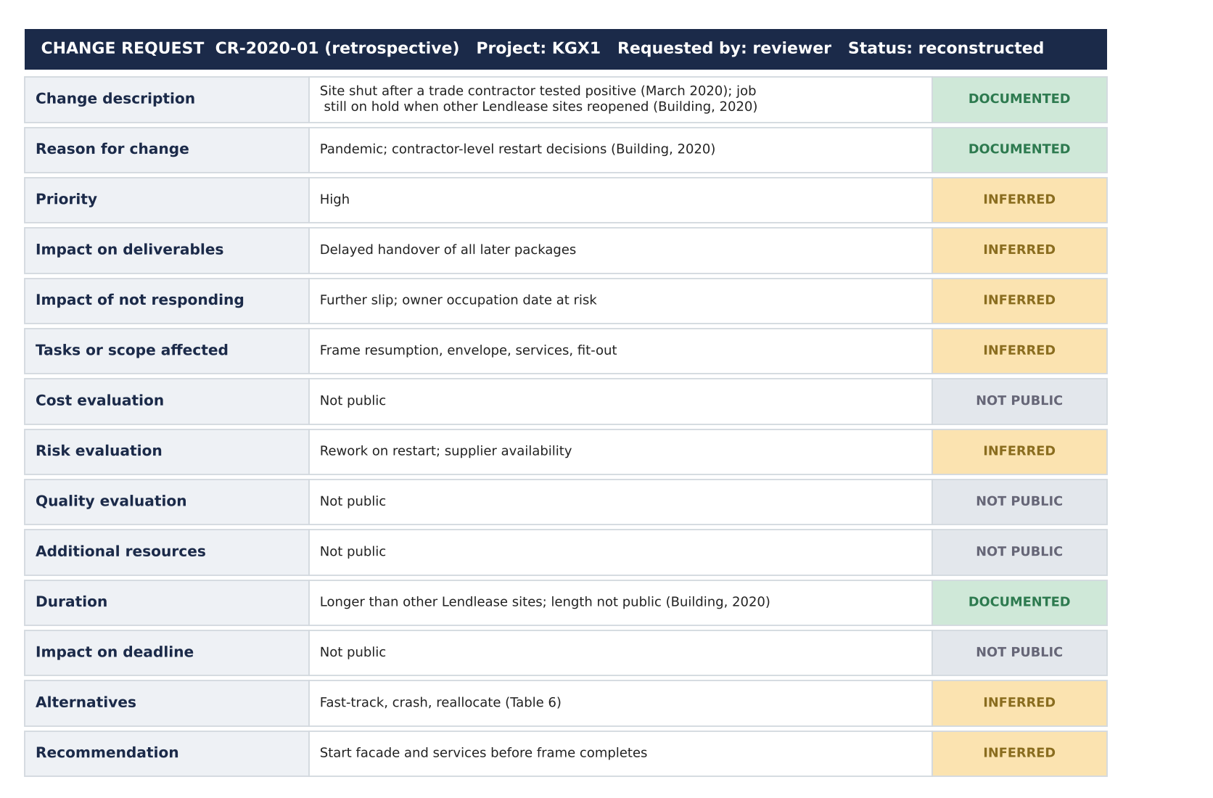
Figure 8: Retrospective change request for the 2020 hold, completed from public sources
Only the description, reason and part of the duration can be completed from public evidence; cost, quality and deadline impact cannot, which shows what a reviewer cannot see.
Table 6: Recovery options for the 2020 hold (ratings from the standard scheme; recommended option marked)
Option | Meaning for the hold | Cost | Scope | Risk added
Scope reduction | Drop terraces | Low | High | Benefit loss
Crashing | Add shifts after restart | High | Low | Fatigue, rework
Fast-tracking (recommended) | Start facade and services before the frame completes | Low | Medium | Rework
Resource reallocation | Move trades from other jobs | Medium | Medium | Other jobs also held

Table 6 recommends fast-tracking, low cost with medium scope impact, though it adds rework risk. Crashing, high cost with low scope impact, would suit a late milestone. Resource reallocation was constrained because other Google jobs were also held (inferred). Change control follows five steps: log, evaluate, review, decide, implement and communicate (Kerzner, 2022). Informal change is faster but invites scope creep; formal change needs a board, which on a private project is the owner's.
Was the response planned or reactive? Restart came after other Lendlease sites reopened (Building, 2020), which looks reactive, but without the change log the data cannot distinguish them. Sydney Opera House is the assignment's reactive case, and Terminal 5 shows that delivery success can still end in public failure at opening (Brady and Davies, 2010).
Recommendation: privately funded megaprojects should disclose a minimum set: baseline dates, approved change log, actual cost at each gate, defect rates and escalation record, so that later reviews can test each signature; stage-gate summaries would suffice, without revealing commercial terms. Communication and leadership mean carrying bad news upward early; poor change management, poor communication and inadequate sponsor support are listed causes (PMI, 2018).

Conclusion
The evidence partly supports the claim. Delay is present, documented by the ten-year gap (Building, 2026); reputational damage is present but weak; budget overruns, resource conflicts and reactive interventions are not observable, which shows an observability gap. Rival R2 fitted best overall, with R3 explaining the 2020 hold; R1 could not be shown. None explains why the first date was set so early. Public data and clearly labelled estimates limit confidence; further tests need the project's change log. Comparing a private building with public megaprojects taught me that disclosure, not method, limits what the tools can prove.

References
APM (2019) APM Body of Knowledge. 7th edn. Princes Risborough: Association for Project Management.
Atkinson, R. (1999) 'Project management: cost, time and quality, two best guesses and a phenomenon, its time to accept other success criteria', International Journal of Project Management, 17(6), pp. 337–342.
Brady, T. and Davies, A. (2010) 'From hero to hubris: reconsidering the project management of Heathrow's Terminal 5', International Journal of Project Management, 28(2), pp. 151–157.
Building (2017a) Google's exciting King's Cross HQ given go-ahead. Available at: https://www.building.co.uk/news/googles-exciting-kings-cross-hq-given-go-ahead/5089175.article (Accessed: 9 November 2026).
Building (2017b) Severfield snags prized steel contract for new Google HQ. Available at: https://building.co.uk/news/severfield-snags-prized-steel-contract-for-new-google-hq/5091122.article (Accessed: 9 November 2026).
Building (2020) Lendlease begins to reopen sites but Google job still on hold. Available at: https://www.building.co.uk/news/lendlease-begins-to-reopen-sites-but-google-job-still-on-hold/5105656.article (Accessed: 9 November 2026).
Building (2026) Google's £1bn King's Cross headquarters to open this summer, 10 years after it was first set to complete. Available at: https://www.building.co.uk/news/googles-1bn-kings-cross-headquarters-to-open-this-summer-10-years-after-it-was-first-set-to-complete/5141281.article (Accessed: 9 November 2026).
Camden Council (2017) Planning application 2017/3133/P: reserved matters for Development Zone A, King's Cross Central (decision notice dated 16 August 2017). Available at: https://camdocs.camden.gov.uk/CMWebDrawer/PlanRec?q=recContainer%3A2017%2F3133%2FP (Accessed: 9 November 2026).
Camden New Journal (2016) Google commits to expanding operations in King's Cross with £1bn campus, 20 November. Available at: https://www.camdennewjournal.co.uk/article/google-commits-to-expanding-operations-in-kings-cross-with-1bn-campus (Accessed: 9 November 2026).
Chapman, C. and Ward, S. (2003) Project risk management: processes, techniques and insights. 2nd edn. Chichester: Wiley.
Construction Enquirer (2017) Lendlease confirmed for Google HQ, 27 February. Available at: https://constructionenquirer.com/2017/02/27/lendlease-confirmed-for-google-hq (Accessed: 9 November 2026).
Cooper, R.G. and Sommer, A.F. (2016) 'The agile–stage-gate hybrid model: a promising new approach and a new research opportunity', Journal of Product Innovation Management, 33(5), pp. 513–526.
Cross London Rail Links, Strategic Rail Authority and Transport for London (2003) The Crossrail business case, September. Available at: https://learninglegacy.crossrail.co.uk/wp-content/uploads/2023/04/Crossrail-Economic-Business-Case-2003.pdf (Accessed: 9 November 2026).
Fleming, Q.W. and Koppelman, J.M. (2010) Earned value project management. 4th edn. Newtown Square, PA: Project Management Institute.
Flyvbjerg, B. (2006) 'Five misunderstandings about case-study research', Qualitative Inquiry, 12(2), pp. 219–245.
Flyvbjerg, B. (2014) 'What you should know about megaprojects and why: an overview', Project Management Journal, 45(2), pp. 6–19.
Flyvbjerg, B., Bruzelius, N. and Rothengatter, W. (2003) Megaprojects and risk: an anatomy of ambition. Cambridge: Cambridge University Press.
Flyvbjerg, B., Holm, M.S. and Buhl, S. (2002) 'Underestimating costs in public works projects: error or lie?', Journal of the American Planning Association, 68(3), pp. 279–295.
Gray, C.F. and Larson, E.W. (2020) Project management: the managerial process. 8th edn. New York: McGraw-Hill Education.
Hillson, D. (2002) 'Extending the risk process to manage opportunities', International Journal of Project Management, 20(3), pp. 235–240.
Kerzner, H. (2022) Project management: a systems approach to planning, scheduling, and controlling. 13th edn. Hoboken, NJ: Wiley.
Merrow, E.W. (2011) Industrial megaprojects: concepts, strategies, and practices for success. Hoboken, NJ: Wiley.
Montealegre, R. and Keil, M. (2000) 'De-escalating information technology projects: lessons from the Denver International Airport', MIS Quarterly, 24(3), pp. 417–447.
Morris, P.W.G. and Hough, G.H. (1987) The anatomy of major projects: a study of the reality of project management. Chichester: Wiley.
New Steel Construction (n.d.) Steel landscraper takes shape in King's Cross. Available at: https://www.newsteelconstruction.com/wp/steel-landscraper-takes-shape-in-kings-cross/ (Accessed: 9 November 2026).
PMI (2018) Pulse of the profession 2018: success in disruptive times. Newtown Square, PA: Project Management Institute.
PMI (2021) A guide to the project management body of knowledge (PMBOK guide) and the standard for project management. 7th edn. Newtown Square, PA: Project Management Institute.
Royce, W.W. (1970) 'Managing the development of large software systems', in Proceedings of IEEE WESCON. Los Angeles, CA: IEEE, pp. 1–9.
Yin, R.K. (2018) Case study research and applications: design and methods. 6th edn. Thousand Oaks, CA: SAGE.
Zwikael, O. and Smyrk, J. (2011) Project management for the creation of organisational value. London: Springer.

Appendix A: Assumptions register by tier
T1 values are documented, T2 values are derived from T1 figures, and T3 values are assumed with a basis and range. I held no published productivity rates or benchmarks, so such items are T3. Appendices are referenced in the body: A (all sections), B (Section 2, Figure 3), C (Section 3, Figure 6), D (Section 3), E (Section 4, Table 4, Figure 7), F (Section 5, Table 5) and G (all sections).
ID | Item | Value | Tier | Basis / source | Low | High
A01 | Steel quantity at completion | 17,000 t | T1 | New Steel Construction (n.d.)
A02 | Steel quantity at contract | 15,900 t | T1 | Building (2017b)
A03 | Steel change | (17,000 - 15,900) / 15,900 = 6.9% | T2 | A01 and A02
A04 | Shell and core contract | About £350m (February 2017) | T1 | Construction Enquirer (2017)
A05 | Headline figure | £1bn (2016 announcement) | T1 | Camden New Journal (2016)
A06 | Stage and scope ratio | 1,000 / 350 = 2.9 | T2 | A04 and A05; not an overrun
A07 | Reserved-matters approval | August 2017 | T1 | Camden Council (2017)
A08 | Opening | Summer 2026 (year inferred from headline) | T1 | Building (2026)
A09 | Approval to opening | 107 months | T2 | August 2017 to July 2026
A10 | First completion date | About mid-2016 | T2 | Opening minus ten years (Building, 2026)
A11 | Steel rate; gang; window | 6 t per gang-day; 12 workers; 34 months | T3 | No published rate held | 4 to 9 t
A12 | Contingency | 10% | T3 | Judgement | 7% | 15%
A13 | PERT for frame O, M, P | 30, 38, 54 months | T3 | Assumed around the network
A14 | Network durations | Table B1 | T3 | Calibrated to 107 months between documented dates | ±25%
A15 | Hold duration | 4 months | T3 | Building (2020): still on hold when others reopened | 2 | 8
A16 | Capacity | 2 concurrent heavy packages | T3 | Assumed site access limit | 2 | 3
A17 | Risk scores | Table E1 | T3 | Judgement with stated evidence | ±1

Appendix B: Gantt and network workings
Months run from approval in August 2017 (month 0). T1 anchors: contractor confirmed February 2017 (month -6), approval August 2017, hold from March 2020 (month 31), opening summer 2026 (month 107). Durations between anchors are T3. Forward pass: ES = max(EF of predecessors). Backward pass: LF = min(LS of successors). Float = LS - ES. WBS: 1 Whole building; 1.1 Pre-construction; 1.2 Enabling and substructure; 1.3 Frame; 1.4 Envelope; 1.5 Services and vertical transport; 1.6 Roof terraces and landscaping; 1.7 Fit-out; 1.8 Commissioning.
Table B1: Schedule workings (T3 durations between T1 anchors)
ID | Activity | Pred. | Dur. | ES | EF | LS | LF | Float | Critical
P | Pre-construction | - | 5 | 0 | 5 | 0 | 5 | 0 | Yes
E | Enabling, substructure | P | 14 | 5 | 19 | 5 | 19 | 0 | Yes
F1 | Frame to March 2020 | E | 12 | 19 | 31 | 19 | 31 | 0 | Yes
H | Pandemic hold (T3) | F1 | 4 | 31 | 35 | 31 | 35 | 0 | Yes
F2 | Frame resumed | H | 22 | 35 | 57 | 35 | 57 | 0 | Yes
V | Envelope | F2 | 20 | 57 | 77 | 63 | 83 | 6 | No
M | MEP, vertical transport | F2 | 26 | 57 | 83 | 57 | 83 | 0 | Yes
L | Roof terraces, landscaping | V | 10 | 77 | 87 | 97 | 107 | 20 | No
O | Fit-out | V, M | 18 | 83 | 101 | 83 | 101 | 0 | Yes
C | Commissioning | O | 6 | 101 | 107 | 101 | 107 | 0 | Yes

Critical path: P-E-F1-H-F2-M-O-C, 107 months. Envelope has 6 months of float and roof terraces 20. The original-plan bar in Figure 3 (January 2013 to mid-2016) is T3 in its split and T2 in its end date.

Appendix C: Trade-overlap assumptions
Steel effort (T2/T3) = 17,000 t / 6 t per gang-day = 2,833 gang-days; 2,833 / (34 x 21) = 4.0 gangs; x 12 workers = about 48 erectors. Rate sensitivity: 4 t gives about 71 erectors and 9 t about 32. Overlaps in Figure 6 are assumed (T3); capacity is two concurrent heavy packages.
Package | Start (month) | End (month) | Concurrent packages | Note
Steel erection | 19 (35 after hold) | 31; 57 | 1 | Hold months 31 to 35
Facade | 57 | 77 | 2 (with services) | Float 6 months
Building services | 57 | 83 | 2 to 3 months at 2 after 77 | Critical
Landscaping | 77 | 87 | 2 (with services, then fit-out) | Float 20 months
Fit-out | 83 | 101 | 2 until 87, then 1 | Critical

Appendix D: Budget workings
Figure | Source | Stage | Scope | Tier | Use
About £350m | Construction Enquirer (2017) | Contract, February 2017 | Shell and core only | T1 | Contract-stage figure
£1bn | Camden New Journal (2016) | Concept, announcement 2016 | Campus headline; wider scope | T1 | Concept-stage figure
2.9 | 1,000 / 350 | - | - | T2 | Stage and scope gap, not overrun

Calculation | Formula | Result
Steel growth (T2) | (17,000 - 15,900) / 15,900 | 6.9%
Steel effort (T3) | 17,000 / 6 | 2,833 gang-days
Erectors (T3) | 2,833 / (34 x 21) x 12 | 48
PERT expected (T3) | (30 + 4 x 38 + 54) / 6 | 39.3 months
PERT standard deviation (T3) | (54 - 30) / 6 | 4.0 months
Contingency (T3) | 10% x £350m | £35.0m

No published benchmark was held, so no benchmark variance is reported, and no unit-rate comparison is made because floor-area figures differ across sources.

Appendix E: Full risk register
ID | Risk | Cat. | P | I | Score | Suggested response | Response used | Plan B | Trigger | Owner | Evidence level | Justification
R1 | COVID-19 closure and hold | External | 4 | 3 | 12 | Avoid | Restart (reduce) | Phased restart plan | Positive case; closure order | Contractor with client | Documented | Occurred (Building, 2020), hence likelihood 4; critical impact
R2 | Decision above project level keeping job on hold | External | 3 | 3 | 9 | Reduce | Escalate only | Pre-agreed standby terms | Group-wide stand-down notice | Client portfolio lead | Documented | Job still on hold after other Lendlease sites reopened (Building, 2020)
R3 | Hung steel structure | Technical | 2 | 4 | 8 | Transfer | Transfer | Second erection gang | Erection over 10% behind plan | Steel supplier | Documented | Remote failure, catastrophic consequence (New Steel Construction, n.d.)
R4 | Delivery and fit-out interface | Operational | 3 | 2 | 6 | Reduce | Not evidenced | Early fit-out appointment | Fit-out scope unfixed 18 months before shell completion | Google | Inferred | Joins two parties' decisions
R5 | Cost-baseline uncertainty | Financial | 4 | 2 | 8 | Reduce | Accept | Scope-defined baseline | Two published totals differ by more than 10% | PMO | Documented | Reported figures sit at different stages and scopes
R6 | Dense site beside rail and canal | Operational | 2 | 2 | 4 | Reduce | Not evidenced | Off-peak deliveries | Delivery slot failures | Contractor | Inferred | Site context; no source held
O1 | Specialist fabricate-and-erect delivery | Opportunity | 3 | 2 | 6 | Exploit | Exploit | Keep on-site capacity | Fabrication slippage | Steel supplier | Documented | Specialist package (New Steel Construction, n.d.)

Appendix F: KPI and EVM method
Method only: no actual cost is public, so no KGX1 CPI exists. The worked example is illustrative (T3) and is not a KGX1 outcome. Assumed position on a £350m shell-and-core scope: BAC £350m; PV £260m; EV £230m; AC £262m.
Measure | Formula | Result
SV | EV - PV | -£30m
CV | EV - AC | -£32m
SPI | EV / PV | 0.88
CPI | EV / AC | 0.88
EAC | BAC / CPI | £398.7m
ETC | EAC - AC | £136.7m
VAC | BAC - EAC | -£48.7m
TCPI | (BAC - EV) / (BAC - AC) | 1.36

Quality: no public defect or rework data exist. I would track defects per package, rework hours and snagging items at handover. A reviewer would need baseline dates, the approved change log, actual cost at each gate and the escalation record.

Appendix G: Evidence log
Facts were corroborated through search results on 9 November 2026; several publisher pages could not be opened from my environment, so items marked "headline" or "snippet" should be confirmed on the page before submission. PMI failure causes are named only: I could not confirm the survey percentages and quote none.
ID | Fact | Value | Source | Tier | Status
E01 | Lendlease confirmed for shell and core | February 2017; about £350m | Construction Enquirer (2017) | T1 | Snippet
E02 | Reserved-matters approval | Decision notice 16 August 2017 | Camden Council (2017) | T1 | Case file found; notice not opened
E03 | Earlier scheme replaced; committee in favour | 2013 outline to 2017 approval | Building (2017a) | T1 | Search summary; wording to confirm
E04 | Steel 15,900 t at contract | December 2017 | Building (2017b) | T1 | Headline summary
E05 | Steel 17,000 t; hung structure; terraces and running track | Descriptive | New Steel Construction (n.d.) | T1 | Snippet
E06 | Site shut March 2020; still on hold when other sites reopened | 2020 | Building (2020) | T1 | Headline
E07 | Opening about ten years after first completion date | Summer 2026 (year inferred) | Building (2026) | T1 | Headline; year to confirm
E08 | Google confirmed a campus; £1bn headline | 20 November 2016 | Camden New Journal (2016) | T1 | Title only
E09 | Crossrail business case published | September 2003 | Cross London Rail Links et al. (2003) | T1 | Search result; not opened
E10 | Comparison-project signatures (Berlin, Big Dig, Denver, Sydney, HS2, vaccine) | As framed by the assignment | None on list | - | Not sourced; used as prompts only

