Table of Contents
1. Introduction 1
2. Approach and methods 1
3. Six lenses 1
4. Four decisions analysed 1
5. How well is it working? 1
6. Recommendations 1
7. Conclusion 1
References 1
Appendices 1
Appendix 1: Photographs (Figs. 1-9) 1
Appendix 2: Source map 1
Appendix 3: Promise-versus-proof ledger 1
Appendix 4: 90-day timeline (estimates) 1

1. Introduction
Meliá White House is a Grade II listed building on Albany Street, London, designed in 1936 and run by Meliá since 1999 (Historic England, n.d.). Meliá reports a £40m, five-year renovation of its 581 bedrooms and suites, restaurant, bar and public spaces, done while the hotel kept trading (Hospitality Net, 2023). Business Traveller (2024) dates completion to April 2023. The hotel now sells itself as premium.
The question is whether the hotel keeps that promise at every point a guest touches and, where it falls short, what is the cheapest way to close the gap. The aim is to assess how consistently the post-renovation strategy reaches the guest, using food and beverage (F&B) as the main lens, and to recommend practical, costed fixes. Four objectives follow:
- Which lenses from the literature suit the problem? (Chapter 3)
- Were four management decisions good enterprise choices? (Chapter 4)
- How well do those decisions work, judged by visit evidence, documents and reviews? (Chapter 5)
- What four fixes are costed, timed and measurable? (Chapter 6)
The argument is that the hotel delivers its premium promise where guests look first (public spaces, breakfast, bar) and falls short where they look closely (condition and consistency). That gap costs more at a quoted rate near £300 than it would at a budget rate. Chapter 2 sets out the method, Chapters 3 and 4 the tools and the decisions, Chapter 5 the evidence, and Chapters 6 and 7 the recommendations and the conclusion.

2. Approach and methods
The work follows five consulting stages: entry, diagnosis, data gathering, feedback and recommendation. Greiner and Metzger (1983) supply the staged logic, and Cope (2003) stresses that a consultant’s credibility and communication decide whether advice is used. A student consultant has no contract and no client feedback loop, so entry and feedback are simulated, and the report claims only diagnosis and recommendation. Feedback is the weakest stage, because no client has tested the findings.
The design is a single-case study (Yin, 2018). One hotel gives depth rather than breadth. That suits a question about consistency across touchpoints, though it limits how far the findings can be generalised.
Primary data came from a hosted visit on 9 September 2025 (Veal, 2017). It had three parts. The group was first seated, and each person introduced themselves in turn, followed by a two-way question-and-answer session about hospitality careers, in which staff asked questions as well as answering them. Next, the group split into small groups and was taken through the hotel’s rooms and facilities. Staff said rooms start from about £300 a night and stressed that the property is more than a hotel of rooms, with F&B, lounge, wellness and workspace facilities. Drinks were served before the group left. Observation was non-participant and recorded in photographs. The staff remarks are paraphrased from memory and are not treated as policy.
The visit was therefore a guided, hospitable one. The first session was about careers, not operations, the hosts chose the route, and the closing drinks may have softened impressions. What it showed was a managed version of the hotel. Sixteen photographs were taken, and five are used as Figures 1 to 5 (Appendix 1). Photographs showing identifiable people were cropped or left out. The findings should be read with that in mind.
Secondary data comprised Camden Council planning documents, Meliá press material, trade press, ranking coverage from Brand Finance and S&P Global, and published guest reviews. Following Denzin (1978) and Bryman and Bell (2015), each claim is checked against at least two source types.
The limits are specific. There was one visit and one managed tour, and management accounts were unavailable. Corporate sources are promotional, and online reviews are self-selected, so the reviews are indicative only (Litvin, Goldsmith and Pan, 2008; Sparks and Browning, 2011). Sources also conflict: Meliá’s press material gives 581 bedrooms, while a Camden Council document gives 548 (Camden Council, 2025). Both figures are reported and neither is chosen silently. The co-working article dates from April 2024, so prices may have changed, and the £300 figure is a verbal staff quote of a starting rate, not a published tariff. Findings are therefore indicative. Appendix 2 maps each source.

3. Six lenses
Six lenses are used, because each one returns in the decisions and recommendations that follow.
Technical and functional quality. Grönroos (1984) separates what is delivered (the room, the food) from how it is delivered (manner and responsiveness). Pizam and Ellis (1999) counter that hospitality satisfaction is multi-attribute in practice, so the two sides blur. Read together, they suggest a hotel can be strong in process and weak in outcome details. For a consultant the split matters because different teams fix each side: training and supervision for process, engineering and housekeeping standards for outcomes. This lens sorts the evidence.
Must-be, performance and delight. Kano et al. (1984) hold that some features are expected and go unnoticed when present, while others delight. Categories are normally set by survey and shift by guest type, so here they are inferred from photographs, and the report says so. A clean lift and grille are must-be features, whereas Arado and Spanish cava are attractive ones. Adding delight on top of weak basics wastes money.
The setting. Turley and Milliman (2000) treat atmosphere as a driver of behaviour, though their evidence comes largely from retail. Poria, Butler and Airey (2003) suggest heritage visitors value a personal link with the past, so worn fabric can read as character. Once the guest has paid a premium rate, the same patina can read as neglect. The lens tests cornices and oak against a dull lift door and a dusty grille.
Value and fairness. Zeithaml (1988) places value in the guest’s head, so it differs from guest to guest. Xia, Monroe and Cox (2004) add that price differences are judged for fairness, and Kimes (2002) notes that yield pricing is rational for the hotel yet can feel unfair. Rooms were quoted at about £300 on the visit, a level online listings also suggest, and that sets a high yardstick. A lift door that is forgiven at a budget price can be resented at a premium one.
Positioning. Kim and Mauborgne (2004) reward standing out by raising what guests value, whereas Treacy and Wiersema (1993) warn that a firm should excel at one value discipline. The lens asks whether a premium, heritage and Spanish-food story is too ambitious to hold across every touchpoint. Coherence is the test applied below.
Service recovery. Smith, Bolton and Wagner (1999) show that how a failure is put right shapes later satisfaction, yet McCollough, Berry and Yadav (2000) caution that recovery cannot substitute for reliability. The lens is applied to breakfast, the hotel’s most visible service. No failure was seen on the visit, so it shapes a precautionary protocol and does not judge past performance.
Taken together: Grönroos classifies what was seen, Kano ranks it, setting and value explain why it matters at this price, positioning asks whether the strategy holds, and recovery asks how failure is handled.

4. Four decisions analysed
Decision 1: the big bet. Meliá reports £40m invested over five years while the hotel stayed open (Hospitality Net, 2023). Grant (1991) would treat a Grade II listed building as a scarce resource that rivals cannot copy. Eisenhardt and Martin (2000) suggest renovating while trading can be read as a capability, because revenue and learning continue. The corridors and gym show the heritage carried through: cornice detail runs through the fitness area, and the lift lobby pairs black marble with a pedimented surround (Fig. 1). Yet Poria et al. (2003) suggest heritage appeals through a personal link with the past, which a neglected finish does not support, and the lift lobby shows how quickly heritage becomes a liability when it is not maintained. The lift door has a dull, uneven finish, and the air-conditioning grille above the cornice is visibly dusty. Camden filings also show works continuing in 2025, including a Wing A refurbishment and a basement conversion (Camden Council, 2025). The verdict: the asset justified the bet, but trading through works moved some cost onto guests, and a £40m spend only protects value if standards are then sustained. The renovation creates an obligation to maintain, not merely to reach a standard once.
Decision 2: the Spanish signature. Arado, the buffet, Spanish wines and organic cava give the hotel a distinct food and drink identity. Kim and Mauborgne (2004) would praise the distinctiveness, but Treacy and Wiersema (1993) would ask whether it is carried through everywhere. The buffet counter shows the concept working where guests can see it: lit shelving of GMED olive oils, a hot-lamp pass, bread in linen bags and a bowl of Real Crisps (Fig. 2). The drinks station adds Spanish wines (Embrujo, La Prensa, Arnegui Rioja Crianza) and, on ice, Codorníu Cuvée Original Brut Ecológico beside Flama d’Or cava. The concept breaks down in the room. The tea and coffee tray holds Nescafé Original sachets and portion milk, on a black marble top with visible water marks and smears (Fig. 4), which contradicts the Spanish, premium identity. The verdict is a good bet undermined by a fixable inconsistency. Gentile, Spiller and Noci (2007) explain why it matters: experience is built from many components, so one weak component dilutes the rest. A guest who enjoyed Spanish oils and cava at breakfast will judge the room’s coffee against that standard, not against a generic hotel. The fix is modest, since a Spanish coffee or tea offer extends an existing supplier relationship instead of creating a new concept.
Decision 3: The Level and public co-working. Business Traveller (2024) reports ten workspaces from £40 a day, with 10% off at Arado and ’35 Bar and complimentary tea, coffee and snacks. The Level lounge has its own entrance on Longford Street and was previously open only to guests in selected suites. Ansoff (1957) would call this related diversification: a new offer sold into familiar markets and assets. Drucker (1985) sees innovation in under-used resources, and a quiet lounge fits that description. Olsen, West and Tse (2008) add that diversification should reinforce the core. The photograph shows a long timber table with power-ready seating beside softer café-style tables facing a garden (Fig. 3). The visit also took in a dark-wood, red-velvet ’35 Bar, so the offer exists as a flexible work-and-dine space with a distinct second outlet. The verdict: a sensible use of space and a plausible cross-selling lever, but usage and revenue are unknown, and the trade press source may carry partner input. The evidence supports intent, not performance, which is why Recommendation 4 tracks it. Ten desks are a small share of a hotel with several hundred rooms. The scheme is better read as a way of drawing local professionals into Arado and ’35 Bar than as a major revenue line, and without redemption data the discount cannot be judged.
Decision 4: the premium badge. Brand Finance’s Hotels 50 2026 ranking places Meliá seventh among luxury hotel brands, the only Spanish company in the top ten strongest luxury brands (Journal des Palaces, 2026). S&P Global’s Sustainability Yearbook 2026 includes Meliá for the ninth consecutive year, in the top 10% of its sector with a score of 77 out of 100 (Breaking Travel News, 2026). These are ranking and corporate claims, not audits, and they describe the group, not this property. Zeithaml (1988) and Xia et al. (2004) suggest a premium badge raises the standard against which every detail is judged, particularly at a rate near £300. Manaktola and Jauhari (2007) find that guests’ green attitudes do not always translate into choices, so sustainability should support the value story, not lead it. The only sustainability cue seen on the visit was the organic cava. A brand that wanted guests to credit its green record would need visible, repeated cues, and one organic product offers little. The verdict: the badge is a promise the hotel must now prove room by room, and the group claims say little about this property.

5. How well is it working?
The three evidence types agree on the pattern. Photographs, documents and reviews all point to strength in public spaces, breakfast and the bar, and weakness in condition and consistency. They differ on scale: the photographs show small, visible faults, whereas the press material promises that the hotel exceeds expectations. Where they conflict, repeated guest accounts outweigh a single promotional claim. Triangulation here is a credibility check, not statistical proof. Read together, the three sources tell one story, even if they tell it at different volumes.
The photographs show a clear split (evidence log in Appendix 1). In the public areas the design intent is consistent and the finish is high. The buffet (Fig. 2), the drinks station, the lounge (Fig. 3), the ’35 Bar and a guest room with walnut headboard, bay window and a framed motorcycle artwork (Fig. 5) all read as premium. The faults sit in surfaces guests touch or look up at: the lift door (Fig. 1), the marble tray top and instant-coffee sachets (Fig. 4), the grille beside the cornice, and a corridor where an open service door shows a laundry cart. The corridor point is minor and may reflect tour timing.
Appendix 3 sets promise against proof. The row that matters most pairs the premium promise with the dull lift door and dusty grille (Fig. 1), rated amber. These are small things, and at a £300 rate they are costly, because Zeithaml (1988) implies the guest paying more expects more. In Kano’s terms they are must-be failures, which explains why they can outweigh the delight Arado delivers.
Zomerdijk and Voss (2010) treat the journey as a chain of touchpoints, so a weak one can stand out, and one dull lift door may outweigh an excellent breakfast. Schneider and Bowen (1993) link staff experience to guest satisfaction, but the causality is weakly supported, so staff are noted as context only.
In Grönroos’s terms, the hotel’s functional quality (process and design intent) is strong and its technical quality (condition) is uneven. The strategy works at the headline touchpoints and falls short on consistency. That is encouraging for management, because condition failures respond to routine checklist control rather than capital spend. The findings therefore describe the upkeep of a largely successful repositioning, not a case for rethinking it. Put plainly, the hotel does not need a new strategy. It needs the existing one applied with the same care every day.

6. Recommendations
All costs and timings are the author’s estimates. Each recommendation is tied to evidence and a lens, and Appendix 4 gives owners, KPIs and timing.
R1. Must-be sweep and weekly guest-eyes walk. Run a 30-day sweep of lifts, grilles, corridors and room details, then a weekly 15-minute manager walk with a short checklist. Figs. 1 and 4 show two of the faults, Kano et al. (1984) rank must-be failures above missing delight, and Turley and Milliman (2000) show that the setting shapes judgement. Measure the weekly checklist pass rate and monthly review mentions of condition faults. Estimate: low cost, one to three months. The risk is that plaster and cornice repairs may need listed-building consent, so start with cleaning and metal polishing.
R2. Breakfast continuity and recovery playbook. Write an outage plan with a backup service area, a scripted apology, a standard make-good such as a drink at ’35 Bar, and a same-day manager follow-up. No failure was seen on the visit, so this is a precaution that protects the strongest touchpoint (Fig. 2). Smith et al. (1999) support recovery, and McCollough et al. (2000) explain why a backup plan is also needed. Measure time to first response, the share of affected guests offered a make-good, and reply time to related reviews. Estimate: low cost, about one month. The risk is that compensation becomes an expectation.
R3. “Spanish morning” in-room kit. Replace instant coffee with a Spanish coffee or tea option and add a local-products card pointing to Arado and ’35 Bar, piloted on one floor. Fig. 4 contrasts with Fig. 2, Kim and Mauborgne (2004) support carrying the distinctive element through, and Treacy and Wiersema (1993) are the counterpoint: choose where to be excellent. Measure in-room F&B mentions, minibar spend and card use. Estimate: low to medium cost, three months. The risk is cost per room across several hundred rooms, so pilot results decide roll-out.
R4. Track The Level. Give each day pass a unique code for the 10% discount, then report weekly passes sold, redemption rate and spend per pass-holder. Fig. 3 and Business Traveller (2024) show the offer, and Ansoff (1957) and Drucker (1985) imply a new use of space is only a good bet if it is watched. Measure occupancy of the ten workspaces and average spend. Estimate: low cost, about two months. The risk is cannibalised full-price spend.
By impact against effort, R2 and R1 come first as the cheapest and most visible, R4 follows, and R3 comes last because it needs the most money and testing. R1 to R3 address must-be reliability and expectation, which the evidence suggests are the main sources of dissatisfaction, and they draw on different teams, so they can run in parallel. Judge success after one quarter against the stated indicators, using the same sources so results compare with this study’s baseline, and redesign any item that shows no movement before spending more. A 90-day timeline is in Appendix 5. The cheap, visible fixes also build the evidence needed to justify the costlier one.

7. Conclusion
Meliá White House largely delivers its premium promise where guests look first, in public spaces, breakfast and the bar, but falls short on condition and consistency, which matters more at a rate near £300. These findings rest on one hosted visit, photographic and document evidence and a small number of self-selected guest reviews. The hotel should fix breakfast continuity and its must-be basics first, because they are cheap, fast and protect the investment already made.

References
Ansoff, H.I. (1957) ‘Strategies for diversification’, Harvard Business Review, 35(5), pp. 113-124.
Breaking Travel News (2026) ‘Meliá recognized in the S&P Global Sustainability Yearbook 2026 for the ninth consecutive year’. Available at: https://www.breakingtravelnews.com/news/article/melia-recognized-in-the-sp-global-sustainability-yearbook-2026-for-the-nint/ (Accessed: 8 October 2026).
Bryman, A. and Bell, E. (2015) Business Research Methods. 4th edn. Oxford: Oxford University Press.
Business Traveller (2024) ‘London’s Meliá White House introduces co-working spaces’, 21 April. Available at: https://www.businesstraveller.com/business-travel/2024/04/21/londons-melia-white-house-introduces-co-working-spaces/ (Accessed: 8 October 2026).
Camden Council (2025) White House Hotel, Albany Street: listed building consent supporting documents. Available at: https://camdocs.camden.gov.uk/CMWebDrawer/Record/7286405/file/document (Accessed: 8 October 2026).
Cope, M. (2003) The Seven Cs of Consulting. 2nd edn. Harlow: FT Prentice Hall.
Denzin, N.K. (1978) The Research Act: A Theoretical Introduction to Sociological Methods. 2nd edn. New York: McGraw-Hill.
Drucker, P.F. (1985) Innovation and Entrepreneurship. New York: Harper & Row.
Eisenhardt, K.M. and Martin, J.A. (2000) ‘Dynamic capabilities: what are they?’, Strategic Management Journal, 21(10-11), pp. 1105-1121.
Gentile, C., Spiller, N. and Noci, G. (2007) ‘How to sustain the customer experience: an overview of experience components that co-create value with the customer’, European Management Journal, 25(5), pp. 395-410.
Grant, R.M. (1991) ‘The resource-based theory of competitive advantage: implications for strategy formulation’, California Management Review, 33(3), pp. 114-135.
Greiner, L.E. and Metzger, R.O. (1983) Consulting to Management. Englewood Cliffs, NJ: Prentice-Hall.
Grönroos, C. (1984) ‘A service quality model and its marketing implications’, European Journal of Marketing, 18(4), pp. 36-44.
Historic England (n.d.) National Heritage List for England: The White House, Albany Street, list entry 1113231. Available at: https://historicengland.org.uk/listing/the-list/list-entry/1113231 (Accessed: 8 October 2026).
Hospitality Net (2023) Meliá White House [press release]. Available at: https://www.hospitalitynet.org/announcement/41009454.html (Accessed: 8 October 2026).
Journal des Palaces (2026) ‘Luxury focus drives Meliá into the world’s top 10 strongest hotel brands’, 3 August. Available at: https://www.journaldespalaces.com/en/pressrelease-79079-Luxury-focus-drives-Meliy-into-the-World-s-Top-10-Strongest-Hotel-Brands.html (Accessed: 8 October 2026).
Kano, N., Seraku, N., Takahashi, F. and Tsuji, S. (1984) ‘Attractive quality and must-be quality’, Journal of the Japanese Society for Quality Control, 14(2), pp. 39-48.
Kim, W.C. and Mauborgne, R. (2004) ‘Blue ocean strategy’, Harvard Business Review, 82(10), pp. 76-84.
Kimes, S.E. (2002) ‘Perceived fairness of yield management’, Cornell Hotel and Restaurant Administration Quarterly, 43(1), pp. 21-30.
Litvin, S.W., Goldsmith, R.E. and Pan, B. (2008) ‘Electronic word-of-mouth in hospitality and tourism management’, Tourism Management, 29(3), pp. 458-468.
Manaktola, K. and Jauhari, V. (2007) ‘Exploring consumer attitude and behaviour towards green practices in the lodging industry in India’, International Journal of Contemporary Hospitality Management, 19(5), pp. 364-377.
McCollough, M.A., Berry, L.L. and Yadav, M.S. (2000) ‘An empirical investigation of customer satisfaction after service failure and recovery’, Journal of Service Research, 3(2), pp. 121-137.
Olsen, M.D., West, J.J. and Tse, E.C.-Y. (2008) Strategic Management in the Hospitality Industry. 3rd edn. Upper Saddle River, NJ: Pearson.
Pizam, A. and Ellis, T. (1999) ‘Customer satisfaction and its measurement in hospitality enterprises’, International Journal of Contemporary Hospitality Management, 11(7), pp. 326-339.
Poria, Y., Butler, R. and Airey, D. (2003) ‘The core of heritage tourism’, Annals of Tourism Research, 30(1), pp. 238-254.
Schneider, B. and Bowen, D.E. (1993) ‘The service organization: human resources management is crucial’, Organizational Dynamics, 21(4), pp. 39-52.
Smith, A.K., Bolton, R.N. and Wagner, J. (1999) ‘A model of customer satisfaction with service encounters involving failure and recovery’, Journal of Marketing Research, 36(3), pp. 356-372.
Sparks, B.A. and Browning, V. (2011) ‘The impact of online reviews on hotel booking intentions and perception of trust’, Tourism Management, 32(6), pp. 1310-1323.
Treacy, M. and Wiersema, F. (1993) ‘Customer intimacy and other value disciplines’, Harvard Business Review, 71(1), pp. 84-93.
Turley, L.W. and Milliman, R.E. (2000) ‘Atmospheric effects on shopping behavior: a review of the experimental evidence’, Journal of Business Research, 49(2), pp. 193-211.
Veal, A.J. (2017) Research Methods for Leisure and Tourism. 5th edn. Harlow: Pearson.
Xia, L., Monroe, K.B. and Cox, J.L. (2004) ‘The price is unfair! A conceptual framework of price fairness perceptions’, Journal of Marketing, 68(4), pp. 1-15.
Yin, R.K. (2018) Case Study Research and Applications: Design and Methods. 6th edn. Thousand Oaks, CA: Sage.
Zeithaml, V.A. (1988) ‘Consumer perceptions of price, quality, and value: a means-end model and synthesis of evidence’, Journal of Marketing, 52(3), pp. 2-22.
Zomerdijk, L.G. and Voss, C.A. (2010) ‘Service design for experience-centric services’, Journal of Service Research, 13(1), pp. 67-82.

Appendices

Appendix 1: Photographs (Figs. 1-5)
All photographs were taken by the author on the hosted tour. Photographs showing identifiable people were cropped or excluded.
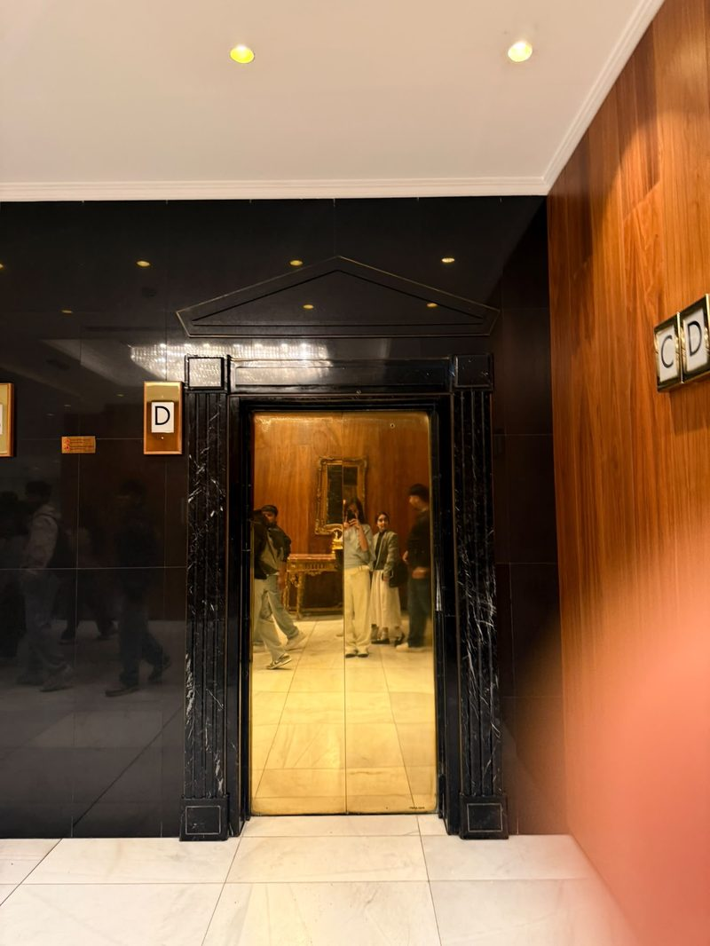
Figure 1. Lift lobby, Meliá White House: black marble surround and brass-coloured door.
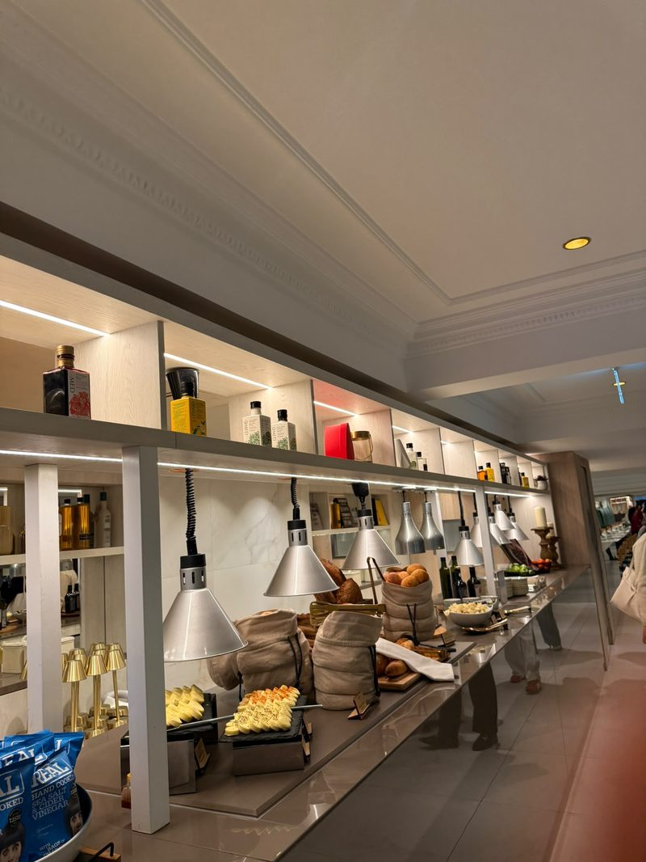
Figure 2. Breakfast buffet counter with lit shelving, GMED oils, hot lamps and linen bread bags.
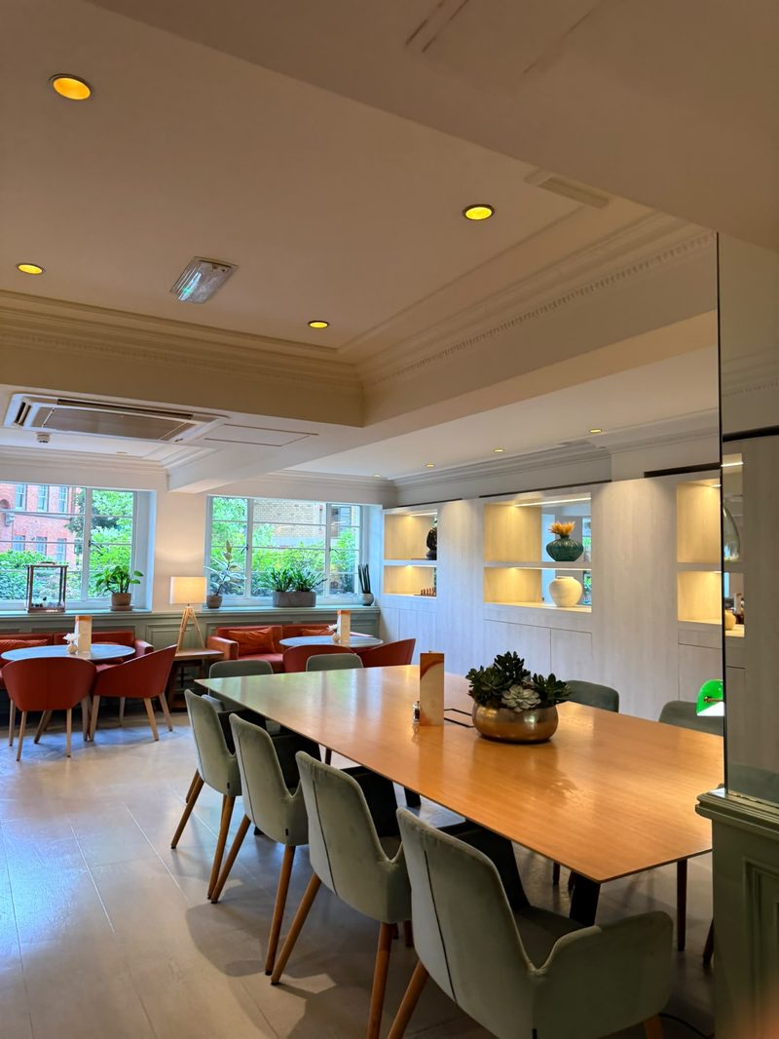
Figure 3. Lounge with long timber table and garden-facing café tables.
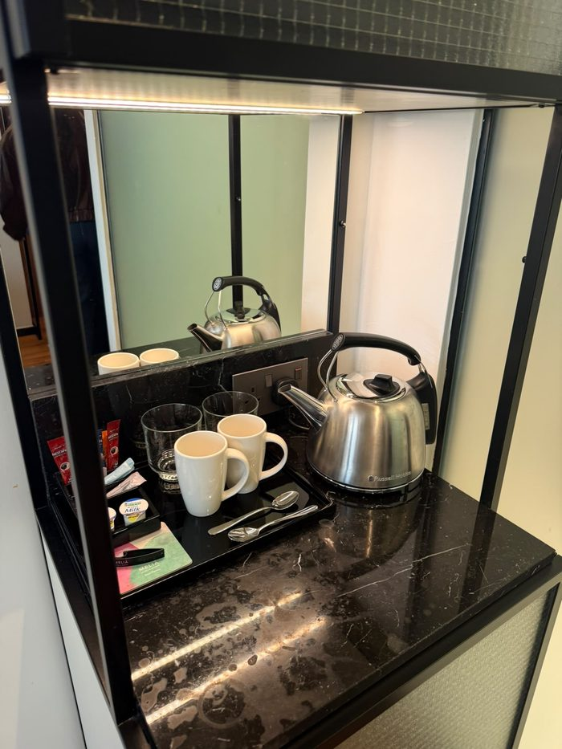
Figure 4. In-room tea and coffee tray with Nescafé sachets on a marked marble top.
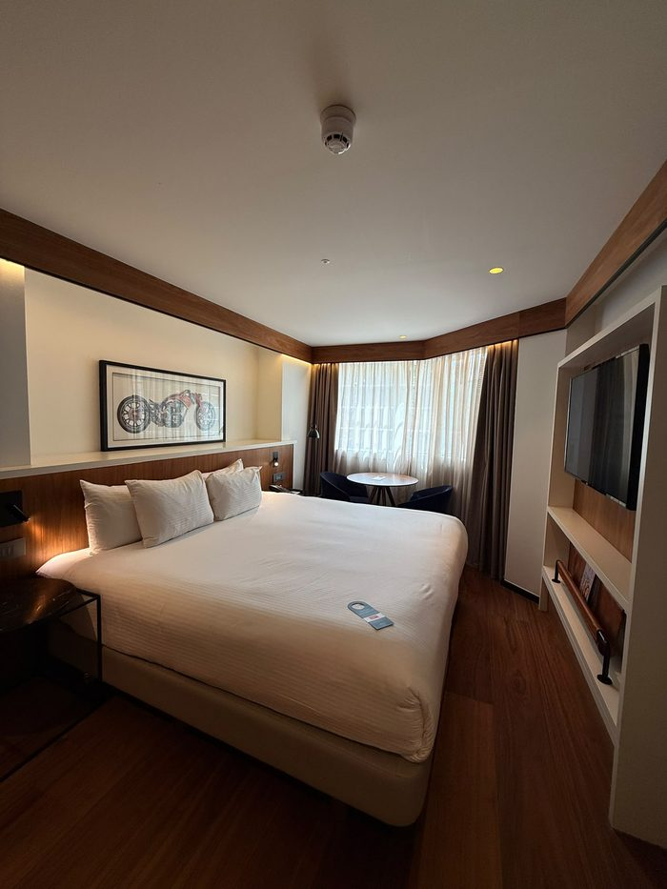
Figure 5. Guest room with walnut headboard, bay window and artwork.
Photographic evidence log
Fig. | What the photograph shows | Kano class | Reading
1 | Lift lobby: black marble surround, pediment, brass-coloured door | Must-be | Gap: door finish looks dull and uneven
2 | Breakfast counter: lit shelving, GMED oils, hot lamps, linen bread bags, Real Crisps | Attractive | Strength
3 | Lounge: long timber table, garden-facing café tables | Attractive | Strength: flexible work-and-dine space
4 | Room tea and coffee tray: Nescafé sachets, portion milk, marked marble | Must-be and attractive | Gap: off-brand coffee, surface marks
5 | Guest room: walnut headboard, bay window, artwork | Attractive | Strength

Appendix 2: Source map
Source | Can prove | Cannot prove | Handle with
Visit observation and photos, 9 September 2025 | What a guest sees in public areas on one day | Typical standards across the year | Say “on the day observed”
Staff session and tour commentary | How staff describe the positioning and the starting rate (about £300 a night) | Official policy; the session was careers-led and informal | Paraphrase; do not quote as policy
Camden planning documents; Historic England list entry | Listing, building form, room count | Current operations; dates may be unclear | Cite date; note the room-count conflict
Meliá press release (Hospitality Net, 2023) | The promise the brand makes | Whether it is kept | Treat as promotional
Business Traveller (2024) | Co-working offer and renovation figures from an independent outlet | Uptake or revenue; possible partner input | Cite exact date
Brand Finance and S&P coverage | Group-level standing | Anything about this hotel | Attribute as claims, not facts

Appendix 3: Promise-versus-proof ledger
Promise | Proof seen | Status | Type | Evidence
Premium, “exceeds expectations” (press release) | Dull lift door, dusty grille, marked tray top | Amber | Technical quality | Figs. 1, 4
Mediterranean F&B identity | Strong at buffet and drinks station; instant coffee in room | Amber | Consistency | Figs. 2, 4
Heritage as an asset | Cornice and oak detail carried through; grille and door finish let it down | Amber | Setting | Fig. 1
A place to work and dine | Lounge, communal table; £40 day pass | Green | Enterprise | Fig. 3; Business Traveller (2024)
Premium guest room | Walnut headboard, bay window, artwork | Green | Technical quality | Fig. 5

Appendix 4: 90-day timeline (estimates)
When | Action | Milestone
Days 1 to 30 | R2, R1 sweep | Playbook signed off; sweep done; weekly walk begins
Days 31 to 60 | R4, R1 weekly | Codes live on day passes; first redemption report
Days 61 to 90 | R3 pilot | One-floor pilot; review of mentions and spend; roll-out decision
Action plan: owners, KPIs and estimates
# | Action | Owner | Timing | Cost (est.) | KPI
R1 | Must-be sweep and weekly walk | Housekeeping / engineering | 1-3 months | Low | Checklist pass rate; condition mentions in reviews
R2 | Breakfast recovery playbook | F&B / guest services | ~1 month | Low | Time to first response; make-good rate
R3 | Spanish in-room kit (pilot floor) | Rooms division / F&B | ~3 months | Low to medium | In-room F&B mentions; minibar spend
R4 | Track The Level | Revenue / F&B | ~2 months | Low | Desk occupancy; redemption rate; spend per pass

