Four Lenses, One Building: Triangulating the Google King’s Cross Headquarters (Platform 37) through Shock, Flex, Level and Pattern

A retrospective project management analysis

Module: Project Management
Student name: [insert]
Student number: [insert]
Submission date: [insert]
Word count (main body): 3,360

Contents
Right-click and select Update Field to refresh the contents.

List of figures and tables
Figure 1: Four-lens diagnostic of documented KGX1 deviations
Figure 2: KGX1 life cycle stages: decision owner and iron-triangle trade-off
Table 1: KGX1 stages, decisions, owners and signatures
Table 2: KGX1 scope statement
Figure 3: KGX1 scope boundary and interfaces
Figure 4: High-level KGX1 schedule: original plan against actual
Table 3: Documented scope changes and public disclosure
Table 4: Resource categories, allocation and resource-based budget
Figure 5: Estimate maturity across the life cycle
Figure 6: Evidence for each cost-escalation cause
Table 5: KGX1 risk register by level and owner
Figure 7: Response-mapped matrix: inherent to residual position
Table 6: KPIs along the output, outcome and benefit chain
Figure 8: Retrospective change request for the 2020 hold
Figure 9: Who decides at each step of change control

Introduction
Platform 37 (KGX1), Google's first wholly owned and designed building outside the United States, was designed by BIG with Heatherwick Studio and delivered by Lendlease in King's Cross (New Steel Construction, n.d.; Building, 2017a; Construction Enquirer, 2017). It sits within a regeneration masterplan and Google's UK strategy, and standard sources supply five failure signatures against which to test it. Four lenses are applied: Shock (compounding uncertainty), Flex (time as shock absorber), Level (nested systems) and Pattern (counter-case) (Engwall, 2003; Flyvbjerg, Bruzelius and Rothengatter, 2003). The report argues that no single lens explains the record and that the evidence often cannot separate them. Triangulation adds nothing if one lens explains everything, and a private building may not compare with public megaprojects (Flyvbjerg, 2006; Yin, 2018). I write as the project manager reviewing retrospectively. Predictions were fixed before testing (Appendix B); derived and assumed figures are labelled by tier.

Section 1: Project Life Cycle Analysis
At project level KGX1 reads as a stage-gated hybrid: Lendlease was confirmed in February 2017, six months before reserved-matters approval in August 2017 (Construction Enquirer, 2017; Camden Council, 2017), so procurement overlapped planning. At programme level it reads as staged waterfall, because approval came as reserved matters under the estate's outline permission (Camden Council, 2017). Waterfall (Initiate, Plan, Implement, Close) sequences work; agile (Concept, Plan, Build, Test, Review, Release) iterates; hybrids combine gates with iteration (Cooper and Sommer, 2016).
Business case preparation justifies the need and closes at funding approval. Planning sets scope, schedule and consents, closing at approval. Design fixes the solution, closing at design freeze. Development builds it, closing at completion. Deployment hands over, fits out and occupies, closing at occupation. Evaluation reviews outcomes and benefits (APM, 2019; PMI, 2021).
Figure 1 tests the four lenses against five deviations, D1 to D5; predictions were fixed first (Appendix B), so a lens cannot be chosen after the data.
Figure 1: Four-lens diagnostic of documented KGX1 deviations (justified in Sections 1 to 5)
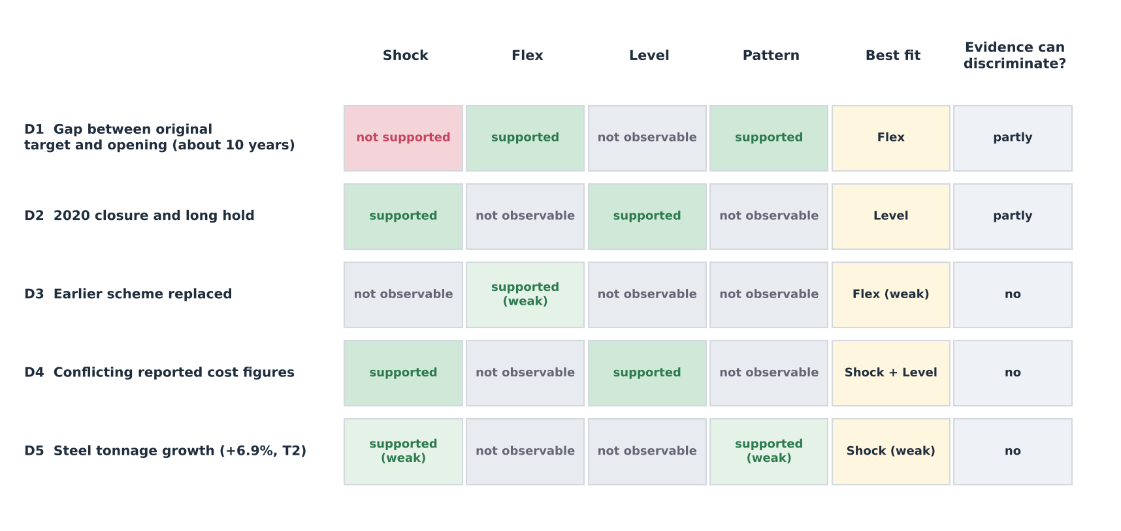
The lenses predict different things of the same stage map. Shock expects overlapping stresses at one stage, Flex stable scope with flexing time, Level decisions above the project lane, and Pattern a recognisable signature stage; a plain stage list could not discriminate among them.
Figure 2 and Table 1 show who owned each stage's decision and which corner of the iron triangle was held or flexed.
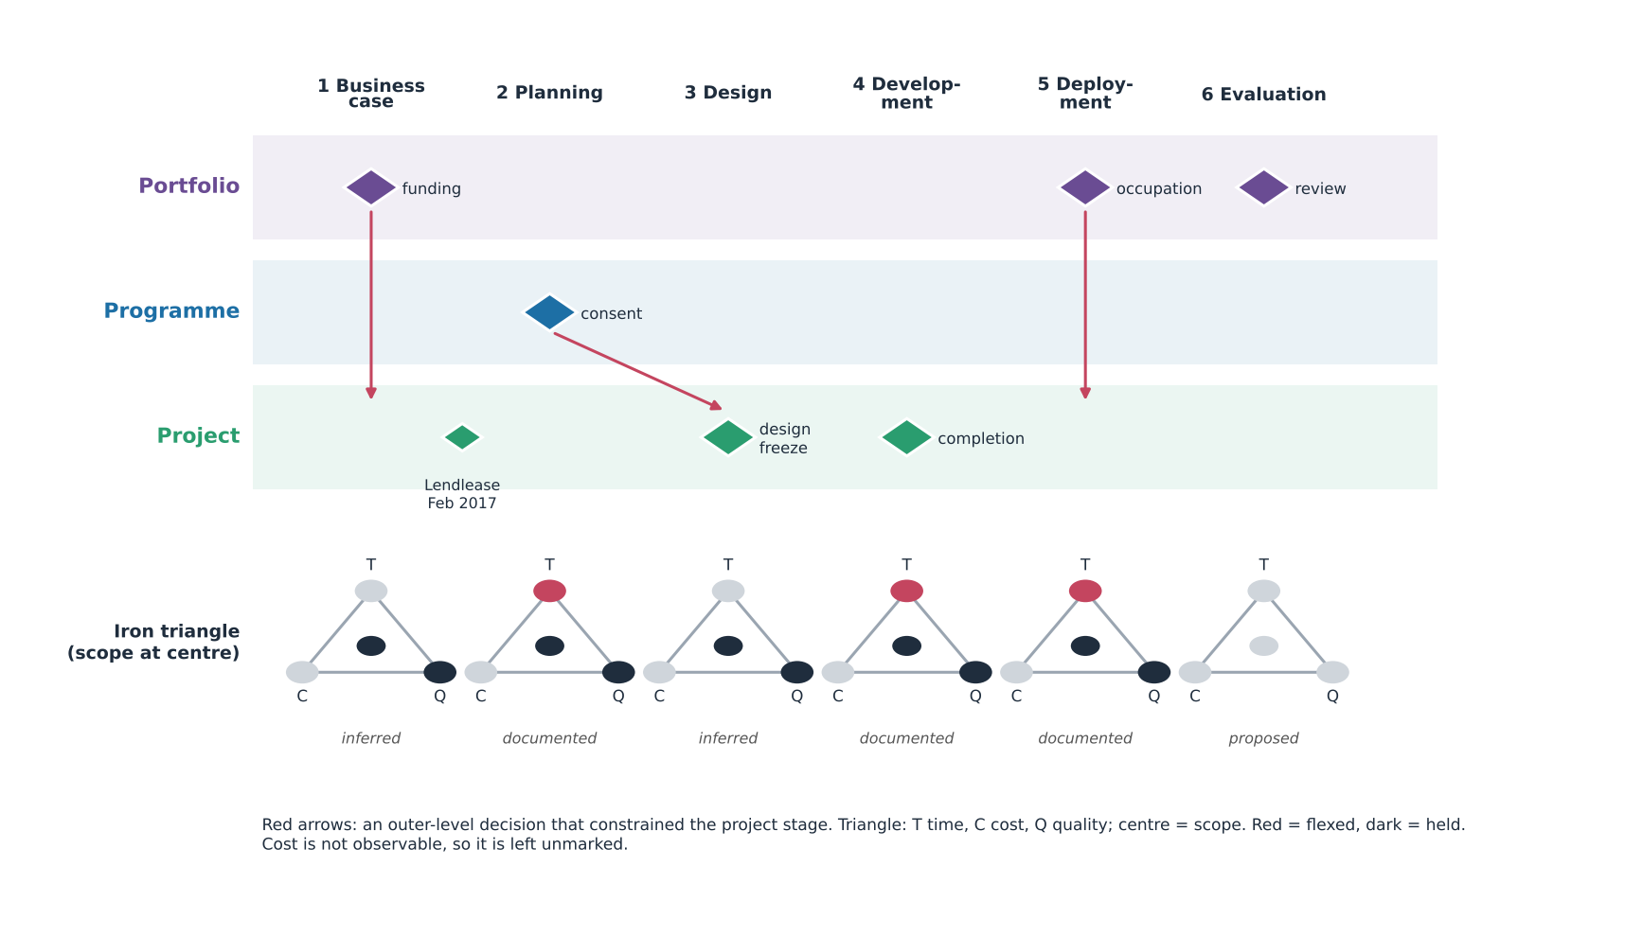
Figure 2: KGX1 life cycle stages: decision owner and iron-triangle trade-off (T1; inferred where marked)
Table 1: KGX1 stages, decisions, owners and signatures (inferred unless cited)
Stage | Timing | Event or decision | Roles | Level | Held or flexed
Business case | To 2016 | Campus confirmed (Camden New Journal, 2016) | Google | Portfolio | Scope, quality held
Planning | 2017 | Contractor February; approval August (Camden Council, 2017) | Camden | Programme | Time flexed
Design | To 2017 | Scheme replaced (Building, 2017a) | Architects | Project | Quality held
Development | 2018 (T3) to 2026 | Hung 17,000 t frame; 2020 hold (Building, 2020) | Lendlease | Project, portfolio | Time flexed
Deployment | 2026 | Move-in from summer (Google, 2026) | Google | Portfolio | Time absorbed
Evaluation | After opening | Benefits review (proposed) | Google | Portfolio | Tests the case

Portfolio and programme levels dominated the early and late stages, the project the middle. The documented sequence is as follows. Google's chief executive confirmed a campus in November 2016; Lendlease was confirmed in February 2017; Camden approved in August 2017; the hung frame followed, with construction from 2018 assumed; the site was shut in March 2020 and still on hold when other Lendlease sites reopened (Building, 2020); and staff move in from summer 2026 (Google, 2026), about ten years after the first completion date (Building, 2026). Approval had to precede mobilisation, yet procurement preceded approval. An outer-level decision constrained the project where the contractor's group, not the site, governed restart. The first completion date, mid-2016 by derivation (T2), passed before approval, so D1 most likely began at planning.
Structured models improve outcomes through different lenses. Waterfall's early baseline controls cost only if estimates are mature, which relies on Shock. Agile review would surface a sponsor's rejection of a scheme sooner than a gate that records approval, which relies on Flex. Stage-gate criteria concentrate checking where consent and structure are tested, which relies on Level, since consent sits above the project. Hybrid iteration shortens feedback but cannot prevent a contractor-group stoppage. Morris and Hough (1987) place failure at the front end; Atkinson (1999) warns that time, cost and quality omit other success criteria; and agile evidence is largely software-based.
Earlier contractor involvement improves buildability but binds the owner before consent. I recommend a formal design-freeze and approval gate with a stated reopening route; it would test Flex directly, since cheap reopening shows time flexing by choice.

Section 2: Business Case, Scope & Schedule
Whose business case was it? Google's. Strategically, its chief executive confirmed a King's Cross campus (Camden New Journal, 2016); commercially, ownership gave control of a flagship; financially, private capital funded it, and no public cash flow exists. Competitiveness and technological positioning appear in Google's account of Platform 37 and a public AI Exchange on the ground floor (Google, 2026). For low-carbon construction I found no objective on my sources, so that theme is untested. A disbenefit is capital concentrated in one asset. Measurable (SMART) benefits are unpublished, a recognised pitfall (Zwikael and Smyrk, 2011), so outputs (the building), outcomes (public and occupier use) and benefits (strategic value) cannot be reviewed.
Google held decisive influence, Camden consent power and Lendlease delivery control. The tension lay in the replacement of the earlier scheme (Building, 2017a), whose cause is inferred. Zwikael and Smyrk (2011) presume an accountable benefits owner, which an owner-occupier supplies, whereas Flyvbjerg's work presumes incentives that private ownership weakens.
Table 2: KGX1 scope statement reconstructed from public sources (T1; inferred where marked)
Element | Content | Level
Deliverables | Building; roof terraces and running track (New Steel Construction, n.d.); public ground-floor space (Google, 2026) | Project
Exclusions | Estate public realm and transport links; neighbouring buildings (inferred) | Programme
Assumptions | Planning consent (Camden Council, 2017); site available on time | Programme
Constraints | Dense urban site (inferred); hung 17,000 t structure | Project

Table 2 shows that two of four elements depend on the programme level.
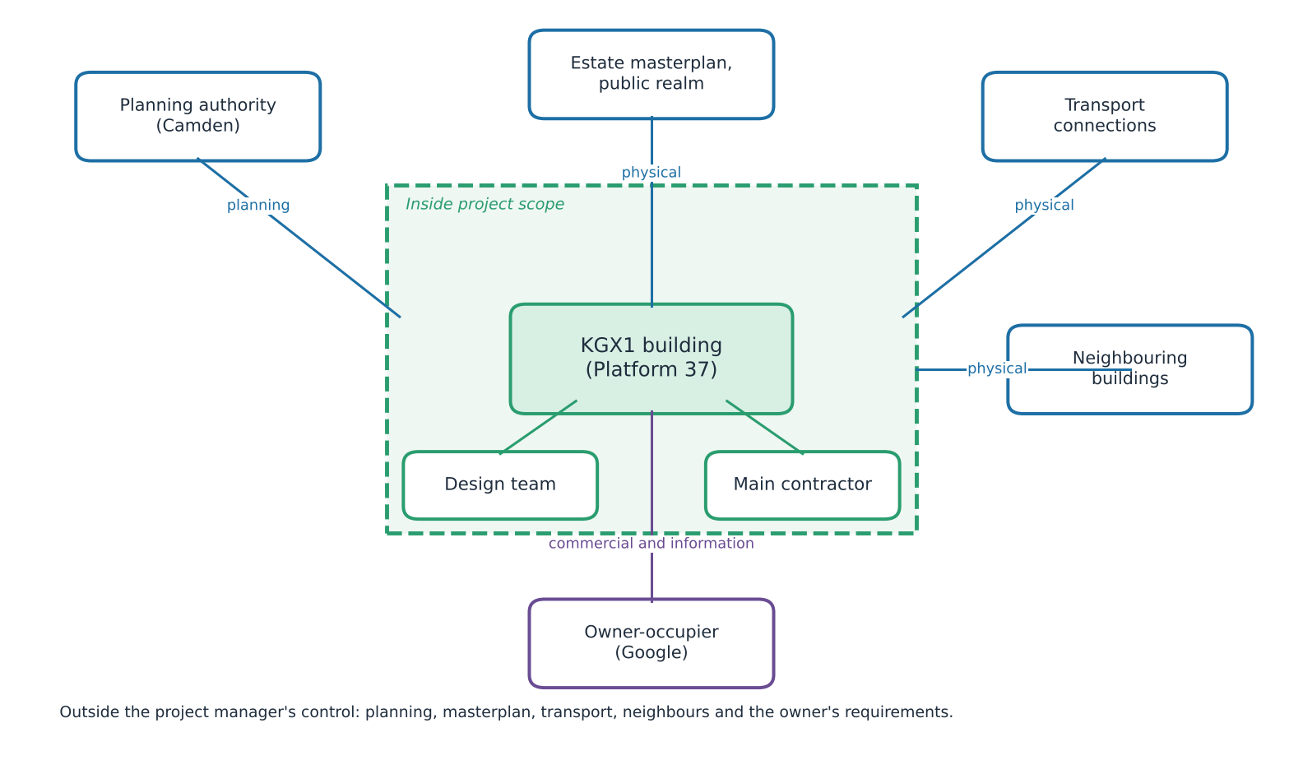
Figure 3: KGX1 scope boundary and interfaces (T1; inferred where marked)
Five of seven interfaces sat outside the project manager's control. Because Google prioritised an owner-occupied flagship, scope fixed the structure, terraces and running track early and left estate infrastructure and detailed fit-out to others (inferred).
Three pressures shaped dates. Political expectations acted through planning consent at programme level, with approval in August 2017. Funding cycles were corporate capital at portfolio level, not public money. Strategic priorities, the technology commitment, dominated. D1 fits Flex best: ownership let dates move while the iconic scheme held, and no firm external deadline is documented. Flex assumes a patient owner with low delay cost, and it is partly circular, since any slip can be redescribed as chosen; its test is whether scope and quality stayed stable. The iconic scheme did, yet the scheme was replaced, so scope did not hold absolutely. D1 cannot be separated from Level, because the approval date was set at programme level. Megaprojects run late (Flyvbjerg, 2014), and optimism bias and strategic misrepresentation, which Flyvbjerg, Holm and Buhl (2002) treat as rival explanations, both remain possible.
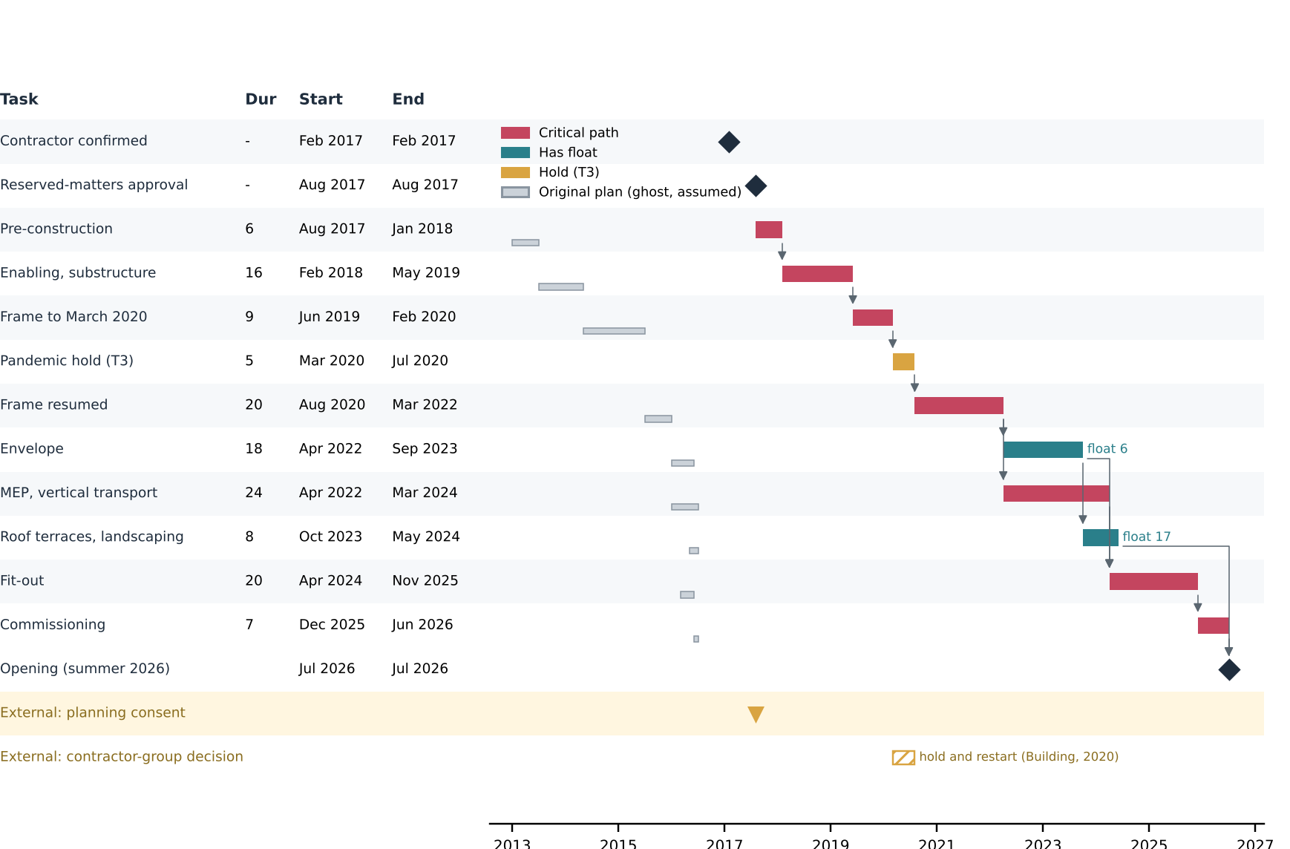
Figure 4: High-level KGX1 schedule: original plan against actual, dependencies, float and critical path (milestones T1; durations T3; Appendix B)
The critical path runs through pre-construction, frame, hold, services, fit-out and commissioning (Gray and Larson, 2020); envelope carries six months of float. Ghost bars diverge before construction, though the original split is assumed. A Gantt chart shows no resources.
Table 3: Documented scope changes and public disclosure, KGX1 and Crossrail
Change or artefact | Detail | Crossrail | KGX1
Scheme replaced | 2013 outline to 2017 approval; cause inferred (Building, 2017a) | - | T1
Steel tonnage | 15,900 t to 17,000 t, +6.9% (T2; Building, 2017b; New Steel Construction, n.d.) | - | T1/T2
Business case | Published 2003 | Public | None found
Cost plan, risk register, progress reports | - | Not checked | None found

Absence of public scope creep is not evidence of absence; Crossrail's public business case (Cross London Rail Links, Strategic Rail Authority and Transport for London, 2003) shows disclosure does not prevent reputational damage. Recommendations: publish a scope-change log; agree dates as ranges with the programme; hold a joint scope-freeze gate before procurement; and record exclusions so later cost comparisons are like for like.

Section 3: Resource Planning & Budget Analysis
Table 4: KGX1 resource categories, allocation and resource-based budget (derived estimate; rates and areas T3)
Category | Example | Constraint
Human | Erectors, trades | Availability
Materials | 17,000 t steel (New Steel Construction, n.d.) | Timing
Equipment | Cranes (inferred) | Site space
Financial | Shell and core about £350m (Construction Enquirer, 2017) | Cost
Technical | Design coordination (inferred) | Feasibility
Package | Quantity x rate | £m (tier)
Steel | 17,000 t x £2,900 | 49.3 (T1, T3)
Substructure | 90,000 m2 x £420 | 37.8 (T3)
Facade | 90,000 m2 x £1,050 | 94.5 (T3)
Services | 90,000 m2 x £950 | 85.5 (T3)
Terraces | 12,000 m2 x £800 | 9.6 (T3)
Preliminaries 12% | On £276.7m | 33.2 (T3)
Contingency 10% | On £309.9m | 31.0 (T3)
Total | Check against £350m | 340.9 (T3)

Steel sets the sequence: frame, then envelope and services, then fit-out. The quantity was 17,000 t at completion (15,900 t at contract), documented; effort is derived. At an assumed 5 t per gang-day and ten-worker gangs over 29 months of 21 days, effort is 3,400 gang-days, about 56 erectors (T3); at 3 t it is about 93 and at 8 t about 35. Areas and rates are assumed because no price book was held; Appendix D gives the workings. The total is a derived estimate, not a KGX1 outcome. Its order of magnitude is plausible; the main uncertainty lies in area and rate, not steel quantity, so reliability is bounded by T3 inputs; each rate is assumed, so the budget illustrates method, not outcome.
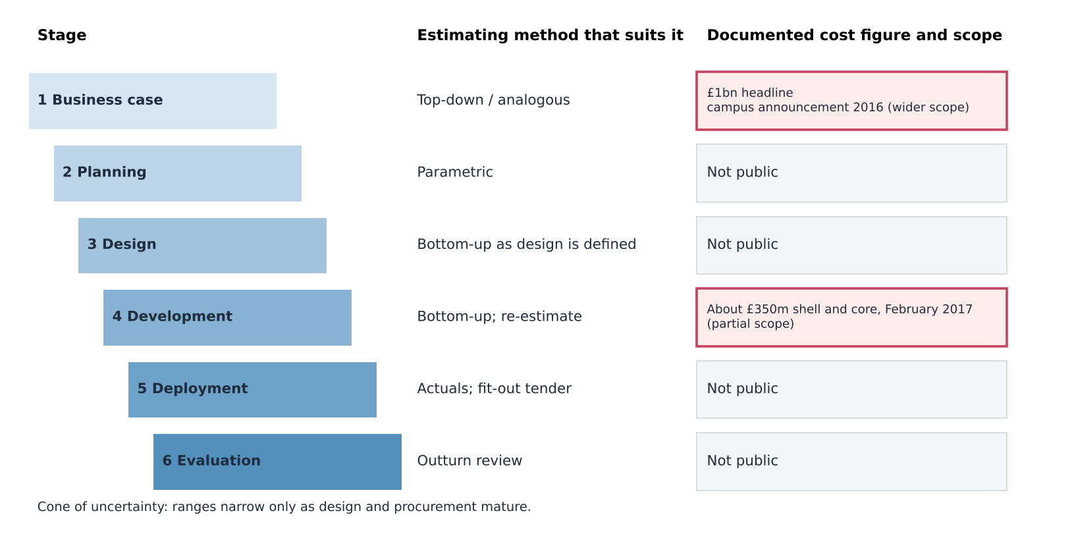
Figure 5: Estimate maturity across the KGX1 life cycle (T1 figures only)
The contract figure and the £1bn headline sit at different stages and scopes, so they cannot be compared directly; the cone of uncertainty narrows only as design matures.
Estimating method should follow maturity: top-down early, parametric at planning, bottom-up as design firms up, though bottom-up precision can disguise optimism (Gray and Larson, 2020; Kerzner, 2022). The derived total of £340.9m sits £9.1m (2.6%) below the contract figure; the closeness is a plausibility check, not validation, since the assumed rates could be tuned. The £1bn headline appeared at concept stage with wider scope (Camden New Journal, 2016), so their ratio, 2.9 (T2), measures stage and scope, not overrun. Optimism bias predicts underestimation (Flyvbjerg, Holm and Buhl, 2002); front-end definition predicts that maturity narrows error (Merrow, 2011); the data cannot adjudicate. Contingency is judgement. PERT for the frame, with 24, 29 and 42 months (T3), gives (24 + 116 + 42) / 6 = 30.3 months.
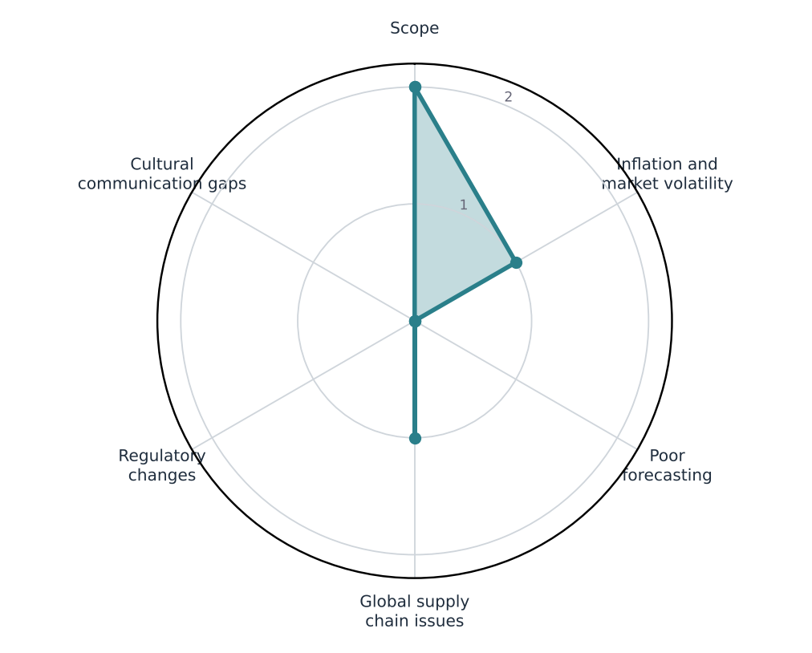
Figure 6: Evidence for each cost-escalation cause at KGX1 (0 none, 1 inferred, 2 documented; a qualitative evidence score)
Only scope is documented, through the tonnage change and replaced scheme; inflation and supply-chain pressure are inferred; the rest are not observable. Lens Shock explains the inferred causes best, though they cannot be separated from Level.
Constraints shaped four outcomes. Specialist availability affected scheduling because the frame gated every later trade. The hung structure affected risk exposure because one delay reaches all successors. Concurrent packages affected feasibility because a dense site (inferred) limits access. Late scope change affected contractor performance because packages are repriced. The resource-conflict signature, illustrated by Denver, is not observable; the observable hold was a contractor-group decision (Building, 2020), which favours Level over Shock. Flex predicts cost secondary to time, which the long hold is consistent with; Level predicts figures belonging to different scopes and levels, which the corridor confirms. These two are compatible, not rival.
Cost planning tested organisational skills and adaptability: a manager had to hold a baseline while reported totals differed by stage and scope. The competency lay in challenging a single precise figure and stating assumptions openly. Section 4 turns the constraints into risks.

Section 4: Risk Assessment & Contingency Planning
Risk management follows four stages: identify, assess, respond, monitor (Chapman and Ward, 2003). I use four categories (operational, external, financial, technical), a 4x4 scale with score = probability x impact (Low 1-2, Medium 3-4, Serious 6-9, High 12-16), and a PMO for consistency and escalation; the process is never one and done (APM, 2019).
Table 5: KGX1 risk register by level and owner (R4 and R6 inferred; others documented; Appendix E)
ID | Risk (category) | Level | P | I | Score | Response | Owner
R1 | COVID-19 closure and long hold (external) | Portfolio | 4 | 3 | 12 | Restart (reduce) | Lendlease
R2 | Group-wide pause with Google's other jobs (external) | Portfolio | 3 | 3 | 9 | Escalate only | Contractor group
R3 | Hung steel structure (technical) | Project | 2 | 4 | 8 | Transfer | Steel supplier
R4 | Delivery and fit-out interface (operational) | Project | 3 | 2 | 6 | Not evidenced | Google
R5 | Cost-baseline uncertainty (financial) | Programme | 4 | 2 | 8 | Accept | Google
R6 | Planning condition change (external) | Programme | 2 | 3 | 6 | Not evidenced | Master developer
O1 | Specialist fabricate-and-erect delivery (opportunity) | Project | 2 | 3 | 6 | Exploit | Steel supplier

Three scores carry the argument. R1 scores 12: the closure occurred, hence likelihood 4. R2 scores 9: the job stayed on hold after other Lendlease sites reopened (Building, 2020), a decision above project level. R3 scores 8: remote failure with catastrophic consequence on the critical frame. Figure 7 colours each cell by the response its position suggests, with arrows from inherent to residual position and circles coloured by owning level. R3's transfer matches its cell and did not move it; R5's acceptance mismatches; R1's restart reduced impact only after occurrence; R2 could not be treated at project level.
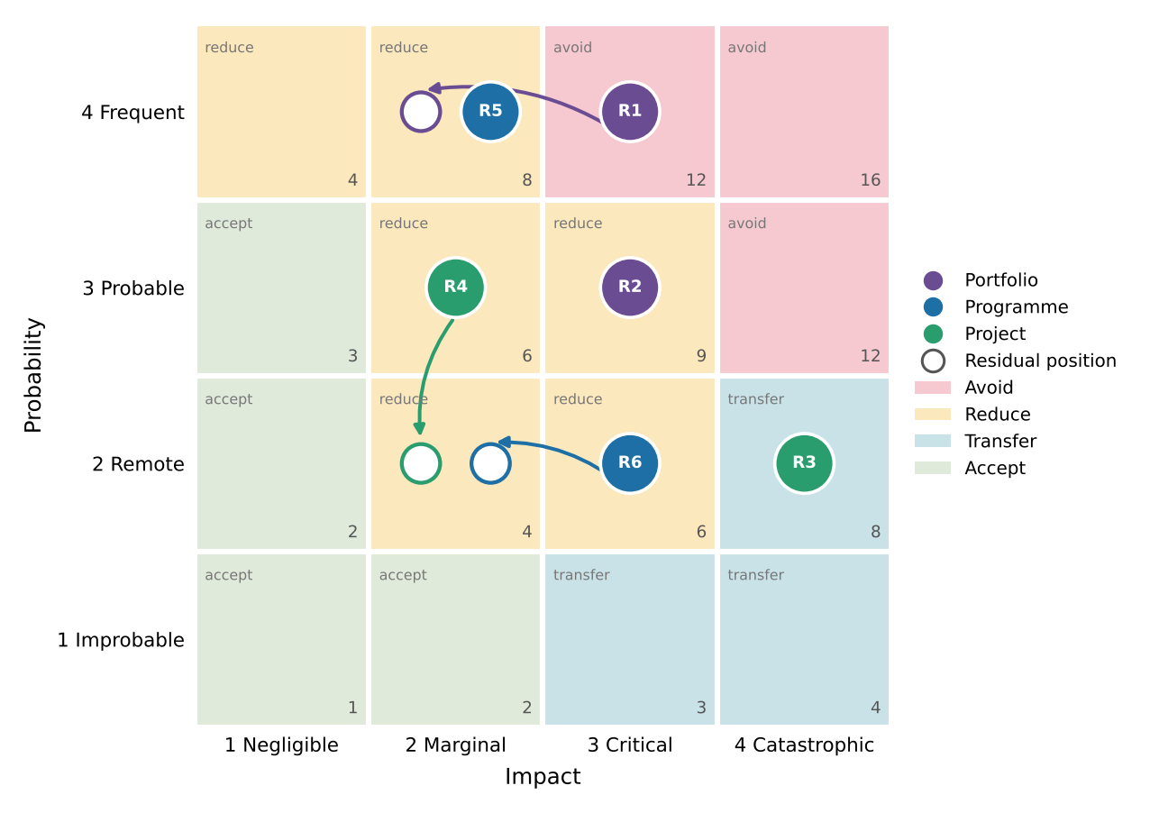
Figure 7: KGX1 risks on a response-mapped matrix: inherent to residual position, by owning level (T3 scores)
The register is relevant to what the project could treat. R3 and R4 were treatable within the project; R1's cause and R2 could only be escalated. A matrix scores each risk alone and is blind to ownership, so it cannot show which level should have acted.
Appetite, tolerance and capacity differ by level. A patient owner with strong capital may tolerate schedule risk, which fits Flex, while the project team, measured on delivery, cannot; the programme, accountable to the planning authority, tolerates public-realm risk least (inferred). Identical delay is therefore a manageable loss at one level and a failure at another.
Three responses can be evaluated. For R1, restart was a reactive reduction, effective only after occurrence. For R2, the manager could only escalate. For R3, transfer to a specialist package suited a risk the supplier could price, yet delay still reaches the owner, because transfer moves risk without removing it. Responses beyond these are inferred. Shock is partly supported: R1 and R2 were one correlated event, but earlier slips did not overlap with it in time. Pattern is mixed: Terminal 5 shows delivery success can still fail at operation (Brady and Davies, 2010), and the trade press framed the opening as "ten years after it was first set to complete" (Building, 2026), one source, so reputational damage is weak.
Plan B statements, one per level. Portfolio reserve: trigger, group-wide stand-down notice; owner, Google; action, standby terms; cost, neutral. Programme contingency: trigger, change to planning conditions; owner, master developer; action, joint interface review; cost, neutral. Project buffer: trigger, positive case on site; owner, project manager; action, phased restart plan; cost, upward. Contingency covers identified risks; management reserve covers unknowns.
Recommendations: hold an interface risk workshop with all levels, including operational readiness; keep one cross-level register; state an escalation route for decisions above project level; and treat opportunities such as O1 within the same process (Hillson, 2002), since poorly defined risks and opportunities weaken any register. Stress management mattered because the manager carried accountability for risks owned elsewhere.

Section 5: Progress Review & Intervention Strategies
KGX1 spans 107 months from approval to move-in (T2: August 2017 to July 2026), with a hung structure and a dense site. Monitoring mattered most at approval, during frame erection, through the 2020 hold and at fit-out.
Four KPI groups apply: schedule (milestones, SPI), cost (CPI, cost variance), quality (defects, rework) and stakeholder communication (Shenhar et al., 2001). Earned value shows that a project is off plan, not why (Fleming and Koppelman, 2010). Actual cost is not public, so a real CPI cannot be computed; Appendix F gives an illustrative example.
Table 6: KPIs along the output, outcome and benefit chain (T1/T2)
Link | KPI and level | KGX1 evidence | Status | Data needed
Output: building | Schedule SPI; project | Move-in from summer 2026; first date missed (Google, 2026; Building, 2026) | Partly known | Baselines
Outcome: use | Stakeholder communication; programme | Public AI Exchange opening later in the year (Google, 2026) | Partly known | Visitor, occupancy data
Benefit: strategic value | Benefits measure; portfolio | Not yet measurable | Not yet known | Targets, review date

The evidence supports the output link partly; outcomes and benefits cannot yet be judged, because the building is only now opening. Three deviations follow. The missed first date would have flagged at once against a baseline; the 2020 hold within one reporting cycle; and the cost-figure conflict at the first CPI, which cannot be computed until scope is fixed. Quality has no public data; I would track defects per package and rework hours. Quality and stakeholder communication are the weakest-evidenced KPI groups; a reviewer would need defect logs and a communications register.
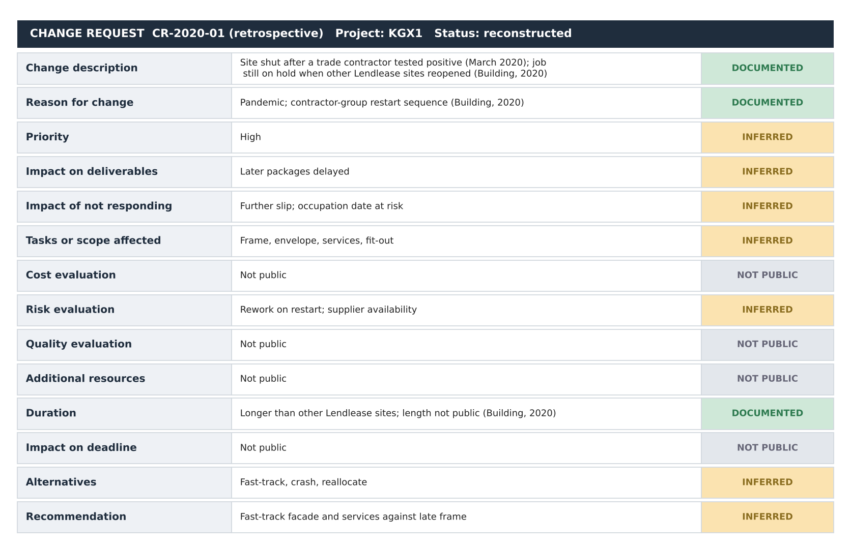
Figure 8: Retrospective change request for the 2020 hold, completed from public sources
Only the description, reason and part of the duration can be completed publicly; cost, quality and deadline impact cannot.
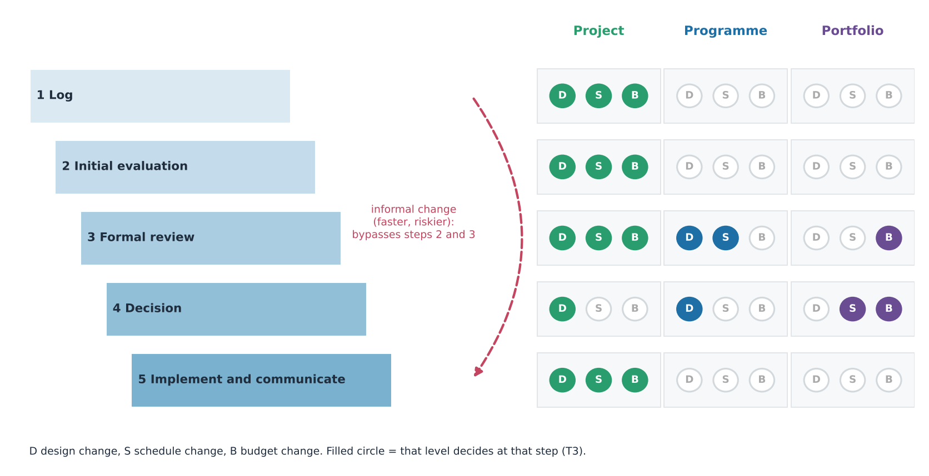
Figure 9: Who decides at each step of change control, by level (T3)
Change control follows five steps: log, evaluate, review, decide, implement and communicate (Kerzner, 2022). The staircase would have stopped an informal budget change at step 3 and required the portfolio level for budget decisions. Together, Figures 8 and 9 show the observability limit: a reviewer can name the steps and decision rights but cannot see whether KGX1 followed them.
Earned value assumes a fixed baseline and a single decision-maker. Where scope flexes and decisions sit above the project, SPI and CPI measure against a plan others may have changed. Benefits-based success (Shenhar et al., 2001) adds customer impact and future preparation, which suits an owner-occupier but cannot yet be measured.
Was the response planned or reactive? Restart came after other Lendlease sites reopened (Building, 2020), which looks reactive, but without the change log the data cannot distinguish them. Sydney Opera House is the assignment's reactive case, and Terminal 5 shows that delivery success can still end in public failure (Brady and Davies, 2010). Recovery options: fast-tracking, low cost with medium scope impact, suits the hold (in the standard example a 15-day activity falls to 11 days by fast-tracking and 9 by crashing, so crashing buys two further days at higher cost); crashing, high cost with low scope impact, suits a late milestone; resource reallocation was constrained because other Google jobs were also held (inferred). Each technique needs an owner: fast-tracking needs contractor consent, and crashing needs owner funding. By lens, D2 is best explained by Level, because the restart sequence followed the contractor's group; Shock explains the cause (COVID-19) but not the decision, Flex fits the unhurried restart, and Pattern cannot code it planned or reactive, so the lenses separate only partly.
Recommendation: private megaprojects should disclose baseline dates, an approved change log, actual cost at each gate, defect rates and an escalation record. Stage-gate summaries would suffice, without commercial terms. Communication and leadership mean carrying bad news upward early and agreeing thresholds with the owner before a baseline is set (Atkinson, 1999).

Conclusion
Triangulation added to any single explanation. Flex fits D1 best, Level fits the 2020 hold and, with Shock, the cost-figure conflict; the lenses cannot be separated for the scheme change or steel growth, and reactive intervention, overruns and resource conflicts are not observable. Parsimony fails: no single lens explains everything. Public data and clearly labelled estimates limit confidence. Comparing four explanations taught me that tools discriminate only where evidence is disclosed, so disclosure, not method, decides what a review can prove. The origin of the first completion date remains unexplained.

References
APM (2019) APM Body of Knowledge. 7th edn. Princes Risborough: Association for Project Management.
Atkinson, R. (1999) 'Project management: cost, time and quality, two best guesses and a phenomenon, its time to accept other success criteria', International Journal of Project Management, 17(6), pp. 337–342.
Brady, T. and Davies, A. (2010) 'From hero to hubris: reconsidering the project management of Heathrow's Terminal 5', International Journal of Project Management, 28(2), pp. 151–157.
Building (2017a) Google's exciting King's Cross HQ given go-ahead. Available at: https://www.building.co.uk/news/googles-exciting-kings-cross-hq-given-go-ahead/5089175.article (Accessed: 9 November 2026).
Building (2017b) Severfield snags prized steel contract for new Google HQ. Available at: https://building.co.uk/news/severfield-snags-prized-steel-contract-for-new-google-hq/5091122.article (Accessed: 9 November 2026).
Building (2020) Lendlease begins to reopen sites but Google job still on hold. Available at: https://www.building.co.uk/news/lendlease-begins-to-reopen-sites-but-google-job-still-on-hold/5105656.article (Accessed: 9 November 2026).
Building (2026) Google's £1bn King's Cross headquarters to open this summer, 10 years after it was first set to complete. Available at: https://www.building.co.uk/news/googles-1bn-kings-cross-headquarters-to-open-this-summer-10-years-after-it-was-first-set-to-complete/5141281.article (Accessed: 9 November 2026).
Camden Council (2017) Planning application 2017/3133/P: reserved matters for Development Zone A, King's Cross Central (decision notice dated 16 August 2017). Available at: https://camdocs.camden.gov.uk/CMWebDrawer/PlanRec?q=recContainer%3A2017%2F3133%2FP (Accessed: 9 November 2026).
Camden New Journal (2016) Google commits to expanding operations in King's Cross with £1bn campus, 20 November. Available at: https://www.camdennewjournal.co.uk/article/google-commits-to-expanding-operations-in-kings-cross-with-1bn-campus (Accessed: 9 November 2026).
Chapman, C. and Ward, S. (2003) Project risk management: processes, techniques and insights. 2nd edn. Chichester: Wiley.
Construction Enquirer (2017) Lendlease confirmed for Google HQ, 27 February. Available at: https://constructionenquirer.com/2017/02/27/lendlease-confirmed-for-google-hq (Accessed: 9 November 2026).
Cooper, R.G. and Sommer, A.F. (2016) 'The agile–stage-gate hybrid model: a promising new approach and a new research opportunity', Journal of Product Innovation Management, 33(5), pp. 513–526.
Cross London Rail Links, Strategic Rail Authority and Transport for London (2003) The Crossrail business case, September. Available at: https://learninglegacy.crossrail.co.uk/wp-content/uploads/2023/04/Crossrail-Economic-Business-Case-2003.pdf (Accessed: 9 November 2026).
Engwall, M. (2003) 'No project is an island: linking projects to history and context', Research Policy, 32(5), pp. 789–808.
Fleming, Q.W. and Koppelman, J.M. (2010) Earned value project management. 4th edn. Newtown Square, PA: Project Management Institute.
Flyvbjerg, B. (2006) 'Five misunderstandings about case-study research', Qualitative Inquiry, 12(2), pp. 219–245.
Flyvbjerg, B. (2014) 'What you should know about megaprojects and why: an overview', Project Management Journal, 45(2), pp. 6–19.
Flyvbjerg, B., Bruzelius, N. and Rothengatter, W. (2003) Megaprojects and risk: an anatomy of ambition. Cambridge: Cambridge University Press.
Flyvbjerg, B., Holm, M.S. and Buhl, S. (2002) 'Underestimating costs in public works projects: error or lie?', Journal of the American Planning Association, 68(3), pp. 279–295.
Google (2026) Platform 37 and The AI Exchange: new spaces for AI innovation and discovery. Available at: https://blog.google/company-news/inside-google/around-the-globe/google-europe/united-kingdom/platform-37-the-ai-exchange/ (Accessed: 9 November 2026).
Gray, C.F. and Larson, E.W. (2020) Project management: the managerial process. 8th edn. New York: McGraw-Hill Education.
Hillson, D. (2002) 'Extending the risk process to manage opportunities', International Journal of Project Management, 20(3), pp. 235–240.
Kerzner, H. (2022) Project management: a systems approach to planning, scheduling, and controlling. 13th edn. Hoboken, NJ: Wiley.
Merrow, E.W. (2011) Industrial megaprojects: concepts, strategies, and practices for success. Hoboken, NJ: Wiley.
Morris, P.W.G. and Hough, G.H. (1987) The anatomy of major projects: a study of the reality of project management. Chichester: Wiley.
New Steel Construction (n.d.) Steel landscraper takes shape in King's Cross. Available at: https://www.newsteelconstruction.com/wp/steel-landscraper-takes-shape-in-kings-cross/ (Accessed: 9 November 2026).
PMI (2021) A guide to the project management body of knowledge (PMBOK guide) and the standard for project management. 7th edn. Newtown Square, PA: Project Management Institute.
Shenhar, A.J., Dvir, D., Levy, O. and Maltz, A.C. (2001) 'Project success: a multidimensional strategic concept', Long Range Planning, 34(6), pp. 699–725.
Yin, R.K. (2018) Case study research and applications: design and methods. 6th edn. Thousand Oaks, CA: SAGE.
Zwikael, O. and Smyrk, J. (2011) Project management for the creation of organisational value. London: Springer.

Appendix A: Assumptions register by tier
T1 values are documented, T2 values are derived from T1 figures, and T3 values are assumed with a basis and range. I held no named price book, cost model or productivity rate, so all rates and areas are T3. Appendices are referenced in the body: A (all sections), B (Introduction, Sections 1 and 2, Figure 4), C and D (Section 3, Table 4), E (Section 4, Table 5, Figure 7), F (Section 5, Table 6) and G (all sections).
ID | Item | Value | Tier | Basis / source | Low | High
A01 | Steel quantity at completion | 17,000 t | T1 | New Steel Construction (n.d.)
A02 | Steel quantity at contract | 15,900 t | T1 | Building (2017b)
A03 | Steel growth | (17,000 - 15,900) / 15,900 = 6.9% | T2 | A01, A02
A04 | Shell and core contract | About £350m (February 2017) | T1 | Construction Enquirer (2017)
A05 | Headline figure | £1bn (2016) | T1 | Camden New Journal (2016)
A06 | Stage and scope ratio | 1,000 / 350 = 2.9 | T2 | A04, A05; not an overrun
A07 | Reserved-matters approval | August 2017 | T1 | Camden Council (2017)
A08 | Move-in | Summer 2026 | T1 | Google (2026); Building (2026)
A09 | Approval to move-in | 107 months | T2 | August 2017 to July 2026
A10 | First completion date | About mid-2016 | T2 | Opening minus ten years (Building, 2026)
A11 | Gross floor area | 90,000 m2 | T3 | No area on my list; sources conflict | 80,000 | 100,000
A12 | Roof terrace area | 12,000 m2 | T3 | Assumed | 8,000 | 16,000
A13 | Rates per t and per m2 | Table D1 | T3 | No price book held | ±25%
A14 | Preliminaries; contingency | 12%; 10% | T3 | Judgement | 8%; 7% | 15%; 15%
A15 | Steel rate; gang; window | 5 t per gang-day; 10 workers; 29 months | T3 | No published rate held | 3 t | 8 t
A16 | PERT for frame O, M, P | 24, 29, 42 months | T3 | Assumed around the network
A17 | Network durations | Table B2 | T3 | Calibrated to 107 months between documented dates | ±25%
A18 | Hold duration | 5 months | T3 | Building (2020): on hold when others reopened | 2 | 8
A19 | Risk scores | Table E1 | T3 | Judgement with stated evidence | ±1

Appendix B: Predictions, network and WBS workings
Table B1 was written before the evidence was tested and has not been edited since; it is the baseline against which Figure 1 is read (Yin, 2018).
Table B1: Predictions by lens (written before testing)
Deviation | S (Shock) predicts | F (Flex) predicts | L (Level) predicts | P (Pattern) predicts
D1 Gap between original target and opening (about ten years) | Several overlapping causes | Mostly time flexing before construction, with scope and quality stable | Conditions or decisions imposed from outside the project | Delay signature present
D2 2020 closure and long hold | A shock compounding earlier ones | Schedule absorbed the hit with no rush to recover | A decision above project level | Reactive rather than planned intervention
D3 Redesign or scope change | Front-end uncertainty | Scope fixed after the change | Planning or programme conditions | Scope-creep signature
D4 Conflicting reported cost figures | Estimates at different maturity | Cost treated as secondary to time | Figures from different scopes and levels | Budget overrun signature, not observable
D5 Steel tonnage growth | Design development under uncertainty | Scope growth tolerated | Not a level effect | Scope creep, weak signal

Months run from approval in August 2017 (month 0). T1 anchors: contractor confirmed February 2017 (month -6), approval August 2017, hold from March 2020 (month 31), move-in summer 2026 (month 107). Durations between anchors are T3. Forward pass: ES = max(EF of predecessors). Backward pass: LF = min(LS of successors). Float = LS - ES. WBS: 1 Whole building; 1.1 Pre-construction; 1.2 Enabling and substructure; 1.3 Frame; 1.4 Envelope; 1.5 Services and vertical transport; 1.6 Roof terraces and landscaping; 1.7 Fit-out; 1.8 Commissioning. The ghost bars in Figure 4 (original plan, January 2013 to mid-2016) are T3 in their split.
Table B2: Network workings (T3 durations between T1 anchors)
ID | Activity | Pred. | Dur. | ES | EF | LS | LF | Float | Critical
P | Pre-construction | - | 6 | 0 | 6 | 0 | 6 | 0 | Yes
E | Enabling, substructure | P | 16 | 6 | 22 | 6 | 22 | 0 | Yes
F1 | Frame to March 2020 | E | 9 | 22 | 31 | 22 | 31 | 0 | Yes
H | Pandemic hold (T3) | F1 | 5 | 31 | 36 | 31 | 36 | 0 | Yes
F2 | Frame resumed | H | 20 | 36 | 56 | 36 | 56 | 0 | Yes
V | Envelope | F2 | 18 | 56 | 74 | 62 | 80 | 6 | No
M | MEP, vertical transport | F2 | 24 | 56 | 80 | 56 | 80 | 0 | Yes
T | Roof terraces, landscaping | V | 8 | 74 | 82 | 99 | 107 | 17 | No
O | Fit-out | V, M | 20 | 80 | 100 | 80 | 100 | 0 | Yes
C | Commissioning | O | 7 | 100 | 107 | 100 | 107 | 0 | Yes

Critical path: P-E-F1-H-F2-M-O-C, 107 months. Envelope has 6 months of float and roof terraces 17.

Appendix C: Resource workings
No chart is included because no labour data are public. Steel effort (T2/T3) = quantity / rate; erectors = effort / (29 months x 21 days) x 10 workers per gang. The base case is 5 t per gang-day.
Rate (t per gang-day) | Effort (gang-days) | Gangs | Erectors
3 (low) | 17,000 / 3 = 5,667 | 9.3 | 93
5 (base) | 17,000 / 5 = 3,400 | 5.6 | 56
8 (high) | 17,000 / 8 = 2,125 | 3.5 | 35

Appendix D: Budget workings
Table D1: Resource-based budget (derived estimate, not a KGX1 outcome)
Package | Quantity | Rate (T3 unless stated) | Cost £m | Tier
Structural steel | 17,000 t (T1) | £2,900 per t | 49.3 | T1 quantity, T3 rate
Substructure and enabling | 90,000 m2 (T3) | £420 per m2 | 37.8 | T3
Facade and envelope | 90,000 m2 (T3) | £1,050 per m2 | 94.5 | T3
Services and vertical transport | 90,000 m2 (T3) | £950 per m2 | 85.5 | T3
Roof terraces and landscaping | 12,000 m2 (T3) | £800 per m2 | 9.6 | T3
Subtotal |  |  | 276.7
Preliminaries and management | 12% of subtotal |  | 33.2 | T3
Subtotal |  |  | 309.9
Contingency | 10% of subtotal | Basis: judgement; reference-class support (Flyvbjerg, Bruzelius and Rothengatter, 2003) | 31.0 | T3
Total (derived estimate) |  |  | 340.9 | T3

Check | Formula | Result
Gap to contract figure (T2/T3) | 350.0 - 340.9 | £9.1m (2.6%)
Stage and scope ratio (T2) | 1,000 / 350 | 2.9
Steel growth (T2) | (17,000 - 15,900) / 15,900 | 6.9%
PERT expected (T3) | (24 + 4 x 29 + 42) / 6 | 30.3 months
PERT standard deviation (T3) | (42 - 24) / 6 | 3.0 months

The estimate sits close to the contract figure, but the rates are assumed and could be adjusted, so the closeness is a plausibility check, not validation. The £1bn headline is at concept stage with wider scope and is not part of this reconciliation. No named published rate source was held, so no benchmark variance is reported.

Appendix E: Full risk register
ID | Risk | Cat. | Level | P | I | Score | Suggested response | Response used | Residual (P x I) | Plan B | Trigger | Owner | Evidence | Justification
R1 | COVID-19 closure and long hold | External | Portfolio | 4 | 3 | 12 | Avoid | Restart (reduce) | 4 x 2 = 8 | Phased restart plan | Positive case | Lendlease | Documented | Occurred (Building, 2020): likelihood 4
R2 | Group-wide pause with Google's other jobs | External | Portfolio | 3 | 3 | 9 | Reduce | Escalate only | 3 x 3 = 9 | Standby terms | Group-wide stand-down notice | Contractor group | Documented | On hold after other sites reopened (Building, 2020)
R3 | Hung steel structure | Technical | Project | 2 | 4 | 8 | Transfer | Transfer | 2 x 4 = 8 | Second erection gang | Erection over 10% behind plan | Steel supplier | Documented | Specialist package (New Steel Construction, n.d.)
R4 | Delivery and fit-out interface | Operational | Project | 3 | 2 | 6 | Reduce | Not evidenced | 2 x 2 = 4 | Early fit-out appointment | Fit-out scope unfixed 18 months before shell completion | Google | Inferred | Joins two parties' decisions
R5 | Cost-baseline uncertainty | Financial | Programme | 4 | 2 | 8 | Reduce | Accept | 4 x 2 = 8 | Scope-defined baseline | Two totals differ by more than 10% | Google | Documented | Figures at different stages and scopes
R6 | Planning condition change | External | Programme | 2 | 3 | 6 | Reduce | Not evidenced | 2 x 2 = 4 | Joint interface review | Change to conditions | Master developer | Inferred | Approval under outline permission (Camden Council, 2017)
O1 | Specialist fabricate-and-erect delivery | Opportunity | Project | 2 | 3 | 6 | Exploit | Exploit | n/a | Keep on-site capacity | Fabrication slippage | Steel supplier | Documented | Specialist package (New Steel Construction, n.d.)

Appendix F: KPI and EVM method; recovery options
Method only: no actual cost is public, so no KGX1 CPI exists. The worked example is illustrative (T3) and is not a KGX1 outcome. Assumed position on a £350m shell-and-core scope: BAC £350m; PV £175m; EV £158m; AC £171m.
Measure | Formula | Result
SV | EV - PV | -£17m
CV | EV - AC | -£13m
SPI | EV / PV | 0.90
CPI | EV / AC | 0.92
EAC | BAC / CPI | £378.8m
ETC | EAC - AC | £207.8m
VAC | BAC - EAC | -£28.8m
TCPI | (BAC - EV) / (BAC - AC) | 1.07

Table F1: Recovery options for the 2020 hold
Option | Meaning for the 2020 hold | Cost impact | Scope impact | Risk added
Scope reduction | Drop roof terraces | Low | High | Benefit loss
Crashing | Add shifts after restart | High | Low | Fatigue, rework
Fast-tracking (recommended) | Start facade and services against a late frame | Low | Medium | Rework
Resource reallocation | Move trades from other jobs | Medium | Medium | Other jobs also held

Quality: no public defect or rework data exist. A reviewer would need baseline dates, the approved change log, actual cost at each gate, defect and rework logs and the escalation record.

Appendix G: Evidence log
Facts were corroborated through search results on 9 November 2026; several publisher pages could not be opened from my environment, so items marked "headline" or "snippet" should be confirmed on the page before submission.
ID | Fact | Value | Source | Tier | Lens that uses it | Status
E01 | Lendlease confirmed for shell and core | February 2017; about £350m | Construction Enquirer (2017) | T1 | S, L | Snippet
E02 | Reserved-matters approval | Decision notice 16 August 2017 | Camden Council (2017) | T1 | L | Case file found; notice not opened
E03 | Earlier scheme replaced; committee in favour | 2013 outline to 2017 approval | Building (2017a) | T1 | F, S | Search summary; wording to confirm
E04 | Steel 15,900 t at contract | December 2017 | Building (2017b) | T1 | S, P | Headline summary
E05 | Steel 17,000 t; hung structure; first Google-owned and designed building outside the US | Descriptive | New Steel Construction (n.d.) | T1 | F, S, P | Snippet
E06 | Site shut March 2020; on hold when other sites reopened; Google's other jobs | 2020 | Building (2020) | T1 | S, L, P | Headline; 'shut again' to confirm
E07 | Opening about ten years after first completion date | Summer 2026 | Building (2026) | T1 | All (D1) | Headline; year confirmed by Google (2026)
E08 | Platform 37; public AI Exchange later in the year; move-in from summer | Announced 12 March 2026 | Google (2026) | T1 | F, L | Headings only
E09 | Google confirmed a campus; £1bn headline | 20 November 2016 | Camden New Journal (2016) | T1 | F, L | Title only
E10 | Crossrail business case published | September 2003 | Cross London Rail Links et al. (2003) | T1 | P, L | Search result; not opened
E11 | Comparison-project signatures (Berlin, Big Dig, Denver, Sydney, HS2, vaccine, NPfIT, Vasa) | As framed by the assignment | None on list | - | P | Not sourced; prompts only

