Applying Project Management Theory to the Google King’s Cross Headquarters (KGX1 / Platform 37)

A retrospective analysis through the iron triangle

Module: Project Management
Student name: [insert]
Student number: [insert]
Submission date: [insert]
Word count (main body): 3,349

Contents
Right-click and select Update Field to refresh the contents.

List of figures and tables
Figure 1: KGX1 mapped to the six life cycle stages
Table 1: KGX1 stages, decisions and the iron-triangle trade-off
Table 2: Scope statement for KGX1
Figure 2: High-level schedule with original target and critical path
Table 3: Resource categories and constraints
Figure 3: Estimated resource histogram
Table 4: Reported cost figures as a budget corridor
Table 5: Risk register
Figure 4: Heat map of risks
Table 6: KPIs applied to documented events
Figure 5: Milestones, slip and intervention points

Introduction
Platform 37 (KGX1), Google's King's Cross headquarters, was designed by BIG and Heatherwick Studio and delivered by Lendlease as an eleven-storey "landscraper" beside the station (BIG, 2024; Construction Enquirer, 2017). Where does uncertainty go when scope and quality are held fixed? In the iron triangle, something else must flex. The triangle simplifies, since quality and stakeholder satisfaction also define success (Atkinson, 1999), but it makes the trade-off testable. This report argues that time absorbed change at KGX1, tests that claim against documented milestones, and would not hold if Google faced hard external deadlines or if delay arose from indecision rather than choice. Each section tests it with a different tool. Documented facts are cited (T1); where data are not public, figures are derived (T2) or estimated (T3), labelled by tier and never presented as KGX1 outcomes. Megaprojects are habitually optimistic about time (Flyvbjerg, 2014).

Section 1: Project Life Cycle Analysis
KGX1 is best read as a stage-gated hybrid, not a pure waterfall. Approval in August 2017 preceded construction in 2018, a sequential path (Royce, 1970), yet Lendlease was confirmed in February 2017, before approval (Construction Enquirer, 2017), and the design gate was reopened after the first scheme was set aside, a loop that waterfall excludes (Cooper and Sommer, 2016).
Six stages structure the analysis. Business case preparation justifies the investment and closes with funding commitment. Planning secures consent. Design fixes form and performance, closing at design freeze. Development procures and builds, closing at completion. Deployment fits out and occupies, closing at handover. Evaluation tests benefits against the case (APM, 2019). Table 1 maps these stages to KGX1.
Table 1: KGX1 stages, decisions and the iron-triangle trade-off (T1; last column interpretive)
Stage | KGX1 event | Stakeholders | Gate | Held or flexed
Business case | Google UK expansion; earlier scheme consented 2013 (Building, 2017) | Google; Camden | Funding | Scope, quality set; time open
Planning | Redesign; approval August 2017 (Camden Council, 2017) | Camden committee | Consent | Time flexed to fix scope
Design | BIG and Heatherwick scheme (BIG, 2024) | Google; architects | Design freeze | Quality held
Development | Lendlease; construction from 2018 (Heatherwick Studio, n.d.); 2020 closure (Building, 2020) | Lendlease; Severfield | Contract; completion | Time flexed under shock
Deployment | Fit-out; opening (Building, 2026) | Google; fit-out contractor | Handover | Time absorbed commissioning
Evaluation | Post-occupancy review; benefits realisation (proposed) | Google | Benefits review | Tests the case

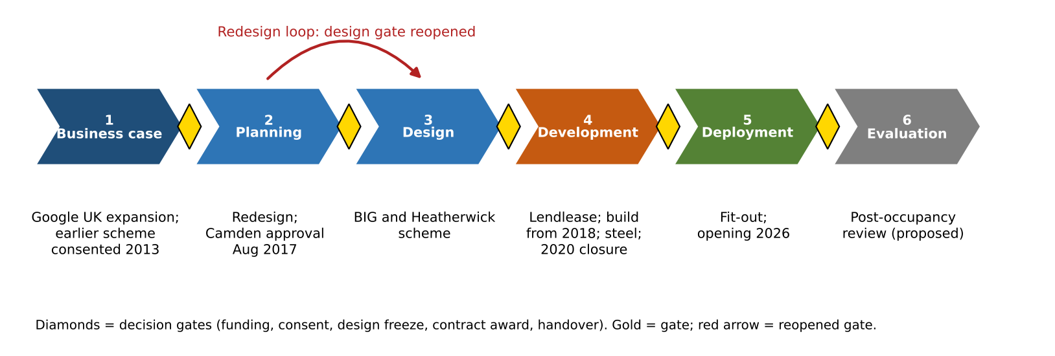
Figure 1: KGX1 mapped to the six life cycle stages, with decision gates and the redesign loop (T1; Table 1 sources)
Figure 1 shows a gate between each stage and the loop returning from planning to design, evidence that the design gate was reopened.
Three transitions mattered. The planning approval fixed the form that design had to realise, which constrained procurement by closing alternatives. Design decisions fixed a hung structure with no internal columns, which constrained steel procurement because a 17,000 t package (New Steel Construction, n.d.) cannot be ordered until loads and geometry are stable. The 2017 contractor confirmation preceded approval, which exposed programme to planning risk. Across these gates scope and quality appear to have been held, while time flexed: the first redesign, the 2020 closure and the late opening all moved dates, not specification.
A competing interpretation deserves weight. A sceptic could read the redesign as productive iteration rather than gate failure: the client improved the scheme before irreversible commitment, which an agile reading would applaud. The evidence cannot separate the two readings, since both predict the same dates; interpretation rests on dates, not intent. What it does show is that the 2013 consent, and any design effort behind it, did not bind the client, so the gate fixed permission rather than intent. That distinction matters because a gate that records consent but not commitment cannot protect the schedule.
On cost control, stakeholder alignment, feasibility and timeline, waterfall controls cost and feasibility through early fixing but aligns stakeholders poorly once a client's view changes. Agile aligns stakeholders and tolerates change, yet its evidence is largely software-based (Serrador and Pinto, 2015) and physical construction cannot iterate cheaply after steel is erected. Stage-gate keeps cost and feasibility under gate review at the price of timeline (Cooper, 1990). I favour a gated spine with iterative design inside it. Its cost is that gates only help if a freeze is honoured; where a client may reopen design, the model protects the schedule less than the budget.
Earlier contractor involvement would have aligned buildability with design, though it risks locking in a scheme the client later rejects. I recommend a formal design-freeze gate, with reopening requiring a change request that states its time and cost effect, so that change is chosen, not drifted into.

Section 2: Business Case, Scope & Schedule
The business case rested on three themes. Global competitiveness: Google's 2016 commitment to a King's Cross campus (Camden New Journal, 2016). Low-carbon construction: BIG's (2024) account of reduced embodied carbon, which I treat as a client aspiration, since its baseline is unverified. Economic and technological positioning: owner-occupation of a flagship asset in London's technology cluster. Its strategic justification is clear; the commercial and financial case is unpublished, so I cannot test it. A named disbenefit is capital tied up in a single asset. Benefits were not stated in measurable (SMART) terms in any public source, a common pitfall (Zwikael and Smyrk, 2011).
Four stakeholders shaped the project. Google, the sponsor, held decisive influence and, by revisiting its original plans (CityAM, n.d.), showed that its dissatisfaction could outweigh momentum. Camden held consent power. Lendlease controlled delivery. Neighbouring occupiers and rail operators (inferred) held interest without power. Resistance from the sponsor, not the public, was the tension that mattered.
Table 2: Scope statement for KGX1, reconstructed from public sources (T1; fixed or flexible column interpretive)
Block | Content | Fixed or flexible
Key deliverables | Landscraper building of about 93,000 m2 (T2; BDC, 2022); roof terraces and running track (New Steel Construction, n.d.); public-realm connections | Fixed early
Exclusions | Land; wider King's Cross public realm (T3) | Fixed
Assumptions | Owner-occupier funding; separate fit-out procurement possible (T3) | Fragile
Constraints | Camden consent; dense site beside rail and canal (inferred); hung steel structure | Constraining

Because ownership and form mattered more than date, scope fixed the building's footprint, terraces and structural concept early and left the schedule open. Because the sponsor prioritised quality, scope also left fit-out procurement open, which proved the fragile assumption.
Three pressures shaped the schedule. Political expectations arrived through planning consent. Funding cycles were corporate capital, not a public budget. Strategic priorities, notably Google's UK and AI commitment, dominated. I argue the strategic priority prevailed: an owner-occupier loses less from a late building than a compromised one. The building opened about ten years after its original target (Building, 2026), showing how an early strategic date can anchor an unrealistic schedule (Flyvbjerg, Holm and Buhl, 2002). Private funding reduces optimism bias but does not remove it.
The argument contains a tension. Corporate ownership implies no external funding discipline, which supports the claim that time was free to flex; yet Google's 2016 commitment to a King's Cross campus (Camden New Journal, 2016) shows strong strategic intent, which might imply urgency. I resolve this by distinguishing commitment to the site from commitment to a date: the later pause to review plans (CityAM, n.d.) suggests the first was firm and the second was not. The main untested assumption is that Google faced no lease expiry or similar deadline elsewhere, which would falsify the claim and which no public source confirms or excludes.
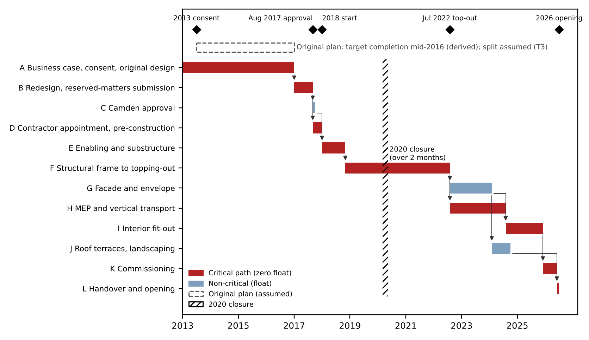
Figure 2: High-level schedule for KGX1 with original target, dependencies and critical path (milestones T1; durations T3; Appendix B)
Critical activities ran through redesign, contractor appointment, structure, services and fit-out; approval and landscaping carried float (Kelley and Walker, 1959). The dashed original plan is assumed. Documented dates show five years from the 2013 consent to the 2018 start and about eight and a half from start to opening, so construction, not only pre-construction, carried most elapsed time; the original construction duration is unknown, which limits any claim about where the slip arose. The Gantt chart shows no resources, hence Figure 3.
Recommendations: set a dual baseline, with a strategic window and a delivery baseline, so a target date is never mistaken for a plan; add a scope-freeze gate before procurement; and publish benefits in SMART terms with an owner (Turner, 2014). Crossrail, whose published business case (Transport for London, 2019) preceded a delayed opening, invites the same caution.

Section 3: Resource Planning & Budget Analysis
Table 3: Resource categories for KGX1 and the constraint each creates (T1; inferred where marked)
Category | KGX1 examples | Constraint
Human | Architects, engineers, erectors, trades | Availability
Materials | 17,000 t steel (New Steel Construction, n.d.); facade systems | Timing
Equipment | Cranes, access platforms (inferred) | Site capacity
Financial | Single-owner capital | Cost
Technical | Modelling tools (inferred) | Feasibility

Allocation follows the critical path: frame, envelope, then fit-out. Steel effort is derived (T2/T3) as 17,000 t divided by an assumed 6 t per gang-day, since I held no published rate, giving about 2,833 gang-days, or 45 erectors over 24 months of 21 working days at eight per gang. Other trades are scaled from this anchor, so the profile is estimated.
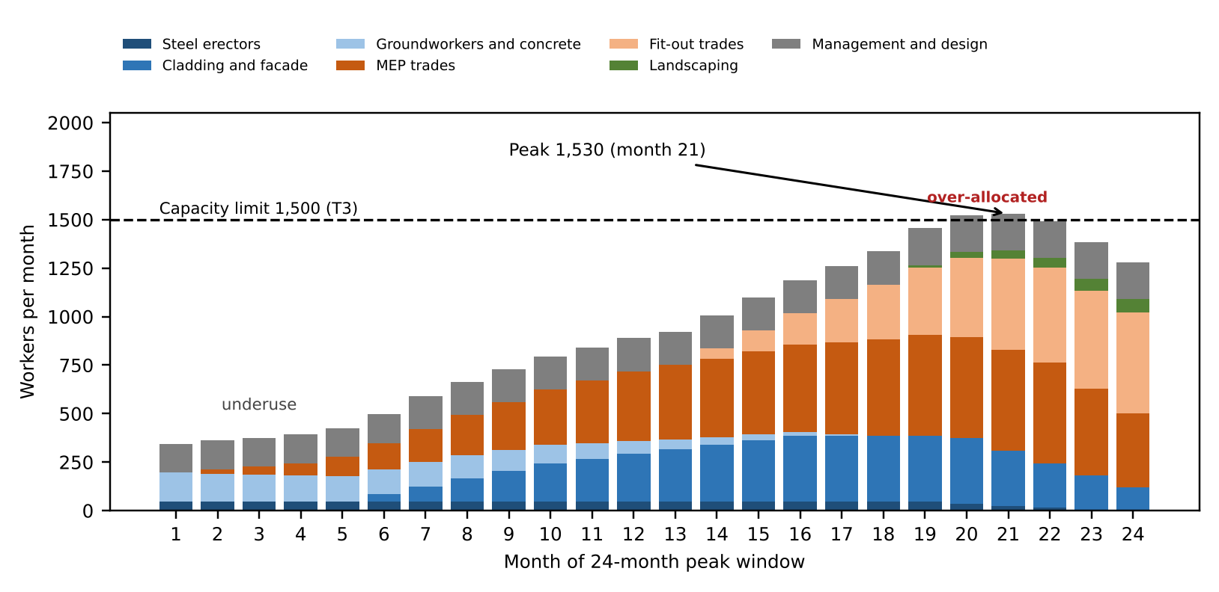
Figure 3: Estimated resource histogram for KGX1 (derived from documented quantities and an assumed productivity rate; T2/T3; Appendix C)
Labour peaks at 1,530 in month 21 as envelope, services and fit-out overlap, exceeding the assumed 1,500 capacity in months 20 and 21 and leaving early months underused. Levelling fit-out entry, an extra shift or delay can resolve this, exposing availability and timing before cost. Estimated labour is no substitute for contractor data, since real allocation reflects shift patterns and deliveries that public sources do not record.
Table 4: Reported KGX1 cost figures as a budget corridor (sources conflict; scope differs)
Figure | Source | Likely includes | Tier | Use
About £350m | Construction Enquirer (2017) | Shell and core | T1 | Floor
£600m | The Construction Index (n.d.) | Building | T1 | Baseline
£1bn | Camden New Journal (2016) | Campus, fit-out, other | T1 | Ceiling
£250m spread | 600 - 350 | Scope gap | T2 | Scope test
1.67 times | 1,000 / 600 | Non-building items | T2 | Caution

The conflict most plausibly reflects scope, so "which number is the budget?" is itself an estimating problem. I adopt £600m, because it describes the building while £350m excludes scope and £1bn probably adds non-construction items. Bottom-up estimating suits the steel package but hides optimism; top-down figures suit the headline; parametric rates (£600m / 92,903 m2 = £6,458/m2) suit the baseline (Gray and Larson, 2020). PERT for start to topping-out, with optimistic 40, most likely 50 and pessimistic 72 months (T3), gives (40 + 200 + 72) / 6 = 52 months (Malcolm et al., 1959); its inputs are judgements, so it inherits their optimism, though the derived 54-month outcome lies within one standard deviation of 5.3 months, supporting the estimate without validating it. Contingency of 7% is judgement, and a reference-class check argues for more (Flyvbjerg, 2006). Best practice would add benchmarks, a WBS, early stakeholder input, buffers and regular review (Appendix D).
Cross-checks sharpen the judgement. Dividing the reported £50m package by 17,000 t gives £2,941/t for supply, fabrication and erection (New Steel Construction, n.d.), and the package is about 8.3% of the £600m baseline (T2). Steel intensity of 183 kg/m2 (17,000 t x 1000 / 92,903 m2) cannot be judged without a published benchmark, so I draw no conclusion from it. If cost was not the binding constraint, availability and timing were, and the steel package is the likeliest candidate: a hung structure sequences every later trade behind it. A single precise total would therefore mislead; the corridor in Table 4, with a stated range of plus or minus 15% (T3), is the more defensible output.
Constraints affected four outcomes. Capacity affected scheduling because overlapping trades queue for access. A hung structure affected risk exposure because steel failure halts every successor. Dense-site access (inferred) affected feasibility because laydown limits deliveries. Single-owner funding affected contractor performance because late design changes reprice packages. PMI reports inaccurate cost estimates in 28% of failures, time estimates 26% and resource forecasting 23% (PMI, 2021).
Cost planning demands estimating judgement and transparent assumptions; the conflicting totals tested precisely that competency (Kerzner, 2022).

Section 4: Risk Assessment & Contingency Planning
Risk management follows four stages: identify, assess, respond, monitor (ISO, 2018). Risks fall into external, operational, technical, financial and commercial categories on a 4x4 scale, with score = probability x impact. The PMO sets the framework and escalates, and the process is continuous, never "one and done" (APM, 2019).
Table 5: KGX1 risk register using the 4x4 probability-impact scale (R3 and O1 inferred; others documented)
ID | Risk (category) | P | I | Score | Response | Plan B | Owner
R1 | COVID-19 closure over two months (external) | 2 | 3 | 6 | Reduce | Re-sequence; fast-track | Lendlease
R2 | Redesign and planning change (external) | 3 | 4 | 12 | Avoid | Change control | Google
R3 | Dense site beside rail, canal (operational) | 3 | 2 | 6 | Reduce | Off-peak logistics | Lendlease
R4 | Hung steel structure (technical) | 2 | 4 | 8 | Transfer | Second erection gang | Severfield
R5 | Shell and fit-out interface (commercial) | 3 | 3 | 9 | Transfer | Early fit-out appointment | Google
R6 | Cost-baseline uncertainty (financial) | 4 | 2 | 8 | Reduce | One scoped baseline | PMO
O1 | Off-site steel fabrication (opportunity) | 3 | 2 | 6 | Exploit | Keep on-site capacity | Severfield

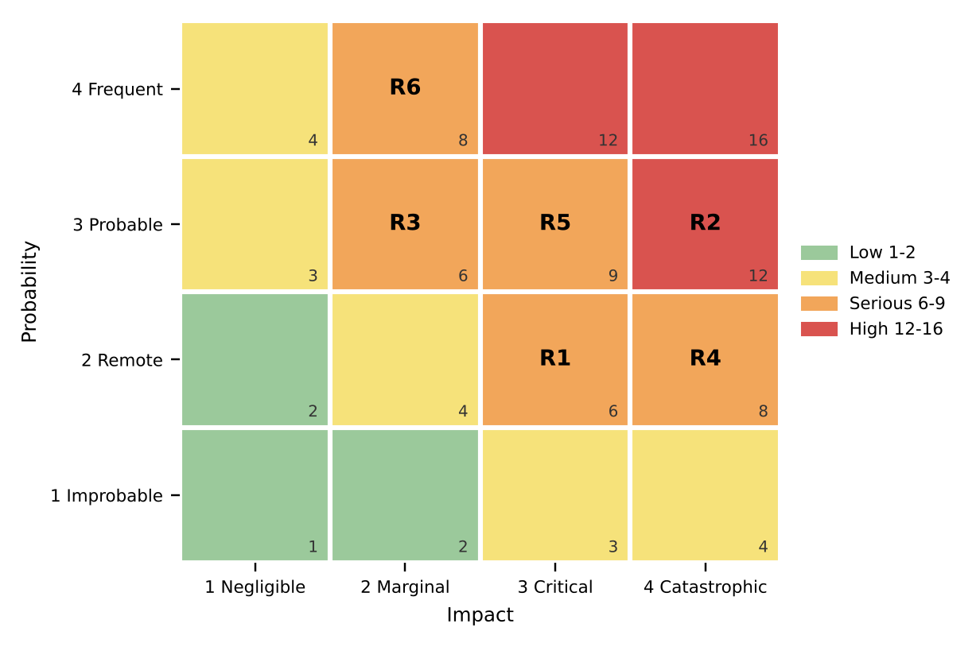
Figure 4: Heat map of KGX1 risks (IDs as in Table 5; T3 scores)
Three scores carry the argument. R2 is High (12) because the first scheme was set aside before approval, so occurrence was probable and programme-wide. R5 scores 9 because separate fit-out procurement was considered. R4 scores 8, pairing remote failure with catastrophic consequence on the critical frame. Risks cluster in the Serious band, which is the cell where threats cannot be accepted. The tool's limit is independence: COVID-19, supply and inflation pressures were linked, so the matrix understates joint exposure (Chapman and Ward, 2003).
Risk appetite, tolerance and capacity differ by owner. I infer that an owner-occupier with strong capital tolerated schedule risk but not quality risk, which shaped responses toward avoiding design compromise. This is inference, since Google has not published its appetite.
The register itself invites challenge. Scores are judgements, so two managers could defensibly rate R3 as 2 by 2 or 3 by 3; the justification, not the number, carries weight. Ranking also hides interaction: R2 and R5 are linked, since redesign alters the interface the fit-out procurement must assume. Treating them separately risks under-managing both.
Three responses can be evaluated. For R1, closure and reopening (Building, 2020) was a reduction, effective only after occurrence; the closure's length suggests limited anticipatory planning. For R2, redesign was avoidance of a poor design and succeeded on quality while costing time. For R4, transfer to a specialist package shifted commercial exposure but not programme consequence, which remains the client's. Responses beyond these are inferred.
Opportunity O1 is inferred: a specialist supplier fabricating and erecting the frame (New Steel Construction, n.d.) suggests off-site fabrication, which could shorten erection on a congested site. Its value depends on an early design freeze, which links the opportunity to R2 and shows that threats and opportunities share a control point. Transfer, similarly, deserves scepticism throughout: contracts allocate cost, but delay on the critical path still reaches the client as lost occupation, so a transferred risk can return as a time loss.
Plan B statements, distinct from management reserve. R2: trigger, client change request after freeze; owner, Google; action, formal change control; cost, upward. R5: trigger, fit-out unawarded twelve months before shell completion; owner, Google and Lendlease; action, early appointment; cost, neutral. R4: trigger, erection over 10% behind plan; owner, Severfield; action, second gang; cost, upward. For R2, EMV = 0.6 x £14m = £8.4m (T3).
Recommendations: hold an early risk workshop before design freeze; keep one integrated register across client and contractors, because fragmented registers hide shared exposure; and state a PMO escalation route with thresholds. Treat opportunities such as O1 with the same discipline as threats (Hillson, 2002).

Section 5: Progress Review & Intervention Strategies
The project spanned over a decade from its original target to opening, with a complex structure and a dense site. Monitoring was critical at approval, during structural erection, through the 2020 closure and at the fit-out interface.
Four KPI groups apply: milestones and SPI; CPI and cost variance; defects and rework; and stakeholder communication (Kerzner, 2022). Earned value shows that a project is off plan, not why (Anbari, 2003; Fleming and Koppelman, 2016). Actual cost is not public, so a real CPI is impossible; I therefore present the formulae as method and apply the indicators qualitatively.
Table 6: KPIs applied to documented KGX1 events (T1/T2). Method: SPI = EV / PV; CPI = EV / AC; SV = EV - PV; CV = EV - AC; EAC = BAC / CPI; TCPI = (BAC - EV) / (BAC - AC)
KPI | KGX1 evidence | What it shows | Intervention
Schedule | About ten-year slip (Building, 2026); approval 2017, start 2018, topping-out 2022 (Gillespies, 2022) | Large slip | Re-baseline after redesign
Cost | Four totals, £350m to £1bn | Scope problem, not CPI | Fix baseline first
Quality | No public data | Unknown | Track defects, rework
Stakeholder | Unanimous Camden vote (Building, 2017); redesign | Approval, early misalignment | Re-engage sponsor

Three deviations are documented. The slip would have been flagged by SPI at the design gate, years before opening. The 2020 closure would have shown immediately as a milestone shortfall. The cost-baseline uncertainty would have appeared at the first CPI, which could not be computed until scope was fixed.
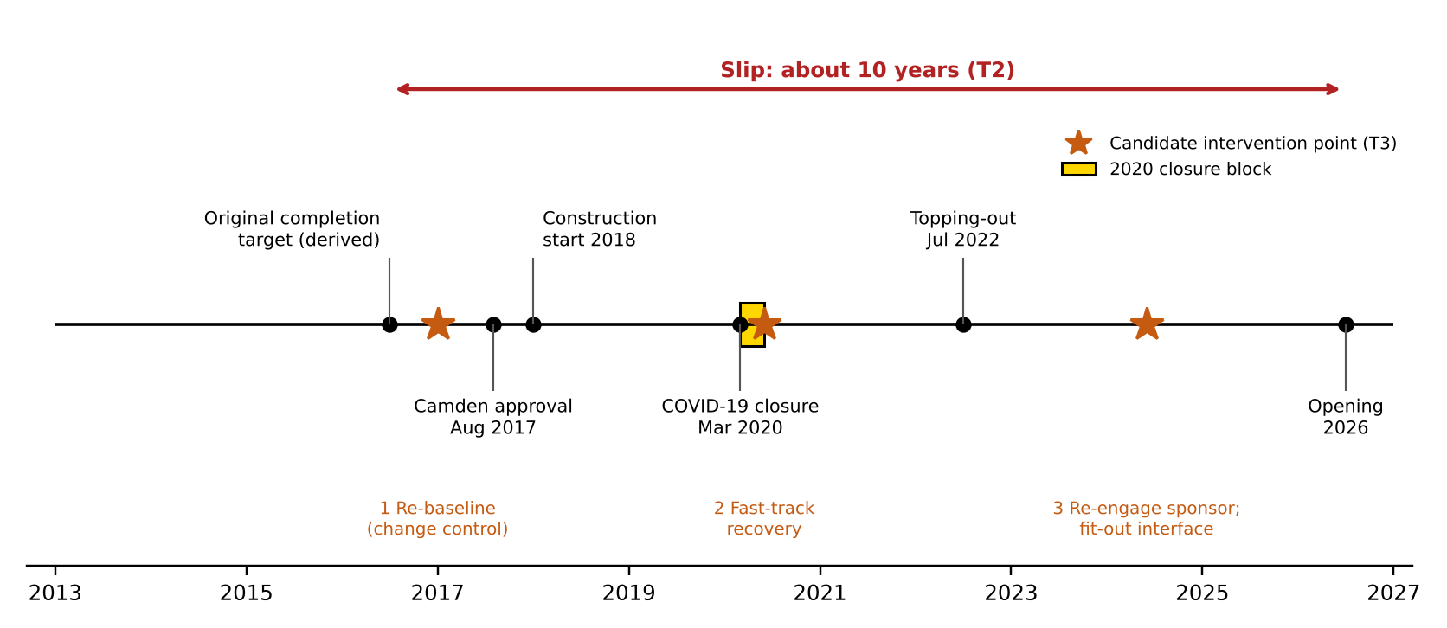
Figure 5: Documented KGX1 milestones, schedule slip and candidate intervention points (T1/T2)
Figure 5 differs from Figure 2: it shows how dates moved. The slip bracket spans the original target to opening, and three marked points, redesign, closure and fit-out, are where re-baselining was possible.
Re-baselining with formal change control would have suited the redesign because it resets the plan, though it can legitimise delay. Fast-tracking, low cost with medium scope impact, would have suited the closure because overlapping facade and services recovers time, though it raises rework risk. Crashing, high cost with low scope impact, suits a milestone at risk after the baseline is fixed, though cost rises. Stakeholder re-engagement would have suited early misalignment because sponsor intent was reopened late, though it needs formal sign-off. Informal change is faster but riskier, and invites scope creep (Gray and Larson, 2020).
The approach has limits. EVM measures output against plan, so a re-baselined plan can hide slip: if each reset was informal, the indicators would show health while the original target receded. Whether KGX1's resets went through formal change control is not public, so I treat it as the central unanswered question. Late intervention is also partly cultural; a sponsor who treats time as flexible may not experience delay as deviation at all, which weakens the case for early warning unless thresholds are agreed in advance.
Cost escalation has several causes: scope change, inflation, poor forecasting, supply-chain disruption, regulation and communication gaps. At KGX1 only scope change and the 2020 disruption are documented, so I cannot apportion cost growth among them. Matching controls to causes still helps. Baseline and variance reporting addresses forecasting; change control addresses scope; reserves released only on named triggers address disruption; audits and dashboards expose drift early; and supplier management addresses the concentration of risk in a single specialist steel package.
One rule follows: a variance beyond plus or minus 10% in SPI or CPI triggers formal review within one reporting cycle, because that exceeds normal estimating tolerance yet leaves time to act. It demands the competency to interpret signals, not merely collect them. Thresholds should also differ: schedule variance on critical activities merits a tighter limit than cost variance on float-bearing work.

Conclusion
The evidence supports the argument that time absorbed change: scope and quality appear held while dates moved, and the falsifying conditions were not found, though they cannot be excluded. The iron-triangle lens explains what flexed but not why the sponsor chose it. Public data and derived estimates limit confidence. Applying re-baselining showed me that a flexible schedule needs formal gates, which would change how I would manage a project: I would agree thresholds with the sponsor before any baseline is set. The lens also hides quality and stakeholder trade-offs, which the evidence leaves unresolved.

References
Anbari, F.T. (2003) 'Earned value project management method and extensions', Project Management Journal, 34(4), pp. 12–23.
APM (2019) APM Body of Knowledge. 7th edn. Princes Risborough: Association for Project Management.
Atkinson, R. (1999) 'Project management: cost, time and quality, two best guesses and a phenomenon, its time to accept other success criteria', International Journal of Project Management, 17(6), pp. 337–342.
BDC (2022) KGX1: the £1bn Google HQ in London's King's Cross. Available at: https://www.bdcmagazine.com/2022/07/kgx1-the-1bn-google-hq-in-londons-kings-cross/ (Accessed: 9 November 2026).
BIG (2024) Google Kings Cross HQ. Available at: https://big.dk/projects/google-platform-37-3347 (Accessed: 9 November 2026).
Building (2017) Google's exciting King's Cross HQ given go-ahead. Available at: https://www.building.co.uk/news/googles-exciting-kings-cross-hq-given-go-ahead/5089175.article (Accessed: 9 November 2026).
Building (2020) Lendlease's Google job finally reopens. Available at: https://www.building.co.uk/news/lendleases-google-job-finally-reopens/5106418.article (Accessed: 9 November 2026).
Building (2026) Google's £1bn King's Cross headquarters to open this summer, 10 years after it was first set to complete. Available at: https://www.building.co.uk/news/googles-1bn-kings-cross-headquarters-to-open-this-summer-10-years-after-it-was-first-set-to-complete/5141281.article (Accessed: 9 November 2026).
Camden Council (2017) Planning application 2017/3133/P: reserved matters for Development Zone A, King's Cross Central. Available at: https://camdocs.camden.gov.uk/ (Accessed: 9 November 2026).
Camden New Journal (2016) Google commits to expanding operations in King's Cross with £1bn campus, 20 November. Available at: https://www.camdennewjournal.co.uk/article/google-commits-to-expanding-operations-in-kings-cross-with-1bn-campus (Accessed: 9 November 2026).
Chapman, C. and Ward, S. (2003) Project risk management: processes, techniques and insights. 2nd edn. Chichester: Wiley.
CityAM (n.d.) Google delays building new King's Cross headquarters to review its plans. Available at: https://www.cityam.com/google-delays-building-new-kings-cross-headquarters-review-its-plans/ (Accessed: 9 November 2026).
Construction Enquirer (2017) Lendlease confirmed for Google HQ, 27 February. Available at: https://constructionenquirer.com/2017/02/27/lendlease-confirmed-for-google-hq (Accessed: 9 November 2026).
The Construction Index (n.d.) Lendlease to build £600m Google offices. Available at: https://theconstructionindex.co.uk/news/view/lendlease-to-build-600m-google-offices (Accessed: 9 November 2026).
Cooper, R.G. (1990) 'Stage-gate systems: a new tool for managing new products', Business Horizons, 33(3), pp. 44–54.
Cooper, R.G. and Sommer, A.F. (2016) 'The agile–stage-gate hybrid model: a promising new approach and a new research opportunity', Journal of Product Innovation Management, 33(5), pp. 513–526.
Fleming, Q.W. and Koppelman, J.M. (2016) Earned value project management. 4th edn. Newtown Square, PA: Project Management Institute.
Flyvbjerg, B. (2006) 'From Nobel Prize to project management: getting risks right', Project Management Journal, 37(3), pp. 5–15.
Flyvbjerg, B. (2014) 'What you should know about megaprojects and why: an overview', Project Management Journal, 45(2), pp. 6–19.
Flyvbjerg, B., Holm, M.S. and Buhl, S. (2002) 'Underestimating costs in public works projects: error or lie?', Journal of the American Planning Association, 68(3), pp. 279–295.
Gillespies (2022) Google headquarters in King's Cross tops out, 6 July. Available at: https://www.gillespies.co.uk/news/google-headquarters-in-kings-cross-tops-out (Accessed: 9 November 2026).
Gray, C.F. and Larson, E.W. (2020) Project management: the managerial process. 8th edn. New York: McGraw-Hill Education.
Heatherwick Studio (n.d.) Google King's Cross. Available at: https://heatherwick.com/project/google-kings-cross/ (Accessed: 9 November 2026).
Hillson, D. (2002) 'Extending the risk process to manage opportunities', International Journal of Project Management, 20(3), pp. 235–240.
ISO (2018) ISO 31000:2018 Risk management: guidelines. Geneva: International Organization for Standardization.
Kelley, J.E. and Walker, M.R. (1959) 'Critical-path planning and scheduling', in Papers presented at the December 1–3, 1959, Eastern Joint Computer Conference. Boston, MA: ACM, pp. 160–173.
Kerzner, H. (2022) Project management: a systems approach to planning, scheduling, and controlling. 13th edn. Hoboken, NJ: Wiley.
Malcolm, D.G., Roseboom, J.H., Clark, C.E. and Fazar, W. (1959) 'Application of a technique for research and development program evaluation', Operations Research, 7(5), pp. 646–669.
New Steel Construction (n.d.) Steel landscraper takes shape in King's Cross. Available at: https://www.newsteelconstruction.com/wp/steel-landscraper-takes-shape-in-kings-cross/ (Accessed: 9 November 2026).
PMI (2021) A guide to the project management body of knowledge (PMBOK guide) and the standard for project management. 7th edn. Newtown Square, PA: Project Management Institute.
Royce, W.W. (1970) 'Managing the development of large software systems', in Proceedings of IEEE WESCON. Los Angeles, CA: IEEE, pp. 1–9.
Serrador, P. and Pinto, J.K. (2015) 'Does agile work? A quantitative analysis of agile project success', International Journal of Project Management, 33(5), pp. 1040–1051.
Transport for London (2019) Crossrail final business case. Available at: https://foi.tfl.gov.uk/FOI-3433-1920/Case%20for%20Crossrail%20Final%20Proof%20100703.pdf (Accessed: 9 November 2026).
Turner, J.R. (2014) Handbook of project-based management: leading strategic change in organizations. 3rd edn. New York: McGraw-Hill.
Zwikael, O. and Smyrk, J. (2011) Project management for the creation of organisational value. London: Springer.

Appendix A: Assumptions register by tier
T1 values are documented, T2 values are derived from T1 figures, and T3 values are assumed with a basis and range. I held no published cost-model shares, productivity rates or steel-intensity benchmarks (BCIS, Spon’s), so those items are T3 and should be replaced if such sources are consulted. Appendix items are referenced in the body: A (all sections), B (Section 2), C and D (Section 3), E (Section 4), F (Section 5), G (all).
ID | Item | Value | Tier | Basis / source | Low | High
A01 | Floor area (Google) | 1,000,000 sq ft | T1 | BDC (2022)
A02 | Conversion | 0.092903 m2/sq ft | T1 | Standard constant
A03 | Floor area used | 92,903 m2 | T2 | A01 x A02
A04 | Shell and core contract | £350m | T1 | Construction Enquirer (2017)
A05 | Reported building cost (baseline) | £600m | T1 | The Construction Index (n.d.)
A06 | Reported headline | £1bn | T1 | Camden New Journal (2016)
A07 | Steel package value | £50m | T1 | New Steel Construction (n.d.); confirm exact page
A08 | Steel quantity | 17,000 t | T1 | New Steel Construction (n.d.)
A09 | Original completion target | About ten years before opening | T1/T2 | Building (2026)
A10 | Contingency | 7% of baseline | T3 | Judgement; reference class argues higher | 5% | 10%
A11 | Capacity limit | 1,500 workers/month | T3 | Assumed site logistics limit | 1,200 | 2,000
A12 | Variance trigger | 10% | T3 | Recommendation | 5% | 15%
A13 | Steel erection rate | 6 t per gang-day | T3 | No published rate held | 4 | 10
A14 | Gang size; working days | 8 workers; 21 days/month | T3 | Assumed
A15 | WBS shares | Table D1 | T3 | Indicative elemental split; no named cost model held | ±3 pts
A16 | AON durations | Table B1 | T3 | Calibrated to documented milestones | ±25%
A17 | PERT O, M, P | 40, 50, 72 months | T3 | Assumed around the derived 54 months
A18 | R2 probability | 0.6 | T3 | Reported client review of plans (CityAM, n.d.) | 0.4 | 0.8
A19 | R2 cost impact | £14m | T3 | 12 months preliminaries plus redesign fees | 10 | 25
A20 | Histogram trade profiles | Appendix C | T3 | Scaled from steel line | ±25%

Appendix B: WBS, AON network and Gantt workings
Months run from January 2013 (month 0), finish-to-start logic. Anchors (T1): 2013 consent, Lendlease February 2017, approval August 2017 (month 56), start 2018 (month 60), topping-out July 2022 (month 115), opening 2026 (month 162). Durations are T3. Forward pass: ES = max(EF of predecessors). Backward pass: LF = min(LS of successors). Slack = LS - ES. The AON has one start and one end node, no loops and one task per node (Kelley and Walker, 1959). WBS: 1 Whole building; 1.1 Preliminaries; 1.2 Enabling and substructure; 1.3 Frame; 1.4 Facade and roof; 1.5 Services and lifts; 1.6 Interior fit-out; 1.7 Landscaping and terraces; 1.8 Design fees; 1.9 Commissioning; 1.10 Contingency.
Table B1: AON schedule (T3 durations)
ID | Activity | Pred. | Dur. | ES | EF | LS | LF | Slack | Critical
A | Business case, consent, original design | - | 48 | 0 | 48 | 0 | 48 | 0 | Yes
B | Redesign, reserved-matters submission | A | 8 | 48 | 56 | 48 | 56 | 0 | Yes
C | Camden approval | B | 1 | 56 | 57 | 59 | 60 | 3 | No
D | Contractor appointment, pre-construction | B | 4 | 56 | 60 | 56 | 60 | 0 | Yes
E | Enabling and substructure | C, D | 10 | 60 | 70 | 60 | 70 | 0 | Yes
F | Structural frame to topping-out (17,000 t) | E | 45 | 70 | 115 | 70 | 115 | 0 | Yes
G | Facade and envelope | F | 18 | 115 | 133 | 121 | 139 | 6 | No
H | MEP and vertical transport | F | 24 | 115 | 139 | 115 | 139 | 0 | Yes
I | Interior fit-out | G, H | 16 | 139 | 155 | 139 | 155 | 0 | Yes
J | Roof terraces, landscaping | G | 8 | 133 | 141 | 153 | 161 | 20 | No
K | Commissioning | I | 6 | 155 | 161 | 155 | 161 | 0 | Yes
L | Handover and opening | K, J | 1 | 161 | 162 | 161 | 162 | 0 | Yes

Project duration 162 months. Critical path: A-B-D-E-F-H-I-K-L. Derived (T2): approval to start under 12 months; start to topping-out 54 months; consent (2013) to start (2018) 5 years; start to opening about 8.5 years; slip about ten years. The original plan bar in Figure 2 (2013 to mid-2016) is T3: only the target completion is derived, so the split of phases is assumed.

Appendix C: Histogram data and rates
Steel effort (T2/T3) = 17,000 t / 6 t per gang-day = 2,833 gang-days; 2,833 / (24 x 21) = 5.6 gangs; x 8 workers = about 45 erectors. Other profiles are T3, scaled from this anchor (plus or minus 25%); no productivity rate was taken from Spon’s or BCIS. Capacity 1,500 (T3). Workers per month, months 1 to 24:
Trade | 1 | 2 | 3 | 4 | 5 | 6 | 7 | 8 | 9 | 10 | 11 | 12 | 13 | 14 | 15 | 16 | 17 | 18 | 19 | 20 | 21 | 22 | 23 | 24
Steel erectors | 45 | 45 | 45 | 45 | 45 | 45 | 45 | 45 | 45 | 45 | 45 | 45 | 45 | 45 | 45 | 45 | 45 | 45 | 45 | 35 | 25 | 15 | 5 | 0
Cladding and facade | 0 | 0 | 0 | 0 | 0 | 40 | 80 | 120 | 160 | 200 | 223 | 247 | 270 | 293 | 317 | 340 | 340 | 340 | 340 | 340 | 285 | 230 | 175 | 120
Groundworkers and concrete | 150 | 146 | 141 | 137 | 133 | 129 | 124 | 120 | 107 | 93 | 80 | 67 | 53 | 40 | 30 | 20 | 10 | 0 | 0 | 0 | 0 | 0 | 0 | 0
MEP trades | 0 | 20 | 40 | 60 | 98 | 135 | 172 | 210 | 248 | 285 | 322 | 360 | 383 | 406 | 429 | 451 | 474 | 497 | 520 | 520 | 520 | 520 | 450 | 380
Fit-out trades | 0 | 0 | 0 | 0 | 0 | 0 | 0 | 0 | 0 | 0 | 0 | 0 | 0 | 53 | 107 | 160 | 222 | 284 | 346 | 408 | 470 | 487 | 503 | 520
Landscaping | 0 | 0 | 0 | 0 | 0 | 0 | 0 | 0 | 0 | 0 | 0 | 0 | 0 | 0 | 0 | 0 | 0 | 0 | 15 | 30 | 40 | 50 | 60 | 70
Management and design | 150 | 150 | 150 | 150 | 150 | 150 | 170 | 170 | 170 | 170 | 170 | 170 | 170 | 170 | 170 | 170 | 170 | 170 | 190 | 190 | 190 | 190 | 190 | 190
Total | 345 | 361 | 376 | 392 | 426 | 499 | 591 | 665 | 730 | 793 | 840 | 889 | 921 | 1,007 | 1,098 | 1,186 | 1,261 | 1,336 | 1,456 | 1,523 | 1,530 | 1,492 | 1,383 | 1,280

Peak 1,530 in month 21; months 20 and 21 exceed capacity by 23 and 30 workers (about 2%). Months 1 to 5 sit below 450 workers (underuse).

Appendix D: Budget workings
Table D1: Indicative cost breakdown (T3 shares; no named cost model held)
WBS element | Share (T3) | £m on £600m
Preliminaries | 11% | 66.0
Enabling, substructure | 9% | 54.0
Frame (steel) | 12% | 72.0
Facade, roof | 14% | 84.0
Services, lifts | 22% | 132.0
Interior fit-out | 10% | 60.0
Landscaping, terraces | 3% | 18.0
Design fees | 10% | 60.0
Commissioning | 2% | 12.0
Contingency | 7% | 42.0
Total | 100% | 600.0

Calculation (T2) | Formula | Result
Floor area | 1,000,000 x 0.092903 | 92,903 m2
Cost per m2, £600m | 600,000,000 / 92,903 | £6,458
Cost per m2, £350m (shell and core only) | 350,000,000 / 92,903 | £3,767
Cost per m2, £1bn | 1,000,000,000 / 92,903 | £10,764
Steel rate | 50,000,000 / 17,000 | £2,941/t
Steel intensity | 17,000 x 1000 / 92,903 | 183 kg/m2
Steel share of £600m | 50 / 600 | 8.3%
Steel share of £350m | 50 / 350 | 14.3%
Steel share of frame line | 50 / 72 | 69%
Cost spread | 600 - 350 | £250m
Headline multiple | 1,000 / 600 | 1.67
Preliminaries per month | 66 / 102 months | £0.65m
R2 impact | 12 x 0.65 + 6.0 (10% of £60m fees) | £13.8m, taken as £14m
R2 EMV | 0.6 x 14 | £8.4m
PERT expected | (40 + 4 x 50 + 72) / 6 | 52 months
PERT standard deviation | (72 - 40) / 6 | 5.3 months
Sensitivity range (T3) | 600 x (1 -/+ 15%) | £510m to £690m

Shares sum to 100% and the lines sum to £600.0m. No published benchmark was held, so no variance against a benchmark is reported. Contingency of 7% (£42m; range 5% to 10%) is a judgement with a reference-class caveat (Flyvbjerg, 2006).

Appendix E: Full risk register
ID | Risk | Cat. | P | I | Score | Band | Response | Plan B | Trigger | Owner | Evidence level | Justification
R1 | COVID-19 closure | External | 2 | 3 | 6 | Serious | Reduce | Re-sequence; fast-track recovery | Positive case; closure | Lendlease | Documented | Closure over two months (Building, 2020); remote at baseline
R2 | Redesign, planning change | External | 3 | 4 | 12 | High | Avoid | Formal change control | Client change request after freeze | Google | Documented | First scheme set aside before 2017 approval
R3 | Dense site beside rail and canal | Operational | 3 | 2 | 6 | Serious | Reduce | Off-peak deliveries; alternative laydown | Delivery slot failures | Lendlease | Inferred | Site context; no source held
R4 | Hung steel structure | Technical | 2 | 4 | 8 | Serious | Transfer | Second erection gang | Erection over 10% behind plan | Severfield | Documented | 17,000 t, no internal columns
R5 | Shell and fit-out interface | Commercial | 3 | 3 | 9 | Serious | Transfer | Early fit-out appointment | Fit-out unawarded 12 months before shell completion | Google, Lendlease | Documented | Separate fit-out procurement considered
R6 | Cost-baseline uncertainty | Financial | 4 | 2 | 8 | Serious | Reduce | One scope-defined baseline | Variance beyond 10% | PMO | Documented | Reported totals from £350m to £1bn
O1 | Off-site steel fabrication | Opportunity | 3 | 2 | 6 | Serious | Exploit | Keep on-site capacity | Fabrication slippage | Severfield | Inferred | Specialist fabricate-and-erect scope

Appendix F: KPI and EVM method
Method only: no actual cost is public, so no KGX1 CPI exists. The worked example below is illustrative (T3) and is not a KGX1 outcome. Assumed midway position: BAC £600m; PV £300m (50% planned); EV £270m (45% earned); AC £309m.
Measure | Formula | Result
SV | EV - PV | -£30m
CV | EV - AC | -£39m
SPI | EV / PV | 0.90
CPI | EV / AC | 0.87
EAC | BAC / CPI | £686.7m
ETC | EAC - AC | £377.7m
VAC | BAC - EAC | -£86.7m
TCPI | (BAC - EV) / (BAC - AC) | 1.13
Status vs 10% threshold | SPI 0.90, CPI 0.87 | SPI at limit; CPI breaches: formal review

Appendix G: Evidence log
Facts were corroborated through search results on 9 November 2026; several publisher pages could not be opened from my environment, so items marked "snippet" or "headline" should be confirmed on the page before submission. Camden record: application 2017/3133/P, decision dated 16 August 2017 (found through search); the specific page URL and committee date still need adding from Camden’s Planning Explorer.
ID | Fact | Value | Source | Tier | Status
E01 | Earlier scheme consented | 2013 | Building (2017) | T1 | To verify wording
E02 | Reserved-matters approval; committee unanimous | August 2017 | Camden Council (2017); Building (2017) | T1 | Reference found; unanimity from snippet
E03 | Google reviewed original plans | Pre-2017 | CityAM (n.d.) | T1 | Headline
E04 | Google commitment to King's Cross campus | 2016 | Camden New Journal (2016) | T1 | Snippet
E05 | Lendlease confirmed; shell and core | Feb 2017; £350m | Construction Enquirer (2017) | T1 | Snippet
E06 | Reported cost | £600m | The Construction Index (n.d.) | T1 | Headline
E07 | Reported headline | £1bn | Camden New Journal (2016) | T1 | Headline
E08 | Construction start | 2018 | Heatherwick Studio (n.d.) | T1 | Snippet
E09 | Steel quantity; hung structure | 17,000 t | New Steel Construction (n.d.) | T1 | Snippet
E10 | Steel package value | £50m | New Steel Construction (n.d.) | T1 | Confirm exact page
E11 | Floor area | Over 1m sq ft | BDC (2022) | T1 | Snippet
E12 | COVID-19 closure and reopening | March 2020; over two months | Building (2020) | T1 | Headline
E13 | Opening about ten years after target | Summer 2026 (year inferred) | Building (2026) | T1 | Headline
E14 | Topping-out | July 2022 | Gillespies (2022) | T1 | Search summary
E15 | Low-carbon construction aim | Aspirational | BIG (2024) | T1 | Baseline unverified
E16 | Conflicts not used | Storeys 10 vs 11; capacity 4,000 vs 7,000 | Various | - | Not used in argument

