Table of Contents

1. Introduction
Meliá White House sits on Albany Street, London, in a Grade II listed building designed in 1936 and run by Meliá since 1999 (Historic England, n.d.). The company reports spending £40m over five years renovating the hotel’s 581 bedrooms and suites, restaurant, bar and public spaces without closing (Hospitality Net, 2023), and Business Traveller (2024) gives April 2023 as the completion date. The hotel now presents itself as a premium property.
The central question is whether that promise holds at every point where a guest meets the hotel and, where it does not, how the gap can be closed at the lowest cost. The aim is to judge how consistently the post-renovation strategy reaches guests, taking food and beverage (F&B) as the main lens, and to propose practical fixes with costs attached. There are four objectives:
- To identify which lenses from the literature fit the problem (Chapter 3)
- To test whether four management decisions were sound enterprise choices (Chapter 4)
- To judge how well those decisions work, using visit evidence and documents (Chapter 5)
- To set out four fixes that are costed, timed and measurable (Chapter 6)
The argument is that the hotel delivers its premium promise where guests look first (public spaces, breakfast, bar) and falls short where they look closely (condition and consistency). That gap matters because the room is sold as a premium product: staff quoted about £300 a night and a booking site listed about £237 to £310 (Booking.com, 2026; Fig. 5).

2. Approach and methods
The project follows five consulting stages: entry, diagnosis, data gathering, feedback and recommendation. The staged logic comes from Greiner and Metzger (1983), while Cope (2003) argues that whether advice gets used depends on the consultant’s credibility and how well they communicate. As students have no contract and no client to give feedback, entry and feedback are simulated here, so the report claims only diagnosis and recommendation. Feedback is the weakest stage, since no client has tested the findings.
The design is a single-case study (Yin, 2018). Looking at one hotel gives depth rather than breadth, which fits a question about consistency across touchpoints, although it restricts how far the findings can be generalised.
The primary data come from a hosted visit to the hotel (Veal, 2017), which had three parts. The group first sat down and introduced themselves one by one, then joined a two-way question-and-answer session on hospitality careers, where staff emphasised that the sector offers a wider range of paths than students tend to expect. Next, the group was divided into small groups and shown the hotel’s rooms and facilities. Staff said rooms start at about £300 a night and described the property as more than rooms, with F&B, lounge, wellness and workspace offers. Finally, drinks were served before the group left. Observation was non-participant and captured in photographs; the staff comments are paraphrased from memory and are not treated as policy.
The visit was therefore guided and hospitable. The opening session concerned careers rather than operations, the hosts chose the route, and the drinks at the end may have softened impressions, so what the group saw was a managed version of the hotel. Sixteen photographs were taken and five are used as Figures 1 to 5 (Appendix 1); photographs showing identifiable people were cropped or left out.
Secondary data came from the Historic England list entry, Meliá press material, trade press, ranking coverage from Brand Finance and S&P Global, and a booking-site price check. Following Denzin (1978) and Bryman and Bell (2015), each claim is checked against a second type of source.
The limits are specific. There was one visit and one managed tour, and management accounts were unavailable. No guest-review or survey data were analysed, so the report cannot say how common the faults seen are. Corporate sources are promotional and are treated as claims. The room count (581) is Meliá’s own figure and was not independently checked. The co-working article is from April 2024, so prices may have changed, and the £300 figure is a verbal staff quote of a starting rate, not a published tariff. The booking-site price is one search for one future stay (8 to 9 November 2026), captured on 8 October 2026, so it shows list prices, not what guests paid. Findings are therefore indicative. Appendix 2 maps each source.

3. Six lenses
Six lenses are used, as each returns in the decisions and recommendations below.
Technical and functional quality. Grönroos (1984) distinguishes what is delivered (the room, the food) from how it is delivered (manner and responsiveness). Pizam and Ellis (1999) respond that in practice hospitality satisfaction depends on many attributes, so the two sides overlap. Read together, they imply that a hotel can perform well in process yet poorly in outcome details. Different teams repair each side: training and supervision for process, engineering and housekeeping standards for outcomes.
Must-be, performance and delight. Kano et al. (1984) argue that some features are expected and go unnoticed when present, while others delight. Categories are usually established by survey and vary by type of guest, so here they are inferred from photographs, and the report says so. A clean lift and grille are must-be features, while Arado and Spanish cava are attractive ones. Adding delight on top of weak basics wastes money.
The setting. Turley and Milliman (2000) treat atmosphere as a driver of behaviour, although most of their evidence comes from retail. Poria, Butler and Airey (2003) propose that heritage visitors value a personal link with the past, so worn fabric can read as character. Once a guest has paid a premium rate, however, the same patina can look like neglect. The lens tests cornices and oak against a dull lift door and a dusty grille.
Value and fairness. Zeithaml (1988) locates value in the guest’s mind, so it varies from guest to guest. Xia, Monroe and Cox (2004) add that guests judge price differences for fairness, and Kimes (2002) observes that yield pricing makes sense for the hotel but can feel unfair to the buyer. Because rooms were quoted at about £300 on the visit and listed at about £237 to £310 on a booking site, depending on discounts (Fig. 5), guests pay different amounts for the same room and therefore apply different yardsticks. A lift door that is forgiven at a discounted price may be resented at the full one.
Positioning. Kim and Mauborgne (2004) reward firms that stand out by raising what guests value, while Treacy and Wiersema (1993) warn that a firm should excel at a single value discipline. The lens asks whether a story built on premium quality, heritage and Spanish food is too ambitious to sustain at every touchpoint.
Service recovery. Smith, Bolton and Wagner (1999) show that the way a failure is put right shapes later satisfaction, but McCollough, Berry and Yadav (2000) caution that recovery cannot replace reliability. No service failure was seen on the visit, so the lens is used to design a preventive protocol rather than to judge past performance.

4. Four decisions analysed
Decision 1: the big bet. Meliá reports £40m invested over five years while the hotel stayed open (Hospitality Net, 2023). Grant (1991) would treat a Grade II listed building as a scarce resource that rivals cannot copy. Eisenhardt and Martin (2000) frame renovating while trading as a capability, because revenue and learning continue. The corridors and gym show the heritage carried through: cornice detail runs through the fitness area (Fig. 2) and the lift lobby pairs black marble with a pedimented surround. Yet Poria et al. (2003) suggest heritage appeals through a personal link with the past, which a neglected finish does not support, and the gym and lift lobby show how quickly it turns into a liability when not maintained. The lift door has a dull, uneven finish, and the air-conditioning grille above the cornice is visibly dusty. The verdict: the asset justified the bet, but a £40m spend only protects value if standards are then sustained. The renovation creates an obligation to maintain, not merely to reach a standard once.
Decision 2: the Spanish signature. Arado, the buffet, Spanish wines and organic cava give the hotel a distinctive food and drink identity. Kim and Mauborgne (2004) would applaud the distinctiveness, whereas Treacy and Wiersema (1993) would ask whether it runs through everything. Where guests can see it, the buffet counter shows the concept at work: lit shelving of GMED olive oils, a hot-lamp pass, bread in linen bags and a bowl of Real Crisps. The drinks station adds Spanish wines (Embrujo, La Prensa, Arnegui Rioja Crianza) and, on ice, Codorníu Cuvée Original Brut Ecológico alongside Flama d’Or cava (Fig. 1). In the room, the concept falls apart. The tea and coffee tray carries Nescafé Original sachets and portion milk on a black marble top with visible water marks and smears, which clashes with a Spanish, premium identity. The verdict: a good bet, weakened by an inconsistency that can be fixed. Gentile, Spiller and Noci (2007) explain the stakes: experience is assembled from many components, so one weak component dilutes the others. The remedy is modest, because a Spanish coffee or tea offer builds on an existing supplier relationship instead of requiring a new concept.
Decision 3: The Level and public co-working. Business Traveller (2024) reports ten workspaces from £40 a day, with 10% off at Arado and ’35 Bar and complimentary tea, coffee and snacks. The Level lounge has a separate entrance on Longford Street and used to be open only to guests in selected suites. Ansoff (1957) would label this related diversification, a new offer sold into familiar markets using existing assets. Drucker (1985) finds innovation in under-used resources, which describes a quiet lounge well, and Olsen, West and Tse (2008) add that diversification ought to strengthen the core. The visit took in a long timber table with power-ready seating next to softer café-style tables facing a garden, and a dark-wood, red-velvet ’35 Bar (Fig. 4), so the offer exists as a flexible work-and-dine space with a second distinct outlet. The verdict: a sensible use of space and a plausible cross-selling lever, but usage and revenue are unknown and the trade press source may reflect partner input. The evidence shows intent rather than performance, which is why Recommendation 4 monitors it.
Decision 4: the premium badge. Brand Finance’s Hotels 50 2026 ranking puts Meliá seventh among luxury hotel brands and names it the only Spanish company among the ten strongest luxury brands (Journal des Palaces, 2026). S&P Global’s Sustainability Yearbook 2026 lists Meliá for the ninth year running, in the top 10% of its sector with a score of 77 out of 100 (Breaking Travel News, 2026). These are rankings and corporate claims rather than audits, and they describe the group, not this property. Zeithaml (1988) and Xia et al. (2004) imply that a premium badge lifts the standard by which every detail is judged, especially at a rate near £300 instead of a discounted rate near £240. Manaktola and Jauhari (2007) find that guests’ green attitudes do not always carry over into choices, so sustainability should support value rather than lead it. The only sustainability cue noticed on the visit was the organic cava (Fig. 1). The verdict: the badge is a promise the hotel now has to prove room by room, and the group-level claims say little about this property.

5. How well is it working?
The evidence types agree on the pattern. Photographs and documents both point to strength in public spaces, breakfast and the bar, and weakness in condition and consistency. They disagree on scale: the photographs show small, visible faults, whereas the press material promises that the hotel exceeds expectations.
The photographs show a clear split (evidence log in Appendix 1). In the public areas the design intent is consistent and the finish is high: the buffet, the drinks station (Fig. 1), the lounge, the ’35 Bar (Fig. 4) and a guest room with walnut headboard, bay window and a framed motorcycle artwork all read as premium. The faults sit in surfaces guests touch or look up at: the lift door, the marble tray top and instant-coffee sachets, the grille beside the cornice (Fig. 2) and a corridor where an open service door shows a laundry cart (Fig. 3). The corridor point is minor and may reflect tour timing.
The author’s own first impression matches the photographs. What stood out first was how premium the hotel felt: the decoration, the marble, the design and the lighting, together with a gym, a bar, well-kept rooms, large beds and attached bathrooms. The one thing that looked wrong was the shelf holding the kettle and cups in the room. Its surface showed marks, possibly from a spilled drink, and it needed cleaning.
The separate bar was the author’s favourite area. Drinks were displayed clearly, each type was served in its own glass (wine in a wine glass, beer in a beer glass, whiskey in a whiskey glass), and there was a set of premium whiskeys. Gentile et al. (2007) argue that experience is built from many small components, and correct glassware is one of them. The bar met a standard that the room shelf did not.
Price changes how all this reads. The author, who comes from a middle-class family in Nepal, would not pay £300 a night for this hotel: the sum equals roughly NPR 61,300 at 204.23 NPR to the pound on 8 October 2026 (Google, 2026), a large amount for a middle-class household, and a stay in this bracket is out of reach for many guests. This is a point about affordability, not about value. Zeithaml (1988) places value in the guest’s head, so the same room can be fair value to one guest and unaffordable to another.
Appendix 4 sets promise against proof. The key row pits the premium promise against the dull lift door and dusty grille (Fig. 2) and is rated amber. These are small matters, but at a rate near £300 they are expensive ones, since Zeithaml (1988) implies that a guest paying more expects more. On Kano’s logic they are must-be failures, which is why they can outweigh the delight that Arado provides.
Zomerdijk and Voss (2010) treat the journey as a chain of touchpoints, and the weakest one shapes the memory, so one dull lift door can outweigh an excellent breakfast.
In Grönroos’s terms, the hotel is strong on functional quality (process and design intent) and uneven on technical quality (condition). The strategy succeeds at the headline touchpoints but falls short on consistency. That is good news for management, since condition problems yield to routine checklist control rather than capital spending.

6. Recommendations
All costs and timings are the author’s own estimates. Every recommendation is linked to evidence and to a lens, and Appendix 5 sets out owners, KPIs and timing.
R1. Must-be sweep and weekly guest-eyes walk. Run a 30-day sweep of lifts, grilles, corridors and room details, followed by a weekly 15-minute manager walk using a short checklist. Figs. 2 and 3 show two of the faults; Kano et al. (1984) rank must-be failures above missing delight, and Turley and Milliman (2000) show that the setting shapes judgement. Track the weekly checklist pass rate and monthly review mentions of condition faults. Estimate: low cost, one to three months. The risk is that repairs to plaster and cornices may need listed-building consent, so begin with cleaning and metal polishing.
R2. Breakfast continuity and recovery playbook. Draft an outage plan covering a backup service area, a scripted apology, a standard make-good such as a drink at ’35 Bar, and a same-day follow-up from a manager. No breakfast failure was seen on the visit, so the measure is preventive. Smith et al. (1999) support recovery, and McCollough et al. (2000) explain why a backup plan is also needed. Track time to first response, the share of affected guests offered a make-good, and reply time to related reviews. Estimate: low cost, about one month. The risk is that compensation turns into an expectation.
R3. “Spanish morning” in-room kit. Swap instant coffee for a Spanish coffee or tea option and add a local-products card that points to Arado and ’35 Bar, trialled on one floor. The in-room tray contrasts with the drinks station (Fig. 1); Kim and Mauborgne (2004) support carrying the distinctive element through, and Treacy and Wiersema (1993) offer the counterpoint of choosing where to excel. Track in-room F&B mentions, minibar spend and card use. Estimate: low to medium cost, three months. The risk is the cost per room across several hundred rooms, so the pilot results should decide the roll-out.
R4. Track The Level. Give every day pass a unique code for the 10% discount, then report weekly passes sold, the redemption rate and spend per pass-holder. Fig. 4 and Business Traveller (2024) show the offer, and Ansoff (1957) and Drucker (1985) suggest that a new use of space is a good bet only if it is monitored. Track occupancy of the ten workspaces and average spend. Estimate: low cost, about two months. The risk is cannibalising full-price spend.
In order of impact against effort, R2 and R1 come first as the cheapest and most visible, R4 follows, and R3 is last because it needs the most money and testing. R1 to R3 tackle must-be reliability and expectation, which the photographs suggest are the main weaknesses. Success should be judged after one quarter against the stated indicators, and any item showing no movement should be redesigned before more is spent. Appendix 5 contains a 90-day timeline.

7. Conclusion
Meliá White House mostly keeps its premium promise where guests look first, in public spaces, at breakfast and in the bar, but it falls short on condition and consistency, which weigh more at a premium rate of about £240 to £310. The findings rely on one hosted visit plus photographic and document evidence, with no guest reviews or survey data. The hotel should start by fixing its must-be basics and preparing a breakfast continuity plan, as both are cheap, quick and protect the investment already made.

References
Ansoff, H.I. (1957) ‘Strategies for diversification’, Harvard Business Review, 35(5), pp. 113-124. Available at: https://hbr.org/1957/09/strategies-for-diversification (Accessed: 8 October 2026).
Booking.com (2026) Availability: Meliá White House, Deluxe Double Room, 8–9 November 2026 [screenshot of booking page, captured 8 October 2026]. Available at: https://www.booking.com/hotel/gb/meliawhitehousehotel.en-gb.html?checkin=2026-11-08&checkout=2026-11-09 (Accessed: 8 October 2026).
Breaking Travel News (2026) ‘Meliá recognized in the S&P Global Sustainability Yearbook 2026 for the ninth consecutive year’. Available at: https://www.breakingtravelnews.com/news/article/melia-recognized-in-the-sp-global-sustainability-yearbook-2026-for-the-nint/ (Accessed: 8 October 2026).
Bryman, A. and Bell, E. (2015) Business Research Methods. 4th edn. Oxford: Oxford University Press.
Business Traveller (2024) ‘London’s Meliá White House introduces co-working spaces’, 21 April. Available at: https://www.businesstraveller.com/business-travel/2024/04/21/londons-melia-white-house-introduces-co-working-spaces/ (Accessed: 8 October 2026).
Cope, M. (2003) The Seven Cs of Consulting. 2nd edn. Harlow: FT Prentice Hall.
Denzin, N.K. (1978) The Research Act: A Theoretical Introduction to Sociological Methods. 2nd edn. New York: McGraw-Hill.
Drucker, P.F. (1985) Innovation and Entrepreneurship. New York: Harper & Row.
Eisenhardt, K.M. and Martin, J.A. (2000) ‘Dynamic capabilities: what are they?’, Strategic Management Journal, 21(10-11), pp. 1105-1121. Available at: https://doi.org/10.1002/1097-0266(200010/11)21:10/11<1105::AID-SMJ133>3.0.CO;2-E (Accessed: 8 October 2026).
Gentile, C., Spiller, N. and Noci, G. (2007) ‘How to sustain the customer experience: an overview of experience components that co-create value with the customer’, European Management Journal, 25(5), pp. 395-410. Available at: https://doi.org/10.1016/j.emj.2007.08.005 (Accessed: 8 October 2026).
Google (2026) Pound sterling to Nepalese rupee exchange rate, 8 October 2026, 01:00 UTC. Available at: https://www.google.com/search?q=PUND+TO+NRP+RATE (Accessed: 8 October 2026).
Grant, R.M. (1991) ‘The resource-based theory of competitive advantage: implications for strategy formulation’, California Management Review, 33(3), pp. 114-135. Available at: https://doi.org/10.2307/41166664 (Accessed: 8 October 2026).
Greiner, L.E. and Metzger, R.O. (1983) Consulting to Management. Englewood Cliffs, NJ: Prentice-Hall.
Grönroos, C. (1984) ‘A service quality model and its marketing implications’, European Journal of Marketing, 18(4), pp. 36-44. Available at: https://doi.org/10.1108/EUM0000000004784 (Accessed: 8 October 2026).
Historic England (n.d.) National Heritage List for England: The White House, Albany Street, list entry 1113231. Available at: https://historicengland.org.uk/listing/the-list/list-entry/1113231 (Accessed: 8 October 2026).
Hospitality Net (2023) Meliá White House [press release]. Available at: https://www.hospitalitynet.org/announcement/41009454.html (Accessed: 8 October 2026).
Journal des Palaces (2026) ‘Luxury focus drives Meliá into the world’s top 10 strongest hotel brands’, 3 August. Available at: https://www.journaldespalaces.com/en/pressrelease-79079-Luxury-focus-drives-Meliy-into-the-World-s-Top-10-Strongest-Hotel-Brands.html (Accessed: 8 October 2026).
Kano, N., Seraku, N., Takahashi, F. and Tsuji, S. (1984) ‘Attractive quality and must-be quality’, Journal of the Japanese Society for Quality Control, 14(2), pp. 39-48.
Kim, W.C. and Mauborgne, R. (2004) ‘Blue ocean strategy’, Harvard Business Review, 82(10), pp. 76-84. Available at: https://hbr.org/2004/10/blue-ocean-strategy (Accessed: 8 October 2026).
Kimes, S.E. (2002) ‘Perceived fairness of yield management’, Cornell Hotel and Restaurant Administration Quarterly, 43(1), pp. 21-30.
Manaktola, K. and Jauhari, V. (2007) ‘Exploring consumer attitude and behaviour towards green practices in the lodging industry in India’, International Journal of Contemporary Hospitality Management, 19(5), pp. 364-377. Available at: https://doi.org/10.1108/09596110710757534 (Accessed: 8 October 2026).
McCollough, M.A., Berry, L.L. and Yadav, M.S. (2000) ‘An empirical investigation of customer satisfaction after service failure and recovery’, Journal of Service Research, 3(2), pp. 121-137. Available at: https://doi.org/10.1177/109467050032002 (Accessed: 8 October 2026).
Olsen, M.D., West, J.J. and Tse, E.C.-Y. (2008) Strategic Management in the Hospitality Industry. 3rd edn. Upper Saddle River, NJ: Pearson.
Pizam, A. and Ellis, T. (1999) ‘Customer satisfaction and its measurement in hospitality enterprises’, International Journal of Contemporary Hospitality Management, 11(7), pp. 326-339. Available at: https://doi.org/10.1108/09596119910293231 (Accessed: 8 October 2026).
Poria, Y., Butler, R. and Airey, D. (2003) ‘The core of heritage tourism’, Annals of Tourism Research, 30(1), pp. 238-254. Available at: https://doi.org/10.1016/S0160-7383(02)00064-6 (Accessed: 8 October 2026).
Smith, A.K., Bolton, R.N. and Wagner, J. (1999) ‘A model of customer satisfaction with service encounters involving failure and recovery’, Journal of Marketing Research, 36(3), pp. 356-372. Available at: https://doi.org/10.1177/002224379903600305 (Accessed: 8 October 2026).
Treacy, M. and Wiersema, F. (1993) ‘Customer intimacy and other value disciplines’, Harvard Business Review, 71(1), pp. 84-93. Available at: https://hbr.org/1993/01/customer-intimacy-and-other-value-disciplines (Accessed: 8 October 2026).
Turley, L.W. and Milliman, R.E. (2000) ‘Atmospheric effects on shopping behavior: a review of the experimental evidence’, Journal of Business Research, 49(2), pp. 193-211. Available at: https://doi.org/10.1016/S0148-2963(99)00010-7 (Accessed: 8 October 2026).
Veal, A.J. (2017) Research Methods for Leisure and Tourism. 5th edn. Harlow: Pearson.
Xia, L., Monroe, K.B. and Cox, J.L. (2004) ‘The price is unfair! A conceptual framework of price fairness perceptions’, Journal of Marketing, 68(4), pp. 1-15. Available at: https://doi.org/10.1509/jmkg.68.4.1.42733 (Accessed: 8 October 2026).
Yin, R.K. (2018) Case Study Research and Applications: Design and Methods. 6th edn. Thousand Oaks, CA: Sage.
Zeithaml, V.A. (1988) ‘Consumer perceptions of price, quality, and value: a means-end model and synthesis of evidence’, Journal of Marketing, 52(3), pp. 2-22. Available at: https://doi.org/10.1177/002224298805200302 (Accessed: 8 October 2026).
Zomerdijk, L.G. and Voss, C.A. (2010) ‘Service design for experience-centric services’, Journal of Service Research, 13(1), pp. 67-82. Available at: https://doi.org/10.1177/1094670509357611 (Accessed: 8 October 2026).

Appendices

Appendix 1: Photographs (Figs. 1-5)
The author took all photographs on the hosted tour. Photographs showing identifiable people were cropped or left out.
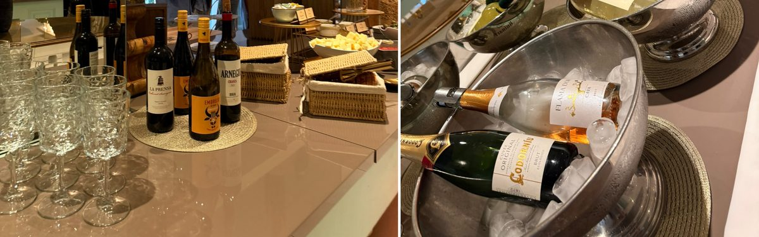
Figure 1. Spanish wines (left) and cava on ice, including Codorníu organic and Flama d’Or (right).
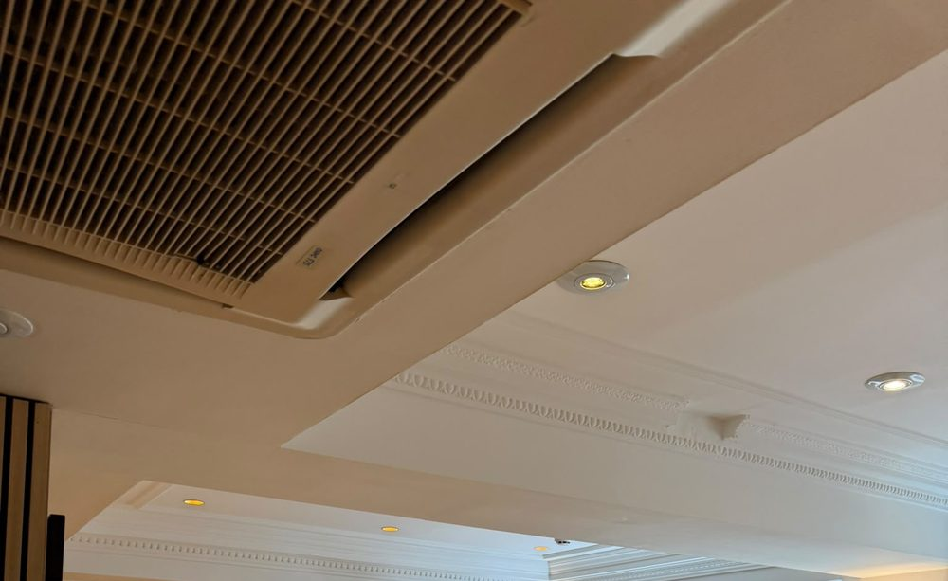
Figure 2. Gym ceiling: air-conditioning grille beside cornice detail.
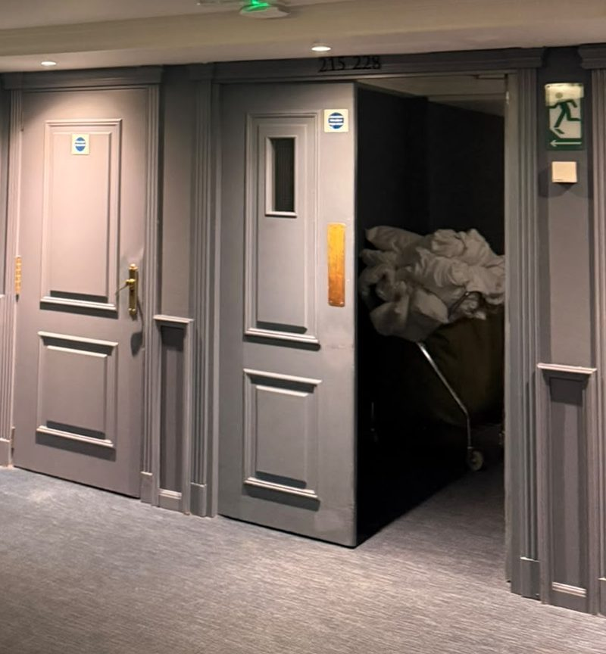
Figure 3. Corridor with an open service door and laundry cart (cropped).
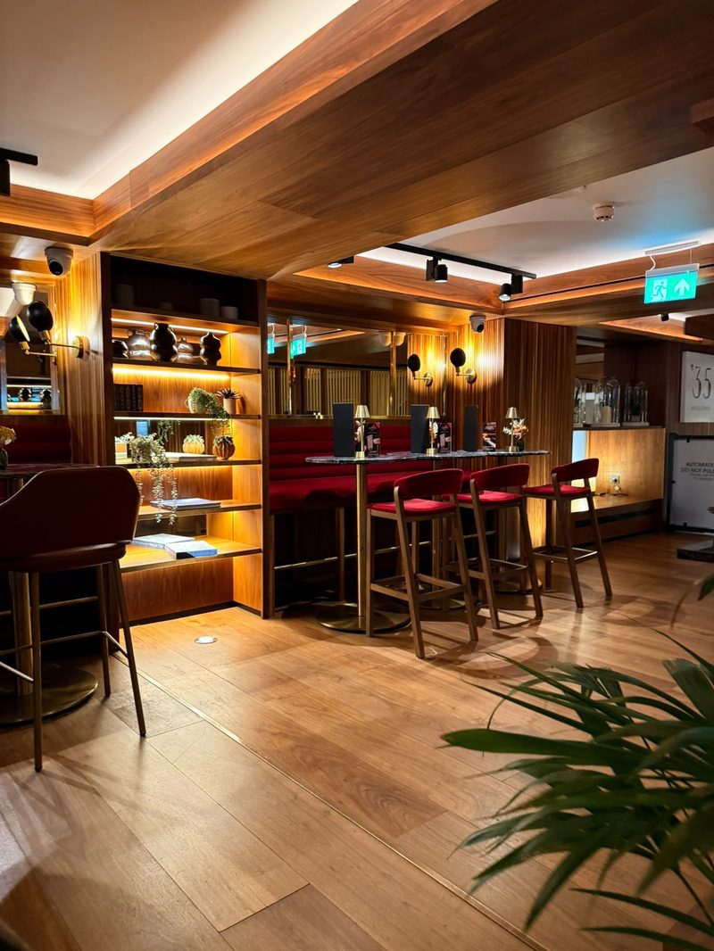
Figure 4. ’35 Bar with walnut cladding and red velvet seating.
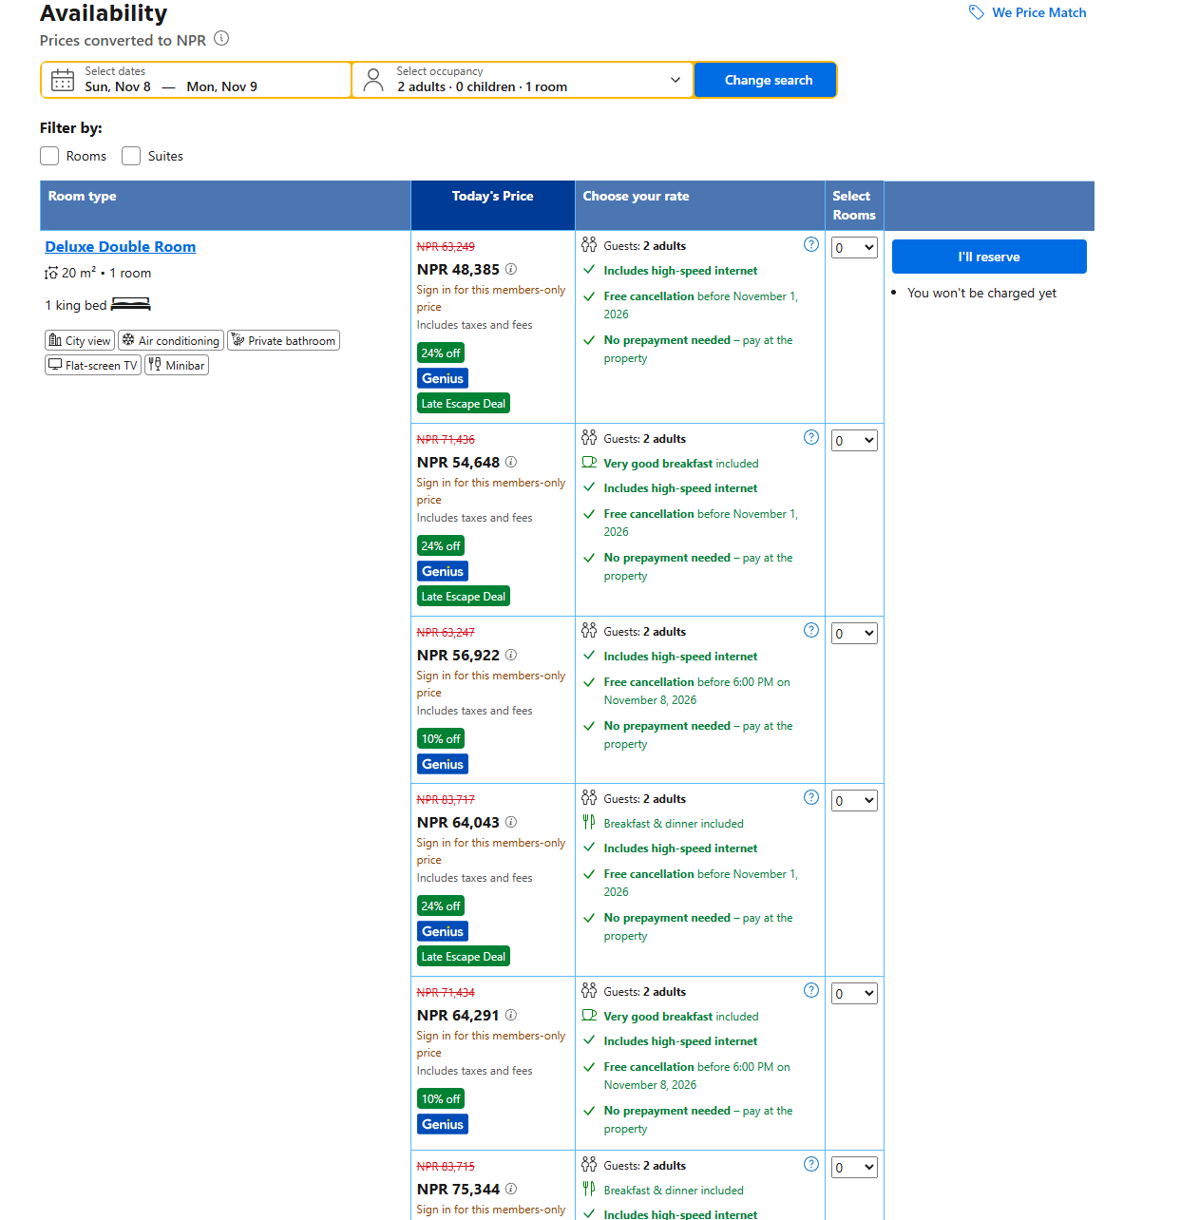
Figure 5. Booking-site availability for a Deluxe Double Room, 8–9 November 2026, captured 8 October 2026 (Booking.com, 2026).
Photographic evidence log
Fig. | What the photograph shows | Kano class | Reading
1 | Spanish wines and cava on ice (Codorníu organic, Flama d’Or) | Attractive | Strength: Spanish provenance, one organic product
2 | Gym: air-conditioning grille beside cornice | Must-be | Gap: grille looks dusty
3 | Corridor: open service door, laundry cart | Must-be | Minor gap: back-of-house visible
4 | ’35 Bar: walnut cladding, red velvet seating | Attractive | Strength; usage unknown

Appendix 2: Source map
Source | Can prove | Cannot prove | Handle with
Visit observation and photos | What a guest sees in public areas on one day | Typical standards across the year | Say “on the day observed”
Staff session and tour commentary | How staff describe the positioning and the starting rate (about £300 a night) | Official policy; the session was careers-led and informal | Paraphrase; do not quote as policy
Historic England list entry | Listing and building form | Current operations | Cite the list entry number
Meliá press release (Hospitality Net, 2023) | The promise the brand makes | Whether it is kept | Treat as promotional
Business Traveller (2024) | Co-working offer and renovation figures from an independent outlet | Uptake or revenue; possible partner input | Cite exact date
Brand Finance and S&P coverage | Group-level standing | Anything about this hotel | Attribute as claims, not facts
Booking.com price check, 8 October 2026 | List prices for one future stay | What guests paid; typical prices | Say “on the day searched”

Appendix 3: Fact check (status as of 8 October 2026)
Fact | Source | Status
£40m renovation over five years; 581 bedrooms and suites | Hospitality Net (2023) press release | Matches the press release as summarised by search
Completed April 2023 | Business Traveller (2024) | Stated there; describe the main programme as complete
Co-working: ten workspaces from £40 a day; 10% off at Arado and ’35 Bar | Business Traveller (2024) | Matches search summaries; prices may have changed since April 2024
Grade II listed; built 1936; nine storeys, star-shaped plan | Historic England list entry 1113231 | Matches the list entry (listed 11 January 1999)
Room count | Hospitality Net (2023): 581 | Meliá’s own figure; not independently checked
Meliá seventh in Brand Finance luxury ranking, Hotels 50 2026 | Journal des Palaces (3 August 2026) | Matches search summary of the release
Meliá in S&P Global Sustainability Yearbook 2026: ninth consecutive year, top 10% of sector, score 77/100 | Breaking Travel News (2026) | Matches the article as summarised by search
Rooms about £300 (staff); about £237 to £310 (booking site, 8–9 Nov 2026) | Staff session; booking site | Screenshot captured 8 October 2026 (Fig. 5): standard NPR 63,249 (about £310), member deal NPR 48,385 (about £237), at 204.23 NPR to the pound on 8 October 2026 (Google Finance, 2026). Hotel page confirmed from the URL

Appendix 4: Promise-versus-proof ledger
Promise | Proof seen | Status | Type | Evidence
Premium, “exceeds expectations” (press release) | Dull lift door, dusty grille, marked tray top | Amber | Technical quality | Fig. 2
Mediterranean F&B identity | Strong at buffet and drinks station; instant coffee in room | Amber | Consistency | Fig. 1
Heritage as an asset | Cornice and oak detail carried through; grille and door finish let it down | Amber | Setting | Fig. 2
A place to work and dine | Lounge, communal table; £40 day pass | Green | Enterprise | Business Traveller (2024)
Premium guest room | Walnut headboard, bay window, artwork | Green | Technical quality | Visit observation

Appendix 5: 90-day timeline (estimates)
When | Action | Milestone
Days 1 to 30 | R2, R1 sweep | Playbook signed off; sweep done; weekly walk begins
Days 31 to 60 | R4, R1 weekly | Codes live on day passes; first redemption report
Days 61 to 90 | R3 pilot | One-floor pilot; review of mentions and spend; roll-out decision
Action plan: owners, KPIs and estimates
# | Action | Owner | Timing | Cost (est.) | KPI
R1 | Must-be sweep and weekly walk | Housekeeping / engineering | 1-3 months | Low | Checklist pass rate; condition mentions in reviews
R2 | Breakfast recovery playbook | F&B / guest services | ~1 month | Low | Time to first response; make-good rate
R3 | Spanish in-room kit (pilot floor) | Rooms division / F&B | ~3 months | Low to medium | In-room F&B mentions; minibar spend
R4 | Track The Level | Revenue / F&B | ~2 months | Low | Desk occupancy; redemption rate; spend per pass

