Managing the Interfaces: the Google King’s Cross Headquarters (KGX1 / Platform 37) as a Project Nested in a Programme and a Portfolio

A retrospective project management analysis

Module: Project Management
Submission date: 9 November 2026
Word count (main body): 3,334

Contents
Introduction 3
Section 1: Project Life Cycle Analysis 3
Section 2: Business Case, Scope & Schedule 5
Section 3: Resource Planning & Budget Analysis 7
Section 4: Risk Assessment & Contingency Planning 9
Section 5: Progress Review & Intervention Strategies 12
Conclusion 13
References 15
Appendix A: Assumptions register by tier 17
Appendix B: Network workings and WBS 18
Appendix C: Resource workings 19
Appendix D: Budget workings 20
Appendix E: Full risk register 21
Appendix F: KPI workings 22
Appendix G: Evidence log 23

List of figures and tables
Figure 1: KGX1 life cycle stages and the level that owned each decision
Table 1: Decision rights by life cycle stage and level
Table 2: KGX1 scope statement
Figure 2: KGX1 scope boundary and interfaces
Figure 3: High-level KGX1 schedule as a network
Table 3: KGX1 resource categories, constraints and control level
Figure 4: Estimate maturity across the life cycle
Figure 5: Where resource constraints bound KGX1, by stage
Table 4: KGX1 risk register by level and owner
Figure 6: Inherent and residual risk positions by owning level
Figure 7: Risk ownership, escalation and contingency by level
Table 5: KPIs along the output, outcome and benefit chain
Figure 8: Who decides at each step of change control

Introduction
Platform 37 (KGX1), Google's King's Cross headquarters, was designed by BIG with Heatherwick Studio and built by Lendlease on a privately developed estate (BIG, 2024; Construction Enquirer, 2017). It sits inside a programme, the King's Cross masterplan, and a portfolio, Google's UK expansion; programmes coordinate related projects, and portfolios allocate capital among them (APM, 2019). This report argues that much apparent delay or drift reflects friction at those interfaces, so project managers must manage interfaces, not only the project (Engwall, 2003; Pellegrinelli, 2011). The claim would fail if documented deviations traced wholly to project-internal causes, such as design or contractor performance; public evidence can suggest, but not settle, that. Documented facts (T1) are cited; derived (T2) and estimated (T3) figures are labelled, and none is an actual KGX1 outcome. Sections 1 to 5 test the claim through life cycle, business case, resource, risk and control analyses.

Section 1: Project Life Cycle Analysis
Viewed from three levels, the six stages are not one life cycle but three that overlap. At project level KGX1 reads as a stage-gated hybrid: Lendlease was confirmed in February 2017, six months before approval in August 2017 (Construction Enquirer, 2017; Camden Council, 2017), so procurement overlapped planning. A gate that one level treats as closed may stay open at another, which is why the level matters. At programme level the masterplan reads as long, staged waterfall, because the estate's partnership structure fixes plot sequence and public realm before any single building (Urban Land Institute, n.d.).
The stages, each closed by a decision, are these. Business case preparation justifies the need and closes at funding approval. Planning sets scope, schedule and consents, closing at approval. Design fixes the solution, closing at design freeze. Development builds it, closing at completion. Deployment hands over, fits out and occupies, closing at occupation. Evaluation reviews outcomes and benefits (APM, 2019). Figure 1 and Table 1 show who held each decision.
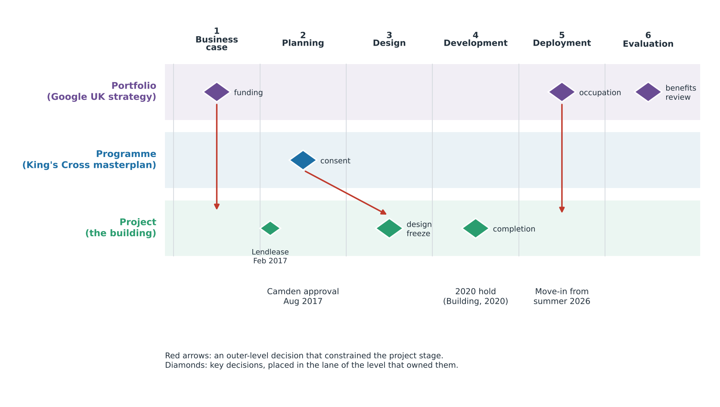
Figure 1: KGX1 life cycle stages and the level that owned each decision (T1; ownership interpretive)
The project lane depends on outer lanes at three points: funding, planning and contractor confirmation. The interface between planning approval and design freeze would have benefited most from a formal gate.
Table 1: Decision rights by life cycle stage and level (D decides, S shapes, I informed; inferred unless cited)
Stage | Portfolio | Programme | Project | Roles and timing
Business case | D | S | I | Google; estate partners; before 2017
Planning | S | D | S | Camden approval August 2017 (Camden Council, 2017)
Design | S | S | D | Architects; owner reviews
Development | I | S | D | Lendlease from February 2017 (Construction Enquirer, 2017); 2020 hold (Building, 2020)
Deployment | D | I | S | Move-in from summer 2026 (Google, 2026)
Evaluation | D | S | I | Benefits review (proposed)

Table 1 shows the portfolio dominating early and late stages, the programme controlling consent, and the project controlling delivery. Three transitions show outer levels constraining the project. First, the portfolio decision to own and occupy the building fixed the business case before the project existed; I infer this, since no business case is public, and it means the manager inherited objectives rather than negotiating them. Second, the programme's planning framework fixed the form design could take: Camden's approval granted reserved matters under the estate's outline permission (Camden Council, 2017), so the design gate could not close before the programme's gate had. Third, contractor appointment fixed the commercial structure six months before approval, exposing Lendlease's programme to a planning outcome it did not control. Approval had to precede mobilisation, yet procurement preceded approval: pace was bought at the price of planning risk. The practical question for the manager is whether each gate was theirs to open or close.
Structured models help differently by level. For cost control, waterfall's early fixing suits the project but hardens assumptions across a decades-long regeneration (Cooper and Sommer, 2016). For stakeholder alignment, agile iteration helps owner reviews of design, yet a masterplan's many parties need stage-gate decision rights. For feasibility, gates concentrate checking where consent and structure are tested. For timeline, agile shortens feedback, but its evidence is largely software-based, and construction cannot iterate cheaply once steel is erected. I favour a hybrid at project level and staged gates at programme level; the cost is that interface conditions must be agreed early, which reduces flexibility. In practice, the choice of model is also a choice about who may change their mind.
Early contractor involvement would align buildability with design but binds the owner before consent. I recommend an explicit interface gate: before each project stage starts, programme-level conditions are confirmed in writing. It fails where outer levels will not commit early, and then merely documents uncertainty (Morris, 2013).

Section 2: Business Case, Scope & Schedule
The business case belonged to Google, not to the project. Its strategic justification is a long-term UK presence for global competitiveness; the commercial justification is ownership of a flagship asset; the financial justification is private capital, and no public cash flow exists to test it. Low-carbon construction is an architect's stated aim (BIG, 2024), though its baseline is unverified here. Technological positioning appears in Google's account of a building for AI teams with a public AI Exchange on the ground floor (Google, 2026). At programme level, regeneration and public realm are benefits the estate's partnership delivers and keeps publicly usable (Urban Land Institute, n.d.). A disbenefit is capital concentrated in one asset. Measurable (SMART) benefits are not public, a recognised pitfall (Zwikael and Smyrk, 2011).
Four stakeholders mattered. Google, the owner, held decisive influence; Camden held consent power; the master developer controlled estate conditions; Lendlease controlled delivery. The tension lay between building-specific priorities and estate-wide obligations; ignoring resistance there is a recognised pitfall.
Table 2: KGX1 scope statement, reconstructed from public sources (T1; inferred where marked)
Element | Content | Level
Deliverables | Building; roof terraces and running track (New Steel Construction, n.d.); public ground-floor space (Google, 2026) | Project
Deliverables | Public-realm links | Programme
Exclusions | Estate public realm and transport links; neighbouring buildings (inferred) | Programme
Assumptions | Planning consent; estate infrastructure available on time (inferred) | Programme
Constraints | Dense urban site (inferred); hung steel structure of 17,000 t (New Steel Construction, n.d.) | Project

Table 2 shows that three of five rows depend on another level. Because Google prioritised an iconic owner-occupied building with public-facing space, scope fixed the structural concept, terraces and ground-floor space early and left public-realm connections and utilities to the programme. Exclusions matter in practice because a cost or schedule comparison that ignores them mistakes scope differences for performance.
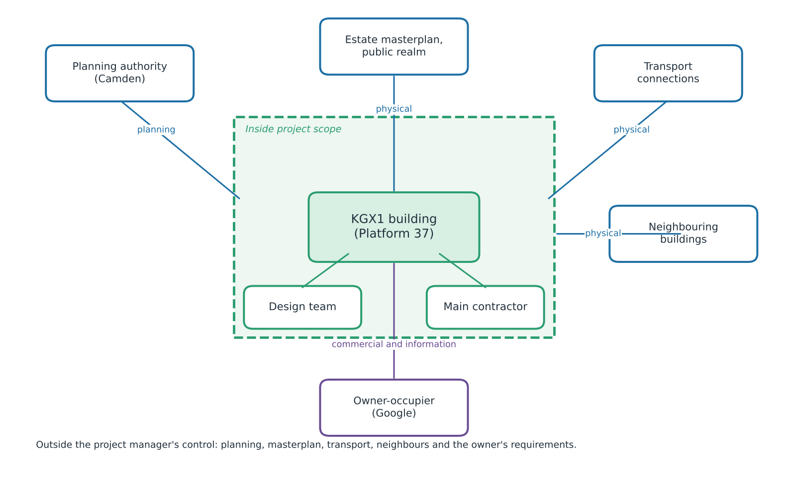
Figure 2: KGX1 scope boundary and interfaces (T1; inferred where marked)
Five of seven interfaces sat outside the project manager's control: planning, masterplan, transport, neighbours and the owner's requirements.
Business acumen and negotiation were tested where the manager could not dictate terms. Acumen meant reading Google's capital logic; negotiation meant agreeing dates and interfaces with the planning authority and master developer without authority over either (Dainty, Cheng and Moore, 2005). A contextual challenge follows: a private owner has little incentive to publish its business case, so transparency must come from governance, not goodwill.
Three pressures shaped the schedule, each at a different level. Political expectations acted through the programme's planning framework, with approval in August 2017 (Camden Council, 2017). Funding cycles were corporate capital at portfolio level, not public money, so dates could flex without external audit. Strategic priorities, the UK and AI commitment, dominated: staff move in from summer 2026 (Google, 2026), 107 months after approval (T2: August 2017 to July 2026). Private funding reduces but does not remove optimism bias (Flyvbjerg, Bruzelius and Rothengatter, 2003), so an early strategic date can still anchor an unrealistic schedule. Miller and Lessard (2000) argue that large projects succeed or fail largely through how institutions and risks are shaped early, consistent with the weight of outer-level decisions here, though the KGX1 evidence is circumstantial.
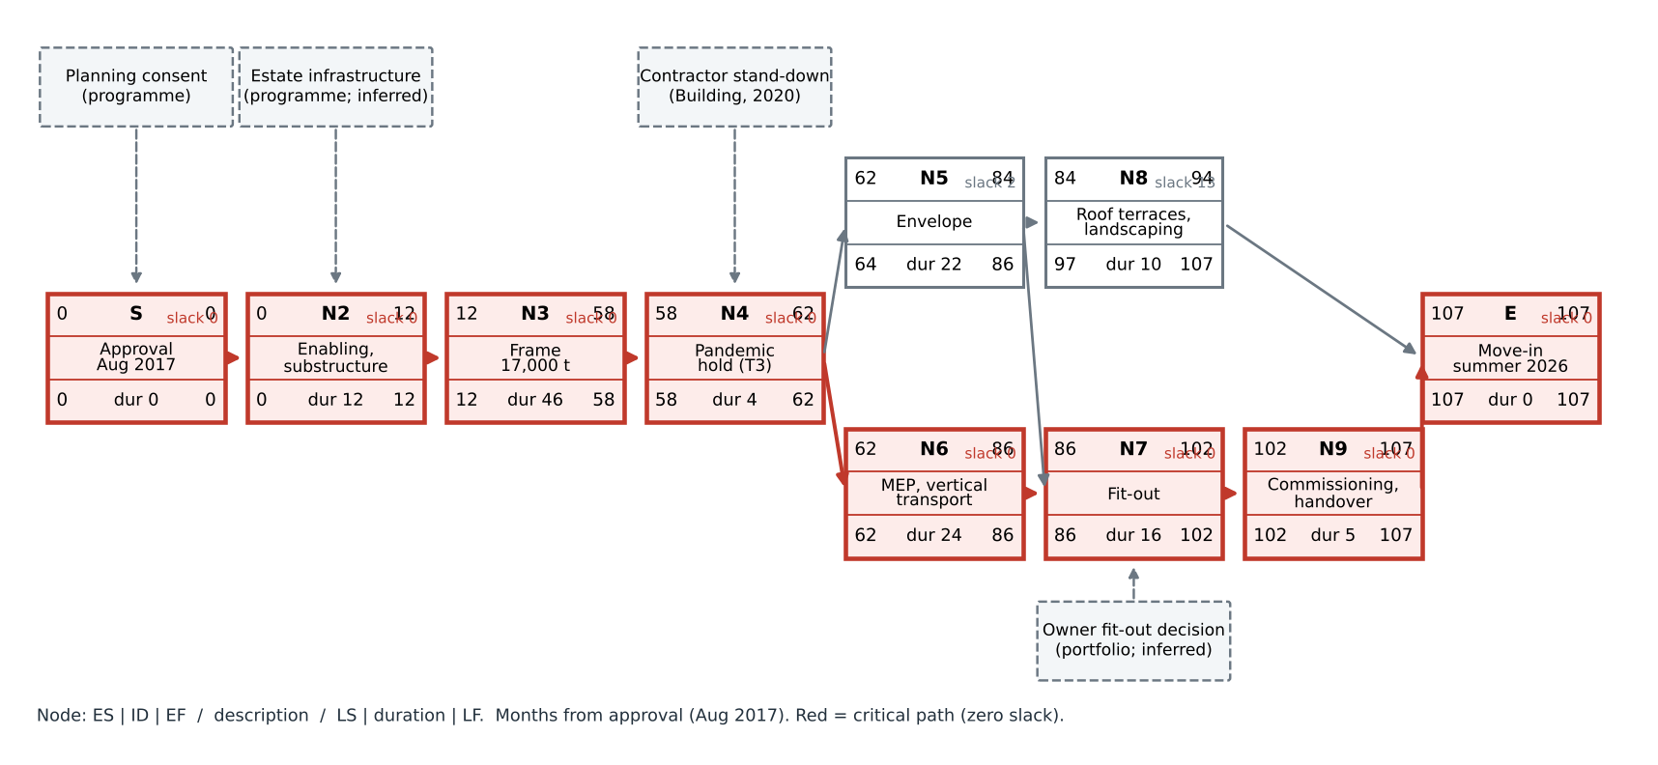
Figure 3: High-level KGX1 schedule as a network with external dependencies and critical path (anchors T1; durations T3; Appendix B)
The critical path runs through enabling, frame, hold, services, fit-out and commissioning (Larson and Gray, 2021); envelope carries two months of slack, and a delay to estate infrastructure could have moved the end date.
Recommendations: confirm interface conditions with the programme before fixing dates; hold a joint scope-freeze gate before procurement; and agree dates as ranges, not points, with the owner (Miller and Lessard, 2000).

Section 3: Resource Planning & Budget Analysis
Table 3: KGX1 resource categories, constraints and control level (T1; inferred where marked)
Category | KGX1 examples | Constraint and level
Human | Architects, engineers, steel erectors, trades | Availability; project and estate
Materials | 17,000 t of steel in a hung structure (New Steel Construction, n.d.) | Timing; project
Equipment | Cranes, access platforms (inferred) | Site space; estate-shared
Financial | Owner's capital; contract sum | Cost; portfolio
Technical | Digital design coordination (inferred) | Feasibility; project

Allocation follows the critical path: frame, then envelope and services, then fit-out. The documented quantity is 17,000 t of steel in a structure hung from the frame (New Steel Construction, n.d.). Assuming 7 t per gang-day (range 5 to 10; T3, since I held no published rate), effort is derived as 17,000 / 7 = 2,429 gang-days; at eight workers per gang over 36 months of 21 working days, that is about 26 erectors (T3). This is derived rather than documented, since no labour data are public, and it matters because the steel sets the pace for every later package. The result is sensitive: at 5 t the figure rises to about 36 erectors, and at 10 t it falls to about 18 (T3).
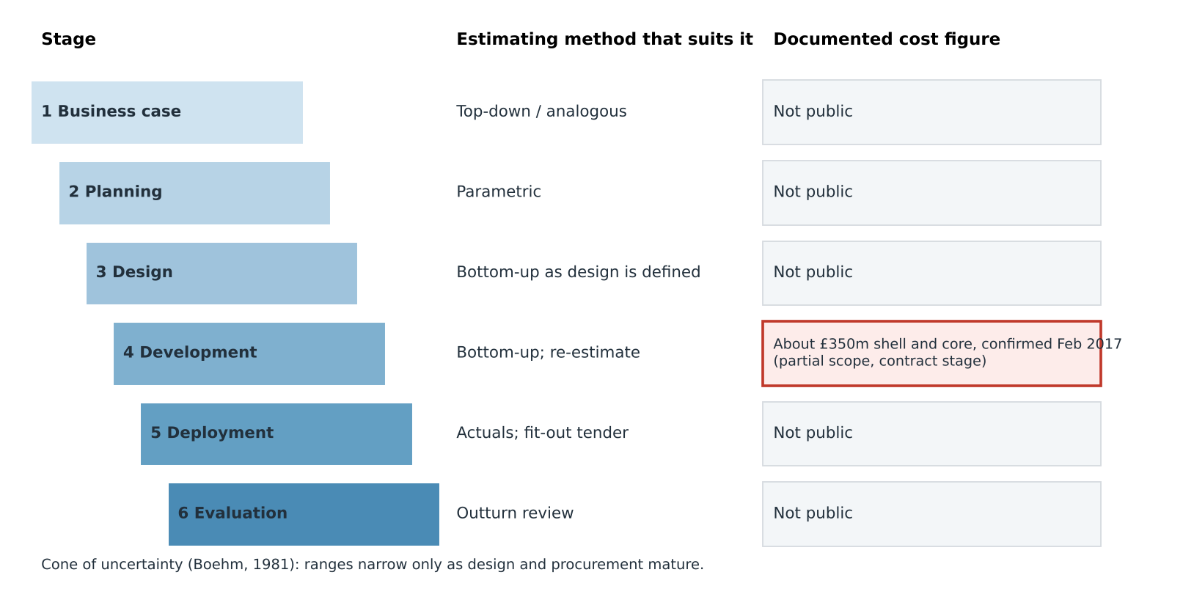
Figure 4: Estimate maturity across the KGX1 life cycle (T1 figure at contract stage only)
Any other total would sit at another stage and scope, so it cannot be compared directly with the documented figure. The cone of uncertainty (Boehm, 1981) implies narrower ranges only as design matures.
Estimating method should follow estimate maturity. Top-down methods suit the business case, parametric methods planning, and bottom-up methods developed design, although bottom-up precision can disguise optimism (Akintoye, 2000; Larson and Gray, 2021). The documented shell-and-core contract of about £350m, confirmed in February 2017 (Construction Enquirer, 2017), sits at contract stage and covers part of the scope, so it cannot be compared with a whole-building total. Contingency is a judgement, not a formula; I assume 10% (range 7% to 15%; T3) with reference-class support (Flyvbjerg, Bruzelius and Rothengatter, 2003). PERT for the frame, with optimistic 36, most likely 46 and pessimistic 62 months (T3), gives (36 + 184 + 62) / 6 = 47 months. Best practice adds benchmarks, a WBS, early stakeholder input, buffers and regular review (Appendix D). In practice the owner and contractor may each hold a buffer, so the same risk can be covered twice or not at all.
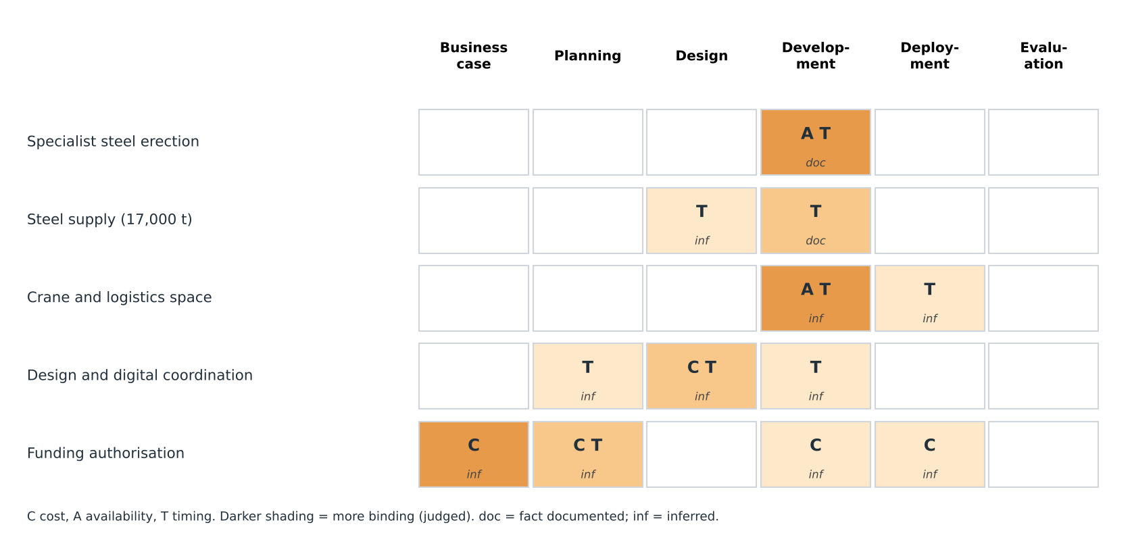
Figure 5: Where resource constraints bound KGX1, by stage (C cost, A availability, T timing; shading shows judged severity)
Availability and timing bound most tightly during development, notably specialist steel erection and crane space; cost bound earlier, at funding authorisation. Estate-level competition is inference.
Constraints shaped four outcomes. Specialist availability affected scheduling because the frame gated every later package. Steel complexity affected risk exposure because one supplier's delay reaches all successors. Constrained crane space affected feasibility because a dense site (inferred) limits simultaneous work. Late design change affected contractor performance because packages are repriced and resequenced (Sun and Meng, 2009), and packages priced before design matures carry that exposure. At estate level, shared labour and logistics can produce the resource allocation syndrome, in which each project optimises its own needs (Engwall and Jerbrant, 2003); here that is inference. PMI attributes 28% of failures to inaccurate cost estimates, 26% to time estimates and 23% to resource forecasting (PMI, 2021).
Cost planning tested organisational skills and adaptability (Dainty, Cheng and Moore, 2005): the manager held a baseline while scope definition, and sometimes the estate, moved around it. Single-project efficiency does not guarantee portfolio efficiency (Martinsuo and Lehtonen, 2007), so implementation depends less on better formulae than on agreeing who holds each buffer.

Section 4: Risk Assessment & Contingency Planning
Risk management follows four stages: identify, assess, respond, monitor (Chapman and Ward, 2003). I use five categories, a 4x4 matrix with score = probability x impact (Low 1-2, Medium 3-4, Serious 6-9, High 12-16), and a PMO for consistency and escalation, since risk management is never one and done (APM, 2019).
Table 4: KGX1 risk register by level and owner (R3, R5, R6 inferred; others documented; Appendix E)
ID | Risk (category) | Level | P | I | Score | Response | Owner
R1 | Contractor hold of Google job (external) | Portfolio | 4 | 3 | 12 | Transfer | Lendlease
R2 | Planning and masterplan interface (external) | Programme | 3 | 3 | 9 | Reduce | Master developer
R3 | Dense site beside rail, canal (operational) | Project | 3 | 2 | 6 | Reduce | Project manager
R4 | Hung steel structure (technical) | Project | 2 | 4 | 8 | Transfer | Steel supplier
R5 | Delivery and fit-out interface (commercial) | Project, portfolio | 3 | 3 | 9 | Reduce | Google
R6 | Estate neighbours' competing demand (operational) | Programme | 3 | 2 | 6 | Reduce | Master developer
O1 | Public AI Exchange space (opportunity) | Portfolio | 3 | 3 | 9 | Exploit | Google

Three scores carry the argument. R1 scores 12: the hold occurred, hence likelihood 4, and its impact was critical because the owner's job stayed on hold after other Lendlease sites reopened (Building, 2020). R2 scores 9 because approval preceded construction (Camden Council, 2017). R5 scores 9 because it joins two levels' decisions. Figure 6 shows risks clustering in the Serious band, responses lowering programme and project scores, with R3 and R6 reaching Medium, while R1 and R4 stay where transfer left them. The matrix scores risks one at a time, yet a contractor's decision can hit a project regardless of its own controls. Escalation is therefore the practical response: a risk the project cannot treat must pass to the level that can.
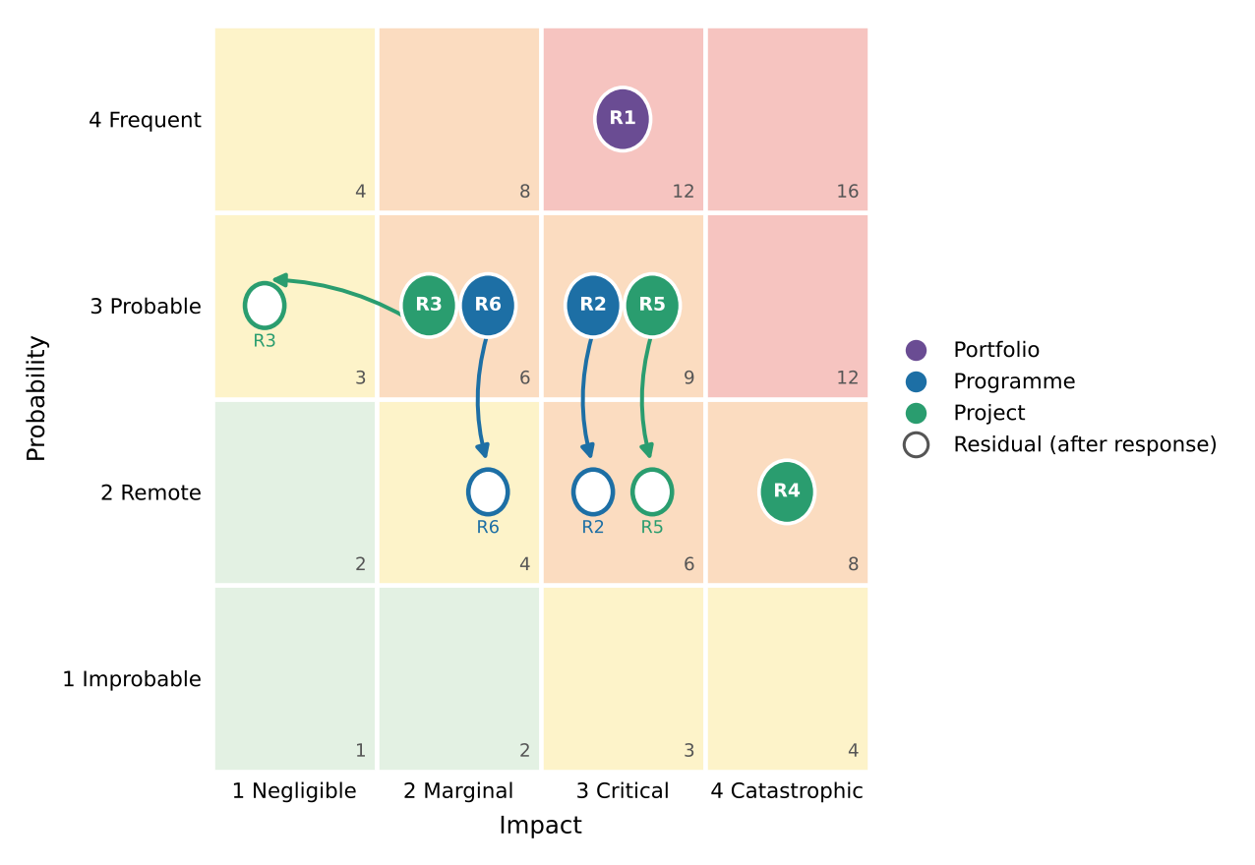
Figure 6: Inherent and residual KGX1 risk positions by owning level (T3 scores)
Stress management mattered because the manager carried delivery accountability for risks others owned (Dainty, Cheng and Moore, 2005).
Appetite, tolerance and capacity differ by level. A portfolio owner with large capital capacity may tolerate schedule risk, while a project team measured on delivery cannot; the programme, accountable to the planning authority and public, tolerates quality and public-realm risk least (Hillson and Murray-Webster, 2007). This is inference, since appetite statements are unpublished, but it implies that identical delay is a manageable loss at one level and a failure at another.
Three responses can be evaluated. For R1, transfer through the contract shifted cost exposure but not programme consequence, so the risk stayed at 12: transfer moves a risk without removing it. For R2, early engagement with the planning authority is inferred, so its effect cannot be verified. For R4, transfer to a specialist supplier (New Steel Construction, n.d.) suited a technical risk the supplier could price, yet delay still reaches the owner. Complex projects also carry systemic risk chains, so top-ranked risks may not be the decisive ones (Williams, 2017).
Figure 7 shows ownership. Plan B statements follow, one per level. Portfolio reserve: trigger, contractor stand-down notice; owner, Google; action, standby terms and second-source options; cost, upward. Programme contingency: trigger, change to masterplan conditions; owner, master developer; action, interface review; cost, neutral. Project buffer: trigger, fit-out scope unfixed eighteen months before shell completion; owner, project manager; action, early appointment; cost, small upward. Contingency covers identified risks; management reserve covers unknowns.
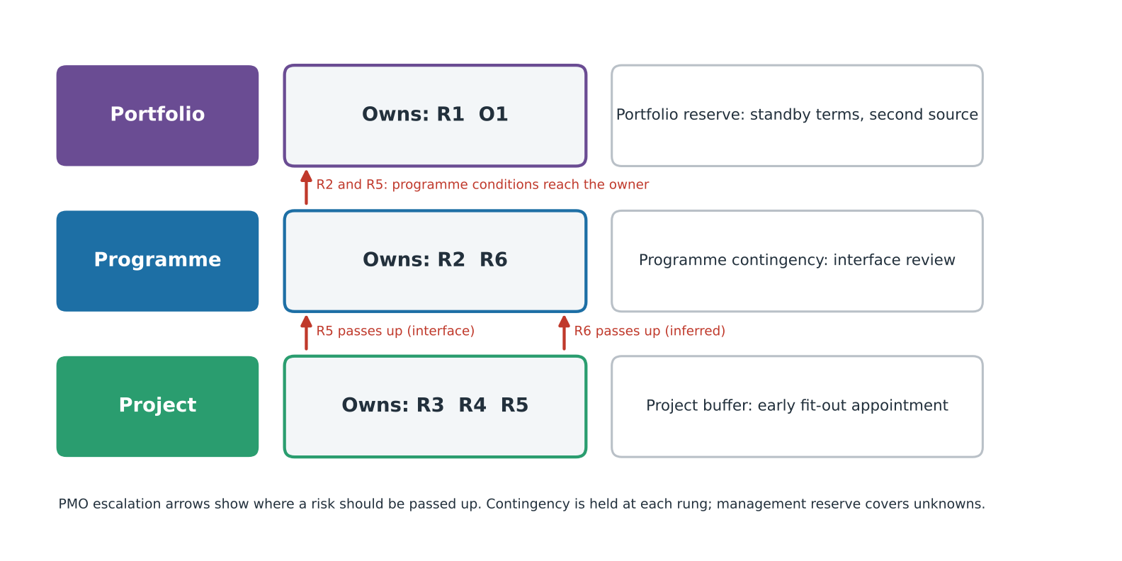
Figure 7: Risk ownership, escalation and contingency by level (T3)
Recommendations: hold an interface risk workshop with all three levels before design freeze; keep one cross-level register; and define a PMO escalation route with thresholds (Pellegrinelli, 2011). Implementation is hard: a cross-level register needs shared definitions, and a private owner may withhold sensitive risks from the master developer, so the PMO's authority is only as strong as the parties' willingness to escalate.

Section 5: Progress Review & Intervention Strategies
KGX1 spans 107 months from approval in August 2017 to staff move-in from summer 2026 (T2; Camden Council, 2017; Google, 2026), with a hung 17,000 t structure and a dense site. Monitoring mattered most at approval, during frame erection, through the 2020 hold and at the fit-out interface.
Four KPI groups apply: schedule (milestones, SPI), cost (CPI, cost variance), quality (defects, rework) and stakeholder communication (Shenhar et al., 2001). Earned value shows that a project is off plan, not why (Fleming and Koppelman, 2010). Actual cost is not public, so a real CPI cannot be computed; I treat the formulae as method, with a tiered example in Appendix F, and read cost through scope definition instead.
Table 5: KPIs along the output, outcome and benefit chain (T1/T2; Appendix F)
Link | KPI and level | KGX1 evidence | Status | Data needed
Output: delivered building | Schedule SPI; project | Move-in from summer 2026; 107 months from approval (T2) | Partly known | Baseline dates
Outcome: public and occupier use | Stakeholder communication; programme | AI Exchange opening later in the year (Google, 2026) | Partly known | Visitor and occupancy data
Benefit: strategic value | Benefits measure; portfolio | Not yet measurable | Not yet known | Benefit targets, review date

Table 5 supports the output link partly and the others hardly at all, because the building is only now opening; judging benefits now would be premature. The practical consequence is that a review date and named owners should be fixed now, or the evaluation stage will lapse.
Three deviations are documented. Schedule: the 107 months from approval to move-in, and the 2020 hold; SPI would have flagged the hold within one reporting cycle and the long-run drift only against a baseline. Cost: only a partial-scope contract figure is public, so CPI is not computable. Quality: no public defect or rework data exist; I would track defects per package and rework hours, escalating at agreed thresholds.
Intervention points were missed or invisible. A formal change request and re-baselining could have followed the 2020 hold, and escalation to portfolio level could have followed contractor stand-down; what prevented them was that the decision rights sat at the contractor and owner, outside the project manager's reach. Whether resets passed through formal change control is not public (Sun and Meng, 2009).
A benefits perspective changes the question. A project can meet schedule and cost KPIs and still fail its owner, or the reverse (Shenhar et al., 2001), so judging performance on outputs alone would reward the wrong behaviour at the wrong level.
Corrective strategies should match deviation and level. Re-baselining suits the hold because it resets a plan that no longer holds, though it can legitimise delay. Fast-tracking, low cost with medium scope impact, suits recovery by overlapping envelope and services, though it raises rework risk. Crashing, high cost with low scope impact, suits a milestone at risk after the baseline is reset. Stakeholder re-engagement suits interface misalignment, though it needs sign-off. Change control follows five steps, log, evaluate, review, decide, implement and communicate (Kerzner, 2022). Each technique also needs an owner: fast-tracking needs contractor consent, and crashing needs owner funding. Figure 8 shows who decides at each step.
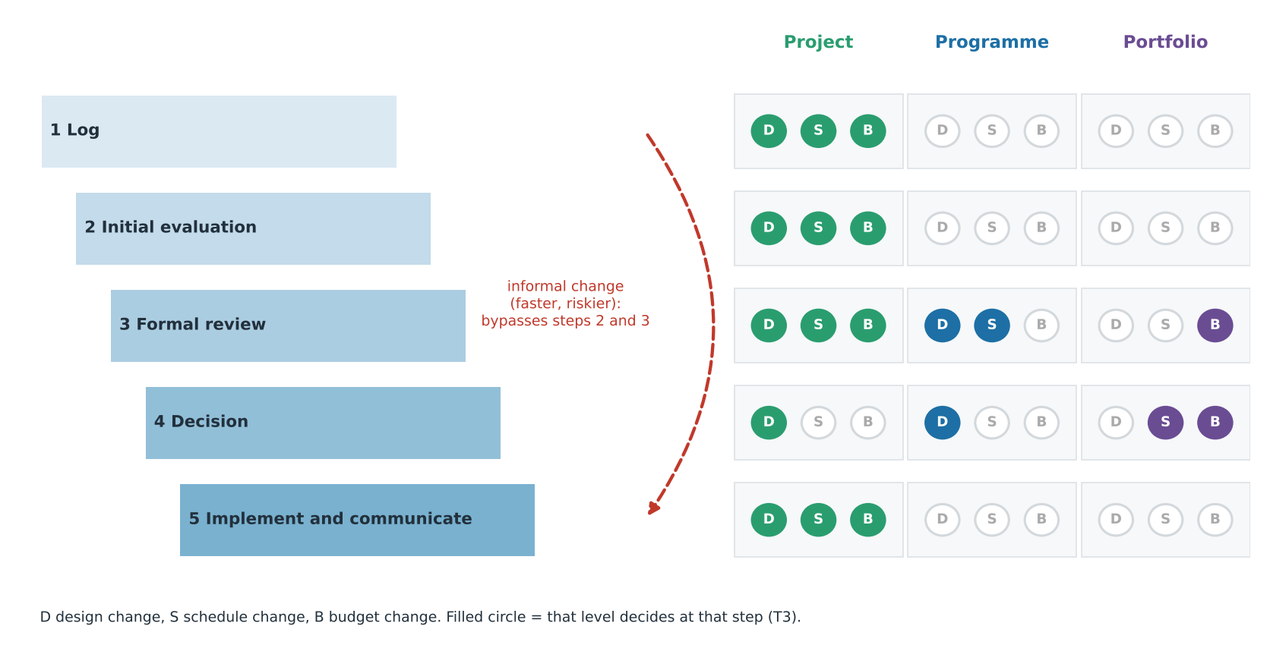
Figure 8: Who decides at each step of change control, by level (T3; informal change bypasses steps 2 and 3)
The staircase would have stopped a late or informal budget change at step 3, and it required the portfolio level for budget decisions.
One rule follows: an SPI below 0.95 on a critical-path package, or any change request above an agreed value, escalates to the next level within one reporting cycle. It demands communication and leadership that carry bad news upward early (Dainty, Cheng and Moore, 2005; Atkinson, 1999).

Conclusion
The evidence only partly supports the nested-systems claim. The strongest evidence is documented: the contractor's hold left Google's job stalled after other sites reopened (Building, 2020), which project controls could not prevent. The lens explains where decisions sat, but cannot show that deviations were not project-internal, so the falsification test remains unresolved. Public data and labelled estimates limit confidence. Negotiation and communication mattered most at the interfaces; applying the tools showed me that escalation thresholds must be agreed across levels before a baseline is set. The interface, not the project alone, is the unit of control.

References
Akintoye, A. (2000) 'Analysis of factors influencing project cost estimating practice', Construction Management and Economics, 18(1), pp. 77–89.
APM (2019) APM Body of Knowledge. 7th edn. Princes Risborough: Association for Project Management.
Atkinson, R. (1999) 'Project management: cost, time and quality, two best guesses and a phenomenon, its time to accept other success criteria', International Journal of Project Management, 17(6), pp. 337–342.
BIG (2024) Google Kings Cross HQ. Available at: https://big.dk/projects/google-platform-37-3347 (Accessed: 9 November 2026).
Boehm, B.W. (1981) Software engineering economics. Englewood Cliffs, NJ: Prentice-Hall.
Building (2020) Lendlease begins to reopen sites but Google job still on hold. Available at: https://www.building.co.uk/news/lendlease-begins-to-reopen-sites-but-google-job-still-on-hold/5105656.article (Accessed: 9 November 2026).
Camden Council (2017) Planning application 2017/3133/P: reserved matters for Development Zone A, King's Cross Central (decision notice dated 16 August 2017). Available at: https://camdocs.camden.gov.uk/CMWebDrawer/PlanRec?q=recContainer%3A2017%2F3133%2FP (Accessed: 9 November 2026).
Chapman, C. and Ward, S. (2003) Project risk management: processes, techniques and insights. 2nd edn. Chichester: Wiley.
Construction Enquirer (2017) Lendlease confirmed for Google HQ, 27 February. Available at: https://constructionenquirer.com/2017/02/27/lendlease-confirmed-for-google-hq (Accessed: 9 November 2026).
Cooper, R.G. and Sommer, A.F. (2016) 'The agile–stage-gate hybrid model: a promising new approach and a new research opportunity', Journal of Product Innovation Management, 33(5), pp. 513–526.
Dainty, A.R.J., Cheng, M.-I. and Moore, D.R. (2005) 'Competency-based model for predicting construction project managers' performance', Journal of Management in Engineering, 21(1), pp. 2–9.
Engwall, M. (2003) 'No project is an island: linking projects to history and context', Research Policy, 32(5), pp. 789–808.
Engwall, M. and Jerbrant, A. (2003) 'The resource allocation syndrome: the prime challenge of multi-project management?', International Journal of Project Management, 21(6), pp. 403–409.
Fleming, Q.W. and Koppelman, J.M. (2010) Earned value project management. 4th edn. Newtown Square, PA: Project Management Institute.
Flyvbjerg, B., Bruzelius, N. and Rothengatter, W. (2003) Megaprojects and risk: an anatomy of ambition. Cambridge: Cambridge University Press.
Google (2026) Platform 37 and The AI Exchange: new spaces for AI innovation and discovery. Available at: https://blog.google/company-news/inside-google/around-the-globe/google-europe/united-kingdom/platform-37-the-ai-exchange/ (Accessed: 9 November 2026).
Hillson, D. and Murray-Webster, R. (2007) Understanding and managing risk attitude. 2nd edn. Aldershot: Gower.
Kerzner, H. (2022) Project management: a systems approach to planning, scheduling, and controlling. 13th edn. Hoboken, NJ: Wiley.
Larson, E.W. and Gray, C.F. (2021) Project management: the managerial process. 8th edn. New York: McGraw-Hill Education.
Martinsuo, M. and Lehtonen, P. (2007) 'Role of single-project management in achieving portfolio management efficiency', International Journal of Project Management, 25(1), pp. 56–65.
Miller, R. and Lessard, D.R. (2000) The strategic management of large engineering projects: shaping institutions, risks, and governance. Cambridge, MA: MIT Press.
Morris, P.W.G. (2013) Reconstructing project management. Chichester: Wiley-Blackwell.
New Steel Construction (n.d.) Steel landscraper takes shape in King's Cross. Available at: https://www.newsteelconstruction.com/wp/steel-landscraper-takes-shape-in-kings-cross/ (Accessed: 9 November 2026).
Pellegrinelli, S. (2011) 'What's in a name: project or programme?', International Journal of Project Management, 29(2), pp. 232–240.
PMI (2021) A guide to the project management body of knowledge (PMBOK guide) and the standard for project management. 7th edn. Newtown Square, PA: Project Management Institute.
Shenhar, A.J., Dvir, D., Levy, O. and Maltz, A.C. (2001) 'Project success: a multidimensional strategic concept', Long Range Planning, 34(6), pp. 699–725.
Sun, M. and Meng, X. (2009) 'Taxonomy for change causes and effects in construction projects', International Journal of Project Management, 27(6), pp. 560–572.
Urban Land Institute (n.d.) In practice: case study – King's Cross, London. Available at: https://urbanland.uli.org/development-business/practice-case-study-kings-cross-london (Accessed: 9 November 2026).
Williams, T. (2017) 'The nature of risk in complex projects', Project Management Journal, 48(4), pp. 55–66.
Zwikael, O. and Smyrk, J. (2011) Project management for the creation of organisational value. London: Springer.

Appendix A: Assumptions register by tier
Tiering follows the report: T1 documented, T2 derived, T3 assumed with a stated basis and range. Productivity rates, cost-model shares and benchmarks were not available to me, so they sit in T3. The body cites the appendices as follows: A for all sections, B for Section 2 and Figure 3, C and D for Section 3, E for Section 4, Table 4 and Figure 6, F for Section 5 and Table 5, and G for all sections. Documented (T1) values appear with their sources in Appendix G and are not repeated here.
ID | Item | Value | Tier | Basis / source | Low | High
A05 | Approval to move-in | 107 months | T2 | August 2017 to July 2026
A06 | Steel erection rate | 7 t per gang-day | T3 | No published rate held | 5 | 10
A07 | Gang size; window; days | 8 workers; 36 months; 21 days/month | T3 | Assumed
A08 | Contingency | 10% of shell and core | T3 | Judgement; reference class (Flyvbjerg, Bruzelius and Rothengatter, 2003) | 7% | 15%
A09 | PERT for frame O, M, P | 36, 46, 62 months | T3 | Assumed around the network duration
A10 | Network durations | Table B1 | T3 | Calibrated to 107 months between documented dates | ±25%
A11 | Pandemic hold | 4 months | T3 | Building (2020): job stayed on hold after other sites reopened | 2 | 8
A12 | WBS shares | Table D1 | T3 | Indicative; no named cost model held | ±3 pts
A13 | Risk scores | Table E1 | T3 | Judgement with stated evidence | ±1
A14 | Escalation trigger | SPI below 0.95 on critical path | T3 | Recommendation | 0.97 | 0.90

Appendix B: Network workings and WBS
Months run from approval in August 2017 (month 0); finish-to-start logic; one start and one end node, no loops, one task per node (Larson and Gray, 2021). Early start is the largest early finish among predecessors and late finish the smallest late start among successors; slack is late start less early start. The T1 anchors are approval (August 2017) and move-in (summer 2026); the 107 months between them are shared among activities by assumption (T3). WBS: 1 Whole building; 1.1 Preliminaries; 1.2 Substructure; 1.3 Frame; 1.4 Envelope; 1.5 Services and vertical transport; 1.6 Fit-out; 1.7 Roof terraces and landscaping; 1.8 Commissioning and handover; 1.9 Contingency.
Table B1: Network schedule (T3 durations between T1 anchors)
ID | Activity | Pred. | Dur. | ES | EF | LS | LF | Slack | Critical
S | Approval (August 2017) | - | 0 | 0 | 0 | 0 | 0 | 0 | Yes
N2 | Enabling, substructure | S | 12 | 0 | 12 | 0 | 12 | 0 | Yes
N3 | Frame (17,000 t) | N2 | 46 | 12 | 58 | 12 | 58 | 0 | Yes
N4 | Pandemic hold (T3) | N3 | 4 | 58 | 62 | 58 | 62 | 0 | Yes
N5 | Envelope | N4 | 22 | 62 | 84 | 64 | 86 | 2 | No
N6 | MEP, vertical transport | N4 | 24 | 62 | 86 | 62 | 86 | 0 | Yes
N7 | Fit-out | N5, N6 | 16 | 86 | 102 | 86 | 102 | 0 | Yes
N8 | Roof terraces, landscaping | N5 | 10 | 84 | 94 | 97 | 107 | 13 | No
N9 | Commissioning, handover | N7 | 5 | 102 | 107 | 102 | 107 | 0 | Yes
E | Move-in (summer 2026) | N9, N8 | 0 | 107 | 107 | 107 | 107 | 0 | Yes

Critical path: S-N2-N3-N4-N6-N7-N9-E, 107 months. Envelope (N5) has 2 months of slack and roof terraces (N8) 13. External dependencies (dashed in Figure 3): planning consent and estate infrastructure (programme), contractor stand-down (documented, Building, 2020) and the owner’s fit-out decision (portfolio, inferred).

Appendix C: Resource workings
No chart is included because no labour data are public. Steel effort (T2/T3) equals quantity divided by rate; at 5, 7 and 10 t per gang-day the figure is about 36, 26 and 18 erectors respectively, over 36 months of 21 days at eight workers per gang (T3).

Appendix D: Budget workings
Table D1: Indicative allocation of the shell-and-core contract (T1 total, T3 shares; no named cost model held)
WBS element | Share (T3) | £m of £350m
Preliminaries | 12% | 42.0
Substructure | 12% | 42.0
Frame | 16% | 56.0
Envelope | 24% | 84.0
Services and vertical transport | 26% | 91.0
Contingency | 10% | 35.0
Total | 100% | 350.0

Calculation | Formula | Result
Steel effort (T2/T3) | 17,000 / 7 | 2,429 gang-days
Erectors (T3) | 2,429 / (36 x 21) x 8 | 26
PERT expected (T3) | (36 + 4 x 46 + 62) / 6 | 47 months
PERT standard deviation (T3) | (62 - 36) / 6 | 4.3 months
Contingency (T3) | 10% x £350m | £35.0m
Approval to move-in (T2) | August 2017 to July 2026 | 107 months

Shares sum to 100% and lines sum to £350.0m. The £350m is a contract-stage, partial-scope figure and is not a whole-building budget. No published benchmark was held, so no benchmark variance is reported.

Appendix E: Full risk register
ID | Risk | Cat. | Level | P | I | Score | Residual (P x I) | Response | Plan B | Trigger | Owner | Evidence level | Justification
R1 | Contractor hold of Google job | External | Portfolio | 4 | 3 | 12 | 4 x 3 = 12 | Transfer | Portfolio reserve: standby terms, second source | Contractor stand-down notice | Lendlease; Google | Documented | Occurred; job stayed on hold after other sites reopened (Building, 2020); transfer did not move it
R2 | Planning and masterplan interface | External | Programme | 3 | 3 | 9 | 2 x 3 = 6 | Reduce | Programme contingency: interface review | Change to masterplan conditions | Master developer | Documented | Approval preceded construction (Camden Council, 2017); early engagement inferred
R3 | Dense site beside rail and canal | Operational | Project | 3 | 2 | 6 | 3 x 1 = 3 | Reduce | Off-peak deliveries; alternative laydown | Delivery slot failures | Project manager | Inferred | Site context; no source held
R4 | Hung steel structure | Technical | Project | 2 | 4 | 8 | 2 x 4 = 8 | Transfer | Second erection gang | Erection over 10% behind plan | Steel supplier | Documented | 17,000 t hung structure (New Steel Construction, n.d.); transfer leaves impact
R5 | Delivery and fit-out interface | Commercial | Project, portfolio | 3 | 3 | 9 | 2 x 3 = 6 | Reduce | Project buffer: early fit-out appointment | Fit-out scope unfixed 18 months before shell completion | Google; project manager | Inferred | Joins two levels' decisions
R6 | Estate neighbours' competing demand | Operational | Programme | 3 | 2 | 6 | 2 x 2 = 4 | Reduce | Joint logistics plan | Delivery clashes | Master developer | Inferred | No overlapping dates found
O1 | Public AI Exchange space | Opportunity | Portfolio | 3 | 3 | 9 | n/a | Exploit | Early programming of the space | Opening date set | Google | Documented | Opening later in the year (Google, 2026)

Appendix F: KPI workings
Illustrative only (T3): public data give no actual cost, so no KGX1 CPI can be computed and the figures below show the method, not an outcome. Assumed position on a £350m shell-and-core scope: BAC £350m; PV £200m; EV £180m; AC £195m.
Results: SV -£20m; CV -£15m; SPI 0.90; CPI 0.92; EAC £379.2m; ETC £184.2m; VAC -£29.2m; TCPI 1.10. The SPI trigger is breached, so the position would escalate.
Quality: no public defect or rework data exist. I would track defects per package, rework hours and snagging items at handover, escalating when agreed thresholds are exceeded.

Appendix G: Evidence log
Status column: what I could verify. Where only a headline or snippet was visible, the underlying page should be read before submission (checked 9 November 2026).
Source | Claim relied on | Verification
Construction Enquirer (2017) | Contractor confirmed for shell and core, about \u00a3350m | Snippet
Camden Council (2017) | Reserved matters decided 16 August 2017 under the outline permission | Case file found, notice unread
New Steel Construction (n.d.) | 17,000 t hung frame; terraces and running track | Snippet
Building (2020) | Other Lendlease sites reopened while the Google job stayed on hold | Headline
Google (2026) | Platform 37 name; AI Exchange; move-in from summer | Headings only
Urban Land Institute (n.d.) | Estate partnership and public-realm arrangements | Snippet; wording to confirm
BIG (2024) | Design team; low-carbon aim | Project page unread
Estate neighbours | Competing demand for labour or space | Inference only

