SWG Technologies: Coventry Network Design Report
Student: Sujal Bist Student ID: 17356743 Module: 400IT

Introduction
SWG Technologies needs one network joining its Skipton (head office), Wrocław and Greenwich sites. This report documents the design I built in Packet Tracer from the single block 192.70.20.0/24. Each site has one 1941 router and one 2960 switch, named Skipton, Wroclaw and Greenwich (Router0, Router1 and Router2 in the brief and worksheet). I cover addressing (A), topology (B), security (C), testing (D) and reliability (E). Each section gives a claim, the evidence for it, and its limits.

A. Addressing
A-i Method. I ordered the requirements largest first and sized each with 2ⁿ − 2 ≥ hosts (Odom, 2019). I then allocated sequentially from the 0th subnet, as the brief requires (Pummill and Manning, 1995). No subnet calculator was used; the binary working is in the worksheet. Sales (30 hosts) needs 5 host bits, so a /27 (255.255.255.224). IT (17 hosts) also needs 5 bits, because a /28 gives only 14 usable addresses and cannot hold 17. HR (8 hosts) needs 4 bits, so a /28. Each router link needs two addresses, so a /30. Fig. 2 shows the allocation. I chose VLSM over fixed-length subnetting because the departments differ in size, and it lets the block be divided on host needs rather than in equal parts (Pummill and Manning, 1995; Kurose and Ross, 2021).
Network | Hosts needed | Mask | Subnet addresses (3 sites) | Usable each
Sales (VLAN 10) | 30 | /27 | .0, .32, .64 | 30
IT (VLAN 20) | 17 | /27 | .96, .128, .160 | 30
HR (VLAN 30) | 8 | /28 | .192, .208, .224 | 14
Router links | 2 | /30 | .240, .244, .248 | 2
Fig. 2: VLSM allocation from 192.70.20.0/24 (gateways at the first usable address; servers .98 and .99 in Skipton IT).
A-ii Efficiency. The plan uses 252 of 256 addresses (98%) and leaves only 192.70.20.252/30 free. VLSM makes this possible: a fixed /27 for all twelve networks would need 12 × 32 = 384 addresses, more than the /24 holds. The links show the saving best, since a /30 instead of a /27 saves 28 addresses per link. Inside the subnets the fit is also close: IT needs 17 hosts plus a gateway, 18 of 30 usable addresses, and HR needs 9 of 14.
Limitations. The design leaves almost no room to grow. Sales has 30 usable addresses, but the gateway takes .1, so only 29 remain, one short of the 30 required. A /26 for Sales would fix that, but it will not fit in this /24 beside everything else, so the real remedy is a larger parent block. Also, the departments are grouped by type, not by site, so the space cannot be summarised into one route per site and OSPF carries every subnet individually; summarisation at area borders is how OSPF keeps routing tables small (Moy, 1998). A layout by site (for example a /26 per site) would allow one summary per router. Finally, 192.70.20.0/24 is public address space, not RFC 1918 private space (Rekhter et al., 1996). That is acceptable in an isolated lab but would need justifying in production.

B. Topology
B-i Design choice. Each site is a star: end devices connect to a switch, and the switch connects to the site router through trunk port Fa0/1, which carries tagged VLAN frames using IEEE 802.1Q (IEEE, 2018) (Fig. 1). The three routers are joined by serial links in a triangle: Skipton–Wrocław 192.70.20.240/30, Skipton–Greenwich .244/30 and Wrocław–Greenwich .248/30. This matches the triangle in the brief. The worksheet lists these links as Se0/0/0 and Se0/0/1, but my routers’ serial ports are Serial0/1/0 and Serial0/1/1, so I applied each address to the interface actually cabled to that neighbour.
I compared two alternatives. Hub-and-spoke centred on Skipton needs only two links, but all branch-to-branch traffic would cross head office, and Skipton would be a single point of failure for the whole WAN. The triangle costs one extra link and removes both problems. For three sites that is a sensible trade. It does not scale, because links grow as n(n−1)/2: ten sites would need 45. A larger company would use redundant hubs or a provider WAN (Kurose and Ross, 2021). I accept the extra link here because the cost of a third serial connection is small compared with losing branch-to-branch connectivity.
B-ii Efficiency and resilience. Wrocław–Greenwich traffic uses the direct /30 and does not hairpin through Skipton. OSPF (process 1, area 0), a link-state protocol that picks the lowest-cost path (Moy, 1998), has FULL adjacencies on every link: Wroclaw and Greenwich each list two neighbours (Fig. 4). If one link fails, OSPF reroutes through the third router, and section D tests this. Inside each site PVST+ prevents Layer 2 loops (Odom, 2019). With one switch per site it is a safeguard rather than an active feature.
Inter-VLAN routing is router-on-a-stick, with one 802.1Q sub-interface per VLAN (Odom, 2019). Skipton has sub-interfaces Gi0/0.10 (VLAN 10, 192.70.20.1), Gi0/0.20 (VLAN 20, .97) and Gi0/0.30 (VLAN 30, .193), as Fig. 4 shows. The limitation is that all three VLANs share one physical link, and each site still has a single router, switch and trunk, so a failure there isolates the site. A Layer 3 switch or a second uplink would remove that.

C. Security
C-i Controls and reasons. On the routers (Fig. 5) I set an enable secret, console and VTY passwords with login, a MOTD warning banner and service password-encryption. The enable secret is stored as an MD5 hash, so a copied config does not reveal it (Odom, 2019). Service password-encryption only applies weak type 7 encoding to the line passwords. It stops shoulder-surfing, not a determined attacker. The banner gives a legal warning to anyone logging in. This matters for SWG because the routers carry all inter-site and inter-VLAN traffic, so control of one router would expose every department. VLANs 10, 20 and 30 split each site into separate broadcast domains.
Port security on the access ports uses sticky MAC learning, a maximum of 2 and violation mode restrict (Fig. 6). This limits MAC flooding and rogue devices (Odom, 2019). I chose restrict over shutdown because shutdown puts the port into err-disabled and needs an administrator to recover it, so one mistake could lock out a legitimate user. The cost is that the port stays up during an attack, so shutdown would suit sensitive ports better. At Wrocław, WPA2-PSK on the SSID “Smartphone” requires a passphrase before a device can join. The weakness is that every user shares one key, so removing a single user means changing it for everyone, and WPA2-Enterprise would be the better choice at scale.
Honest limits. The VLANs are segmentation, not isolation: inter-VLAN routing is on and I configured no ACLs, so Sales can still reach HR. The switch configurations do not have service password-encryption enabled. The brief mandates Telnet, which sends passwords in clear text (Postel and Reynolds, 1983), and the passwords it supplies are weak, so this suits a lab only.
C-ii Head office to branches. The sites are joined by dedicated point-to-point serial links, not the public internet, and OSPF runs only over them. That limits exposure, but nothing on those links is encrypted or authenticated, so a rogue router on a link could inject routes. Recommended improvements, not implemented: IPsec site-to-site tunnels if the links ever ran over the internet (Kent and Seo, 2005), OSPF authentication (Moy, 1998; Bhatia et al., 2009), SSH instead of Telnet, per-VLAN ACLs, and shutting unused ports.

D. Network testing
D-i Results. I ran the worksheet tests. The brief names “PC20” and “Router3”, which do not exist in my topology, so I used PC__ and the Greenwich router: state your substitutes as the nearest real devices. In Fig. 8 the DNS server pinged its gateway, 192.70.20.97, and all four replies arrived (0% loss). The TTL of 255 shows the reply came straight from the router’s own interface with no hops between, and the times were under 1 ms except one at 7 ms. A first request can time out while ARP resolves the gateway’s MAC address (Plummer, 1982). That did not happen here, so the entry was probably already cached. A cross-site ping from PC01 to PC100 also succeeded, with 4 of 4 replies and 0% loss. The times were 19, 37, 2 and 1 ms: the slow first replies are the ARP and first-packet delay, and later replies settled at 1 to 2 ms. The TTL of 126 is the PC’s starting value of 128 minus two routers (Skipton and Greenwich), which confirms the direct two-router path. Add the remaining worksheet pings. These results support the addressing in A.
Traceroute shows the ingress address of each router, so each hop is one routed step (Kurose and Ross, 2021). PC70 to Laptop77 (Wrocław Sales to IT) showed 192.70.20.33 and then the destination, two hops, because the Wroclaw router routes between VLANs. PC01 to PC100 (Skipton HR to Greenwich Sales) showed 192.70.20.193, then 192.70.20.246, the Greenwich end of the direct link, then the destination (Fig. 9). The single timeout (*) on the first probe of the last hop is the same ARP delay, this time at the Greenwich router, and the following probes replied in under 1 ms. This shows OSPF chose the direct path and not the longer one through Wrocław, which supports B-ii. PC73 to PC01 (Wrocław to Skipton) showed 192.70.20.33, then 192.70.20.241, then the destination, and PC02 to PC08 (Skipton HR to IT) showed 192.70.20.193 and then the destination confirm both. Every path is the shortest available, so the OSPF costs on the equal serial links behave as intended. A successful ping from Laptop78 to the DNS server also shows that routing and name services work together.
D-ii Troubleshooting. First, show interfaces trunk on the Skipton switch returned nothing. Fa0/1 was not trunking, so VLAN traffic could not reach the router. I diagnosed it by checking the trunk table first, because an empty table points to the port mode and not to addressing or routing. I entered switchport mode trunk on Fa0/1. The command then showed 802.1q trunking with VLANs 1, 10, 20 and 30 active (Fig. 3).
Second, show ip interface brief on Skipton showed Serial0/1/1 unassigned and down, and show ip ospf neighbor listed only one neighbour (192.70.20.250), so the Greenwich link was not up (Fig. 4). After configuring the link, Greenwich listed Skipton (192.70.20.241) as a neighbour on 192.70.20.245. The final adjacency check confirmed it. The lesson is to verify each layer in turn: interfaces, then adjacencies, then routes, then end-to-end pings.
Fault tolerance test. To test resilience, I shut down Serial0/1/1 on the Skipton router and repeated the traceroute from PC01 to PC100. The route changed and passed through 192.70.20.193 (Skipton HR gateway), 192.70.20.242 (Wrocław serial interface) and 192.70.20.250 (Greenwich serial interface) before reaching the destination, one hop more than the direct path. The ping still succeeded, so PC01 could reach PC100 with the direct link down (Fig. 10). OSPF removed the failed route and selected the alternative through the other routers (Moy, 1998). The cost is a longer path and higher latency, but connectivity is kept, which proves the resilience claimed in B. It tests one link failure only: a second failure, or the loss of the Wroclaw router, would still isolate a site.

E. Reliability and resilience
E-i How the design supports SWG. A single link failure does not cut any site off, because the link-shutdown test in D rerouted through the third router. The nine department VLANs form nine separate broadcast domains, so a broadcast storm in one stays there. DNS and HTTP in Skipton IT serve every site: the browser at PC18 loaded www.coventrylab.ac.uk (Fig. 7), which also confirms inter-site routing, DNS resolution and the HTTP service together. Because each site reaches the servers through its router and the serial links, a server fault and a routing fault look different in testing, and that speeds up diagnosis. The addressing is documented and predictable, and each department has its own subnet and gateway, so a fault can be narrowed quickly to one department at one site.
E-ii Security and topology together. The two complement each other. Port security protects the edge from rogue devices, and OSPF over the mesh protects the availability of the core. Neither covers the other’s weakness: the mesh does nothing against a rogue device, and port security does nothing against a failed link. Confidentiality is only partly covered, because the links are not encrypted, so the design gives access control and availability but not full protection of data in transit.
Critical limits. Skipton hosts both DNS and HTTP, so a Skipton failure removes name resolution for every site. Each site has one router and one switch, and the addressing leaves almost no growth room. The result is a network that is easy to document but not yet fault tolerant at site level. Next I would add a second DNS server at a branch, redundant uplinks and a first-hop redundancy protocol such as HSRP (Odom, 2019), and plan a larger addressing block laid out by site.

Conclusion
The design meets the brief with a 98% efficient VLSM plan, a triangle of OSPF-connected routers and basic access controls, and the tests show the direct path and the failover path. I would rate it a sound base for three small sites, not a finished enterprise design. Its weaknesses are the tight addressing, the single points of failure at each site and the lack of ACLs and encryption. The improvements in C and E address these.

Figures
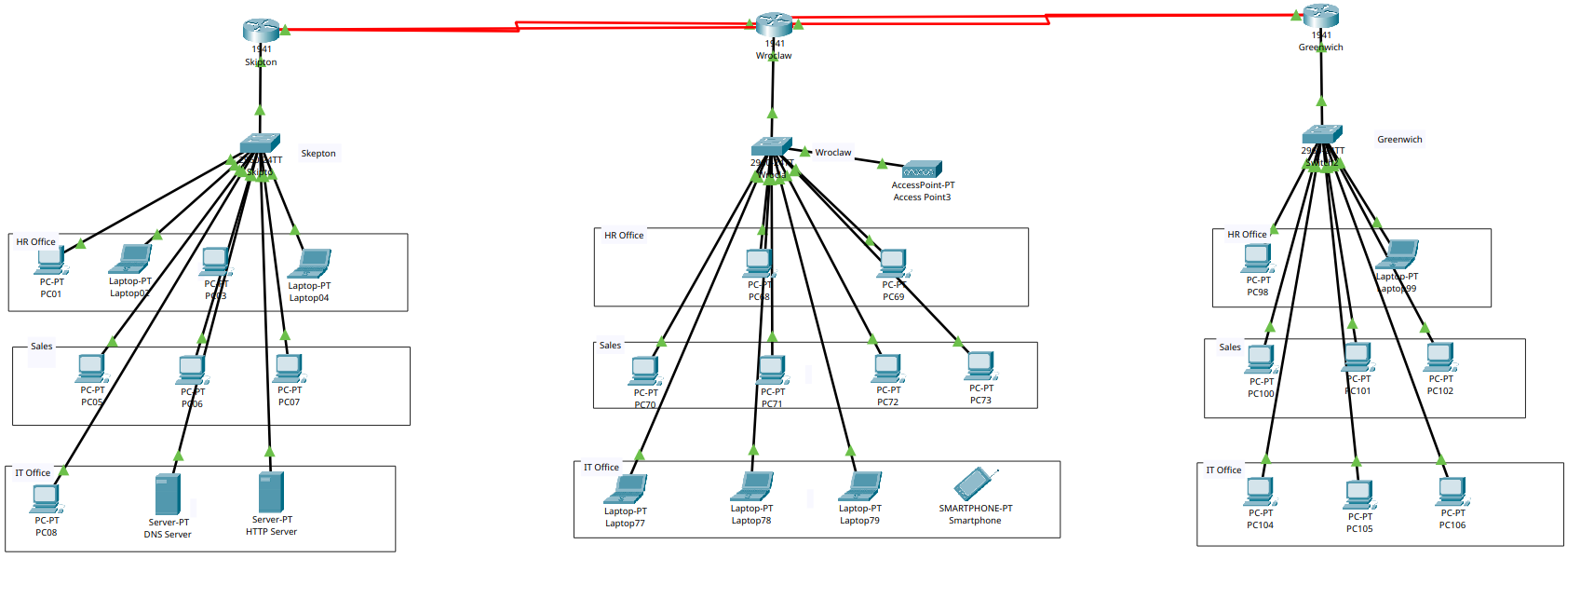
Fig. 1: Full topology in Packet Tracer (three sites, triangle of serial links).
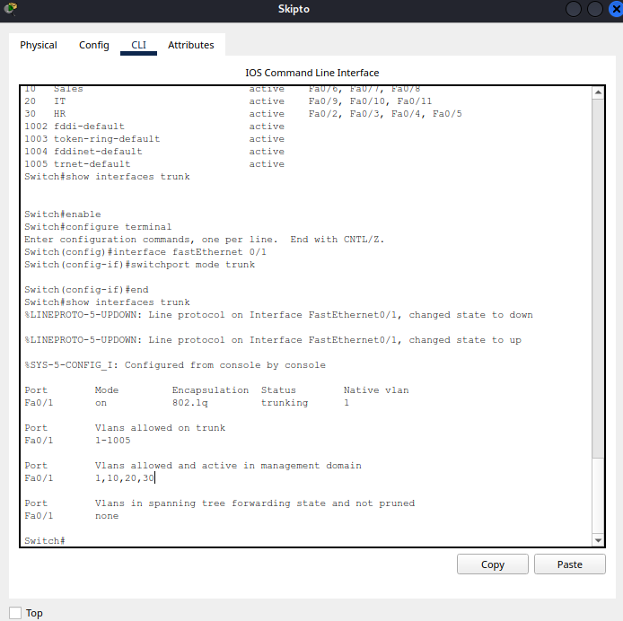 | 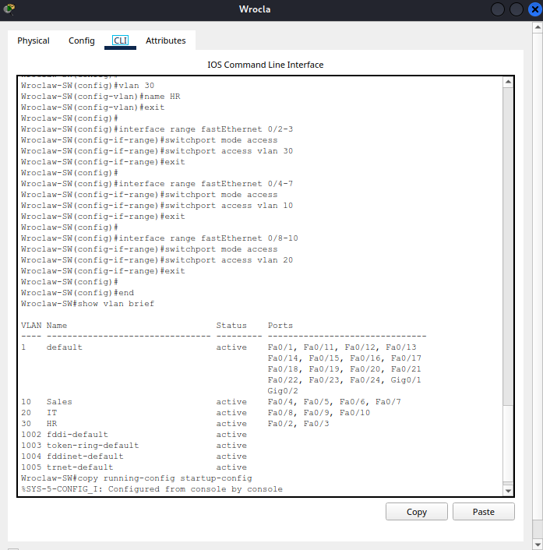
Fig. 3: Skipton switch show interfaces trunk after the fix (left); Wrocław switch show vlan brief (right).
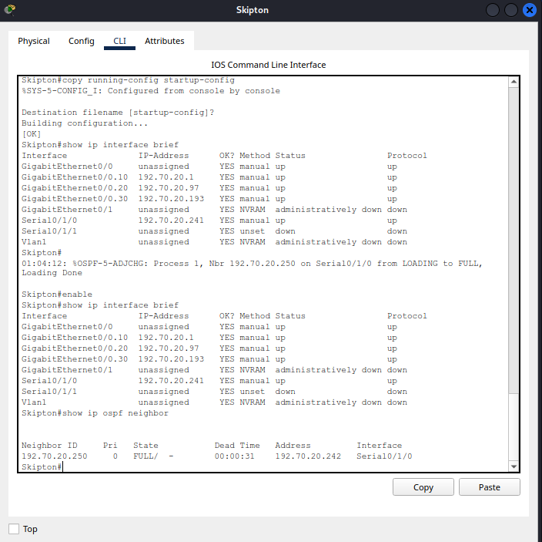 | 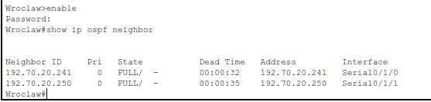 | 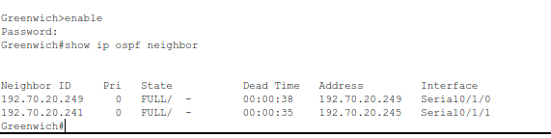
Fig. 4: Skipton sub-interfaces and OSPF neighbour (left); Wrocław neighbours (centre); Greenwich neighbours (right). «Add show ip route with O routes for one router.»
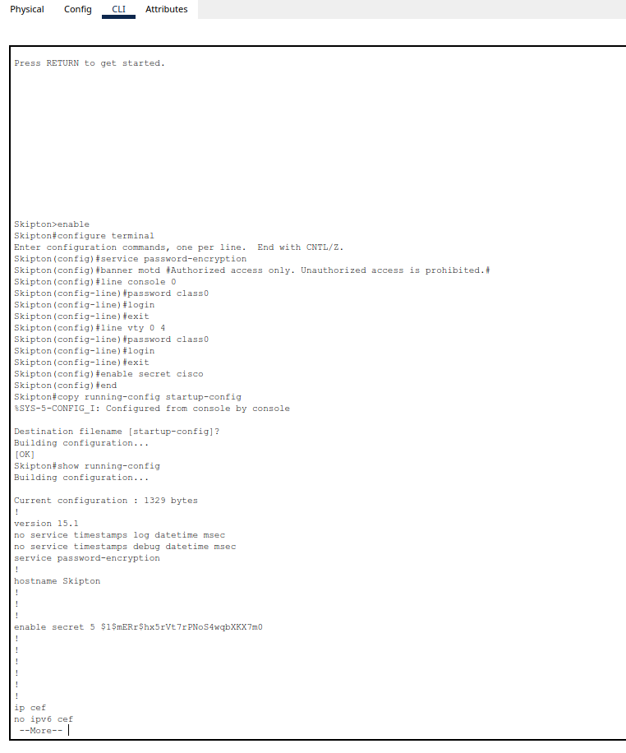 | 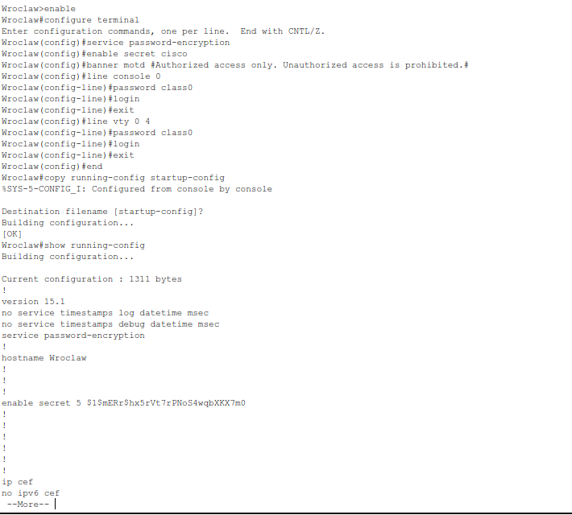
Fig. 5: Router security configuration, Skipton (left) and Wrocław (right).
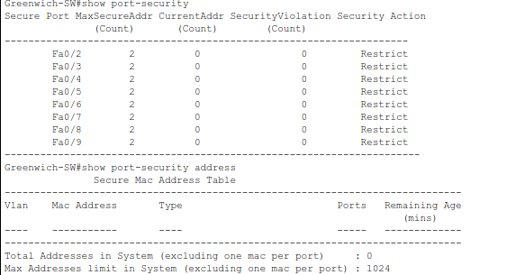
Fig. 6: show port-security, Greenwich switch (sticky MAC, maximum 2, restrict). «Add the Skipton or Wrocław output with learned MACs after traffic.»
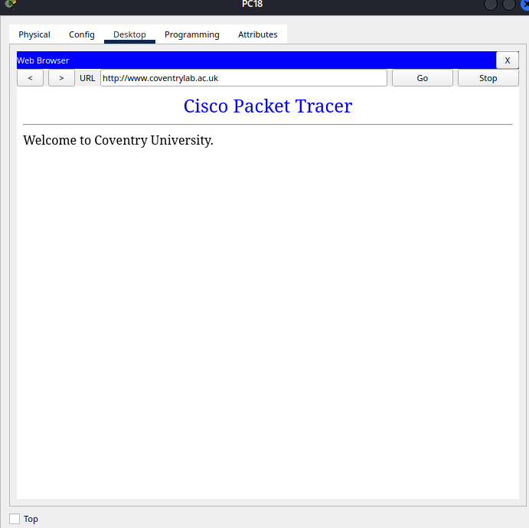 | 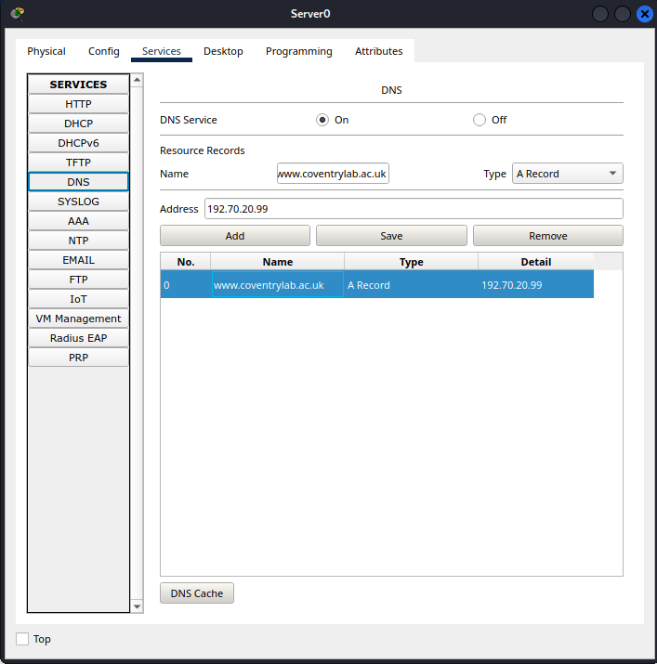
Fig. 7: DNS A record on the DNS server (left); PC18 loading www.coventrylab.ac.uk (right).
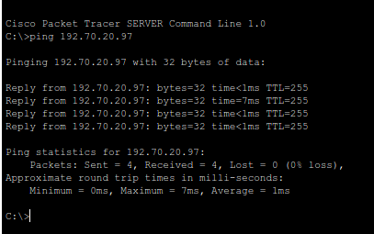 | 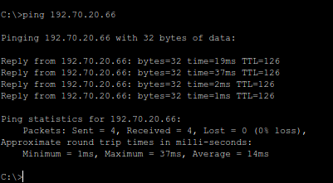
Fig. 8: Ping from the DNS server to its gateway 192.70.20.97 (left, TTL 255); ping from PC01 to PC100 192.70.20.66 (right, TTL 126, 0% loss).
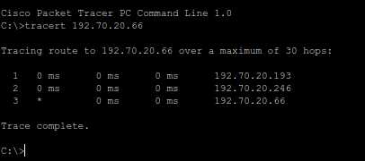
Fig. 9: Traceroute from PC01 to PC100 (192.70.20.66) on the direct path: gateway .193, Greenwich link end .246, destination.
Fig. 10: insert the traceroute and successful ping captured with Serial0/1/1 shut down.

AI acknowledgement
Edit to match what you actually did. I used Claude (Anthropic, 2026) to help structure and draft this report. I checked the configurations, addresses and test results against my Packet Tracer network and my worksheet, and I take responsibility for the content.

References
Bhatia, M. et al. (2009) RFC 5709: OSPFv2 HMAC-SHA Cryptographic Authentication. IETF.
IEEE (2018) IEEE Std 802.1Q-2018: Bridges and Bridged Networks. New York: IEEE.
Kent, S. and Seo, K. (2005) RFC 4301: Security Architecture for the Internet Protocol. IETF.
Kurose, J.F. and Ross, K.W. (2021) Computer Networking: A Top-Down Approach. 8th edn. Harlow: Pearson.
Moy, J. (1998) RFC 2328: OSPF Version 2. IETF.
Odom, W. (2019) CCNA 200-301 Official Cert Guide, Volume 1. Indianapolis: Cisco Press.
Plummer, D. (1982) RFC 826: An Ethernet Address Resolution Protocol. IETF.
Postel, J. and Reynolds, J. (1983) RFC 854: Telnet Protocol Specification. IETF.
Pummill, T. and Manning, B. (1995) RFC 1878: Variable Length Subnet Table for IPv4. IETF.
Rekhter, Y. et al. (1996) RFC 1918: Address Allocation for Private Internets. IETF.

