

400IT Networking Coursework Practical Assessment
Student: Sujal Bist
Student ID: 17356743
Module: 400IT

SWG Technologies: Coventry Network Design Report

Introduction
SWG Technologies needs one network joining its Skipton (head office), Wrocław and Greenwich sites. This report documents the design I built in Packet Tracer from the single block 192.70.20.0/24. Each site has one 1941 router and one 2960 switch, named Skipton, Wroclaw and Greenwich (Router0, Router1 and Router2 in the brief and worksheet). I cover addressing (A), topology (B), security (C), testing (D) and reliability (E). Each section gives a claim, the evidence for it, and its limits.

A. Addressing
A-i Method. I ordered the requirements largest first and sized each with 2ⁿ − 2 ≥ hosts (Odom, 2019). I then allocated sequentially from the 0th subnet, as the brief requires (Pummill and Manning, 1995). No subnet calculator was used; the binary working is in the worksheet. Sales (30 hosts) needs 5 host bits, so a /27 (255.255.255.224). IT (17 hosts) also needs 5 bits, because a /28 gives only 14 usable addresses and cannot hold 17. HR (8 hosts) needs 4 bits, so a /28. Each router link needs two addresses, so a /30. Fig. 2 shows the allocation. I chose VLSM over fixed-length subnetting because the departments differ in size, and it lets the block be divided on host needs rather than in equal parts (Pummill and Manning, 1995; Kurose and Ross, 2021).
Network | Hosts needed | Mask | Subnet addresses (3 sites) | Usable each
Sales (VLAN 10) | 30 | /27 | .0, .32, .64 | 30
IT (VLAN 20) | 17 | /27 | .96, .128, .160 | 30
HR (VLAN 30) | 8 | /28 | .192, .208, .224 | 14
Router links | 2 | /30 | .240, .244, .248 | 2
Fig. 2: VLSM allocation from 192.70.20.0/24 (gateways at the first usable address; servers .98 and .99 in Skipton IT).
A-ii Efficiency. The plan uses 252 of 256 addresses (98%) and leaves only 192.70.20.252/30 free. VLSM makes this possible: a fixed /27 for all twelve networks would need 12 × 32 = 384 addresses, more than the /24 holds. The links show the saving best, since a /30 instead of a /27 saves 28 addresses per link. Inside the subnets the fit is also close: IT needs 17 hosts plus a gateway, 18 of 30 usable addresses, and HR needs 9 of 14.
Limitations. The design leaves almost no room to grow. Sales has 30 usable addresses, but the gateway takes .1, so only 29 remain, one short of the 30 required. A /26 for Sales would fix that, but it will not fit in this /24 beside everything else, so the real remedy is a larger parent block. Also, the departments are grouped by type, not by site, so the space cannot be summarised into one route per site and OSPF carries every subnet individually; summarisation at area borders is how OSPF keeps routing tables small (Moy, 1998). A layout by site (for example a /26 per site) would allow one summary per router. Finally, 192.70.20.0/24 is public address space, not RFC 1918 private space (Rekhter et al., 1996). That is acceptable in an isolated lab but would need justifying in production.

B. Topology
B-i Design choice. Each site is a star: end devices connect to a switch, and the switch connects to the site router through trunk port Fa0/1, which carries tagged VLAN frames using IEEE 802.1Q (IEEE, 2018) (Fig. 1). The three routers are joined by serial links in a triangle: Skipton–Wrocław 192.70.20.240/30, Skipton–Greenwich .244/30 and Wrocław–Greenwich .248/30. This matches the triangle in the brief. The worksheet lists these links as Se0/0/0 and Se0/0/1, but my routers’ serial ports are Serial0/1/0 and Serial0/1/1, so I applied each address to the interface actually cabled to that neighbour.
I compared two alternatives. Hub-and-spoke centred on Skipton needs only two links, but all branch-to-branch traffic would cross head office, and Skipton would be a single point of failure for the whole WAN. The triangle costs one extra link and removes both problems. For three sites that is a sensible trade. It does not scale, because links grow as n(n−1)/2: ten sites would need 45. A larger company would use redundant hubs or a provider WAN (Kurose and Ross, 2021). I accept the extra link here because the cost of a third serial connection is small compared with losing branch-to-branch connectivity.
B-ii Efficiency and resilience. Skipton–Greenwich traffic uses the direct /30 and does not hairpin through Wrocław (Fig. 9). OSPF (process 1, area 0), a link-state protocol that picks the lowest-cost path (Moy, 1998), has FULL adjacencies on every link: Wroclaw and Greenwich each list two neighbours (Fig. 4). If one link fails, OSPF should reroute through the third router. I did not run a link-failure test, so this rests on the adjacencies in Fig. 4 and the protocol design, and it is a limitation of my testing. Inside each site PVST+ prevents Layer 2 loops (Odom, 2019). With one switch per site it is a safeguard rather than an active feature.
Inter-VLAN routing is router-on-a-stick, with one 802.1Q sub-interface per VLAN (Odom, 2019). Skipton has sub-interfaces Gi0/0.10 (VLAN 10, 192.70.20.1), Gi0/0.20 (VLAN 20, .97) and Gi0/0.30 (VLAN 30, .193), as Fig. 4 shows. The limitation is that all three VLANs share one physical link, and each site still has a single router, switch and trunk, so a failure there isolates the site. A Layer 3 switch or a second uplink would remove that.

C. Security
C-i Controls and reasons. On the routers (Fig. 5) I set an enable secret, console and VTY passwords with login, a MOTD warning banner and service password-encryption. The enable secret is stored as an MD5 hash, so a copied config does not reveal it (Odom, 2019). Service password-encryption only applies weak type 7 encoding to the line passwords. It stops shoulder-surfing, not a determined attacker. The banner gives a legal warning to anyone logging in. This matters for SWG because the routers carry all inter-site and inter-VLAN traffic, so control of one router would expose every department. VLANs 10, 20 and 30 split each site into separate broadcast domains.
Port security on the access ports uses sticky MAC learning, a maximum of 2 and violation mode restrict (Fig. 6). This limits MAC flooding and rogue devices (Odom, 2019). I chose restrict over shutdown because shutdown puts the port into err-disabled and needs an administrator to recover it, so one mistake could lock out a legitimate user. The cost is that the port stays up during an attack, so shutdown would suit sensitive ports better. At Wrocław, WPA2-PSK on the SSID “Smartphone” requires a passphrase before a device can join. The weakness is that every user shares one key, so removing a single user means changing it for everyone, and WPA2-Enterprise would be the better choice at scale.
Honest limits. The VLANs are segmentation, not isolation: inter-VLAN routing is on and I configured no ACLs, so Sales can still reach HR. The switch configurations do not have service password-encryption enabled. The brief mandates Telnet, which sends passwords in clear text (Postel and Reynolds, 1983), and the passwords it supplies are weak, so this suits a lab only.
C-ii Head office to branches. The sites are joined by dedicated point-to-point serial links, not the public internet, and OSPF runs only over them. That limits exposure, but nothing on those links is encrypted or authenticated, so a rogue router on a link could inject routes. Recommended improvements, not implemented: IPsec site-to-site tunnels if the links ever ran over the internet (Kent and Seo, 2005), OSPF authentication (Moy, 1998; Bhatia et al., 2009), SSH instead of Telnet, per-VLAN ACLs, and shutting unused ports.

D. Network testing
D-i Results. I ran the worksheet ping and traceroute tests using the devices in my Packet Tracer topology. The worksheet refers to PC20 and Router3, which are not present in my topology, so I used the nearest available devices instead.
In Fig. 8, the DNS server successfully pinged its gateway, 192.70.20.97, receiving all four replies with 0% packet loss. The TTL of 255 is consistent with a response from the router’s directly connected interface. The response times were below 1 ms except for one reply at 7 ms. No timeout occurred, suggesting that the gateway’s MAC address was already available through ARP (Plummer, 1982).
The cross-site ping from PC01 to PC100 also succeeded, with four replies and 0% packet loss. Response times were 19, 37, 2 and 1 ms. The initial delays may have been caused by ARP resolution or first-packet processing. The TTL of 126 is consistent with an initial TTL of 128 and two router hops.
Traceroute shows the responding router hops along the packet’s route (Kurose and Ross, 2021). PC01 to PC100 showed 192.70.20.193, then 192.70.20.246, and finally the destination (Fig. 9), consistent with the direct Skipton–Greenwich route chosen by OSPF. One probe timed out, but subsequent probes received replies in under 1 ms. Together with the ping results, this supports the IP addressing and routing configuration described in Section A.
I ran the worksheet tests using the devices available in my Packet Tracer topology, with device names updated to match the assignment where applicable. The worksheet refers to PC20, which is not present in my topology, so I used the corresponding available device for the relevant test. Router3 was represented by the Greenwich router.
D-ii Troubleshooting. First, show interfaces trunk on the Skipton switch returned nothing. Fa0/1 was not trunking, so VLAN traffic could not reach the router. I diagnosed it by checking the trunk table first, because an empty table points to the port mode and not to addressing or routing. I entered switchport mode trunk on Fa0/1. The command then showed 802.1q trunking with VLANs 1, 10, 20 and 30 active (Fig. 3).
Second, show ip interface brief on Skipton showed Serial0/1/1 unassigned and down, and show ip ospf neighbor listed only one neighbour (192.70.20.250), so the Greenwich link was not up (Fig. 4). After configuring the link, Greenwich listed Skipton (192.70.20.241) as a neighbour on 192.70.20.245. The final adjacency check confirmed it. The lesson is to verify each layer in turn: interfaces, then adjacencies, then routes, then end-to-end pings.
Limitation of testing. I did not test a link failure, so the resilience of the triangle is shown by the two OSPF neighbours on each router (Fig. 4) and not by a failover trace. A shutdown test on one serial link, followed by a repeat traceroute, would prove it.

E. Reliability and resilience
E-i How the design supports SWG. A single link failure should not cut any site off, because each router has two OSPF neighbours (Fig. 4), although I did not test this. The nine department VLANs form nine separate broadcast domains, so a broadcast storm in one stays there. DNS and HTTP in Skipton IT serve every site: the browser at PC18 loaded www.coventrylab.ac.uk (Fig. 7), which confirms that DNS resolution and the HTTP service work together. Because each site reaches the servers through its router and the serial links, a server fault and a routing fault look different in testing, and that speeds up diagnosis. The addressing is documented and predictable, and each department has its own subnet and gateway, so a fault can be narrowed quickly to one department at one site.
E-ii Security and topology together. The two complement each other. Port security protects the edge from rogue devices, and OSPF over the mesh protects the availability of the core. Neither covers the other’s weakness: the mesh does nothing against a rogue device, and port security does nothing against a failed link. Confidentiality is only partly covered, because the links are not encrypted, so the design gives access control and availability but not full protection of data in transit.
Critical limits. Skipton hosts both DNS and HTTP, so a Skipton failure removes name resolution for every site. Each site has one router and one switch, and the addressing leaves almost no growth room. The result is a network that is easy to document but not yet fault tolerant at site level. Next I would add a second DNS server at a branch, redundant uplinks and a first-hop redundancy protocol such as HSRP (Odom, 2019), and plan a larger addressing block laid out by site.

Conclusion
The design meets the brief with a 98% efficient VLSM plan, a triangle of OSPF-connected routers and basic access controls, and the tests show the direct path between sites. I would rate it a sound base for three small sites, not a finished enterprise design. Its weaknesses are the tight addressing, the single points of failure at each site and the lack of ACLs and encryption. The improvements in C and E address these.

Figures
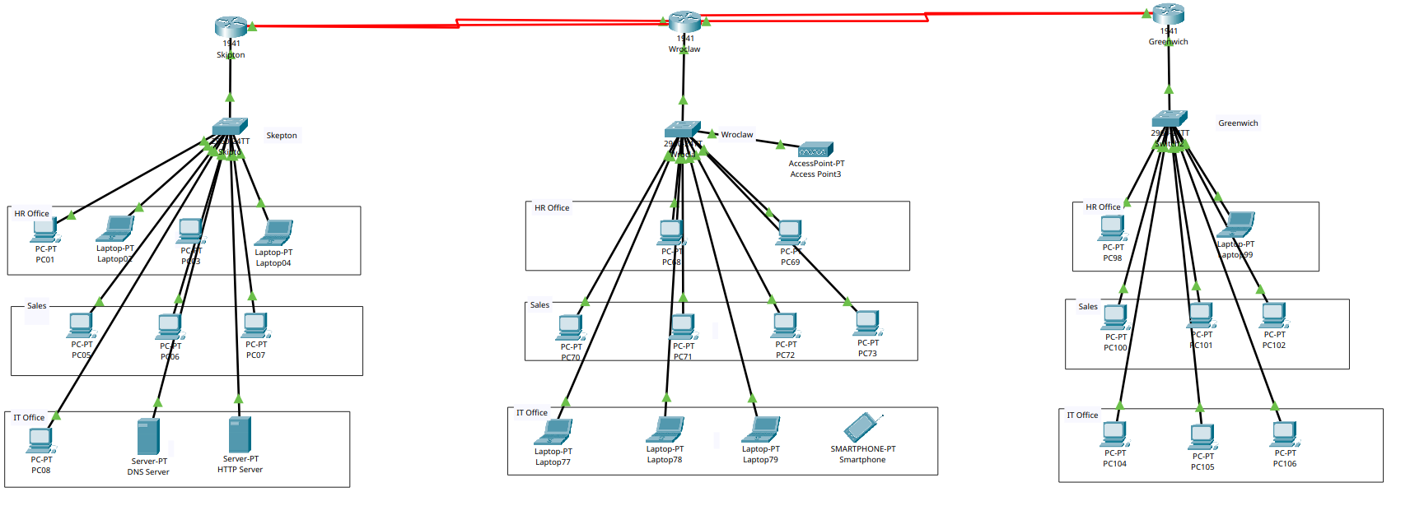
Fig. 1: Full topology in Packet Tracer (three sites, triangle of serial links).
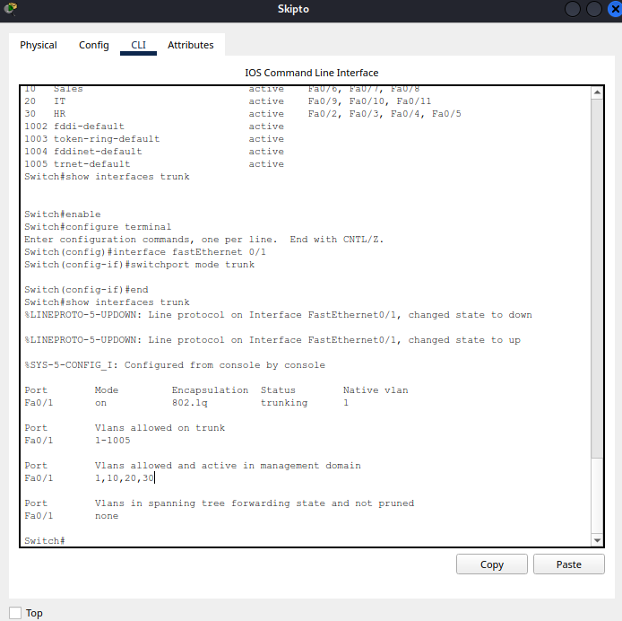 | 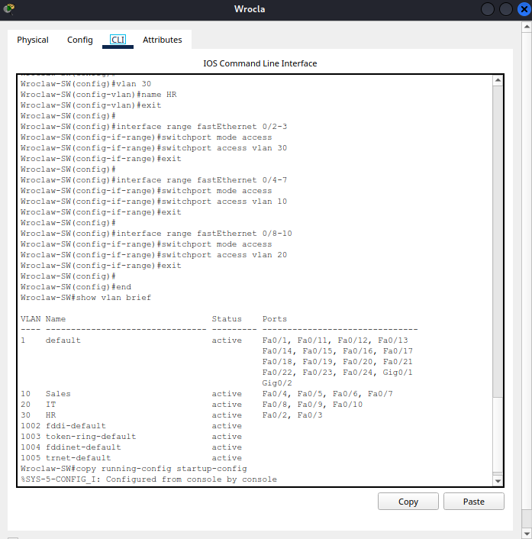
Fig. 3: Skipton switch show interfaces trunk after the fix (left); Wrocław switch show vlan brief (right).
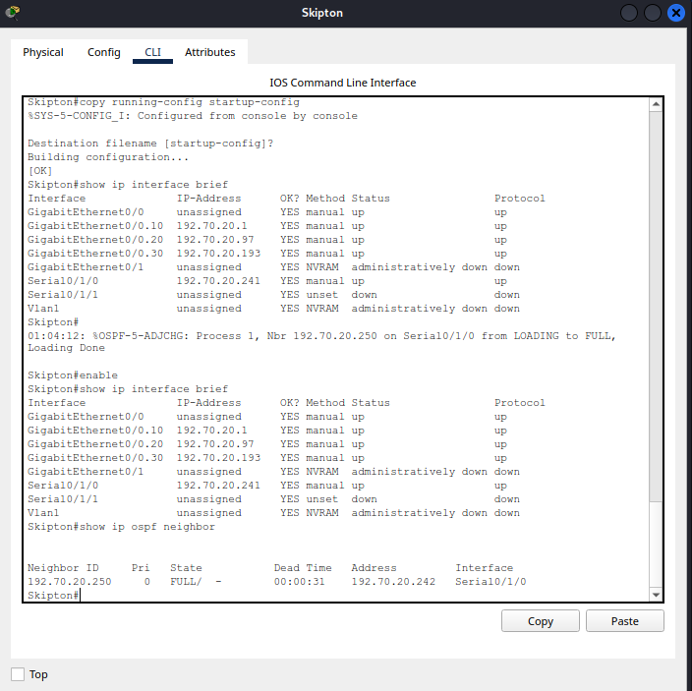 | 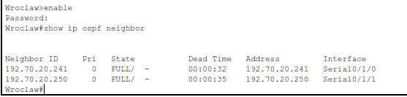 | 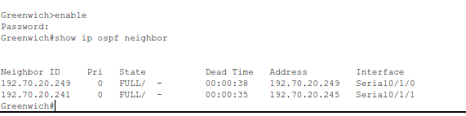
Fig. 4: Skipton sub-interfaces and OSPF neighbour (left); Wrocław neighbours (centre); Greenwich neighbours (right).
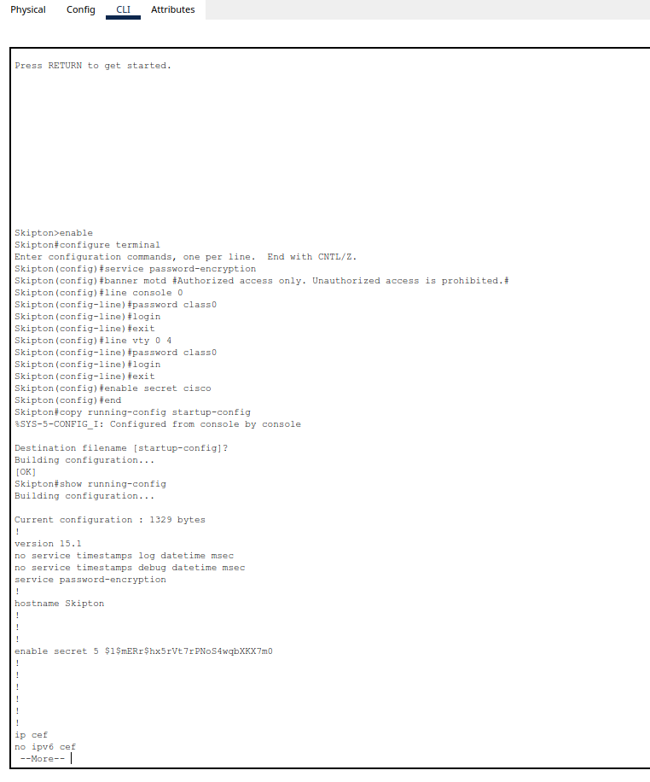 | 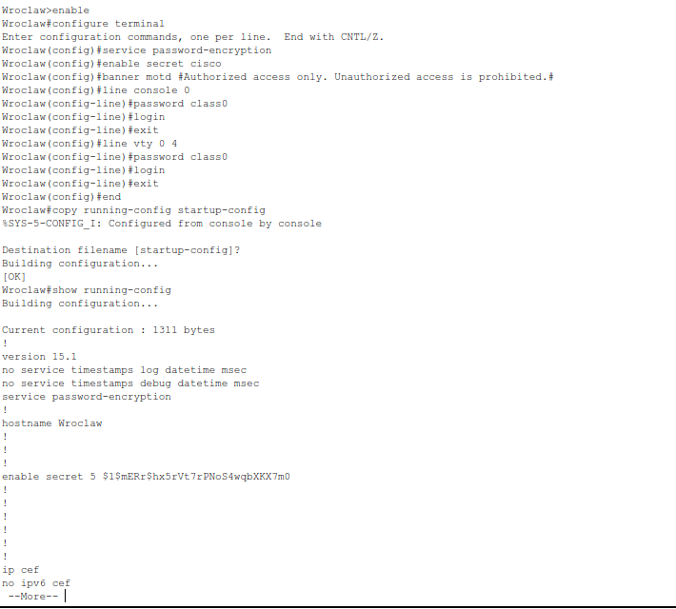
Fig. 5: Router security configuration, Skipton (left) and Wrocław (right).
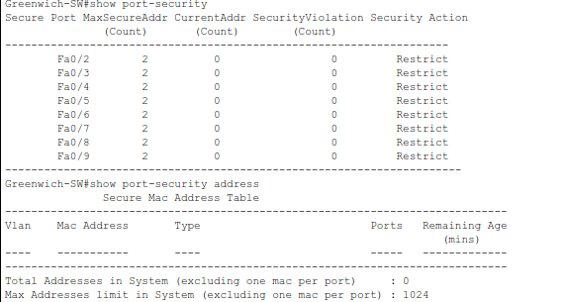
Fig. 6: show port-security, Greenwich switch (sticky MAC, maximum 2, restrict).
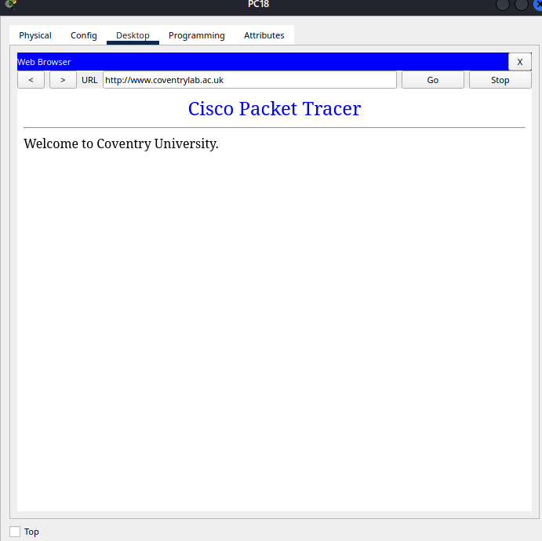 | 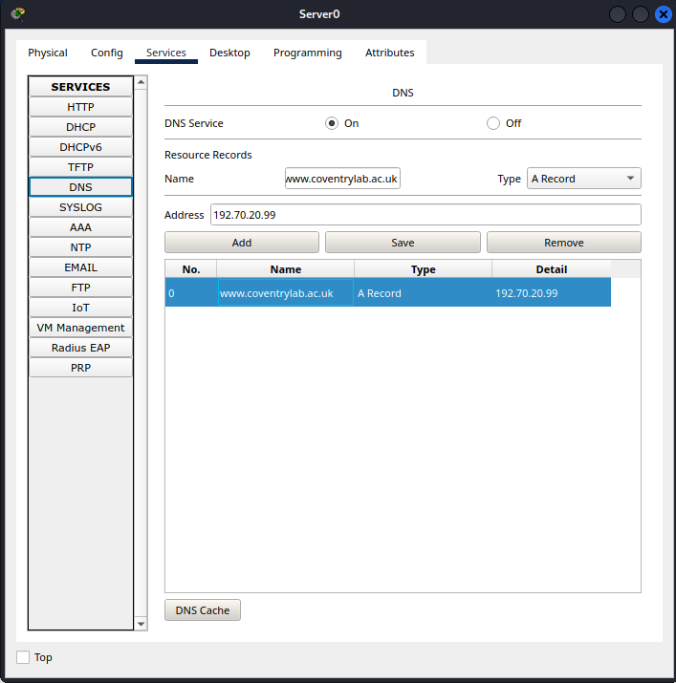
Fig. 7: DNS A record on the DNS server (left); PC18 loading www.coventrylab.ac.uk (right).
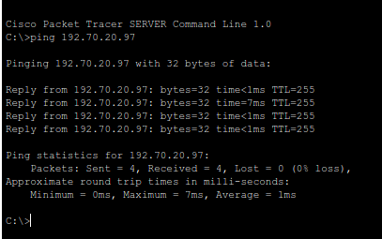 | 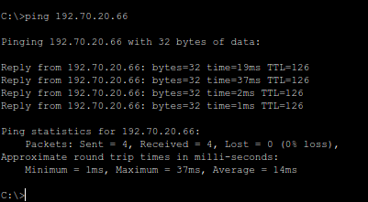
Fig. 8: Ping from the DNS server to its gateway 192.70.20.97 (left, TTL 255); ping from PC01 to PC100 192.70.20.66 (right, TTL 126, 0% loss).
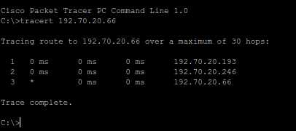
Fig. 9: Traceroute from PC01 to PC100 (192.70.20.66) on the direct path: gateway .193, Greenwich link end .246, destination.

AI acknowledgement
I used Claude (Anthropic, 2026) to help structure and draft this report. I checked the configurations, addresses and test results against my Packet Tracer network and my worksheet, and I take responsibility for the content.

References
Bhatia, M. et al. (2009) RFC 5709: OSPFv2 HMAC-SHA Cryptographic Authentication. IETF.
IEEE (2018) IEEE Std 802.1Q-2018: Bridges and Bridged Networks. New York: IEEE.
Kent, S. and Seo, K. (2005) RFC 4301: Security Architecture for the Internet Protocol. IETF.
Kurose, J.F. and Ross, K.W. (2021) Computer Networking: A Top-Down Approach. 8th edn. Harlow: Pearson.
Moy, J. (1998) RFC 2328: OSPF Version 2. IETF.
Odom, W. (2019) CCNA 200-301 Official Cert Guide, Volume 1. Indianapolis: Cisco Press.
Plummer, D. (1982) RFC 826: An Ethernet Address Resolution Protocol. IETF.
Postel, J. and Reynolds, J. (1983) RFC 854: Telnet Protocol Specification. IETF.
Pummill, T. and Manning, B. (1995) RFC 1878: Variable Length Subnet Table for IPv4. IETF.
Rekhter, Y. et al. (1996) RFC 1918: Address Allocation for Private Internets. IETF.

