**Mini Project 6**

Names of group members: Karan Risbud(KSR190005), Shubham Vartak(SXV200115)

Contribution of each group member: Both the Project group members worked together on the project. Collaborated to solve the problem and implementation of R programming.

**Q1. Consider the prostate cancer dataset available on eLearning as prostate cancer.csv. It consists of data on 97 men with advanced prostate cancer. A description of the variables is given in Figure 1. We would like to understand how PSA level is related to the other predictors in the dataset. Note that vesinv is a qualitative variable. You can treat gleason as a quantitative variable. Build a “reasonably good” linear model for these data by taking PSA level as the response variable. Carefully justify all the choices you make in building the model. Be sure to verify the model assumptions. In case a transformation of response is necessary, try the natural log transformation. Use the final model to predict the PSA level for a patient whose quantitative predictors are at the sample means of the variables and qualitative predictors are at the most frequent category.**

**Read the data:**

cancer_data <- read.csv("D:/Fall'21/STATS/mini_project_6/prostate_cancer.csv",header = T, sep = ',')

**Plot box plots of PSA**

# side by side plots

par(mfrow=c(1,2))

boxplot(cancer_data$psa, main = "Boxplot of PSA")

qqnorm(cancer_data$psa)

qqline(cancer_data$psa)

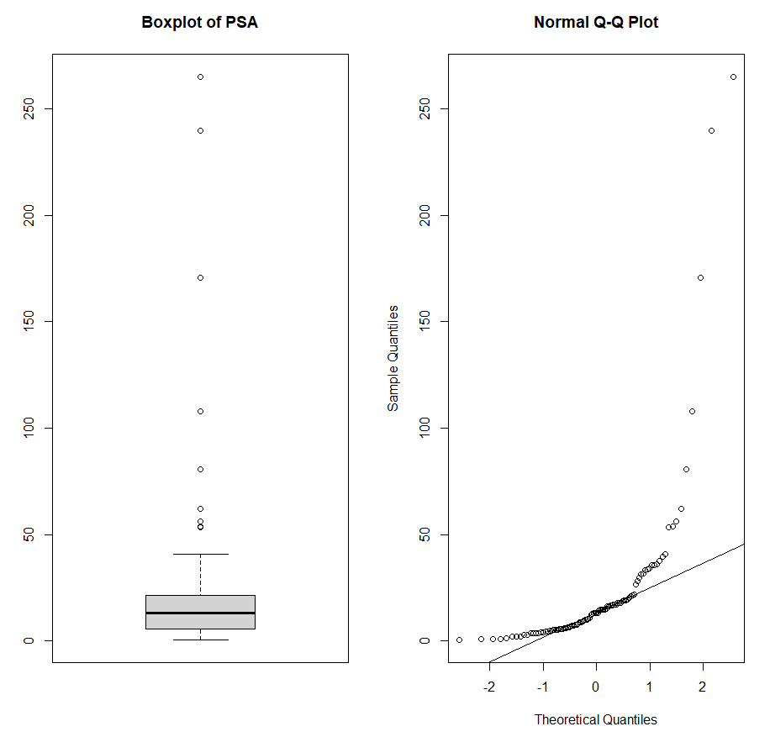

**Observation:**

In the above plot, we can see that there are many outliers in the data and as the line doesn’t fit the QQ-plot well, we can conclude that the data isn’t normally distributed.

We use logarithmic transformation of these values for better fit. Now drawing the boxplot and qqplot for log(psa), we get.

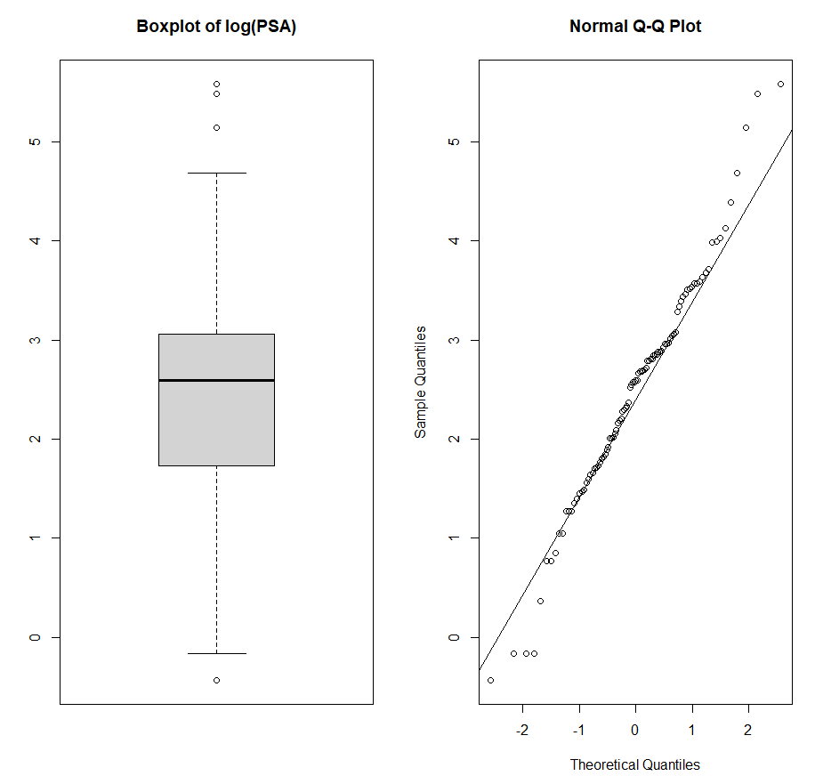

**Observation:**

Now the boxplot has comparatively less outliers and the qqplot looks normally distributed.

Now, we’ll plot scatterplots of every predictor with the response variable to see on which predictor it depends.

**Rcode:**

par(mfrow = c(2,4))

y <- log(cancer_data$psa)

plot(cancer_data$cancervol,y)

fit1 <- lm(y ~ cancervol, data = cancer_data)

abline(fit1)

plot(cancer_data$weight, y)

fit2 <- lm(y ~ weight, data = cancer_data)

abline(fit2)

plot(cancer_data$age, y)

fit3 <- lm(y ~ age, data = cancer_data)

abline(fit3)

plot(cancer_data$benpros, y)

fit4 <- lm(y ~ benpros, data = cancer_data)

abline(fit4)

plot(cancer_data$vesinv, y)

fit5 <- lm(y ~ vesinv, data = cancer_data)

abline(fit5)

plot(cancer_data$capspen, y)

fit6 <- lm(y ~ capspen, data = cancer_data)

abline(fit6)

plot(cancer_data$gleason, y)

fit7 <- lm(y ~ gleason, data = cancer_data)

abline(fit7)

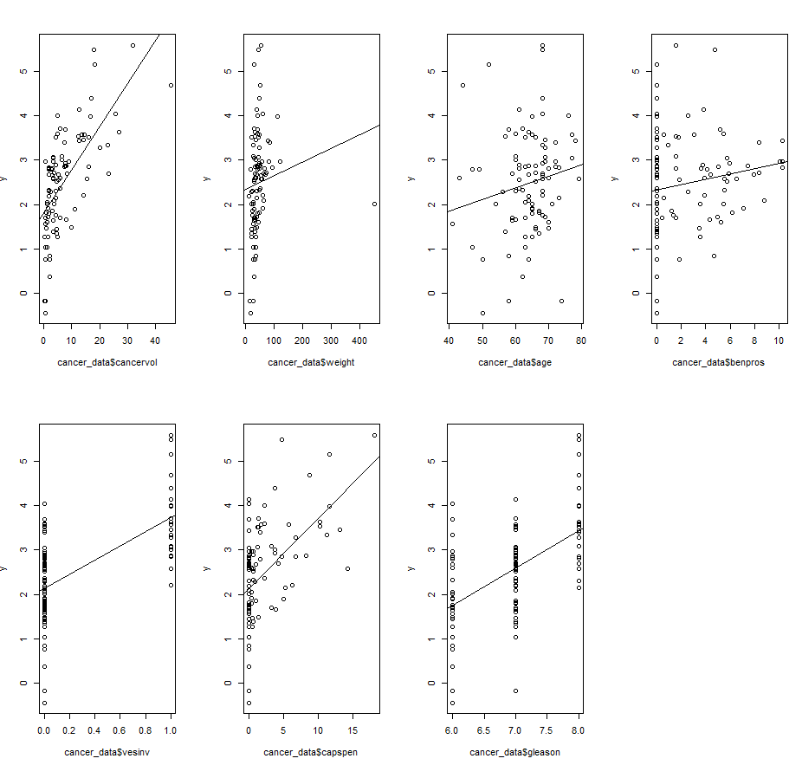

To understand the co-relation between PSA and the predictors, we’ll plot the co-relation graph.

**Rcode:**

library(GGally)

ggpairs(data=cancer_data, columns=c(1:9), title="PSA vs all predictors")

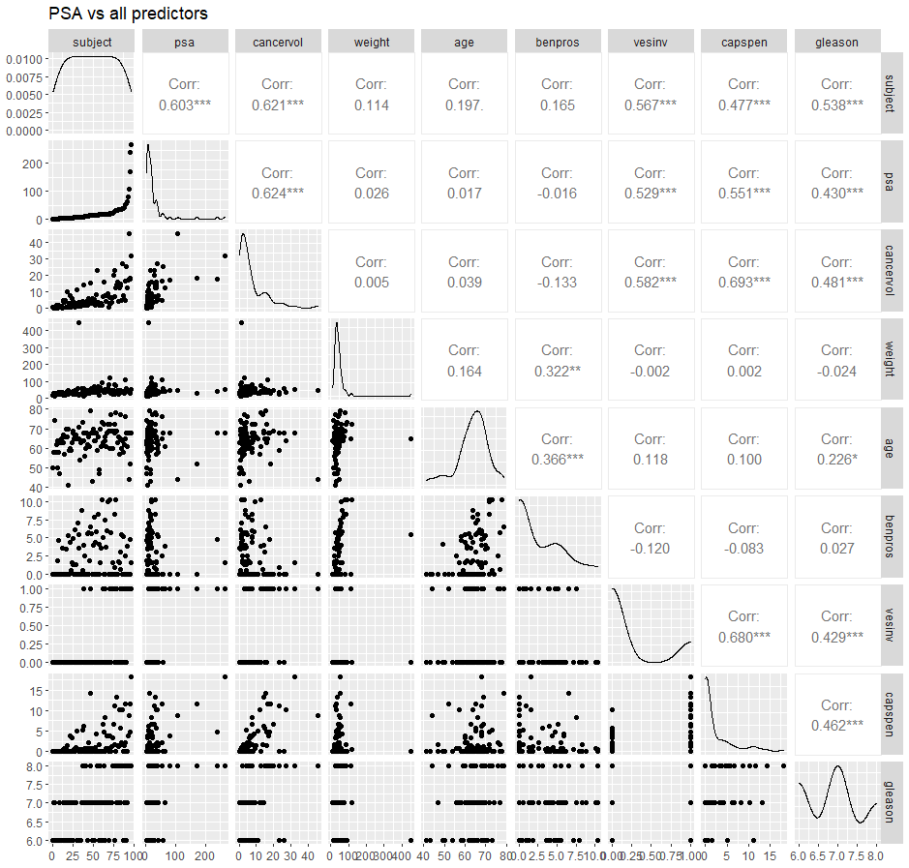

**Observation:**

We can infer that cancervol, benpros, gleason and vesinv are highly co-related to PSA.

Now we’ll use built in “step” function in R to get the models best suited for the data.

Doing the forward stepwise search we end up with a linear model which includes the predictors – cancervol, benpros, gleason and vesinv (treated as a categorical variable).

**R-code:**

fit8.forward <- step(lm(y ~ 1, data = cancer_data), scope = list(upper = ~ cancervol + weight + age + benpros + as.factor(vesinv) + capspen + gleason), direction = "forward")

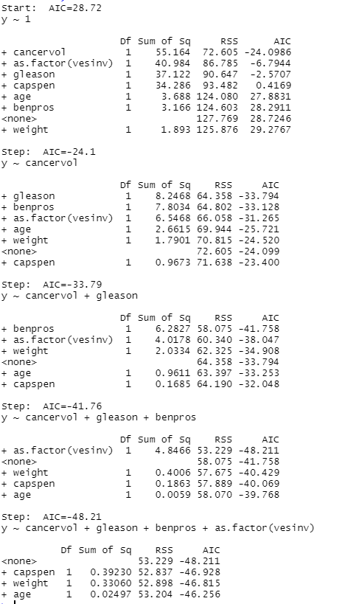

**Observation:**

The problem that we can encounter using the step () function is that, the output model may be a over-fitted model which fits the data perfectly but might lose performance when we try to predict a new value which was not seen during the training time.

So, to verify the model, we’ll remove some of the predictors and check if the new model performs any better.

We do so by generating models which have one less model than the model generated by the automated methods and then use the anova function which compare analysis of variances for one or more fitted models.

**R-code:**

gbv_fit = lm(y ~ gleason + benpros + as.factor(vesinv), data = cancer_data)

anova(gbv_fit, fit8.forward)

summary(gbv_fit)$adj.r.squared

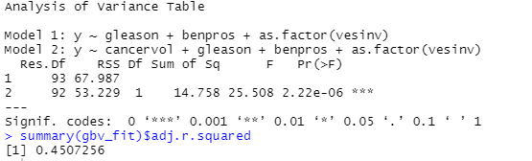

**R-code:**

cbv_fit = lm(y ~ cancervol + benpros + as.factor(vesinv), data = cancer_data)

anova(cbv_fit, fit8.forward)

summary(cbv_fit)$adj.r.squared

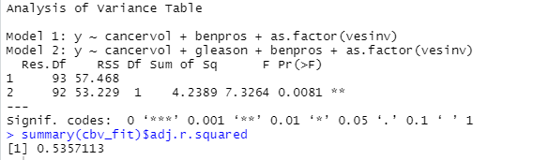

**R-code:**

cgv_fit = lm(y ~ cancervol + gleason + as.factor(vesinv), data = cancer_data)

anova(cgv_fit,fit8.forward)

summary(cgv_fit)$adj.r.squared

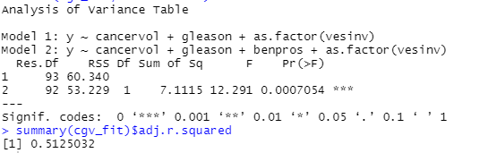

**R-code:**

cgb_fit = lm(y ~ cancervol + gleason + benpros, data = cancer_data)

anova(cgb_fit, fit8.forward)

summary(cgb_fit)$adj.r.squared

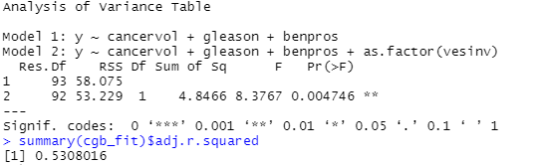

summary(fit8.forward)$adj.r.squared



**Observation:**

Using Anova, results we found that the best model that fits the given data has the predictors cancervol, benpros, gleason and vesinv.

summary(fit8.forward)

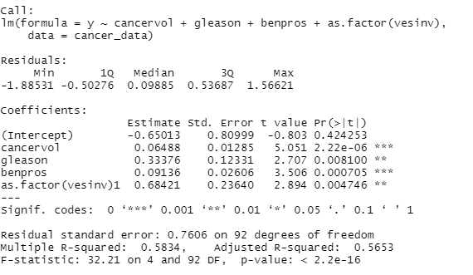

**Observation:**

The p-value is less than 0.05 and F-statistics is large which is in favour of null hypothesis. There is not sufficient evidence to rule out this model.

Now to verify the model quality we check the residual plot for the given model

Drawing the scatter plot, qqplot and time series plots of the residuals we get:

**R-code:**

par(mfrow=c(1,1))

plot(fitted(fit8.forward), resid(fit8.forward), main="Scatter Plot of Residuals")

abline(h = 0)

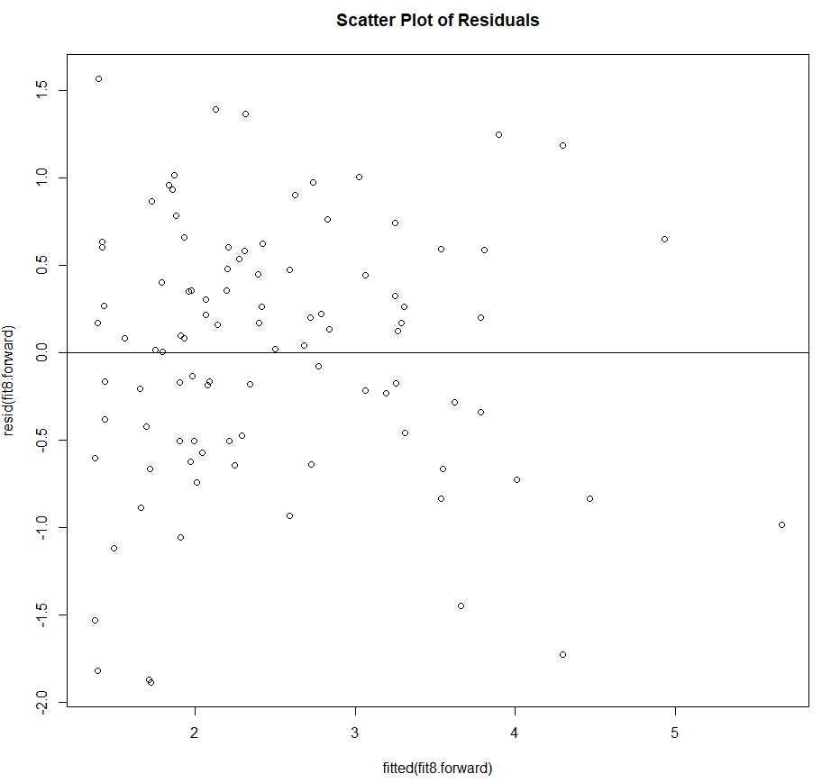

**R-code:**

qqnorm(resid(fit8.forward))

qqline(resid(fit8.forward))

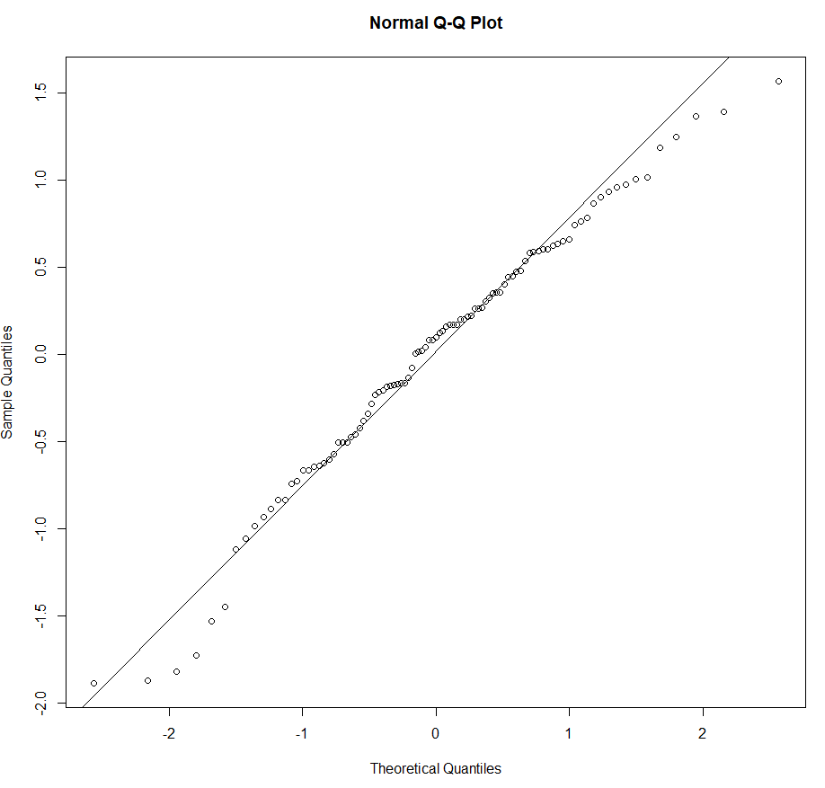

**R-code:**

plot(resid(fit8.forward), type = 'l', main = "Time Series Plot for Residuals")

abline(h=0)

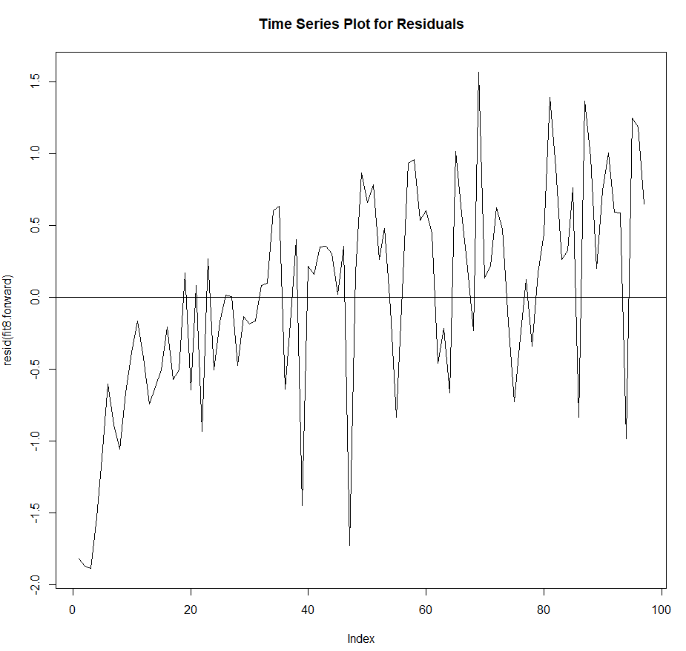

The above three graphs show that the error quantities have zero mean, constant variance, and are normally distributed and are independent.

**R-code:**

prediction = fit8.forward$coefficients["(Intercept)"] +

(fit8.forward$coefficients["cancervol"]*mean(cancer_data$cancervol)) +

(fit8.forward$coefficients["benpros"]*mean(cancer_data$benpros)) + (fit8.forward$coefficients["as.factor(vesinv)1"]*unique(cancer_data$vesinv)[which.max(tabulate(match(cancer_data$vesinv, unique(cancer_data$vesinv))))]) +

(fit8.forward$coefficients["gleason"]*mean(cancer_data$gleason))



Predicted output is 2.330541 However as we had taken the log transformation earlier for the PSA values, the value we have predicted is the log of the needed value. So computing antilog of the value

**R-code:**

exp(prediction)



So the final predicted value is **10.2835**