AWS Sagemaker

In a typical production environment, it is time consuming to deploy machine learning (ML) systems. And it is difficult to deploy and manage environments for ML systems. AWS Sagemaker makes it easier to deploy and manage your ML system environment.

AWS Sagemaker is an end-to-end machine learning platform, which allows to easily deploy production ready machine learning systems. It features auto scaling on deployed distributed ML models. It provides optimized algorithms and also allows for custom built algorithms for use. It provides flexibility in training models by providing support to other frameworks.
It supports deep learning frameworks like TensorFlow, Apache MXNet and Gluon. It also supports Apache spark to deploy ML models similar to Spark’s MLLib. And custom built algorithms or models based on other frameworks like scikit-learn can be deployed using docker images. It also integrates jupyter notebook for easier writing up of ML model code to be hosted and deployed.
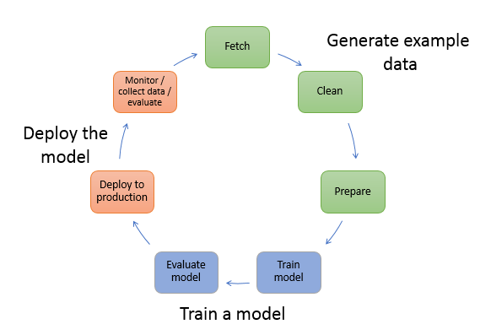

Fig 1. Machine Learning model deployment.

Below flow diagram explains the workflow of AWS Sagemaker.
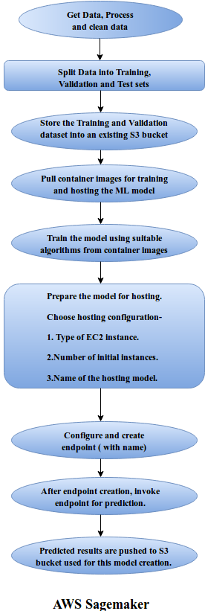

Below screenshots are workflow of a sample Model creation on AWS Sagemaker.

1. Create notebook instance in Amazon Sagemaker.
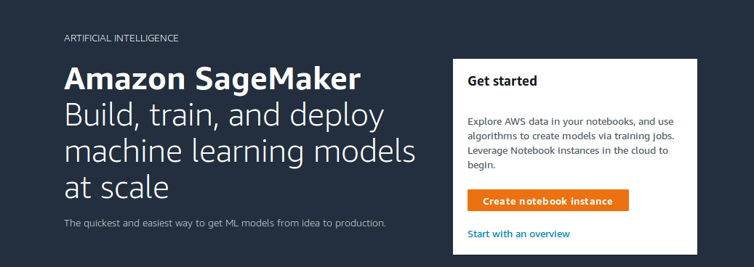

2. Notebook Instance settings.

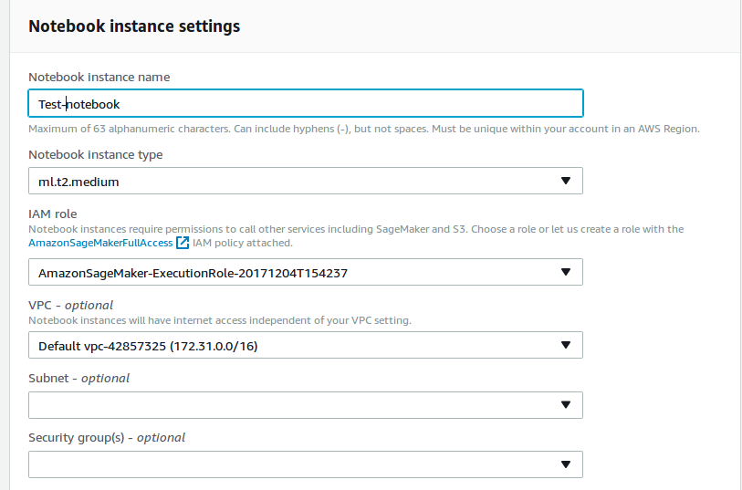

3. Notebook instance.

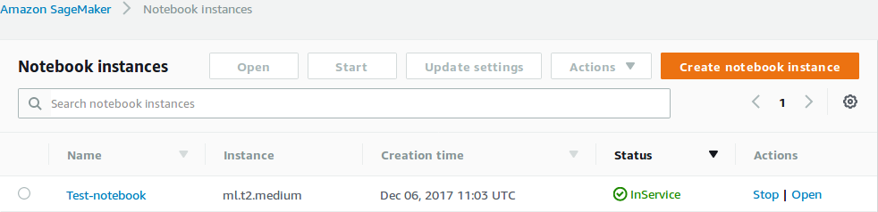
4. Open notebook instance.

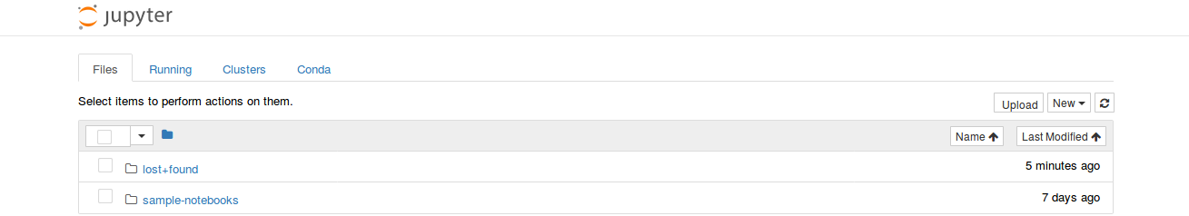
5. Running sample notebook (breast cancer prediction).

5.1. Checking available kernels to run notebook.

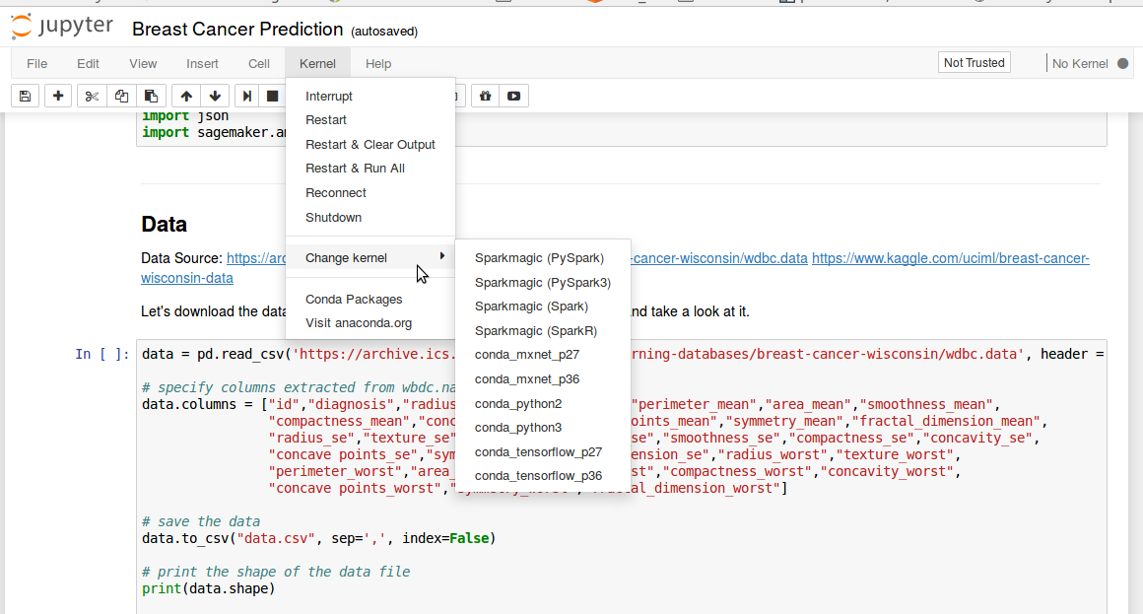

6. Training ML model.
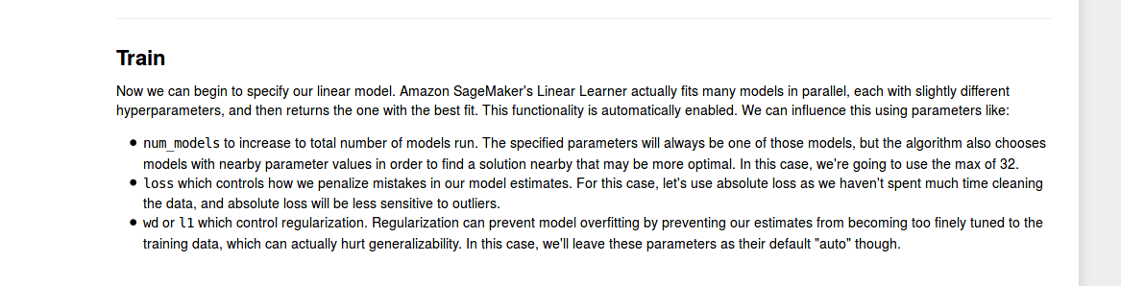

7. Specifycontainers images used for training.
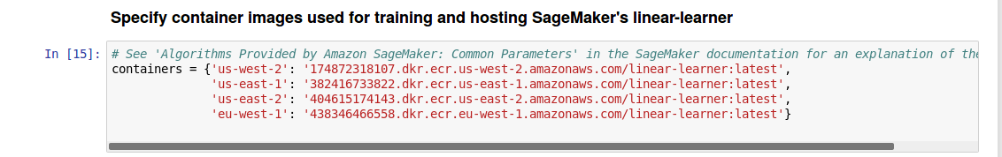

8. Creating hosting model for use.
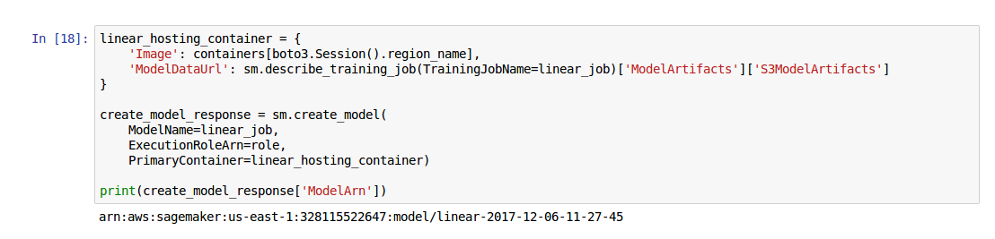
9. Creating endpoint for hosting model with initial number of instances.

9.1. Configure endpoint.

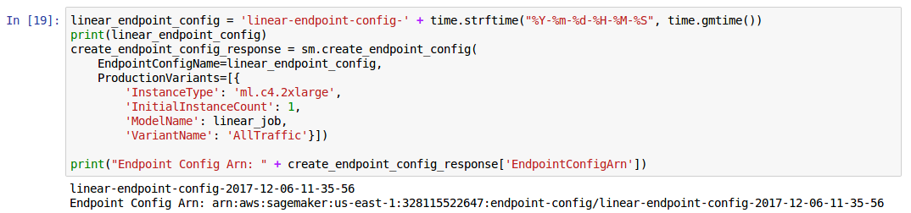

9.2. Creating Endpoint.
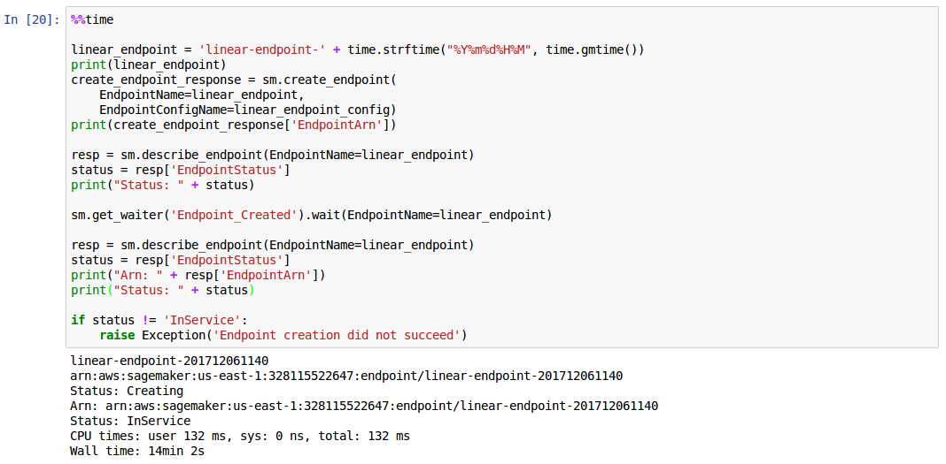

10. Prediction invoking endpoint.

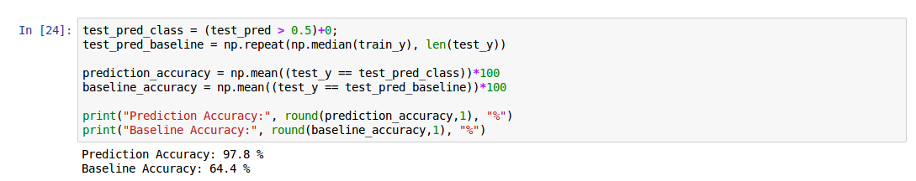
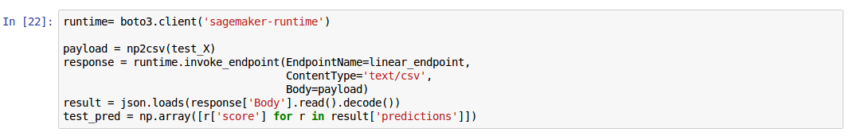

Results and training dataset are stored in S3 bucket. Custom built or other framework based algorithms can be hosted into container image and can be used like above. Sagemaker assumes S3 bucket already exists else you need to handle the exception of S3 bucket.

11. S3 Bucket output.

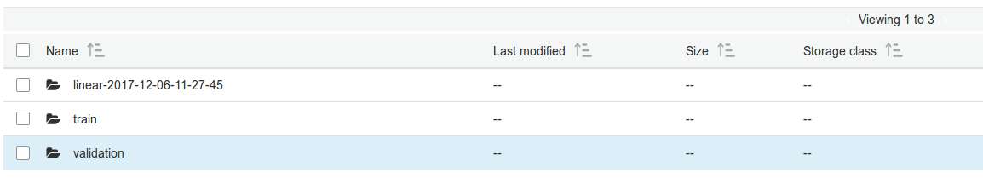

12. Hosted Model.

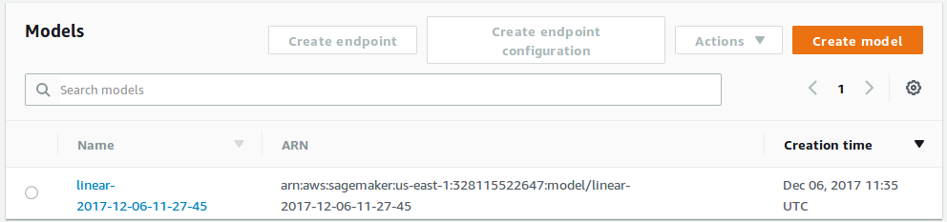

13. Endpoint.
Endpoint can invoked from the console instead of jupyter notebook.

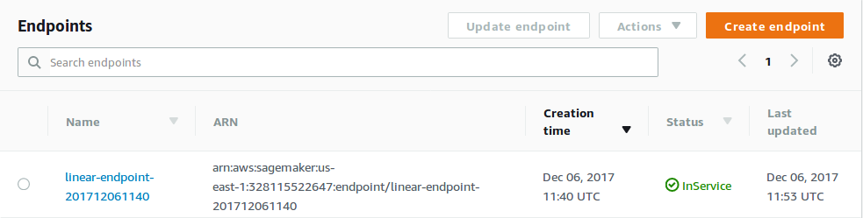

AWS Sagemaker endpoint can be embedded into your application by using or invoking the endpoint with help of boto3 and sagemaker SDK.

This document is simple take on AWS Sagemaker, it can be tuned accordingly to needs of the requirement at hand. It is essential to know docker to build docker files for your custom built or other frame work based algorithms.

References:

- https://github.com/awslabs/amazon-sagemaker-examples
- https://docs.aws.amazon.com/sagemaker/latest/dg/whatis.html
- https://pypi.python.org/pypi/sagemaker

