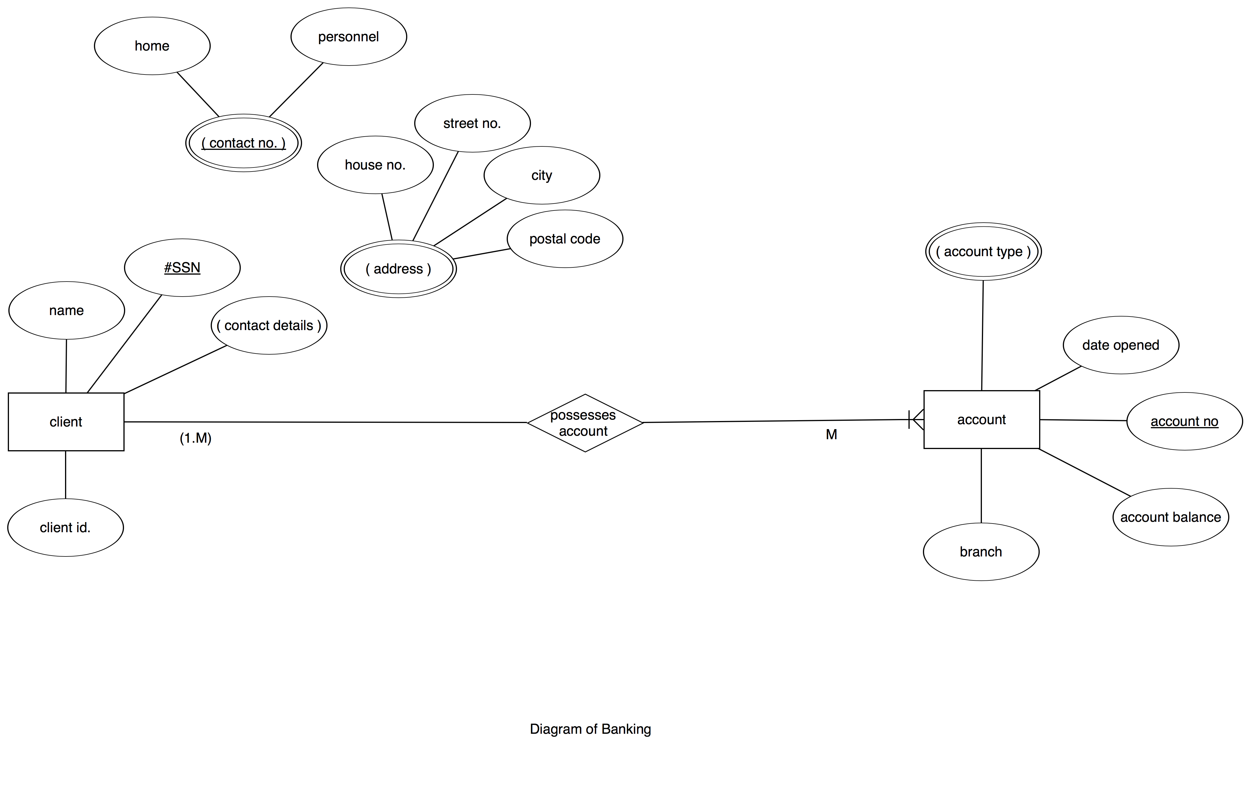

Entities: CLIENT, ACCOUNT

Attributes:

CLIENT: name, #ssn, contact details

CONTACT DETAILS: address, contact no.

ADDRESS: house no. , street no. , city, postal code.

CONTACT NO. : home, personnel

ACCOUNT: account type, date opened, account no., acount balance, branch

Relationship among Entities: Client operates its own account