# **Project Binder**

|  |  |
| --- | --- |
|  | |
| **Document Intention:** | Store the submissions, meetings and roadmap plans. |
| **Document Authors:** | Alfred Manville |
| **Document Version Date-Stamp:** | 10/02/2023 |
| **Document History (Contents):** | |
| Contents  **Project Binder** 1  **WhatsApp Group Chat Creation – 30th January 2023; 09:35** 1  **Mr Lancaster Meeting – 2nd February 2023; 14:30 – 14:55** 2  **Group Meeting – 2nd February 2023; 15:15 – 15:45** 5  **Group Meeting – 7th February 2023; 11:45 – 12:15** 6  **Initial Current System Description – 7th February 2023; 18:54** 7  **GitHub Repo – 8th February 2023; 14:53** 7  **Group Meeting – 8th February 2023; 15:00 – 16:00** 7  **Consultant Meeting – 8th February 2023; 16:00 – 16:30** 8  **Discord Server – 9th February 2023; 19:43** 9  **Initial Use Case analysis diagram – 10th February 2023; 21:40** 9  **Use Case analysis decode – 12th February 2023; 19:10** 10  **Use Case analysis diagram, phase 2 – 12th February 2023; 20:30** 11  **Use Case analysis diagram, complete – 12th February 2023; 23:40** 11 | |

# **WhatsApp Group Chat Creation – 30th January 2023; 09:35**

Mohamed Mudhir creates the WhatsApp group chat for communication.

# **Mr Lancaster Meeting – 2nd February 2023; 14:30 – 14:55**

**Meeting Itinerary**

* A set of questions to ask Mr Lancaster based on the missing information in the requirement specification.
* A set of statements to confirm specifications based on the requirement specifications.

**Questions and Statements for Mr Lancaster (Author: Alfred Manville, Syed Hussain, Samina Matin):**

* A ticket is considered a blank that had the flight itinerary placed on the coupons.
* We need to know more about both these flight coupons (What they entail and represent) and auditor coupons. We have information for the combinations of coupons that can exist but nothing on the auditor coupons.
* We need to find out what miscellaneous services are provided by the airline and how they correspond to coupons and the codes 451 and 452.
* We need to find out the difference between manual and automatic flight entry for the different types of blanks.
* We need to have the ability to blacklist a blank, we also know the format of a blank.
* We know system administrators enter data for the blanks and are provided with the information for what blanks to enter from the airlines. Blanks are then delegated to travel advisors by the Office Manager via assignment (Blanks can only be used when assigned). These can also be re-assigned.
* I think we can consider the term “blank” means something along the lines of blank ticket.
* It looks like the [people] actors are System Administrator, Office Manager and Travel Advisor but there may be another actor that produces sales reports (Like an accountant), this needs to be asked about.  “Office manager is also the only role who can generate all types of reports.”
* We need to store exchange rates for local currency to USD (How does this work (Manual Entry, API?)?)
* Storing of commission percentages per type of sold ticket (Manual Entry I believe?), excludes airport taxes/fees.
* Process refunds, needs to be associated with the rates used for the ticket at the time of sale, can be processed up to a year after the sale.
* Do the travel advisors need to log in? Does the system administrator? (Wait a minute, they do want more access control security)
* Why are the terms Travel Agent and Travel Advisor used interchangeably (And travel agent is also described as a client business of AirVia which adds to the confusion)
* I’m slightly confused if were making the software system for AirVia or for their travel agents (the people they sell the tickets through) - This does need clarification, but it looks like the system administrator, office managers and travel advisors use it (As separate users) It provided for AirVia and their client travel agents.
* “Of highest priority for the new system is the graphical user interface. It must be clear, consistent and make the system easy to use.” how do they want us to do this?
* Modify an existing sale, changing its rate while not needing to re-enter the entire sale.
* Commission rates should be set software side (How is this accomplished, where are the different rates defined for and for whom?)
* Customer accounts to allow them to have loyalty rewards and pay later. Clarification on the discount system needed?
* How should we do concurrency (DATABASES already use CRUD and atomic operations [May be design the system so it only needs to make an entry per operation so con-currency is enforced?])
* Formatting of reports? (Although we do have them but they’re landscape and therefore hard to read)
* We need to know more about the current system.

**Meeting Transcript:**

* Alfred: So we know the blanks which have flight coupons are these having special data attached to them
* Mr Lancaster: So the main thing is that the system records what blanks, which means which ticket gets which particular ID numbers these tickets are stored as. There might be some additional data attached to these, but this is not of an essence for the business. Really the software you are meant to develop is about giving the demonstration of about the sales of these tickets.
* Alfred: So there are miscellaneous blanks provided, to different like 451 and 452, do these like respond to specific service types?
* Mr Lancaster: You can maybe the other employees can tell you exactly what they correspond to, the main thing is that these types of coupons should be attachable to the tickets, for example 451 could be excess luggage. The point is that the software is such that it can record these miscellaneous tickets that make part of the ticket whatever they might mean, excess luggage is clearly something that may be needed and maybe be something else.
* Alfred: So I’m assuming with blanks, multiple blanks are a ticket or is it just a single blank?
* Mr Lancaster: So a ticket is made out of multiple of multiple coupons it is in the description of the ticket type EG: 444 is a specific number of coupons + Miscellaneous coupons. The software should take care of the fact the ticket is made up of multiple coupons. Each of these blanks can have the miscellaneous coupons attached to the tickets.
* Alfred: So there is also manual and automatic entry with different types of blanks. How does this differ? So the software needs to support manual input for these.
* Mr Lancaster: Yes, yes it does.
* Alfred: Do these attach to specific vouchers or the entire ticket, for the flight data?
* Mr Lancaster: A flight can be made out of different leg where each of these coupons are each of the different. EG: London to Dubai then Dubai to Melbourne.
* Alfred: So the administrators manage the blank allocation, office manager handles blank allocation, travel advisors handle the payment system? Do customers interact with the system?
* Mr Lancaster: No Customers do not interact with the system.
* Alfred: Local Currency to USD for international sites? Is there a need to use an API or are the values entered manually?
* Mr Lancaster: I’m not a computer scientist, you will have to confirm this with other employees but the system and software you develop is a prototype, it does need to interact with anything externally. You just need to be able to enter the exchange rates into the software, you do not need to interact with a currency exchange software. Although it would be a reasonable next stop. But I will reiterate, for the purpose of the software you need to develop you will need to enter the exchange rates with a suitable GUI is all that is needed.
* Unknown Member: Sorry can I go back to the question previously about the customer it says regular customers can allow them to pay later is this account only accessible to the travel agent.
* Mr Lancaster: Yes be all means, I will reiterate that any customers does not access the system.
* Unknown Member: None of the customers act on the system does that mean the travel agent makes an account for the customer?
* Mr Lancaster: Yes
* Unknown Member: What are the different roles that can interact with the system.
* Mr Lancaster: I think this has already been specified, these are all the people who work for the travel agents.
* Alfred: So, there are different commission percentages for each travel agent this, SO are these stored manual by manual entry?
* Mr Lancaster: As opposed to?
* Alfred: …
* Mr Lancaster: There are different rates could be given to different travel advisors, so the software. One thing you must clarify with other employees is the following: does this commission rate pertain to a different travel agency (travel agent) or they pertain to different travel advisors in a travel agency. In any case the point is the following: Rates can be set up in your system, assuming the answer to the question is different travel agencies are given different commission rates that makes sense to me, that means that the software is that AirVia is agreeing with a travel agency EG: UK is selling tickets. Are agreeing that 444 tickets are attracting 9% of the commission 201 3% of the commission. So there is a functionality of the system that collects programmatically the commission for each travel agency. So that is a functionality of the software that needs to be developed.
* Alfred: So pre-tax and post-tax how does this work?
* Mr Lancaster: So the gross amount of money would be taxed.
* Alfred: How does this work?
* Mr Lancaster: As you can see in the document examples of this have been given.
* Alfred: So there was something in the document about extra access control security, so for example, logging in with a username and password?
* Mr Lancaster: Yes that is what we have in mind.
* Unknown Member: About the commission system, just to clarify, the different commissions are they per agency.
* Mr Lancaster: But also, I repeat, check that these particular commission rates are per travel agency or per sales advisor. As long as you have a functionality for this per ticket type per travel agency, this would be very easy to implement per sales advisors that that point.
* Alfred: So is this true?
* Mr Lancaster: This is something I would like you to check with other employees.
* Alfred: So you want an easy to use interface with this piece of software, is there any specific design?
* Mr Lancaster: We are not user interface experts, we leave it up to you to decide, the short answer to that is it has to be intuitive and allow the staff to carry out their tasks efficiently, there is no color scheme or anything like that. We leave it up to you.
* Alfred: Would you like it to be customizable if necessary?
* Mr Lancaster: It could be but since you have a certain limited amount of time and resources. You should have one fixed GUI approach and show it to us.
* Alfred: Do you want the reports to be presented the exact same way the previous system has done?
* Mr Lancaster: The content of the reports is needed to be the same, the essence. But the format of the reports needs not be followed (The layout) but the content in the previous reports should be the same in your current reports.
* Karan: Is there anything about the design of the previous system?
* Mr Lancaster: Nothing yet in what we’ve already told you in the stuff we have been given. We want you to base the software on what we give you, no more, no less.
* Alfred: Ok, for concurrency, since this is tied into a database with atomic operations, does that mean the concurrency has already been taken care of?
* Mr Lancaster: Again, I’m not a computer scientist, not a software engineer, we leave it for you to decide, because the system is going to be used concurrently with multiple travel advisors, office manager, admin, however. So therefore, the bigger the travel agent, the bigger the concurrency it needs. There could be data inconsistency. We want you to think about how this could be precluded so that no data inconsistence can arise. From the top of my head if an assignment of tickets is happening by an office manager to different travel advisor, this has to be not assigned to multiple travel advisors nor sold by multiple. But you as the experts in what features of the technology you decide to use to deploy so no inconsistency in the data happens.
* Alfred: Tickets and blanks can also be blacklisted if they become stolen, I’m assuming this also requires an interface for entry.
* Mr Lancaster: This is only a simple recording of what has been blacklisted. It doesn’t sound particularly complex on your side to implement it.
* Alfred: Are the numbers after the identifier of the blank generated in a certain way or are they random?
* Mr Lancaster: No, as the report shows, you have ranges of values, they are sequential as the stock turnover report shows, there are particular ranges of tickets being allocated to the travel agency and then to a travel advisor.
* Karan: From a security perspective, are there any security measures on a customer database?
* Mr Lancaster: Apart from what we discussed now, which is being the username and password, there are no other particular security functionality, we want you to focus on the functionality of the system given the time and resources you have.
* Alfred: I’m assuming if customers have been given an account, they can have discounts as returning customers and support late payments?
* Mr Lancaster: Yes, suitable functionality in the system should allow for late payment is recorded by the system in a sense as it will be a late payment, and updates the system and therefore the database.
* Karan: What would a refund policy would be for customers that purchased a ticket?
* Mr Lancaster: There is nothing more than what we send there, the refund was said in the document and I have nothing else to add.
* Karan: You know Alfred, we need an explanation on the report, can you remember the question? I don’t remember it.
* Alfred: I can’t remember either…
* Alfred: That’s all the information we need to have.
* Alfred: Oh, right. Issuing tickets, do we have to like issue a ticket thing or is it just recorded on the system?
* Mr Lancaster: Ah, it’s just recorded on the system.
* Alfred: That should be it.
* Alfred: Tax rates, fixed or should they be changing?
* Mr Lancaster: Well it should be configurable, once its set, it will be automatically once you start selling tickets. But the system should be such that it should be configurable as flights are sold all around the world and is required from a business perspective.
* Alfred: And when also when processing, they obviously have different commission rates and you have to store it with a ticket in order to issue a valid refund.
* Mr Lancaster: Yes, yes.
* Alfred: That allows you to calculate the full reverse of the money you have to pay back to the customer.
* Mr Lancaster: Correct.
* Alfred: Do you have to issue receipts to customers?
* Mr Lancaster: If this is not mentioned in the brief, there is nothing extra, no more, no less.
* Unknown Member: Something about the exchange rates, do we use something like an API.
* Mr Lancaster: I have just answered that. We have finished, thanks very much, thank you for coming.

**Meeting Results**

* A blank is made up of multiple flight coupons, each with a leg of a journey attached to them (Plus the addition of an Auditors coupon) which makes up a ticket when sold.
* There are miscellaneous blanks / coupons that are sold as add on extras (EG: Extra luggage)
* The knowledge of which blanks are attached to which blank IDs is not necessarily needed.
* There are manual and automatic entries for different types of blanks.
* Administrators manage blank allocation from airlines.
* Office managers handle blank allocation to advisors and produce reports.
* Travel advisors handle the payment system.
* Customers do not interact with the system [directly].
* No API is required for currency conversion nor tax, but a configurable interface should be provided to set these up.
* An account for customers is set up by an advisor for late payment and rewarding loyal customers with discounts.
* Commission rates are definitely set per agent but may be set per advisor – need to be stored to process refunding.
* The gross amount of money is taxed.
* Username and password login are required for the security of the system.
* Fixed, intuitive user interface required.
* Produced reports should have the same content but do not need to keep the layout.
* Concurrency support is required.
* Blacklisting of blanks is a simple recording.
* Late payment allows for updating the database so the payment can be recorded as made.
* Purchases are just recorded on the system.

# **Group Meeting – 2nd February 2023; 15:15 – 15:45**

**Meeting Itinerary**

* Work out initial group roles with justification.
* Assign a person to work on a logo.
* Come up with a group name.
* Discuss when to move the consultant meeting due to it clashing with some members religious observances.

**Meeting Results**

* Mohamed Mudhir assigned to creating the logo.
* Interim team name is “Group 13”, interim logo is the number “13”.
* Consultant meeting should take place on a Monday or Tuesday.

**Roles:**

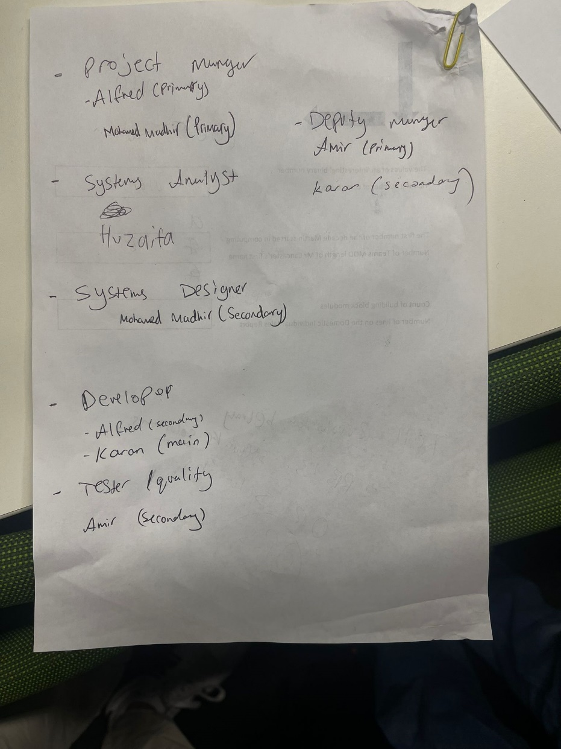

# **Group Meeting – 7th February 2023; 11:45 – 12:15**

**Meeting Itinerary**

* Work out actual group name.
* Continue discussing role assignments.
* Work out better ways to communicate that way work gets done.
* Work out if the consultant meeting should be Wednesday or Thursday this week.
* Discuss using GitHub to store out files over OneDrive.
* Discuss and create document formats used for submission.

**Meeting Results**

* “Skyway Solutions” decided as the group name.
* A discord server will be created later this week.
* A GitHub repo will be created later this week.
* Alfred Manville creates the initial template for the documents.
* Consultant meeting will be held on Wednesday at 16:00.

**Roles:**

# **Initial Current System Description – 7th February 2023; 18:54**

Author: Syed Hussain

The existing software system used by the airline is responsible for generating important reports such as ticket stock turnover, interline sales, and domestic sales reports. Despite its crucial role, the system has a dated design and lacks a graphical user interface, making it appear more like a terminal. Unfortunately, the system also lacks proper security measures to regulate access by different actors or users. A limitation in the software requires manual coding of the currency exchange rate each time a sale is made in a different currency, which can lead to errors if the information is incorrect. If this occurs, the entire sale must be deleted and recreated, causing inconvenience. Furthermore, commission rates for tickets sold by travel agents are also hard-coded, adding to the limitations of the system. The system also struggles with concurrency control issues with the database, causing further complications in the smooth functioning of the system.

# **GitHub Repo – 8th February 2023; 14:53**

Karan Sambee creates the GitHub repo and invites all of the group as contributors.

# **Group Meeting – 8th February 2023; 15:00 – 16:00**

**Meeting Itinerary**

* Finalize role assignments.
* Get started on the use case analysis diagram by decoding the use cases and actors as a group.
* Create a discord server.
* Finalize the document template using the logo.
* Discuss the current system and what we still need to know.

**Meeting Results**

* Template document updated.
* Use case analysis started.
* Role assignments completed.

**Roles:**

**Template Document:**

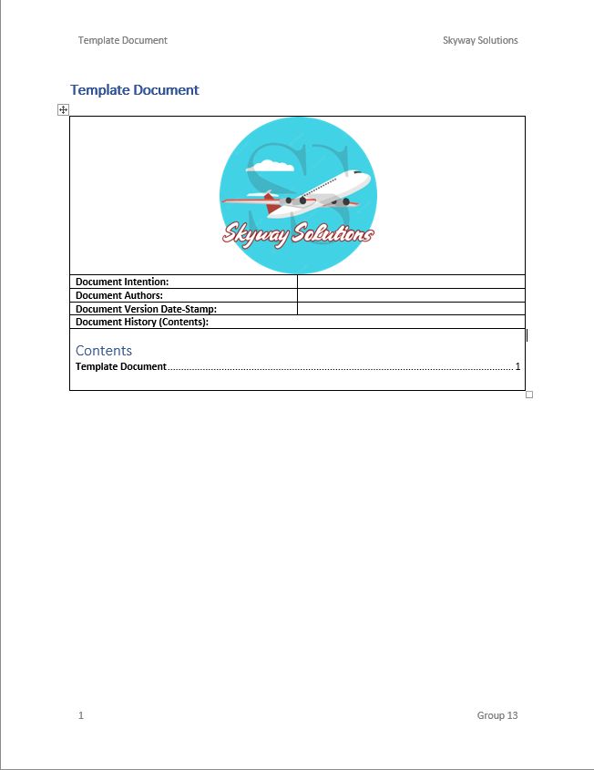

**Logo (Author: Mohamed Mudhir):**



# **Consultant Meeting – 8th February 2023; 16:00 – 16:30**

**Meeting Itinerary**

* First meeting with consultant.
* Discuss communication issues and progress.

**Meeting Results**

* Given advice on how to deal with our communication issues.
* Encouraged to get a good amount done before our next meeting on Monday the 13th of February 2023 at 14:00.
* Given advice on running a team, settings tasks and deadlines and contacting if issues arise.
* A roadmap for the week ending the 12th of February 2023 is now planned.

**Roadmap – 12th of February**

|  |  |  |
| --- | --- | --- |
| **Task** | **Assigned** | **Deadline** |
| Complete use case analysis diagram. | Samina Matin, Syed Hussain | 11/02/2023 |
| Complete use case analysis specifications. | Mohamed Mudhir, Maudud Ahmed, Huzaifa Pathan | 12/02/2023 |
| Complete class analysis diagram. | Alfred Manville, Maudud Ahmed | 13/02/2023 |
| Start GUI designing. | Karan Sambee | TBA – Also requires boundary classes from class design diagram. |

# **Discord Server – 9th February 2023; 19:43**

Mohamed Mudhir creates the discord server.

# **Initial Use Case analysis diagram – 10th February 2023; 21:40**

Authors: Samina Matin, Syed Hussain

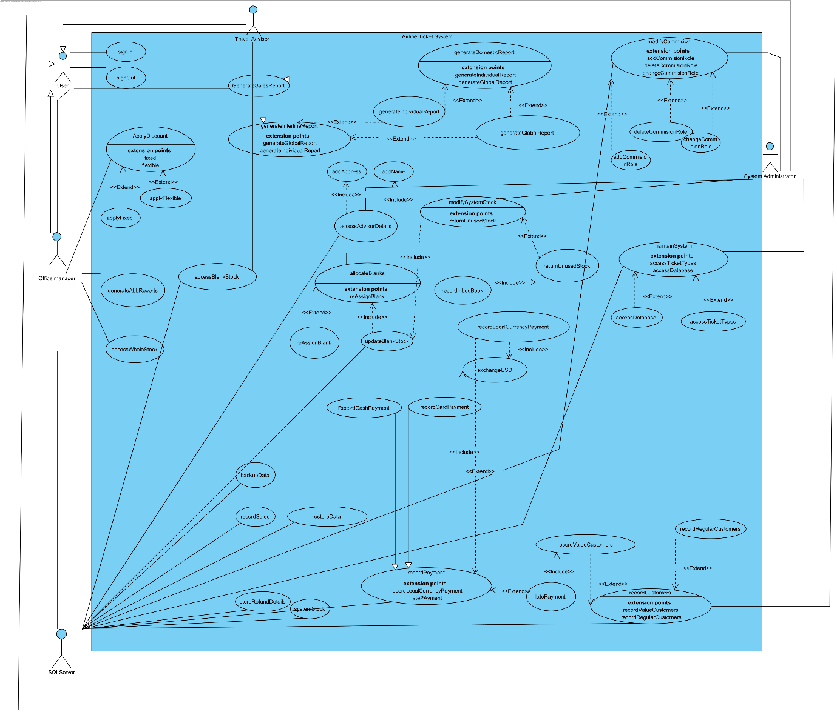

# **Use Case analysis decode – 12th February 2023; 19:10**

Authors: Alfred Manville

Key:

0^ - Inherit / Include 0

^0 - Base 0

[0]x - x Extends 0

x[0] - x Provides 0

= - Done

Actors:

User^0

0^Advisor

0^Office Manager

0^System Administrator

Time

Database

Logbook

Use Cases:

=SignIn

=SignOut

=1^ApplyDiscount[0]

=[0]FixedDiscount

=[0]FlexibleDiscount

=BackupData

=RestoreData

=GenerateTicketStockReport

=GenerateInterlineSalesReport^5

=5^2^GenerateInterlineIndividualSalesReport

=5^GenerateInterlineFullSalesReport

=GenerateLocalSalesReport^6

=6^2^GenerateLocalIndividualSalesReport

=6^GenerateLocalFullSalesReport

=RecordPayment[1]^0

=0^RecordCardPayment

=0^RecordCashPayment

=[1]RecordUSDConvertedPayment

=1^[1]RecordLatePayment

=RetrievePaymentRecord^3

=3^ModifyPaymentRecord

=3^RecordRefund

=CreateCustomerAccount

=1^ModifyCustomerAccount

=1^DeleteCustomerAccount

=RetrieveCustomerAccount^1

=CreateBlankStock

=AccessBlankStock^4

=4^RecordRevokeBlank

=4^AssignBlank[3]

=4^ReturnUnusedBlankStock

=[3]ReassignBlank

=2^SetCommissionRate[2]

=[2]SetAdvisorCommissionRate

=SetExchangeRates

=SetTaxRates

=CreateAccount

=2^ModifyAccount

=2^DeleteAccount

=RetrieveAccount^2

=1^3^PaymentTooLateAlert

# **Use Case analysis diagram, phase 2 – 12th February 2023; 20:30**

Authors: Alfred Manville; Based on Authors: Samina Matin, Syed Hussain

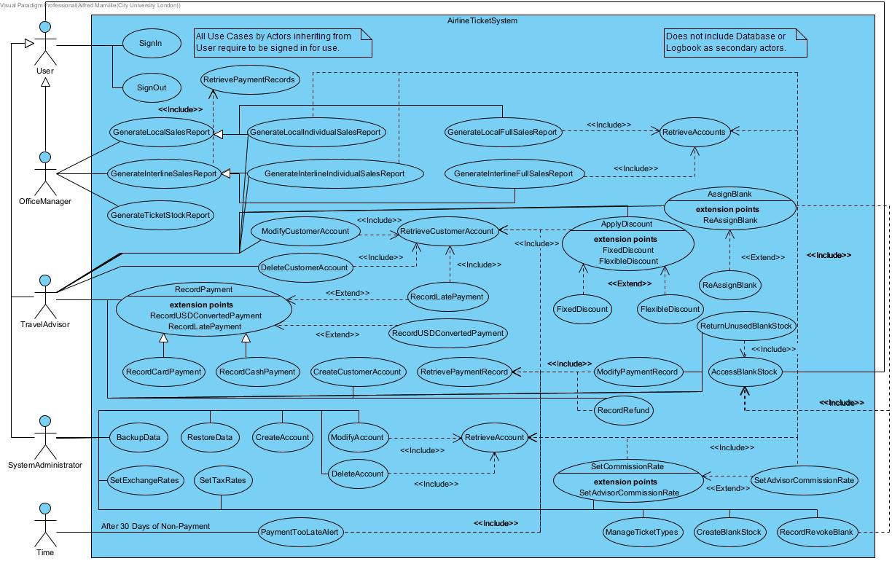

# **Use Case analysis diagram, complete – 12th February 2023; 23:40**

Authors: Alfred Manville; Based on Authors: Samina Matin, Syed Hussain

