# **GUIs**

|  |  |
| --- | --- |
|  | |
| **Document Intention:** | Stores the GUI designs and flows. |
| **Document Authors:** | Mohamed Mudhir, Karan Sambee |
| **Document Version Date-Stamp:** | 05/03/2023 |
| **Document Version:** | 1 |
| **Document Version History:** | |
| 1. Document Created. | |

### **Administrator GUI**

Links to: GUI::SystemAdministratorGUI

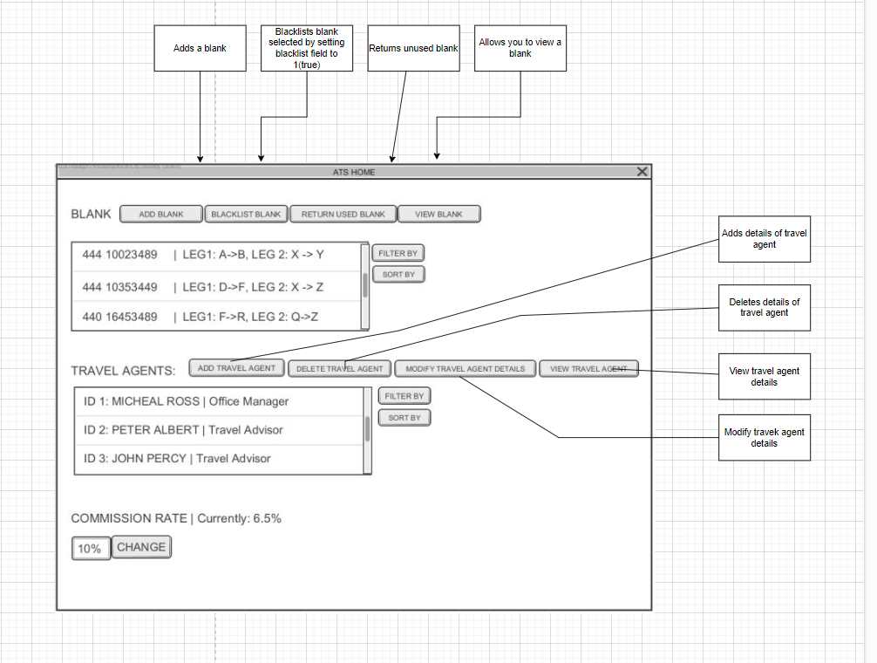

### **Office Manager GUI**

Links to: GUI::OfficeManagerGUI

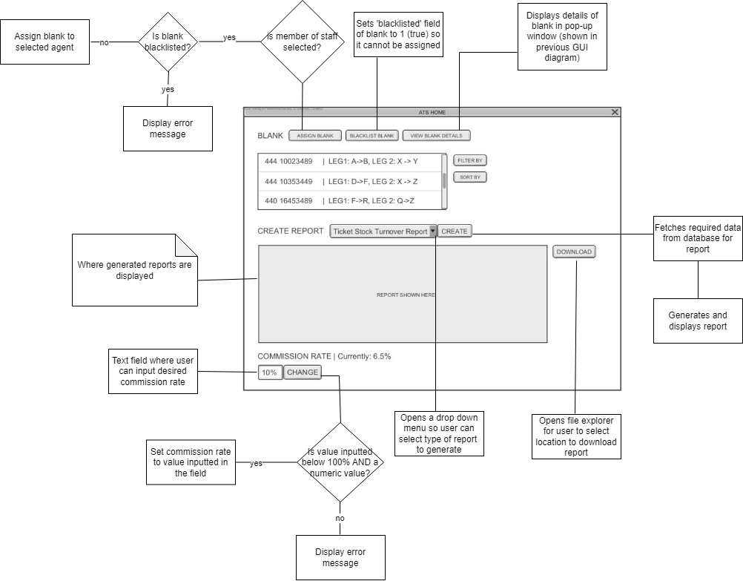

### **Login GUI**

Links to: GUI::LoginGUI

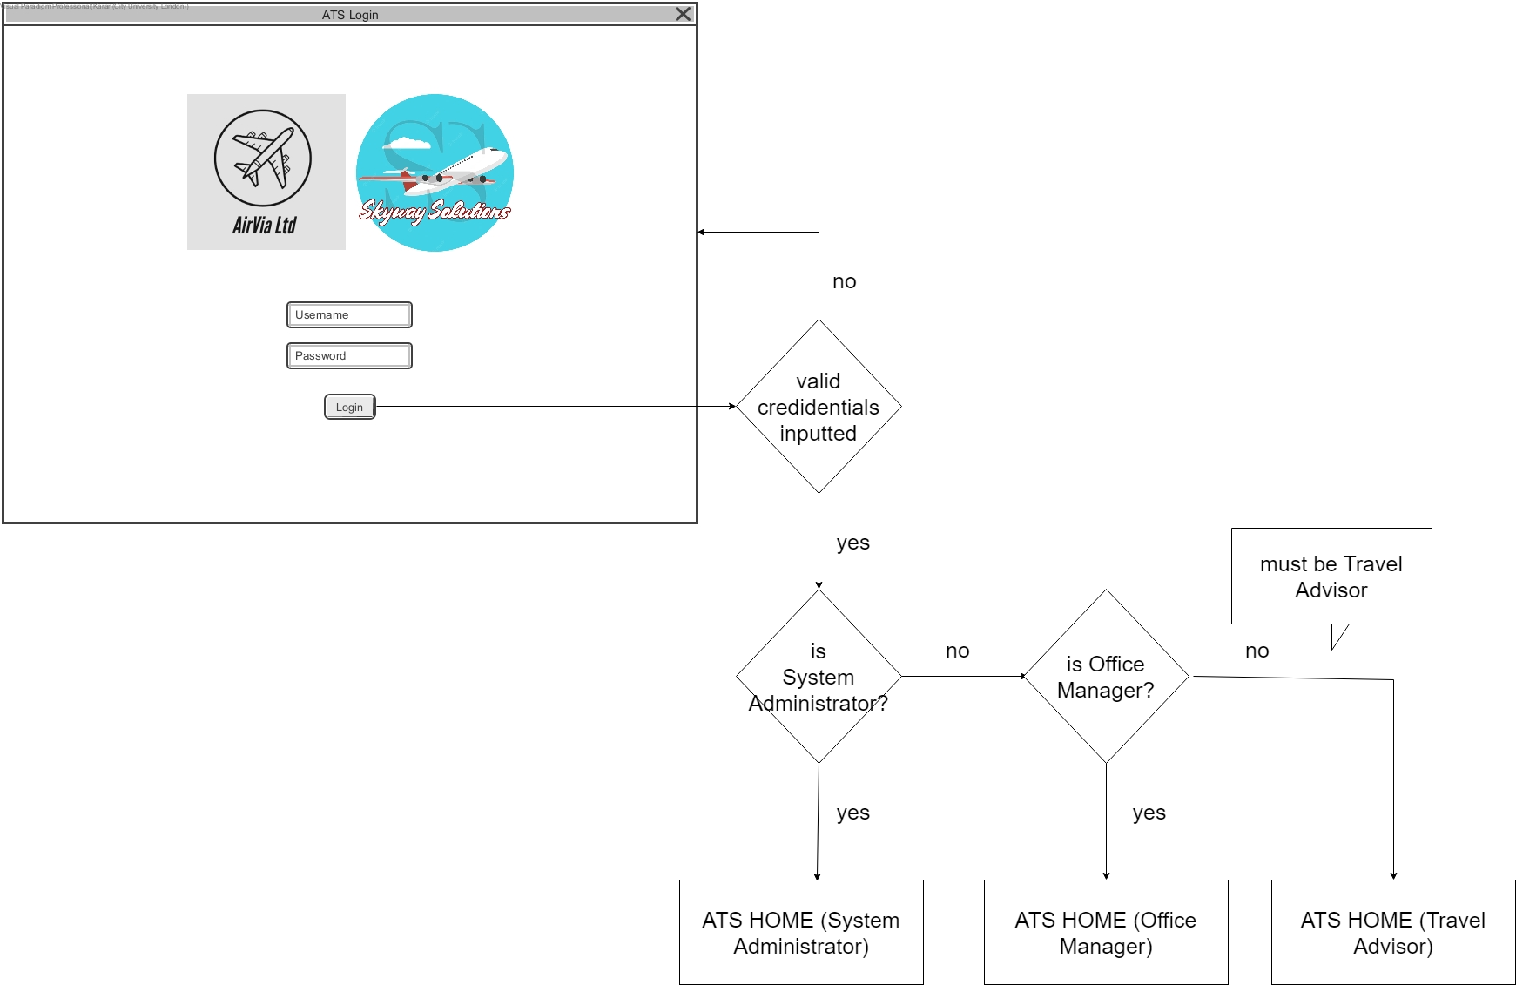

### **Travel Advisor GUI**

Links to: GUI::TravelAdvisorGUI

