# **2nd February 2023; 15:15 – 15:45 – Meeting**

|  |  |
| --- | --- |
|  | |
| **Document Intention:** | Meeting information. |
| **Document Authors:** | Alfred Manville |
| **Document Version Date-Stamp:** | 19/02/2023 |
| **Document Version:** | 1 |
| **Document Version History:** | |
| 1. Document Created. | |
| **Meeting Itinerary:** | |
| * Work out initial group roles with justification. * Assign a person to work on a logo. * Come up with a group name. * Discuss when to move the consultant meeting due to it clashing with some members religious observances. | |

**Roles:**

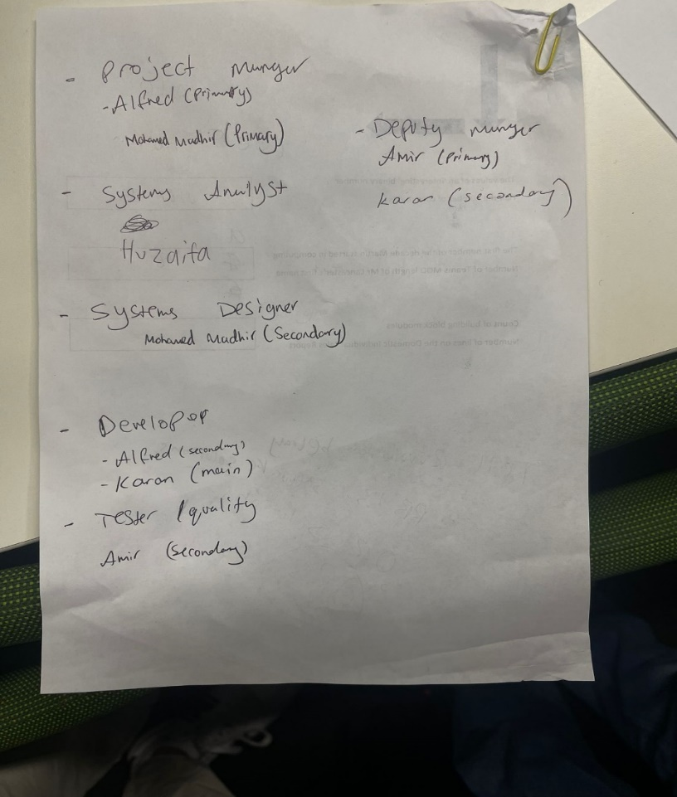

**Meeting Results**

* Mohamed Mudhir assigned to creating the logo.
* Interim team name is “Group 13”, interim logo is the number “13”.
* The other interim team name was “KHAAMSS solutions”
* Consultant meeting should take place on a Monday or Tuesday.