# **8th February 2023; 15:00 – 16:00 Meeting**

|  |  |
| --- | --- |
|  | |
| **Document Intention:** | Meeting information. |
| **Document Authors:** | Alfred Manville |
| **Document Version Date-Stamp:** | 19/02/2023 |
| **Document Version:** | 1 |
| **Document Version History:** | |
| 1. Document Created. | |
| **Meeting Itinerary:** | |
| * Finalize role assignments. * Get started on the use case analysis diagram by decoding the use cases and actors as a group. * Create a discord server. * Finalize the document template using the logo. * Discuss the current system and what we still need to know. | |

**Meeting Results**

* Template document updated.
* Use case analysis started.
* Role assignments completed.

**Roles:**

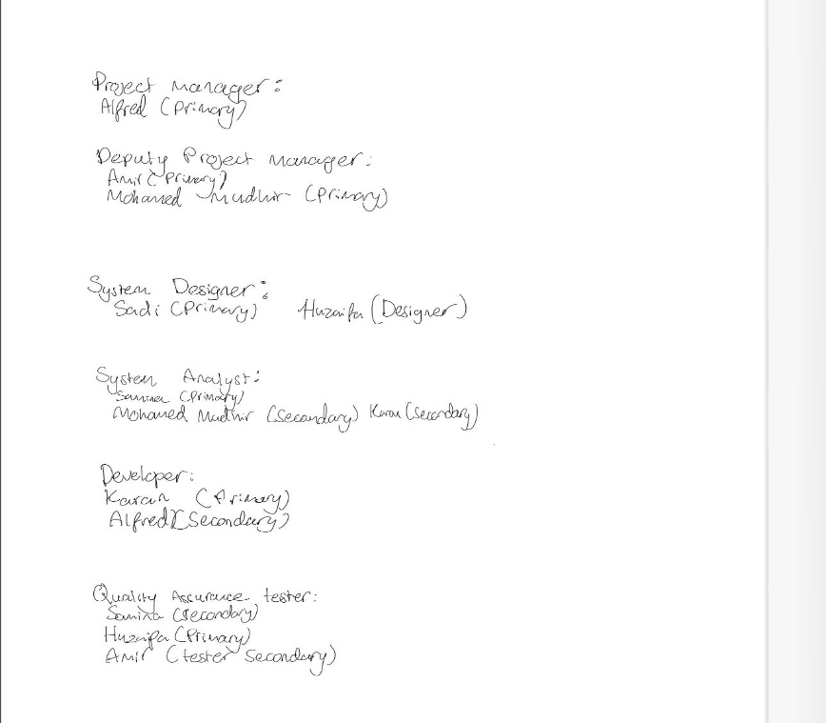

**Template Document:**

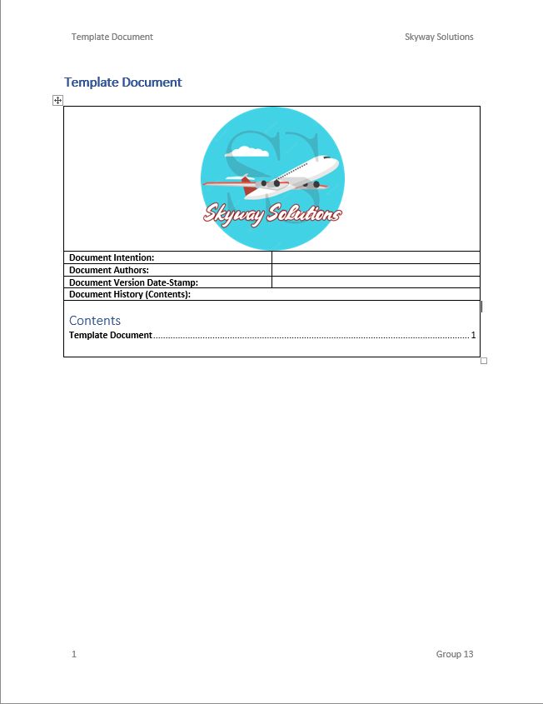

**Logo (Author: Mohamed Mudhir):**

