**8 Appendix**

**8.1 Appendix A**

Figure 1.1: Table explaining variables

|  |  |  |
| --- | --- | --- |
| **Variable** | **Distribution (if applicable)** | **Description** |
| $$P_{t}$$ |  | Trading price in period t |
| $$E_{t-1}$$ |  | True price in period t |
|  | N(0, 1.52) | Individual error term in assessing true price |
| $$M_{t}^{s}$$ |  | Short term (10 period) simple moving average of the true price, at time t |
| $$M_{t}^{l}$$ |  | Long term (50 period) simple moving average of the true price, at time t |
| $$A^{i}$$ | U(0, 1) | Individual activation frequency |
| $$A_{t}$$ | U(0, 1) | Activation frequency threshold for period t |
| $$P^{max}$$ |  | Maximum recorded trading price for that run |
| $$P^{min}$$ |  | Minimum recorded trading price for that run |
| $$\sim N\left(0,1\right)$$ |  | A random realisation from a N(0, 1) distribution |
| $$x_{t,g}^{i}$$ |  | Expected “good state” outcome for individual i in period t |
| $$x_{t,b}^{i}$$ |  | Expected “bad state” outcome for individual i in period t |
| $$p_{t,g}^{i}$$ |  | Expected probability of the “good state” outcome for individual i in period t |
| $$p_{t,b}^{i}$$ |  | Expected probability of the “bad state” outcome for individual i in period t |
| $$U_{t}^{i}$$ |  | Prospect-utility for individual i in period t |
| $L^{i}$, | U(0, 0.5] | Individual threshold which utility must surpass for individual to place a trade |
| $${}_{t-b_{i}}^{}{R_{t}}$$ | bi ~ ⎡(0, 10)⎤ | The return on the asset over some fixed period t-b and t, where b is an integer representing how backward looking the trader is |
| $$f^{i}$$ | U(0, 1) | Individual faith rate, a lower faith rate trader trades less aggressively and is more likely to mutate between flavours |
| $$S^{i}$$ | U(1, 2) | Scale factor to transform utility to order quantity |
|  |  | Absolute value of a random realisation from a N(3, 1) distribution |
| $$I^{i}$$ |  | Inventory (stock balance) of individual i |

Figure 8.2: Table explaining functions

|  |  |
| --- | --- |
| **Function** | **Definition** |
| $$σ(x)$$ | Standard sigmoid transformation: $σ\left(x\right)= \frac{1}{1+e^{-x}}$ |
| $$w(p)$$ | Probability weighting function[1] |
|  | Value function $V\left(x\right)=\left\{\begin{aligned}x^{α}, \text{if }x≥0 \\ -λ{\left(-x\right)}^{β}, \text{ if }x<0\end{aligned}, α=0.44, β=0.49,λ=1.06\right.$ |

**8.2 Appendix B**

The line of best fit for each graph was derived by sequentially testing polynomials of increasing magnitude. First a linear line of best is tested. Then a quadratic one is tested. If the quadratic term fails a t-test of being significantly different from 0, then the linear one is used. If not, the polynomial increases in order until the leading term is not significant from 0.

The graphs below show the results for stationarity tests, as well as tests for cointegration between the trading price and the “true price” at various significance levels. A standard Augmented-Dickey Fuller Test is used for conducting stationary with MacKinnon critical values.

Figure 8.3: Graph Showing Proportion of Runs Stationary at 1% Significance

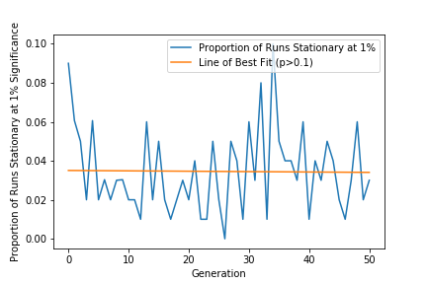

Figure 8.4: Graph Showing Proportion of Runs Stationary at 5% Significance

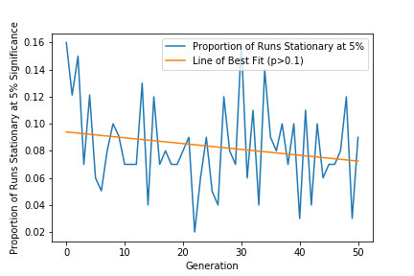

Figure 8.5: Graph Showing Proportion of Runs Stationary at 10% Significance

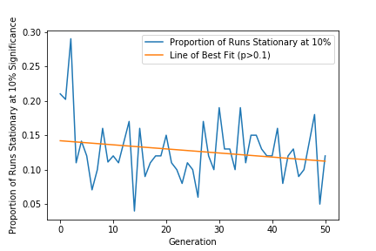

Figure 8.6: Graph Showing Proportion of Runs with Evidence for Cointegration at 1% Significance

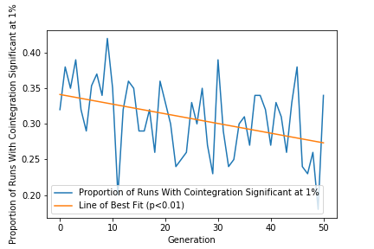

Figure 8.7: Graph Showing Proportion of Runs with Evidence for Cointegration at 5% Significance

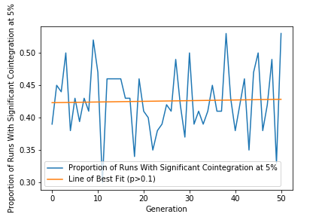

Figure 2: Graph Showing Proportion of Runs with Evidence for Cointegration at 10% Significance

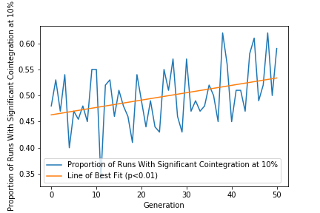

**8.3 Appendix C**

The input data for the model contains 2 features, the true price and the trading price. To assess the importance of each feature, a sensitivity analysis is conducted. The test works by taking the model predictions after training, $\hat{y}$, and then altering each input feature by some small amount, $x_{i}+ε$. The perturbations used in this example are random realisations from the distribution N(0, 0.22). How much the prediction changes based on the small change in each input feature can be used as a measure of the relative importance of each input feature (measured by the root mean square difference between the original prediction and the new prediction $\tilde{y_{i}}$. As the perturbation has been chosen somewhat arbitrarily, the correct way to interpret the results from this test is as a ratio (or some measure comparing the two features, not independently).

**8.4 Appendix D**

The Wald-Wolfowitz test (also known as “runs test”) is a two-sided hypothesis test that looks at runs of a series to assess whether or not each item in the series is an independent realisation of a random variable. To conduct the test, each market run was converted to a binary series, where each period is allocated a 1 if the market price rose that period, or a 0 if the market price fell that period. From this, a number of “runs” are determined, where a run is a sequence of any length (including 1) of consecutive draws of the same value (either 1 or 0). For example, the sequence “100010” has 4 runs. The null hypothesis of the test is that the number of runs in a sequence of N is a random variable with conditional distribution approximately normal (given the number of positive and negative observations, i.e. 1s and 0s), with parameters:

$Mean: μ=\frac{2n_{1}n_{2}}{n_{1}+n_{2}}$

$$Sample variance: S^{2}=\frac{2n_{1}n_{2}(2n_{1}n_{2}-n_{1}-n_{2})}{{\left(n_{1}+n_{2}\right)}^{2}(n_{1}+n_{2}-1)}$$

Where n1 is the number of 1s and n2 is the number of 0s in the sequence. The test statistic is then:

$$Z=\frac{R-μ}{S}$$

Where R is the number of runs in the sequence. The null hypothesis is rejected when this test statistic falls within the critical regions of a standard normal distribution, depending on the chosen significance level.

1. The weighting function and value functions from (Kahneman & Tversky, 1992)