AMBIENT DISPLAY
Complete Product, Architecture & UX Design Blueprint (1-Stop Designer Guide)
This document is a comprehensive, standalone specification designed for UI/UX product designers. It explains the complete product philosophy, features, technical architecture, and user flows of Ambient Display. Every existing screen from both the mobile Android app and macOS desktop companion is documented alongside explicit callouts detailing what the engineering implementation currently does and how the future UI should be elevated.

1. Executive Product Brief
Conventional alarm clocks operate on an archaic model: they require manual setting and assume a rigid bedtime. If a person wants 7.5 hours of sleep and plans to sleep at 10:00 PM, they set an alarm for 5:30 AM. However, real human habits are dynamic. If they stay awake watching videos, browsing social media, or reading in bed until 11:15 PM, the alarm doesn't adapt—it rings at 5:30 AM regardless, leaving the user sleep-deprived and groggy. Furthermore, traditional alarms shock the sleeper awake in a pitch-black room with shrill ringtones, spiking cortisol levels.
The Paradigm Shift: Ambient Display introduces an intelligent, zero-friction sleep detection and sunrise alarm ecosystem spanning Android (bedside phone) and macOS (workstation displays and laptop). Instead of demanding manual alarms:
• Silent Sleep Detection: The phone detects when you actually fall asleep based on screen locks and UsageStats inactivity compensation.
• Dynamic Circadian Push: If you stay awake in bed within your configurable bedtime window, your target wake-up time dynamically pushes forward to guarantee 7.5 hours of restorative sleep.
• Ambient Room Beacon: External workstation monitors turn into an ultra-dim bedroom countdown, smoothly illuminating into a warm sunrise glow 30 minutes before wake-up.
• Intelligent Glance Filter: Waking up at 3:00 AM for 20 seconds to check a quick message or drink water will never postpone or reset your alarm, while sustained nocturnal activity (>3 minutes) triggers a gentle, respectful prompt.
✦ CORE DESIGN PRINCIPLE: Ambient Display should feel like high-end wellness hardware (similar to Oura Ring, Apple Health, or Loftie Clock). The UI must replace technical developer clutter with calm, organic nighttime aesthetics.

2. Detailed Feature Breakdown

2.1 Smart Sleep Detection & Inactivity Compensator
When the user locks their phone during their eligible nocturnal hours (default: 9:00 PM – 6:00 AM), the background service begins sleep tracking. However, if a user put their phone face down 35 minutes earlier while falling asleep, simply recording the lock timestamp would be inaccurate. The app queries Android's UsageStatsManager to determine the true last user interaction. If inactivity exceeds a threshold (default: 30 minutes), the bedtime is back-calculated to when the user actually drifted off.

2.2 Eligible Sleep Window vs. Auto-Push Window
Dual Window Mechanics: To avoid false triggers and unnecessary alarms, the system strictly defines two distinct time windows:
1. Eligible Sleep Window (e.g. 9:00 PM – 6:00 AM): Prevents false alarms during daytime productivity. Leaving your phone face down at 2:00 PM on a workday will completely ignore inactivity and never trigger sleep.
2. Auto-Push Window (e.g. 9:00 PM – 11:00 PM): During this evening window, any phone interaction automatically and silently rolls your 7.5-hour wake target forward without interrupting you. Outside this window (e.g., past 11:00 PM), the alarm is locked and requires user consent to change.

2.3 Midnight Glance vs. Insomnia Filter
Humans frequently wake up momentarily in the night to check the time or drink water. Ambient Display categorizes midnight activity:
• Brief Glance (< 60s): Screen unlocked and locked within 60 seconds. The existing sleep session and morning alarm remain completely untouched.
• Prolonged Activity (> 3 min): Screen stays on past 3 minutes (e.g. scrolling social media). A high-priority heads-up prompt is presented with two explicit choices: 'Keep Original Alarm' or 'Reset Bedtime to Now (Push 7.5h)'.

2.4 Multi-Monitor Workstation Ambient Display
Over local Wi-Fi, the Mac receives the bedtime trigger and renders a borderless mirrored display across all connected monitors. The background is pitch black (#000000) with ultra-dim monochromatic countdown typography. Power assertions (IOPMAssertion) prevent the MacBook and external screens from going to sleep. Pressing the physical ESC key on the Mac instantly dismisses the display.

2.5 Circadian Dawn Simulation & Morning Alarm
30 minutes prior to the wake target, the displays transition into a gentle dawn amber (#FFBF66) glow, gradually brightening to suppress melatonin. At T-0 minutes, screens switch to a warm sunrise yellow (#FFB800) with a 'Good Morning' greeting, while the phone fires an exact hardware RTC audio alarm.

2.6 Zero-Cloud Local Wi-Fi Sync & Away Mode
No external servers, user accounts, or telemetry exist. The Mac advertises over Bonjour (_ambientdisplay._tcp) and the Android app auto-discovers it. All configuration changes sync bidirectionally. If Away Mode is enabled, external monitors stay off while the phone alarm continues to work normally.

2.7 Remote Screen Message Billboard (Manual Display Broadcast)
Allows the user to manually type a custom message on their phone and broadcast it to connected Mac workstation displays (e.g. 'Taking a quick walk. Back in 15m!'). Features dynamic monitor targeting (all displays mirrored or specific monitor), duration control (persistent billboard or 15s/30s timed toast), and seamless mutual-exclusion state reversion (if a message is dismissed on a screen during an active sleep session, that screen immediately reverts back to its sleep countdown).

3. Complete Visual Screen-by-Screen Gallery
Below are the actual screenshots captured directly from the OnePlus 12 mobile device and MacBook Air workstation. Each image includes detailed annotations describing what the user is experiencing and what needs design refinement.

3.1 Mobile App: Dashboard, Settings & Active Sleep
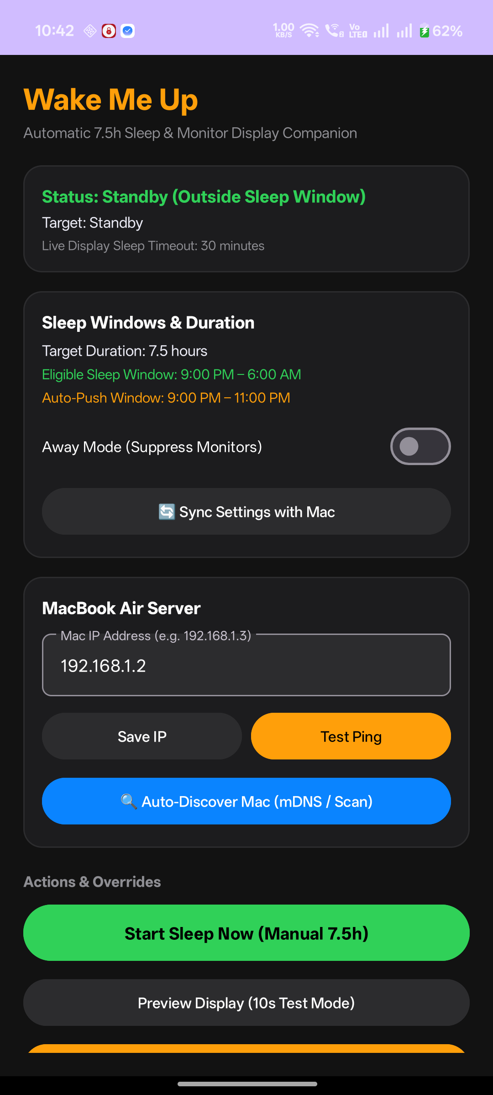 | SCREEN 1: MOBILE COMPANION TOP  Mobile Home Dashboard & Settings  • Status Card: Shows 'Standby (Outside Sleep Window)' in fresh green. In daytime, it indicates sleep tracking is inactive.  • Sleep Windows & Duration: Displays target 7.5h duration, Eligible Window (9PM-6AM), and Auto-Push Window (9PM-11PM).  • Away Mode Toggle: Allows user to suppress monitor activation when sleeping away from home.  • Mac Connection Card: Shows the connected Mac IP (192.168.1.2) with Save, Ping, and Auto-Discover buttons.  • Design Goal: Transform this engineering card view into an organic circular circadian visualizer with integrated pairing status.

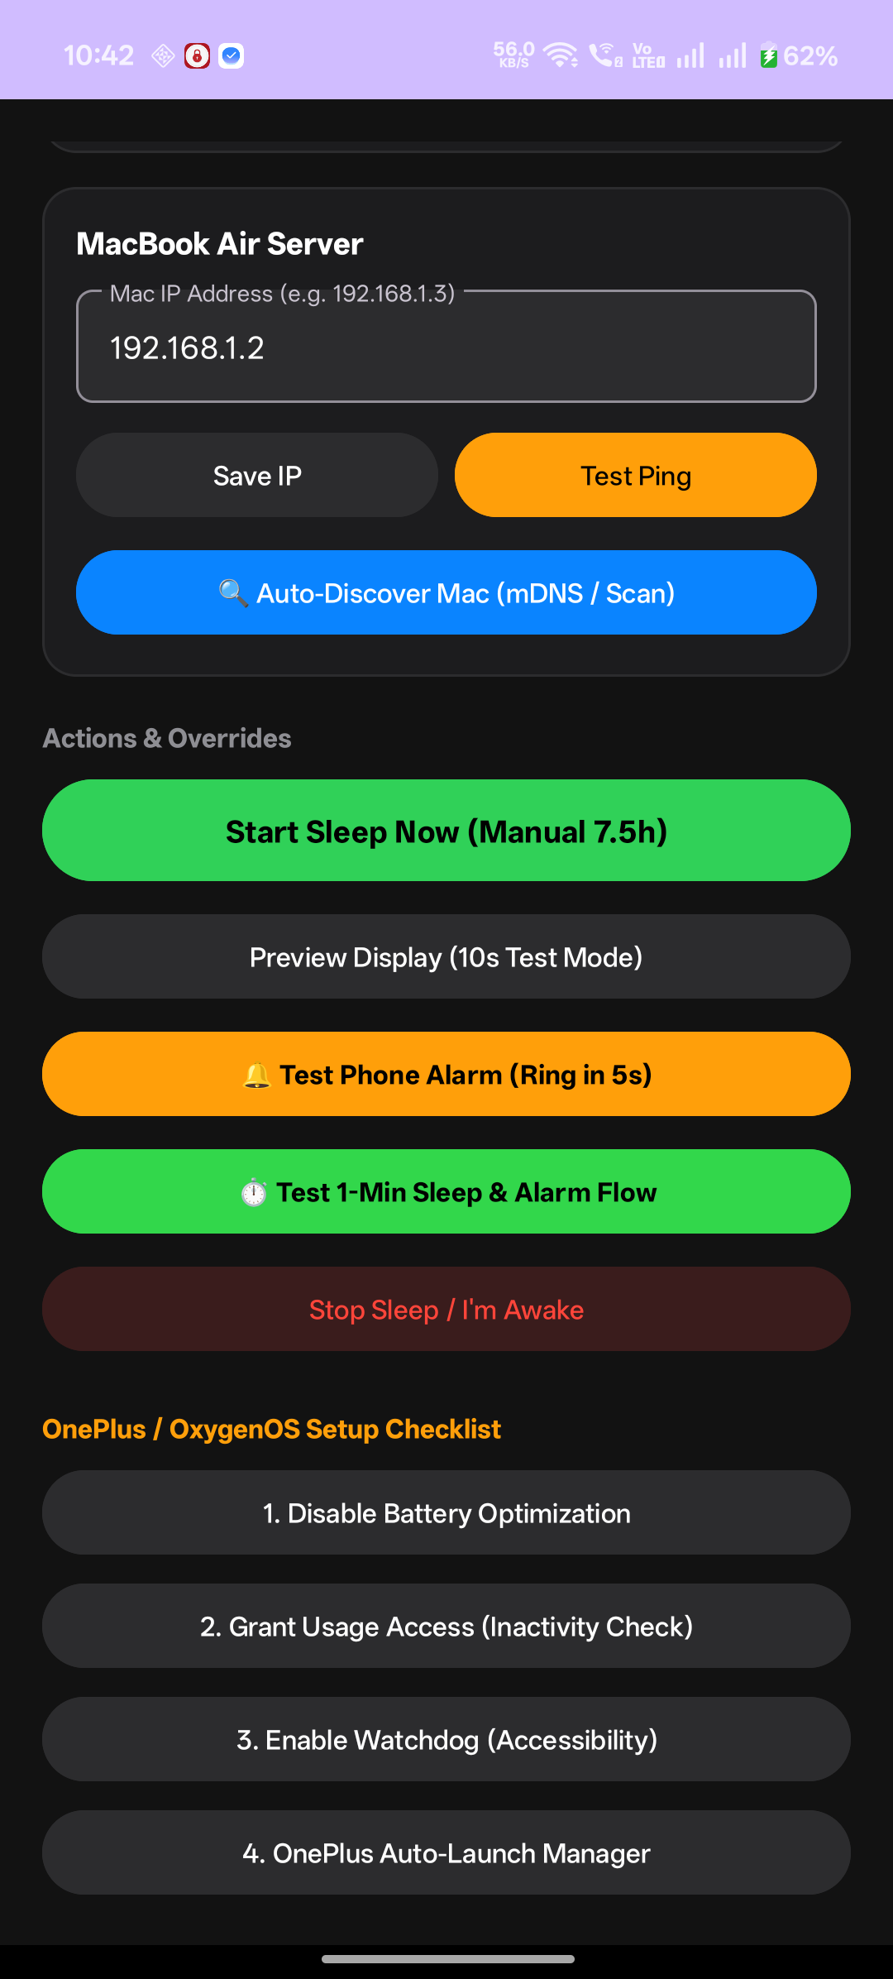 | SCREEN 2: MOBILE COMPANION BOTTOM  Action Triggers & Device Health Checklist  • Start Sleep Now Button: Primary action button allowing immediate manual sleep initiation for 7.5 hours.  • Preview Display (10s): Tests the external Mac monitor ambient screen directly from bed.  • Test Phone Alarm: Triggers immediate audio alarm verification to ensure volume and vibration work.  • OxygenOS Setup Checklist: Critical battery optimization and accessibility watchdog links to prevent background OS kills.  • Design Goal: Move the OxygenOS setup checklist into a dedicated secondary 'Device Health' sheet to keep the primary screen calm.

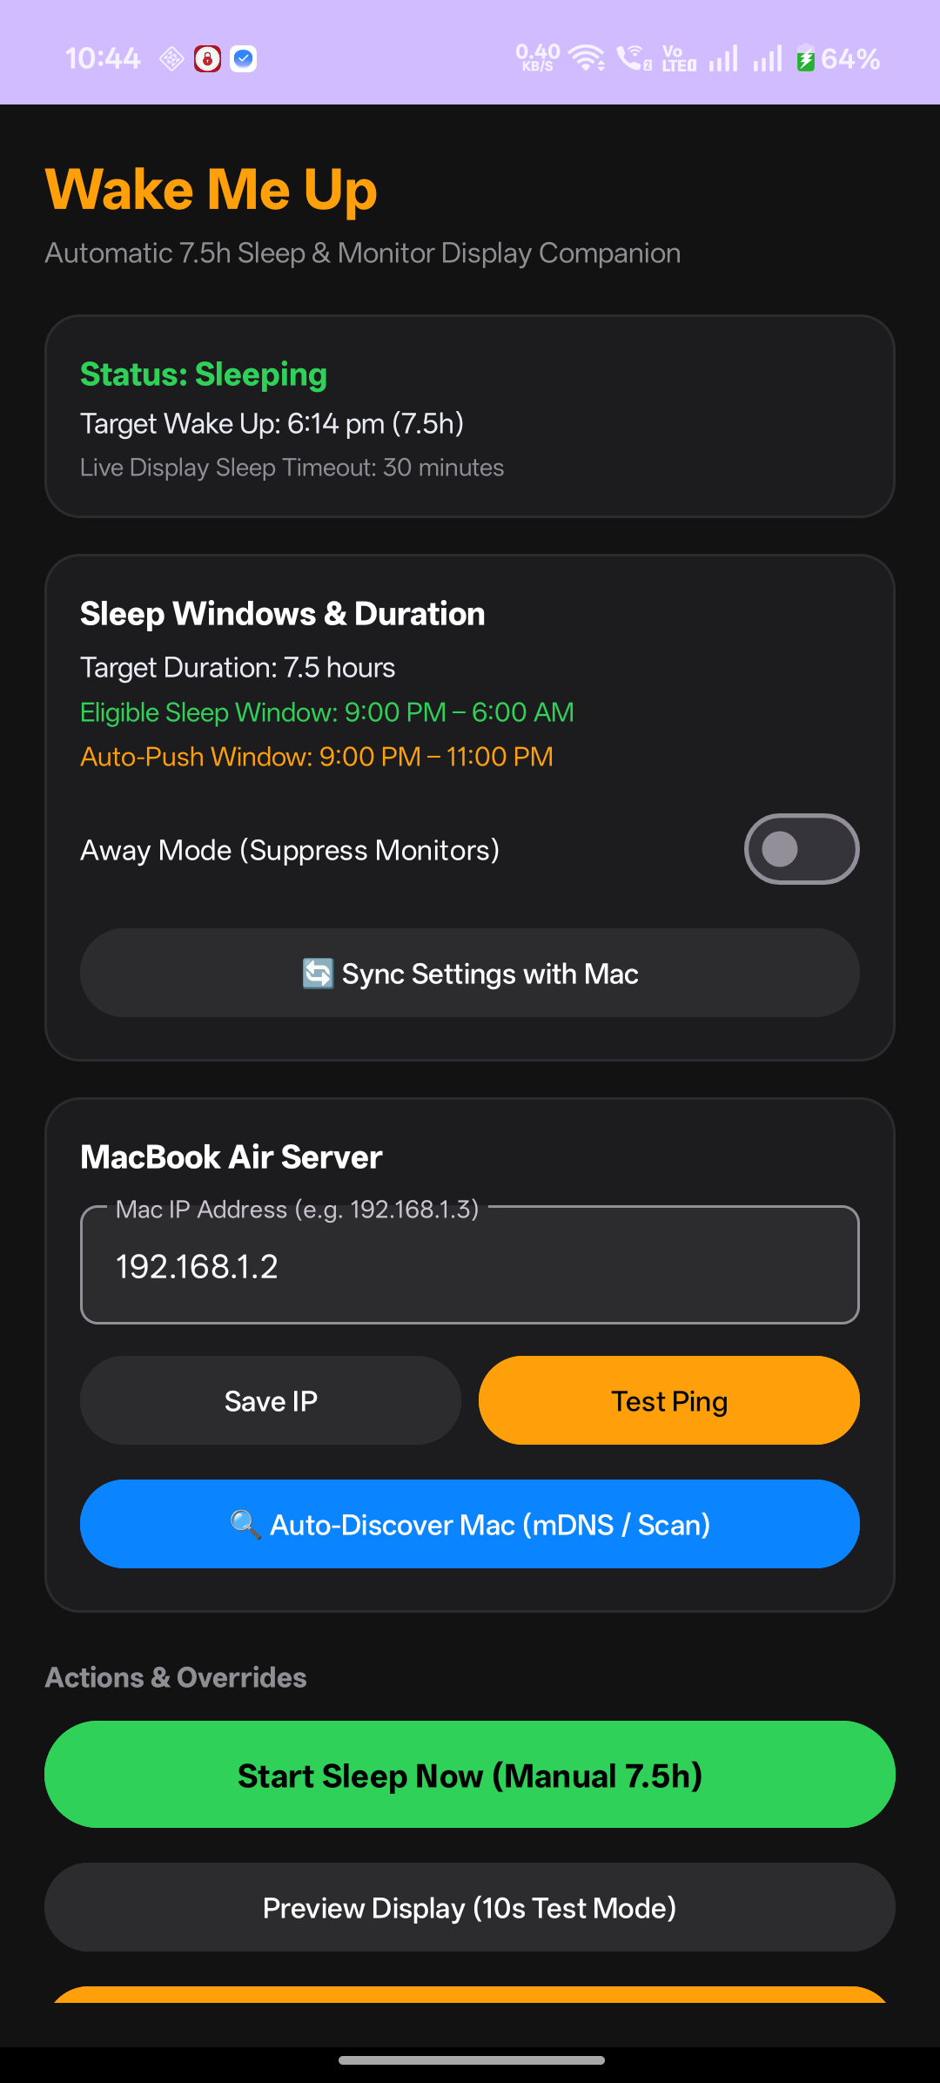 | SCREEN 3: LIVE ACTIVE SLEEP  Active Sleep Tracking State  • Status Transition: Status card turns into 'Status: Sleeping' with dynamic target wake-up time calculated to the exact minute.  • Countdown Context: Displays real-time countdown progress toward the 7.5-hour target.  • Instant Control: The primary action transforms into 'Stop Sleep / I'm Awake' to end tracking at any time.  • Design Goal: Provide a breathing ambient pulse indicator with night-sky gradient visuals indicating restful tracking.

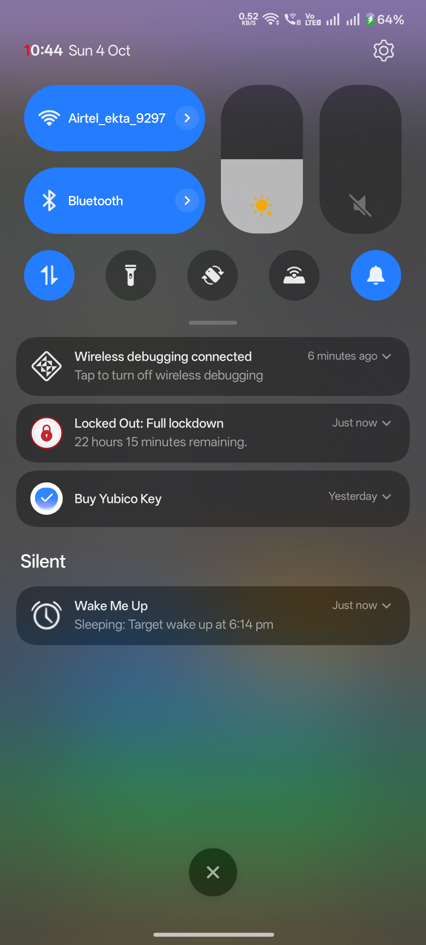 | SCREEN 4: ANDROID NOTIFICATION SHADE  System Notifications & Quick Glance  • Persistent Notification: High-priority foreground notification displaying real-time target wake-up time at a glance.  • Lock Screen Visibility: Visible on always-on display (AOD) or lock screen so users know their alarm is active without unlocking.  • Doze Immunity: Guarantees the background detection service stays alive through heavy Android battery saver modes.

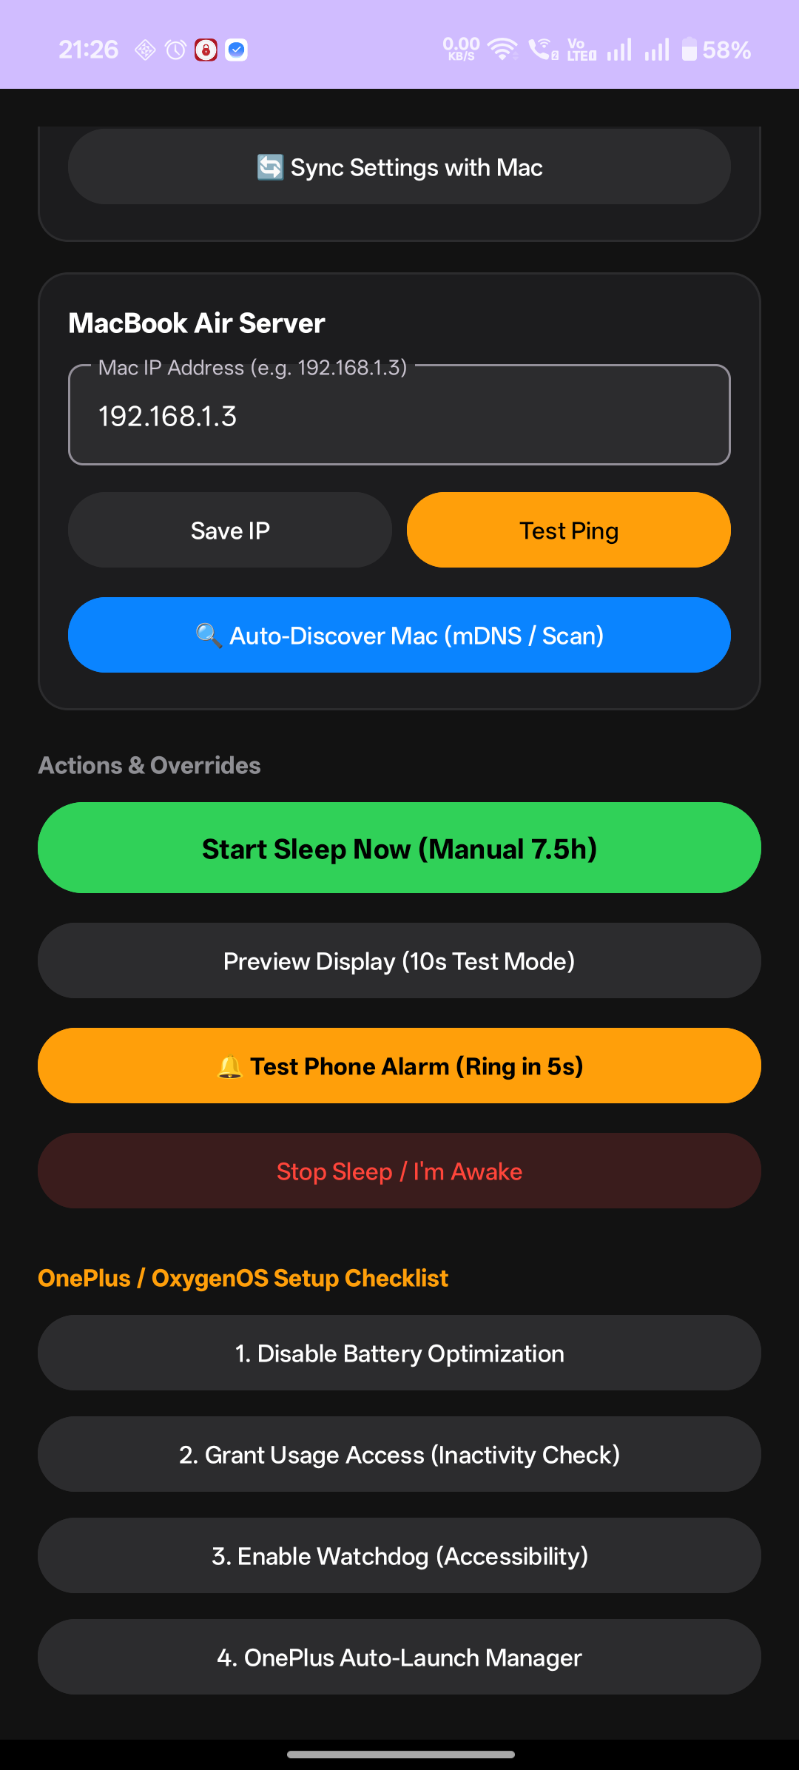 | SCREEN 5: WAKE-UP ALARM RINGING  Morning Alarm Ringing Experience  • Full Screen Illumination: Fires over lock screen when exact target minute is reached with audio and vibration.  • Dismiss Action: Provides an immediate 'Stop Alarm / I'm Awake' button to turn off sound and sync wake state to Mac.  • Design Goal: Replace basic button with a soothing full-screen sunrise gradient and an affirmative 'Slide to Wake Up' gesture.

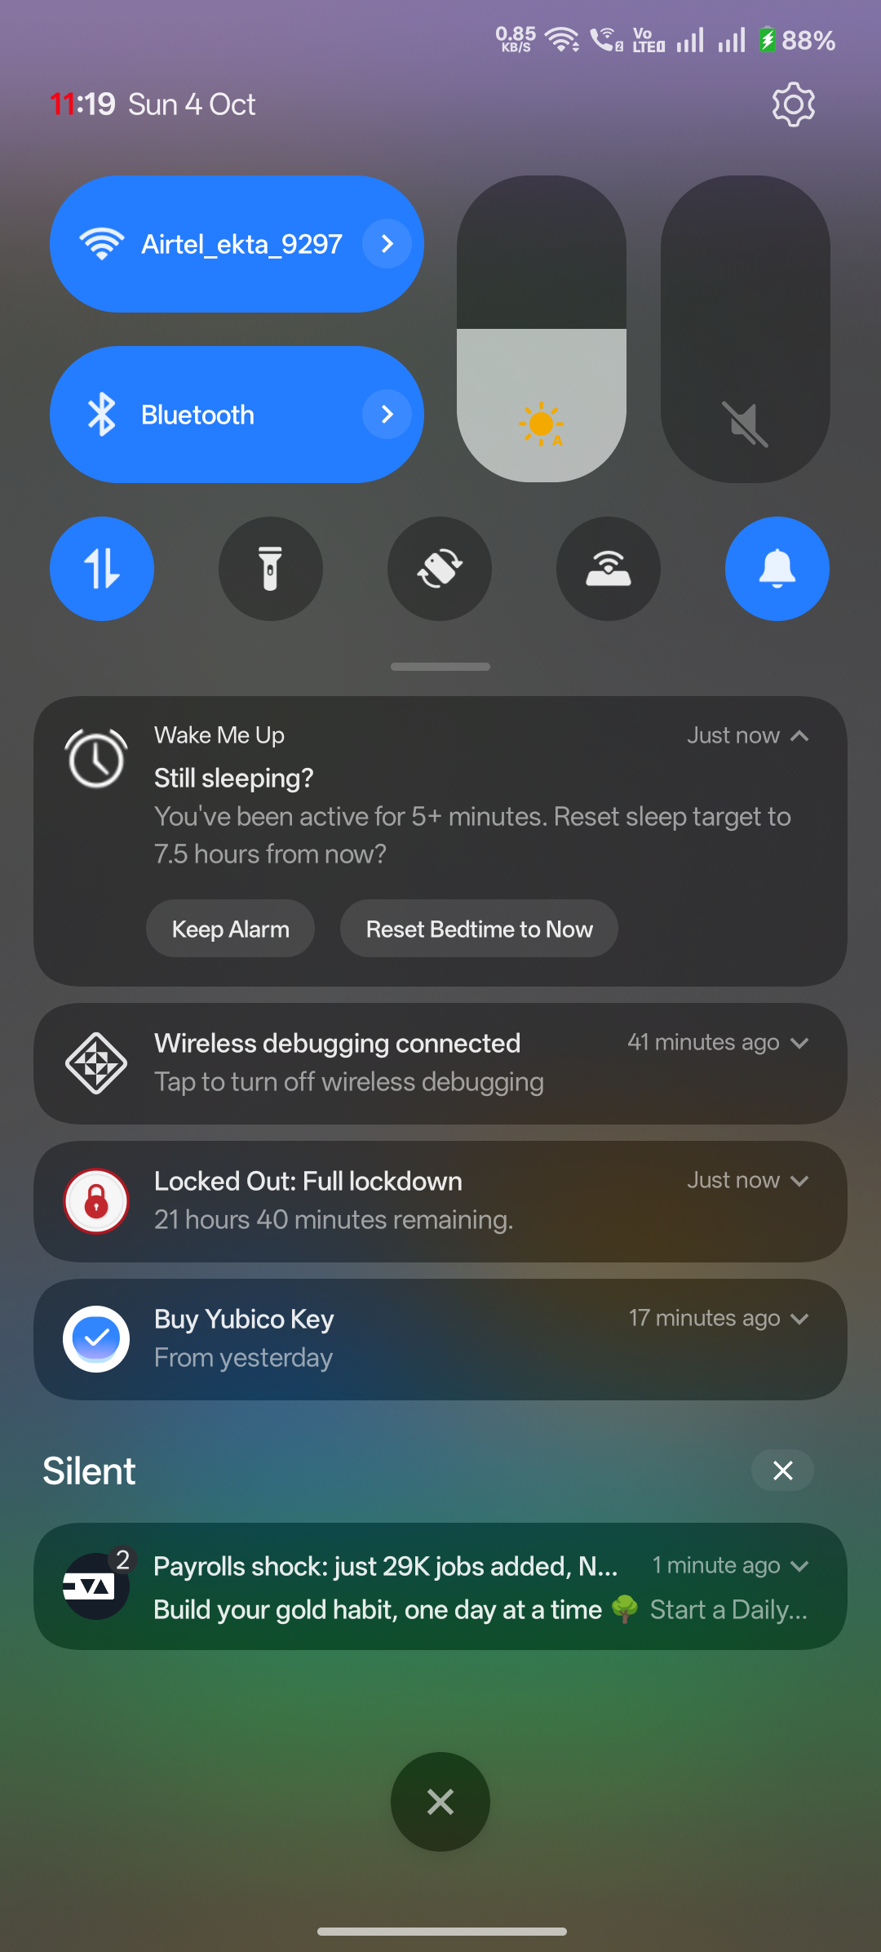 | SCREEN 6: MIDNIGHT ACTIVITY FILTER  Midnight Prolonged Activity Prompt (Live Notification)  • Interactive Choice: Appears if phone remains active past threshold during nocturnal hours ('Still sleeping? You've been active for 5+ minutes').  • Action 1: Keep Alarm: Dismisses prompt and preserves the existing morning wake-up schedule.  • Action 2: Reset Bedtime to Now: Recalculates a fresh 7.5-hour schedule starting from the current moment.  • Design Goal: Elevate into a calm, non-intrusive bottom sheet or banner with high contrast and smooth dark mode styling.

3.2 macOS Desktop Utility: Menu Bar & Preferences
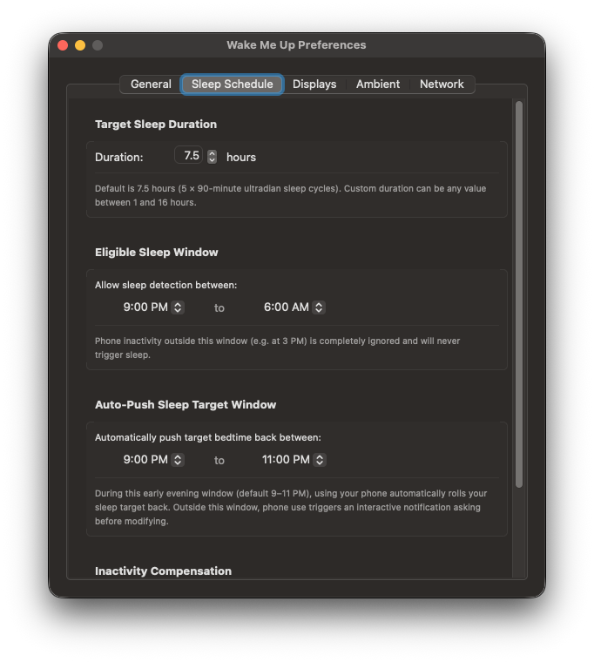 | SCREEN 7: MAC PREFERENCES - SLEEP SCHEDULE  Sleep Schedule & Dynamic Window Settings  • Target Sleep Duration: Numeric stepper allowing custom durations between 1.0 and 16.0 hours (default 7.5h).  • Eligible Sleep Window: Configurable start and end dropdowns (e.g. 9:00 PM to 6:00 AM) that sync with the mobile app.  • Auto-Push Window: Configurable early-evening window (e.g. 9:00 PM to 11:00 PM) for automatic sleep target postponement.  • Inactivity Offset: Configurable minutes subtracted from bedtime when phone was left untouched before lock.

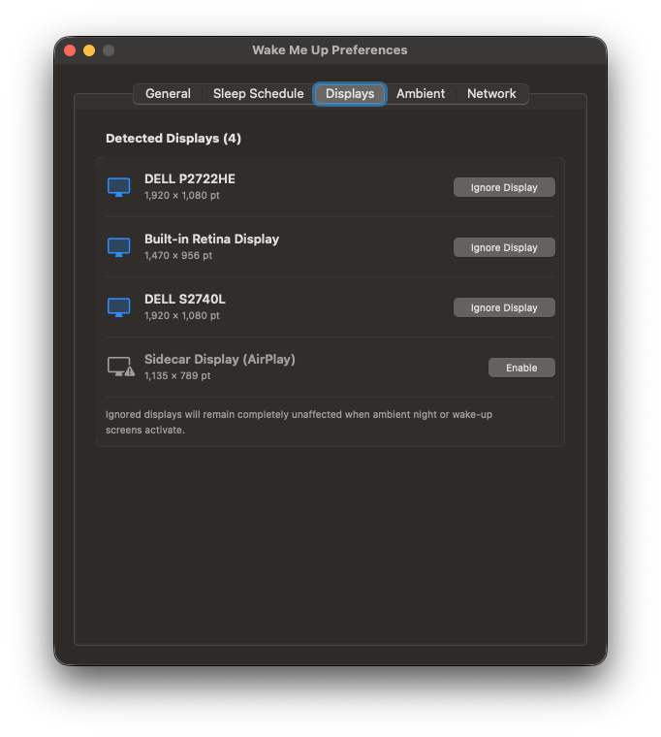 | SCREEN 8: MAC PREFERENCES - DISPLAYS TAB  Multi-Monitor Selection Manager  • Detected Hardware: Lists all connected physical and virtual screens (Dell P2722HE, Built-in Retina, Dell S2740L, Sidecar).  • Ignore Display Toggles: Allows users to selectively exclude screens (e.g., exclude iPad Sidecar or secondary monitor).  • Resolution & Aspect Ratio: Displays point dimensions and native frame parameters for pixel-perfect overlays.

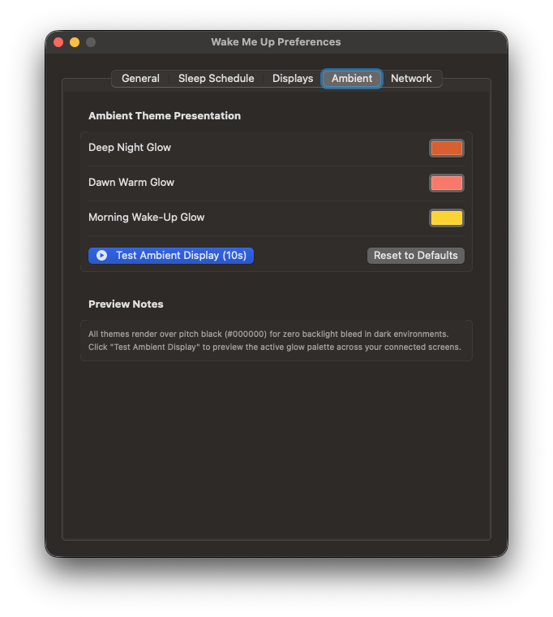 | SCREEN 9: MAC PREFERENCES - AMBIENT TAB  Circadian Ambient Color & Palette Customizer  • Deep Night Glow: Color picker for nocturnal ultra-dim countdown (default ember #D95926).  • Dawn Warm Glow: Color picker for T-30 minute melatonin suppression glow (default Sunrise Coral #FA7268).  • Morning Wake-Up Glow: Color picker for sunrise wake greeting (default Radiant Solar Gold #FFD000).  • Test Ambient Display Button: Fires an immediate 10-second mirrored preview across all monitors.

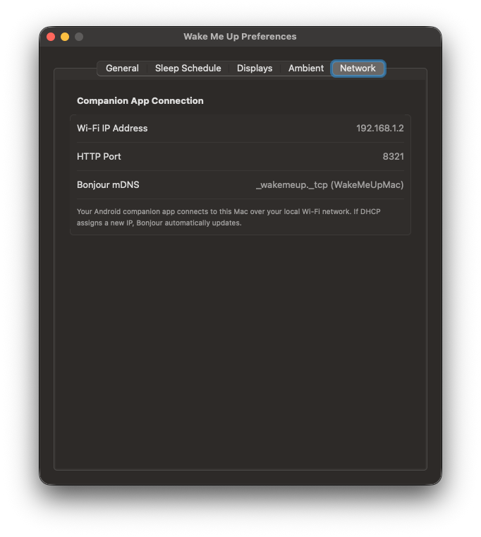 | SCREEN 10: MAC PREFERENCES - NETWORK TAB  Local Network Hub & Auto-Discovery Info  • Local Wi-Fi IP: Displays the current DHCP Wi-Fi address (192.168.1.2) allocated to the MacBook.  • HTTP Port: Lightweight HTTP server running on dedicated port 8321.  • Bonjour mDNS: Broadcasts _ambientdisplay._tcp service so phone discovers the Mac without manual IP entry.

3.3 Workstation Ambient Display Modes (Physical Monitors)
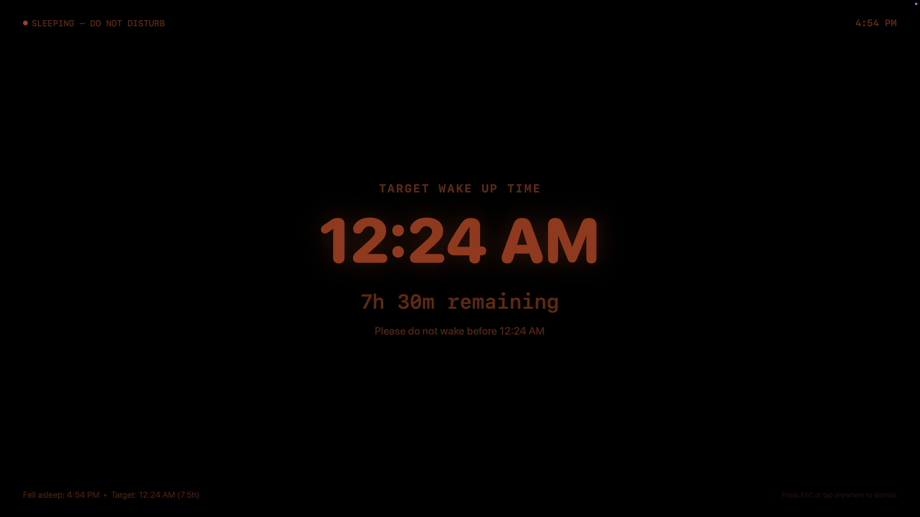 | SCREEN 11: WORKSTATION NIGHT COUNTDOWN  Night Countdown Ambient Mode (Ultra Dim)  • Pure True-Black Canvas: #000000 background ensures zero backlight bleed on IPS/OLED displays in a dark bedroom.  • Minimal Typography: Monochromatic, subdued countdown displays remaining sleep hours and minutes.  • Power Assertions: Keeps screens powered without letting macOS trigger DPMS standby.  • Dismissal: Pressing the ESC key on the Mac keyboard immediately closes the overlay.

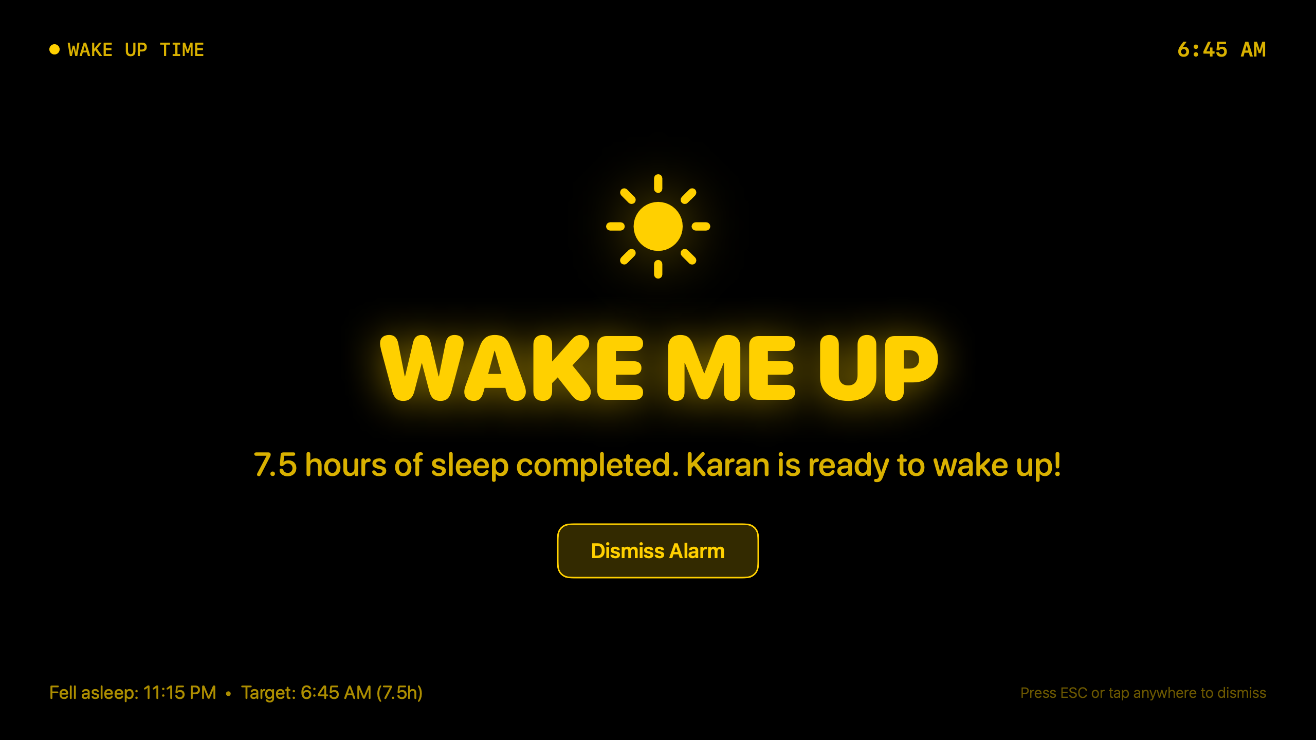 | SCREEN 12: MORNING SUNRISE ILLUMINATION  Sunrise Wake-Up Simulation (Radiant Solar Gold #FFD000)  • Authentic 3-Stage Progression: Evolves naturally from Midnight Ember (#D95926) -> Dawn Coral (#FA7268) -> Radiant Solar Gold (#FFD000).  • Wake-Up Greeting: Displays warm 'AMBIENT DISPLAY' banner with current time, sun iconography, and 7.5 hours completed message.  • Audio Harmonization: Coordinates with the phone's acoustic alarm for a synchronized multi-device awakening.

3.4 Remote Screen Message Billboard (Live Mobile & Monitor Pairing)
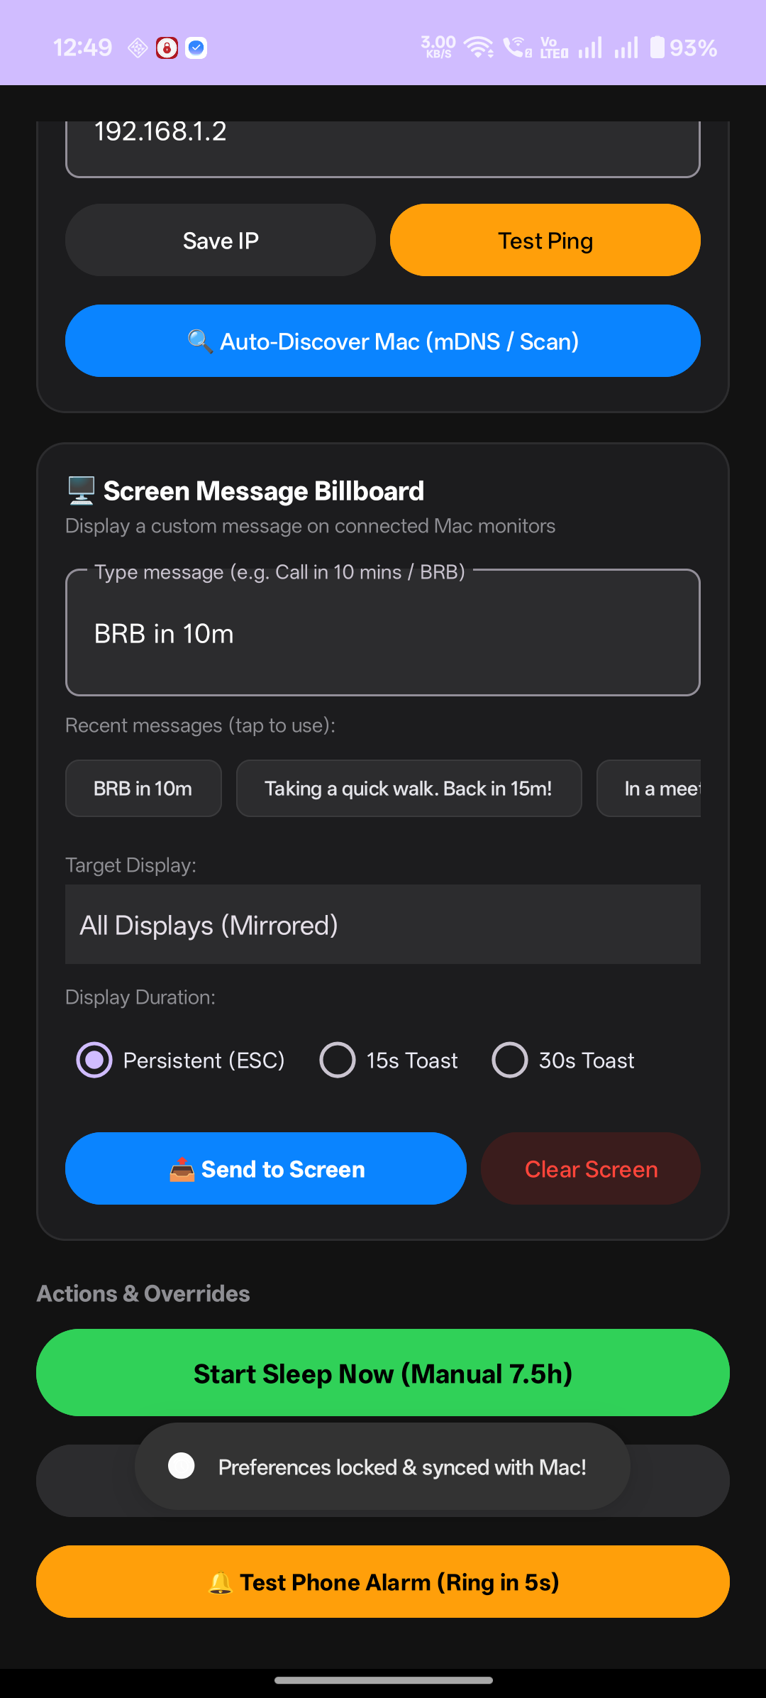 | SCREEN 13: MOBILE SCREEN MESSAGE CARD  Mobile Message Composer & Remote Controller  • Custom Message Field: Multi-line input allowing arbitrary custom text (e.g. 'Taking a quick walk. Back in 15m!').  • Dynamic Display Targeting: Spinner dynamically queried from Mac to target 'All Displays (Mirrored)' or a single monitor.  • Duration Selector: Radio options for Persistent (manual ESC dismiss), 15s Toast, or 30s Toast.  • Action Controls: Instant 'Send to Screen' broadcast and remote 'Clear Screen' button.

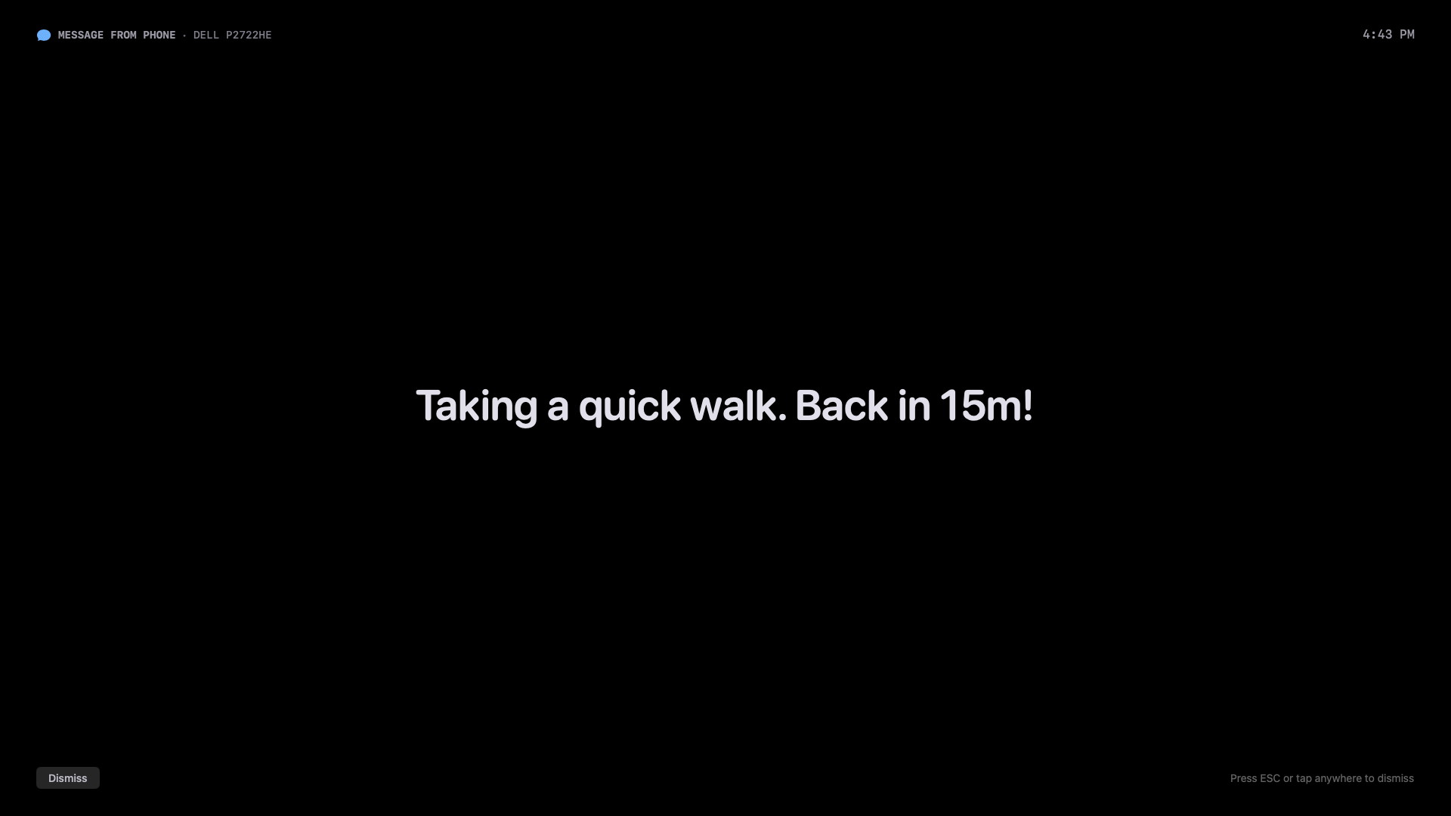 | SCREEN 14: MAC MONITOR BILLBOARD OVERLAY  Workstation Billboard Display (DELL Monitor)  • Pure True-Black Canvas: #000000 background prevents OLED/IPS backlight glow in dark environment.  • Dynamic Auto-Scaling Typography: Soft off-white (#E0E0E6) font automatically scales based on length (massive for short notes, proportional for sentences).  • Source & Timestamp Header: Subtle header indicating origin ('MESSAGE FROM PHONE') and current time.  • Universal Dismissal: Dismissable via ESC key on Mac keyboard, clicking anywhere on screen, or 'Clear Screen' on mobile.

4. Technical Architecture & Communication Protocols
Ambient Display operates as a distributed local-first ecosystem. No external cloud infrastructure or user databases are utilized. All telemetry and synchronization take place over local Wi-Fi between the Android mobile device and macOS workstation.

4.1 Local REST API Endpoints (Mac Server :8321)
• GET /api/status: Returns current session state (idle, sleeping, wakeUpReady), active monitors count, and away mode.
• POST /api/sleep: Payload: { bedtime_epoch_ms, duration_minutes, reason }. Activates sleep session and mirrored display overlays.
• POST /api/wake: Payload: {}. Dismisses ambient overlays, releases power assertions, returns app to idle.
• POST /api/test: Payload: { duration_seconds }. Runs 10s preview across all displays.
• POST /api/away: Payload: { is_away_mode }. Toggles or sets Away Mode status.
• GET & POST /api/config: Bidirectional synchronization of sleep duration, window start/end hours, and inactivity offsets.
• GET /api/displays: Returns real-time list of connected Mac displays with ID, localized name, dimensions, and active mode (idle, sleeping, message).
• POST /api/message: Payload: { text, target_display_id, duration_seconds }. Renders fullscreen message overlay on targeted monitor(s).
• POST /api/message/dismiss: Payload: { target_display_id }. Clears message and seamlessly reverts screen(s) to sleep countdown or desktop.
• GET /api/message/status: Returns all active messages and remaining countdown timers.

4.2 Resilient Network Auto-Discovery
To handle dynamic home routers where DHCP addresses change (e.g. from 192.168.1.3 to 192.168.1.2), Ambient Display implements a multi-tier discovery pipeline:
1. Cached IP Quick-Probe (< 400ms): Attempts instant connection to the last verified IP.
2. Bonjour / mDNS Service Discovery: Resolves '_ambientdisplay._tcp' published by macOS NWListener.
3. High-Speed Subnet Scan (< 200ms): Concurrently probes all 254 subnet socket endpoints on port 8321 to locate the Mac even if router mDNS multicast is filtered.

5. UX & UI Design Recommendations for Mobile Redesign
The current mobile application functions with complete engineering reliability, but its visual presentation is that of an internal engineering test tool. A senior UI/UX designer should transform the app based on the following structural pillars:
Hero Circadian Ring: Replace flat card boxes with a focal circular circadian ring. The ring shows bedtime, target wake time, and visual gradient arcs representing the Sleep Phase (deep ember), Dawn Phase (amber), and Wake Time (sunrise gold).
Seamless Hardware Connection Pill: Condense the current 5-button Mac connection card into a single elegant hardware pill at the top: '🟢 Connected to MacBook Air'. Tapping the pill opens a connection bottom sheet with advanced network controls.
Integrated Windows Timeline Dial: Replace numeric dropdowns with an intuitive 24-hour circular slider allowing users to visually sculpt their Eligible Sleep Window and Auto-Push Window with smooth haptic feedback.
Secondary Settings Sheet: Relocate technical checklists (OnePlus battery optimizations, ADB developer controls, raw IP fields) into a secondary 'Device Health & Settings' sheet, preserving the serenity of the main resting view.
Soothing Sunrise Alarm Screen: Design a full-screen morning gradient canvas with gentle rhythmic pulsing typography and an affirmative 'Slide to Wake Up' thumb slider to prevent accidental dismissal.
✦ DESIGNER ACTION ITEM: Deliverables expected from designer: Figma design system with Night/Dark mode palette, Component specifications, Hero Home Dashboard screen, Active Sleep mode screen, Sunrise Alarm Ringing screen, and Settings / Hardware sheet.

