**Chapter 1**

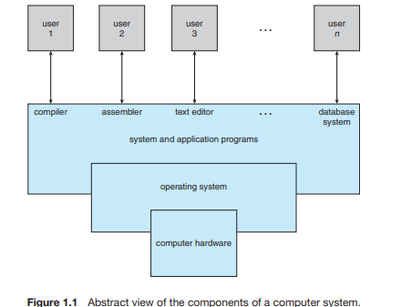

An **operating system** is the one program running at all times on the computer—usually called the kernel. (Along with the kernel, there are two other types of programs: system programs, which are associated with the operating system but are not necessarily part of the kernel, and application programs, which include all programs not associated with the operation of the system.)

**Computer System Organization**