Simple text for showing addText() function  
 with color  
 and back color.

**Bold + underline**

Center this text.

Align this text to the right.

Those two lines are in the same paragraph,  
but they are separated by a line break.

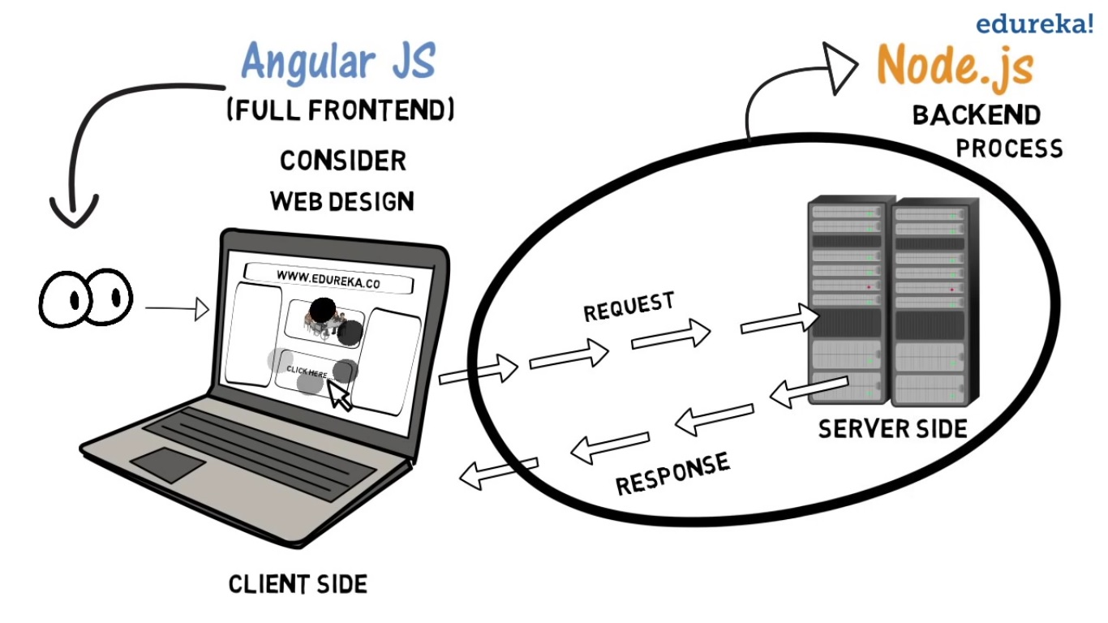

Since asd you can do asd cool asd!

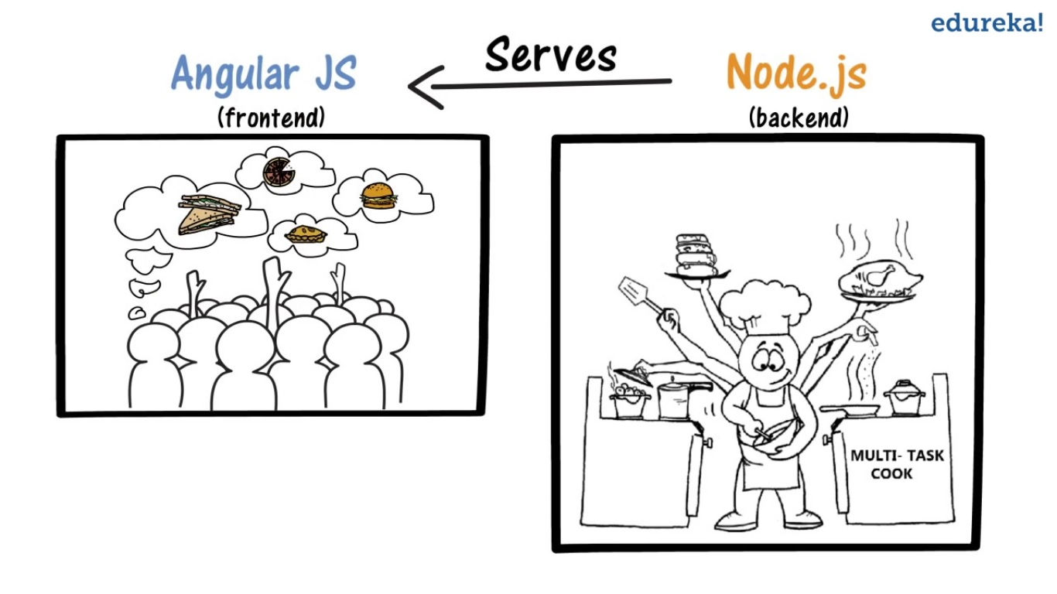

Fonts face only. Fonts face and size.  
[External link](https://www.google.com)  
Internal link

1. Option 1
2. Option 2

|  |  |  |
| --- | --- | --- |
| **Sr. No.** | **Title1** | **Title2** |
| 1 | text 1@ | start |
| 2 | text 2$ |  |
| 3 | text3? |  |
| 4 | text4! | END |

