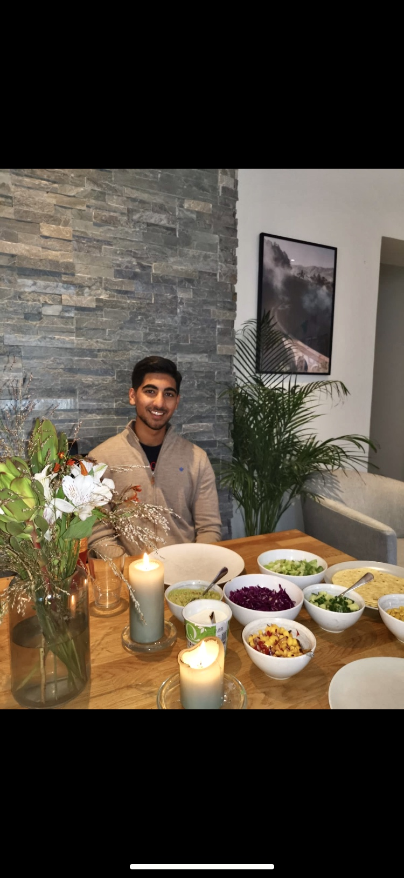

I am currently pursing my first year of a bachelor’s program in Informatics at NTNU, Trondheim. With this course, I have got the opportunity to gain theoretical and practical knowledge in important fields of technology and programming. I am a person with innovative, and Out of the Box thinking. In the future, I would like to explore further to fetch more value with solid commitment to further improve and innovate the field of technology.

PROFILE & OBJECTIVE

KARAN

SANDHU

Ka

EDUCATION

K

2020- 2023

DEDICATED   
INFORMATIC STUDENT   
AT NTNU

**BACHELOR’S IN INFORMATICS**

NTNU, TRONDHEIM

The degree consists of a three-year course in informatic, with a wide range of subjects. Both theoretical and practical skills are used throughout the years, in addition to a couple of relevant expeditions.





2017-2020

**HIGH SCHOOL, SCIENCE**

SANDVIKA VIDEREGÅENDE SKOLE, BÆRUM

DOB:03.09.2001

Here my elective subjects were science based. I was also the leader of the student council for my grade.



ONLINE COURSES

+47 99 11 22 50

**JAVA COURSE**

CODEWITHMOSH.COM

ONGOING



I choose to advance my java skills because of how good of an object-oriented language it is, the rich API’s and all the great development tolls it has. Most importantly java is everywhere you look, which makes it an interesting and powerful language.



EXPERIENCE

KARAN.S.01@HOTMAIL.COM

**JAVASCRIPT INTERMEDIATE**

CODEWITHMOSH.COM

[](https://www.google.com/maps/place/Thomas+Angells+gate+10B,+7011+Trondheim/@63.4328247,10.3969302,17z/data=!3m1!4b1!4m5!3m4!1s0x466d319bf4bf2e9b:0x99b01b8b93fb6652!8m2!3d63.4328223!4d10.3991189)

2020

THOMAS ANGELLS GATE 10B, 7011, TRONDHEIM

I wanted to improve my JavaScript skills, so I can become a better front-end developer. JavaScript will also sharpen my problem solving and algorithm skills in any other languages as well.

[](http://singhsandhu.com/)

TECH & Language SKILLS

MY WEBSITE

(MADE WITH HTML, CSS AND JAVASCRIPT)

HTML

JAVASCRIPT

PYTHON



[](https://www.linkedin.com/in/karan-singh-sandhu-bb72bb1a6/) [](https://www.facebook.com/karansinghsandhu01/)

MS 365

PUNJABI

JAVA

CSS

ENGLISH

NORWEGIAN

¨

**LEADER OF WELCOME COMMITTEE, NTNU**

NTNU

EXPERIENCE CONTINUED

ONGOING

**ELISE STAUTLAND– HEAD OF COURSE COMMITTEE AT NTNU**

Mob: +47 466 47 599 E-mail: elise.stautland@getmail.no

**ANNA AGATA – FORMER EXECUTIVE BOARD MEMBER FOR ENT3R**

Mob: +47 955 53 818 E-mail: Anneabr@stud.ntnu.no

REFERENCES

TRAVEL

MOVIES

FOOTBALL

BADMINTON

INDIAN DANCE

PHOTOGRAPHY

TECHNOLOGY LOVER

As a member of the course committee I get to manage several events and courses with different IT companies in the semester. This work requires logistical skills, event management, and communication skills

Within the first few months I managed to become the leader of the welcome committee, which takes on management skills, public speaking, weekly board meetings and strategizing to make the first weeks for the new students the next semester as educational and entertaining as possible for 300 students. The preparations require a lot of commitment and efforts.

ONGOING

**COURSE COMMITTEE, NTNU**

NTNU



RELIABLE

CREATIVE

DEDICATED

ORGANIZED

FAST LEARNER

HARD WORKING

TIME MANAGEMENT

PERSONAL

The work done at Narvesen has helped me better my communications skills, both in person and in mails. As a secretary I had to manage and answer questions from customers and the franchise.

2015- 2020

**NARVESEN, SALESMAN/SECRETARY**

BEKKESTUA, OSLO

INTERESTS

PEOPLE MANAGEMENT

EVENT MANAGEMENT

HTML, CSS, EXCEL

SOCIAL MEDIA

TECHNOLOGY

EXPERTISE