GUI INterface Testing

Document By : Karan Subedi(C7202332)

Karan Subedi C7202332

**GUI OUTPUTS**

**DrawLine**

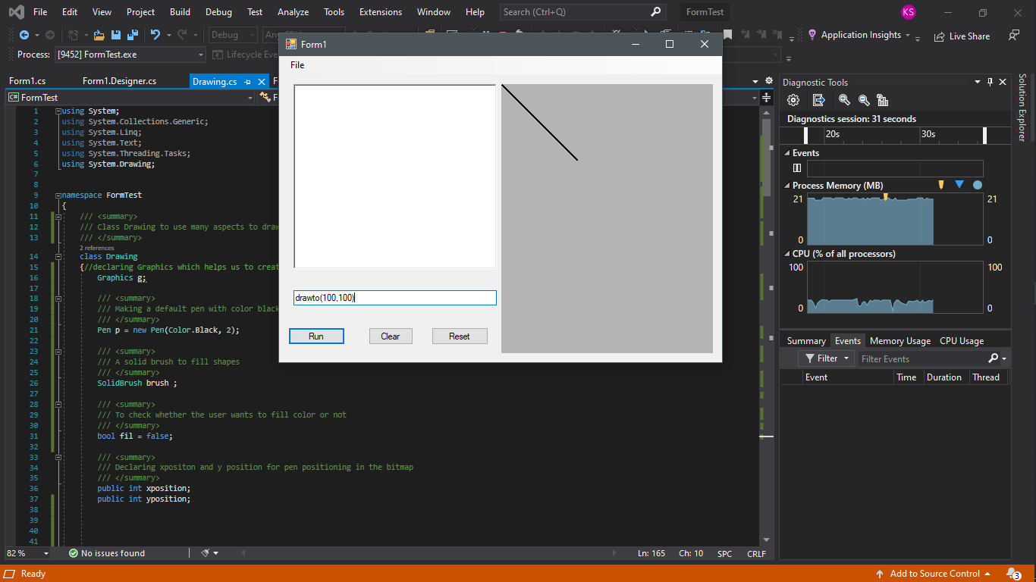

**Drawing a line on the bitmap**

Moveto Command

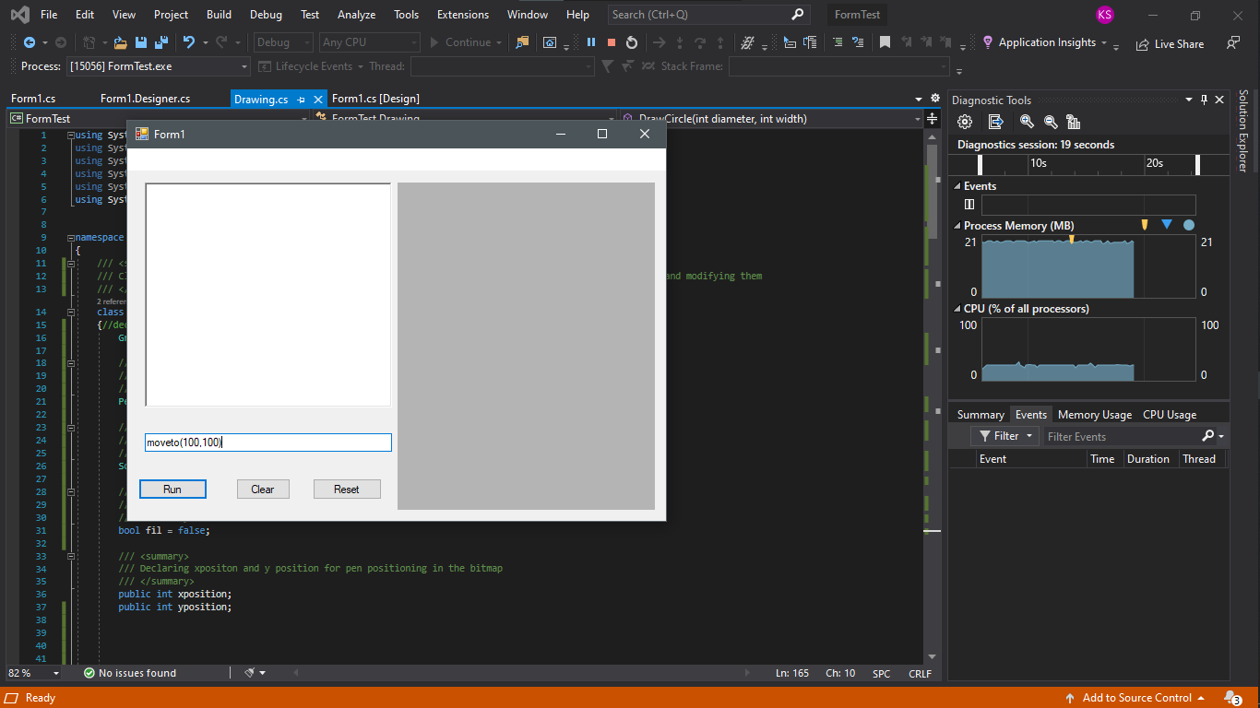

Move to command works as it is not showing on the bitmap but next image of rectangle shows that it has been made on a place where it supposed to move

Draw rectangle Command

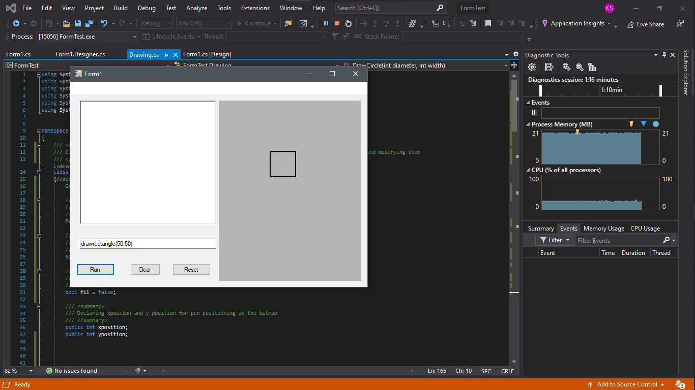

Drawing rectangle on the place where the cursor was supposed to move

Draw Circle

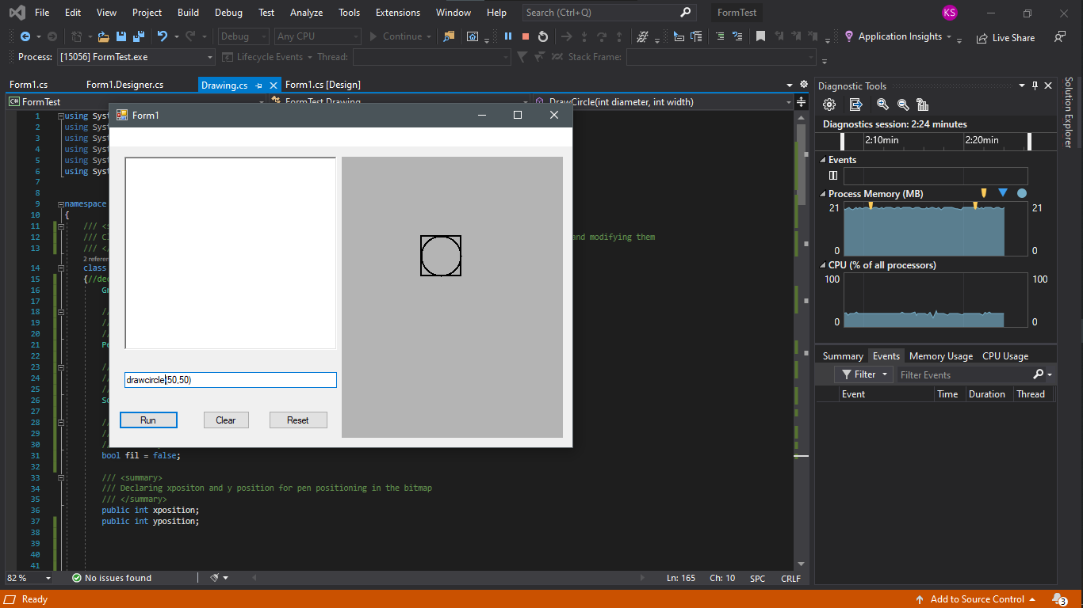

Drawn a circle inside a square or rectangle on the point where the move to command was said to go

**Fill Shapes and colored pen**

**Filling a shape with red by using solid brush**

1. **Loading a file with some commands pre entered in it**

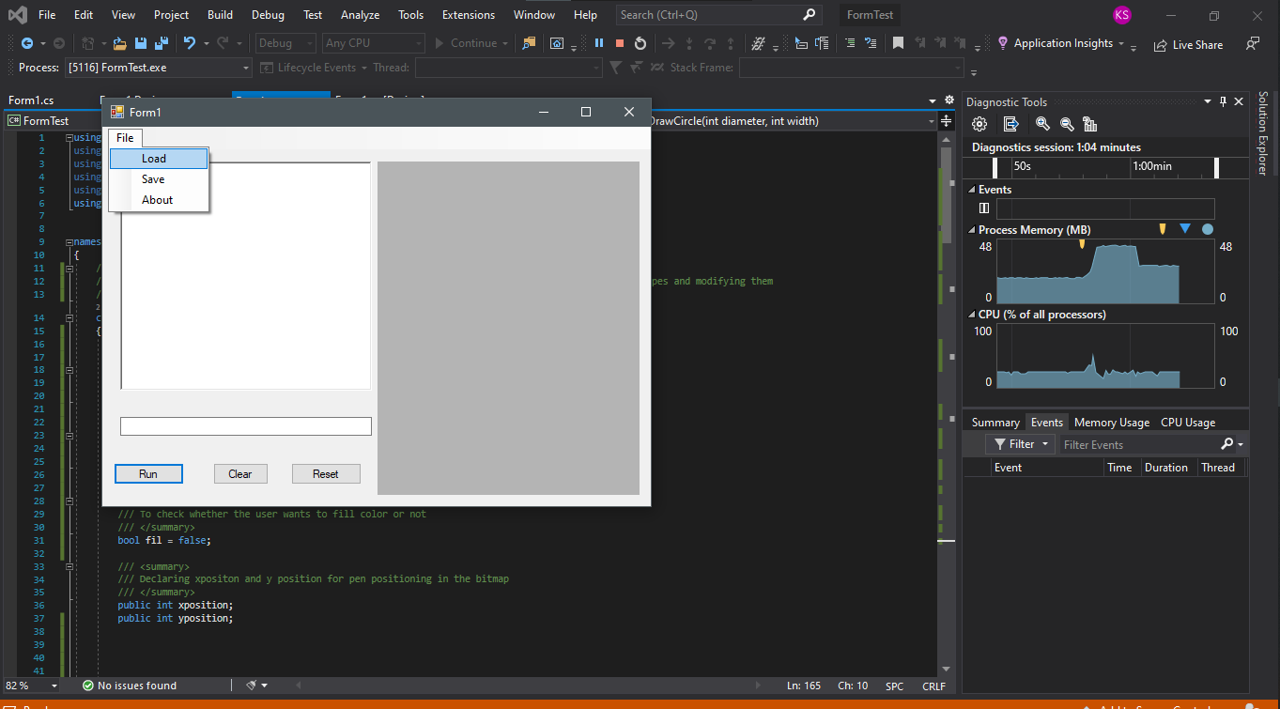

**File load Successful**

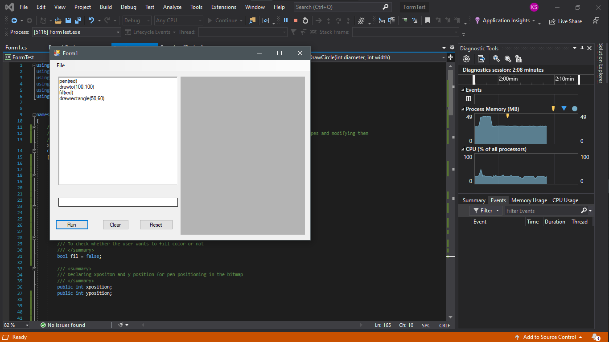

**Using Red pen to create a line and a solid red brush to fill the rectangle**

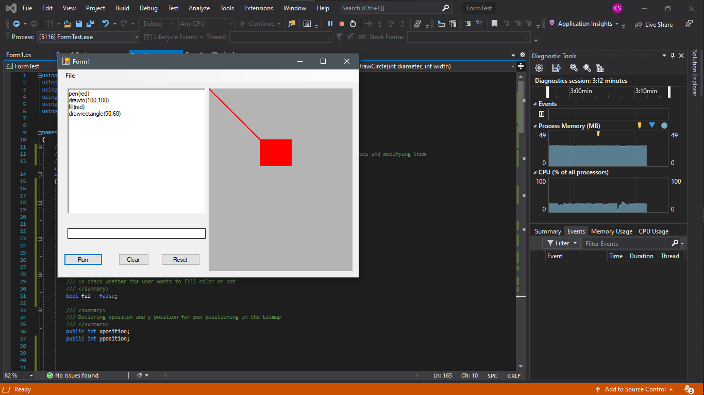

**Syntax Checking**

**Checking Syntax for various invalid line**

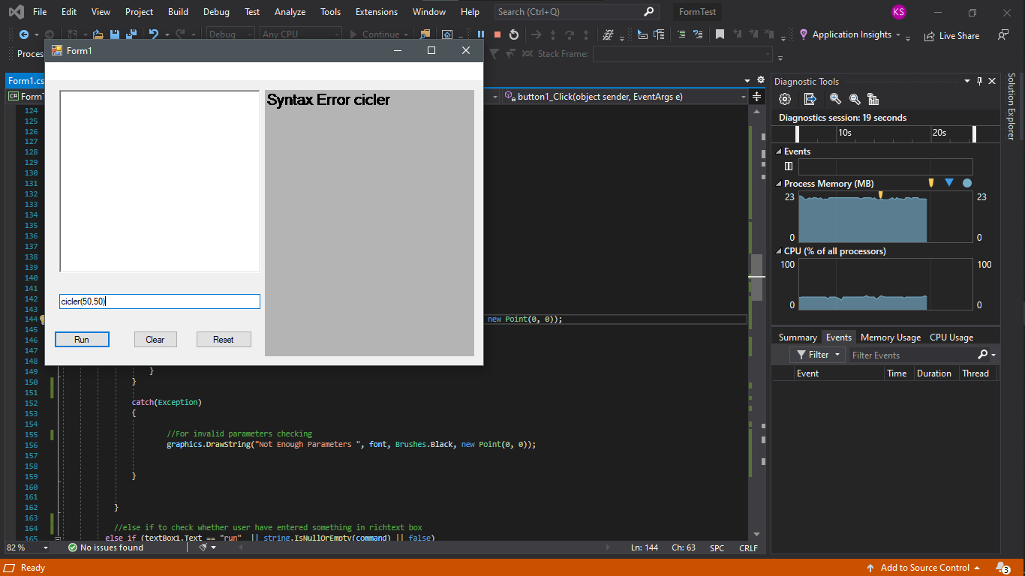

**Pameters invalid checking**

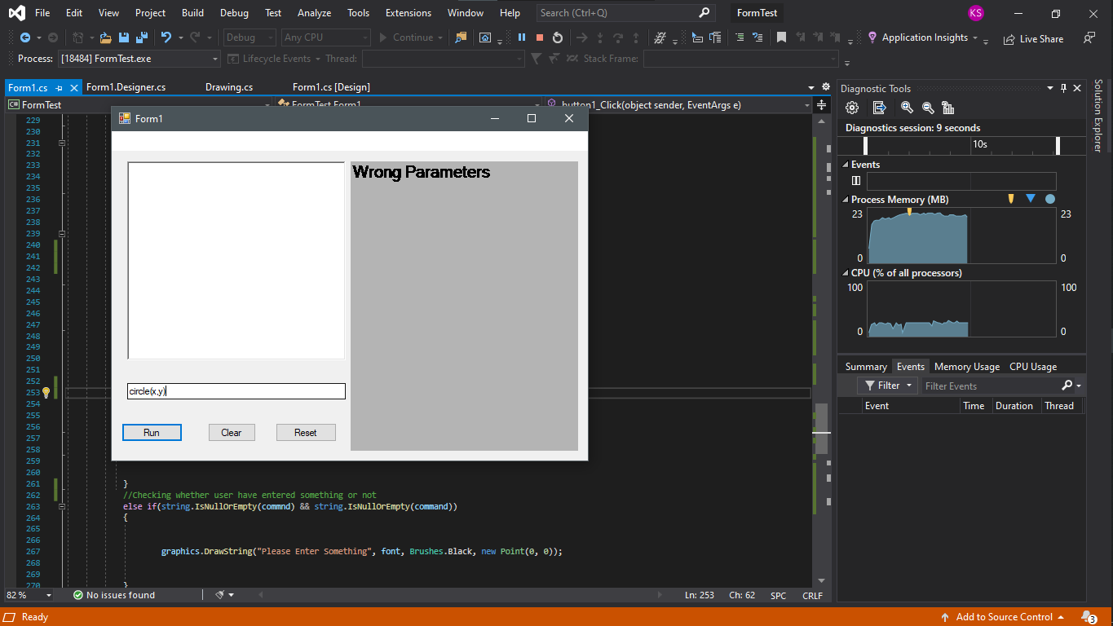

**Test Case**

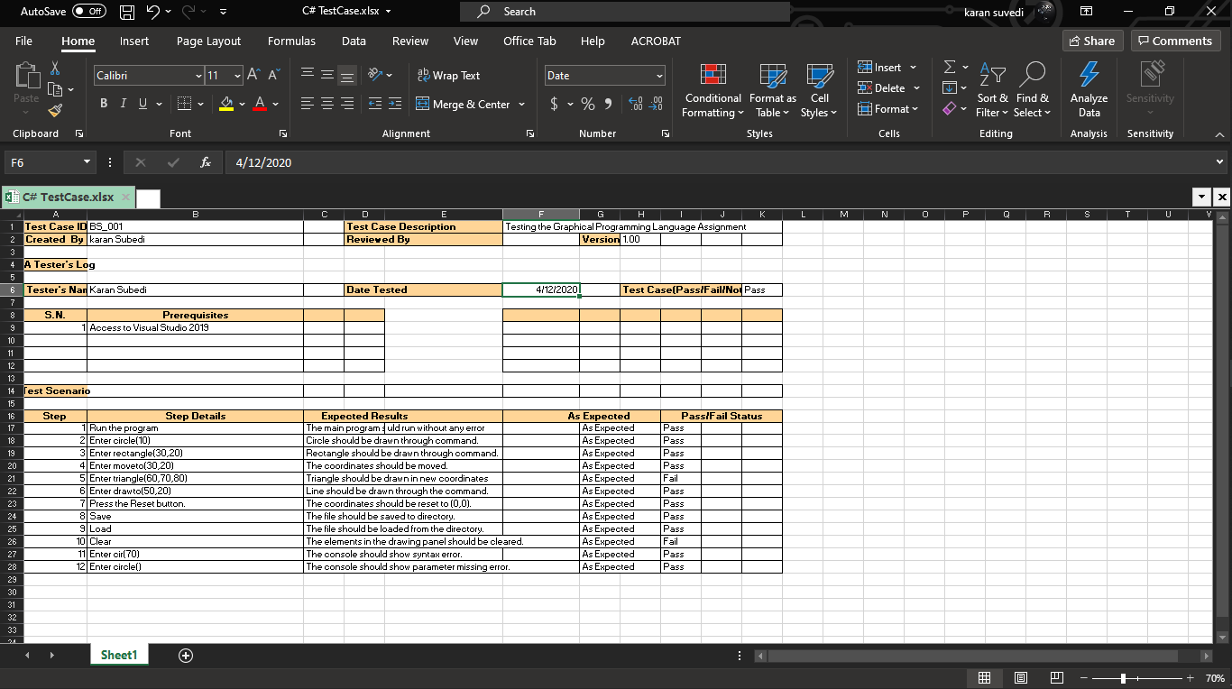

**Unit Test**

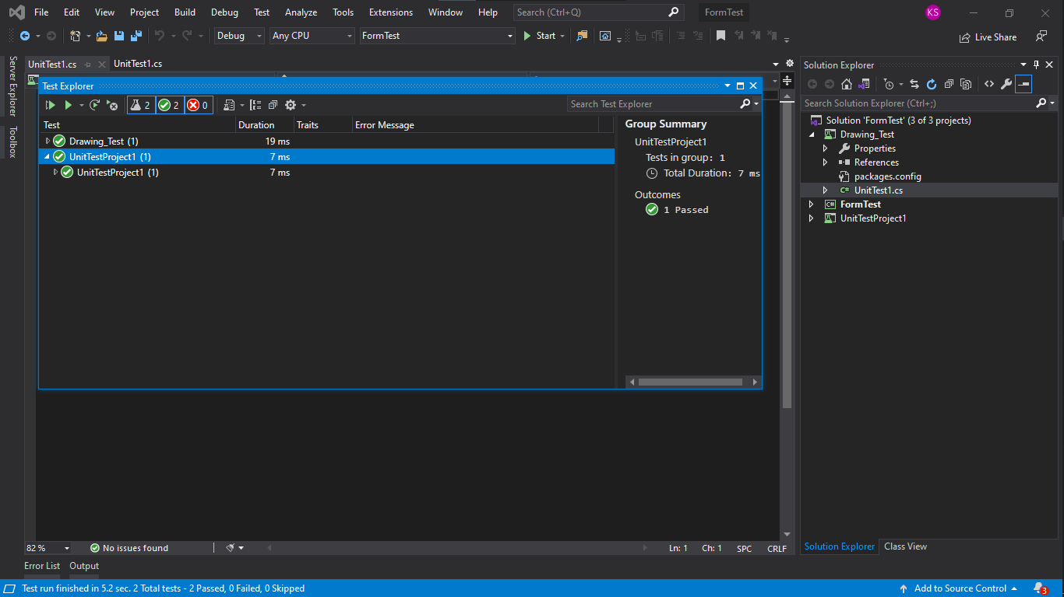

**Version Control**

