Unit-1

Introduction of Computer Graphics
Computer Graphics involves technology to access. The Process transforms and presents information in a visual form. The role of computer graphics insensible. In today life, computer graphics has now become a common element in user interfaces, T.V. commercial motion pictures.
Computer Graphics is the creation of pictures with the help of a computer. The product of the computer graphics is a picture it may be a business graph, drawing, and engineering.
In computer graphics, two or three-dimensional pictures can be created that are used for research. Many hardware devices algorithm has been developing for improving the speed of picture generation with the passes of time. It includes the creation storage of models and image of objects. These models for various fields like engineering, mathematical and so on.
Today computer graphics is entirely different from the earlier one. It is not possible. It is an interactive user can control the structure of an object of various input devices.

Definition of Computer Graphics:
It is the use of computers to create and manipulate pictures on a display device. It comprises of software techniques to create, store, modify, represents pictures.

Why computer graphics used?
Suppose a shoe manufacturing company want to show the sale of shoes for five years. For this vast amount of information is to store. So a lot of time and memory will be needed. This method will be tough to understand by a common man. In this situation graphics is a better alternative. Graphics tools are charts and graphs. Using graphs, data can be represented in pictorial form. A picture can be understood easily just with a single look.
Interactive computer graphics work using the concept of two-way communication between computer users. The computer will receive signals from the input device, and the picture is modified accordingly. Picture will be changed quickly when we apply command.
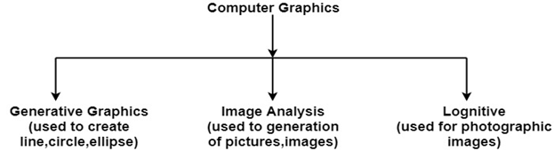

Application of Computer Graphics

- Education and Training: Computer-generated model of the physical, financial and economic system is often used as educational aids. Model of physical systems, physiological system, population trends or equipment can help trainees to understand the operation of the system.
- Use in Biology: Molecular biologist can display a picture of molecules and gain insight into their structure with the help of computer graphics.
- Computer-Generated Maps: Town planners and transportation engineers can use computer-generated maps which display data useful to them in their planning work.
- Architect: Architect can explore an alternative solution to design problems at an interactive graphics terminal. In this way, they can test many more solutions that would not be possible without the computer.
- Computer Art: Computer Graphics are also used in the field of commercial arts. It is used to generate television and advertising commercial.
- Entertainment: Computer Graphics are now commonly used in making motion pictures, music videos and television shows.
- Visualization: It is used for visualization of scientists, engineers, medical personnel, business analysts for the study of a large amount of information.
- Educational Software: Computer Graphics is used in the development of educational software for making computer-aided instruction.
- Printing Technology: Computer Graphics is used for printing technology and textile design.
- Presentation Graphics: Example of presentation Graphics are bar charts, line graphs, pie charts and other displays showing relationships between multiple parameters. Presentation Graphics is commonly used to summarize:
- Financial Reports
- Statistical Reports
- Mathematical Reports
- Scientific Reports
- Economic Data for research reports
- Managerial Reports
- Consumer Information Bulletins
- And other types of reports

Interactive and Passive Graphics

Non-Interactive or Passive Computer Graphics:
In non-interactive computer graphics, the picture is produced on the monitor, and the user does not have any controlled over the image, i.e., the user cannot make any change in the rendered image. One example of its Titles shown on T.V.
Non-interactive Graphics involves only one-way communication between the computer and the user, User can see the produced image, and he cannot make any change in the image.

Interactive Computer Graphics:
In interactive Computer Graphics user have some controls over the picture, i.e., the user can make any change in the produced image. One example of it is the ping-pong game.
Interactive Computer Graphics require two-way communication between the computer and the user. A User can see the image and make any change by sending his command with an input device.

Advantages:
- Higher Quality
- More precise results or products
- Greater Productivity
- Lower analysis and design cost
- Significantly enhances our ability to understand data and to perceive trends.

Display Devices:
The most commonly used display device is a video monitor. The operation of most video monitors based on CRT (Cathode Ray Tube). The following display devices are used:
- Refresh Cathode Ray Tube
- Random Scan and Raster Scan
- Color CRT Monitors
- Direct View Storage Tubes
- Flat Panel Display
- Lookup Table

Cathode Ray Tube (CRT):
CRT stands for Cathode Ray Tube. CRT is a technology used in traditional computer monitors and televisions. The image on CRT display is created by firing electrons from the back of the tube of phosphorus located towards the front of the screen.
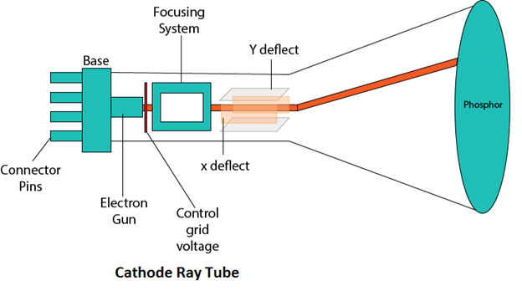
Once the electron heats the phosphorus, they light up, and they are projected on a screen. The color you view on the screen is produced by a blend of red, blue and green light.

Components of CRT:
Main Components of CRT are:
- Electron Gun: Electron gun consisting of a series of elements, primarily a heating filament (heater) and a cathode. The electron gun creates a source of electrons which are focused into a narrow beam directed at the face of the CRT.
- Control Electrode: It is used to turn the electron beam on and off.
- Focusing system: It is used to create a clear picture by focusing the electrons into a narrow beam.
- Deflection Yoke: It is used to control the direction of the electron beam. It creates an electric or magnetic field which will bend the electron beam as it passes through the area. In a conventional CRT, the yoke is linked to a sweep or scan generator. The deflection yoke which is connected to the sweep generator creates a fluctuating electric or magnetic potential.
- Phosphorus-coated screen: The inside front surface of every CRT is coated with phosphors. Phosphors glow when a high-energy electron beam hits them. Phosphorescence is the term used to characterize the light given off by a phosphor after it has been exposed to an electron beam.

Random Scan and Raster Scan Display:

Random Scan Display:
Random Scan System uses an electron beam which operates like a pencil to create a line image on the CRT screen. The picture is constructed out of a sequence of straight-line segments. Each line segment is drawn on the screen by directing the beam to move from one point on the screen to the next, where its x & y coordinates define each point. After drawing the picture. The system cycles back to the first line and design all the lines of the image 30 to 60 time each second. The process is shown in fig:
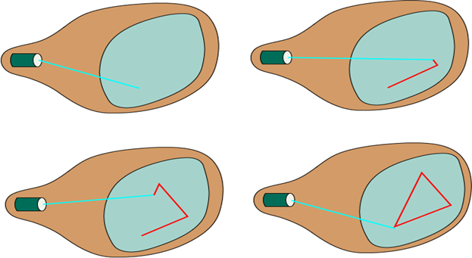
Random-scan monitors are also known as vector displays or stroke-writing displays or calligraphic displays.

Advantages:
- A CRT has the electron beam directed only to the parts of the screen where an image is to be drawn.
- Produce smooth line drawings.
- High Resolution

Disadvantages:
- Random-Scan monitors cannot display realistic shades scenes.

Raster Scan Display:
A Raster Scan Display is based on intensity control of pixels in the form of a rectangular box called Raster on the screen. Information of on and off pixels is stored in refresh buffer or Frame buffer. Televisions in our house are based on Raster Scan Method. The raster scan system can store information of each pixel position, so it is suitable for realistic display of objects. Raster Scan provides a refresh rate of 60 to 80 frames per second.
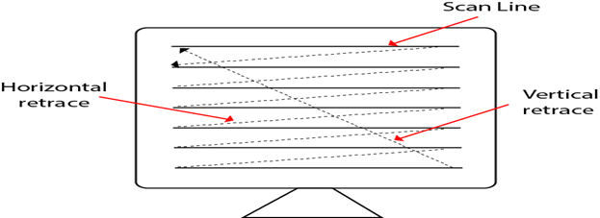
Frame Buffer is also known as Raster or bit map. In Frame Buffer the positions are called picture elements or pixels. Beam refreshing is of two types. First is horizontal retracing and second is vertical retracing. When the beam starts from the top left corner and reaches the bottom right scale, it will again return to the top left side called at vertical retrace. Then it will again more horizontally from top to bottom call as horizontal retracing shown in fig:
Types of Scanning or travelling of beam in Raster Scan
- Interlaced Scanning
- Non-Interlaced Scanning
In Interlaced scanning, each horizontal line of the screen is traced from top to bottom. Due to which fading of display of object may occur. This problem can be solved by Non-Interlaced scanning. In this first of all odd numbered lines are traced or visited by an electron beam, then in the next circle, even number of lines are located.
For non-interlaced display refresh rate of 30 frames per second used. But it gives flickers. For interlaced display refresh rate of 60 frames per second is used.

Advantages:
- Realistic image
- Million Different colors to be generated
- Shadow Scenes are possible.

Disadvantages:
- Low Resolution
- Expensive

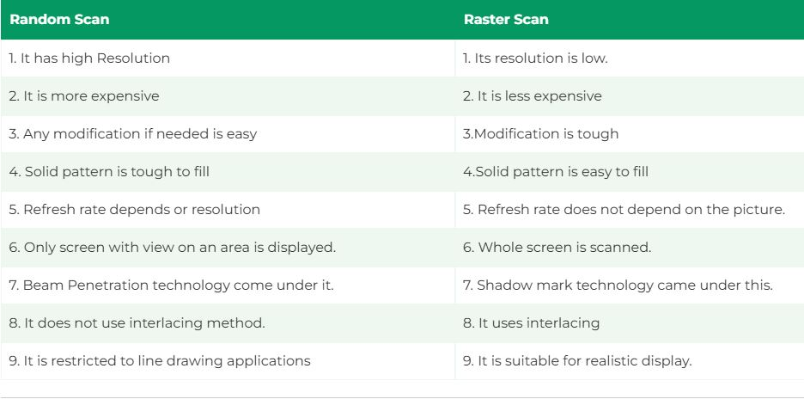
Differentiate between Random and Raster Scan Display:

Color CRT Monitors:
The CRT Monitor display by using a combination of phosphors. The phosphors are different colors. There are two popular approaches for producing color displays with a CRT are:
- Beam Penetration Method
- Shadow-Mask Method

1. Beam Penetration Method:
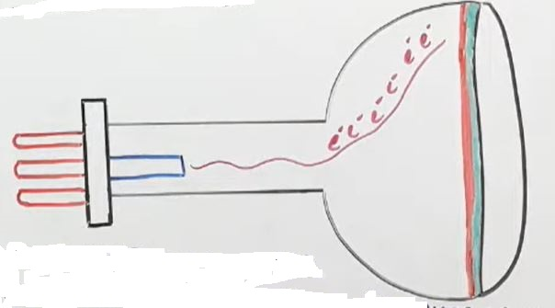
The Beam-Penetration method has been used with random-scan monitors. In this method, the CRT screen is coated with two layers of phosphor, red and green and the displayed color depends on how far the electron beam penetrates the phosphor layers. This method produces four colors only, red, green, orange and yellow. A beam of slow electrons excites the outer red layer only; hence screen shows red color only. A beam of high-speed electrons excites the inner green layer. Thus screen shows a green color.

Advantages:
- Inexpensive

Disadvantages:
- Only four colors are possible
- Quality of pictures is not as good as with another method.

2. Shadow-Mask Method:
- Shadow Mask Method is commonly used in Raster-Scan System because they produce a much wider range of colors than the beam-penetration method.
- It is used in the majority of color TV sets and monitors.
Construction: A shadow mask CRT has 3 phosphor color dots at each pixel position.
- One phosphor dot emits: red light
- Another emits: green light
- Third emits: blue light
This type of CRT has 3 electron guns, one for each color dot and a shadow mask grid just behind the phosphor coated screen. Shadow mask grid is pierced with small round holes in a triangular pattern.Figure shows the delta-delta shadow mask method commonly used in color CRT system.
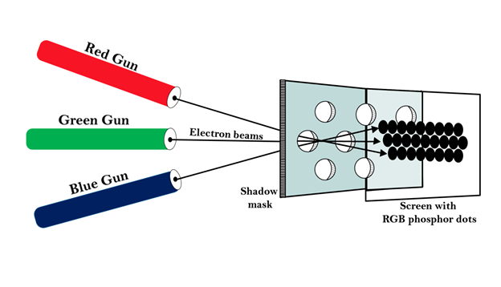

Working: Triad arrangement of red, green, and blue guns.
The deflection system of the CRT operates on all 3 electron beams simultaneously; the 3 electron beams are deflected and focused as a group onto the shadow mask, which contains a sequence of holes aligned with the phosphor- dot patterns.
When the three beams pass through a hole in the shadow mask, they activate a dotted triangle, which occurs as a small color spot on the screen.
The phosphor dots in the triangles are organized so that each electron beam can activate only its corresponding color dot when it passes through the shadow mask.

Advantage:
- Realistic image
- Million different colors to be generated
- Shadow scenes are possible

Disadvantage:
- Relatively expensive compared with the monochrome CRT.
- Relatively poor resolution
- Convergence Problem

Direct View Storage Tubes:
DVST terminals also use the random scan approach to generate the image on the CRT screen. The term "storage tube" refers to the ability of the screen to retain the image which has been projected against it, thus avoiding the need to rewrite the image constantly.
Function of guns: Two guns are used in DVST
- Primary guns: It is used to store the picture pattern.
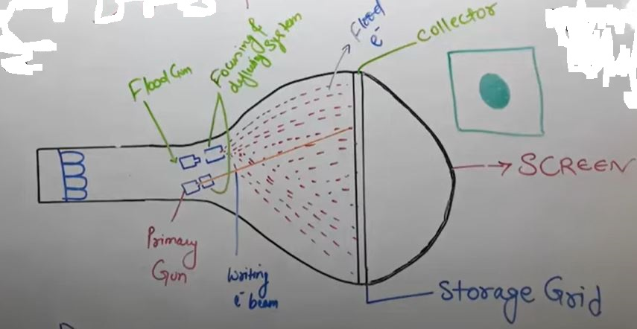
- Flood gun or Secondary gun: It is used to maintain picture display.

Advantage:
- No refreshing is needed.
- High Resolution
- Cost is very less

Disadvantage:
- It is not possible to erase the selected part of a picture.
- It is not suitable for dynamic graphics applications.
- If a part of picture is to modify, then time is consumed.

Flat Panel Display:
The Flat-Panel display refers to a class of video devices that have reduced volume, weight and power requirement compare to CRT.
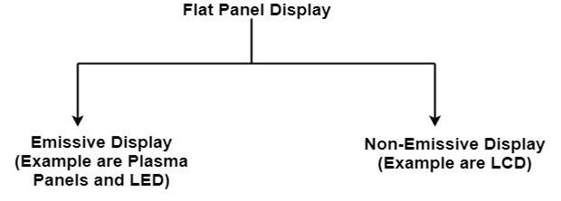
Example: Small T.V. monitor, calculator, pocket video games, laptop computers, an advertisement board in elevator.

1. Emissive Display: The emissive displays are devices that convert electrical energy into light. Examples are Plasma Panel, thin film electroluminescent display and LED (Light Emitting Diodes).
2. Non-Emissive Display: The Non-Emissive displays use optical effects to convert sunlight or light from some other source into graphics patterns. Examples are LCD (Liquid Crystal Device).

Plasma Panel Display:
Plasma-Panels are also called as Gas-Discharge Display. It consists of an array of small lights. Lights are fluorescent in nature. The essential components of the plasma-panel display are:
- Cathode: It consists of fine wires. It delivers negative voltage to gas cells. The voltage is released along with the negative axis.
- Anode: It also consists of line wires. It delivers positive voltage. The voltage is supplied along positive axis.
- Fluorescent cells: It consists of small pockets of gas liquids when the voltage is applied to this liquid (neon gas) it emits light.
- Glass Plates: These plates act as capacitors. The voltage will be applied, the cell will glow continuously.
The gas will slow when there is a significant voltage difference between horizontal and vertical wires. The voltage level is kept between 90 volts to 120 volts. Plasma level does not require refreshing. Erasing is done by reducing the voltage to 90 volts.
Each cell of plasma has two states, so cell is said to be stable. Displayable point in plasma panel is made by the crossing of the horizontal and vertical grid. The resolution of the plasma panel can be up to 512 * 512 pixels.

Advantage:
- High Resolution
- Large screen size is also possible.
- Less Volume
- Less weight
- Flicker Free Display

Disadvantage:
- Poor Resolution
- Wiring requirement anode and the cathode is complex.
- Its addressing is also complex.

LED (Light Emitting Diode):
In an LED, a matrix of diodes is organized to form the pixel positions in the display and picture definition is stored in a refresh buffer. Data is read from the refresh buffer and converted to voltage levels that are applied to the diodes to produce the light pattern in the display.

LCD (Liquid Crystal Display):
Liquid Crystal Displays are the devices that produce a picture by passing polarized light from the surroundings or from an internal light source through a liquid-crystal material that transmits the light.
LCD uses the liquid-crystal material between two glass plates; each plate is the right angle to each other between plates liquid is filled. One glass plate consists of rows of conductors arranged in vertical direction. Another glass plate is consisting of a row of conductors arranged in horizontal direction. The pixel position is determined by the intersection of the vertical & horizontal conductor. This position is an active part of the screen.
Liquid crystal display is temperature dependent. It is between zero to seventy degree Celsius. It is flat and requires very little power to operate.

Advantage:
- Low power consumption.
- Small Size
- Low Cost

Disadvantage:
- LCDs are temperature-dependent (0-70°C)
- LCDs do not emit light; as a result, the image has very little contrast.
- LCDs have no color capability.
- The resolution is not as good as that of a CRT.

Input Devices
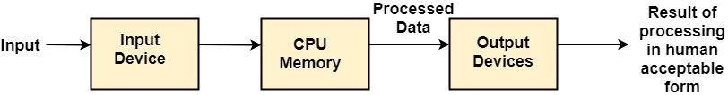
The Input Devices are the hardware that is used to transfer transfers input to the computer. The data can be in the form of text, graphics, sound, and text. Output device display data from the memory of the computer. Output can be text, numeric data, line, polygon, and other objects.

These Devices include:
- Keyboard
- Mouse
- Trackball
- Spaceball
- Joystick
- Light Pen
- Digitizer
- Touch Panels
- Voice Recognition
- Image Scanner

Keyboard:
The most commonly used input device is a keyboard. The data is entered by pressing the set of keys. All keys are labeled. A keyboard with 101 keys is called a QWERTY keyboard.
The keyboard has alphabetic as well as numeric keys. Some special keys are also available.
- Numeric Keys: 0, 1, 2, 3, 4, 5, 6, 7, 8, 9
- Alphabetic keys: a to z (lower case), A to Z (upper case)
- Special Control keys: Ctrl, Shift, Alt
- Special Symbol Keys: ; , " ? @ ~ ? :
- Cursor Control Keys: ↑ → ← ↓
- Function Keys: F1 F2 F3....F9.
- Numeric Keyboard: It is on the right-hand side of the keyboard and used for fast entry of numeric data.

Function of Keyboard:
- Alphanumeric Keyboards are used in CAD. (Computer Aided Drafting)
- Keyboards are available with special features line screen co-ordinates entry, Menu selection or graphics functions, etc.
- Special purpose keyboards are available having buttons, dials, and switches. Dials are used to enter scalar values. Dials also enter real numbers. Buttons and switches are used to enter predefined function values.

Advantage:
- Suitable for entering numeric data.
- Function keys are a fast and effective method of using commands, with fewer errors.

Disadvantage:
- Keyboard is not suitable for graphics input.

Mouse:
A Mouse is a pointing device and used to position the pointer on the screen. It is a small palm size box. There are two or three depression switches on the top. The movement of the mouse along the x-axis helps in the horizontal movement of the cursor and the movement along the y-axis helps in the vertical movement of the cursor on the screen. The mouse cannot be used to enter text. Therefore, they are used in conjunction with a keyboard.

Advantage:
- Easy to use
- Not very expensive

Trackball
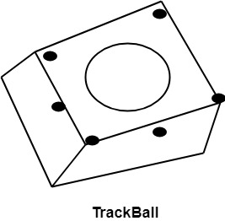
It is a pointing device. It is similar to a mouse. This is mainly used in notebook or laptop computer, instead of a mouse. This is a ball which is half inserted, and by changing fingers on the ball, the pointer can be moved.

Advantage:
- Trackball is stationary, so it does not require much space to use it.
- Compact Size

Spaceball:
It is similar to trackball, but it can move in six directions where trackball can move in two directions only. The movement is recorded by the strain gauge. Strain gauge is applied with pressure. It can be pushed and pulled in various directions. The ball has a diameter around 7.5 cm. The ball is mounted in the base using rollers. One-third of the ball is an inside box, the rest is outside.

Applications:
- It is used for three-dimensional positioning of the object.
- It is used to select various functions in the field of virtual reality.
- It is applicable in CAD applications.
- Animation is also done using spaceball.
- It is used in the area of simulation and modeling.

Joystick:
A Joystick is also a pointing device which is used to change cursor position on a monitor screen. Joystick is a stick having a spherical ball as its both lower and upper ends as shown in fig. The lower spherical ball moves in a socket. The joystick can be changed in all four directions. The function of a joystick is similar to that of the mouse. It is mainly used in Computer Aided Designing (CAD) and playing computer games.
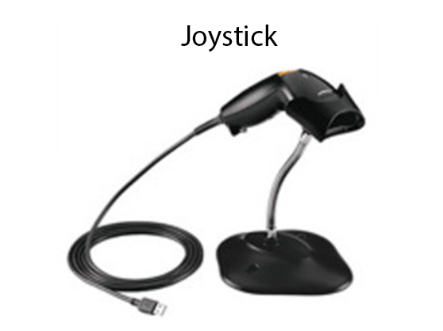

Light Pen
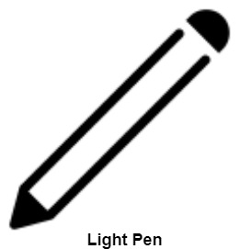
Light Pen (similar to the pen) is a pointing device which is used to select a displayed menu item or draw pictures on the monitor screen. It consists of a photocell and an optical system placed in a small tube. When its tip is moved over the monitor screen, and pen button is pressed, its photocell sensing element detects the screen location and sends the corresponding signals to the CPU.

Uses:
- Light Pens can be used as input coordinate positions by providing necessary arrangements.
- If background color or intensity, a light pen can be used as a locator.
- It is used as a standard pick device with many graphics system.
- It can be used as stroke input devices.
- It can be used as valuators

Digitizers:
The digitizer is an operator input device, which contains a large, smooth board (the appearance is similar to the mechanical drawing board) & an electronic tracking device, which can be changed over the surface to follow existing lines. The electronic tracking device contains a switch for the user to record the desire x & y coordinate positions. The coordinates can be entered into the computer memory or stored or an off-line storage medium such as magnetic tape.
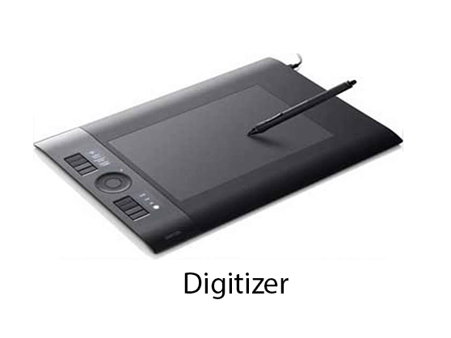

Advantages:
- Drawing can easily be changed.
- It provides the capability of interactive graphics.

Disadvantages:
- Costly
- Suitable only for applications which required high-resolution graphics.

Touch Panels:
Touch Panels is a type of display screen that has a touch-sensitive transparent panel covering the screen. A touch screen registers input when a finger or other object comes in contact with the screen.
When the wave signals are interrupted by some contact with the screen, that located is recorded. Touch screens have long been used in military applications.

Voice Systems (Voice Recognition):
Voice Recognition is one of the newest, most complex input techniques used to interact with the computer. The user inputs data by speaking into a microphone. The simplest form of voice recognition is a one-word command spoken by one person. Each command is isolated with pauses between the words.
Voice Recognition is used in some graphics workstations as input devices to accept voice commands. The voice-system input can be used to initiate graphics operations or to enter data. These systems operate by matching an input against a predefined dictionary of words and phrases.

Advantage:
- More efficient device.
- Easy to use
- Unauthorized speakers can be identified

Disadvantages:
- Very limited vocabulary
- Voice of different operators can't be distinguished.

Output Devices

It is an electromechanical device, which accepts data from a computer and translates them into form understand by users.
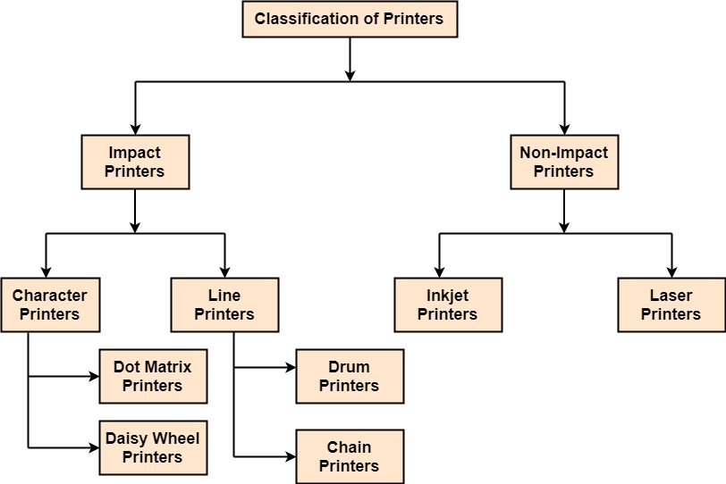

Following are Output Devices:
- Printers
- Plotters

Printers:
Printer is the most important output device, which is used to print data on paper.
Types of Printers: There are many types of printers which are classified on various criteria as shown in fig:
1. Impact Printers: The printers that print the characters by striking against the ribbon and onto the papers are known as Impact Printers.
These Printers are of two types:
- Character Printers
- Line Printers
2. Non-Impact Printers: The printers that print the characters without striking against the ribbon and onto the papers are called Non-Impact Printers. These printers print a complete page at a time, therefore, also known as Page Printers.
Page Printers are of two types:
- Laser Printers
- Inkjet Printers

Dot Matrix Printers:
Dot matrix has printed in the form of dots. A printer has a head which contains nine pins. The nine pins are arranged one below other. Each pin can be activated independently. All or only the same needles are activated at a time. When needless is not activated, and then the tip of needle stay in the head. When pin work, it comes out of the print head. In nine pin printer, pins are arranged in 5 * 7 matrixes.
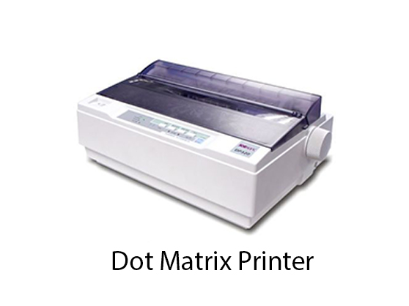
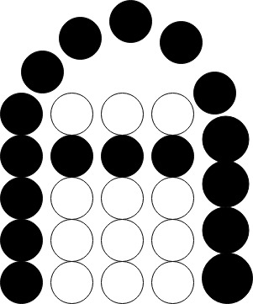

Advantage:
- Dot Matrix Printers prints output as dots, so it can print any shape of the character. This allows the printer to print special character, charts, graphs, etc.
- Dot Matrix Printers come under the category of impact printers. The printing is done when the hammer pin strikes the inked ribbon. The impressions are printed on paper. By placing multiple copies of carbon, multiple copies of output can be produced.
- It is suitable for printing of invoices of companies.

Daisy Wheel Printers:
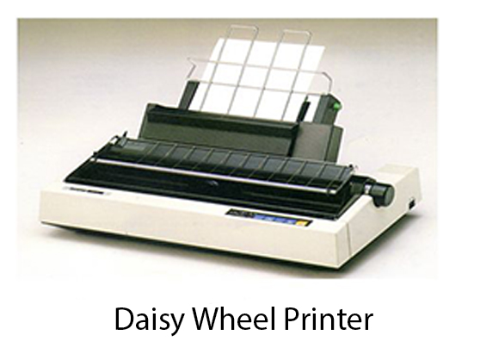
Head is lying on a wheel and Pins corresponding to characters are like petals of Daisy, that's why called Daisy wheel printer.

Advantage:
- More reliable than DMPs
- Better Quality

Disadvantage:
- Slower than DMPs

Drum Printers:
These are line printers, which prints one line at a time. It consists of a drum. The shape of the drum is cylindrical. The drum is solid and has characters embossed on it in the form of vertical bands. The characters are in circular form. Each band consists of some characters. Each line on drum consists of 132 characters. Because there are 96 lines so total characters are (132 * 95) = 12, 672.
Drum contains a number of hammers also.

Chain Printers:
These are called as line printers. These are used to print one line at a line. Basically, chain consists of links. Each link contains one character. Printers can follow any character set style, i.e., 48, 64 or 96 characters. Printer consists of a number of hammers also.

Advantages:
- Chain or Band if damaged can be changed easily.
- It allows printing of different form.
- Different Scripts can be printed using this printer.

Disadvantages:
- It cannot print charts and graphs.
- It cannot print characters of any shape.
- Chain Printers is impact printer, hammer strikes so it is noisy.

Non-Impact Printers:

Inkjet Printers:
These printers use a special link called electrostatic ink. The printer head has a special nozzle. Nozzle drops ink on paper. Head contains up to 64 nozzles. The ink dropped is deflected by the electrostatic plate. The plate is fixed outside the nozzle. The deflected ink settles on paper.
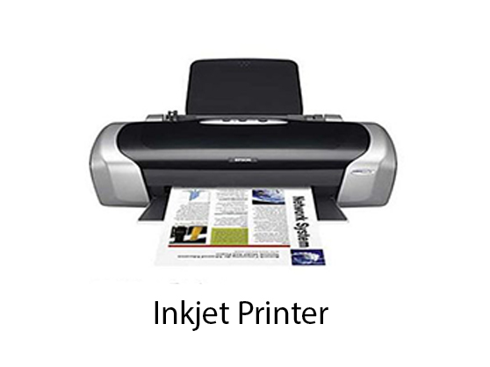

Advantages:
- These produce high quality of output as compared to the dot matrix.
- A high-quality output can be produced using 64 nozzles printed.
- Inkjet can print characters in a variety of shapes.
- Inkjet can print special characters.
- The printer can print graphs and charts.
Disadvantages:
- Inkjet Printers are slower than dot matrix printers.
- The cost of inkjet is more than a dot matrix printer.

Laser Printers:
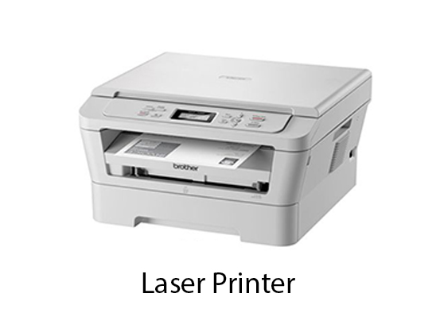
These are non-impact page printers. They use laser lights to produces the dots needed to form the characters to be printed on a page & hence the name laser printers.

The output is generated in the following steps:
Step1: The bits of data sent by processing unit act as triggers to turn the laser beam on & off.
Step2: The output device has a drum which is cleared & is given a positive electric charge. To print a page the modulated laser beam passing from the laser scans back & forth the surface of the drum. The positive electric charge on the drum is stored on just those parts of the drum surface which are exposed to the laser beam create the difference in electric which charges on the exposed drum surface.

Step3: The laser exposed parts of the drum attract an ink powder known as toner.
Step4: The attracted ink powder is transferred to paper.
Step5: The ink particles are permanently fixed to the paper by using either heat or pressure technique.
Step6: The drum rotates back to the cleaner where a rubber blade cleans off the excess ink & prepares the drum to print the next page.

Plotters
Plotters are a special type of output device. It is suitable for applications:
- Architectural plan of the building.
- CAD applications like the design of mechanical components of aircraft.
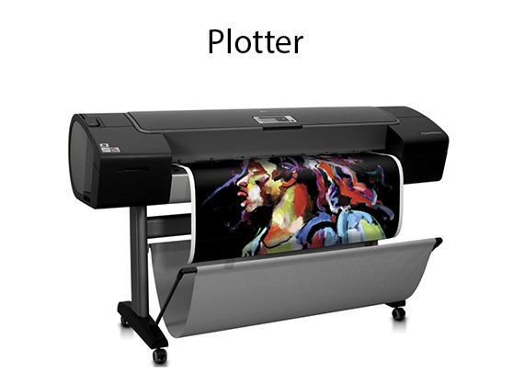
- Many engineering applications.

Advantage:
- It can produce high-quality output on large sheets.
- It is used to provide the high precision drawing.
- It can produce graphics of various sizes.
- The speed of producing output is high.

Drum Plotter:
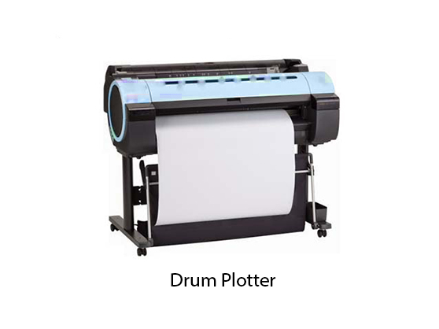
It consists of a drum. Paper on which design is made is kept on the drum. The drum can rotate in both directions. Plotters comprised of one or more pen and penholders. The holders are mounted perpendicular to drum surface. The pens are kept in the holder, which can move left to the right as well as right to the left. The graph plotting program controls the movement of pen and drum.

Flatbed Plotter:
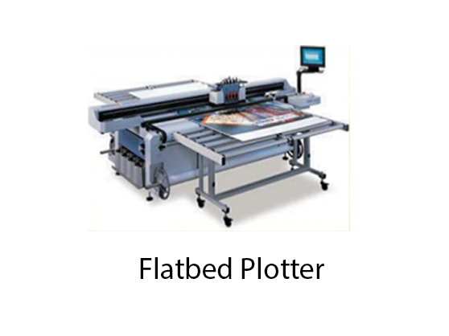
It is used to draw complex design and graphs, charts. The Flatbed plotter can be kept over the table. The plotter consists of pen and holder. The pen can draw characters of various sizes. There can be one or more pens and pen holding mechanism. Each pen has ink of different color. Different colors help to produce multicolor design of document. The area of plotting is also variable. It can vary A4 to 21'*52'.

It is used to draw
- Cars
- Ships
- Airplanes
- Shoe and dress designing
- Road and highway design

Graphics Software:
There are two types of Graphics Software.
1. General Purpose Packages: Basic Functions in a general package include those for generating picture components (straight lines, polygons, circles and other figures), setting color and intensity values, selecting views, and applying transformations.
Example of general purpose package is the GL (Graphics Library), GKS, PHIGS, PHIGS+ etc.
2. Special Purpose Packages: These packages are designed for non programmers, so that these users can use the graphics packages, without knowing the inner details.
Example of special purpose package is
- Painting programs
- Package used for business purpose
- Package used for medical systems.
- CAD packages

Unit-2

Scan Conversion Definition
It is a process of representing graphics objects a collection of pixels. The graphics objects are continuous. The pixels used are discrete. Each pixel can have either on or off state.
The circuitry of the video display device of the computer is capable of converting binary values (0, 1) into a pixel on and pixel off information. 0 is represented by pixel off. 1 is represented using pixel on. Using this ability graphics computer represent picture having discrete dots.
Any model of graphics can be reproduced with a dense matrix of dots or points. Most human beings think graphics objects as points, lines, circles, ellipses. For generating graphical object, many algorithms have been developed.

Advantage of developing algorithms for scan conversion
- Algorithms can generate graphics objects at a faster rate.
- Using algorithms memory can be used efficiently.
- Algorithms can develop a higher level of graphical objects.

Examples of objects which can be scan converted
- Point
- Line
- Sector
- Arc
- Ellipse
- Rectangle
- Polygon
- Characters
- Filled Regions
The process of converting is also called as rasterization. The algorithms implementation varies from one computer system to another computer system. Some algorithms are implemented using the software. Some are performed using hardware or firmware. Some are performed using various combinations of hardware, firmware, and software.

Pixel or Pel:
The term pixel is a short form of the picture element. It is also called a point or dot. It is the smallest picture unit accepted by display devices. A picture is constructed from hundreds of such pixels. Pixels are generated using commands. Lines, circle, arcs, characters; curves are drawn with closely spaced pixels. To display the digit or letter matrix of pixels is used.
The closer the dots or pixels are, the better will be the quality of picture. Closer the dots are, crisper will be the picture. Picture will not appear jagged and unclear if pixels are closely spaced. So the quality of the picture is directly proportional to the density of pixels on the screen.
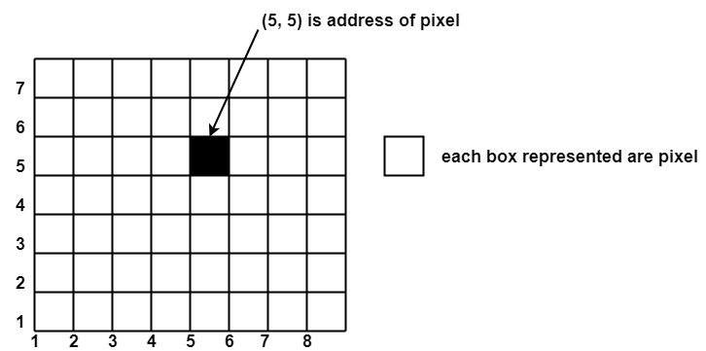
Pixels are also defined as the smallest addressable unit or element of the screen. Each pixel can be assigned an address as shown in fig:

Different graphics objects can be generated by setting the different intensity of pixels and different colors of pixels. Each pixel has some co-ordinate value. The coordinate is represented using row and column.
P (5, 5) used to represent a pixel in the 5th row and the 5th column. Each pixel has some intensity value which is represented in memory of computer called a frame buffer. Frame Buffer is also called a refresh buffer. This memory is a storage area for storing pixels values using which pictures are displayed. It is also called as digital memory. Inside the buffer, image is stored as a pattern of binary digits either 0 or 1. So there is an array of 0 or 1 used to represent the picture. In black and white monitors, black pixels are represented using 1's and white pixels are represented using 0's. In case of systems having one bit per pixel frame buffer is called a bitmap. In systems with multiple bits per pixel it is called a pixmap.

Scan Converting a Point
Each pixel on the graphics display does not represent a mathematical point. Instead, it means a region which theoretically can contain an infinite number of points. Scan-Converting a point involves illuminating the pixel that contains the point.
Example: Display coordinates points as shown in fig would both be represented by pixel (2, 1). In general, a point p (x, y) is represented by the integer part of x & the integer part of y that is pixels [(INT (x), INT (y).
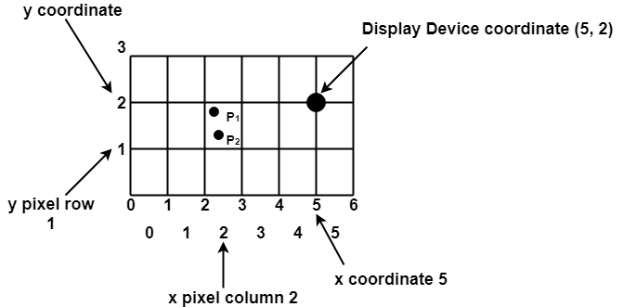

Scan Converting a Straight Line
A straight line may be defined by two endpoints & an equation. In fig the two endpoints are described by (x₁,y₁) and (x₂,y₂). The equation of the line is used to determine the x, y coordinates of all the points that lie between these two endpoints.
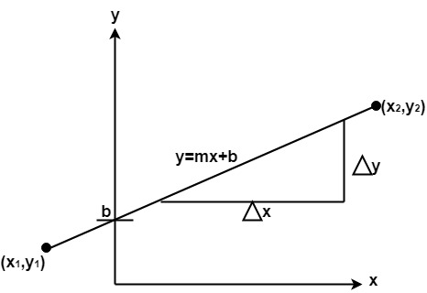
Using the equation of a straight line, y = mx + b where m = & b = the y interrupt, we can find values of y by incrementing x from x =x1, to x = x2. By scan-converting these calculated x, y values, we represent the line as a sequence of pixels.

Properties of Good Line Drawing Algorithm:
1. Line should appear Straight: We must appropriate the line by choosing addressable points close to it. If we choose well, the line will appear straight, if not, we shall produce crossed lines.
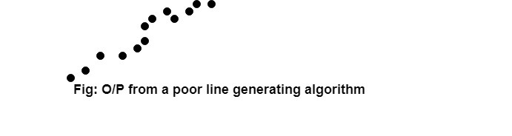
The lines must be generated parallel or at 45° to the x and y-axes. Other lines cause a problem: a line segment through it starts and finishes at addressable points, may happen to pass through no another addressable points in between.
2. Lines should terminate accurately: Unless lines are plotted accurately, they may terminate at the wrong place.
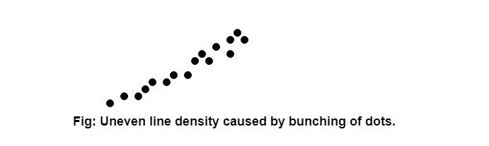
3. Lines should have constant density: Line density is proportional to the no. of dots displayed divided by the length of the line.
To maintain constant density, dots should be equally spaced.
4. Line density should be independent of line length and angle: This can be done by computing an approximating line-length estimate and to use a line-generation algorithm that keeps line density constant to within the accuracy of this estimate.
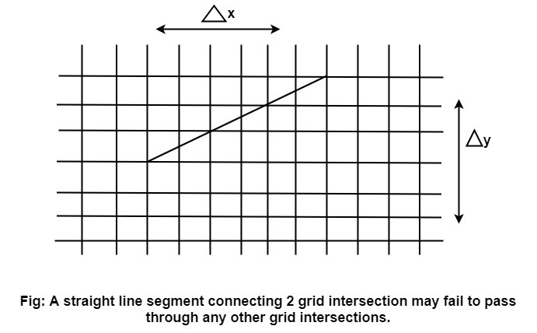
5. Line should be drawn rapidly: This computation should be performed by special-purpose hardware.

Algorithm for line Drawing:
- Direct use of line equation
- DDA (Digital Differential Analyzer)
- Bresenham's Algorithm

