Python programming lab practical questions with Solutions (SEM -1)
- Write a Python program to check whether a number is even or odd.


num = int(input("Enter a number: "))

if num % 2 == 0:

print("Even")

else:

print("Odd")

OUTPUT:
Enter a number: 7 Odd
Enter a number: 12 Even

- Write a Python program to check whether a number is positive, negative, or zero.


num = int(input("Enter a number: "))

if num > 0:

print("Positive")

elif num < 0:

print("Negative")

else:

print("Zero")

OUTPUT:
Enter a number: -5
Negative
Enter a number: 10
Positive
Enter a number: 0
Zero
3.Write a Python program to find the largest of three numbers entered by the user.


a = int(input("Enter first number: "))

b = int(input("Enter second number: "))

c = int(input("Enter third number: "))

if a >= b and a >= c:

print("Largest:", a)

elif b >= a and b >= c:

print("Largest:", b)

else:

print("Largest:", c)

OUTPUT:
Enter first number: 15
Enter second number: 25
Enter third number: 10
Largest: 25

4. Write a Python program to check whether a given

year is a leap year or not.

year = int(input("Enter a year: "))

if (year % 400 == 0) or (year % 100 != 0 and year %
4

== 0):

print("Leap Year")

else:

print("Not a Leap Year")

OUTPUT:
Enter a year: 2024
Leap Year
Enter a year: 1900
Not a Leap Year
Enter a year: 2000
Leap Year

5.Write a Python program to calculate the sum of digits of a given number.

num = int(input("Enter a number: "))

total = 0

while num > 0:

digit = num % 10

total += digit

num //= 10

print("Sum of digits:", total)

OUTPUT:
Enter a number: 123
Sum of digits: 6
Enter a number: 4567
Sum of digits: 22

6. Write a Python program to check whether a given

number is a palindrome.

num = int(input("Enter a number: "))

temp = num

rev = 0

while num > 0:

digit = num % 10

rev = rev * 10 + digit

num //= 10

if temp == rev:

print("Palindrome")

else:

print("Not Palindrome")

OUTPUT:
Enter a number: 121
Palindrome
Enter a number: 123
Not Palindrome

7.Write a Python program to generate the Fibonacci sequence up to n terms.


n = int(input("Enter number of terms: "))

a, b = 0, 1

for _ in range(n):

print(a, end=" ")

a, b = b, a + b

OUTPUT:
Enter number of terms: 5
0 1 1 2 3
Enter number of terms: 8
0 1 1 2 3 5 8 13

- Write a Python program to print the multiplication table of a number using a loop.
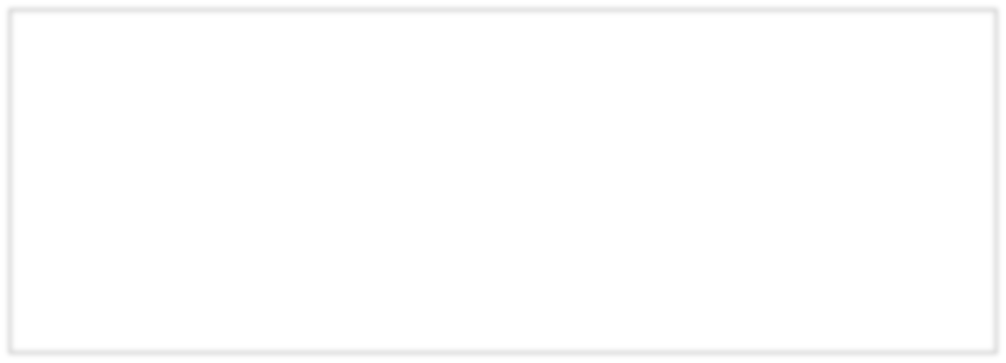

num = int(input("Enter a number: "))

for i in range(1, 11):

print(num, "x", i, "=", num * i)

OUTPUT:
Enter a number: 5
5 x 1 = 5
5 x 2 = 10
5 x 3 = 15
5 x 4 = 20
5 x 5 = 25
5 x 6 = 30
5 x 7 = 35
5 x 8 = 40
5 x 9 = 45
5 x 10 = 50

- Write a Python program to display numbers from 1 to 10 but skip the number 5 using the continue statement.

fo
r i in range(1, 11):

if i == 5:

continue

print(i)

OUTPUT:
1 2 3 4 6 7 8 9 10

- Write a Python program to print numbers from 1
to 20, but stop printing if the number becomes greater than 12 using the break statement.



for i in range(1, 21):

if i > 12:

break

print(i)

OUTPUT:
1 2 3 4 5 6 7 8 9 10 11 12
- Write a Python program that takes a string from the user and counts the number of vowels.


text = input("Enter a string: ").lower()

vowels = "aeiou"

count = 0

for ch in text:

if ch in vowels:

count += 1

print("Number of
vowels:", count)

OUTPUT:
Enter a string: Hello World
Number of vowels: 3
Enter a string: Programming
Number of vowels: 3

- Write a Python function to calculate the factorial of a number using recursion.


def factorial(n):

if n == 0 or n == 1:

return 1

return n * factorial(n
-

1)

num = int(input("Enter a number: "))

print("Factorial:",
factorial(num))

OUTPUT:
Enter a number: 5
Factorial: 120
Enter a number: 0
Factorial: 1

- Write a Python function that checks whether a number is prime or not.


def is_prime(n):

if n <= 1:

return False

for i in range(2, int(n**0.5) + 1):

if n % i == 0:

return False

return True


num = in
t(input("Enter a number: "))

if is_prime(num):

print("Prime")

else:

print("Not Prime")

OUTPUT:
Enter a number: 7
Prime
Enter a number: 10
Not Prime

- Write a Python function that takes a list of numbers as input and returns the sum of all numbers.

def sum_list(numbers):

return sum(numbers)

nums

=
[int(x) for x in input("Enter numbers separated
by space: ").split()]

print("Sum:", sum_list(nums))

OUTPUT:
Enter numbers separated by space: 1 2 3 4 5
Sum: 15

- Write a Python program to find the largest element in a list using the built-in max() function.


nums = [int(x) for x in input("Enter numbers separated

by space: ").split()]

print("Largest element:", max(nums))

OUTPUT:
Enter numbers separated by space: 3 7 2 9 1
Largest element: 9

- Write a Python program to check whether a string entered by the user is a palindrome using a user-

defined function.

def is_palindrome(s):

return s == s[::
-
1]

text = input("Enter a string: "
)

if is_palindrome(text):

print("Palindrome")

else:

print("Not Palindrome")

OUTPUT:
Enter a string: madam
Palindrome
Enter a string: hello
Not Palindrome

Q17. Design, Develop and Implement a menu driven Program in Python to perform the following tasks: a. Read three numbers and print largest of it
- Read a number and print sum of its digits
- Read a number and print reverse of it (without using built-in function)
Support the program with appropriate functions for each of the above tasks.


# Function to find largest of three numbers

def find_largest(a, b, c):

if a >= b

and a >= c:

return a

elif b >= a and b >= c:

return b

else:

return c

# Function to find sum of digits of a number def sum_of_digits(num): total = 0 while num > 0:
digit = num % 10 total = total + digit num = num // 10 return total

# Function to reverse a number def reverse_number(num): rev = 0 while num > 0:
digit = num % 10 rev = rev * 10 + digit num = num // 10
return rev

# Main Program with Menu while True: print("\n--- MENU ---")
print("1. Find Largest of Three Numbers") print("2. Sum of Digits of a Number") print("3. Reverse a Number") print("4. Exit")

choice = int(input("Enter your choice: "))

if choice == 1:

x = int(input("Enter first number: ")) y = int(input("Enter second number: ")) z = int(input("Enter third number: ")) print("Largest number is:", find_largest(x, y, z))

elif choice == 2:
n = int(input("Enter a number: "))
print("Sum of digits:", sum_of_digits(n))

elif choice == 3:

n = int(input("Enter a number: ")) print("Reverse of number:",
reverse_number(n))

elif choice == 4: print("Exiting program...")
break
else:
print("Invalid choice! Please try again.")
--- MENU ---
1. Find Largest of Three Numbers
2. Sum of Digits of a Number
3. Reverse a Number
4. Exit
Enter your choice: 1
Enter first number: 10
Enter second number: 25
Enter third number: 15
Largest number is: 25

--- MENU ---
1. Find Largest of Three Numbers
2. Sum of Digits of a Number
3. Reverse a Number
4. Exit
Enter your choice: 2
Enter a number: 123
Sum of digits: 6

--- MENU ---
1. Find Largest of Three Numbers
2. Sum of Digits of a Number
3. Reverse a Number
4. Exit
Enter your choice: 3
Enter a number: 456
Reverse of number: 654

--- MENU ---
1. Find Largest of Three Numbers
2. Sum of Digits of a Number
3. Reverse a Number
4. Exit
Enter your choice: 4
Exiting program...

Q18.A university portal allows students to check their CGPA. The system takes total marks and total credits as input.
- If the user enters text instead of numbers, the program should handle it.
- If credits entered are 0, handle division by zero. Finally, display the CGPA rounded to 2 decimals.

try:
total_marks = float(input("Enter total marks: ")) total_credits = float(input("Enter total credits: "))


if total_credits == 0: print("Error: Credits cannot be zero.") else:
cgpa = total_marks / total_credits
print("Your CGPA is:", round(cgpa, 2))

except ValueError: print("Error: Please enter numbers only.")

OUTPUT:
Enter total marks: 450
Enter total credits: 60
Your CGPA is: 7.5
Enter total marks: abc
Error: Please enter numbers only.
Enter total marks: 300
Enter total credits: 0
Error: Credits cannot be zero.
Q19. Design a custom Python module named math_utils that contains the following functions:
- is_prime(n): Check if a number is prime.
- factorial(n): Compute the factorial of a number using recursion.
- convert_to_binary(n): Convert a number into its binary representation.

Then, in your main program:
- Take a number as input from the user.
- Use functions from your module to check if the number is prime, find its factorial, and display its binary representation.
Also, handle exceptions if the user enters invalid (non-integer or negative) values.


# Function to check if a number is prime

def is_prime(n):

if n <= 1:

return False

for i in range(2, int(n**0.5) + 1):

if n % i == 0:

return False

return True

# Function to calculate factorial using recursion

d
ef factorial(n):

if n == 0 or n == 1:

return 1

else:

return n * factorial(n
-

1)

# Function to convert a number into binary

def convert_to_binary(n):

if n == 0:

return "0"


binary = "" while n > 0: binary = str(n % 2) + binary n = n // 2 return binary

# Main Program try: num = int(input("Enter a positive integer: "))

if num < 0:
print("Error: Number must be non-negative.") else:
print("Is Prime:", is_prime(num)) print("Factorial:", factorial(num)) print("Binary Representation:", convert_to_binary(num))

except ValueError: print("Error: Please enter a valid integer.")

OUTPUT:

Enter a positive integer: 7
Is Prime: True
Factorial: 5040
Binary Representation: 111

Enter a positive integer: 10
Is Prime: False
Factorial: 3628800
Binary Representation: 1010

Q20.A restaurant billing system displays a menu with items and prices. Develop a program that should: I. Show food items with prices.
- Take the user’s order (multiple items).
- Calculate the total bill.
- Apply a 10% discount if the bill is above ₹500. V. Exit option to close billing.
- Use functions for add_to_order, calculate_total, apply_discount.
- Use match-case for menu selection.
Handle invalid inputs using exceptions.


menu = {

1
:

(
"Pizza"
,
200
)
,

2
:

(
"Burger"
,
120
)
,

3
:

(
"Pasta"
,
150
)
,

4
:

(
"Sandwich"
,
100
)
,

5
:

(
"Cold Drink"
,
50
)

}

order_list = []

def

add_to_order(choice):

if

choice
in

menu:

order_list.append(menu[choice])

print(menu[choice][
0
]
,
"added."
)



else
:

print(
"Wrong choice!"
)

def

calculate_total():

total =
0

for

item
in

order_list:

total = total + item[
1
]

return

total

def

apply_discount(amount):

if

amount >
500
:

return

amount
-

(
amount *
0.1
)

else
:

return

amount

while

True
:

print(
"
\
n
---

MENU
---
"
)

for

key
in

menu:

print(key,
menu[key][
0
]
,
"
-

₹
"
, menu[key][
1
])

print(
"6. Show Bill and Exit"
)

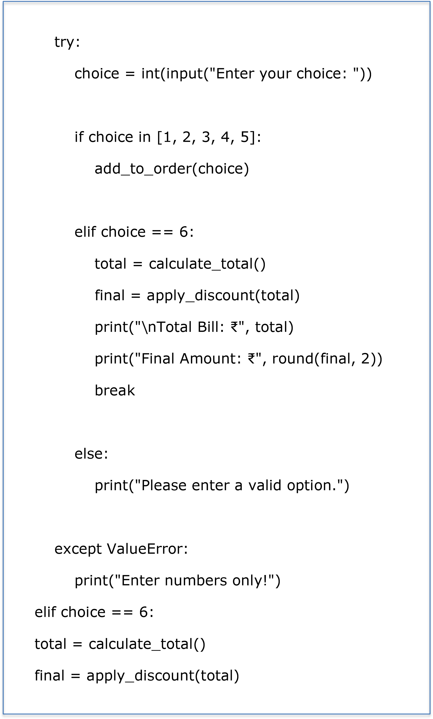

print(
"
\
nTotal Bill:
₹
"
, total)

print(
"Final Amount:
₹
"
, round(final,
2
))

break

else
:

print(
"Please enter a valid option."
)

except

ValueError:

print(
"Enter numbers only!"
)

OUTPUT:
--- MENU ---
1 Pizza - ₹ 200
2 Burger - ₹ 120
3 Pasta - ₹ 150
4 Sandwich - ₹ 100
5 Cold Drink - ₹ 50
6. Show Bill and Exit
Enter your choice: 1
Pizza added.
--- MENU ---
1 Pizza - ₹ 200
2 Burger - ₹ 120
3 Pasta - ₹ 150
4 Sandwich - ₹ 100
5 Cold Drink - ₹ 50
6. Show Bill and Exit
Enter your choice: 2
Burger added.
--- MENU ---
1 Pizza - ₹ 200
2 Burger - ₹ 120
3 Pasta - ₹ 150
4 Sandwich - ₹ 100
5 Cold Drink - ₹ 50
6. Show Bill and Exit
Enter your choice: 6

Total Bill: ₹ 320
Final Amount: ₹ 320

Q21.Write a Python program to read a text file and count the frequency of each word in it. Display the words along with their frequencies in sorted order.

filename = input("Enter file name: ") with open(filename, 'r') as f: text = f.read().lower()
words = text.split()

clean_words = [''.join(ch for ch in w if ch.isalnum(
))
for w in
words if w.strip()]

freq = {}

for w in clean_words:

if w:

f
req[w] = freq.get(w, 0) + 1

for w in sorted(freq):

print(w, ":", freq[w])

OUTPUT:
hello : 2
world : 1
python : 3
programming : 1

Q22.Write a Python program to remove duplicate elements from a list, sort the list, and then display both the original and the updated lists.


lst = [5, 3, 8, 3, 2, 5, 1]

print("Origin
al list:", lst)

unique_list = list(set(lst))

unique_list.sort()

print("Updated list:", unique_list)

OUTPUT:
Original list: [5, 3, 8, 3, 2, 5, 1]
Updated list: [1, 2, 3, 5, 8]

Q23.Write a Python program to read student names and marks from a text file and display the names of students who have scored more than 75 marks.


filename = inp
ut("Enter file name: ")

with open(filename, 'r') as f:

for line in f:

name, marks = line.split()

if int(marks) > 75:

print(name)

OUTPUT:
Riya
Neha
Sita

Q24.Write a Python program to count the occurrence of each character in a string and display the most frequent character.

s = input("Enter a string: ")

freq = {}

for ch in s:

freq[ch] = freq.get(ch, 0) + 1

print(
"Character frequencies:", f
req)

most_frequent = max(freq, key=freq.get)

print("Most frequent character:", most_frequent)

OUTPUT: Enter a string: programming Character frequencies: {'p': 1, 'r': 2, 'o': 1, 'g': 2, 'a': 1, 'm': 2, 'i': 1, 'n': 1} Most frequent character: r
Q25.Write a Python program to extract all valid email addresses from a given text using regular expressions and store them in a dictionary.


import re

text = input("Enter text: ")

emails = re.findall(r'
\
b[A
-
Za
-
z0
-
9
._%
+
-
]+
@[A
-
Za
-
z0
-
9.
-
]+
\
.[
A
-
Za
-
z]{2,}
\
b', text)

email_dict = {}

for i, email in enumerate(emails, start=1):

email_dict[i] = email

print(
"Extracted Emails:", email_dict)

OUTPUT:
Enter text: Contact us at info@example.com or support@company.org
Extracted Emails: {1: 'info@example.com', 2: 'support@company.org'}

Q26.Design, Develop and Implement a menu driven
Program in Python for the following operations on File
- Read
- Write
- Append
- Delete
- Exit
import os
filename = "data.txt"

while True:

print("\nFile Operations Menu") print("1. Read") print("2. Write") print("3. Append") print("4. Delete")
print("5. Exit")

choice = input("Enter your choice (1-5): ")

if choice == '1':
if os.path.exists(filename): with open(filename, 'r') as f: print("\nFile Content:\n")
print(f.read()) else:
print("File does not exist.")

elif choice == '2':
text = input("Enter text to write: ") with open(filename, 'w') as f: f.write(text)
print("File written successfully.")

elif choice == '3': text = input("Enter text to append: ") with open(filename, 'a') as f: f.write("\n" + text)
print("Text appended successfully.")

elif choice == '4':

if os.path.exists(filename): os.remove(filename) print("File deleted successfully.") else: print("File not found.")

elif choice == '5':
print("Exiting program...")
break
else:
print("Invalid choice. Please enter a number between 1 and 5.")

OUTPUT:
File Operations Menu
1. Read
2. Write
3. Append
4. Delete
5. Exit
Enter your choice (1-5): 2
Enter text to write: Hello World
File written successfully.
File Operations Menu
1. Read
2. Write
3. Append
4. Delete
5. Exit
Enter your choice (1-5): 1
File Content:
Hello World
File Operations Menu
1. Read
2. Write
3. Append
4. Delete
5. Exit
Enter your choice (1-5): 3
Enter text to append: This is appended text
Text appended successfully.

File Operations Menu
1. Read
2. Write
3. Append
4. Delete
5. Exit
Enter your choice (1-5): 5
Exiting program...

Q27.Create a class Student with attributes like name, roll number, and marks. Define methods to assign and display the details of students.
class Student: def __init__(self): self.name = "" self.roll_no = 0
self.marks = 0.0

def assign_details(self):
self.name = input("Enter name: ") self.roll_no = int(input("Enter roll number: ")) self.marks = float(input("Enter marks: "))


def display_details(self): print("\nStudent Details") print("Name:", self.name) print("Roll Number:", self.roll_no)
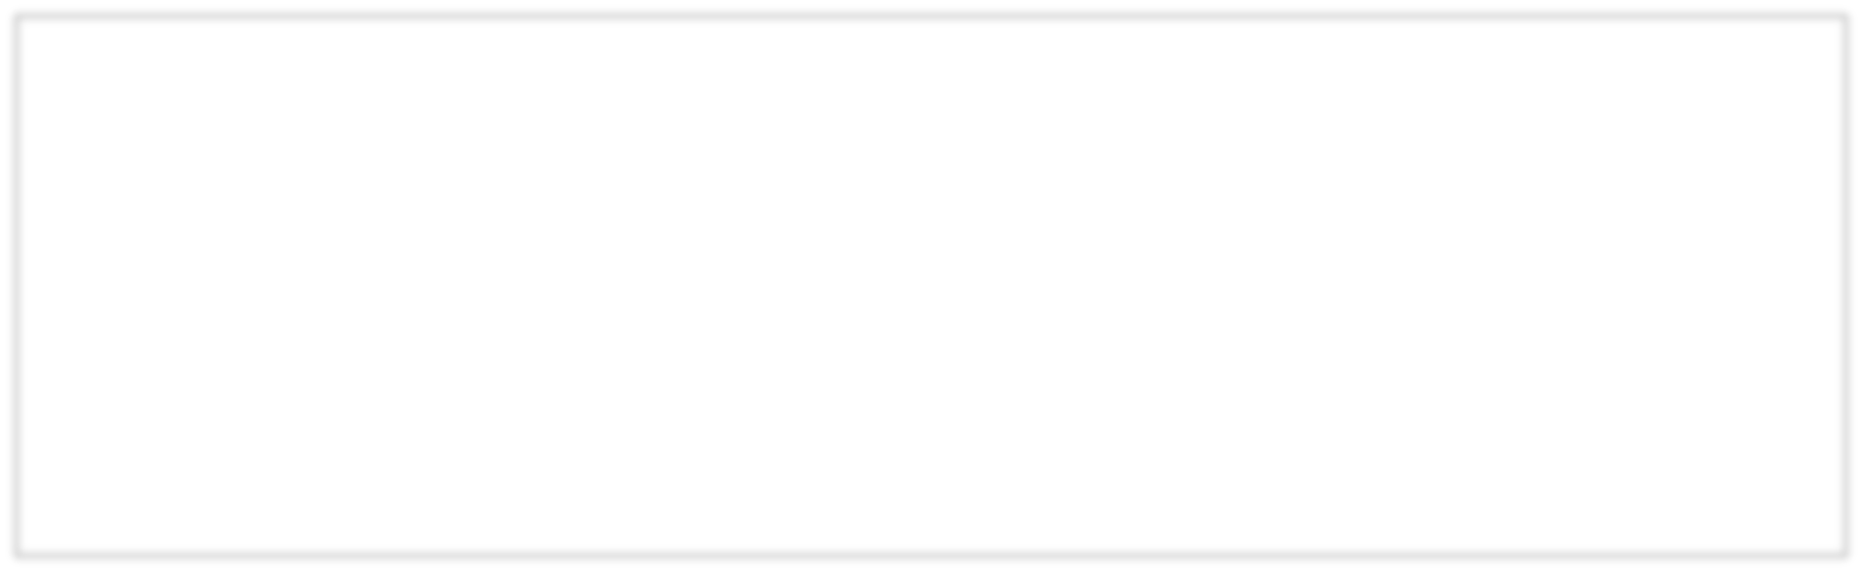

print("Marks:", self.marks)

s1 = Student()

s1.assign_details()

s1.display_details()

OUTPUT:
Enter name: Rohan
Enter roll number: 101
Enter marks: 85.5
Student Details
Name: Rohan
Roll Number: 101
Marks: 85.5
Q28.Write a Python program to demonstrate inheritance using a base class Person and a derived class Employee, where the derived class includes additional attributes.

class Person: def __init__(self, name, age): self.name = name
self.age = age

def display(self): print("Name:", self.name)
print("Age:", self.age)

class Employee(Person):

def __init__(self, name, age, emp_id, salary): super().__init__(name, age) self.emp_id = emp_id
self.salary = salary

def show(self): self.display()
print("Employee ID:", self.emp_id) print("Salary:", self.salary)

e1 = Employee("Riya", 25, "E101", 45000) e1.show()

OUTPUT:
Name: Riya
Age: 25
Employee ID: E101
Salary: 45000


Q29.Write a Python program to demonstrate polymorphism by creating a base class Shape and derived classes Circle and Square, each having its own area() method.
class Shape:

def area(self):

pass

class Circle(Shape):

def __init__(self, radius):

self.radius = radius

def area(self):

return 3.14 * self.radius * self.radius

class Square(Shape):

def __init__(self, side):

self.side = side

def area(self):

return self.side * self.side

shapes = [Circle(5), Square(4)]

for s in shapes:

print("Area:", s.a
rea())

OUTPUT:
Area: 78.5
Area: 16

Q30.Write a Python program to implement encapsulation using private data members and methods in a BankAccount class. Include deposit and balance checking functionalities.


class BankAccount: def __init__(self, account_number, balance): self.__account_number = account_number self.__balance = balance

def deposit(self, amount):
if amount > 0: self.__balance += amount print("Amount deposited:", amount) else:
print("Invalid deposit amount.")

def __show_balance(self) : print("Current Balance:", self.__balance)

def check_balance(self): self.__show_balance()

acc = BankAccount("A101", 5000) acc.deposit(1500)
acc.check_balance()

OUTPUT:
Amount deposited: 1500
Current Balance: 6500

Q31.Write a Python program to demonstrate multiple inheritance using classes Teacher, Researcher, and Professor, where Professor inherits from both. 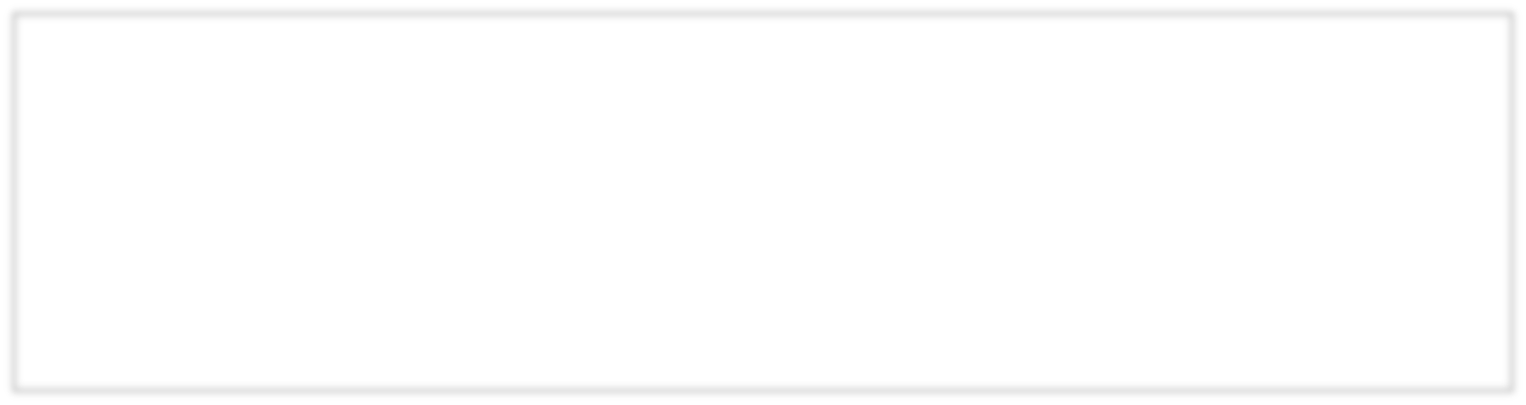class Teacher:

def teaching(self):

print("Teaches students.")


class Researcher:

def researching
(
self
):

print("Conducts research work.")

class Professor(Teacher, Researcher):

def guiding(self):

print("Guides students in projects and research.")

p = Professor()

p.teaching()

p.researching()

p.guiding()

OUTPUT:
Teaches students.
Conducts research work.
Guides students in projects and research.

Q32.Define an abstract base class DeliveryService with abstract methods calculate_charges(weight) and track_package(id).
Create two subclasses DHL and FedEx implementing these methods. Demonstrate abstraction by calling methods using base class reference.


from abc import ABC, abstra
ctmethod

class DeliveryService(ABC):

@abstractmethod

def calculate_charges(self, weight):

pass

@abstractmethod

def track_package(self, id):

pass

class DHL(DeliveryService):

def calculate_charges(self, weight):

return weight * 50

def track_package(self, id):
print("DHL Package ID", id, "is in transit.")

class FedEx(DeliveryService):
def calculate_charges(self, weight):
return weight * 60

def track_package(self, id): print("FedEx Package ID", id, "is delivered.")

service: DeliveryService

service = DHL()
print("DHL Charges:", service.calculate_charges(5)) service.track_package("D101")

service = FedEx()

print("FedEx Charges:", service.calculate_charges(5)) service.track_package("F202")

OUTPUT:
DHL Charges: 250
DHL Package ID D101 is in transit.
FedEx Charges: 300
FedEx Package ID F202 is delivered.

Q33.Write a Python program using NumPy to perform matrix addition and matrix multiplication on two 2×2 matrices.

import numpy as np

A = np.array([[1, 2],
[3
,
4]])

B = np.array([[5, 6],

[7
,
8]])

print("
Matrix A:
\
n", A)

print("Matrix B:
\
n", B)

add = A + B

print("
\
nMatrix Addition:
\
n", add)

mul = A.dot(B)

print("
\
nMatrix Multiplication:
\
n", mul)

Matrix A: Matrix Multiplication:
[[19 22]
[[1 2] [43 50]]
[3 4]]
Matrix B:
[[5 6]
[7 8]]

Matrix Addition:
[[ 6 8]
[10 12]]
Q34.Write a Python program using NumPy to calculate the mean, median, and standard deviation of an array

of numbers
.

import numpy as np

data = np.array([10, 20, 30, 40, 50])

print("Array Elements:", data)

mean = np.mean(data)

median = np.median(data)

std_dev = np.std(data)

print("Mean:", mean)

print("Median:", median)

print("Standard Deviation:", std_dev)

Array Elements: [10 20 30 40 50]
Mean: 30.0
Median: 30.0
Standard Deviation: 14.142135623730951
Q35.Write a Python program using Pandas to create a DataFrame containing student details (name, marks, and age) and display descriptive statistics of the data.


data = {

'Name': ['Riya', 'Amit', 'Neha', 'Rohan', 'Sita'],

'Marks': [85, 76, 90, 68, 80],

'Age': [20, 21, 19, 22, 20]

}

df = pd.DataFrame(data)

print("Student DataFrame:
\
n", df)

print("
\
nDescriptive Statisti
cs:
\
n", df.describe())

OUTPUT:
Student Data Frame:
Name Marks Age
0 Riya 85 20
1 Amit 76 21
2 Neha 90 19
3 Rohan 68 22
4 Sita 80 20

Descriptive Statistics:
Marks Age
count 5.000000 5.000000
mean 79.800000 20.400000
std 8.732125 1.140175
min 68.000000 19.000000
25% 76.000000 20.000000
50% 80.000000 20.000000
75% 85.000000 21.000000
max 90.000000 22.000000

Q36.Write a Python program using Matplotlib to plot a line graph showing the marks of students in a subject. Label the axes and give an appropriate title. 

# Data

students = ['Riya', 'Amit', 'Neha', 'Rohan', 'Sita']

marks = [85, 76, 90, 68, 80]

# Plot the line graph

plt.plot(students, marks, marker='o'
, linestyle='
-
', color='b')

# Add labels and title

plt.xlabel('Students')

plt.ylabel('Marks')

plt.title('Marks of Students i
n a Subject')

# Display the graph

plt.show()

OUTPUT:
(A line graph showing marks of students with points connected by lines)

Q37.Write a Python program using Seaborn to create a boxplot representing marks of students across different subjects.
import seaborn as sns import pandas as pd import matplotlib.pyplot as plt

# Create DataFrame data = {
'Student': ['Riya', 'Amit', 'Neha', 'Rohan', 'Sita'] * 3,
'Subject': ['Math', 'Science', 'English'] * 5,

'Marks': [85, 78, 92, 74, 88, 81, 69, 95, 72, 90, 88, 76, 84, 91, 79]}

df = pd.DataFrame(data)

# Create a boxplot

sns.boxplot(x='Subject', y='Marks', data=df)

# Add labels and title

plt.xlabel('Subjects')

plt.ylabel('Marks')

plt.title('Marks of Stu
dents Across Different Subjects')

# Display the plot

plt.show()

OUTPUT:
(A boxplot showing distribution of marks across different subjects)

Q38.A health dataset contains columns: Age, Cholesterol_Level, and Heart_Disease (Yes/No).
Plot the following:
- A histogram of cholesterol levels.
- A scatter plot of Age vs. Cholesterol, with color indicating heart disease presence.
- A box plot of cholesterol levels grouped by heart disease.

import seaborn as sns import pandas as pd import matplotlib.pyplot as plt

# Create a sample dataset data = {
'Age': [25, 32, 40, 45, 50, 55, 60, 65, 70, 75],

'Cholesterol_Level': [180, 190, 210, 230, 250, 270, 260, 300, 280, 310],
'Heart_Disease': ['No', 'No', 'Yes', 'Yes', 'Yes', 'Yes', 'No', 'Yes', 'No', 'Yes']}
df = pd.DataFrame(data)

# (a) Histogram of cholesterol levels plt.figure(figsize=(6, 4))
sns.histplot(df['Cholesterol_Level'], bins=8, kde=True, color='skyblue')
plt.title('Histogram of Cholesterol Levels') plt.xlabel('Cholesterol Level') plt.ylabel('Frequency') plt.show()

# (b) Scatter plot of Age vs Cholesterol with color by Heart
Disease
plt.figure(figsize=(6, 4))

sns.scatterplot(x='Age', y='Cholesterol_Level', hue='Heart_Disease', data=df, palette='coolwarm', s=80) plt.title('Age vs Cholesterol Level') plt.xlabel('Age') plt.ylabel('Cholesterol Level') plt.show()

# (c) Box plot of cholesterol levels grouped by heart disease plt.figure(figsize=(6, 4))
sns.boxplot(x='Heart_Disease', y='Cholesterol_Level', data=df, palette='Set2')
plt.title('Cholesterol Levels by Heart Disease') plt.xlabel('Heart Disease') plt.ylabel('Cholesterol Level') plt.show()

OUTPUT:
(Three plots: histogram, scatter plot, and boxplot showing cholesterol data analysis)

