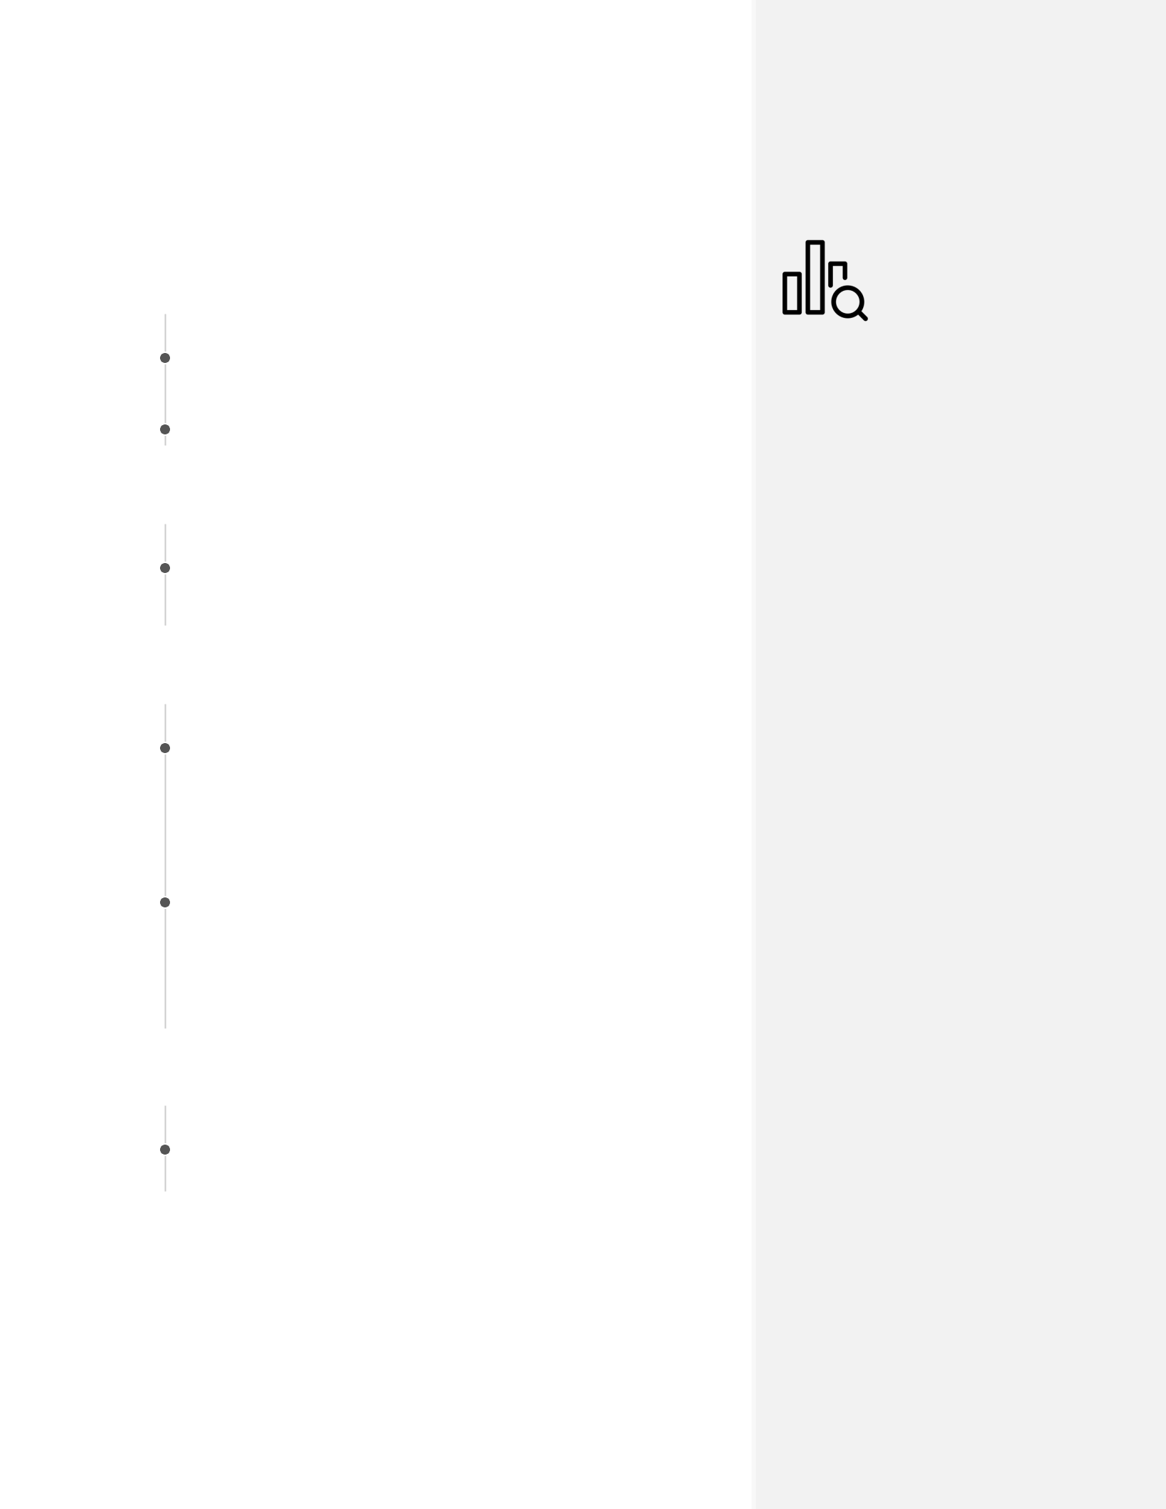

NOTA REALPERSON

**Data analysis and visualization expert seeking Spring 2020 internship**

EDUCATION

|  |  |  |
| --- | --- | --- |
| 2014– | **Tufts University** |  |
| Current | MS Candidate in Data Analysis | Medford, MA |
| 2008– | **Undergraduate University** |  |
| 2012 | B.A. in Finance | Troy, NY |

RESEARCH EXPERIENCE

|  |  |  |
| --- | --- | --- |
| 2014– | **Graduate Research Assistant** |  |
| 2019 | Tufts University | Medford, MA |

* + Developed research questions
  + Provided additional guidance for undergraduate mentors

SELECTED PROJECT EXPERIENCE

|  |  |  |
| --- | --- | --- |
| 2016– | **DATA-200 Foundations of Data Analyics** |  |
| 2018 | Tufts University | Medford, MA |

* Deployed a project which predicted likelihood of house purchase with 89% accuracy on data from Boston in 2019.
* Iterated the model to select the best approach, given neural net, random forest and logistic regression.

|  |  |  |
| --- | --- | --- |
| 2015 – | **Other project** |  |
| 2018 | Tufts University | Medford, MA |

* + Evaluated
  + Deployed
  + Managed
  + Use your action verbs! Attend the Crafting Your Data Science Resume workshop by Kyle Monahan

SELECTED PRESENTATIONS

|  |  |
| --- | --- |
| March | **DATA-200 Final Project** |
| 2019 | Presented a model for housing price detection, and summarized |
|  | main results and assumptions of the model to my cohort. |
|  | Medford, MA |

CONTACT INFO

[NotaRealperson@gmail.com](mailto:NotaRealperson@gmail.com) [github.com/kylemonahan/](https://github.com/kylemonahan/) +1 123-456-7891

SKILLS

List your **key skills**, linked to the job description.

Performing **data analysis**, with a focus on financial models

Experienced in **data communication** and clientrelations

Wrote production-level **R/Python/Stata/SQL**

**Machine Learning** on cloud platforms (AWS)

*Last updated on 2020-11-18.*