Jan 2020 -

Mar 2020

2020 -

2021

2018 -

2020

2013 -

2016

Mar 2021

Jul 2020

Jun 2020

May 2020

Apr 2020

Apr 2020

Feb 2020

Jun 2019

Jun 2019

Jan 2019

Feb 2017

**ABHIJEET JAIN**

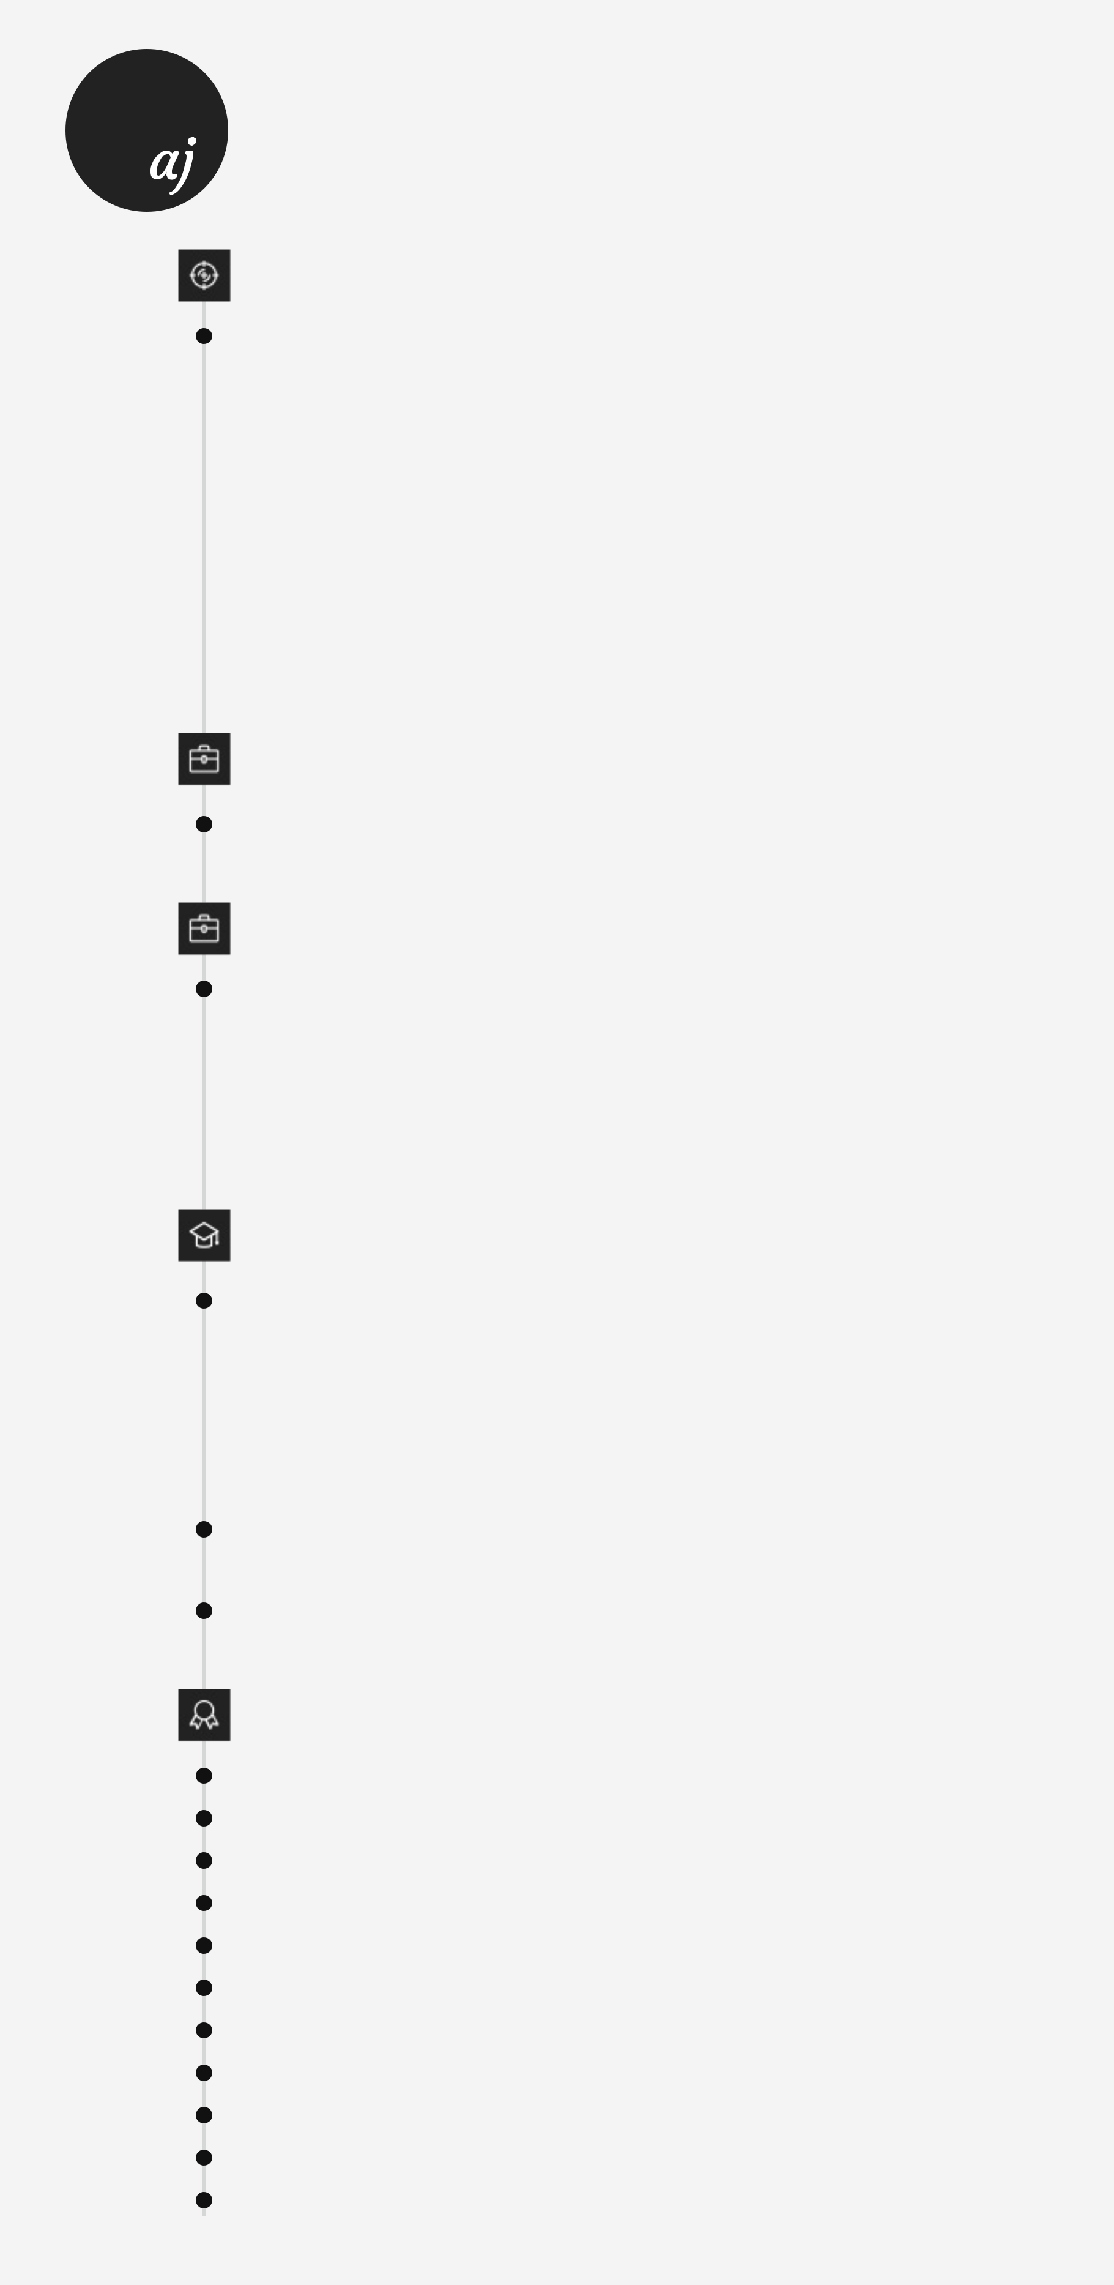

Web Development | Data Science | Finance

**Summary**

**Career Objective :** Have gained good exposure to understand various aspects of **Data Science** through the Masters Program which has developed a great sense of confidence at a very personal level. Hence, I seek a challenging position in the area of **Data Analytics, Data** **Science, Business Analysis & related fields** where I can share my skills & expand my capabilities further in the pursuit of progressive career advancement.

* Poised & articulate professional with exceptional skills in supporting global leadership teams in the development & implementation of Data science strategies to improve decision making & increase profitability.
* Conducting research, analyzing & interpreting data to aid in decision-making efforts.
* Adept at communicating across diverse international audiences and collaborating cross-functionally to achieve corporate objectives.
* Financial Management & Analysis to gain knowledge of finance, investing & dividend decision.

**Experience**

**Business & Data Analyst : M/s. Riya Fashions (Etiquette Apparel)**

• Payment Working, Trend Analysis and Inventory Analysis on MS-Excel

**Projects : Data Science**

**Building User-Based Recommendation Model for Amazon :** Python, Machine Learning

* **Exploratory Data Analysis:** Which movies have maximum views/ratings? What is the average rating for each movie? Define the top 5 movies with the maximum ratings. Define the top 5 movies with the least audience.
* **Recommendation Model:** Some of the movies hadn’t been watched and therefore, are not rated by the users. Netflix would like to take this as an opportunity & built a Machine Learning Recommendation Algorithm which provides the ratings of each of the users.

**Education**

**Master's Program : Data Scientist**

Simplilearn Certified in collaboration with IBM

* Data Science with Python
* Data Science with R
* Advance Machine Learning
* Tableau 10
* Big Data Hadoop & Spark Developer

**MBA : Finance**

Shri Govindram Seksaria Institute of Technology and Science, Indore (SGSITS)

**BBA : Marketing**

Shri Jayatilal Hirachand Sanghvi Gujarati Innovative College of Commerce & Science, Indore

**Certifications**

**Fundamental Analysis :** Zerodha

**Business Analytics with Excel :** Simplilearn

**Business Analytics & Data Mining Modelling Using R :** NPTEL

**Stock Market Basics :** Zerodha

**Interpreting Data Using Statistical Models with Python :** Pluralsight

**Core Python :** Pluralsight

**Python for Data Science & Machine Learning Bootcamp :** Udemy

**Introduction To Python Programming :** Udemy

**Data Science Foundations - Level 1 :** IBM

**Big Data Foundations - Level 1 :** IBM

**IELTS Academic Test Score** - Overall Band Score - 7.0 / 9.0 : IELTS Official

**Personal Info**



**Address**

Indore, Madhya Pradesh, India

**Phone**

+91-7974661621

**E-mail**

[abhijeet.a.jain@gmail.com](mailto:abhijeet.a.jain@gmail.com)

**GitHub**

<https://github.com/abhijeetjain101>

**LinkedIn**

<https://www.linkedin.com/in/abhijeet-jain-610b4a125/>

**Core Competencies**



**Data Mining / Modelling**

**Data Wrangling/Data Munging**

**Financial Analysis**

**Market Research/Analysis**

**Strategic Planning**

**Statistical Modelling**

**Machine Learning**

**Data Visualization**

**Technical Analysis**

**Fundamental Analysis**

**Forecasting**

**Technical Skills**



**Languages :** HTML, CSS, JavaScript, Node.js, React.js, Django, Python, Machine Learning, R

**Libraries :** Numpy, Pandas, Matplotlib, Seaborn, Plotly, sklearn, beautifulsoup

**Software's :** Adobe Photoshop, Adobe Illustrator, Adobe After Effects

**Data Visualization :** Tableau

**MS Office :** Word, PowerPoint, Excel, Outlook

**Others :** IBM SPSS

**Additional Information**



**Soft Skills :** Leadership, Teamwork, Problem Solving, Communication and Adaptability

**Co-curricular Activities :** Sports, Painting, Reading