**Figures:**

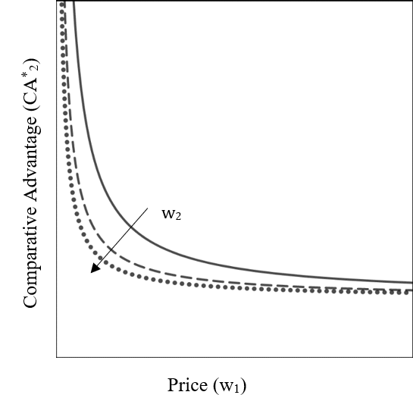

**Fig 1:** Comparative Advantage in relationship with its price for the firm.

Politician *j*

Firm *i*

Politician *k*

**Fig 2:** Multi-partner alliance of firm *i* with politician *j* and *k*