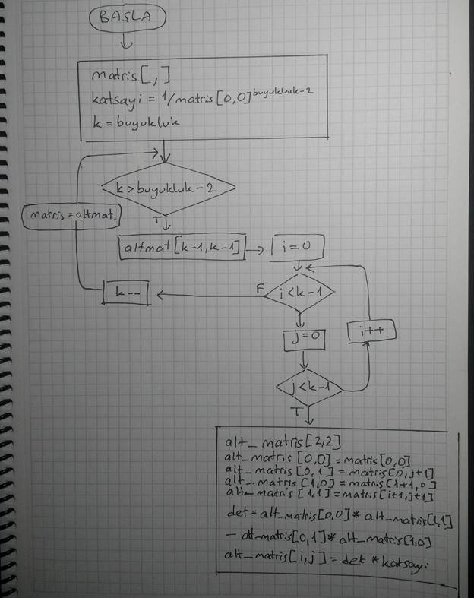

C# Kodu (.NET Core 3.0 Console App):

using System;

namespace sayisalAnaliz_hft04

{

class Program

{

static void Main(string[] args)

{

int[,] matris = new int[,]

{

{ 1, 3, 5, 6 },

{ 2, 4, 7, 8 },

{ 1, 1, 2, 2 },

{ 3, 3, 5, 6 }

};

int buyukluk = matris.GetLength(0);

int det = 0;

int katsayi = 1 / ((int) Math.Pow(matris[0, 0], buyukluk - 2));

Console.WriteLine("Matris[0, 0] = {0}, Buyukluk: {1}, Katsayi: {2}", matris[0, 0], buyukluk, katsayi);

for (var k = buyukluk; k > buyukluk - 2; k --)

{

int[,] altMat = new int[k - 1, k - 1];

for (var i = 0; i < k - 1; i++)

{

for (var j = 0; j < k - 1; j++)

{

int[,] mat2x2 = new int[2, 2];

mat2x2[0, 0] = matris[0, 0];

mat2x2[0, 1] = matris[0, j + 1];

mat2x2[1, 0] = matris[i + 1, 0];

mat2x2[1, 1] = matris[i + 1, j + 1];

det = mat2x2[0, 0] * mat2x2[1, 1] - mat2x2[0, 1] * mat2x2[1, 0];

altMat[i, j] = det * katsayi;

}

}

matris = altMat;

for (int i = 0; i < k - 1; i++)

{

for (int j = 0; j < k - 1; j++)

{

Console.Write(string.Format("{0} ", altMat[i, j]));

}

Console.Write(Environment.NewLine + Environment.NewLine);

}

Console.WriteLine("-------------");

}

Console.WriteLine(det);

}

}

}