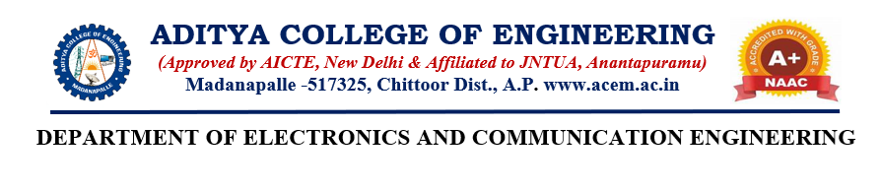
AI-Powered Smart Wound Scanner to Detect Healing Stages

Abstract:
The evaluation of wound healing is an important task in clinical dermatology and post-surgical care. Traditional methods rely on visual inspection and manual measurements, which are often subjective and inconsistent. This project presents a lightweight software-based solution called an AI-Powered Smart Wound Scanner. The system processes wound images using image preprocessing techniques such as resizing, noise reduction, and normalization to ensure consistent input quality. K-Means clustering is applied in the LAB color space to accurately segment the wound region. Feature extraction is then performed to calculate wound area and tissue color percentages.
Finally, a Support Vector Machine (SVM)-based ensemble classifier with an RBF kernel is used to classify the wound into healing stages: Inflammation, Proliferation, and Maturation. The system achieves an accuracy of over 97.5% while remaining computationally efficient. The complete system is integrated into a web-based dashboard using Flask, providing real-time predictions along with clinical support features such as diet and care recommendations, improving the reliability and efficiency of wound assessment.
Keywords: - Artificial Intelligence, Wound Healing, Image Preprocessing, K-Means Clustering, LAB Color Space, Feature Extraction, SVM Ensemble, Image Segmentation, Medical Image Processing, Clinical Decision Support System

K. Manoj Kumar Reddy –228P1A0448 Signature of the Guide
K. Manikanta –228P1A0445 Mrs.C.K. HEMANTHA LAKSHM
K. Indu Priya – 228P1A0431 Assistant Professor
S. Archana – 228P1A0407

