#5(Current Status: Active): This involves disabling form radio buttons being

disabled based on a user choice.

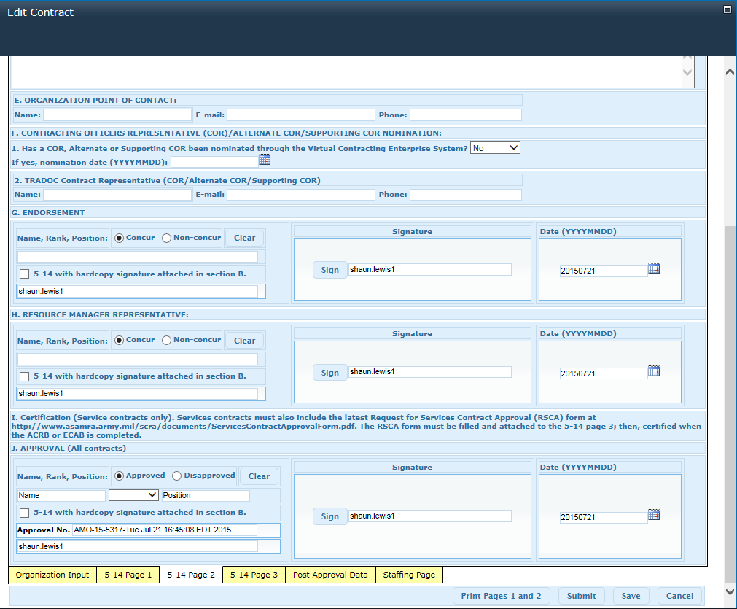

Use Case 1: When user clicks section G. ‘Endorsement’ radio buttons,

Section H. ‘Resource Manager Representative’ [Concur and Non-Concur]

radio buttons, text fields, checkbox, and ‘Clear’ button are enabled. Section J Approval radio buttons,

text fields, checkbox, and ‘Clear’ button are disabled.

Use Case 2: When user clicks section H. ‘Resource Manager Representative’ radio buttons,

section J ‘Approval’ radio buttons, text fields, checkbox, and ‘Clear’ button

are enabled.

#4(Current Status: Active): This involves presenting the 'Unlock' button to

function based on user permissions.

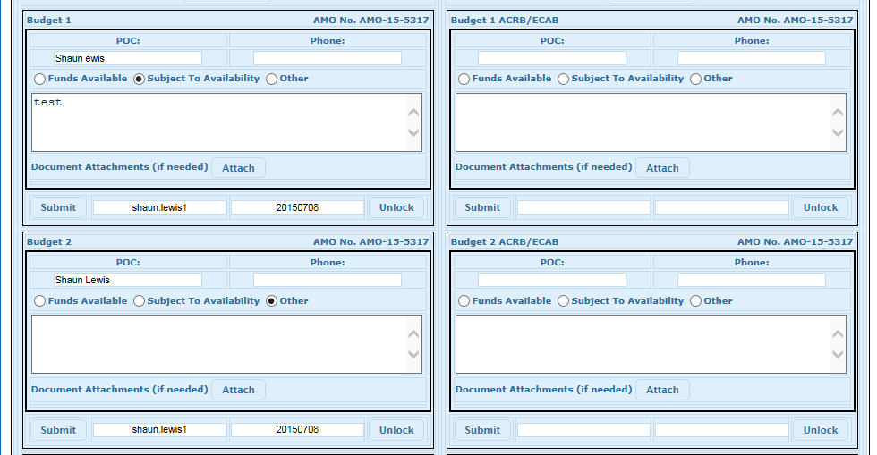

Use Case 1: When a user who have not created the contract clicks the ‘Staffing Page’ and scrolls down to the above region of the form, the ‘Unlock and ‘Submit’ buttons should be disabled.

#17(Current Status: Active): Involves additional printing of more than two

pages of the form. The form is currently set to print only two pages.



Use Case 1: When users edit the form, the print options located at the bottom of the form only prints pages 1 and 2 which represents the corresponding tabs of ‘5-14 Page 1’ and ‘5-14 page 2.’ Users would like to print the complete

Form.

#8(Current Status: Active): Involves certain top navigation components from

being hidden from view based on the current user permissions.



Use case 1: User wants certain components to be hidden based on audience targeting.