BLG 335E

HW1 REPORT

**O. Kürşat Karayılan**

**150140011**

# a)

**Bubblesort**

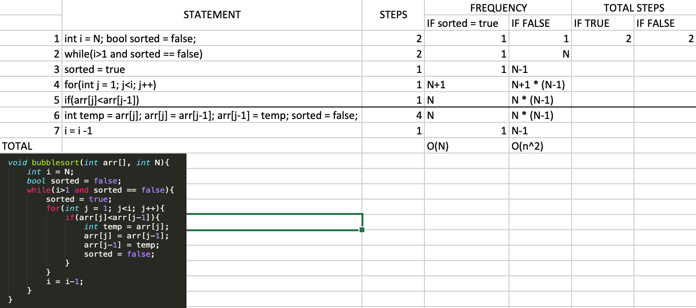

Bubble sort works with O(n^2) time complexity. In my implementation it is same. If the list is already sorted, then it works with O(n).

**Merge**

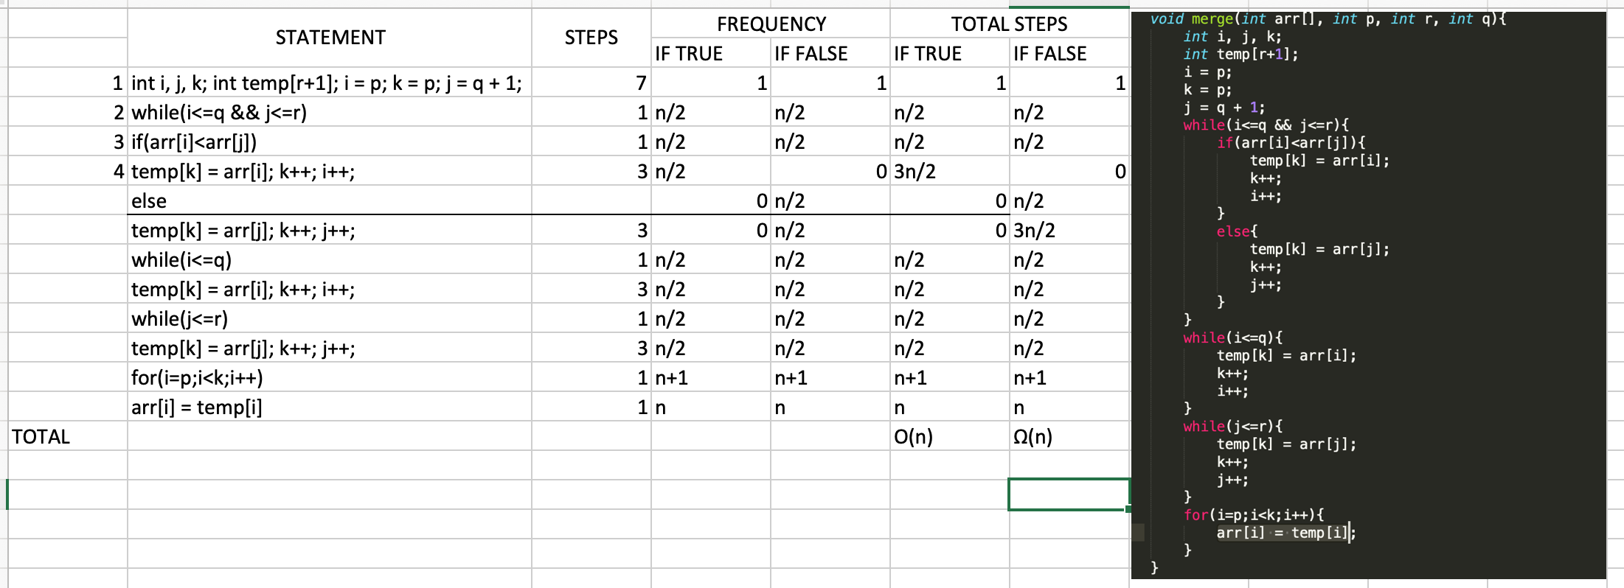

Merge function works with O(n). Whether the list sorted or not, it is same.

**Mergesort**

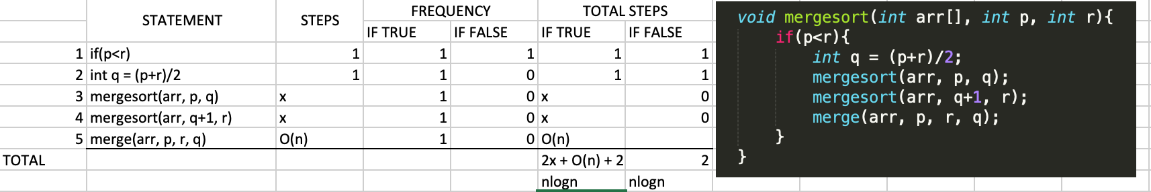

Mergesort’s time complexity is nlogn. I got same result from the equation T(n)=2T(n/2)+O(n).

# b)

Bubblesort works good if the list already sorted. Because it checks whole list just for once after the second(new one) implementation of the algorithm. But if the list unsorted, time increases significantly. It sorts 1mil number in 50mins. Mergesort works good in all cases as we can see above picture.

# c)

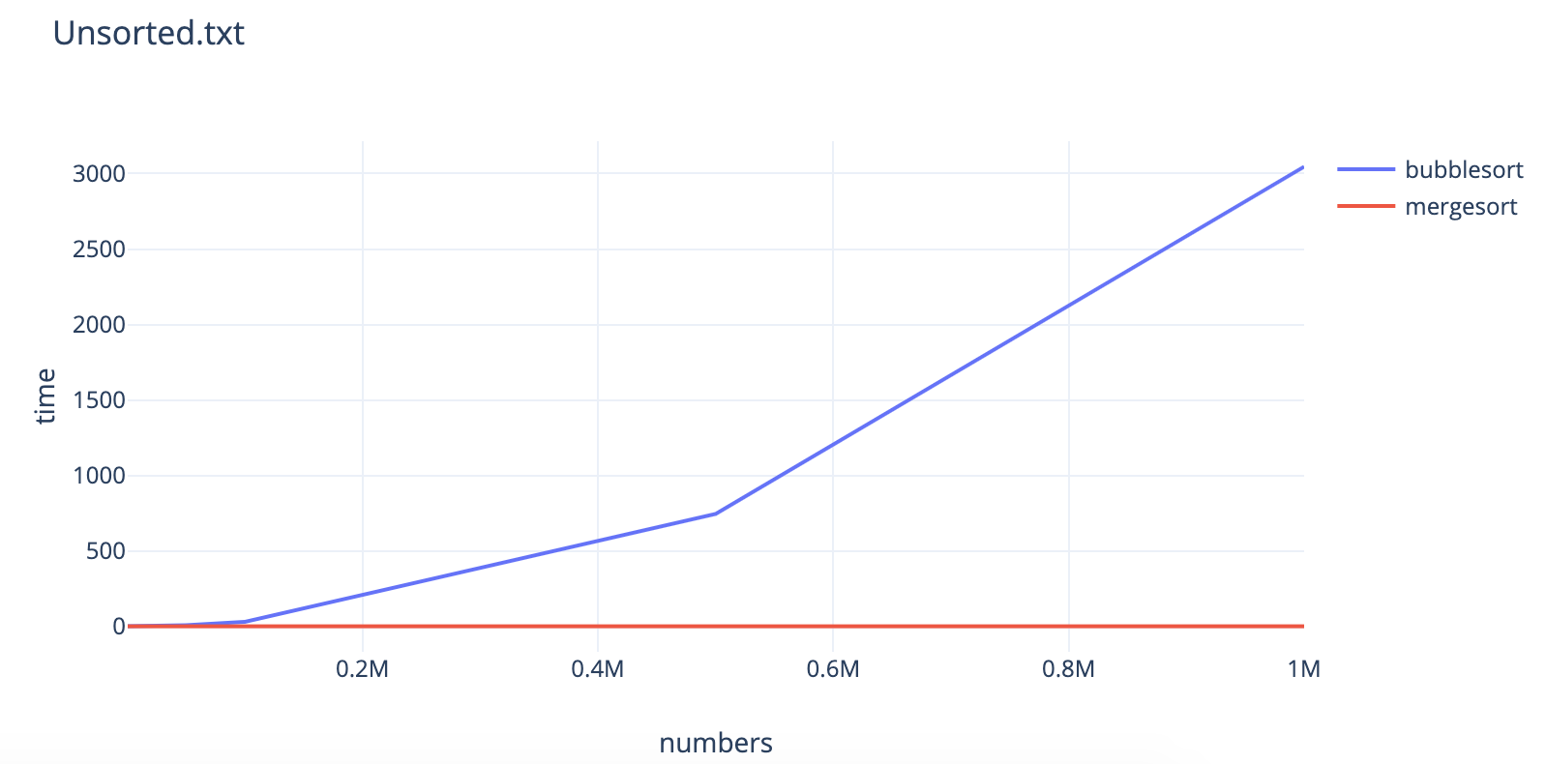

# 

As you can see from the plots mergesort works almost like a constant time compared to bubblesort for unsorted list. But bubblesort works slightly better for sorted list, because time amounts already in very small scale. We can choose mergesort for unsorterd list and bubblesort for sorted list.

# d)

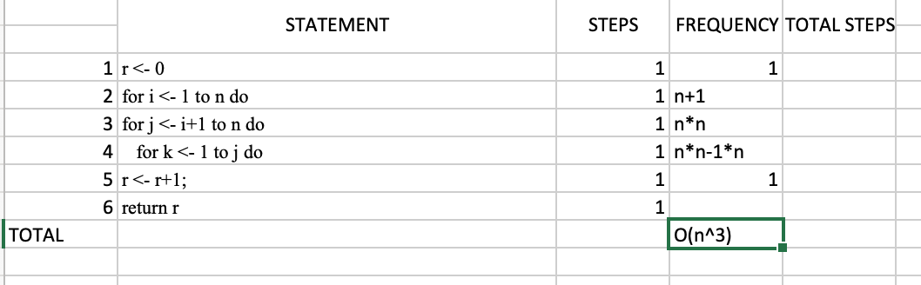

It’s time complexity O(n^3)

We can write the function as following equation: