

Acceptance Test Procedure
SH2000 Dual-Ridge Horn Antenna, 2–32 GHz
Document no | ATP-SH2000-001
Stock no | 5985-01-234-5678
Revision | B
Release date | 07.11.2026
Classification | Company confidential

Document change record
Table 1 – Document change record
Rev. | Date | Description | Prepared | Approved
A | 12.05.2026 | First issue | E. Kaya | M. Demir
B | 07.11.2026 | Software installation steps and record form added | E. Kaya | M. Demir

Contents
1 Scope
2 General information
2.1 Project
2.2 Stock definition
2.3 Unit introduction
3 Documents
3.1 Applicable documents
3.2 Reference documents
4 Abbreviations and symbols
5 Tests
5.1 Return loss (VSWR) test
5.1.1 Hardware list
5.1.2 Software list
5.1.3 Test set-up
5.1.4 Software preparation and installation
5.1.5 Test steps
5.2 Radiation pattern test
6 Annexes
6.1 Annex A – Test record form
List of figures
Figure 1 – SH2000 dual-ridge horn antenna
Figure 2 – Return loss test set-up
List of tables
Table 1 – Document change record
Table 2 – Stock definition
Table 3 – Main characteristics
Table 4 – Applicable documents
Table 5 – Reference documents
Table 6 – Abbreviations
Table 7 – Symbols
Table 8 – Hardware list
Table 9 – Software list
Table 10 – Software installation steps
Table 11 – Return loss test steps
Table 12 – Form A-1: return loss test record

Scope
This procedure describes how the SH2000 dual-ridge horn antenna is tested before it is accepted: the hardware and software needed, how the test set-up is built, how the software is prepared and installed, and the steps of each test. Measured values are recorded on the form in Annex A, not in this document.
The procedure applies to every SH2000 delivered under the project, at the acceptance test after production.

General information

Project
The SH2000 is used as the reference antenna of the Divit EMC Range project, where it measures the gain and pattern of the antennas under development.

Stock definition
Table 2 – Stock definition
Item | Value
Stock no | 5985-01-234-5678
Part no | 617-355-SH2000
Manufacturer | Microwave Vision Group
Description | Dual-ridge horn antenna, 2–32 GHz
Unit of issue | Each

Unit introduction
The SH2000 is a broadband dual-ridge horn. The ridges keep the impedance near 50 Ω over the whole band, so one antenna covers 2–32 GHz. It is fed through an SMA connector at the back of the waveguide section.
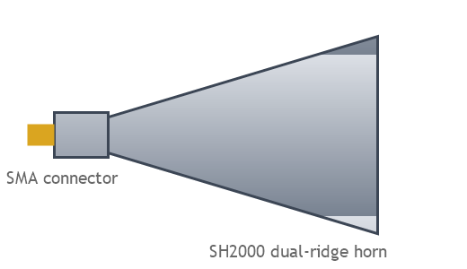
Figure 1 – SH2000 dual-ridge horn antenna
Table 3 – Main characteristics
Characteristic | Requirement | Verified in
Frequency range | 2–32 GHz | 5.1
VSWR | ≤ 2.0 : 1 | 5.1
Gain | 3–17 dBi | 5.2
Mass | ≤ 0.3 kg | Visual inspection

Documents

Applicable documents
The following documents form part of this procedure; their latest revision applies.
Table 4 – Applicable documents
No | Document no | Title | Rev.
AD1 | SPEC-SH2000-01 | SH2000 product specification | C
AD2 | QP-TEST-004 | Calibration of test equipment | F
AD3 | IEEE Std 149-2021 | Recommended practice for antenna measurements | –

Reference documents
Table 5 – Reference documents
No | Document no | Title | Rev.
RD1 | UM-VNA-220 | Vector network analyser user manual | 3

Abbreviations and symbols
Table 6 – Abbreviations
Abbreviation | Meaning
ATP | Acceptance test procedure
AUT | Antenna under test
DUT | Device under test
SMA | SubMiniature version A connector
VNA | Vector network analyser
VSWR | Voltage standing wave ratio
Table 7 – Symbols
Symbol | Quantity | Unit
f | Frequency | GHz
G | Gain | dBi
Γ | Reflection coefficient | –
λ₀ | Free-space wavelength | m

Tests

Return loss (VSWR) test
The test checks that the antenna is matched to 50 Ω over 2–32 GHz: the VSWR may not exceed 2.0 : 1 at any frequency.

Hardware list
Table 8 – Hardware list
No | Equipment | Manufacturer | Model | Serial no | Calibration due
1 | Vector network analyser | Rohde & Schwarz | ZNA43 | 101234 | 03.2027
2 | Calibration kit, 2.92 mm | Rohde & Schwarz | ZN-Z229 | 100987 | 01.2027
3 | Test cable, 1 m | Huber+Suhner | SF102 | C-0441 | –
4 | Torque wrench, 0.9 N·m | Rohde & Schwarz | ZN-ZTW | T-017 | 06.2027
5 | Absorber panel | Divit | ABS-60 | – | –

Software list
Table 9 – Software list
No | Software | Version | Purpose
1 | VNA firmware | 2.40 | Runs the network analyser
2 | Divit Antenna Test Suite | 1.3.0 | Drives the measurement and writes the record file
3 | Calibration kit data | ZN-Z229 V2 | Standards of the calibration kit

Test set-up
The antenna points at the absorber panel at least 1 m away, so the reflections of the room stay below the measured return loss (Figure 2).
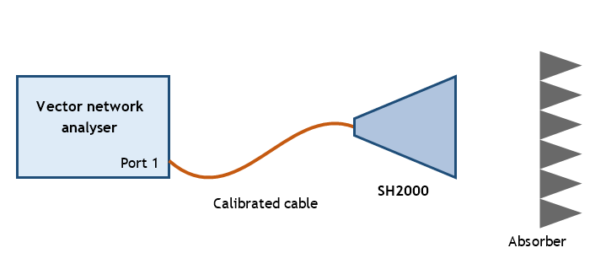
Figure 2 – Return loss test set-up

Software preparation and installation
Caution: install the software with the analyser switched off; a running analyser may lose its calibration.
Table 10 – Software installation steps
Step | Action | Expected result | ✓
1 | Copy the Divit Antenna Test Suite 1.3.0 installer to the test computer. | Installer present | ☐
2 | Run the installer as administrator and accept the default folder. | Installation finished without error | ☐
3 | Load the ZN-Z229 calibration kit data into the analyser. | Kit listed under Calibration > Kits | ☐
4 | Start the test suite and select the SH2000 test plan. | Plan opens, 2–32 GHz, 1601 points | ☐

Test steps
Table 11 – Return loss test steps
Step | Action | Expected result | ✓
1 | Switch the analyser on and let it warm up for 30 minutes. | Ready indication | ☐
2 | Calibrate port 1 at the end of the test cable (open, short, load). | Calibration valid | ☐
3 | Connect the SH2000 with the torque wrench at 0.9 N·m. | Connector tight, not over-torqued | ☐
4 | Start the sweep from the test suite. | VSWR curve shown | ☐
5 | Read the highest VSWR and record it on form A-1. | VSWR ≤ 2.0 : 1 | ☐

Radiation pattern test
The pattern is measured in the anechoic chamber with the positioner; the hardware, set-up and steps follow the same layout as 5.1 and are given in the chamber procedure (RD1).

Annexes

Annex A – Test record form
Fill in one form per antenna; the form is kept with the delivery documents.
Table 12 – Form A-1: return loss test record
Antenna serial no |  | Test date
Tested by |  | Test station
Results
Frequency band | Highest VSWR | Limit | Result
2–8 GHz |  | ≤ 2.0 : 1 | ☐ Pass ☐ Fail
8–18 GHz |  | ≤ 2.0 : 1 | ☐ Pass ☐ Fail
18–32 GHz |  | ≤ 2.0 : 1 | ☐ Pass ☐ Fail
Remarks
Signature |  | Quality assurance
Verdict | ☐ Accepted ☐ Rejected

